Effective teamwork and communication
By Maria Michael

Student No: 191 38 94
Module: Effective teamwork and communication
Module Code: BMSW4002
Professor: Ejiro Esohwode
University of Wales, Trinity Saint David
May 5, 2021
Contents
1 Introduction 3
2 Models of Communication 4
2.1 Shannon-Weaver Model of Communication 4
2.2 Schramm’s Model of Communication 6
2.3 Berlo’s SMCR Model of Communication 7
3 Effective Communication 10
4 Poor/ Ineffective Communication 11
4.1 Consequences of Poor Communication in the Workplace 12
5 Conclusion 12
6 References 13
7 Appendix 16

Introduction

Communication is defined as the process by which one party imparts or transmits meaning/ information to another (Harper, 2001). When we communicate with each other, we increase our shared knowledge. This sharing can sometimes lead to conflicts, particularly when it is about opposing views and interests (Rosengren, 1999). Additionally, there may even be barriers to effective communication that can lead to conflicts. This document is geared towards exploring communication in the world of work by examining three models of communication, characteristics of effective and poor communication, and the consequences of poor communication.
In doing so, different case studies (located in the Appendix) will be integrated throughout the discussion to be used as examples of different models or communication phenomena within the models, as is appropriate. This will include causes of poor communication as well as the means of avoiding it in the future.

Models of Communication
Models are systematic representations of events or objects in an idealized and abstract form, and usually eliminate details while focusing on the essential factors (Mortensen, 1972). Communication models clarify and simplify the communication process and allows one to visualize what previously could only be described conceptually. They also create a framework for identifying and resolving problems in the communication process.
In the following section, I will briefly examine three models of communication: Shannon-Weaver, Schramm’s, and Berlo’s.

Shannon-Weaver Model of Communication

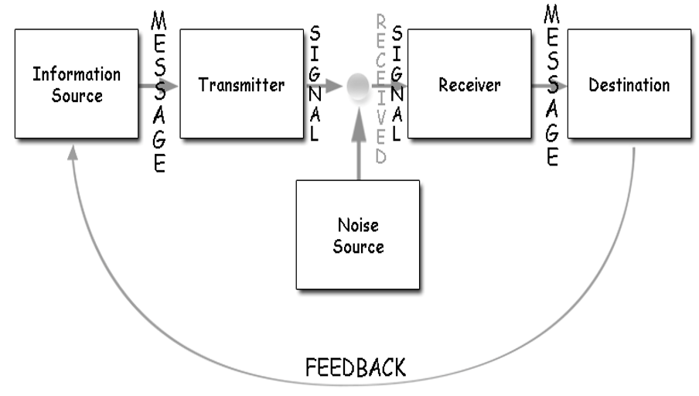
Figure 1. Shannon-Weaver model of communication
This model is based on seven (7) basic concepts (Chandler, 1994):
- Sender –the producer of the message. S/he decides on how the message should be sent, and then sends it
- Transmitter – converts the message into a signal
- Channel – means used to send the message. The signal is converted to be sent via the channel
- Receiver/ Decoder – receives and reconstructs the message
- Destination – point to which the reconstructed message finally arrives
- Noise – disturbances that prevent messages from getting to the destination as intended.
- Feedback – recipient’s response to the received message.
The sender encodes and sends the message to the destination via technological channels, including mobile phones and email. The mobile phone converts the message (audio, text or multimedia) to digital form and transmits it via radio waves. The receiver then decodes the message, and presents it to the recipient/ destination in a form identical to the original. Problems may occur during the communication process due to noise in the channel.
This communication model is applicable to the scenario involving Maria and Pedro, as it covers all aspects of the communication that occurred between them. Specifically, it includes the disturbance (i.e. noise on the building site) that prevented the message from getting to Pedro as intended by Maria, thus causing a miscommunication. Such a miscommunication could have been avoided if a different channel was used. For example, if Maria had sent a text message, a misunderstanding would be less likely. Additionally, the fact that ‘chicken’ and ‘kitchen’ sound similar could have contributed to the misunderstanding.
Even further, Maria instructed Pedro to “get” instead of perhaps “purchase” or “buy” a chicken. Had any of these words been used, Pedro is less likely to have misunderstood. Even if he heard “buy me a kitchen”, the ridiculous nature of such a request would either caused him to seek clarification or conclude that she was asking him to buy chicken.
This model, like the others to follow, does have several drawbacks. Chief among these is the fact that it is not as easily applied to group or mass communication as it is to person-to-person communication. Additionally, it focuses on linear/ one-way communication, when communication can sometimes require some level of back and forth before the message is understood (Wallace, 2019).

Schramm’s Model of Communication
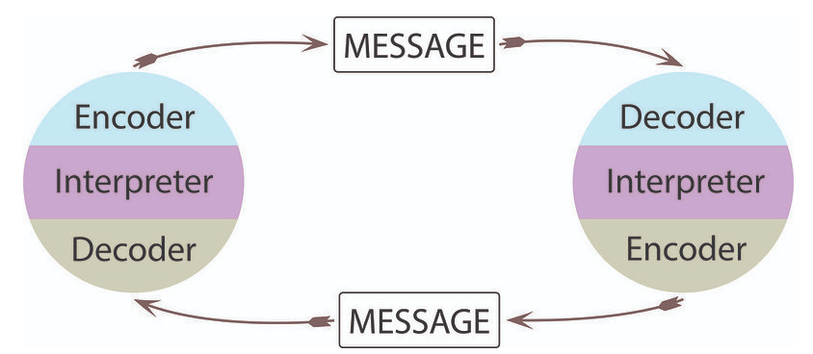
Figure 2. 1.1 Schramm’s Model of Communication. Source: Wrench, et al. (2020).
Introduced in 1954 by Wilbur Schramm, this model is an improvement on the Shannon-Weaver model. It treats communication as a bidirectional process taking place between encoder and decoder, as opposed to a strictly linear process (Wrench, et al., 2020). It takes people’s interpretation of the message into account, and contends that people’s knowledge, cultural background and experience all play an important role in determining how a message is interpreted. In fact, Schramm argues that the message is useless until and unless the recipient is able to understand it. He further states that the communication process is neither complete nor effective if no feedback is obtained from the recipient of the message.
This model could also apply to Maria and Pedro. If Pedro had provided more meaningful feedback (perhaps by repeating what he heard back to her), he would have created the opportunity for her to clarify any misunderstandings. Even though the communication broke down, Schramm’s model also works with the case of Mark and Alana. As Mark was speaking, Alana would nod, communicating to him that she was listening to and understanding what he was saying.
One major drawback of Schramm’s model is the fact that it ignores situations in which there is a power balance between the communicators; the leader is peaking and the listener is attempting to understand the message. Also, much like Shannon-Weaver, Schramm’s model does not work for mass communication, and focuses on communication between two individuals (Drew, 2015).

Berlo’s SMCR Model of Communication
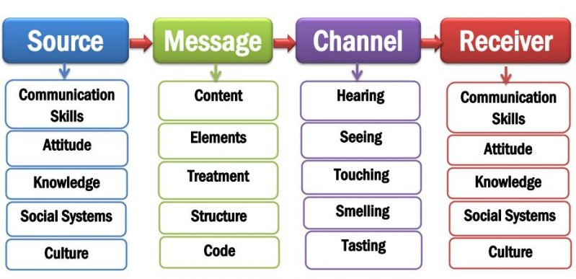
Figure 3. Berlo’s SMCR Model of Communication. Source: (Kobiruzzamam, 2021)
Developed in 1960 based on the Shannon-Weaver Model of Communication, the SMCR (sender, message, channel, receiver) model was proposed by David Berlo, and describes the factors that improve the effectiveness of communication, as shown in Figure 3 (Lee, 2021).
S – Source
Several source-based factors affect the quality of the communication. Communication skills refers to sender’s capacity to write or vocalize his views or ideas. Attitude refers to the source’s position, which the listener may affect. If the source of the message has the necessary knowledge on the topic being discussed, then s/he will be more effective in transmitting that information. The sender’s values, beliefs and opinions (i.e. social systems) also play an important role in how effective s/he is at communicating (Devimeenakshi & Tyagi, 2013). Finally, cultural differences also affect messaging. The sender may find a message inoffensive while the recipient, from another culture, may find it incredibly offensive.
M – Message
This is primary material that is being provided by the sender to the receiver, and may take the form of audio, text, or multimedia. Berlo identified five (5) features of the message element that determine the effectiveness of the communication process:
- Content –substance of the message, from start to finish.
- Elements – non-verbal accompaniments of the content, and includes things like language, and gestures.
- Treatment – manner in which the message is conveyed to the recipient.
- Structure – how the message is arranged.
- Code – form taken by the message whether language, text, audio, multimedia etc.

C – Channel
The vehicle used convey the message between sender and receiver, and includes instruments such as radios, mobile phones, newspapers, etc. The five senses (seeing, tasting smelling, hearing, and touching) determine the effectiveness of this element of the communication process.
R – Receiver
Recipient of the message/ information that was sent by the source. The same factors that affect the efficacy of communication on the sender’s side also affects the communication on the receiver’s side. In their absence, the communication process is rendered ineffective.
Berlo’s model is also an ideal framework for identifying and preventing the source of communication errors between Maria and Pedro. The coding of the message in this case should have been different; instead of sending an audio-based message, it should have been text-based. This is because a visual message can still get through effectively even when the environment has auditory disturbances (Morrill & Cooper, 2014).
Berlo’s model could be reasonably applied to the scenario between Mark and Alana. Specifically, by loosening his tie and crossing his legs when talking about the problems he has with the company, Mark could be unknowingly offending Alana. This demeanor (or element of the message) is perhaps not aligned with the cultural standards in America.
Another case of message elements or treatments being a communication barrier is that of Barry. Most of the employees did not speak English as their primary language. Therefore, simply posting signs, in English, telling them what to do would not be sufficient. He should have considered using visual signs showing these actions (or pictograms) rather than text, or presenting this information in the native language of the workers.
Though Berlo’s model can be useful, it does not take factors such as the need for feedback into consideration; it is a linear communication model. Additionally, it does not consider the effects of noise on communication (Mahajani, 2016).
Now that we have explored the communication models, we will look at what constitutes effective communication.

Effective Communication
The ability to effectively communicate with colleagues, superiors and subordinates alike is a critical to the proper functioning of a workplace, regardless of industry. The seven Cs of communication outlined below are indispensable if we wish to be fully understood when we communicate with others (Ellis & Abbott, 2017). They are focused primarily on the sender of the message:
- Clear – be clear about goals or message. Think about the purpose for communicating with a particular person. If the speaker is not clear about the reason for communicating, then the listener will not be sure. The listener should not need to ‘read between the lines’ in order to understand your message.
- Concise – focus on the main point that you want to make, and keep the message as brief as necessary. One should not have to listen to five (5) sentences in order to understand what could be said in a single sentence. This requires the elimination of filler words in our communication.
- Concrete – the receiver has a clear idea of what the sender is saying. Details may be included, and the facts given are clear and readily understood.
- Correct – fits the audience, and is error-free. It should also fit the knowledge and education level of the receiver.
- Coherent – has to be logical, with all the points mentioned being relevant to the main issue being discussed.
- Complete – the sender provides the recipient with all the information they need so that they can respond or act in an appropriate manner (Sureka, et al., 2018).
- Courteous – communication characterised by an open, honest, friendly attitude towards conveying the message. It is mindful of the receiver’s perspective when formulating and sending the message.
One workplace/ industry that generally communicates effectively is customer service/ support centre. These entities tend to use a script when responding to customers’ requests or providing information. Calls made to these support centres are usually answered with a friendly, welcoming (courteous) tone. Since the companies would specialize in a particular good or service, the scripts tend to be made specific to a particular problem. For example, how to connect a wireless printer. Additionally, such a script, as read by the service provider to the client, would have clear information relevant to the brand and model of printer that the customer owns (correct information), excluding other makes and models (concise). The information/ instructions would be provided in a logical (coherent) order so that no step is missed or executed at the wrong time. At the end of the interaction, the customer would have had his/ her issue resolved, as the information provided would have been complete.
Now that effective communication is understood, we will briefly look at poor communication and its consequences.

Poor/ Ineffective Communication
Poor communication occurs when there is a difference between what the sender of a message wants to communicate and what the recipient understands. This can have detrimental consequences for any industry, and health and social care is no different.

Consequences of Poor Communication in the Workplace
A major source of workplace disputes is poor communication. This is often due to the elements of the message (see M-Message in Berlo’s model) or differences in culture and communication styles, or the absence of communication altogether. For example, Isa (2015) outlines a situation in which a supervisor put another worker in charge of another employee’s tasks without first informing that employee. Such a move can reasonably be seen as an insult, and serve to increase tension among workers. This not only creates conflict, but also negatively impacts morale and productivity.
Additionally, research conducted by King et al. (2013) has found that poor communication forms a major hurdle to the safe and effective transfer of patients between hospitals and skilled nursing facilities (SNF). Poor communication was also identified by Pourasghar et al. (2016) as a major contributor to undesirable results in healthcare facilities whenever patients are being transferred from hospitals to care facilities.

Conclusion
In the workplace, effective communication is key to avoiding confusion, building positive company culture, and improving productivity. Shannon-Weaver, Schramm’s, and Berlo’s SMCR communication models are all useful frameworks for understanding and assessing the communication process in order to identify and resolve communication issues. We also saw that effective communication is characterised by several features, as outlined by the seven Cs. The case studies demonstrates how miscommunication can occur, and also provides a means of avoiding those errors in the future.

References
Chandler, D., 1994. The Transmission Model of Communication. [Online]
Available at: http://visual-memory.co.uk/daniel/Documents/short/trans.html?LMCL=xbWw8Z&LMCL=RcvMrF
[Accessed 11 April 2021].
Devimeenakshi & Tyagi, S., 2013. A Study on Teaching Business Communication/English in Indian Classroom. English Language Teaching, May.6(6).
Drew, C., 2015. Osgood-Schramm Model of Communication – Pros & Cons. [Online]
Available at: https://helpfulprofessor.com/osgood-schramm/
[Accessed 27 April 2021].
Ellis, P. & Abbott, J., 2017. Communication at the heart of leadership: the seven Cs. Journal of Kidney Care, 24 May.2(3).
Harper, D., 2001. communicate (v.). [Online]
Available at: https://www.etymonline.com/search?q=communicate
[Accessed 12 April 2021].
Isa, A. A., 2015. Conflicts in Organizations: Causes and Consequences. Journal of Educational Policy and Entrepreneurial Research (JEPER), 2(11), pp. 54-49.
King, B. J. et al., 2013. The Consequences of Poor Communication During Transitions from Hospital to Skilled Nursing Facility: A Qualitative Study. Journal of the American Geriatrics Society, 3 June, 61(7), pp. 1095-1102.
Kobiruzzamam, M. M., 2021. SMCR Model of Communication- David Berlo’s SMCR Model of Communication Example. [Online]
Available at: https://newsmoor.com/smcr-model-of-communication-david-berlos-smcr-model-of-communication-example/
[Accessed 12 Aprril 2021].
Lee, D., 2021. Developing Effective Communications. [Online]
Available at: https://extension.missouri.edu/publications/cm109
[Accessed 27 April 2021].
Mahajani, J., 2016. BERLO’S SMCR MODEL OF COMMUNICATION. [Online]
Available at: https://etechmethod.wordpress.com/2016/10/11/berlos-smcr-model-of-communication/
[Accessed 27 April 2021].
Morrill, M. & Cooper, S., 2014. How to improve communication in noisy environments. [Online]
Available at: https://www.ishn.com/articles/98716-how-to-improve-communication-in-noisy-environments
[Accessed 12 April 2021].
Mortensen, C. D., 1972. Communication Models. In: Communication: The Study of Human Communication. s.l.:McGraw-Hill Book Co..
Pourasghar, F., Kavakebi, N., Tabrizi, J. S. & Mohammadi, A. B., 2016. Barriers to Communication and Information Exchange in Patient Transfer and Its Consequences. Global Journal of Health Science, 8(12), pp. 178-189.
Rosengren, K. E., 1999. Communication: An Introduction. s.l.:SAGE.
Sureka, B., Garg, P. & Khera, P. S., 2018. Seven C’s of Effective Communication. American Journal of Roentgen.
Wallace, L., 2019. Moving away from the Shannon and Weaver model. [Online]
Available at: https://www.isentia.com/latest-reads/moving-away-from-the-shannon-and-weaver-model/
[Accessed 27 April 2021].
Wrench, J. S., Punyanunt-Carter, N. M. & Thweatt, K. S., 2020. Models of Interpersonal Communication. [Online]
Available at: https://socialsci.libretexts.org/@go/page/66549
[Accessed 15 April 2021].

Appendix


