Module: Marketing Fundamentals
Module Code: LCBB4004
Program: BA Business Management

Assignment Title: Assessment 2
Marketing Fundamentals Analysis and Evaluation

Company Chosen: Sainsbury UK

Module Lecturer: Tushara Balendran

Student Name: Rumyana Lyubomirova Popova
Student ID: 1909673

Table of Contents
Introduction 2
Definition of marketing 2
Main stages in the marketing process 2
Macro environmental analysis 3
Porter’s Five Forces Model 6
SWOT Analysis 10
Relation between the Macro environment and SWOT Analysis 11
Segmentation, Targeting and Positioning 12
Marketing Mix elements (7Ps of marketing) 13
Conclusion 15
Recommendations 15
Reference List 17

Introduction
The impact of Covid-19 is being realised by all the businesses throughout the world. In this concern, the leaders a large range of interrelated issues to keep their employees and customers safe, increase liquidity and cash and reorient operations. As a marketing manager hired by a selected organisation, it is required to conduct an external and internal analysis of the selected company, taking into account the impact of Covid-19 on the selected organisation. The selected organisation is Sainsbury UK. The PESTLE analysis, Porter's Five Forces Model and SWOT Analysis will be developed along with justification. Segmentation, targeting and positioning will also be explored in the light of the impact of Covid-19.

Definition of marketing
Marketing is being regarded as the set of institutions, activities and processes to communicate, create, deliver and exchange offerings that deliver value to the customers, society and clients (Morgan et al. 2019). Again, as per Parment, Kotler and Armstrong (2021), marketing is being defined as the art and science of creating, exploring and delivering value to satisfy the needs of the target market at a considerable profit. Thus, marketing helps to refer to various activities undertaken by a company to promote the selling or buying of a particular product or service. Marketing tends to include selling, advertising and delivering services and products to various businesses and consumers. Overall, it can be said that marketing is the process to get the different types of people involved and interested in the service or product of the company through careful market analysis and research.

Main stages in the marketing process
Mission: The mission statement helps to detail the reason for doing business by the company. The mission statement helps to plan for marketing to achieve organisational goals. For example, the mission of Sainsbury is to recreate high-quality service to customers by ensuring a good financial return to stakeholders, considering the impact of Covid-19.
Situational Analysis: The situational analysis tends to include both the internal and external factors that could affect the business (Chan, Shen and Cai 2018). Several businesses are trying to adapt to the changing market during the pandemic. In this respect, a thorough analysis tends to include the PESTLE Analysis, SWOT, and Porter's Five Forces. Such analysis tends to decipher important problems and understand the strengths and opportunities of the business to win over the market.
Marketing plan: A business marketing plan is a tool to identify ideal customers and the methods to reach them. The first step is to define the target audience by performing market segmentation. Then, the measurable goals are set to track the milestones by providing concise information. In this respect, a marketing budget is important to include costs of advertisement, branding, and staffing.
Marketing mix decisions: This stage is important to develop the process of planning marketing. The marketing mix decisions tend to be developed by considering either the four Ps or six Ps of marketing (Chou et al. 2020). The marketing mix will be developed by taking into account situational analysis and steps of the target audience.
Implementation and Control: This step will include the launching of the marketing plan to persuade the customers to use their products. In this respect, resources are needed to market the products to the customers. The competitors will be monitored and adaptations will be made to the ever-changing demands of the customers.

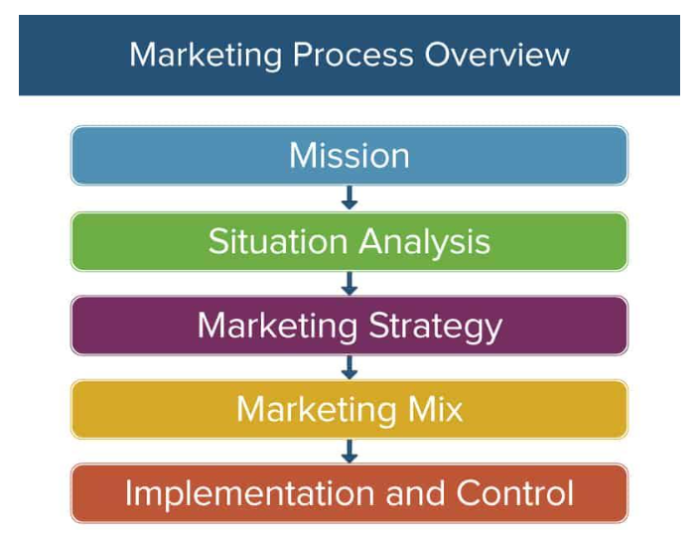
Figure: The stages in marketing process
Source: Smartsheet. Com (2022)

Macro environmental analysis
The macro-environment analysis is to be made by relating PESTLE factors to Sainsbury. PESTEL Analysis is a tool to monitor the macro-environmental factors to impact an organisation or industry (Pan, Chen and Zhan 2019). The main advantage of this tool is to encourage strategic and external thinking. The disadvantage of this tool is that the factors tend to change quickly.
Political: The political relationships and regulations tend to be stable in the UK in the pandemic situation. The UK retail industry has to comply with the health guidelines developed by the government. The government imposed lockdowns that tend to restrict in-person shopping. There tends to be uncertainty regarding the restrictions of future trade in Europe that can affect the retail industry-based companies. The Brexit impact also increased the cost of foreign products for companies, like Sainsbury. However, for Sainsbury, ongoing monitoring is being facilitated as regular threats of lockdown loom. Thus, the political force tends to be unfavourable to Sainsbury as it becomes difficult for the company to import products affordably from abroad.
Economic: The current Covid-19 pandemic has added to the larger dependence on online shopping and poor market performance by retail. The conversions regarding exchange rates tend to be volatile which affects negotiations with suppliers. Sainsbury has developed a 261 million pounds annual loss despite improving sales of groceries during the pandemic (the Guardian 2022). However, the GDP in the UK has grown by 0.1% in 2022 which signals the gradual recovery of the economy. The UK retail industry has started employing workers for in-store activities. In this respect, the companies like Sainsbury are focussing on innovation to create high profits in the long run. Thus, the economic force tends to be partially favourable to Sainsbury as the footfalls have risen to a small extent.

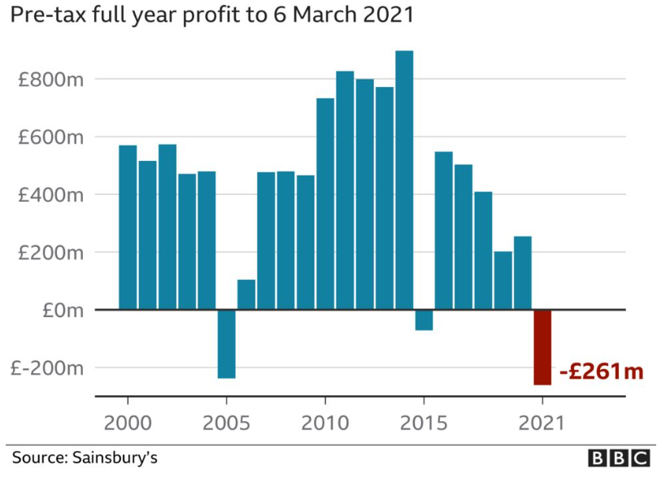
Figure: Covid impact on Sainsbury's profit
Source: BBC.com (2022)

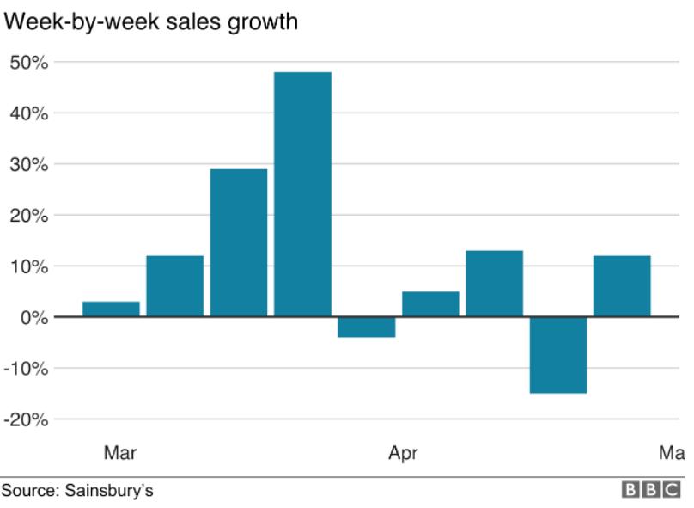
Figure: Grocery sales Sainsbury
Source: BBC.com (2022)

Social: The customers have become increasingly cautious about their choices due to the pandemic impact. The retailers are currently offering the products online by collecting data from the customers. However, to cope with the changing customer demands, market research is important and investments are required. The UK retail tends to shape its offerings based on preferences and cultural diversity. Thus, social force tends to be favourable to Sainsbury as it is gradually adapting to the shifts in consumer behaviour through market research.
Technological: the UK is a technologically advanced country with a strong online presence and improved development and research centres. In Covid-19, the UK retail focuses on website ease of use for customers. Sainsbury's digital business has become twice with the shift in online in the Covid-19 (Internet Retailing 2022). Thus, technological force tends to be favourable to Sainsbury as it focuses on advancements in analytics to develop large accurate models to ensure profitability.
Legal: There have been concerns over family-friendly implications as an impact of the pandemic as most of these have been brought in by the EU. Also, there have been legal restrictions on the part of the government regarding the use of masks and sanitisers on the road, malls, theatres, and retail outlets. In this concern, UK retail tends to abide by these legal restrictions. Retail companies, like Sainsbury, also tend to comply with the Modern Slavery Act important for retail. Thus, legal force tends to be unfavourable to Sainsbury due to the lack of contractual flexibility in peak trading periods.
Environmental: As an impact of Covid-19, there tends to be a rise in environmentally conscious and ethical shoppers in the UK retail. In this respect, a retail company like Sainsbury tends to develop an ethical sourcing policy with the development of sustainable logistics operations. Also, the UK retail industry is focusing on the reduction of carbon footprint and plastic wastes to minimise ecological damage (Upadhyay, Kumar and Akter 2021). Thus, environmental force tends to be favourable to Sainsbury as the suppliers tend to be audited against the new standards of sustainability. This tends to focus more on balancing the ecology with the demands of the customers.

Porter’s Five Forces Model
Porter's Five Forces Model is a model to analyse the competitive forces and determine industry weakness to shape it (Bartunek 2020). The advantage of this model is to develop the opportunities to expand the business. The disadvantage lies in the unavailability of quantitative dimensions that cannot consider the factors of risk to the business.

Forces | Analysis | Degree
The threat of New Entrants | The threat of new entrants in the UK retail is low. This is due to the fact that the new entrants tend to require large investments in the pandemic. Further, the companies like Sainsbury have achieved an advanced level of technology in the UK. This translates automatically into lesser opportunities for new entrants. Further, this tends to constitute a source of market comfort for the company with the increased security of its market position. Again, the stricter Covid regulations for new entry by the government tend to create a competitive advantage for Sainsbury. | Low
Threat of Substitutes | There tend few substitutes for the products in the retail industry in which Sainsbury operates. Further, in Covid, people tend to demand more staple food items and groceries (Loxton et al. 2020). Thus, the threat of substitutes is low for Sainsbury as there tends to exist no ceiling on the maximum profit earned by the firms, like Sainsbury. Again, some of the substitutes in the UK retail tend to be more expensive. Comparatively, Sainsbury tends to deliver the products to the customers at a lower price during the pandemic than substitutes. | Low
Bargaining power of the buyers | The number of buyers in the UK retail has a moderate number of companies to select from and thus they tend to possess a medium control over their prices. Thus, the bargaining power of buyers for Sainsbury is medium. Again, the buyers tend to find some difficulty in switching. As an impact of the pandemic, there tends to be a rise in middle-class buyers in the UK retail. Thus, there tends to be the pressure to purchase at higher prices, thus making the buyers more or less price sensitive. | Medium
Bargaining power of the suppliers | A large number of suppliers in the UK retail who tend to provide less differentiated and fairly standardised supplies (Etro 2021). Thus, the bargaining power of suppliers for Sainsbury tends to be low due to the low switching costs. Moreover, in the pandemic situation, the suppliers will have to focus on reasonable pricing as the profits of the company are closely dependent on the suppliers. Also, as an impact of Covid, Sainsbury in the UK retail provides an equitable pricing policy for all the suppliers. | Low
Competitive Rivalry | The level of competition has got increased due to Covid in the UK retail (Pantano et al. 2020). Every firm is focusing on responding to customer needs to gain position and improve the market share. Thus, the competitive rivalry for Sainsbury tends to be high as the retail industry is facing a challenge due to economic turbulence caused by Covid. The competitors are more likely to engage in completive actions to make the companies, like Sainsbury within the industry push to full capacity. | High

SWOT Analysis
The SWOT Analysis is the model to help the companies to identify the forces influencing an action, strategy or initiative (Benzaghta et al. 2021). The principal advantage of SWOT Analysis is that it develops a systematic manner to analyse a complex situation, besides analysing opportunities. The disadvantage of SWOT Analysis is that there are no weighing factors to help in the subjective analysis of the relevant data.

Strengths  - Sainsbury is regarded as one of the largest chains of supermarkets in the UK.  - The company is following ethical and sustainable policies with an increased focus on employee diversity.  - The company's save to invest approach in a pandemic is accelerating the cost savings plan.  - Sainsbury has a diversified business with a concrete market share. | Weaknesses  - The demand for clothing and general merchandise has become weak due to Covid.  - The company has a low margin in its business of food.  - The company tends to operate in a single operating market.  - The value of investments for Sainsbury has got decreased in the short run.
Opportunities  - As an impact of Covid, Sainsbury can help to expand in the global market with the help of technological collaborations and online mechanisms.  - Sainsbury bank can lead to increased savings for the people, besides easy payments through the policies of growth and diversification.  - Technology analytics will help to create customer insights by improved marketing research. | Threats  - There can be the threat of competition from Tesco, Morrisons due to the consistent innovations and creativity in the pandemic.  - Brexit can create a large impact on the prices that can affect coping with the increased demands of the customers in the long run.

Figure: Sainsbury SWOT Analysis
Self-created

Relation between the Macro environment and SWOT Analysis
The two models to be related include Macro environment and SWOT Analysis.
Macro environment through PESTLE Analysis has helped to focus on the external environment factors of UK retail. This has helped to explore the various forces to help Sainsbury to increase its sales and customer retention in Covid. SWOT Analysis has helped to focus both on the internal and external factors to help Sainsbury determine its competitive advantage by analysing its strengths, opportunities, weaknesses and threats. Thus, as a marketing manager of Sainsbury, both PESTLE and SWOT Analysis have been assessed during the organisation of the business activities in Covid. In this way, the internal and external analysis of Sainsbury tends to review corporate strategy with the help of both SWOT and PESTLE Analysis. However, SWOT Analysis tends to lead to a more balanced approach (Tsangas et al. 2019). This helps Sainsbury to justify the internal factors with the development of control over the external influences. Again, PESTEL Analysis tends to help the company to analyse deeply the threats section in SWOT to justify the impact of Covid on Sainsbury.

Segmentation, Targeting and Positioning
Segmentation
Market segmentation is a strategy to break down the target market audience into manageable groups (Liu et al. 2019). Sainsbury has focused on geographic segmentation before Covid through which the company tends to identify the needs of the customers by detecting location. However, in the pandemic situation, the company tends to adopt both geographical and behavioural segmentation By using behavioural segmentation, Sainsbury tends to focus on the online shopping habits of the customers. This is to correlate to the likelihood that they will develop an online purchase through the website. Moreover, through behavioural segmentation, the brand loyalty of the customers tends to be justified to help in the increase of the profits and sales in Covid. In this respect, behavioural data tends to be useful for the company to cope with the shifts in consumer behaviour. Besides, this data tends to relate directly to the process of interaction with the brand required in the current pandemic situation.
Targeting
Targeting in marketing is a strategy to break a large market into smaller segments and concentrate on a specific group of customers (Lessmann et al. 2021). The main target audience of Sainsbury tends to include both female and male shoppers, particularly the families. However, with the rise in Covid, Sainsbury tends to target people who are tech-savvy and online customers mainly. Also, the young generation and the middle-class people have become the target market of the company. In this way, the retail company tends to focus on mass marketing to reach its products to undifferentiated customers. Thus, mass targeting in Covid tends to develop a large market appeal by considering the behaviour of the customers. This type of targeting tends to be less risky in times of economic turbulence. The targeting approach by Sainsbury tends to run the risk of increased competition with largely personalised content and products.
Positioning
Positioning is the process to create a distinct mental image or position of a service or product in the minds of the customers as compared to the other firms (Fayvishenko 2018). Sainsbury has been known for the development of its positioning strategy based on the characteristics of the products. Thus, the main focus has been on quality. With the advent of Covid, Sainsbury is increasingly focusing on positioning strategy based on competition. The competition among various UK retail companies has got increased during the pandemic situation. As a result, they tend to focus more on differentiation to improve their revenue margin. In this respect, Sainsbury is positioning its brand against competitors by focusing more on innovation and creativity to improve the base of the customers. Besides, based on the targeting approach, Sainsbury has also positioned itself at the mid-tier of the current market. This will help the firm in future to penetrate the discounted segment of the market.

Marketing Mix elements (7Ps of marketing)

Figure 1: 7Ps of Marketing
(Source: Created by Author)
Product-Sainsbury sells products in five categories, which are separate product lines on their own. The company sells products with a lot of variety to its customers. The customers perceive it to be of very high quality, and better than most competitors. Sainsbury had assumed that with the ease of lockdown restrictions, consumer demand would rise (sainsbury.co.uk 2020). However, the company incurred losses as the sales at stores had significantly reduced and customers were still not stepping out of their houses.
Price- Sainsbury follows a competitive pricing strategy. The products that incur a higher cost in manufacturing are priced higher than the competitors. The company also sells products as bundles. In the aftermath of the pandemic, the company had to close down their Argo stores while restructuring its business. The company incurred an exceptional cost of 617 million pounds when trying to protect their employees and customers (Simpson 2021).
Place-The Company distributes its products through two marketing channels. The first where it sells directly to the customers and the second is where it sells to the wholesalers. Sainsbury works with over 500 retailers across the country of UK who supplies the company with the required raw materials for the production process. Sainsbury has its own online retail shop which saw a rise in the number of orders during the pandemic.
Promotion- Sainsbury uses multiple channels to promote its products. It uses traditional channels like the radio and television and helps them in reaching a wide range of customers. The company also advertises the products on social media like YouTube and Twitter.
People- Sainsbury being a grocery chain could not close its stores during the pandemic. The primary priority for Sainsbury's has been to protect their colleagues and customers. The company has made changes in its business which resulted in added material costs. The company provided full-payment to their employees who were vulnerable or resided with a family member who was vulnerable. The company also gave a thank you payment of 10% to 157,000 employees (sainsbury.co.uk 2020). The company took measures to give extra importance to elderly and disabled customers. According to cnbc.com (2020), the organisation also took added measures to increase security and social distancing which led to a rise in costs for the company.
Process- The Company has to make sure that the products they are selling are available at their stores and stock up with more products. The company is actively involved in conducting market research to make sense of their customer needs. In the online delivery system, the company has created an inventory through which they record the orders and ship accordingly. The pandemic saw a rise in the online orders and the sales of furniture and clothing reduced at the Argo stores with the changes in priorities of the customer.
Physical evidence- Sainsbury sells its products in distinguished packaging differentiated by colour. The products can be easily identified on the shelves at the store. The products are separated according to their time. Do and Vu (2020) suggests that the supply chain of Sainsbury faced obstacles during the pandemic due to the restrictions imposed by the UK government. The quality of packaging saw a change with the interruption in the supply chain.

Conclusion
The overall report has focussed on the critical internal and external analysis and evaluation of the selected company, Sainsbury. The PESTLE factors have been related to Sainsbury to depict the industrial impact due of Covid-19. The technological factors tend to be favourable to Sainsbury due to improved online presence as a result of Covid. From Porter's Five Forces, the threat of new entrants has been low for Sainsbury due to increased Covid regulations by the government. From SWOT Analysis, the opportunity lies in increased global expansion online. Targeting, segmentation and positioning have also been related to signify the corporate strategy.

Recommendations
Certain recommendations for Sainsbury to cope with the challenges created by Covid-19: the recommendations include
- Sainsbury will have to focus more on the socially conscious values of the customers rather than on quality. This will help to provide the customers with a larger sense of their power in holding the larger organisations, like Sainsbury to account. In this respect, the marketers will have to communicate a concrete sense of their brand's purpose to the customers that will help to create a real difference. In this way, Sainsbury will help to develop clear commitments to causes that will help to empower the customers in a challenging situations.
- Sainsbury will have to place agility as a modern approach to marketing in Covid rather than a technological process. In this respect, the marketers of the company should have to develop a mind-set of marketing agility that can include continuous demand sensing and customer listening. This will help to improve the operations of the company by creating a competitive edge. Thus, the faster decision cycles will be made and more flexibility will be generated across financial projections to improve the buyer's perception of products.
- Sainsbury will have to create partnerships with retail SME to help to secure resources in Covid-19. In this respect, the pandemic situation will be a good opportunity to leverage partnerships. Such partnership will help the company to innovate and promote new every day-use products by highlighting digital engagement. In this way, the marketers will move forward with more experimentation with its weaknesses and threats.

Reference List
Bartunek, J.M., 2020. Accomplishing impact by performing our theories: It can be done, though not easily. The Journal of Applied Behavioral Science, 56(1), pp.11-31 [Available at: https://journals.sagepub.com/doi/pdf/10.1177/0021886319885451]
Benzaghta, M.A., Elwalda, A., Mousa, M.M., Erkan, I. and Rahman, M., 2021. SWOT analysis applications: An integrative literature review. Journal of Global Business Insights, 6(1), pp.55-73 [Available at: https://digitalcommons.usf.edu/cgi/viewcontent.cgi?article=1148&context=globe]
Chan, H.L., Shen, B. and Cai, Y., 2018. Quick response strategy with cleaner technology in a supply chain: coordination and win-win situation analysis. International Journal of Production Research, 56(10), pp.3397-3408 [Available at: https://www.tandfonline.com/doi/abs/10.1080/00207543.2016.1278283]
Chou, S.F., Horng, J.S., Liu, C.H.S. and Lin, J.Y., 2020. Identifying the critical factors of customer behavior: An integration perspective of marketing strategy and components of attitudes. Journal of Retailing and Consumer Services, 55, pp.1-18 [Available at: https://fardapaper.ir/mohavaha/uploads/2020/06/Fardapaper-Identifying-the-critical-factors-of-customer-behavior-An-integration-perspective-of-marketing-strategy-and-components-of-attitudes.pdf]
Do, Q. and Vu, T., 2020. Understanding consumer satisfaction with railway transportation service: An application of 7Ps marketing mix. Management Science Letters, 10(6), pp.1341-1350.Available at: http://m.growingscience.com/msl/Vol10/msl_2019_340.pdf
Etro, F., 2021. Product selection in online marketplaces. Journal of Economics & Management Strategy, 30(3), pp.614-637 [Available at: https://onlinelibrary.wiley.com/doi/full/10.1111/jems.12428]
Fayvishenko, D., 2018. Formation of brand positioning strategy. Baltic Journal of Economic Studies, 4(2), pp.245-248 [Available at: http://baltijapublishing.lv/index.php/issue/article/download/407/pdf/]
Internet Retailing. 2022. Sainsbury’s digital business remains twice its pre-pandemic size as supermarket moves into second place in ecommerce grocery market. [online] Available at: <https://internetretailing.net/strategy-and-innovation/strategy-and-innovation/sainsburys-digital-business-remains-twice-its-pre-pandemic-size-as-supermarket-moves-into-second-place-in-ecommerce-grocery-market-23961> [Accessed 13 April 2022].
Lessmann, S., Haupt, J., Coussement, K. and De Bock, K.W., 2021. Targeting customers for profit: An ensemble learning framework to support marketing decision-making. Information Sciences, 557, pp.286-301 [Available at: https://www.econstor.eu/bitstream/10419/230723/1/irtg1792dp2018-012.pdf]
Liu, J., Liao, X., Huang, W. and Liao, X., 2019. Market segmentation: A multiple criteria approach combining preference analysis and segmentation decision. Omega, 83, pp.1-13 [Available at: https://www.sciencedirect.com/science/article/abs/pii/S0305048317306503]
Loxton, M., Truskett, R., Scarf, B., Sindone, L., Baldry, G. and Zhao, Y., 2020. Consumer behaviour during crises: Preliminary research on how coronavirus has manifested consumer panic buying, herd mentality, changing discretionary spending and the role of the media in influencing behaviour. Journal of risk and financial management, 13(8), pp.1-18 [Available at: https://www.mdpi.com/1911-8074/13/8/166/pdf]
Morgan, N.A., Whitler, K.A., Feng, H. and Chari, S., 2019. Research in marketing strategy. Journal of the Academy of Marketing Science, 47(1), pp.4-29 [Available at: https://eprints.whiterose.ac.uk/136066/1/JAMS%2520Final%2520Version%2520Unblinded.pdf]
Pan, W., Chen, L. and Zhan, W., 2019. PESTEL analysis of construction productivity enhancement strategies: A case study of three economies. Journal of Management in Engineering, 35(1), pp.1-22 [Available at: https://ascelibrary.org/doi/abs/10.1061/(ASCE)ME.1943-5479.0000662]
Pantano, E., Pizzi, G., Scarpi, D. and Dennis, C., 2020. Competing during a pandemic? Retailers’ ups and downs during the COVID-19 outbreak. Journal of Business Research, 116, pp.209-213 [Available at: https://www.ncbi.nlm.nih.gov/pmc/articles/pmc7241368/]

Parment, A., Kotler, P. and Armstrong, G., 2021. Principles of Marketing Scandinavian Edition, 3rd edn, uPDF eBook. Pearson Higher Ed [Available at: https://books.google.co.in/books/about/Principles_of_Marketing_Scandinavian_Edi.html?id=AuMmEAAAQBAJ&redir_esc=y]
The Guardian. 2022. Sainsbury’s slumps to £261m loss on back of Covid costs. [online] Available at: <https://www.theguardian.com/business/2021/apr/28/sainsburys-slumps-to-261m-loss-on-back-of-covid-costs> [Accessed 13 April 2022].
Tsangas, M., Jeguirim, M., Limousy, L. and Zorpas, A., 2019. The application of analytical hierarchy process in combination with PESTEL-SWOT analysis to assess the hydrocarbons sector in Cyprus. Energies, 12(5), pp.1-25 [Available at: https://www.mdpi.com/1996-1073/12/5/791/pdf]
Upadhyay, A., Kumar, A. and Akter, S., 2021. An analysis of UK retailers’ initiatives towards circular economy transition and policy-driven directions. Clean Technologies and Environmental Policy, pp.1-9 [Available at: http://repository.londonmet.ac.uk/6197/1/Revised%20Manuscript.pdf]
About.sainsburys.co.uk. 2020.Update on the impact of COVID-19 and Preliminary Results for the 52 weeks to 7 March 2020 .[Online], Available at:https://www.about.sainsburys.co.uk/news/latest-news/2020/30-04-2020-prelims [Accessed on 13th April 2022]
Bbc.com 2021. Sainsbury's: Cost of Covid has been high. Emma Simpson. [Online], .Available at: https://www.bbc.com/news/business-56912064 [Accessed on 13th April 2022]
Cnbc.com 2020.Britain’s Sainsbury’s warns coronavirus profit impact could be $623 million[Online], Available at: https://www.cnbc.com/2020/04/30/uk-sainsburys-warns-coronavirus-profit-impact-could-be-500-million.html [Accessed on 13th April 2022]

