Jack Pasquantonio

Build, deploy, configure and manage a 2nd type Hyperviser platform
2100962
Table of Contents
Team and evaluation 1
Abstract 2
Introduction 2
Part 1 (Group Work – Task 1 & 2 in Worksheet 1) 3
Part 2 (Individual Work – Task 3 (Observational Task) in Worksheet 1) 20
Terminologies 22
Conclusion 24
Reflection 24

Team and evaluation

Name of the Team:KPJ
Team Members
Student Name | Student ID
Jack Pasquantonio | 2100962
peter siow | 2104217
kai higgins | 2104154

Team Evaluation (Self Evaluate your Team)
 | Student 1 | Student 2 |  | Student 3 |  | Student 4 |  | Student 5
Student 1 | 2 |  | 3 |  | 3
Student 2 | 3 |  | 4 |  | 3
Student 3 | 3 |  | 4 |  | 3

Student 1: this was myself; I did the least amount of work due to other life demands and life issues. This was difficult because I could not support the team as much as I would have liked to. This did cause me some confusion when it came back to the times I could help as I would have to understand what had happened and what needed to be done from me to get the best out of this.
Student 2: this was peter Siow, I would say he did the largest amount of work which was most of the contribution, he was the one with the most amount of experience when it came to virtual machines, this made it easier for him to start the setup process and help find the solutions to the problems of running a VM when they had arisen. Overall peter did get the problems and gave it all to make sure this project could be done with little hassle.
Student 3: this was Kai Higgins also had quite a lot of knowledge about virtual machines and he gave a lot of work which has been forwarded in this project. The major problem we had was that we were using personal machines for the VM and lead to kai’s machine not to handle the multiple virtual machines running at the same time however, he worked his hardest and shared machine usage with us and would kindly fill in the worksheets where needed when we asked.

Abstract

During the course of this assignment, there will be multiple screenshots throughout which were given by the team which shows the process we went through from using oracle virtual box and will explain how we got to the end solution. There will also be a personal written section known as task 3 which where I will be explaining hypervisors, DHCP and the tasks throughout the worksheet.

Introduction

The aim of this task is to construct a network using a virtual machine, which is a common practice due to the benefits of flexibility, scalability, and security that it offers. Specifically, we will be detailing our process of creating a virtual machine network and discussing the strategic decisions we made as a team to optimize the network's functionality and performance. Our primary goal is to produce a comprehensive documentation of our work that highlights the key considerations involved in setting up a reliable and efficient virtual network.

Part 1 (Group Work – Task 1 & 2 in Worksheet 1)
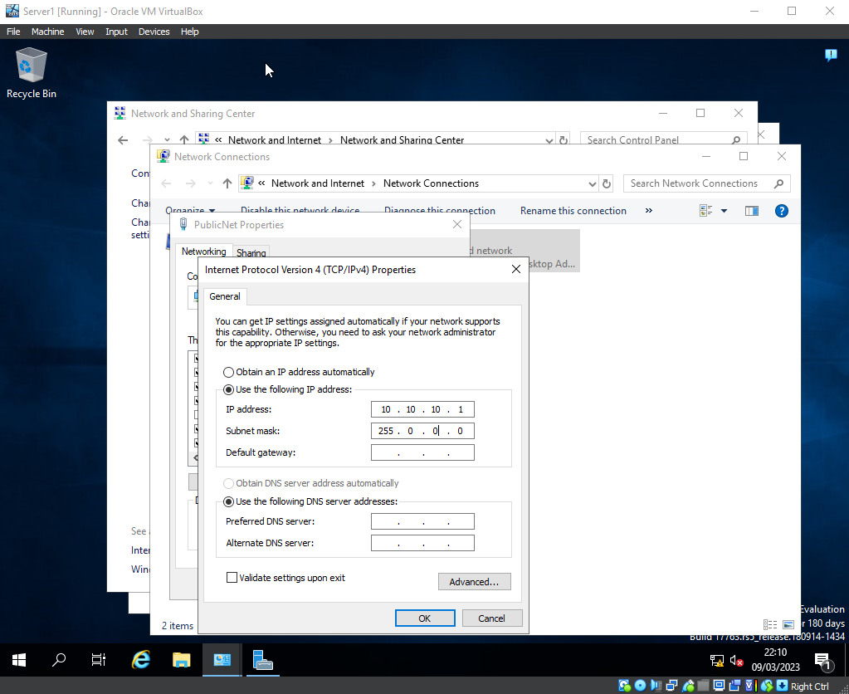
In this screenshot peter and Kai were configuring the PublicNet network IP this was the DNS server which would allow the connection to the domain from the individual workstations and allow them to join the network. (Kai)
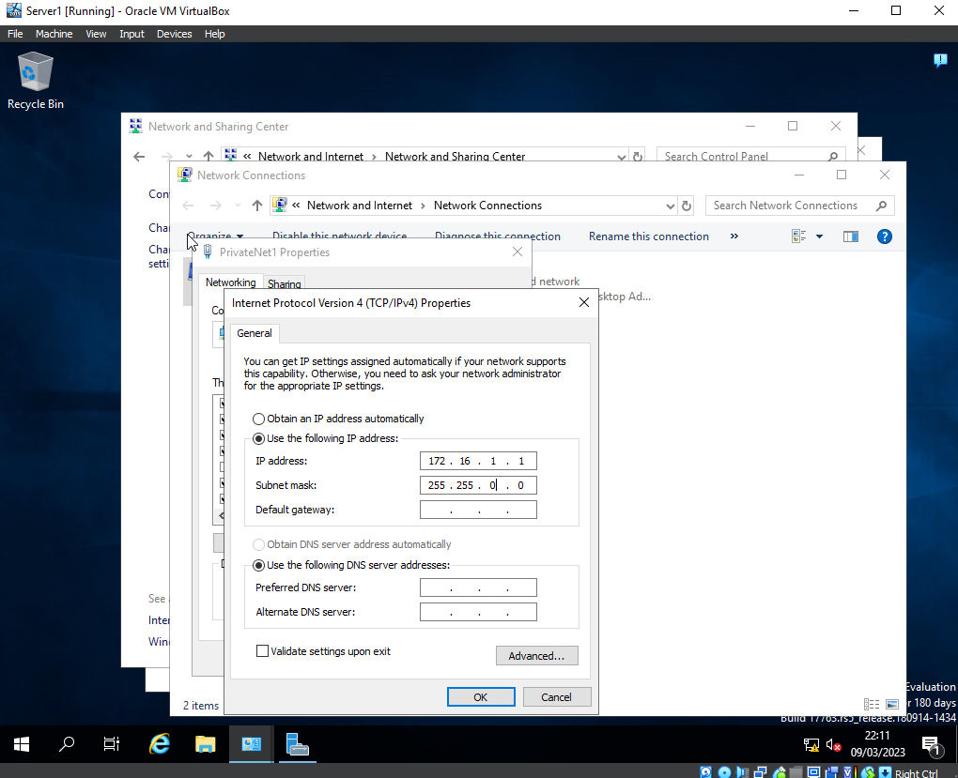
This shows the group configuring the IP address and subnet mask for the other side of the network PrivateNet1 this is the server where clients are able to communicate without installing any roles and features.(Group)
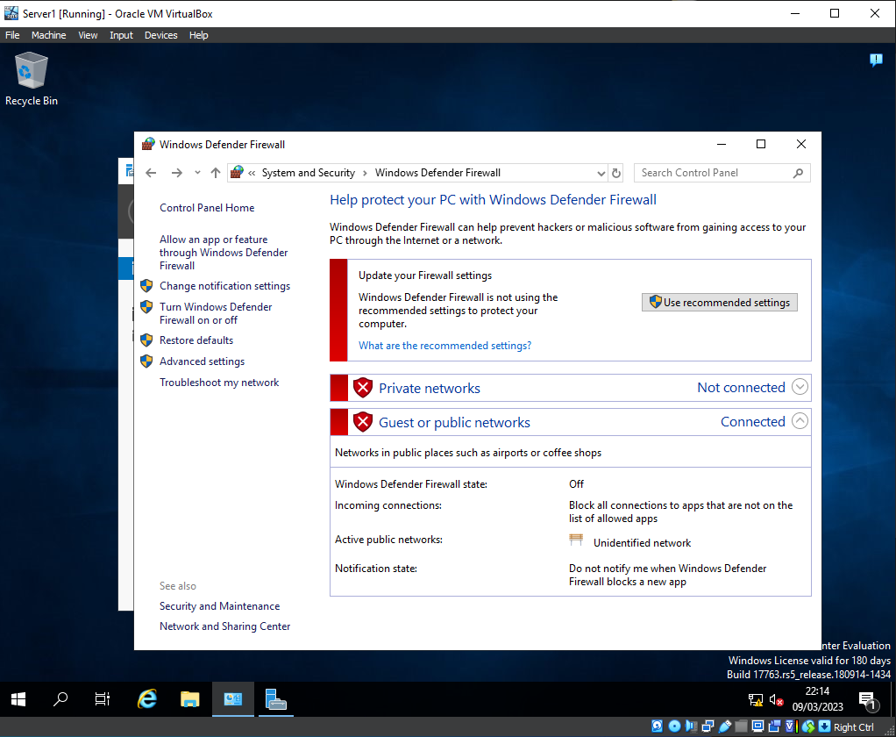
Before we could test the connectivity between the server and the client, we had the realisation that we needed to disable the firewalls in both server and client machine for the packets to be sent and received.(Peter)
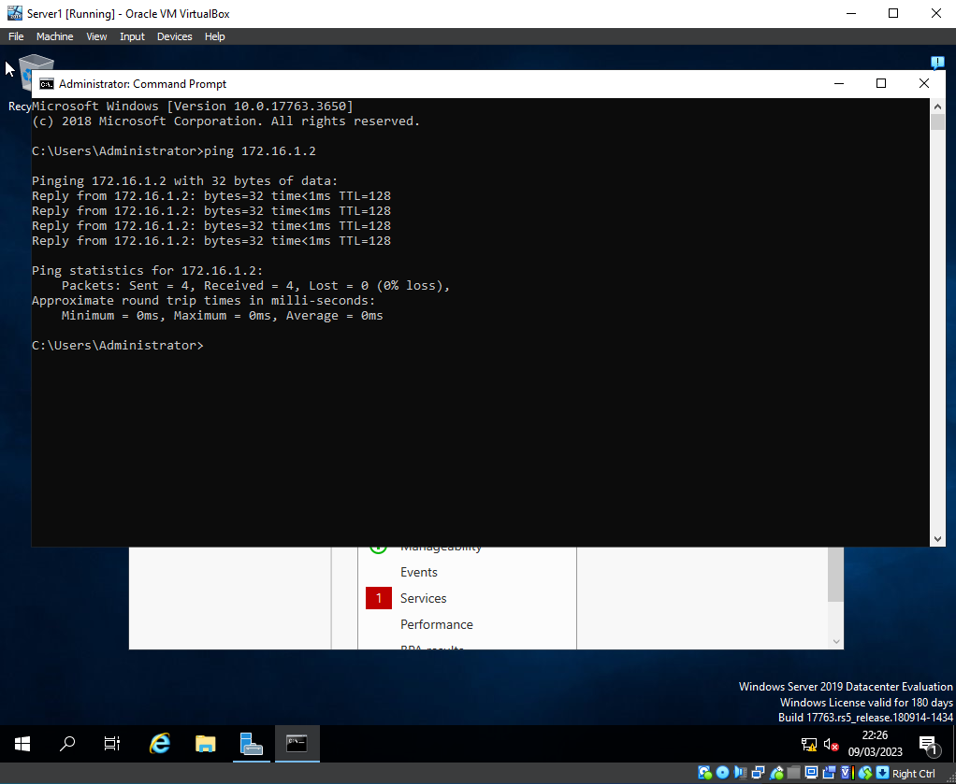
This picture shows the server is successfully sending a ping request to the workstations of the client and all the packets were successful received without any loss.(Peter and Kai)
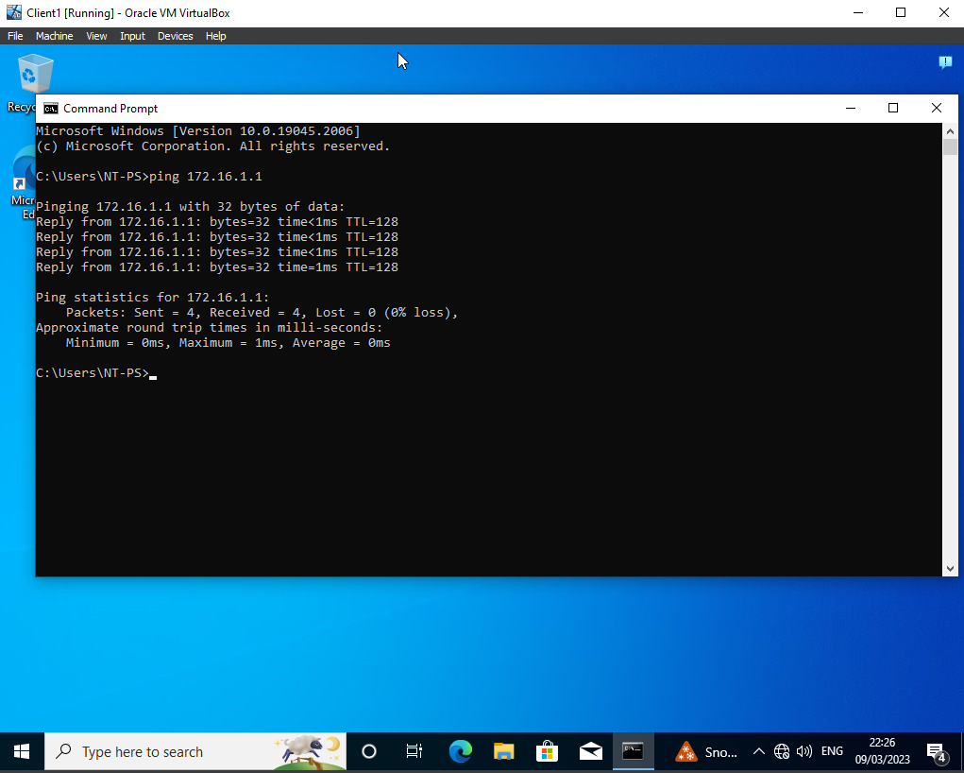
they provided image depicts successful pings from client to the server, all packets were received without any loss exactly the same to the server to client ping. (Peter and Kai)
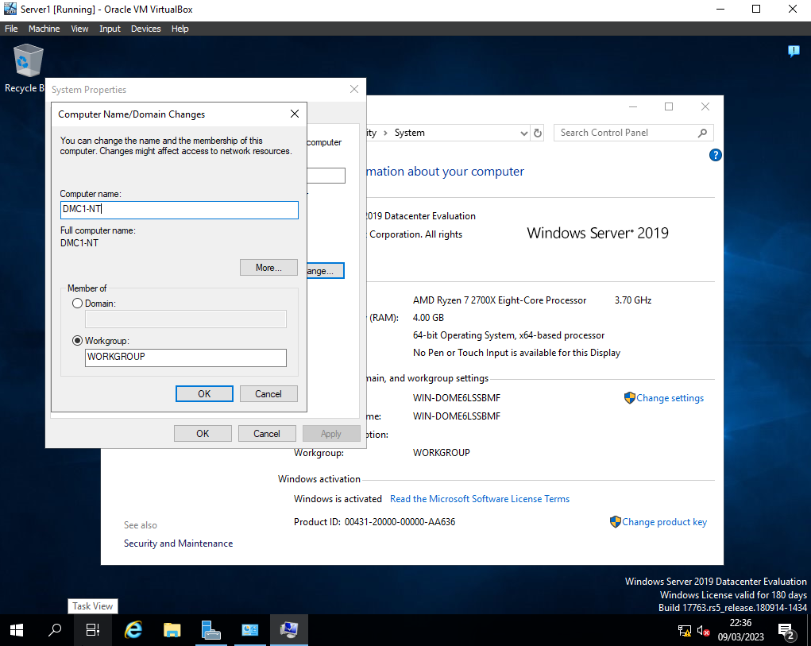
In this screenshot we show the change of the hostname of the server which needed to be changed and be unique, this was decided to be changed to the name of “DMC1-NT” (Peter)
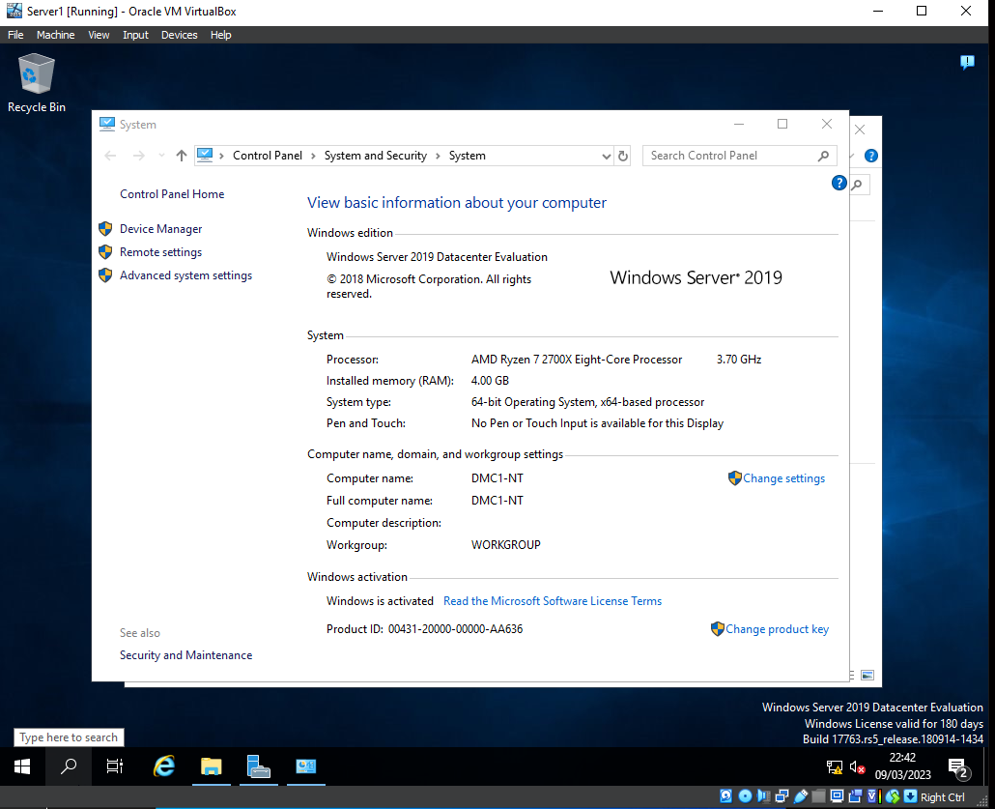
Once the one the previous step was done, the server in question needed to be restarted to be able to make the changes and see them take place(Peter)
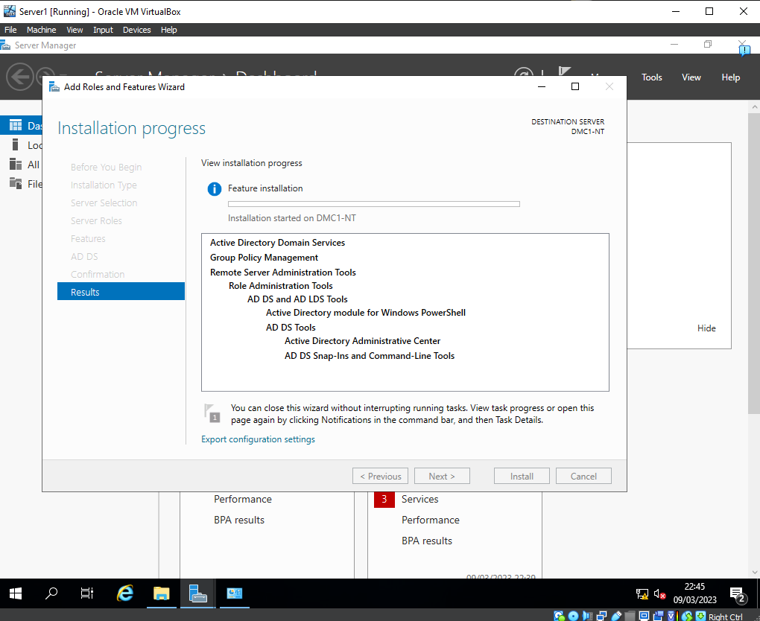
Installing Active Directory Domain Services was the most important part it allowed us to create a domain as well as creates user accounts for that domain. (Peter)
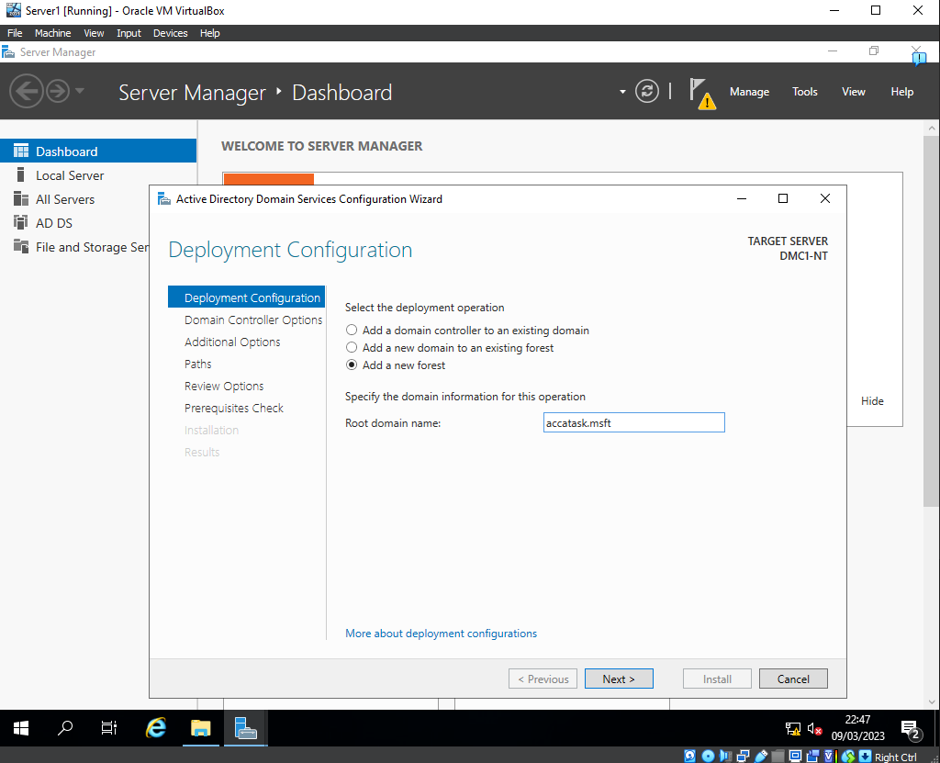
In this we created a domain where we used the name as accatask.msft where the clients would be able join on their workstations to gain access to their user accounts from the network (Jack)
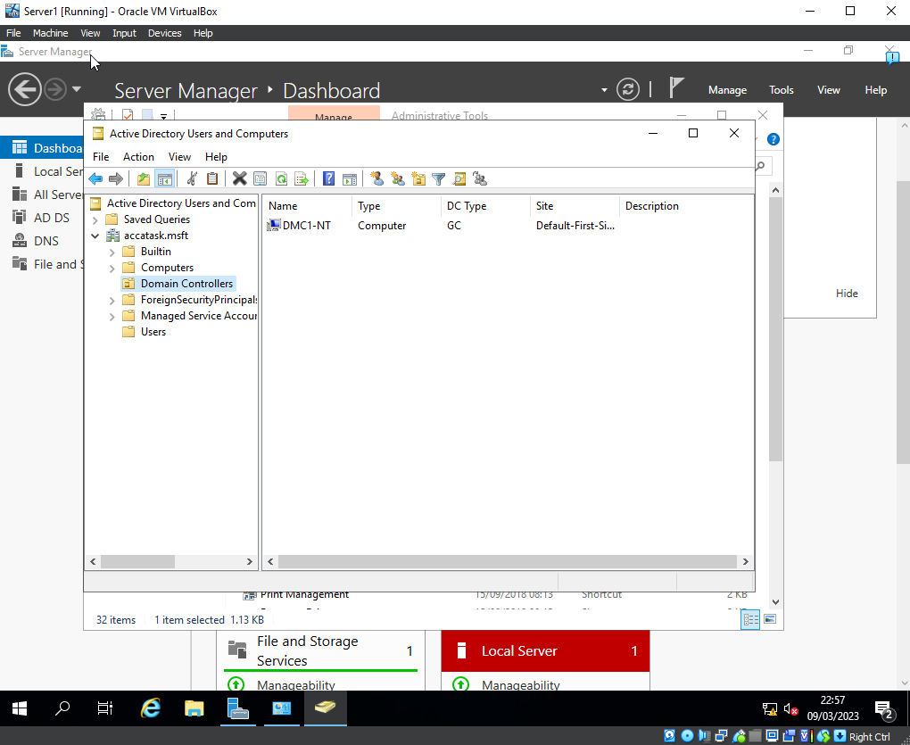
In this we can see that we are located inside of the active directory users and computers in which we can see that the server workstation is a part of the domain controllers (Kai)
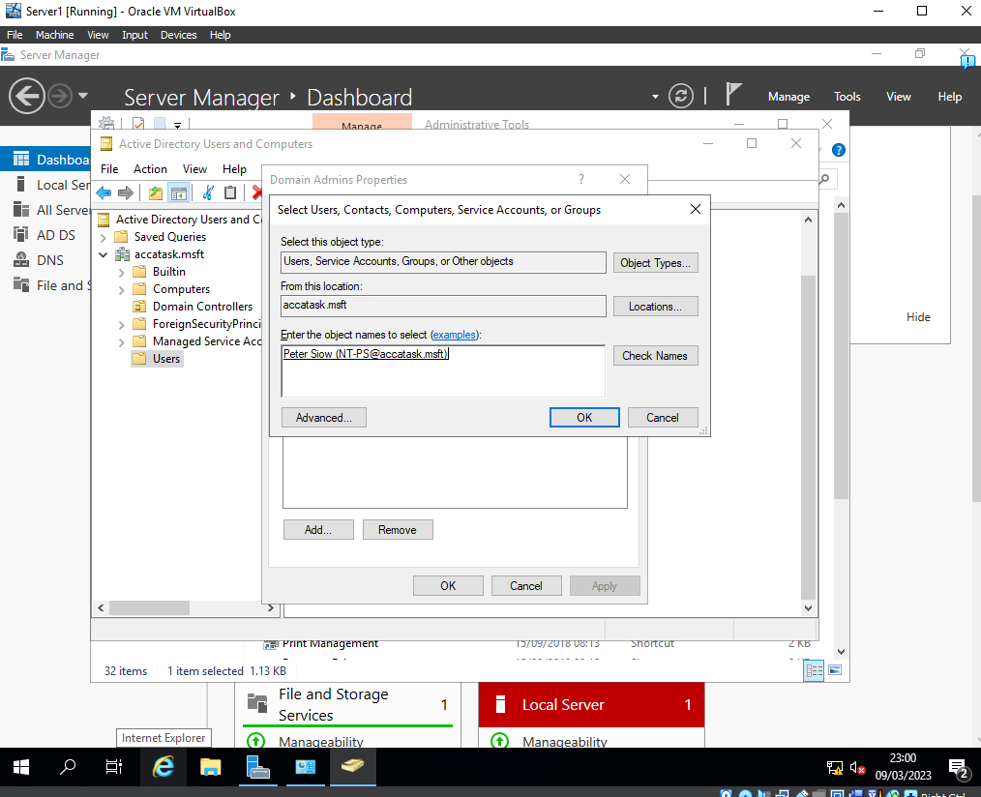
Created a secondary domain user as a backup this is in case of any security flaws which may come up (Peter)
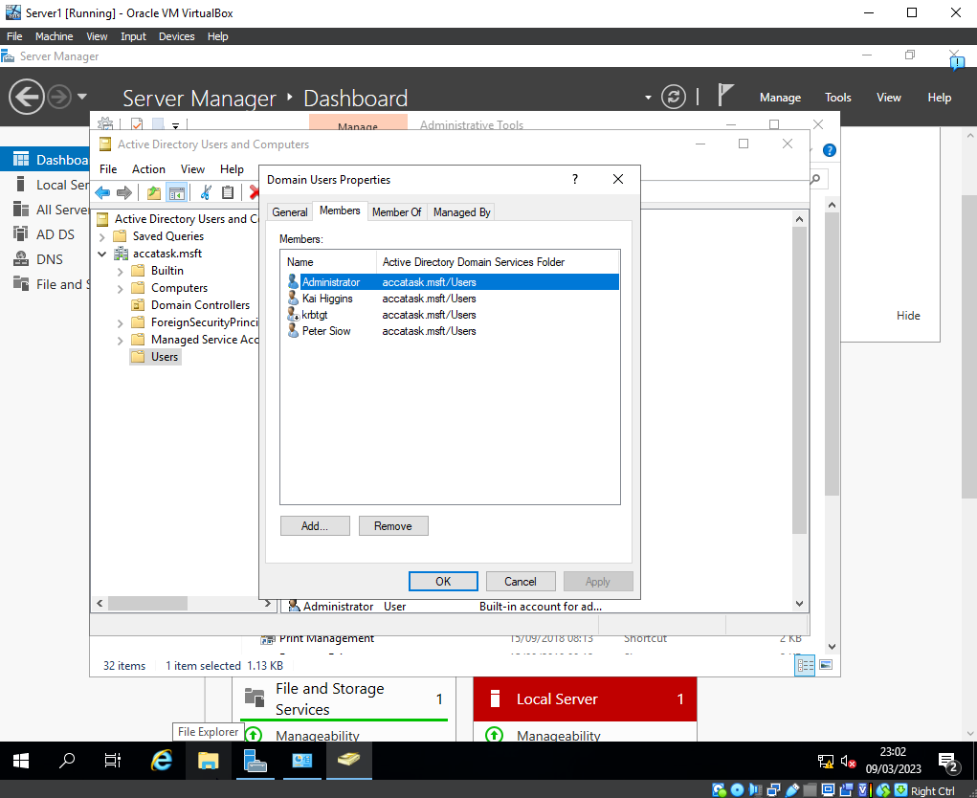
this shows all current user that are setup within the domain (Kai)
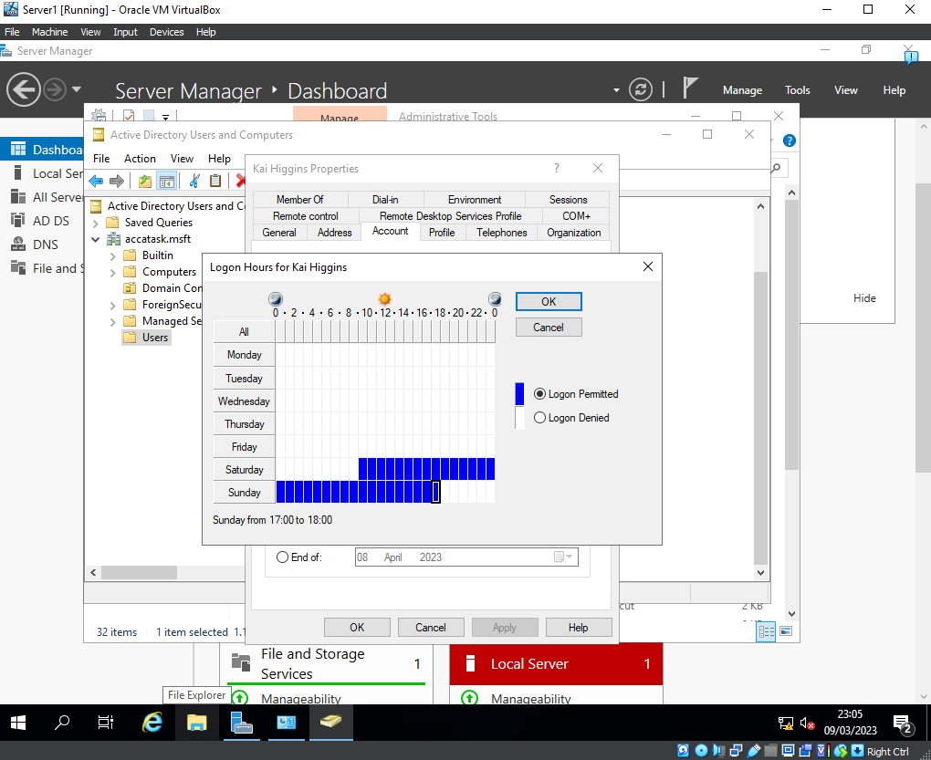
this shows the adjustment of the login hours to make sure the network is only accessible on their user account due to the privileges required access it and only within a certain frame of time (Kai)
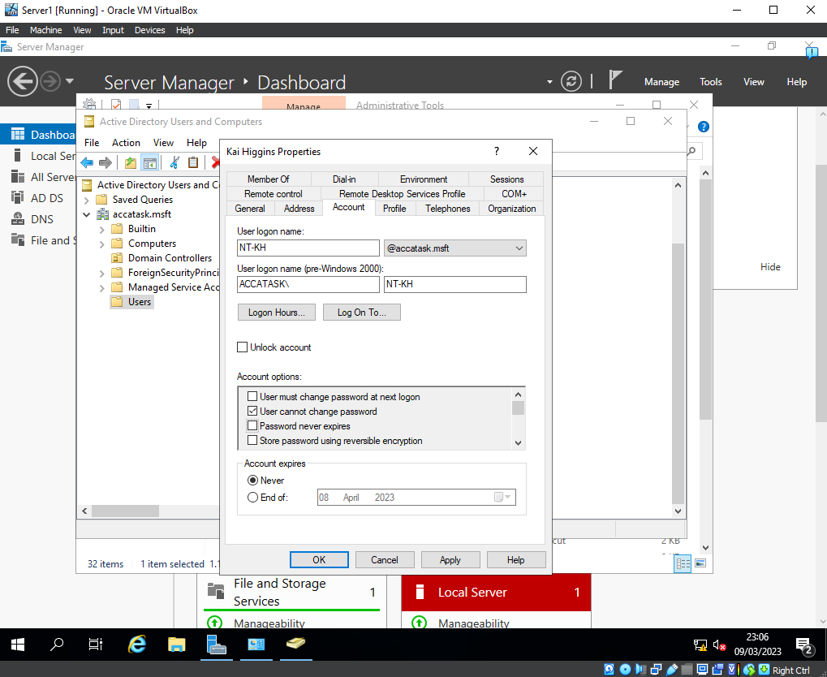
this makes sure that only a network admin can change the password once it has been set. (Kai)
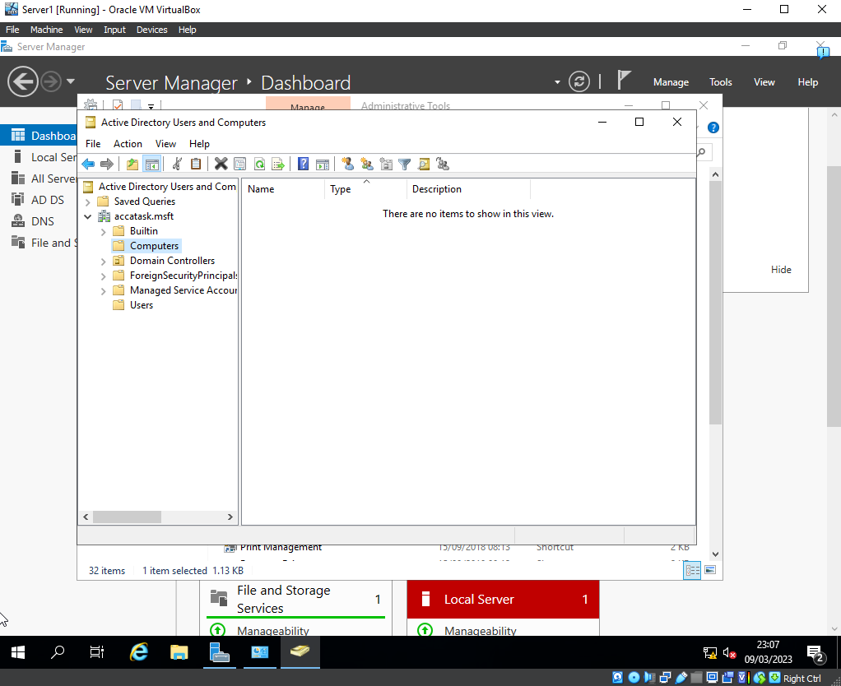
this shows that currently there are no computer that have been added to the network (Jack)
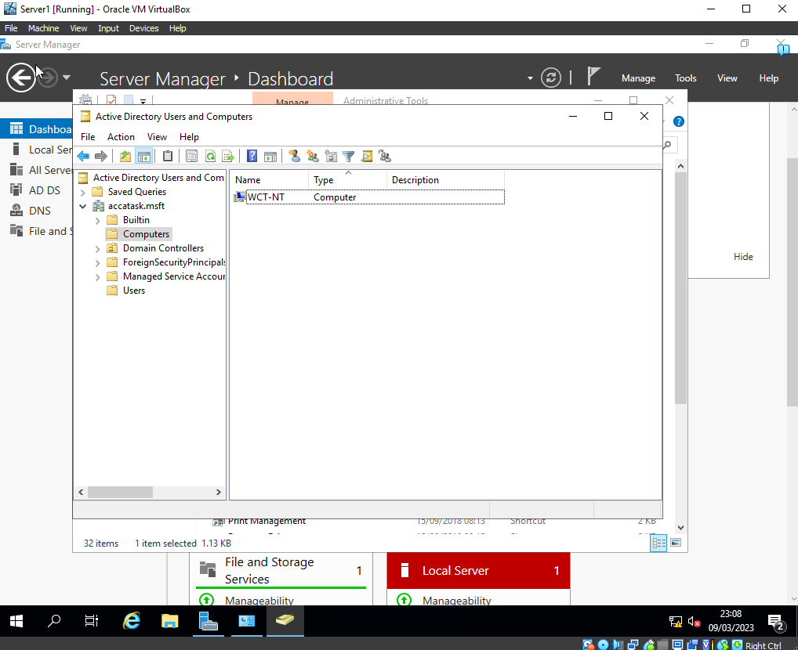
added a client computer which will be named “WCT-NT” in the domain (Jack)
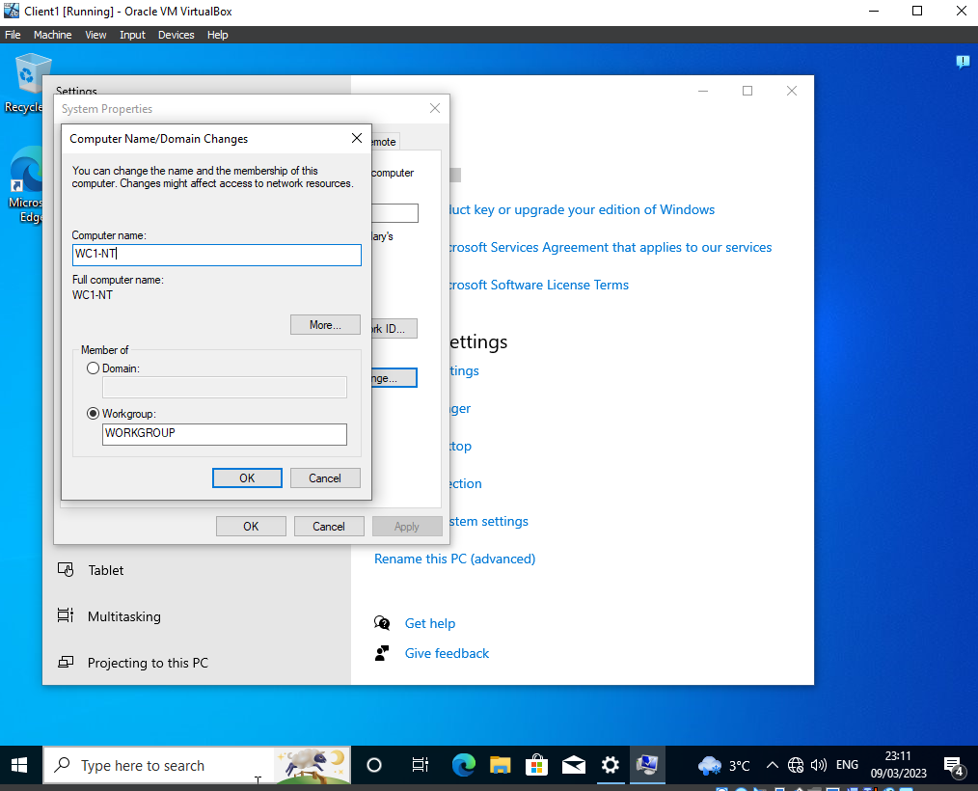
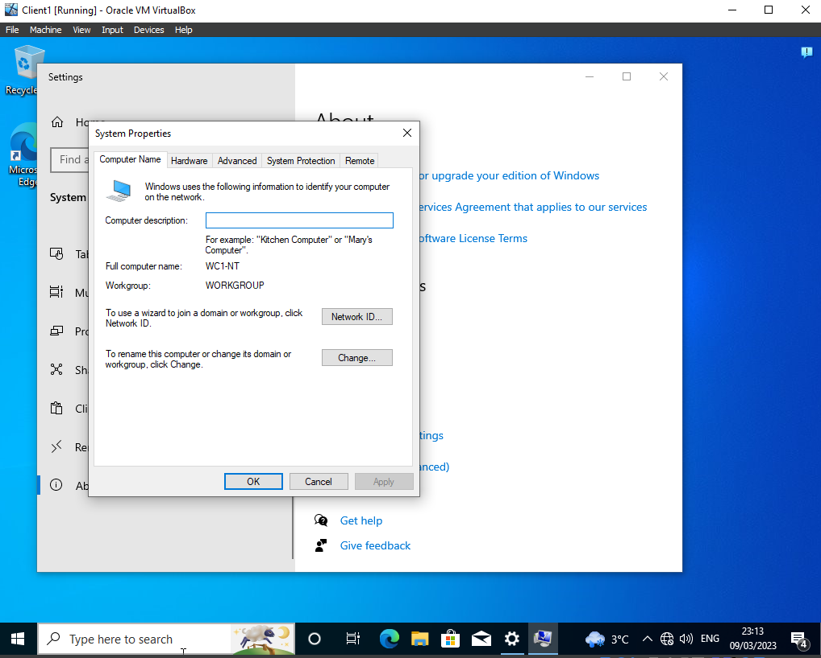
Changing the name of the client PC to match name in the active directory (Peter)

Part 2 (Individual Work – Task 3 (Observational Task) in Worksheet 1)

The group opted to use type 2 hypervisors in the tasks, as these hypervisors allowed us to install another operating system on top of the existing host operating system. This was advantageous for the main purpose of the task in which we had to overcome, making it more suitable and beneficial to using type 1 hypervisor.

While we were working through the assignment, we encountered several problems we felt perhaps using a type 1 hypervisor would have been more efficient. For instance during one of the practical elements, we found that running on the host operating system caused a major decrease in load times and slower processing of tasks. The only solution we found to this was using a type 1 hypervisor which would have solely used the hardware and would have enabled a smother resource handling and therefore better efficiency.

While I just made there was benefits to using a type 1 hypervisor that did not out way the disadvantages it brought us. Typically a type 1 hypervisor is used at an enterprise level where they have more complex network configurations and setup processes, that is fundamentally required, this is something a type 2 would not be able to handle given its resource allocation. However that does leave it with the benefit for smaller work like this as it can run multiple at once, so using a type 1 for our use case would be stupid and overkill given the scale.

If we had chosen a type 1 hypervisor we could have ran into a compatibility problem where our existing systems whereas, a type 2 hypervisor will have a larger range of compatibility. The only drawback to this is a lower quality and noticeable weaker security system than is shown for a type 1, this is due to the fact that is not directly run through the hardware in which you would need direct access to change. This could have lead to a risk of an attack of the system if it was deployed into the world.

As I said before one problem with type 2 hypervisors is the resource allocation, this is due to the fact there are at least 2 operating systems in play at one time that automatically double the resource requirement of the system in hand. This caused some major inconsistencies with the system we used it caused various loading times as well as navigation on the machine becoming slow and choppy in frame times.

DHCP

DHCP which stands for dynamic host configuration protocol, assigns iP addresses dynamically which a given network. In a real-world deployment this is when a device joins the network it has its MAC address (what it physically is called) then it needs to be given a iP address so other devices can find it, this is where DHCP comes in it will give it a iP address automatically when the device makes contact and then requests to join the network this will send out either a IPV4 or IPV6 address as well as the default gateway, subnet mask and also the DNS server information on that network.

DHCP was the most important part for us in creating the network as it held our DNS server. This meant that when we implemented a user in the domain controller, the client on their virtual machine could connect to the network, on there workstation they could then be prompted and proceed to login in with a user account that was assigned from the network.

Active Directory
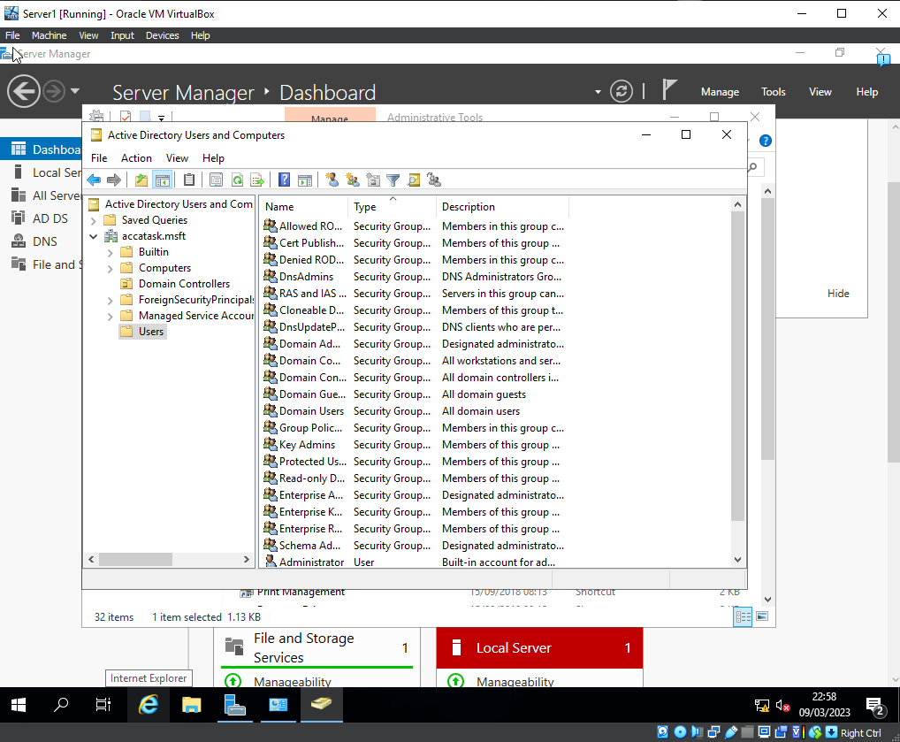

Terminologies

There are many terminologies which are important for when the group did have to test the if connectivity between the server and client virtual machine were working.

The term “ping” as used during the task, and it is used to test if packets can be sent and received to another device in that network. An example of this, the client’s virtual machine can ping to check if it reachable from this machine, this is handy if to test if the network has been set up correctly. In windows is a command line code which requires “ping 192.168.1…” , it will give you back 4 replies in which provide a summary of the information it gather like if they were sent and received and even howe many milliseconds to took to reach. On mac the response is a little different it will give much more replies but doesn’t give you information on the packets, which is needed by network admins to find the issues.

Another important key was the server management on the server virtual machine, the machines needed to have certain roles and features to enable the creation of user accounts and them to be accessed across the network. This was done through server manager which is important not only to use but businesses also as they would use it to make sure everything they have is okay for use as well.

Previously we used a term called “firewall” which is a built in security feature that will block certain types of traffics from coming or going out from the device. On windows this is called “Windows Defender” and it is a default application that is turned on from initial startup. This can prevent clients from sending information to the server if it is deemed harmful the easier to solution to fix this is to disable it on both the server and device and use an alternative solution with more options to change to the needs of the user.

When we compare to a Linux firewall, there are some note worthy differences. One of the main ones is that a Linux firewall must be configured through the command line there is no GUI to help you through it, which is why it can be difficult for those with little networking experience or have only done it through User interfaces. Another difference is that they use a packet filter system, this means that with every packet that get passed through will get looked that and then will either get going to will get sent back this is all based on the configuration.

OOBE or out of box experience is the first time a user interacts with a product or service, which will create a lasting impression on the user. In our case, we had the choice when setting up to use either the standard version of windows server 2019 or windows server Datacentre with a desktop experience. This was a useful thing to add to a setup like this as us who didn’t have much knowledge on how to create it using command line, it allowed us to feel welcomed with a user interface which gave us all the necessary tools like server manager, which can only come from the windows server operating system and allowed us to install the services needed to create the user accounts in active directory.

Conclusion
In conclusion, I showed why it was the import to discuss the settings which were used and compared the different operating systems and what they are good for and then shown why we used Windows Server and why it was suited for our network. But we should have engaged more as a group when we was working on the virtual machine as well as given ourselves more time to create the assignment. If could make a future change it would be to do a much larger range of research, but if I could change anything in the future, I would make sure to do a lot more research as well getting things more organized so I can help my team better.

Reflection
Reflecting on the work which my team completed, I do believe we’ve could’ve achieved better results and much clearer answers and this is due to mostly me due to having an unorganised and heavy style of life, we should have had more interactions with each other. I think this also led us to very little preparation. On a repeat of this we would work through it together and do a lot of research into the subject area, so we are more prepared.

