Callum Cross
Student Number: 1705149
Lecturer: Kemi Ademoye
Date: 10/12/2018

APPLICATION dEVELOPMENT
Module Code: ACCA5012

Table of Contents
Abstract 1
Application Design Concepts 2
Design Principles 2.1
Purpose 2.2
Communication 2.3
Typefaces 2.4
Colours 2.5
Images 2.6
Navigation 2.7
Grid-Based-Layouts 2.8
“F” Pattern Design 2.9
Load Time 2.10
Mobile Friendly 2.11
Requirements 3
Introduction 3.1
Target Market 3.2
Software Requirements Specification 3.3
Design 4
Fonts 4.1
Colour 4.2
Responsive 4.3
Images 4.4
Grid System 4.5
Loading Times 4.6
Implementation 5
Navigation-Bar 5.1
Main-Content 5.2
Main-Footer 5.3
Bootstrap 5.4
jQuery 5.5
Cascading Style Sheets 5.6
Website Images 5.6

Table of Contents
Evaluation 6
Test Cases 6.1
Final Evaluation 6.2
Future Improvements 6.3
References 7

Abstract (1)
The following document will be discussing the design principles and what effect those principles could have on user experience and website performance. The document also discussed the steps I took to create and implement the website I designed which was the task set for this assignment.

Application Development Concepts (2)
Design Principles (2.1)
Effective web design is judged by the users of the website and not the website creator/owners. There are many factors that are important in the effectiveness and usability of the website. [1] [2] [3]
These factors of web design have shown to improve user experience and helpfulness of the website. The factors have been listed below.
Purpose (2.2)
A good website design will always provide to the needs of user. The purpose of a website could be to give information needed by the user or some type of interaction towards your business an example of this could be a product page that lists all of the products. [1] [2] [3]
Communication (2.3)
A good communication between the web page and user can greatly help keeping the user to stay on the website and even come back in the near future. Communication can be shown by having headlines, sub-headlines and organising information in the correct order instead of bullet points and long windy sentences. [1] [2] [3]
Typefaces (2.4)
A good font type and size can make or break your website because if the user cannot read the font correctly then they will leave the website and possibly not come back again. [1] [2] [3]
Colours (2.5)
A well thought out colour design for the website is crucial in the design phase. The correct colour palette can help with the user experience as this will allow an easier time reading. White space/Negative space can be effective at giving your website a modern and uncluttered look. [1] [2] [3]
Images (2.6)
A simple but effective image can speak a thousand words to the user as you can represent many areas of text with one photo. Images can also create a more dynamic environment on your website as it allows users to have a break from text and keep them interacting with your website. [1] [2] [3]
Navigation (2.7)
Navigation should always be made simple for the user to move around your website. Complex navigation system will not allow the user to retrieve the information they need in a short amount of time possibly resulting in the user leaving the website. A simple navigation layout will allow the user to find the information they want in a short and effective way. [1]
Grid Based Layouts (2.8)
Placing images and text in random parts of your web page could end up creating an appearance of messy and unprofessional. A grid-based layout allows the creator to have more control on where text and images are placed on screen and in an orderly fashion. [1] [2] [3]
“F” Pattern Design (2.9)
Studies have been researched and found that most users look at a website in a “F” pattern. Most of what people will see on a website is in the top and left side of the screen, the right side of the screen is rarely seen. Trying to force a user to look at a certain part of your website can unethical and should be more focused at a user normal reading behaviour by displaying important information in an order of importance using the “F” pattern. [1] [4] [5]
Load Time (2.10)
Everybody hates web pages that take a long time to load. Making a website that has quick loading times means that users can have a smooth experience whilst using the website. Tips on making a website to have quick loading times could be optimising images size and scale and you could decrease loading times by combining code into a JavaScript file or CSS File. [1]

Mobile Friendly (2.11)
Most people in the world now use mobiles for everyday use this means that people might connect to your website via a mobile device which means it needs to be compatible with the device otherwise the user will not be able to use your website. This can be done by creating a responsive website that will adjust to different sizes to allow access off a mobile.
You could also build a dedicated mobile site that will run independently for mobile devices only.
Requirements (3)
Introduction (3.1)
The software I have implemented is a responsive website designed around my favourite sport Formula 1 (F1). F1 is the most prestigious sport where the best drivers in the world race and compete for both the Drivers World Championship and Constructors World Championship. [4]
Target Market (3.2)
My website’s target market is focused around other motorsport enthusiast’s like myself who would like to find the latest information on Formula 1 in a quick and easy way. The website provides information about Formula 1 and the current season and what’s currently happening in Formula 1.
Software Requirements Specification (3.3)
The software requirements specification I used for this was the IEEE 830. This specification had a basic and simple layout for me to design my website around. A main requirement that I had to base my website off was the purpose of my website and what I wanted to achieve in the process. [6]
Another requirement which was signified in the specification was the user interface and my idea was to create the web page and navigational system in the website to be simple and smooth giving the user the required information they need in a very short amount of time. [6]
Breakpoints (3.4)
The breakpoints I chose to use were mostly down to which device and categorising them into 3 devices types, Large, Medium and finally small this allowed me to create 3 different types of layouts and allow me to fulfil each device’s height and width ratios.

Content Display (3.5)
The content display layout I have chosen was an easy and simplistic layout that allowed multiple images and text boxes to be added whilst looking and clean and easy both look at and read.
Design (4)
The design principles I followed for my website allowed me to create a an easy to use and responsive website with information to be found easily and quickly. I have listed the main principles I used within my website.
Fonts (4.1)
The fonts I wanted in my website had to be easy to read and large enough that they were easily visible. The font I used was mainly sans-serif as this provided me with both requirements completed as it’s widely used font around the world.
Colour (4.2)
I used a colour palette that was easy to be seen and easy on the eye but also was focused towards the Formula 1 main colour which is red. I also made sure the colours I combined with each other did not look weird together or messy.
Responsive (4.3)
I designed my website also be responsive so that both a computer and mobile device can connect to it and the website will adjust no matter what size the device is. This allows any user to have a smooth and streamline experience when visiting my website.
Images (4.4)
Images used in my website have been found specifically so that when the user is looking for information on a driver or track then they can quickly scroll for that picture rather than looking through to text to find which driver or track it’s talking about.
Grid System (4.5)
My website also uses a Grid Based System so each web page is organised and easy to follow along whilst the user is scrolling through. This system also allowed me to connect images to text by using boxes to contain information together.

Loading Times (4.6)
Finally, my website was focused towards quick loading times allowing web pages to load as quick as possible creating and allowing a smooth experience for the user when going through my website without any interruptions or slow loading times. I did this by optimising my images to a specific size and thoroughly testing them before use. I also used jQuery for the Animations on the website as it’s exteremely easy to use and fast.
Implementation (5)
The main classes that I used within my website have been aimed towards organisation so I am able to keep track on which parts I’m editing in both the HTML file and CSS files. The main classes I used within my website are shown below.
Navigation-Bar (5.1)
This class was mainly used to keep all my navigation bar contained so that it was easy and simple to add and remove web pages as I pleased this also allowed me to edit the navigation bar only without editing anything else.
Main-Content (5.2)
Main-Content class was used on every web page and contained all the main-content that was shown the user including both text and images and would include a grid system in it.
Main-Footer (5.3)
My Main-Footer class was used for all the footer information shown to the user at the bottom of every web page and permitted small links to be shown to the user including web page links just so that the user did not have to scroll to the top of the page.
Bootstrap (5.4)
I mainly used bootstrap to allow me to easily create a grid system that was fluid and responsive to any device and allowed me to create an organised layout in my web pages.
jQuery (5.5)
jQuery was mainly used with its built-in functions to use animations on all my web pages and also lets me create fancy web pages which makes it look more interactive to the user.
The functions I used with jQuery are shown below:
- .each()
- .hide()
- .fadeIn()
- .slideIn()
- .slideDown()
- $(document).ready()
Cascading Style Sheets (5.6)
The final piece of my website was CSS that allowed me to create a design around my website for example changing the background of the web page or making boxes smaller and easier to read and see.

Website Images (5.7)
Home Page – Top
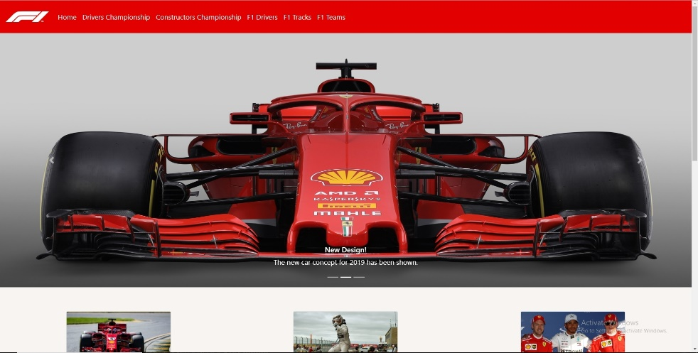

Home page – Bottom
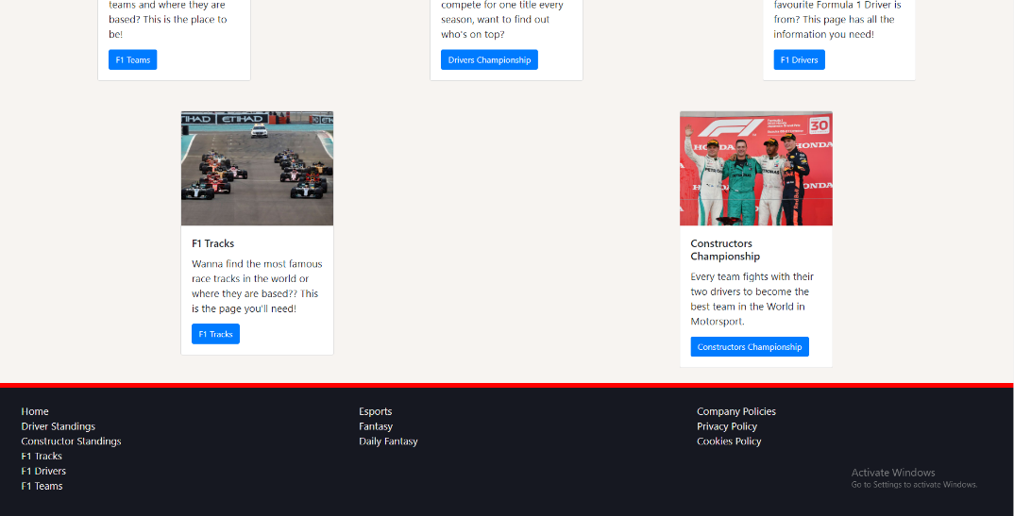
Drivers’ Championship – Top
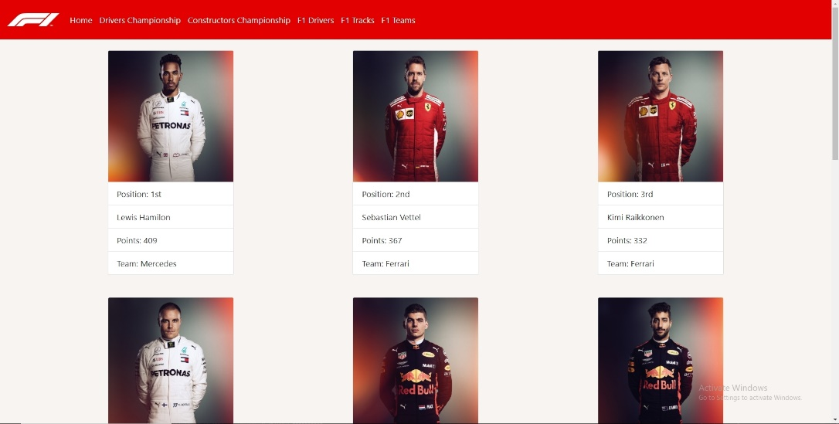
Drivers’ Championship – Bottom
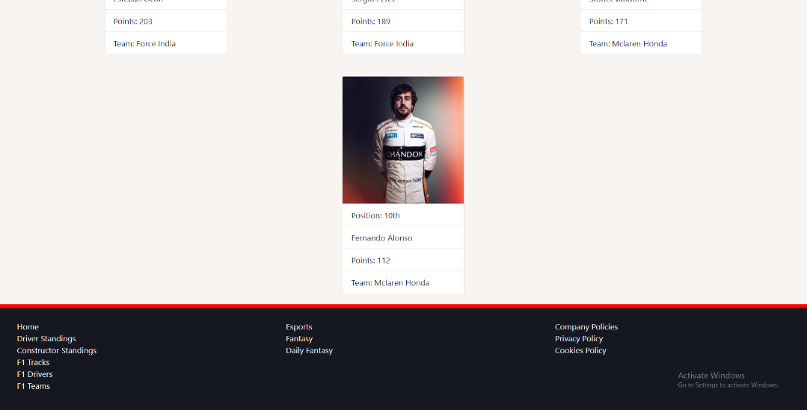

Constructors Championship - Top
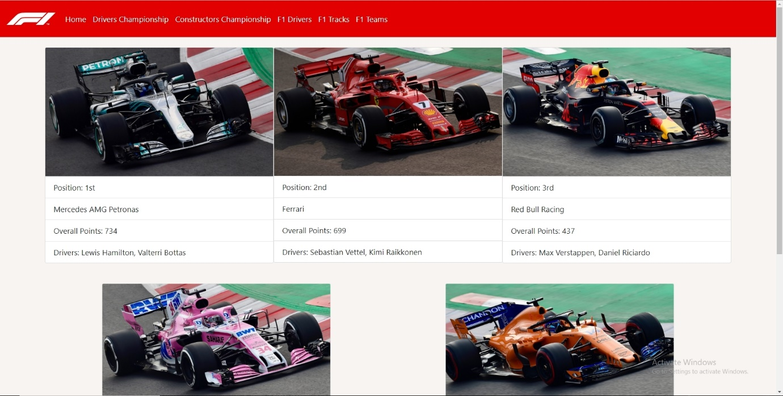

Constructors Championship - Bottom
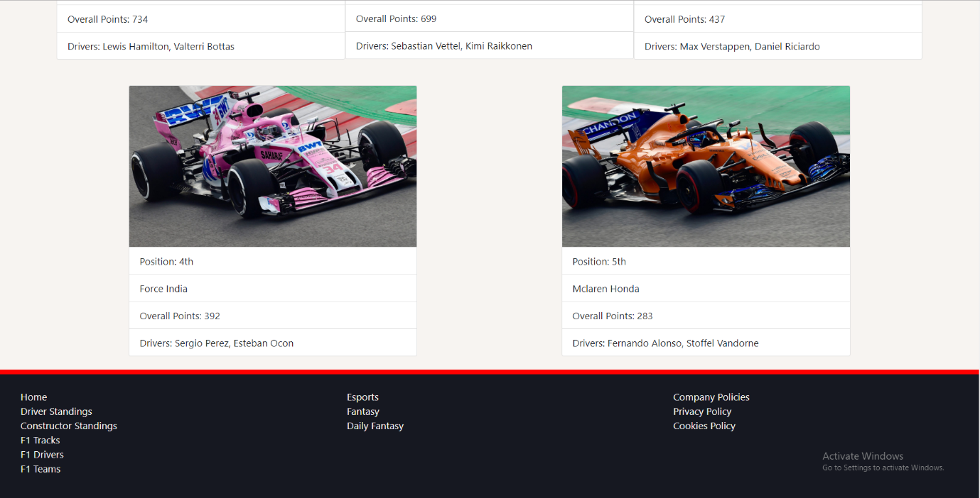

F1 Drivers Info - Top
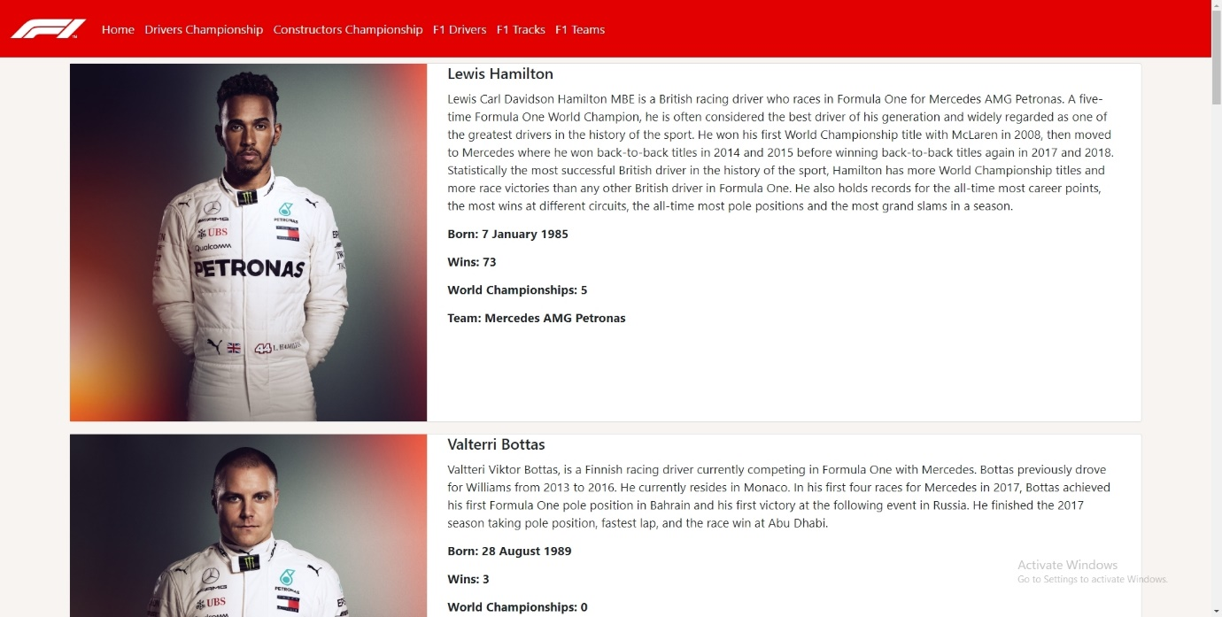

F1 Drivers Info - Bottom
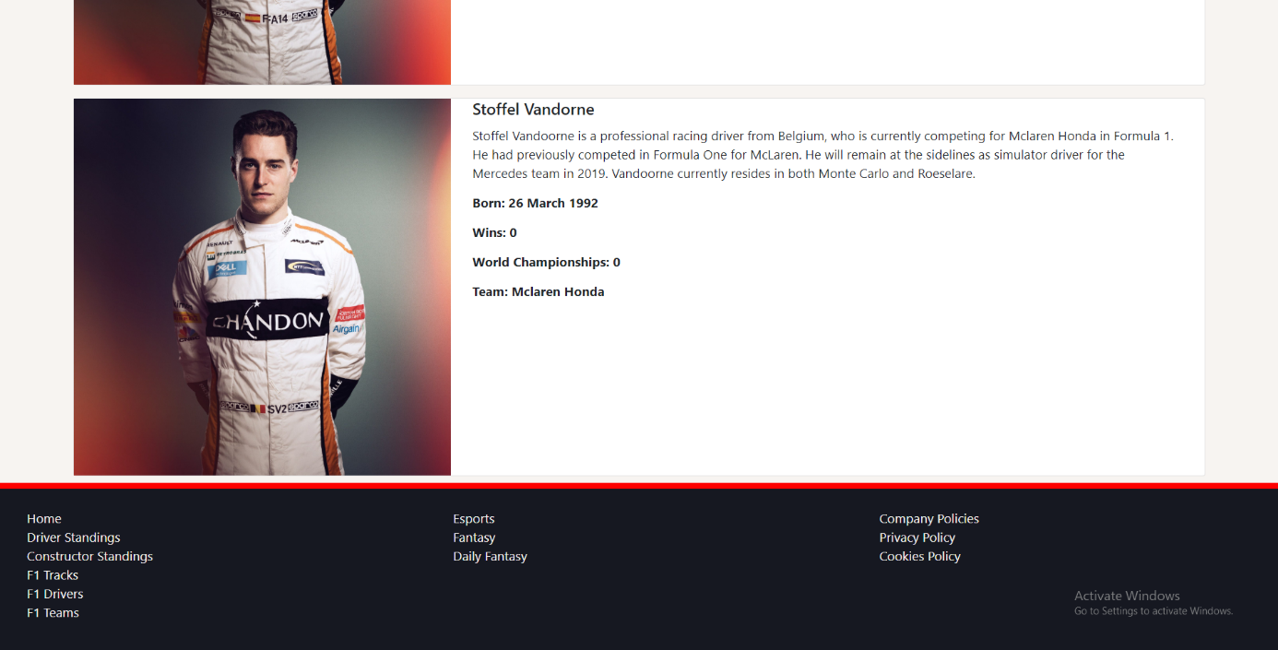

F1 Tracks Info - Top
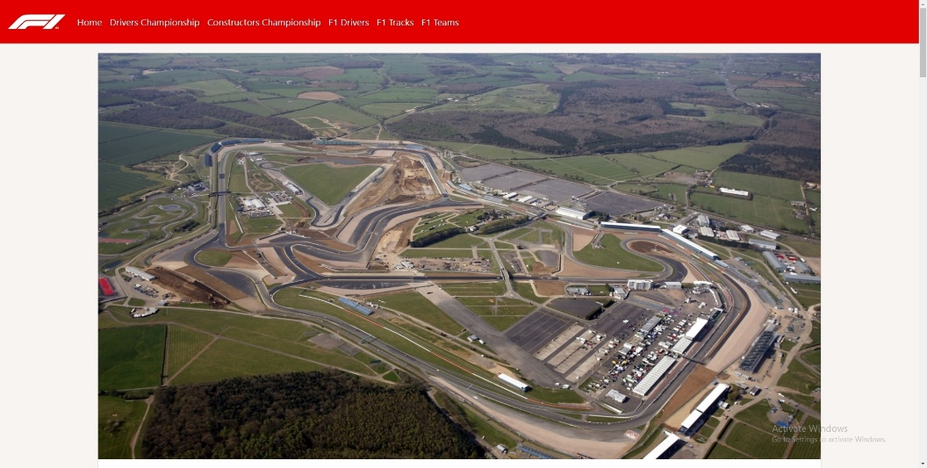
F1 Tracks Info - Bottom
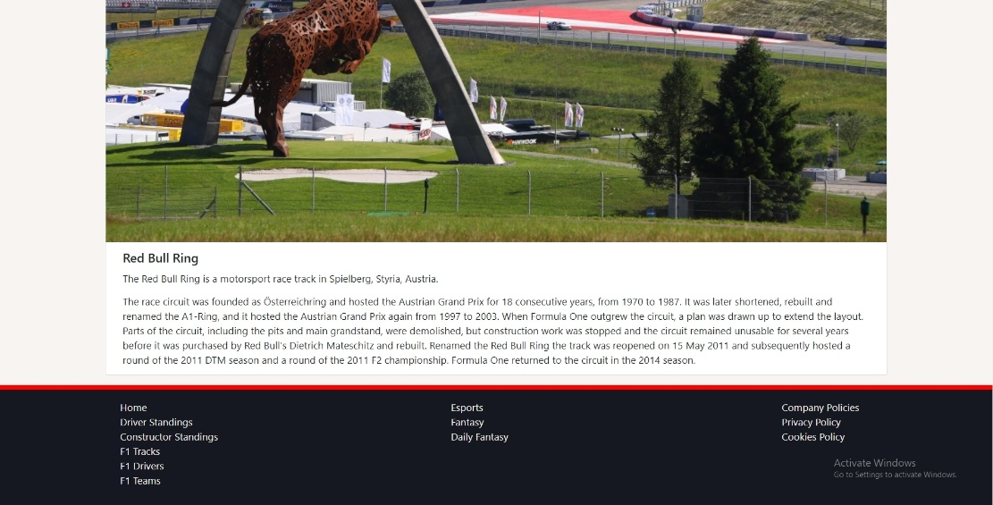

F1 Teams Info - Top
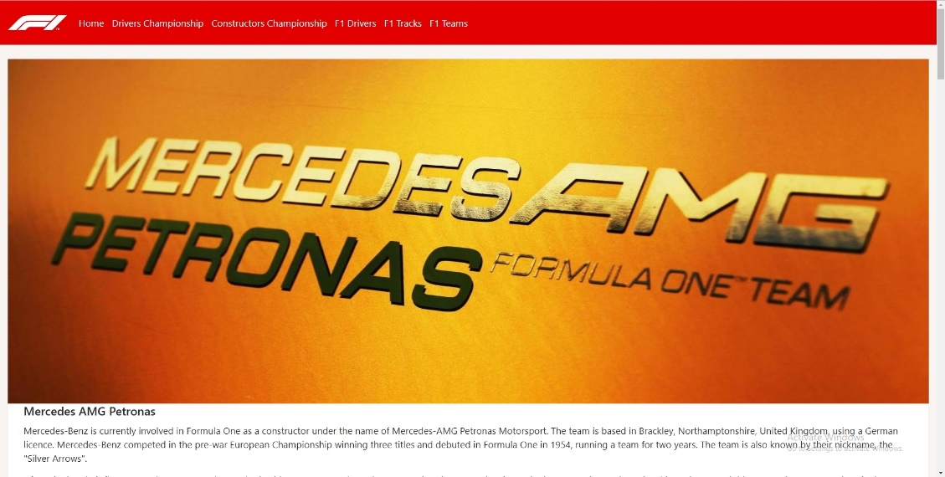
F1 Teams Info - Bottom
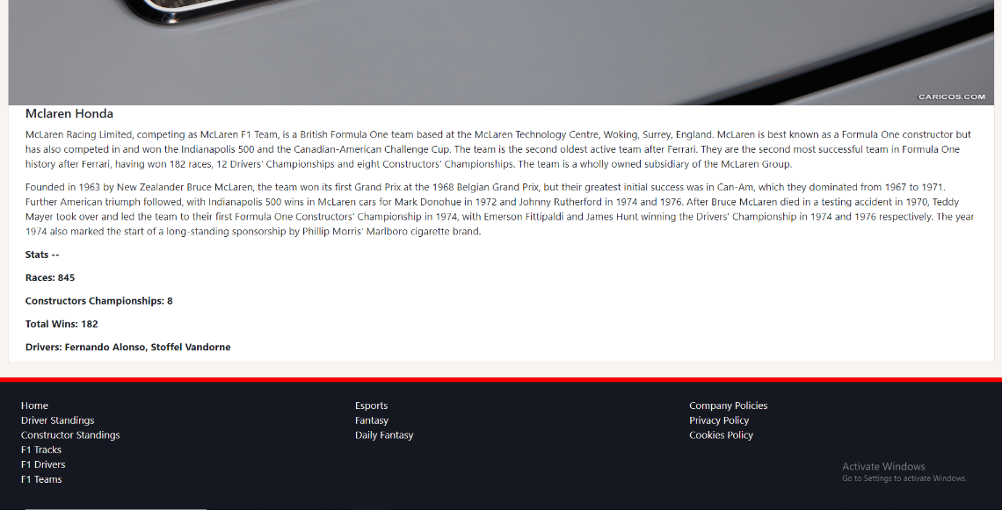

Evaluation (6)
Test Cases (6.1)
Project: | Formula 1 Website
Test ID: | 1
Test Description: | Responsive website test in different sizes of the web page to be tested.
Test Execution: | The web page will be changed to multiple sizes and test to see if all information can still be seen.
Expected Output: | Webpage should be able to change sizes dynamically and all information should be organised correctly.
Actual Output: | The webpage organised the information dynamically as the web page was being changed to different sizes

Project: | Formula 1 Website
Test ID: | 2
Test Description: | Navigation Bar can take the user to all web pages on the website.
Test Execution: | The navigation bar will be thoroughly checked to make the sure the navigation bar can take the user to every web page on the website.
Expected Output: | The user should be taken to the correct web page when the user has clicked on the link on the navigation bar.
Actual Output: | The user was taken to the correct web page when the link on the navigation bar was clicked.

Test ID: | 3
Test Description: | This test will make sure that all animations are correctly loaded when the user loads the web page.
Test Execution: | The user will click each web page and make sure that all animations load correctly and all information is shown.
Expected Output: | All animations should load when the user enters the web page and should not affect the users viewing experience and all information should load.
Actual Output: | The user loaded each web page and all animations were loaded and all information was shown to the user.

Final Evaluation (6.2)
The design and feel of the website are definitely better than I expected it to be as it’s a simple/basic layout and allows the user to easily find information quickly and efficiently.
User experience on my website I feel will be good because of the simplistic design of the website and it show’s a lot of information in a small but contained area with the designated content next to it so the user will have an easy time finding it.
The content I provided on my web page is very good as it allows the user to find information about both drivers and tracks and also allows the user to look at current stats of the Formula 1 season. The website also allows the user to look at information of teams and the drivers that currently drive for them.
Future Improvements (6.3)
My current website could defiantly be improved in different ways but the main improvements that I would do in the future would be:
More content could defiantly be added to more of the web pages to allow the user have a more interactive experience on the website.
The Navigation bar could highlight the button you are currently over so the user knows that if they click the link it will take you somewhere and it will let user have a greater experience.
Finally, I think in the future I will use a custom font as the current one looks very basic and is used on every page on the website and will create a look of dullness and little creativity.

References (7)
[1] SW. Woods, '10 Top Principles Effective Web Design', 2014. [Online].
Available: https://shortiedesigns.com/2014/03/10-top-principles-effective-web-design/ [Accessed: 10- Dec - 2018].

[2] VF, Friedman, '10 Principles of Good Web Design', 2014. [Online]. Available: https://www.smashingmagazine.com/2008/01/10-principles-of-effective-web-design/ [Accessed: 10- Dec - 2018].

[3] PL. Laja, '8 Effective Web Design Principles You Should Know', 2012. [Online]. Available: https://conversionxl.com/blog/universal-web-design-principles/ [Accessed: 10- Dec - 2018].

[4] JN. Nielsen, 'F-Shaped Pattern for Reading Web Content', 2006. [Online]. Available: https://www.nngroup.com/articles/f-shaped-pattern-reading-web-content-discovered/ [Accessed: 10- Dec - 2018].

[5] SM. Mialki, 'What is the F-Pattern and How to Use It for Increased Conversions', 2018. [Online].
Available: https://instapage.com/blog/f-pattern-layout
[Accessed: 10- Dec - 2018].

[6] MR. Rouse, 'Software Specification Requirements', 2007. [Online].
Available: https://searchsoftwarequality.techtarget.com/definition/software-requirements-specification
[Accessed: 10- Dec - 2018].

