

Ian Dodd

Fault Tree Analysis

University of Wales Trinity St. David

Level 5 Systems Engineering ACDA5021

Academic Year: 2025 - 2026

Table of Contents
List of Figures iii
List of Equations iv
1 Introduction 1
2 Fault Tree Structure 1
2.1 Fault Tree 2
3 Probability Calculations 3
3.1 Base Probabilities 3
3.2 Sweetener Logic 4
3.3 System Success Probability 4
4 Application of Human Factors 4
4.1 Adjusted probabilities 4
4.2 Recalculated system probability 5
5 Reflection 5
5.1 Effect of Fatigue on Nocturnal Tea Production 5
5.2 Engineering Design Implications 6
5.3 Alternative Paths of Analysis 6
6 Conclusion 8
References 9

List of Figures
Figure 2-1 - Fault Tree 2

List of Equations
(3-1) 3
(3-2) 3
(3-3) 3
(3-4) 3
(3-5) 3
(3-6) 4
(3-7) 4
(4-1) 4
(4-2) 5
(4-3) 5
(4-4) 5

Introduction
Fault Tree Analysis (FTA) is a systems engineering method used to evaluate the probability of system failure by mapping logical relationships between subsystems and events. It begins with a top event and is then broken down into contributing causes using Boolean logic. FTA allows us to quantify how individual component reliabilities and human performance combine to affect overall system success.
The analysis incorporates human factors, such as fatigue, allowing it’s effects to be the performance of the system to be demonstrated throughout the system.

Fault Tree Structure
To calculate the probability of success, the system is broken down into key events:
- Tea availability
- Water availability
- Kettle reliability
- Functioning power
- Cup available and functional
- Milk available and fresh
- Sweetener or sugar available
- Drink availability
The logical structure is that most events are AND gates due to the fact that all of those events must succeed for a successful cup of tea. Sweetener choice is an OR gate, as either sugar or sweetener suffices. Drink Availability can be posed as an OR gate, however the availability of coffee in this case is not relevant to the production of a cup of tea, so can be excluded.

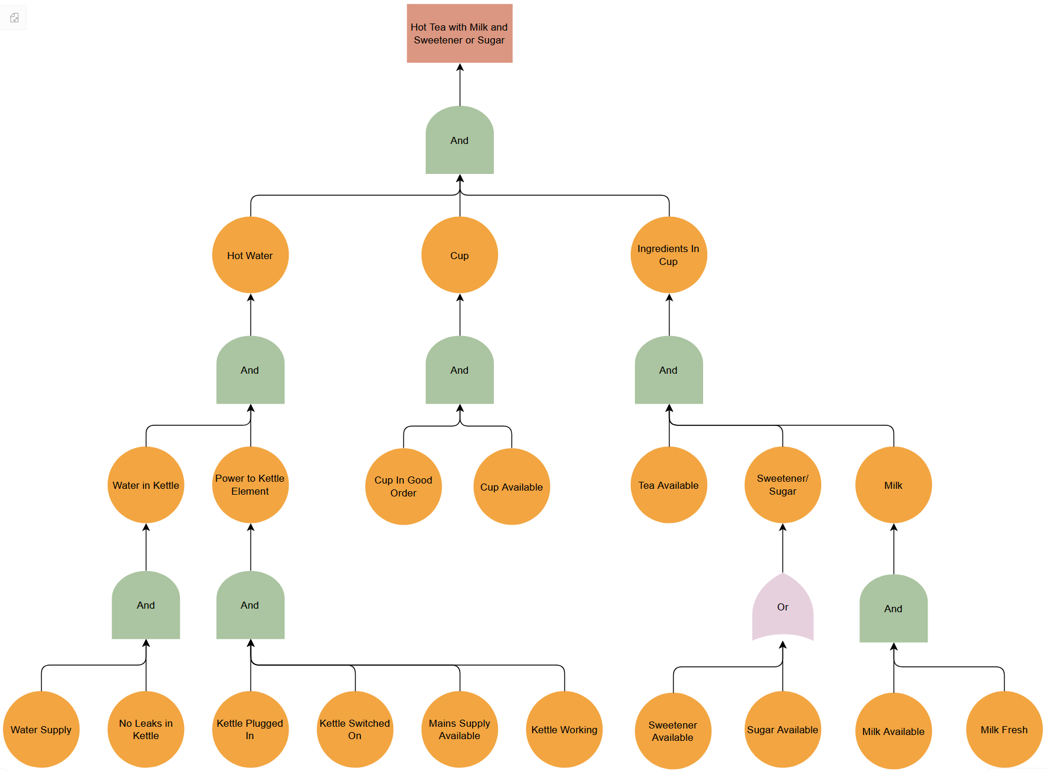
Fault Tree
Figure 2-1 - Fault Tree

Probability Calculations

Base Probabilities
From the dataset:
- Tea availability = 0.98
- Water supply success
$$1⋅0.01=0.99$$ | (3-1)
- Kettle not leaking
$$1⋅0.001=0.999$$ | (3-2)
- Kettle reliability = 0.99
- Plug-in reliability = 0.89
- Switch-on reliability = 0.89
- Mains supply success
$$1⋅0.01=0.99$$ | (3-3)
- Cup availability = 1.00
- Cup reliability = 0.99
- Milk availability and freshness
$$0.95⋅0.95=0.9025$$ | (3-4)

Probability Notation of Full System:
$$P_{success}= P_{tea}∩P_{water}∩P_{kettle,no leak}∩P_{kettle,working}∩P_{plug}∩P_{switch}∩P_{mains}∩P_{cup,available}∩P_{cup,working}∩P_{milk}∩(P_{sweetener }∪P_{sugar})$$ | (3-5)

Sweetener Logic
$$P_{sweet​}=1-\left[\left(1-P_{sugar}​\right)\left(1-P_{sweetener}​\right)\right]$$  $$=1-\left[\left(1-0.88\right)\left(1-0.99\right)\right]$$  $$=0.9988$$ | (3-6)

System Success Probability
All required elements are multiplied (AND logic):
$$P_{success}= P_{tea}⋅P_{water}⋅P_{kettle,no leak}⋅P_{kettle,working}⋅P_{plug}⋅P_{switch}⋅P_{mains}⋅P_{cup,available}⋅P_{cup,working}⋅P_{milk}⋅P_{sweet}$$  $$= 0.98 ⋅0.99 ⋅0.999 ⋅0.99 ⋅0.89 ⋅0.89 ⋅0.99 ⋅1 ⋅0.99 ⋅0.9025 ⋅0.9988$$  $$P_{success}= 0.671 (67.1\%)$$ | (3-7)

Application of Human Factors
The FTA is the conducted again with the modified probabilities that represent the degraded human performance at night:
- Plug-in reliability reduces to 75% of normal
- Switch-on reliability reduces to 75% of normal
- Cup selection reduces to 90% of normal

Adjusted probabilities
- Plug
$$0.89⋅0.75=0.6675$$ | (4-1)
- Switch
$$0.8⋅0.75=0.6675$$ | (4-2)
- Cup availability
$$1.0⋅0.9=0.9$$ | (4-3)

Recalculated system probability
All required elements multiplied with recalculated probabilities:
$$P_{fatigue}= P_{tea}⋅P_{water}⋅P_{kettle,no leak}⋅P_{kettle,working}⋅P_{plug,fatigue}⋅P_{switch,fatigue}⋅P_{mains}⋅P_{cup,available,fatigue}⋅P_{cup,working}⋅P_{milk}⋅P_{sweet}$$  $$= 0.98 ⋅0.99 ⋅0.999 ⋅0.99 ⋅0.6675 ⋅0.6675 ⋅0.99 ⋅0.9 ⋅0.99 ⋅0.9025 ⋅0.9988$$  $$P_{fatigue}= 0.34 (34\%)$$ | (4-4)

Reflection
This FTA highlights two major points; Human actions dominate failure probability and that the multiplicative effect of all of these dependencies compounds significantly.

Effect of Fatigue on Nocturnal Tea Production
Fatigue reduces success probability from 67.1% to 34%, effectively halving performance. This is a significant difference and highlights the importance of human factors in regards to system reliability, particularly where manual actions are critical steps in the process. The results demonstrate that even when technical components are highly reliable, degradation in human performance can dominate overall outcome of a system like this.

Engineering Design Implications
The results of the FTA immediately raise questions about how a redesign of the process could improve robustness. With a focus on reliable tea preparation under all conditions, including the state of the human operator, clear benefits can be achieved by minimising dependence on human precision.
Design improvements that follow this approach include the use of automation. For example, automating the kettle removes the requirement for the user to correctly plug in and switch on the device, which are identified as key failure points under adverse conditions. Simplification of the process for the user can also improve reliability. Systems such as pre-prepared tea solutions reduce the number of steps involved and therefore reduce the number of opportunities for failure.
The introduction of fail-safe features can further improve success probability by mitigating issues such as kettle leaks. A culture of preparedness, such as maintaining a kettle with a cup’s worth of water already available, could reduce the impact of water supply failure. Introducing redundancy into the system, for example through additional cups or more robust milk alternatives such as UHT milk, would also reduce the likelihood of single points of failure.
Overall, the aim is to reduce the number of sequential dependencies, replace human actions with engineered controls where practical, and improve component reliability where supported by cost-benefit analysis.

Alternative Paths of Analysis
Fault Tree Analysis (FTA) originated in the early 1960s at Bell Labs, where it was developed to support reliability assessment of complex systems such as the Minuteman missile programme [1]. Its structured approach to identifying failure pathways was later adopted extensively by NASA and other aerospace and defence organisations, where high reliability and safety assurance are critical [1], [2], [3].
Since then, FTA has become a foundational tool within engineering and systems safety. However, it is only one approach, and there are multiple systems analysis methods in use. Alternative techniques could also have been used to derive similar insights in this scenario, each offering different perspectives and advantages. For example, Reliability Block Diagrams (RBDs) provide a success-oriented representation of the system, modelling how components must function together for the system to succeed [3, p. 32]. Rather than the failure-focused nature of FTA, RBDs offer an alternative visualisation of a system and can simplify the calculation of overall reliability for systems with clear series and parallel structures [3, p. 33]. Their limitation lies in reduced capability to capture complex logical dependencies and conditional relationships, an advantage of FTA.
Human Reliability Analysis (HRA) would be especially relevant given the strong influence of human factors identified in this report. Applying HRA could provide a more rigorous and defensible basis for the degraded probabilities used in this analysis, rather than applying simple scaling factors [4]. The drawback is that HRA methods can require a lot of data and which requires detailed analysis, which may not be practical for simpler systems such as this.
Despite the availability of alternative methods, the application of FTA in this case provides important outputs. It provides a quantified success probability, the identification of critical failure paths, and allows for the prioritisation of design improvements.
All of these modelling approaches are widely applicable across engineering design reviews, can find use in the OME space, and can contribute to ‘right first time’ outcomes with the identification of potential issues at the design stage.

Conclusion
This analysis demonstrates that even a simple task like making tea is a complex system when viewed through an engineering lens. Under normal conditions, the probability of success is approximately 67%, dropping dramatically to 34% while fatigued.
Human reliability was identified to be the dominant risk factor, and system performance can be significantly improved by reducing reliance on human actions through design interventions.
Fault Tree Analysis, therefore allowed a look at the failure paths of the system, enabling productive design considerations. An example of FTA helping identify weaknesses early and enabling development of a more robust, resilient system.

References
[1] C. A. E. II, Fault Tree Analysis Primer. Fredericksburg, VA: CreateSpace Independent Publishing Platform, 2011.
[2] W.E. Vesely, F.F. Goldberg, N.H. Roberts, and D.F. Haasl, ‘Fault Tree Handbook (NUREG-0492)’, Division of Systems and Reliability, Research Office of Nuclear Regulatory, Research U.S. Nuclear Regulatory Commission, Jan. 1981.
[3] NASA, ‘Fault Tree Handbook with Aerospace Applications’, Office of Safety and Mission Assurance, Aug. 2002.
[4] A. D. Swain and H. E. Guttmann, ‘Handbook of human-reliability analysis with emphasis on nuclear power plant applications. Final report’, NUREG/CR-1278, SAND-80-0200, 5752058, Aug. 1983. doi: 10.2172/5752058.

