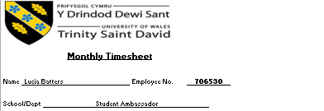

date | description | hours | Hourly rate | Cost centre | Post number
20/02/2026 | Unibuddy community catch-up meeting | 0.35 | £12.60
20/02/2026 | Unibuddy posts and communities work | 0.5 | £12.60
20/02/2026 | Unibuddy work | 0.25 | £12.60

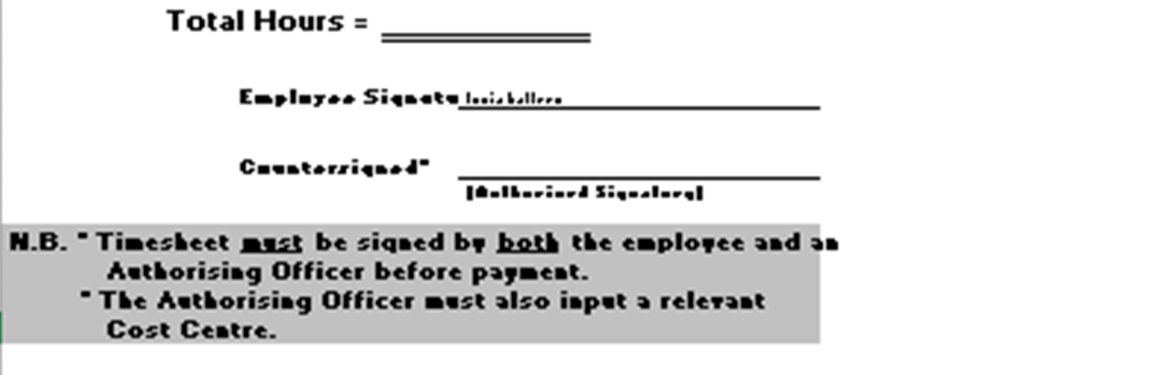
1.1

