Deconstruct the meaning of an artwork in the relation to the politics of representation from the perspective of gender studies, the post-colonial condition of the visualisation of violence

How Kara Walkers ‘The Katastwof Karavan’ relates to the post-colonial condition of the visualisation of violence, through the perspective of gender studies, and why this is important for our generation

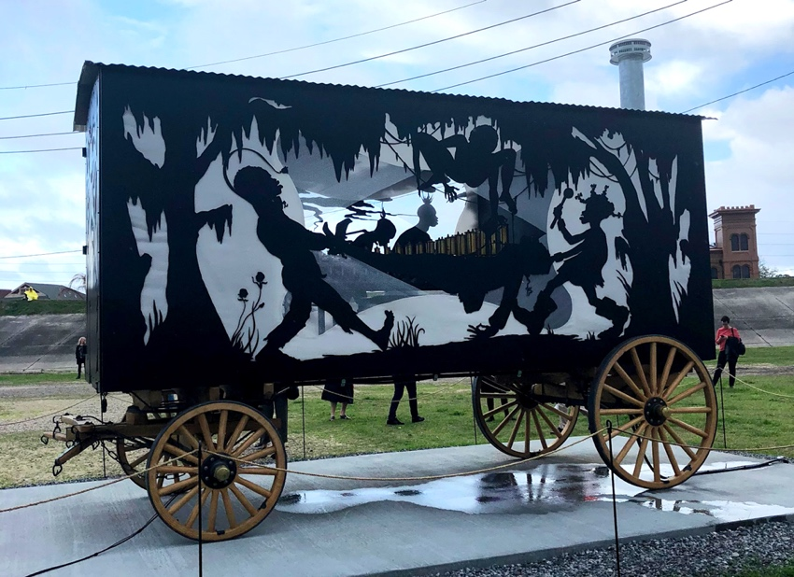
The post-colonial condition of the visualization of violence, through the lens of gender studies highlights the intersection of power dynamics, colonial legacies, and gender-based violence. In many post-colonial societies, historical inequalities and cultural norms have left indelible imprints on how violence, particularly gender-based violence, is portrayed and perceived. Postcolonial feminism is a branch of feminist theory that specifically examines the intersection of gender and postcolonialism. It looks at how
The katastwof karavan Art News (2019)
imperialism and colonialism impacted women in colonized regions and how these women have resisted and responded to such influences. Gender is a focal point for resistance and empowerment in postcolonial societies. According to ‘Tate.org (1997) kara walker born 1969’, ‘Kara walker is a contemporary painter, silhouettist, print-maker, installation artist, filmmaker, and professor who explores gender, race, sexuality and violence within her work, she is regarded as one of the most prominent and acclaimed Black American female artists working today.’ One of her most recognised works, ‘The Katastwof Karavan’, is a piece of work focusing on the important themes of race and gender, I would like to deconstruct the piece looking at it through the perspective of gender studies, the post-colonial condition of the visualisation of violence, and how the purpose of the piece can still be applied today.

Women have had such pivotal roles in movements for social justice, independence, and human rights. Women have challenged oppressive gender norms, fought for their rights, and contributed to the reconstruction of national identities in the postcolonial era. ‘The katastwof karavan’ is an important example of this. As maintained by ‘Tate (2019) Artist Kara Walker’, The artist once said, “My name is Kara Walker. I’m an artist. I’m really interested in making work that explores the power struggles and history and mythologies that inform the way we perceive ourselves and the way that we perceive others particularly around race or gender.” Kara Walker makes powerful work that really touches well on tough topics that are often not really talked about as something that is still important to discuss in the present day, her main theme in a lot of her work is slavery, using a lot of graphic and intense imagery and it really does affect people emotionally, . As mentioned in an article by ‘VICE (2017) Kara Walker Showed Me the Horror of American Life’, the article reads “The first time I saw Kara Walkers art, I felt like I had been assaulted.” Another part reads, “But what disturbed me the most was an image of a black woman having sex with her white master while a black child pulled at the mans shoe”. People are often able to understand the horrors of an experience or period of time or event a bit better through artwork in this way. Art can introduce people to new sets of emotions, experiences and ideas that they had never witnessed before, and that is why it is important. Postcolonial art, literature, and cultural expressions often analyse the complexities of gender inside postcolonial contexts. This includes exploring the ways gender roles are renegotiated, the impact of colonial legacies on women's lives, and the ways in which women navigate and challenge patriarchal structures.
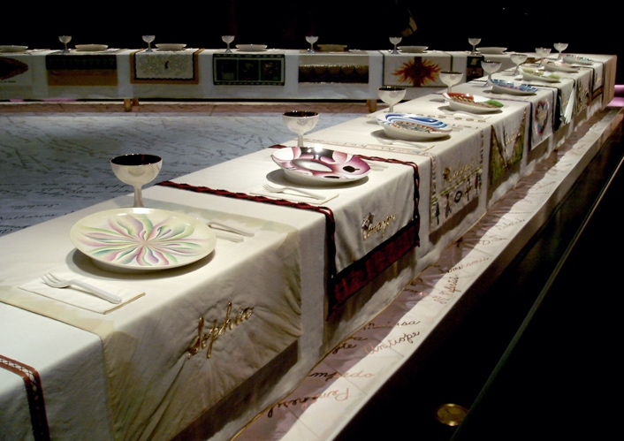
Another very significant piece of artwork that addresses feminism within the context of postcolonialism is Judy Chicago’s “The Dinner Party”. A piece displayed between 1974 and 1979, this celebrated installation features a triangular banquet table with place settings for 39 historically significant women. "The Dinner Party" is often only ever seen as a feminist artwork, but it also has strong connections to postcolonialism in the way it highlights the contributions and struggles of women from diverse cultural backgrounds. The table settings celebrate women from different eras and geographic locations, including postcolonial regions, who have made significant contributions to society despite historical oppression and colonial legacies.
The Dinner Party Smart history (2017)
For example, the table setting for Sojourner Truth includes references to her experiences as a formerly enslaved African American woman, while the setting for Sacajawea recognizes the Shoshone guide and interpreter who played a crucial role in the Lewis and Clark expedition in a postcolonial context.
"The Dinner Party" really emphasises the intersectionality of women's experiences, the resistance against patriarchal and colonial norms, and their contributions to postcolonial struggles for equality and justice. This monumental piece of work truly exemplifies the interplay between feminism and postcolonialism, as it celebrates women's achievements while acknowledging the challenges they faced within the context of colonial histories and gender-based oppression. I would say that it is definitely important to notice artwork that highlights the experiences of people who have been affected by a whole range of political issues, post colonialism is a huge one and so is sexism and the patriarchy, and so similarly to the Katastwof Karavan, this piece accents these issues and brings forward the experiences of these people.

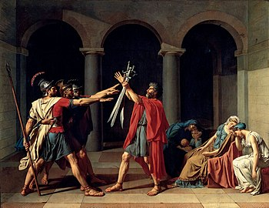
Artwork has had a profound transformation over the years regarding the portrayal of race and gender. Artwork has sort of always mirrored what is happening in that time period, mirroring societal norms, or politics, often reflecting prevalent biases and stereotypes. A lot of historical artwork often reflects the former colonisation happening in certain eras and places, a significant example of this is a painting by the French Neoclassical painter Jacques-Louis David, painted In 1784 titled ‘The Oath of the Horatii’. Whilst this painting doesn’t directly portray African colonization, it does give us a bit of insight into the societal and political ideologies of the time when European powers were increasing their empires, including Africa. Artwork often gives us a political insight into what was happening at the time, but obviously from a certain perspective, and artwork like this sort of glorifies the work of the colonisers, so it is important to appreciate artwork from people who actually experienced the terrors of African colonisation, so this is why I think responding to pieces like the katastwof karavan is important, ‘Katastwof is the Haitian creole way of saying disaster or catastrophe’ national gallery of art (2022), the piece is meant to feel like a corruption, a disaster, its not sugar coating anything, its graphic its raw, real and personal, Haiti is a county formed by the only successful African Slave revolt in history. Haitis history is marked by colonisation, mostly by France. The artwork has a very visual narrative that truly explores the complexities and aftermath of colonisation in Haiti.
The oath of horatii Wikipedia (2019)

In an article exploring cultural diversity in art (2023) it says “Art can be a powerful storytelling tool. By representing cultural narratives, artists can share the unique histories, myths, and traditions of different cultures.” They also speak later on about how “If you want to explore cultural diversity in art, the first step is to respect and appreciate diversity of cultural backgrounds and experiences. Each culture has its unique way of expressing art, and these differences should be celebrated, not compared or ranked. Art in many forms, has the remarkable ability to reflect the diversity of the world. Whether its through traditional folk art, contemporary installations, or digital illustrations, artists have the unique opportunity to express their cultural experiences and perspectives. By doing so, they contribute to a global scene that is rich in diversity, giving us numerous ways to explore cultural diversity in art” What that article talks about is exactly right and can be well related to the work of Kara Walker, the way she incorporated her culture as a Black American Female into her work, the art of her culture and inspiration from the music of her culture, ‘jazz and gospel and African American music are testaments to survival of our culture in the face of unrelenting, nihilistic “progress” and how its regarded as a monument in American History etc.’ nga.gov (2022)

To conclude, ‘The katastwof karavan’ by Kara Walker, acts as a platform for conversation, inviting viewers to reflect of the implications of colonization, the real legacies it leaves behind, the importance of preserving and acknowledging cultural heritage. It is a powerful representation of the intersection of art, history and the ongoing effects of colonialism that are still going on the world around us. It is important to seek out artwork like Kara Walkers, to be educated and enlightened about topics that are trodden on in this generation, the effects of colonialism still effect so many peoples day to day lives today, and that important to acknowledge, it is also important to really appreciate works from artists who make art portraying the history or experience of their own cultures, to get a true understanding and point of view, The Katastwof Karavan really is a symbolic representation of historical events, cultural memory and resilience.

Word count 1423

Reference list
Tate.org (1997) Kara Walker born 1969 https://www.tate.org.uk/art/artists/kara-walker-2674

VICE (2017) Kara Walker showed me the horror of the American life https://www.vice.com/en/article/59ywgz/kara-walker-showed-me-the-horror-of-american-life

national gallery of art (2022) https://www.nga.gov/features/the-katastwof-karavan.html

Daisie Team exploring cultural diversity in art (2023)https://blog.daisie.com/cultural-diversity-in-art-techniques-best-practices/#:~:text=It%20challenges%20our%20perceptions%2C%20broadens,profound%20impact%20on%20artists%20themselves.

The katastwof karavan Art News (2019) https://www.artnews.com/art-news/news/kara-walker-calliope-whitney-museum-13193/

The Dinner Party Smart history (2017) https://smarthistory.org/judy-chicago-the-dinner-party/
The oath of horatii Wikipedia (2019) https://en.wikipedia.org/wiki/Oath_of_the_Horatii

