Name : Purna Lal Sapkota
Student P. Number : 2108557
Programme : BA International Hotel Management
Module : Financial Management for the Hotel industry
Module Level : 5
Module Code : BMIH5007
Lecturer : Dale Clarke
Topic: Report – Comparison of two organizations

Marriott International vs Hilton Hotels
Table of Contents
Introduction 1
Comparison between approaches of financial management 1
Total revenue 2
Market Position 3
Growth Potential 4
Financial Commitment to CSR 5
Source of funding 6
Recommendations 7
Conclusion 7
References 8

Introduction
To gain an understanding of the use of approaches of financial management within different business organizations. So, the report consists of the comparison approaches to the financial management of two hospitality organizations by considering the areas like total revenue, market position, growth potential, and financial commitment to CSR. It also consists of the recommendation for two hospitality organizations on the opportunity for growth and potential for outsourcing.
Hilton hotel is one the flagship brand and largest hotel in the world Hilton hotel is targeted for both business and leisure travels so located near airports, convention centers, and popular vacation places throughout the world (Cardiff, 2022).
Marriott Hotels is an international hotel chain that has approximately 30 brands with 8000 properties within 131 countries of the world with 1423044 rooms. Marriott hotel has some core values which are putting people first, acting with integrity, embracing change, and serving the world (Peterson, 2019).
Comparison between approaches of financial management
Financial management has two approaches which are the traditional approach and the modern approach. The traditional approach focuses on the arrangement of long-term and short-term funds for business from financial institutions and the mobilization of funds through equity shares, preference shares, bonds, and debentures, and the orientation of the finance function with the accounting function (Borisova, 2022). But the modern approach to financial management focuses on investment decisions, financial decisions, and dividend decisions (Cardiff, 2022).

Total revenue
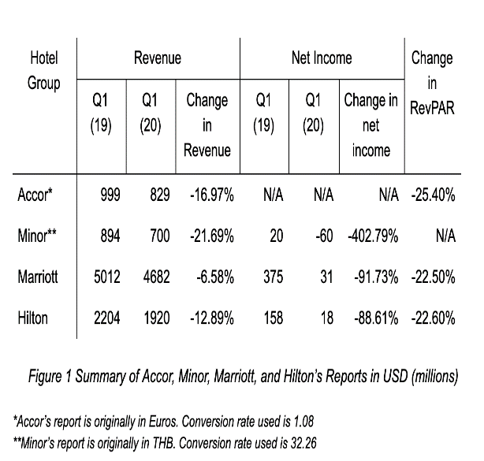  Figure 1: Total revenues of the Hilton hotel.  Source: (Cowie, 2018). | 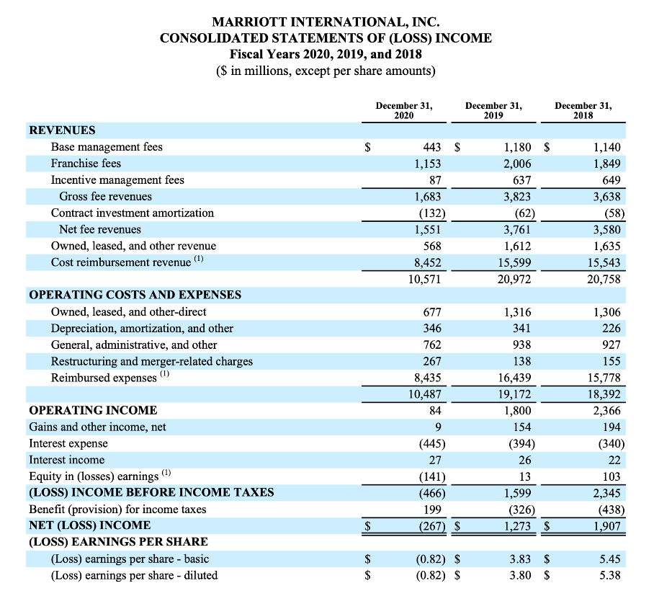  Figure 1: Total revenues of the Marriott hotel.  Source: (David, 2020).
The total revenue of the Hilton hotel identified from 2019 to 2020 is $2204 million and $1920 million whereas the total revenue of the Marriott hotel in 2019 and 2020 are $1180 and $443 that is showing the total revenue of the Hilton Hotel is more than the total revenue of the Marriott Hotel (David, 2020). Also, identified that the Hilton hotel mostly focuses on the approach of financial management which identified its total revenue does not link with the accounting function. But the Marriott hotel follows the traditional approach of financial management where Marriott hotel performs orientation of finance function with the accounting function and compliance of legal provisions (Cowie, 2018). Because the table of net income is showing that the manager of the Marriott hotel identified the earnings per share by using the accounting function where prepares an income statement using total revenue and adjusts (Ergul, 2020). That orients the financial function of the Marriott Hotel with the accounting functions. As Hilton Hotel focuses on a modern financial approach so the financial manager of the Hilton Hotel focuses on financial decisions by focusing on debt and equity which ensures the debt of the organization remains less than the equity of Hilton Hotel (Fay, 2021). So, the manager of the Hilton Hotel focuses on collecting funds from retained earnings rather than the collection of funds from financial institutions. This helped Hilton Hotel to reduce non-operational expenses by reducing the interest expense for a loan from a financial institution. That helped Hilton Hotel to ensure higher total revenue than Marriott hotel. But as Marriott Hotel focuses on traditional financial management which inspires the financial management of Marriott hotel to collect long-term and short-term finance from financial institutions like bank loans that cause lower total revenue for Marriott hotel because it bears the cost of the interest expense for funding in business that negatively impacts on its net income (Fehre, 2020).

Market Position
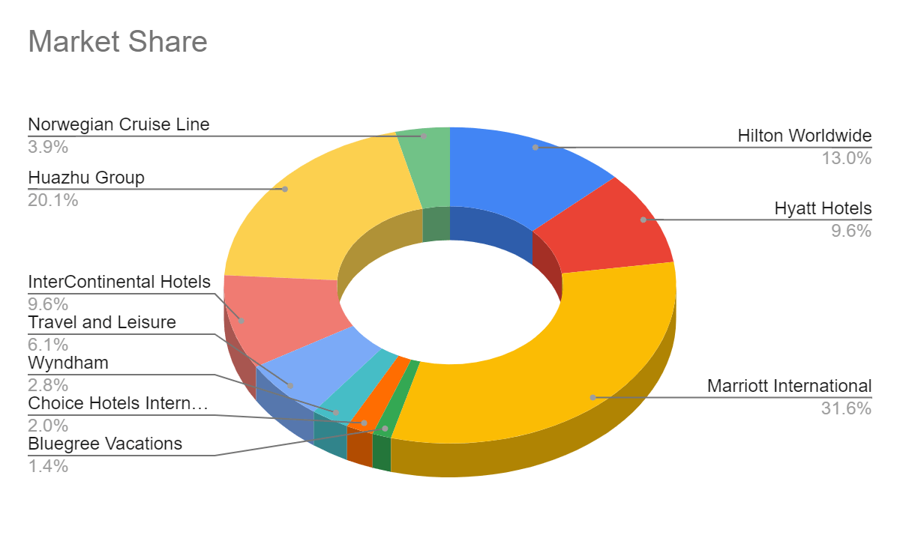
Figure 3: Market position of Hilton hotel and Marriott hotel.
Source: (Setini and Caisar Darma, 2020).
The market position of the business organizations within the industry refers to 4 types of market leaders, market challengers, market followers, and market niches. So, by analyzing the market share of the Hilton Hotel and Marriott Hotel it is identified that Hilton Hotel is a market follower where it keeps its position rather than competing forcefully. because it has a market share of 13.0% which is less than Marriott International 931.6%) and Huazhu Group (20.1%) (Setini and Caisar Darma, 2020). Also, Marriott hotel has a market share of 31.6% which is more than other hotels that are showing Marriott hotel is a market leader whose dominance affects the competition. As Marriott hotel follows the traditional approach of financial management which refers effective utilization of funds to maximize the profitability of the firm and the wealth of its owners and the mobilization of funds through financial instruments like equity shares and preference shares (Florian, 2020). So as Marriott hotel is focusing on maximizing market share by collecting funding through share offerings which are helping to large investments that are helping to increase market share that is helping in maximize profitability and wealth of owners. because maximization of market share is an opportunity for higher profitability along with increasing the wealth of the owners increasing market share increases the value of the stock of the shareholders which increases the wealth of the owners (Jumadilova and Sailaubekov, 2019). But Hilton Hotel follows the modern approach of financial management which refers to investment decisions that are an approach of financial management which refers to making investment decisions in fixed assets when identified those investments will provide higher profitability (Jack, 2020). So, that kind of perception caused barriers for Hilton Hotels to take the financial risk to invest in businesses to get higher market share and higher profitability and only focus on keeping its market position rather than forceful. competition.
Growth Potential
According to Kenneth (2022), growth potential refers to an organization's ability to generate larger profits through business expansion in the future. Hilton Hotel follows the modern approach of financial management which refers to the managers should focus on identifying the total fund requirements of the firm, the assets to be acquired, and the pattern of financial assets. So, the manager of the Hilton Hotel focuses on financial decisions. That is an approach of modern financial management to identify the requirement of funds by performing a budget and then identify the debt-to-equity ratio to identify whether Hilton hotel has appropriate debt-to-equity by managing long-term and short-term debt in the funding business (Mecaj, 2019). So, when identifying that taking a loan from financial institutions could increase the financial risk of business then the manager of Hilton hotel focused on collecting the required funds from retained earnings. As retained earnings are used as long-term and short-term finance which could reduce the growth potential of Hilton Hotel because retained earnings are secured by the business organization to use for future growth opportunities (Peterson, 2019). Another way the Marriott hotel follows traditional financial management where focus on collecting long-term and short-term funds from financial institutions rather than using retained earnings and saving retained earnings for further growth of the business (Rogger, 2020). That is increasing the growth potential of the Marriott hotel more than Hilton Hotel because a higher amount of saved retained earnings will inspire the manager of the Marriott Hotel to make market development decisions in the future that will ensure business growth.
Financial Commitment to CSR
Financial commitment to CSR refers business organizations to protecting their stakeholder’s interests through financial decisions-makings (Słowik, 2019). As the Hilton hotel follows the modern approach to financial management. That refers to focusing on dividend decisions where dividend decisions affect in 2 ways the amount to be paid out and influence share price and the amount of profit gained through internal investment which maximizes the value of the firm and positively impacts on increasing the share value of the shareholders (Whittard and Khan, 2020). that is helping the Hilton Hotel to fulfil its financial commitment to CSR by following modern financial management where Hilton hotel ensures the interest of its shareholders who is the stakeholder of the Hilton hotel by performing internal investment through the profitability of the organization that maximizes shareholders’ wealth (Seekingalpha.com, 2022). Also, identify the amount of dividend to pay to the shareholders by identifying impacts on share price to ensure an appropriate amount for paid up as dividend to shareholders that could help to increase share price (Yazdimoghaddam, 2020). That is helping to fulfil the financial commitment to CSR to employees and the government of the Hilton hotel by maintaining the sustainability of business because increasing share price help to gain profitability and profitability is a pillar of sustainability. That is helping to ensure employees’ employment along with providing tax to the government and using a specific amount from profitability for social people (Zheng, 2019). For example, Hilton Hotels invested $1 million in social development activities that are helping to meet its responsibility towards social people.
Also, the Marriott hotel follows the traditional approach of financial management where the focus is on maximizing profitability along with maximizing the wealth of the owners. That is helping Hilton hotel gain the position of market leader which has approximately 31.6% of the market share which is helping to fulfill its financial commitment to CSR by protecting shareholders' interest within the business by increasing market share which increases profitability that increases the percentage of dividend and wealth of shareholders (Borisova, 2022). Also, increasing market share through the financial activities of Marriott hotel is helping to gain higher profitability where approximately 2% of the yearly profit Marriott hotel spends on CSR activities for social people (Cowie, 2018). Along with helping to ensure the interest of the government and employees because increasing profitability refers higher rate of tax that positively impacting on governmental spending for society people of the UK along with ensuring employability for UK people by increasing the sustainability of the business (David, 2020).
Source of funding
The source of funding for business depends on the financial management approaches followed by the business organizations (Ergul, 2020). For example, Hilton Hotel follows the modern approach to financial management which refers to ensuring an ideal debt-to-equity ratio by ensuring less debt than equity capital of business whereas Hilton hotel ensures retained earnings as long-term investments in business rather than collecting finance from a bank loan or other financial institutions (Fay, 2021). But Marriott hotel if following a traditional financial approach which refers to collecting short-term and long-term finance through share offerings, bonds, debentures, and financial institutions which are the source of finance for the Marriott hotel rather than collecting funds from retained earnings (Jack, 2020).
Recommendations
Opportunity for growth: Hilton Hotel should focus on opportunities for growth to gain a competitive position within the market by performing business expansion in a different market (Kenneth, 2022). That will help to increase the market share and profitability of Hilton Hotel where Hilton Hotel will get the opportunity to achieve the position of market leader within the industry. For this Hilton Hotel should keep its retained earnings for further future growth rather than using them as a short-term funding source that will increase opportunities for the potential growth of the business.
Potential for outsourcing: Marriott Hotel should focus on Outsourcing employees, food, and so on to serve its customers. Because Outsourcing will help Mariotte Hotel to reduce its cost of business-like recruitment costs and the cost to recruit chefs to prepare food, and so on (Jumadilova and Sailaubekov, 2019). That will help Marriott hotel to increase its total sales revenue efficiently.
Conclusion
The findings of the report successfully meet the aim of the report by efficiently comparing both traditional and modern financial approaches applied by the Hilton hotel and Marriott hotel which helped to identify the efficiencies of both traditional and modern financial approaches. Hilton hotel follows the modern approach of financial management which focus on collecting fund for business from retained earnings but Marriott hotel who follows the traditional approach of financial management focus on collecting fund from financial institutions, share offering debentures, and bonds. Hilton hotel is efficient in earning higher sales revenue, but Marriott hotel is efficient in covering up market share where Marriott hotel is a market leader and Hilton hotel is a market follower. As Hilton hotel focus on collecting fund from retained earnings which is reducing its potential growth opportunities in the future because retained earnings are for future growth, but Hilton Hotel use retained earnings as short-term funding. But Marriott hotel collects funds from the financial institution which is ensuring its potential growth opportunity through retained earnings along with increasing its interest cost. Both Hilton hotel and Marriott hotel are supporting society people by spending social people from their yearly profit along with ensuring the interest of the government, shareholders, and employees by ensuring business sustainability by gaining profitability.

References
Borisova, O. (2022). Funds financial management approaches. Management and Business Administration, (1), pp.150–160.
Cardiff (2022). Hilton Worldwide Holdings: Showing Resilience in A Tough Environment (NYSE:HLT) | Seeking Alpha. [online] seekingalpha.com.
Cowie, K.A. (2018). Book review-Recognizing potential and harnessing it for transformative growth. Global Business and Organizational Excellence, 37(3), pp.67–70.
David (2020). 3 Main Approaches to Financial Management | Management. [online] Learn Accounting: Notes, Procedures, Problems and Solutions.
Ergul, M. (2020). Quality of relationship on information technology outsourcing for organizational success in hospitality industry. Journal of Hospitality and Tourism Technology, 5(3), pp.229–244.
Fay (2021). OUTSOURCING PRACTICES IN HOSPITALITY INDUSTRY. JOURNAL OF TOURSIM AND HOSPITALITY MANAGEMENT, pp.01–09.
Fehre, K. (2020). Challenging corporate commitment to CSR. Management Research Review, 39(11), pp.1410–1430.
Florian (2020). Financial management. London: Bpp Learning Media.
Jack (2020). Hilton Hotels Corporation - Company Profile, Information, Business Description, History, Background Information on Hilton Hotels Corporation. [online] www.referenceforbusiness.com.
Jumadilova, S. and Sailaubekov, N. (2019). Company’s financial state forecasting: methods and approaches. Investment Management and Financial Innovations, 14(3), pp.93–101.
Kenneth (2022). Strong Growth and Buried Treasure on The Balance Sheet of Hyatt (NYSE:H) | Seeking Alpha. [online] seekingalpha.com.
Mecaj, A. (2019). CSR Actions and Financial Distress: Do Firms Change Their CSR Behavior When Signals of Financial Distress Are Identified? Modern Economy, 05(04), pp.259–271.
Peterson (2019). Topic: Marriott International. [online] www.statista.com.
Rogger (2020). How Are Accor, Minor, Marriott, and Hilton Doing for Q1 2020? [online] Hotelintel.co.
Seekingalpha.com (2022). Marriott International: Wide-Moat Business but Overvalued (NASDAQ:MAR) | Seeking Alpha. [online] seekingalpha.com.
Setini, M. and Caisar Darma, D. (2020). Towards Market Share: Segmentation, Target and Market Position. International Business Management, 13(9), pp.405–414.
Słowik, B. (2019). Bond issue as an external source of funding the business activity. Annales Universitatis Mariae Curie-Skłodowska, sectio H, Oeconomia, 48(1), p.101.
Whittard, D. and Khan, J. (2020). The UK’s international investment position. Economic & Labour Market Review, 4(6), pp.25–34.
Yazdimoghaddam, J. (2020). A model for financial supply chain management with two different financial approaches. Journal of Modelling in Management, ahead-of-print(ahead-of-print).
Zheng (2019). Performance Gap in Hospitality Financial Management Courses: A Comparison Between Working and Non-Working Students. The Journal of Hospitality Financial Management, 4(1), pp.143–144.

