Front Office Operations

Name:Stefan Cheles
Student number:1815342
Lecturer name:Jahanzeeb Qurashi

Table of Contents
Introduction 3
Part 1 A) Discuss with industrial examples in your report (inclusive literature) the importance of Front office operation in Hotel? 3
Theories of Hotel Operations 3
The Importance of Front Office Operation in Hotel 5
Parts 1 B) Also, with examples analyze the operational role of the following 5 Star hotel Front office staff: 5
(1) Front Office Manager 5
(2) Night Auditor 6
Conclusion 7
References 8

Introduction
In this assignment, the importance of the front office operation in the hotel can be understood. Apart from this, the theories related to the operations of the hotel are also taken into consideration for recognizing the positive side of the front office. The operational role of the 5-star hotel front office staff and its impact on the growth of the hotel is also stated along with the responsibility of the front office manager and night auditor. From this, the information about the function of the front office in case of hotel management can be gathered. Some of the examples are also provided in the form of evidence.

Part 1 A) Discuss with industrial examples in your report (inclusive literature) the importance of Front office operation in Hotel?

Theories of Hotel Operations
As per the study of, Aithal and Kumar, (2016), different models and theories are used by the hotel in operating their business. Among these, the first and the most effective one is the Theory X and Theory Y. Theory X is used for expending the employees by giving them efforts in doing their job in a proficient manner. Apart from this, Theory Y is used for bringing the skills of the employees with which the supervisor can help them to get developed through the process of communication. With these two theories, the employees can work as per the needs of the hotel and this also helps in teaching them some of the vital aspects through which, development can be brought within the hotel management. According with the perception of, Lawter, Kopelman and Prottas, (2015), this theory has been used by the company, Google and it has been noticed that with this theory, they have been able to improve the skills of their employees which in turn, created a positive impact on the hotel operations.
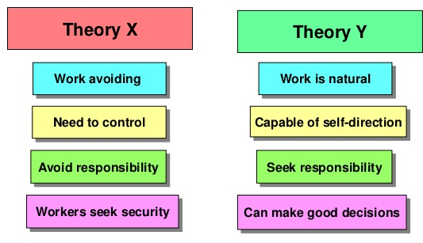
Figure 1: Douglas McGregor’s Theory X and Theory Y
(Source: Lawter, Kopelman and Prottas, 2015)
Maslow’s Hierarchy of Needs Theory is also used by many organizations as it is helpful in understanding the attempts of the people. In addition to this, some of the basic needs of the people can also be considered through this. This theory is helpful in understanding focusing on the issues of self actualization and self realization. The self-accomplishment is also taken into consideration along with these factors. The hotel will be able to understand the needs of the people with the support of this as the safety and the physiological matters are also focused with the help of this. The front office manager can use this for recognizing the needs of the employees and the ways by which, the design programs can be improved (Shih et al., 2019). The communication process will also be enhanced with this. In the context of, Expert Program Management, (2018), it has been noticed that Apple is using this theory for increasing the self-actualization within the employees.
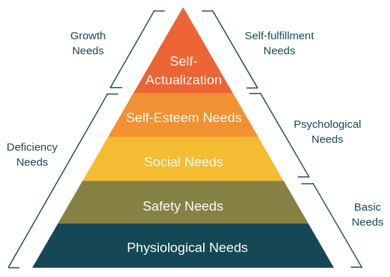
Figure 2: Maslow’s Hierarchy of Needs
(Source: Expert Program Management, 2018)
Thus, through the help of these theories, the hotel will be able to gain a better position in the global market. It will also be successful in increasing the capabilities of the employees. The front office of hotel will get the scope to know the drawbacks faced by the employees in the hotel management.

The Importance of Front Office Operation in Hotel
Front office department has a vital role in a different hotel and this is the process by which, the hotel gets the chance to interact with the guests. It is the responsibility of the front office department to create a scenario where the facilities and services can be provided to the new customers. As per the study of, Korez-Vide, Tansek and Milfelner, (2016), they should also focus on the different needs of the customers. In this case, the personal appearance and communication skills are the most important issue as with the help of this, they will be able to create good communication with the customers. The front office is also responsible for coordinating the activities within the hotel. Apart from this, the subordinates will also be supervised and along with this, the training and hiring process is also carried forward. This department also concentrates on the method of preparing the budget and improving the performance of the employees (Quarshie and Amenumey, 2018). They also try to amend all the necessary changes that are addressed by the customers.
The front office operations are helpful in maintaining their relationship with the guests. Apart from this, they should also try to integrate the use of technology with the help of which, appropriate facilities can be provided to the customers. According to the viewpoint of, Dinh, (2018), it will also be efficacious for the hotel to manage the cut-throat competition that is prevailing in the global market. For a hotel, maintaining a good relationship with the consumers is the most important factor. Due to this, they also need to have well effective desk professionals who can deliver better services to the customers. The representative of the front desk should know about the prices and policies that are related to the services. These facilities have been beneficial for many hotels like Holiday Inn, Accor and Hilton Hotels.

Parts 1 B) Also, with examples analyze the operational role of the following 5 Star hotel Front office staff:

(1) Front Office Manager
The front office manager is having a significant role in managing the operations of the 5-star hotel organizations. It is the responsibility of the manager to maintain the working relationship among the departments of the hotel. In addition to this, communication is also initiated for the betterment of the hotel. The manager also has control over the master key. They also concentrate on delivering better room status. They are also maintained and communicated as per the needs of the customers. The front office manager provides training to the employees and in addition to this, they are also supervised by minimizing the workload. The participation in front office personnel is also observed to be one of the roles of the manager. The manager also continues its job role by resolving the problems that are faced by the guests. They try to satisfy them by providing effective services and facilities (Astuti, Ginaya and Sadguna, 2018). The manager of the front office also looks onto the matter of allocating the budgeting issue that is one of the vital aspects of the hotel.
On the other hand, the front office manager is also bound to know the various cash handling, credit and check cashing policies so that they can deliver such knowledge to the customers. Regularly scheduled meetings are needed to be held for recognizing the various measures by which, the hotel will be able to take part in the competitive run. The maximization of room revenue and the analyzing of rate variance and monitor credit report are also carried on by the front office manager. The maintenance of the revenue and stationery suppliers falls under the duty of the front office manager. Such facilities of the manager have been noticed in many of the hotels like Holiday Inn and Choice Hotels.

(2) Night Auditor
Similar to the front office manager, the night auditor is also having some responsibilities in the 5-star hotel. It is their duty to manage the hotel matters at night and along with this, they should also manage the cash transactions during that time. The guest charge vouchers, as well as the credit card vouchers, are also managed with the help of the night auditor. In the absence of the front desk officers, it is their responsibility to manage the check-in and check-out activities. The room venues, as well as the occupancy percentage, are controlled by the night auditors. The financial summaries are maintained by them apart from their other roles. The night audit processes are carried forward with the help of the night auditors. Keeping the records and managing the operations of the front office are correlated to the responsibility of the night auditor.
The fire safety system and the duty of the manager are also monitored with the support of the night auditor. The balancing of all the front office accounts is managed by the night auditor. Producing the managerial and operational reports also comes under the role of the night auditor (Cooper et al., 2016). The verification of the daily hotel transactions is carried forward with the help of the night auditor. It is also the duty of the night auditor to focus on the different functions of the front office such as PBX and front desk. In the absence of senior management, it is the duty of the leader of the night auditor team to serve the duty of the manager.

Conclusion
From the above assignment, the front office operations of the international hotel management are focused. It has been noticed that different theories and models like Maslow’s Hierarchy of Needs and Theory X and Theory Y are used for understanding the issues within the front office of the hotel. Apart from this, the role and responsibility of the front office manager and night auditor are also observed that are helping the hotel and its different operational functions. It can be understood that the front office plays a vital role in the management of a hotel.

References
Aithal, P.S. and Kumar, P.M., 2016. Comparative analysis of theory X, theory Y, theory Z, and Theory A for managing people and performance. International Journal of Scientific Research and Modern Education (IJSRME), ISSN (Online), pp.2455-5630.
Astuti, N.N.S., Ginaya, G. and Sadguna, I.G.A.J., 2018, October. A Hotel Front Desk Receptionist and Catur Paramita Values: A Study of Implementing Local Wisdom in Hospitality Industry. In 1st International Conference on Social Sciences (ICSS 2018). Atlantis Press.
Cooper, T., Scott, J., Barclay, E., Sims, M. and Love, T., 2016. Crime prevention and young people: Models and future direction for youth night patrols. Crime Prevention and Community Safety, 18(4), pp.266-283.
Dinh, T., 2018. Front Desk Development Hanoi Hilton Opera House.
Expert Program Management, 2018. Maslow’s Hierarchy of Needs. Maslow’s Theory of Human Motivation. [Online] available at: https://expertprogrammanagement.com/2019/06/maslows-hierarchy-of-needs/ [Accessed on: 7th November, 2019]
Korez-Vide, R., Tansek, V. and Milfelner, B., 2016, April. Assessing intercultural competence of front office employees: the case of hotels in Slovenia. In Biennial International Congress, Tourism & Hospitality Industry (pp. 158-173).
Lawter, L., Kopelman, R.E. and Prottas, D.J., 2015. McGregor's theory X/Y and job performance: A multilevel, multi-source analysis. Journal of Managerial Issues, pp.84-101.
Quarshie, J.M. and Amenumey, E.K., 2018. Utilisation of information and communication technologies in hotel operations in the central region of Ghana. Journal of Hospitality Management and Tourism, 9(1), pp.1-13.
Shih, C.Y., Huang, C.Y., Huang, M.L., Chen, C.M., Lin, C.C. and Tang, F.I., 2019. The association of sociodemographic factors and needs of haemodialysis patients according to Maslow's hierarchy of needs. Journal of clinical nursing, 28(1-2), pp.270-278.

