
Skills for the Workplace
Module Assignment Submission
Student Name: | Alhaj Moqaddas
Student Number: | 1807602
Module No: | BMSK6003
Module Title: | Leading and Implementing Workplace Change

Statement of Confirmation of Authenticity
By the act of making this submission, the student declares that this is the work of the student named above. The work has not, in whole or in part, been knowingly presented elsewhere for assessment, or where assessment has been built on a previous assessment, this has been identified. Where materials have been used from other sources it has been properly acknowledged. If this statement is untrue, the student acknowledges that an assessment offence has been committed.
Attention is drawn to the plagiarism and unfair practice policies of both the University and of ILM.

Table of Contents

Introduction 2
Change in Business Environment 2
Current Business Environmental Changes: 3
Understanding the Micro and Macro Factors for Business Environment Change 4
SWOT Analysis 4
PESTLE Analysis: 6
Managing change with Leadership 8
Transformational Change: 11
Stakeholder Analysis: 12
Managing Employee Resistance through Change Management: 14
Kotter’s 8 Step Model of Change: 15
Conclusion 18
References 19

Introduction
Changes in the business environment forces organisations towards different operational changes. During this type of changes organisations move from one state to another in order to deal with the current market competition. The covid-19 pandemic has been a significant factor for business environmental changes from both micro environment perspective and macro environment perspective. A change in the business environment requires some changes within the business organisation itself. However in order to deal with these changes business organisations need to verify that the organisation is ready for the changes and have the ability to adopt these changes. This assignment is based on identifying different aspects related with the business environment change happening in the recent years. The assignment aims to provide a critical discussion about environmental changes and organisation capabilities by pinpointing the micro and macro environment factors. Some of the contemporary issues are highlighted with relevance. Lastly, a stakeholder analysis has been conducted to deal with complex workplace change.

Change in Business Environment
As of 2020, businesses are still in a dilemma, what type of changes can help them to deal with the current business environment. One of the most important factors of environment changes is the impact of these changes in business organisations. For example, during the covid-19 pandemic employees have to work from home and some of the employees who do not have technical knowledge found it very difficult to work from home. The following literature review is a critical analysis related to change management and how organisations can deal with business environmental changes (Lamberton, and Dave, 2020). Data has been collected from different journals, articles, online published papers etc in order to get a clear view about organisational environmental changes and its impact on the functions of the organisation.

Current Business Environmental Changes:
Not only the covid-19 pandemic but also recession have hit the business world from different angles. It was really hard for businesses around the world to sustain during the pandemic. Some of the businesses did outstanding performance during a pandemic while most of the businesses suffered from the economic imbalance caused by the covid-19 pandemic. The business environment drastically changed in recent years. According to the research of Vasconcelos & Ramirez, (2021) businesses that failed to adapt with the current environmental changes failed to sustain and were forced to complete shutdown. Some of the businesses were doing standard operating procedures that were not enough to make the business compete with other businesses. Kempton (2021) said that according to the behavioral theory of organisation, every organisation should have an adaptive learning system that can help them with any type of business environmental changes. But because business organisations do not focus that much on identifying potential threats and opportunities, they fail terribly when there are any changes in the business environment. This is particularly true for small and medium-sized businesses. But in case of larger business organisations the statement is not as correct as it is for SME businesses. As Yu & Ramanathan, (2020) found that, larger business organisations paint a good amount of money and time on finding out the potential success factors as well as threats from the business environment also from the competitors. Because of their larger operations business organisations are not able to respond quickly to the environmental changes. Sometimes businesses that are able to respond gradually earn more benefits from the environment. They can find out actions that can produce more efficient and effective results for the long-term.
Different researchers like Paton and McCalman (2000) find out that, in order to deal with business environmental changes, businesses need to develop their capabilities in order to develop effective change management systems. On the other hand Hussey, (2020) suggested that businesses simply adopt any change as it will only disrupt their business operations rather than giving any benefit. Businesses need to find a reasonable fit through their capabilities that can gradually help them to deal with the environmental changes. This is an effective strategy when all of the business organisations are gradually dealing
with the business environment changes. But in recent years because of the covid-19 pandemic the gradual adaptation strategy is not effective. Because the business environment is rapidly changing from 2020 and in order to deal with these changes businesses need to develop their capabilities faster (Creasey, 2020). For example, the world has seen a lockdown situation during the pandemic that was very sudden. Not all of the businesses have their own websites or capability to sell their products and services through online. Therefore in order to deal with the change businesses needed to develop their own website and increase their capabilities to sell products online. Anderson & Anderson (2010) stated that customers have many options to purchase their desired products and services but a particular business has a limited number of customers; therefore, if they lose these customers during the pandemic because of not having a website that allows the customers to purchase products and services it will have a terrible impact on the profit margin.

Understanding the Micro and Macro Factors for Business Environment Change

SWOT Analysis
This is one of the main method to understand the micro environmental factors that are causing changes in the business environment. Micro environmental factors are directly connected with the business and have direct impact. There are four aspects of SWOT analysis. They are Strengths, Weaknesses, Opportunities and Threats.

Strengths: During the covid-19 pandemic, and also because of the advancement of the information technology and communication technology, business world is rapidly shifting towards online or more specifically towards e-commerce business. People are getting accustomed with the online shopping and e-commerce platforms. It is more convenient and saves their time and cost.

Weaknesses: A major crisis was identified in the research of Vasileva, (2018) as he said, people will soon find it difficult to be a loyal customer of a particular brand or business. It is hard for businesses to stay in the competition because of more and more new entries. For example, in the initial stage of mobile phone manufacture, there were three to four major players like Nokia, Apple, Samsung and Motorola. Today, because of tough competition from Xiaomi, One Plus along with the other major smartphone manufacturers businesses like Nokia and Motorola has been on the verge of closing their mobile business (Sardak and Movchanenko. 2018). To stay in the competition businesses need to invest more on their R&D, innovation and creativity.

Opportunities: Because of the rapid growth in technology, businesses that are able to take the leverage of this opportunity will see the light of growth. For example, because of the covid-19 pandemic, almost all of the apparel business in UK were forced to close their stores for a particular period of time. In the meantime businesses like, Boohoo, ASOS started to sell their products online while business like Primark did not go online and saw a huge lose. According to the research of Wong & Mohamad (2020) the covid-19 pandemic has increased the opportunity of business growth for small and medium sized businesses that are using technology like food and grocery delivery services, special hand made products and food restaurants etc. initially these businesses suffered because of the pandemic but like Amazon, they also utilised the opportunity of people staying at their home.

Threats: One of the potential threat for businesses from the micro environment is the covid-19 and it’s after effect. Businesses are still suffering from the after effect of the covid-19 pandemic. Loizia and Zorpas, (2021) stated that businesses are still in distress as their supply chain has been disrupted, in order to maintain the economic condition some businesses cut off few employees and now they need to hire new employees that raised the HR cost.

PESTLE Analysis:
One of the most widely used and efficient way to understands that macro environmental factors for environmental change is the PESTLE analysis. Researchers like Rastogi and Trivedi, (2016) suggested PESTLE analysis for a faster and competent visualization of the changing business environment. There are five factors in the PESTLE analysis and all of them make their own and collective impact on the business.

Political Factors: In recent years because of the USA and China business war, almost all of the businesses that are connected with these regions are affected. Christodoulou and Cullinane (2019) found that besides the business war between the two countries, both USA and China made their own embargo on countries that make any deals with the opposite countries. But because of the covid-19 pandemic, this business war has been minimized and right now every country is trying to self-develop from the business point of view. There are political issues like foreign trade policy, tax policies that are common in international as well as domestic trade.

Economic Factors: The great recession from 2007 to 2009 was a very hard hitter for the business world. After that the world is right now facing the recession caused by covid-19 pandemic. Vasconcelos & Ramirez, (2021) also added that as most of the businesses that were doing business from their physical stores are either forced to close for a while or go to online platforms to sell their products. Along with that, unemployment increased and people are now having lower purchase power. Today people in UK have the GDP per Capita as the lowest in the last 10 years (Tradingeconomics, 2021). All of these factors together have strong impact on the business and cause severe changes in the business environment.

Social Impact: Covid-19 pandemic developed social distancing among people because of the easy to spread nature of the coronavirus. This has a great impact on the business world, as people were no longer able to work in their office and forced to work from home. But for those people who are engaged in works that cannot be done from their home suffered along with their related business. For example, Shtal and Toiboldinova, (2020) talked about people in the supply chain, these people are forced to stop their work during the covid-19 lockdown and therefore businesses were unable to ensure procurement of raw materials. Major sources of raw materials like China, Vietnam and India were the major suffers of Covid-19 Pandemic and it forced countries that were taking raw materials from these countries to find out new sources of raw materials.

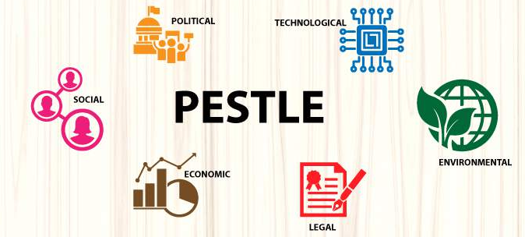
Figure: PESTLE Analysis

Technological Changes: Technology in one of the factor from the PESTLE analysis that has never been suffered like the other factors. Technology ensured that people are able to work from their homes and do their daily tasks. Technology ensured that businesses are able to sell their products online. Yu & Ramanathan, (2020) said, because of technology the business world did not suffered as it could without technological advancement. Today people are able to purchase their desired products and services and take deliveries at their home without making and direct contact with the sellers or delivery man. The emergence and advancement of e-commerce is possible because of technology.

Legal Factors: the business world in recent years did not have any strong influential factors from the legal perspectives. Only USA and China has their own legal regulations for businesses that do business with either of these two countries. For example, Wong & Mohamad (2020) said, USA has developed strong regulations for China operated businesses and also forced other countries to restrict their business relationships with China, but as a major source of raw materials and mass production ability, cutting business with China is not an easy task for other businesses.

Environmental Impacts: In recent years the environmental issues has become a great concern for businesses. Customer’s consciousness has increased about the products and services they use and consume. Customers want products that are not manufactured by harming the environment. They want sustainable and green products. The covid-19 pandemic raised the issue and customers today has become more concern about their health and safety. Turner, (2020) said this is one of the main reason that the necessity of developing sustainable products will only increase in the upcoming years. Businesses that produce products and services by negatively affecting the environment are somewhere in danger. One of the most influential example of sustainable business is the recent Tesla Giga Nevada by Tesla that is a lithium-ion battery manufacturing plant for their Tesla cars. This plant is the largest factory in the world and it only use sustainable energy for its day to day activities.

Managing change with Leadership
The year 2020 has become a year of disruption. Almost every functional area of business is affected by the covid-19 pandemic. Virtualization has taken place and become the new normal. Online work, online learning, e-commerce etc. are somewhere making their position stronger in the business world. The acceleration of the new changing environment requires organisations to do years of work in months, months of work in weeks. Satell (2020) suggested through his research that in order to understand and deal with these changes organisations need to develop leadership abilities. Today leaders not only need to be dynamic but also should have the ability of multitasking in order to overlap the changes simultaneously. Organisations can deal with crises when the leader has a strong mind setup and understanding of the current changing business environment. Wren (2020) found that a leader like Jeff Bezos, Elon Musk have the abilities to know the market and predict the future. He also added that it is not expected for every leader to be Jeff Bezos or Elon Musk, but if the leaders of organisations can understand artificial intelligence, information technology, automation etc. in order to be more relevant to the current business environment changes then it will not only benefit them in decision making but also find out ways of business growth. Matthew & James (2020) identified three particulate dimensions of business environmental changes that brought by the covid-19 pandemic to the business world, they are -
- Perpetual - it is happening all the time and become a continuous process
- Pervasive - unfolding different areas of life at the same time
- Exponential - the accelerating process is very rapid
The characteristics and quality of leaders that are needed for change management in recent years has been identified by different researchers. Tsoukas and Robert (2020) on one hand, expect that in case of crisis like covid-19 pandemic an efficient leader posture himself as a faster decision maker, predict the uncertainty of the future and have the ability to control this uncertainty. On the other hand researchers like Satell (2020) said that, a leader should be a model of authenticity also should have the moral values to make ethical decisions that can support change management. Leader today should not be a model of an individual hero, but a democratic person who moves forward by taking everyone along with him.
According to the research of Connors & Smith (2011), leaders who portray themselves as a person who knows everything do not do well in the practical life today. Because of the vastness of business operations it is not possible for a person to know everything and therefore sapient leaders or democratic leaders are the perfect match to deal with the business environmental changes in recent years. Moving forward collectively and collaboratively is the motto of these leaders so that they can make safe and less risky moves to deal with the changes.
Leaders should not engender the trust of the employees as Kempton (2021) said, when a leader develops relationship with the employees and shares information with one another, it is easier for this type of organisation to deal with change management as employees are a major factors that resist change.
According to the research of Aswathappa, & Reddy (2009) leaders need to be habitual, they need to be authentic and desperate. Leaders who do not take information and processed data from the employees, lack the ability to make effective decisions on their own. As one of the sapient leaders of Walmart said that, 'he is not at Walmart to run Walmart, he is there to lead Walmart'. Owning the employees does not make a person a leader, it is the ability to provide the guidelines to the employees that makes a person a leader. In case of implementing changes leaders need to involve a group of employees so that their employees are confused about the implementation of change.
On the other hand Lamberton and Dave (2020) said that a good leader always tries to empower the employees not only in specific situations but throughout the journey. By empowering the employees leaders are able to develop trust among the employees that is a crucial factor for the change implementation. When employees get to know that the organisation is trying to implement any change it is a common human tendency to threaten perceptions and develop anxiety. Some employees can also think that their job is in danger because of the change that the organisation is willing to implement. This is particularly true for employees who are not technologically skilled and the organisation is going to implement any change that is related with technology. It is the duty of the leaders to provide necessary information to the employees in order to make them psychologically safe. Developing a good conversation among a group of employees can be an effective way for the leaders to share information with one another and make the employees comfortable. Connors & Smith (2011) said, in business organisation change is not an act of solo activities, rather it involves group of activities where employees play one of the most important roles. Because of the covid-19 pandemic there are some drastic changes that organisations implemented without the consent of the employees, in this type of situation transformational leaders can develop an engagement with the employees in order to make them informed about the changes by explaining every why and how. A good leader should motivate relationships, establish the foundation of trust and applause the performance of employees.

Transformational Change:
In order to deal with the current environmental changes of recent years, Wiggins (2009) said that transformational change in businesses can allow to be more competitive by engaging with the current opportunities and trends. Transformational change is the process of alterations where business need to change the functional areas in order to deal with the environmental factors. Transformational changes develop new ideas and behaviors of the employees. This is particularly important as employees are one of the key stakeholders of business that have the power of resistance. That is why Todnem, (2005) added that the transformational change can have big impact if it is associated with the concerns of the employees. Transformational change is a process of reorientation of the operational aspects of a business and it also works on individual level. Because of the current changing scenario of the business environment transformational changes can help to flexibly deal with the changes. Below is a transformational change model -

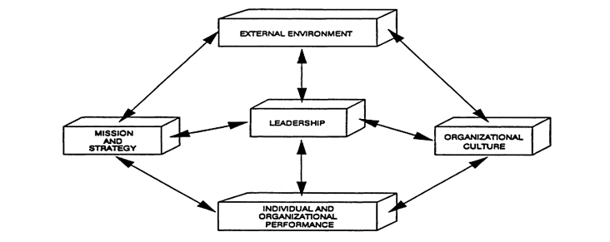
The model establish the fact that in order to achieve transformational changes businesses need to align and interrelate all of the factors. The effect of change starts with external factors that can be managed by proper leadership styles by developing new mission and strategy with the organisational culture. In order to achieve the mission and strategy individual and organisational performance is required to bring in the line of organisational culture. Leaders more specifically the transformational leaders have the quality to respond to all of the external environment factors and make decisions accordingly by developing operative strategies.

Stakeholder Analysis:
In order to deal with changes and implement any change like the transformational change mentioned above, organisations first need to conduct stakeholder analysis. For some organisations this a critical issue while for some other organisations stakeholder analysis can be very prolific before implanting changes. In business organisations there are internal and external stakeholders involved in change management. Internal stakeholders are the employees working with the business and the external stakeholders include customers, competitors and investors etc. Ganta and Manukonda, (2014) said that while ensuring change management, businesses need to consider all of the or at least maximum number of stakeholders so that there are less resistance and it is easier for them to manage these resistance.
However, with a proper stakeholder analysis, businesses can ensure that all of the stakeholders are considered and their risk assessment is properly worked out for further actions. Armstrong (2009) found that in some particular cases, whether a group of stakeholder possess a minimum number of risk and resistant, involving this groups can influence other stakeholder groups to see the benefit of change and accept them.

All of the internal stakeholder group have their own unique set of skills that are required to implement change in the business organisation and if organisation do not involve every group of stakeholders in their stakeholder analysis, than it can be a disaster. With a particular stakeholder analysis, business is able to find out how these individual groups of stakeholders will react to the change and then develop actions plans to mitigate any resistance or risks.
Stakeholders like the financial executives and managers who have direct control over other areas of the business so ensuring the benefit of the changes to these group of stakeholders is predominantly important said by Jones & Aguirre (2004).
One of the main reason of conducting stakeholder analysis before implementing any change is to find out what are the risks associated with the stakeholders about the change. This is especially important for internal stakeholders as they are the key to make the business function properly. For example, Burnes, (2004) mentioned in his book that while implementing ERP software, employees as well as the executives oppose to the decision as it requires special training to use the software. He also added that those employees who are able to us the software faster than their colleagues develop a good reputation among others and therefore these experts get the opportunity to get priorities from the business while others stay in the same position unless they also learn to use the software.
On the other hand Ventris, (2004) made his research on change management and found out that identifying risky stakeholders with a stakeholder analysis helps businesses to develop strategies with the aim of engaging every stakeholder group a part of the change. Developing a category of stakeholder groups can also help businesses to focus on these particular groups of stakeholders rather than wasting money and time to reduce resistance from all of the stakeholders. Besides the stakeholder groups that possess minimum risks for the change can be the advocate of the business by convincing the other stakeholder groups.

Managing Employee Resistance through Change Management:
In every organisation, employees possess the power to resist any change that the organisation is willing to implement. Employees are more concern about their current position within the organisation and sometimes fails to see the bigger picture. Although there can be no technical or structural barrier in fro of the business while implementing change, employees have the ability to flounder such initiatives. In their research, Fernandez and Rainey (2006) said that change management needs to develop strategies that can minimise risks associated with the employees. This can be done by not taking any hard decisions rather involving these employees in the change. Employee resistance is a common factor while implementing changes. That is why, Ganta and Manukonda, (2014) mentioned that businesses need to start with individuals rather than going for a larger group to educate them about the constructive sides of the change that the business wants to implement. It is also possible that the employees do not have the potential training or behavioral traits that can match the desired changes. This can result to less employee engagement and make employees reluctant to participant in organisational tasks. Burnes, (2004) suggested the leaders and managers to come forward before this type of situation transpires. Before implementing any change, it is the duty of the managers to ensure that workforce readiness and employees are not doubtful about the change. Petouhoff (2016) arbitrated that one of the effective strategy for the managers is to develop relationship with the senior team members of particular groups as they have strong positions in their respective groups and they can easily encourage other employees of that group about the change. However, Mosenkis, (2002) said, the most effective way to implement change is involving all groups of employees in the change process. This can be done by giving information to employees about the change if there are any group of employees who are not directly related with the change process. Coaching and mentoring is a good method to develop guidelines for the employees during and after the implementation of change.

Kotter’s 8 Step Model of Change:
The Kotter’s 8 step change model provides a critical and strategic approach to administer change in business. As the name suggests there are 8 steps in the model.
1. Develop a Sense of Urgency: In the very first step the business need to develop the urgency of change. Business can simply identify and highlight the potential threats as well as the opportunities for the business so that the stakeholders can understand the importance and necessity of change.

2. Build a Guiding Coalition: In the second step the leaders need to identify the effective changes that can help the business to deal with the threats and opportunities mentions in the step one. In this stage leaders and executives are responsible to develop a strong and capable change coalition that can work as a team to manage change (Gill, 2003).

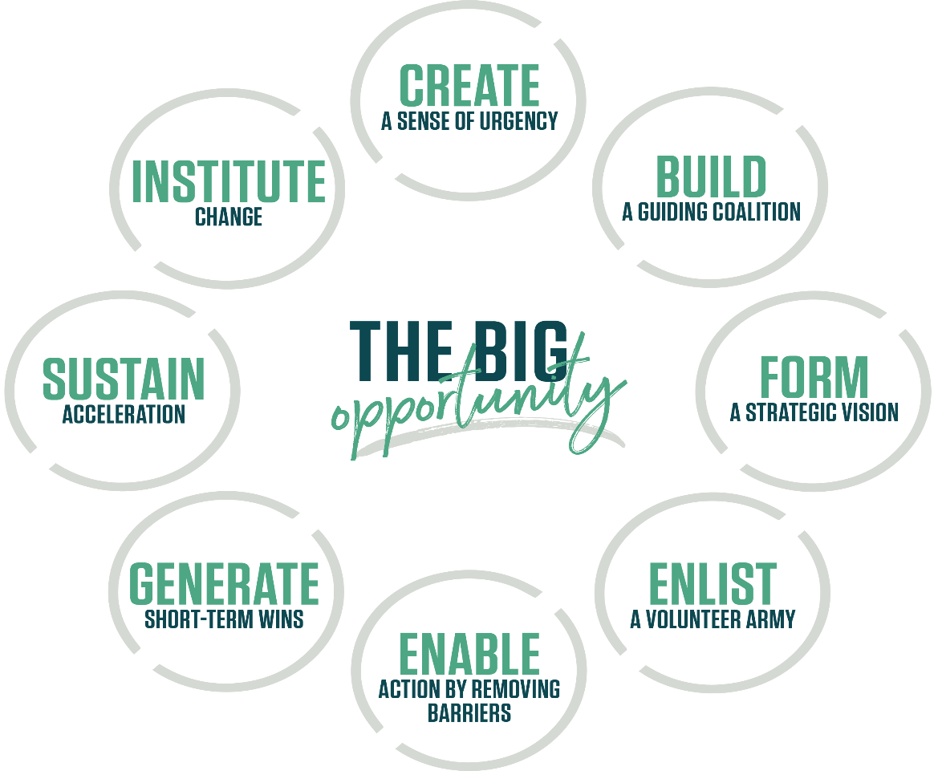
3. Form a Strategic Vision: Linking different concepts and ideas together in order to make the change management more effective. In this stage leaders need to identify the values that can come by implementing the changes. Developing a clear vision with relevant information can help the leaders to make other stakeholders understand the vision and its necessity for the business.

4. Enlist a Volunteer Army with Communication: In every business there are people involved who are not under the communication radar every moment. Involving people on a larger scale can develop the reliability of the required change. Therefore, business leaders need to involve themselves with every stakeholders of the business with strong communication network and address the proposed vision to them. One of the most suitable way to develop positive communication throughout the organisation is to identify and point out concerns and anxieties related with the vision from different stakeholder’s point of view.

5. Removing Barriers: Leaders in businesses who want to implement change according to the vision need to appoint new managers or identify the existing managers who are capable to deliver the change by eliminating the barriers (Moran and Brightman, 2001). These managers ensure that the organisational structure and process are according with the desired change. In order to eliminate barriers these managers make proactive decisions.

6. Generate Short Term Wins: For the purpose of motivating the employees about the change, leaders and appointed managers can assign short term goals that are also easy to achieve. Success is one of the best motivational factor. Developing these short-term targets can gradually lead the business towards its objective of implementing change.

7. Build on the Change: This is the analysis step where the business leaders and managers are required to check what is going right and what is going wrong so far. This is the area where the business leaders are allowed to set more ambitious goals that can give better momentum after achieving them.

8. Anchor the Changes in Corporate Culture: In the last step the business can simply provide about the information of success and other positive aspects that the business get from the change. However it is important for the leaders to ensure that the change becomes a fundamental part of the business and its culture (Kelman, 2005).

Conclusion
Change is an alteration of the existing strategy that the business is using. Because of the covid-19 pandemic where almost all the businesses got affected, the business environment has been drastically changed during the period. Not only by the environment but also other micro and macro environmental factors are influencing the change. Competition has gone tougher instead of the fact that there are many businesses that are completely shut down because of the covid-19 pandemic. Customers become aware of the products and services they consume and they now focus on sustainability. The Global Marketplace has developed a solid need for change in recent years because of globalisation and technological advancement and the covid-19 pandemic only fueled this rapid change. In order to deal with change organisations need to implement change management strategy by incorporating appropriate leadership style and employee involvement. Change cannot be sudden and therefore they need to follow specific steps like the Kotter's 8 step change model or Lewin's change management model. These models are helpful to figure out strategies and steps that are necessary for the business to implement the desired changes.

References
Anderson, D., & Anderson, L.A. (2010). Beyond Change Management: How to Achieve Breakthrough Results through Conscious Change Leadership (Vol. 36). Hoboken, New Jersey: John Wiley & Sons.
Armstrong, M.A. (2009). A Handbook of Human Resources Management. 11th ed. London: Kogan Page.
Aswathappa, K., & Reddy, G.S. (2009). Organisational Behaviour (Vol. 20). Mumbai: Himalaya Publishing House.
Burnes, B. (2004). Managing Change: A Strategic Approach to Organisational Dynamics. 4th edition. Harlow: Prentice Hall.
Christodoulou, A., Cullinane, K. (2019). Identifying the Main Opportunities and Challenges from the Implementation of a Port Energy Management System: A SWOT/PESTLE Analysis. Sustainability 11(21): 1-15.
Connors, R., & Smith, T. (2011). Change the Culture, Change the Game: The Breakthrough Strategy for Energizing Your Organization and Creating Accountability for Results. New York: Penguin.
Creasey, T., (2020). 4 Change Management Trends in 2020. [online] Blog.prosci.com. Available at: <https://blog.prosci.com/4-change-management-trends-for-2020> [Accessed 23 September 2021].
Fernandez, R. and Rainey, H.G. (2006). Managing Successful Organizational Change in the Public Sector. Public Administration Review, March/April, pp 168 – 176.
Ganta, V. C. and Manukonda, J. K. (2014). Leadership during Change and Uncertainty in Organizations. International Journal of Organizational Behavior & Management Perspectives, 3(3), 1183.
Gill, R. (2003). Change management- or change leadership? Journal of Change Management 3, no.4: 307–318.
Hussey, D.E. (2020). How to Manage Organisational Change (Vol. 28). Kogan Page Publishers: London.
Jones, J. & Aguirre, D. (2004). 10 Principles of Change Management: Tools and techniques to help companies transform quickly. Prentice Hall.
Kelman, S. (2005). Unleashing change: A study of organizational renewal in government. Washington, D.C.: Brookings Institution Press.
Kempton, L., (2021). How to Start Managing Change When the Change is Unclear. [online] Blog.prosci.com. Available at: <https://blog.prosci.com/how-to-start-managing-change-when-the-change-is-unclear> [Accessed 23 September 2021].
Lamberton, C., Damiano, B., and Dave, H. (2020). Impact of Robotics, RPA and AI on the Insurance Industry: Challenges and Opportunities. Journal of Financial Perspectives 4 (1): 8–20.
Loizia, P.; Voukkali, I.; Chatziparaskeva, G.; Navarro-Pedreño, J.; Zorpas, A.A. (2021). Measuring the level of environmental performance on coastal environment before and during the COVID-19 pandemic: A case study from Cyprus. Sustainability, 13, 2485.
Matthew, D. H., Michael, Y. & James, K. (2020). Attitudes toward Change and Transformational Leadership: A Longitudinal Study, Journal of Change Management, 20:3, 202-219.
Moran, J. W. and Brightman, B. K. (2001). Leading organizational change. Career Development International 6. no.2: 111–118.
Mosenkis, S. (2002). Coping with Change in the Workplace. Information Outlook, 6(10): 6-10.
Paton, R. A. and McCalman, J. (2000). Change Management: A guide to effective implementation. 2nd Edition. New Delhi: Response Books.
Petouhoff, N. (2016). The Business Impact of Change Management. Graziado Business Review, 9(3): 1-8.
Rastogi, N., Trivedi, M.K. (2016). Pestle Technique – A Tool to Identify External Risks in Construction Projects. International Research Journal of Engineering and Technology 3(1): 384-388.
Sardak S.E., Movchanenko I.V. (2018). Business Environment of Enterprise, 1st International Scientific and Practical Conference, Batumi, Georgia, Volume II, 13-14.
Satell, G., (2020). You Don’t Need a Grand Strategy to Achieve Organizational Change. [online] Harvard Business Review. Available at: <https://hbr.org/2020/03/you-dont-need-a-grand-strategy-to-achieve-organizational-change> [Accessed 23 September 2021].
Shtal, T.V., Buriak, M.M., Amirbekuly, Y., Ukubassova, G.S., Kaskin, T.T., Toiboldinova, Z.G. (2020). Methods of analysis of the external environment of business activities. Revista Espacios 39(12): 1-22.
Todnem, R. (2005). Organisational Change Management: A Critical Review. Journal of Change Management, 5(4): 369 – 380.
Tradingeconomics.com. (2021). United Kingdom GDP per capita PPP | 1990-2020 Data | 2021-2023 Forecast | Historical. [online] Available at: <https://tradingeconomics.com/united-kingdom/gdp-per-capita-ppp#:~:text=GDP%20per%20capita%20PPP%20in,of%2030035.89%20USD%20in%201991.&text=United%20Kingdom%20GDP%20per%20capita%20PPP%20%2D%20values%2C%20historical%20data%20and,updated%20on%20September%20of%202021.> [Accessed 23 September 2021].
Tsoukas, H. and Robert, C. (2020). On Organizational Becoming: Rethinking Organizational Change. Organizational Science 13 (5): 567–582.
Turner, S. (2020). Tools for success: a manager’s guide. London: McGraw Hill.
Vasconcelos, F. C., & Ramirez, R. (2021). Complexity in business environments. Journal of Business Research, 64(3), 236–241.
Vasileva, E. (2018). Application of the Pest Analysis for Strategic Planning of Regional Development. 49th International Scientific Conference Quantitative and Qualitative Analysis in Economics, Economic Faculty in Nis, 223-229.
Ventris, G. (2004). Successful change management: the fifty key facts. London: Continuum.
Wiggins, L. (2009). Managing the ups and downs of change communication. Strategic Communication Management, 13(1): 20-23.
Wong, W. P., Ahmad, N. H., Nasurdin, A. M., & Mohamad, M. N. (2020). The impact of external environmental on business process management and organizational performance. Service Business an International Journal, 8(4), 559–586.
Wren, H., (2020). Metrics for Measuring Change Management 2021. [online] Zendesk. Available at: <https://www.zendesk.com/blog/measuring-change-management-success/> [Accessed 23 September 2021].
Yu, W., & Ramanathan, R. (2020). Effects of business environment on international retail operations: case study evidence from China. International Journal of Retail & Distribution Management, 40(3), 218–234.

