UNIVERSITY OF WALES TRINITY SAINT DAVID

The Healthcare Leadership Model (HLM).
Is it fit for the purpose?
Constantin Polgar (2116259) | 7/5/24 | BA Developing Leadership and Management

DECLARATION

This work has not previously been accepted in substance for any degree and is not being concurrently submitted as a candidature for any degree.

Signed: Constantin Polgar.

Date: 04th July 2024.

- STATEMENT 1

- This dissertation is being submitted in partial fulfilment of the requirements for the degree of BA.

- Signed: Constantin Polgar,

- Date: 04th July 2024.

- STATEMENT 2

- This dissertation is the result of my own independent work/investigation, except where otherwise stated.

- Other sources are acknowledged by footnotes giving explicit references. A bibliography is appended.

- Signed: Constantin Polgar.

- Date: 04th July 2024.

STATEMENT 3

I hereby give consent for my dissertation, if accepted, to be available for photocopying and for interlibrary loan, and for the title and summary to be made available to outside organisations.

Signed: Constantin Polgar.

Date: 04th July 2024.

STATEMENT 4

I hereby give consent for my dissertation, if accepted, to be available on the university's IT system to those who have consented to use the system.

Signed: Constantin Polgar.
Date… 04th July 2024.

Acknowledgements
This dissertation proves that all barriers can be overcome and that the only way to succeed is by accepting all the challenges that come with our lives.
My family has always been proud of me, and they always encouraged me, and I am grateful for their support.
I want to thank my supervisor, Gareth Hughes, for his valuable guidance, continuous support and professionalism. This dissertation has been completed successfully due to Mr Hughe's implication. Thank you for your time and effort!
I would also like to thank Maria Heffernan for her professionalism and valuable support, as well as all the lecturers who guided me through this fantastic journey.
I want to thank my friend Landiana for her support and continuous motivating messages that made me push harder.
Finally, I thank all my colleagues for being the most fantastic colleagues ever!

Table of Contents
Chapter One 1
1.0 Introduction 1
2.0 Aims and Objectives 2
Chapter Two 4
3.0 Literature Review 4
3.1 Introduction 4
3.2 The NHS Healthcare Leadership Model (HLM) 6
3.3 Documented Challenges in Implementing the HLM 8
3.4 Critique of the NHS Healthcare Leadership Model 9
3.5 The Impact of Leadership on Staff 10
3.6 Conclusion 11
Chapter Three 12
4.0 Research Methodology 12
Chapter Four 23
5.0 Analysis of Results 23
6.0 Discussion 35
Chapter Five 37
7.0 Conclusions and Recommendations 37
Recommendations: 38
8.0 Bibliography 40
Appendices 51

Abstract
A mixed-methods approach is used in this study to evaluate the NHS's Healthcare Leadership Model (HLM). The research extensively evaluates leadership efficacy and its effects on employee well-being and service excellence by integrating qualitative interviews and quantitative surveys. The results highlight the benefits of encouraging work cultures and practical dispute-resolution techniques and the drawbacks of poor communication and unequal leadership support. It is suggested that communication tactics be improved, inclusivity initiatives be strengthened, specialised leadership development be invested in, employee well-being be promoted, and measures for ongoing progress be established.
Effective leadership is essential in healthcare settings since it impacts organisational culture, employee morale, and patient care standards within the National Health Service (NHS). To assess leadership effectiveness fully, this study uses a mixed-methods approach, combining quantitative survey data from several hospital departments with qualitative insights from interviews. It seeks to offer a comprehensive picture of how leadership affects worker welfare and service excellence in hospitals by drawing on secondary research.
The study examines complex views of leadership effectiveness that are not adequately reflected by quantitative surveys alone using qualitative interviews. Quantitative surveys provide statistically rigorous validation of qualitative findings while simultaneously providing broad insights into organisational trends. With digital interviews and electronic questionnaires improving data collection efficiency and adhering to ethical norms, purposeful sampling guaranteed representation across NHS roles.
In addition to statistical analysis of survey data to measure opinions of organisational climate and leadership efficacy, descriptive analysis of interview data revealed recurrent themes in organisational dynamics and leadership practices. This study thoroughly evaluates NHS leadership by combining qualitative insights with quantitative data. The evaluation is based on primary results and previous research on organisational behaviour and healthcare leadership.

Chapter One

Introduction

The National Health Service (NHS) is one of the world's most extensive publicly funded health services, tasked with providing comprehensive healthcare to the UK population (NHS Confederation, 2023). Effective leadership within the NHS is critical to managing its vast and complex operations and ensuring high standards of patient care. The NHS has developed the Healthcare Leadership Model (HLM) to guide and enhance organisational leadership practices. The literature review will evaluate the HLM's suitability for its intended use and critically analyse and contrast various NHS leadership styles.
Leadership in healthcare plays a pivotal role in shaping organisational performance, staff satisfaction, and patient outcomes (West et al., 2017). Understanding various leadership styles, such as transformational and transactional, is crucial as they have been extensively studied to gauge their effectiveness in different contexts (Jangsiriwattana, 2020).
The NHS Healthcare Leadership Model fosters compassion, inclusion, and collaboration, creating a supportive and efficient work environment (NHS Leadership Academy, 2024). However, the practical implementation of the HLM and its impact on day-to-day leadership practices have been the subject of ongoing debate, indicating the relevance and timeliness of this research (Ham, 2023). This literature review will delve into these issues, drawing on empirical studies and theoretical frameworks to evaluate the effectiveness of the HLM and compare it with leadership practices in the private healthcare sector.
The review will comprehensively address specific objectives, including identifying leadership styles that lead to successful people management and analysing transformational and transactional leadership styles. By critically engaging with the literature, this review will build a comprehensive understanding of leadership in the NHS and provide a solid foundation for further research.

2.0 Aims and Objectives
The Health Care Leadership Model (HLM)- Evaluation.
This study intends to evaluate the NHS's healthcare leadership, highlighting both advantages and disadvantages and analysing its effects on employee well-being and service quality.

Objectives:
1. The first objective is to perform a thorough literature study to understand the current leadership in the NHS better. Determining the main obstacles, effective tactics, and opportunities for development in NHS leadership practices will include reviewing the literature, regulations, and existing case studies.
2. Conducting Primary Research with NHS Staff:
The research for this project will be conducted among NHS employees to provide up-to-date, objective input on leadership effectiveness through online surveys distributed to staff members from hospitals or care homes in South Wales via social media and email. Interviews will also be conducted within different departments.

3. Analysing Research Findings to Determine Impact on Staff Well-being:
This section uses qualitative and quantitative approaches to evaluate how the current leadership affects workers' well-being. Data will be gathered through questionnaires and interviews, which will then be analysed to find patterns and reoccurring themes in leadership behaviours and their implications on work satisfaction and employee morale. This all-encompassing strategy guarantees a complete comprehension of the connection between leadership ideologies and worker welfare in the NHS.

4. Identifying Successful Leadership Styles in NHS:
This objective aims to identify the leadership styles that work best for overseeing healthcare staff.
A mixed-methods approach combining qualitative and quantitative data collecting and analysis will be used to determine the most effective leadership styles within the NHS. Comprehensive insights into the effects of different leadership styles on job satisfaction and well-being will be obtained through semi-structured interviews with a heterogeneous group of NHS employees. Simultaneously, standardised surveys will collect quantitative data from a broader sample to analyse the effects and prevalence of specific leadership styles. Key leadership behaviours that support positive outcomes will be identified by integrating statistical analysis of questionnaire responses and thematic analysis of interview data. Using a comprehensive strategy, the NHS can improve employee well-being and service quality by developing actionable insights into effective leadership.

5. Critically Analysing the effectiveness of HLM
To critically evaluate the Healthcare Leadership Model's (HLM) efficacy by looking at how it affects staff engagement and organisational performance. The data collected through primary research will be analysed, and the results will be based on real-world deployments in healthcare settings and empirical findings.

Chapter Two

3.0 Literature Review

3.1 Introduction
One of the world's most extensive publicly funded health services, the National Health Service (NHS), is responsible for providing all UK citizens with comprehensive healthcare (Thorlby, 2020). The NHS needs strong leadership to manage its extensive and complicated operations and guarantee high levels of patient care. The NHS created the Healthcare Leadership Model (HLM) to direct and improve organisational leadership practices (NHS Leadership Academy, 2024).

Figure 3.1- Healthcare Leadership Model.

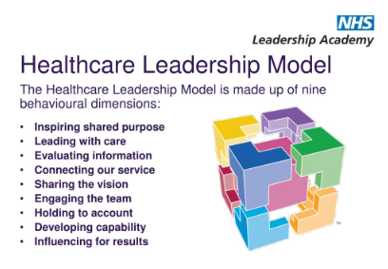

The HLM is a structured framework with nine elements that people may use to improve their leadership skills and ensure their behaviour is consistent with NHS principles. Every dimension delineates distinct behaviours and attributes imperative for proficient leadership in healthcare environments.
The HLM's Key Performance Indicators (KPIs) are intended to assess how well a leader performs in each area.

These KPIs include measurements of patient satisfaction, staff well-being, service excellence, and operational effectiveness. In addition to their ability to motivate employees and accomplish strategic objectives, leaders are evaluated on their capacity to motivate, inspire, and develop their teams.
To sum up, the HLM offers an extensive framework for enhancing leadership skills inside the NHS.

Through concentration on these nine aspects, leaders can cultivate a climate of empathy, diversity, and superior medical care. The model guarantees that leadership practices stay in line with the changing demands of the healthcare system by promoting ongoing reflection and improvement (NHS Leadership Academy, 2024).

According to Sfantou et al. (2017), leadership in the healthcare industry is crucial in determining worker happiness, organisational performance, and patient outcomes. Comprehending diverse leadership styles, including transformational and transactional approaches, is vital since they have been thoroughly examined to determine their efficacy in disparate settings (Young et al., 2021). Positive outcomes in healthcare settings are frequently linked to transformational leadership, which involves inspiring and motivating people (Saravo et al., 2017). Conversely, transactional leadership emphasises regular oversight and sanctions and rewards based on performance (Tavanti, 2008).

The NHS Healthcare Leadership Model (HLM) is designed to foster compassion, inclusion, and collaboration to create a supportive and efficient work environment (NHS Leadership Academy, 2024). However, the practical implementation of the HLM and its impact on day-to-day leadership practices have been the subject of ongoing debate, indicating the relevance and timeliness of this research (Storey & Holti, 2013). This literature review will delve into these issues, drawing on empirical studies and theoretical frameworks to evaluate the effectiveness of the HLM.

3.2 The NHS Healthcare Leadership Model (HLM)
The (HLM) is a comprehensive framework created to improve the NHS's capacity for leadership. It is centred on nine leadership conduct components, all meant to promote an inclusive, compassionate, and high-standard care culture (NHS Leadership Academy, 2024).

Inspiring Shared Purpose: This aspect highlights the need to have leaders who can express a distinct and captivating vision. By exhibiting a sincere dedication to the NHS's principles and objectives, these leaders motivate others and ensure that each team member recognises the importance of their contributions. Leaders can improve motivation and engagement by directing their team's efforts towards shared goals by cultivating a feeling of shared purpose (NHS Leadership Academy, 2024).

Leading with Care: Skilled leaders genuinely care about the welfare of the people in their team. This component builds a supportive, nurturing work atmosphere and demonstrates empathy. Prioritising care helps leaders avoid stress and burnout, which boosts job satisfaction and enhances performance. Building a healthy and productive team culture is possible for leaders who are thoroughly aware of each team member's unique needs (NHS Leadership Academy, 2024).

Evaluating Information: To make wise decisions, leaders must be adept at obtaining, examining, and evaluating data. This aspect emphasises how critical thinking and evidence-based decision-making are vital in healthcare environments. Influential leaders can find various sources of knowledge, develop fresh concepts, and design well-thought-out improvement strategies (NHS Leadership Academy, 2024).

Connecting Our Service: This component emphasises how important it is for CEOs to establish solid alliances and networks inside and outside their companies. Good leaders try to promote cooperation and communication because they recognise the connections between social and healthcare services.
Leaders can significantly enhance patient care by dismantling organisational silos and improving service integration (NHS Leadership Academy, 2024).

Sharing the Vision: This dimension is around communication. To guarantee that every team member is on the same page and driven, leaders need to communicate their vision and objectives clearly and compellingly. This calls for speaking, listening, and interacting with others to create a shared understanding and dedication to the organisation's goals (NHS Leadership Academy, 2024).

Engaging the Team: Team leaders should actively seek advice from their members and include them in decision-making processes.

This dimension strongly emphasises building an inclusive workplace where each team member feels appreciated and enabled to contribute. Teams that are actively involved are more likely to be creative, devoted, and successful in their jobs (NHS Leadership Academy, 2024).

Holding to Account: An essential aspect of leadership is accountability. This dimension focuses on a leader's capacity to monitor performance, set clear expectations, and offer helpful criticism. Maintaining standards and achieving goals are made possible by holding people and groups accountable, which is crucial for providing high-quality care (NHS Leadership Academy, 2024).

Developing Capability: Long-term success depends on investing in team members' development. This dimension emphasises leaders' role in seeing potential, creating growth opportunities, and encouraging ongoing learning and development. Leaders guarantee that their organisation is capable of meeting future challenges and delivering high-quality care by investing in the capabilities of their workforce (NHS Leadership Academy, 2024).

Influencing for Results: Leaders need to be skilled at persuading others to accomplish their goals. This dimension entails fostering connections, winning over stakeholders, and managing organisational difficulties to promote positive change.
Strong leaders mobilise resources and support through their influence, which makes it easier for projects and advancements to be carried out successfully (NHS Leadership Academy, 2024).

The HLM is a tool for organisational development and a manual for developing one's leadership skills. It motivates leaders at all levels to consider their actions, look for criticism, and refine their methods. NHS executives may establish a healthcare system that is more inclusive, effective, and compassionate by following the guidelines provided in the HLM (NHS Leadership Academy, 2024).

3.3 Documented Challenges in Implementing the HLM
Hierarchical and Siloed Practices
Despite its strengths, the HLM faces challenges in implementation. Many NHS organisations still experience hierarchical and siloed working practices, hindering the development of a truly collaborative and inclusive culture (King's Fund, 2024). According to Mannion and Davies (2018), there is a gap between the ideals of the HLM and the realities of daily leadership practice in the NHS. The demands and limitations that leaders frequently experience make it difficult to accept and implement the HLM's tenets completely.
Bullying and Racism in the NHS
Racism and bullying are severe problems in the NHS that have an impact on employee morale and corporate culture. According to a 2020 NHS Workforce Race Equality Standard (WRES) survey, a sizable percentage of NHS employees reported being bullied, harassed, or abused by coworkers. In comparison to their white counterparts, Black, Asian, and Minority Ethnic (BAME) personnel they have reported greater incidences of bullying and discrimination (NHS England, 2020). These unfavourable encounters cast doubt on the HLM's core values, which prioritise kindness, inclusivity, and assistance.
Impact on Staff Well-being
The prevalence of bullying and racism has severe implications for staff well-being. Studies have shown that bullying can lead to increased stress, burnout, and mental health issues among healthcare workers (Kline, 2020).
Similarly, racism has been connected to lower job satisfaction and more excellent rates of employee turnover among BAME personnel. (Archibong et al., 2019).
Resistance to Change
Another major obstacle to successfully applying the HLM is resistance to change. Large, well-established healthcare organisations like the NHS can have ingrained cultures and traditions. There may be opposition to new leadership models on many levels since they call for altering organisational culture and individual behaviour. (Smith,2024).

Resource Constraints
As recent research has shown, enduring issues make it difficult for the NHS to implement the Healthcare Leadership Model (HLM). Two significant obstacles are the lack of resources and the continuous labour scarcity. Furthermore, according to Morgan (2022), there are substantial obstacles to good leadership and employee well-being because of workforce shortages, which have been made worse by the COVID-19 pandemic. Additionally, research emphasises that the stress and burnout among healthcare workers intensified during the pandemic have made it difficult for leaders to prioritise and allocate resources for training and development (Couper et al., 2022). This combination of financial, staffing, and health pressures underscores the complex environment in which NHS leaders operate, making it challenging to implement the HLM fully.

3.4 Critique of the NHS Healthcare Leadership Model
Measuring the impact of the HLM on leadership effectiveness and organisational outcomes is challenging. While the model provides a comprehensive framework for leadership development, assessing its impact requires robust evaluation mechanisms and continuous feedback from staff and stakeholders. Determining whether the HLM accomplishes its intended goals can be challenging without well-defined measures and standards (Jones et al., 2022).
The effectiveness of leadership development programs has also been a recent research focus. Streeton et al.(2021) evaluated the impact of leadership development initiatives in the NHS. They found that comprehensive programs that include training on emotional intelligence, adaptive leadership, and strategic thinking are more effective in producing competent leaders. They stressed the need for continuous professional development and support to ensure the sustainability of leadership improvements.

3.5 The Impact of Leadership on Staff
Research highlights how important supporting leadership was during the COVID-19 pandemic. Leaders who showed empathy and made mental health services available were crucial in reducing stress and anxiety in NHS employees. (Cole et al., 2020). Kumar (2020) emphasises that morale-boosting measures throughout the crisis relied heavily on clear leadership and efficient communication.
The work experience of minority employees has been demonstrated to be enhanced by inclusive leadership strategies. Leadership that addresses systemic prejudices and advances equality creates a more positive and encouraging work environment, according to the NHS Staff Survey (2020).
Job happiness and employee morale have been linked to transformational leadership. Burnout can be considerably decreased, and workplace engagement can be significantly increased by leaders who excite and motivate their people while offering personalised support (Jamal et al., 2023).

Incoherent Methods of Leadership. There is a great deal of variation in leadership practises throughout NHS trusts, even with the benefits that have been emphasised. According to the NHS Staff Survey, some leaders do a better job of supporting their staff members and creating a happy work environment than others, which causes differences in the experiences and well-being of their employees (NHS Confederation, 2020).

Impact on staff's health.
A recent reference on the impact of ineffective leadership on staff turnover and morale can be found in multiple studies and articles published in 2023. For instance, a survey of toxic leadership behaviour among nurse managers found that such leadership significantly decreases job satisfaction and increases turnover intentions. The study highlights that toxic leadership behaviours, including poor communication and lack of support, correlate directly with higher turnover rates and lower nurse morale​ (Cakiroglu, 2023)​. Furthermore, a thorough analysis of employee morale data shows that inefficient management techniques and inadequate leadership are significant causes of low morale and high turnover. In particular, managers can explain as much as 70% of the variation in employee engagement, and 63% of workers mentioned poor communication as a cause for leaving their positions. This highlights leadership's crucial role in preserving employee happiness and retention. (Pindar, 2023).
High turnover disrupts team cohesion and continuity of care, ultimately affecting patient outcomes. Furthermore, poor leadership can contribute to a toxic work environment, where bullying and harassment are prevalent, further exacerbating staff dissatisfaction and retention issues (West et al., 2015).
Although staff leadership was essential throughout the pandemic, there have been significant long-term effects on mental health. More long-lasting and thorough mental health assistance techniques are required. Research indicates that existing approaches frequently fail to address the underlying causes of stress and burnout because they are reactive rather than proactive (NHS Confederation, 2020).

Increased Burnout and Stress
Leadership that lacks empathy and fails to address the well-being of staff can contribute to high burnout and stress among healthcare workers.
Studies have shown that burnout among healthcare professionals is linked to poor leadership practices, such as lack of support, unrealistic workload expectations, and inadequate resources (Webber, 2024). Burnout not only affects the mental and physical health of staff but also reduces their ability to provide high-quality care, leading to adverse patient experiences and outcomes.

3.6 Conclusion
This study aimed to analyse the effects of the Healthcare Leadership Model (HLM) on service quality, employee well-being, and leadership effectiveness within the National Health Service (NHS). A thorough literature study and primary research with NHS employees have drawn several essential conclusions.
Intending to foster inclusive and prosperous leadership across NHS organisations, the HLM offers a robust framework (NHS Leadership Academy, 2024). The practical execution of this approach is confronted with notable obstacles, including deeply ingrained hierarchical behaviours (Woolnough, 2024), racism and bullying (NHS England, 2020), reluctance to change (Smith, 2024), and limited resources.
The benefits of inclusive and supportive leadership styles for staff well-being and organisational outcomes have been demonstrated by empirical studies, particularly in times of crisis such as the COVID-19 pandemic (Cole et al., 2020). According to Iqbal et al. (2019), transformational leadership, which is typified by inspiration and motivation, has the potential to improve job satisfaction and lower burnout among healthcare workers.
NHS executives need to take proactive measures to resolve these issues. This entails encouraging an environment of transparency and responsibility, placing a high value on diversity and inclusivity, and offering ongoing assistance with leadership development. The NHS can raise employee well-being, increase service quality, and better serve patients by addressing systemic challenges and aligning leadership practices closely with the HLM's values.
In conclusion, continuous efforts are necessary to ensure the successful implementation of the HLM, although it provides a valuable framework for leadership development in the NHS. The NHS can create a resilient and encouraging work environment that benefits its staff and the patients it serves by tackling current issues and utilising the capabilities of inclusive and transformative leadership.

Chapter Three

4.0 Research Methodology

To conduct a thorough assessment of the Healthcare Leadership Model (HLM) inside the NHS, this study uses a mixed-methods approach. Integrating qualitative and quantitative methodologies facilitates a comprehensive comprehension of leadership efficacy and its influence on employee welfare and service excellence.
Qualitative methods.
Staff interviews with the NHS will be semi-structured to collect qualitative data. This methodology is selected due to its capacity to probe deeply into personal experiences and viewpoints, offering valuable insights into the individualised facets of leadership (Sawatsky et al., 2019). Themes like staff morale, leadership philosophies, and the HLM's perceived efficacy will all be covered in the interviews.
Quantitative methods.
A broader sample of NHS employees will get structured questionnaires as part of the quantitative data collection process. This methodological decision seeks to identify overarching trends and patterns throughout various organisational departments and functions (Bryman, 2016). Validated scales to gauge traits, including organisational commitment, perceived leadership effectiveness, and work satisfaction, will be included in the surveys.
The research sample may not represent the entire population, and respondent bias in self-reported data may also provide potential limits. By using strict sample procedures and a triangulation of data sources, attempts will be made to lessen these restrictions.
This study uses a mixed methods approach driven by the six stages of the research onion framework created by Saunders et al. (2009). The research onion will function as a methodological framework for methodically investigating several research method layers, guaranteeing a thorough assessment of the Healthcare Leadership Model (HLM) in the context of the National Health Service (NHS).

Figure 4.1- Research onion (Saunders et al., 2009).
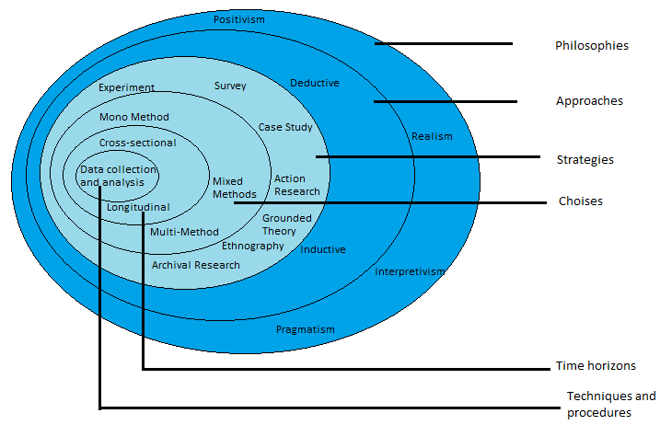

It has six layers: time, data gathering methodologies, research philosophy, research approach, research strategy, and research decision. A brief overview of every layer is given below, with a focus on surveys and interviews:
Research Philosophy: Using an interpretive approach, the study seeks to comprehend the varying subjective experiences and perspectives of NHS workers about job satisfaction, work-life balance, leadership, and working conditions. This method strongly emphasises the contextual nature of the data and the complexity of human behaviour.
Interpretivism is a method of study that emphasises comprehending the intricate realm of lived experience via the perspective of its inhabitants. It aims to learn each person's unique experiences, convictions, and driving forces within the framework of their social environment (Neuman, 2014).
The reason interpretivism was selected is that it enables a thorough investigation of the individual and environmental elements affecting the experiences of NHS personnel.
To fully capture the complexity of leadership and its effects on healthcare workers, this method acknowledges that reality is socially created and strongly emphasises comprehending phenomena from the participants' viewpoints (Bryman, 2016).
The study's use of interpretivism allows it to delve into the interpretations and meanings of NHS employees' experiences, offering valuable insights into how they view management and working circumstances.

The Research Approach: An inductive methodology is applied, beginning with gathering quantitative data via surveys and qualitative data via interviews to produce insights and patterns that help draw more general conclusions regarding the efficacy of NHS leadership.
Inductive reasoning is gathering evidence and formulating hypotheses in response to that evidence's analysis. It begins with measurements and observations, from which patterns and regularities are found, forming more comprehensive generalisations and theories (Thomas, 2006).
The inductive approach was selected because it begins with specific observations and progresses to more generalisations and theories. This approach works well for investigating novel or poorly known phenomena, including the unique accomplishments and challenges of leadership in the NHS. The study can use an inductive approach to create a grounded understanding of NHS leadership based on empirical evidence (Thomas, 2006). This is necessary to provide fresh ideas and theories that consider healthcare practitioners' actual experiences.

Research Strategy: To thoroughly examine NHS leadership, a mixed-methods approach combining qualitative interviews and quantitative questionnaires is used. This strategy enables a thorough analysis of more general patterns and in-depth individual experiences.

Mixed-approaches research incorporates qualitative and quantitative research methods to provide a more thorough grasp of study challenges. Combining the advantages of the two approaches provides a more comprehensive understanding of the study subject (Leavy, 2022).
The mixed-methods strategy was selected because it uses the advantages of both qualitative and quantitative research, which is warranted.
While quantitative data from questionnaires offer breadth and generalizability, qualitative data from interviews provide depth and context. In addition to strengthening the research findings' robustness, this combination offers a more comprehensive grasp of the research problem (Hill et al., 2023). Mixed approaches are beneficial in healthcare research where both individual experiences and statistical trends are significant.

Research Choice: To improve the breadth and depth of the research, this study uses a mixed-methods approach that incorporates both qualitative and quantitative techniques. While standardised questionnaires enable the collection of measurable data, semi-structured interviews offer rich, detailed data.
According to Lee (2019), a mixed-methods approach employs qualitative and quantitative techniques to offer a more comprehensive and nuanced knowledge of the study subject.
The reason for a mixed-method choice is that the researcher can fully answer the study questions by employing this strategy. Quantitative questionnaires enable measuring and examining more general trends and patterns, whereas qualitative interviews record specific individual experiences and contextual elements. Using a dual method, the research findings are guaranteed to be comprehensive and broadly applicable, giving a more complete view of the dynamics of NHS leadership (Tashakkori & Teddlie, 2021).

Time Horizon: To capture data at a single moment in time, a cross-sectional time horizon is chosen. This method allows a quick overview of how NHS staff members now see leadership and related issues.
A cross-sectional temporal horizon captures data at a specific moment, which offers a picture of the phenomenon under study (Bryman, 2016).
A cross-sectional method is used to get a current picture of NHS staff members' experiences and perceptions. This method makes it feasible to gather data from a sizable sample in an effective manner at a given moment in time, which enables the analysis and identification of current trends and problems in NHS leadership (Levin, 2006). Although it doesn't monitor changes over time, it offers insightful information on current circumstances and the direct consequences of leadership approaches.
Data Collection Procedures:
1 Primary Research Methods:
Interviews
Semi-structured interviews are qualitative data collection in which the interviewer adheres to guidelines while remaining flexible to delve deeper into subjects as needed (Busetto et al., 2020).
The reason for semi-structured interviews for this research is their adaptability and capacity to produce in-depth answers. With this approach, participants can openly voice their opinions, and the researcher can go deeper into subjects (Busetto et al., 2020). Understanding the intricate and unique experiences of NHS employees requires conducting interviews, which provide rich qualitative data that can highlight underlying problems and offer new perspectives (Glegg, 2018).

To secure at least 10 participants, invitations will be sent to 15 varied NHS personnel, including leaders, physicians, nurses, and carers. The views of NHS leadership, working conditions, work-life balance, and general job satisfaction will all be investigated in these interviews. Employers from hospitals and care facilities in South Wales will make up the sample, and purposeful sampling will guarantee thorough insights from people with pertinent experiences and viewpoints.
Phone calls, emails, and maybe social media groups will be used for recruitment. Microsoft Teams will be used to conduct the interviews, and GDPR compliance will be followed while audio and video recordings are handled. Leadership concepts, decision-making procedures, inclusiveness, communication, and worker welfare will all be covered in an interview guide.
According to Busetto et al. (2020), semi-structured interviews facilitate flexibility and thorough responses, offering intricate insights into participants' perspectives, experiences, and emotions. Furthermore, interviews allow for greater questioning flexibility, which enables a more detailed examination of responses (Glegg, 2019). Researchers may be able to comprehend the research issue more thoroughly, thanks to this dynamic engagement (Dunwoodie et al., 2023).

Questionnaires:
A series of predetermined questions are included in questionnaires, a quantitative data collection technique, to systematically collect information from respondents (Kircher & Zipp, 2022).
Questionnaires in this research are used to gather data from many respondents efficiently. Questionnaires improve the validity of the findings and make cross-group comparisons easier. Researchers can swiftly and effectively reach many people with this strategy.
A structured questionnaire will be sent out to gather quantitative information. Open and closed-ended questions will be included to collect comprehensive data on decision-making, inclusivity, communication, leadership styles, and well-being. The questionnaire will be delivered by email and online survey platforms to obtain at least 80 completed forms out of 150 that are distributed. Twenty closed questions are included in the design for quantitative analysis, while a few open-ended questions are included for qualitative insights.
The choice to disseminate 150 questionnaires is based on the expectation of a response rate of roughly 80, which is reasonable for professional online surveys and will allow for a statistically significant sample size (Baruch and Holtom, 2008). This sample size guarantees a range of representation from different departments and jobs in the NHS, which improves the findings' generalizability and dependability (Dillman et al., 2014). By aiming for a large audience, the research can gather diverse viewpoints regarding leadership and working circumstances, resulting in a thorough picture of the state of events in the NHS today.

While qualitative comments will be thematically analysed to find recurring themes, quantitative data will be statistically analysed. According to Kircher and Zipp (2022), the utilisation of questionnaires in a systematic manner enhances the dependability of results and facilitates cross-group comparisons. Studies looking to generalise findings over a larger population or those with limited resources can benefit from the efficient data collection from many respondents that questionnaires enable. Researchers can quickly and efficiently reach a wide range of people with this strategy (Michalis et al., 2018).
The research attempts to critically analyse the efficacy of the Healthcare Leadership Model by utilising this structured technique, which includes purposive sampling, and by offering specific personal insights and statistics that can be used generally.

Data Analysis
Qualitative Analysis:
The semi-structured interviews with NHS personnel, comprising leaders, doctors, nurses, and carers, will gather the qualitative data.
Thematic Analysis:
Coding
After transcribing the interviews, open coding will be used to determine important words and themes. Codes allocated to each text segment will represent different subjects or concepts. Terry et al. (2017) state that to guarantee the precise capture of the subtleties of the data, a thorough line-by-line analysis is conducted during the first coding step.
Categorisation
Related codes will be sorted into broader categories or themes. This process will involve axial coding to find relationships between codes and to organise them into higher-order themes. Identifying patterns and similarities in the responses will aid in understanding the complex interactions and experiences described by NHS employees (Birks et al., 2019).
Interpretation
The themes will be investigated to get important insights into how NHS workers view and experience inclusivity, decision-making, leadership philosophies, and well-being. To ensure that the conclusions are based on a broader understanding of the area, this interpretive step will involve connecting the themes to the literature already written about leadership in healthcare and the Healthcare Leadership Model (HLM) (NHS Leadership Academy, 2024). This strategy will be based on studies that highlight the significance of leadership philosophies in healthcare environments (Sfantou et al., 2017)

Content Analysis
By classifying and evaluating the substance of the data, content analysis is a systematic approach to qualitative data analysis. Content analysis will be used in this research to learn more about how NHS employees view leadership practices and the Healthcare Leadership Model (HLM) (Kleinheksel et al., 2020).
Every interview response and open-ended survey question will be meticulously examined and grouped according to reoccurring themes to ascertain the frequency of subjects. Every subject or topic will have its frequency of occurrence counted. This quantitative method of analysing qualitative data aids in determining the issues that participants bring up most frequently (Assarroudi et al., 2018). For instance, themes like leadership support, organisational culture, and effective communication could come up often in conversations.

Contextual Analysis
Contextual analysis is used to analyse the particular contexts or situations in which themes and subjects emerge in the qualitative data. This analysis goes beyond just tallying incidents to comprehend the subtleties and complexity of staff members' experiences and viewpoints. The interpretation of the meaning and relevance of each topic will consider contextual elements, including departmental distinctions, organisational structures, and respondent personal backgrounds (Castleberry and Nolen, 2018.).
For example, contextual analysis offers more profound insights into why particular issues are emphasised in specific settings, whereas frequency analysis tells which themes are discussed most frequently.
This two-pronged strategy guarantees a thorough comprehension of how leadership behaviours affect worker welfare in various NHS contexts.

Quantitative Analysis:
Both closed-ended and open-ended questions from structured questionnaires will be used to gather the quantitative data for this investigation. Data on decision-making, inclusion, communication, leadership philosophies, and employee health in the NHS are to be collected.
Statistics:
To thoroughly comprehend the responses, several statistical methods will be used to analyse the quantitative data gathered from structured questionnaires.
Frequency distribution
A frequency distribution analysis will ascertain the frequency and percentage of answers to every closed-ended question. Finding the most common distributions and trends in the data requires this method (Bryman, 2016).
Bryman (2016), for instance, highlights the value of frequency distribution in quantitative research to learn about response patterns among various organisational divisions or demographic categories.

Measures of Central Tendency
The core or typical values of the numerical data will be determined by computing measures of central tendency, such as mean, median, and mode. According to MacDougall (2021), these statistics are crucial for determining the participants' mean or most common replies. They provide a brief overview that captures the general features of the dataset.

Measures of dispersion
Measures of dispersion, such as standard deviation and range, will be generated to evaluate the variability in answers (Field, 2024). The range gives information about the degree of variation within the dataset, whereas the standard deviation measures the dispersion of data points around the mean.
In his discussion of the importance of measures of dispersion in statistical research, Field (2024) shows how these metrics, which capture the distributional properties of data, enhance measures of central tendency.

Ethical Considerations
Ethical concerns are crucial to this research to ensure the study complies with the highest ethical standards. All participants will be asked to provide informed consent, ensuring that they are aware of the goals of the study, its methods, and their rights, which include the freedom to discontinue participation at any time without incurring any fees (Orb et al., 2001). The study will abide by the General Data Protection Regulation (GDPR) (European Union, 2016) to protect data confidentiality and privacy and guarantee that personal data is kept safe and used exclusively for research.
Participants will be guaranteed anonymity to avoid any possible identification and safeguard their personal information (Wiles et al., 2008). Only the study team will access the encrypted files containing the data. The relevant review board will be contacted to obtain ethical permission, guaranteeing that all rules and laws of ethics are adhered to (Creswell,2021).
An ethical form signed by the researcher and the supervisor will be forwarded to each participant for signing. This piece of paper is also a consent form, and it will inform the participants regarding data collection and handling, the purpose of the research, and the procedures used.

Chapter Four

5.0 Analysis of Results

This chapter comprehensively analyses the data acquired from the research's interviews and questionnaires. It looks for significant patterns and discoveries associated with the primary research questions to guarantee that the information gathered is clear. Statistical techniques analyse the quantitative data collected from the surveys to identify trends and correlations. Concurrently, a thematic analysis is carried out on the qualitative data from the interviews to pinpoint significant themes and enhance comprehension of the participants' perspectives. By integrating these discoveries, this chapter offers a comprehensive study of the data, setting the stage for the debates, conclusions and recommendations that will occur in the following chapters.

Questionnaire
Figure 1

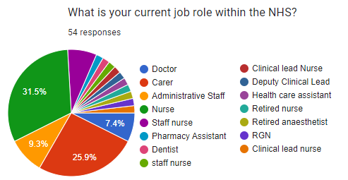
Figure 1 depicts work roles. 92.7 per cent of respondents have care responsibilities, and only 9.3 per cent have administrative functions.

Figure 2
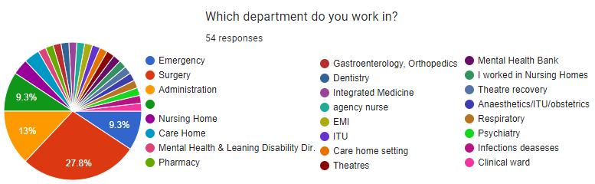
Figure 2 reveals that Surgery is in the lead, followed by Administration and Emergency however several departments are visible.

Figure 3
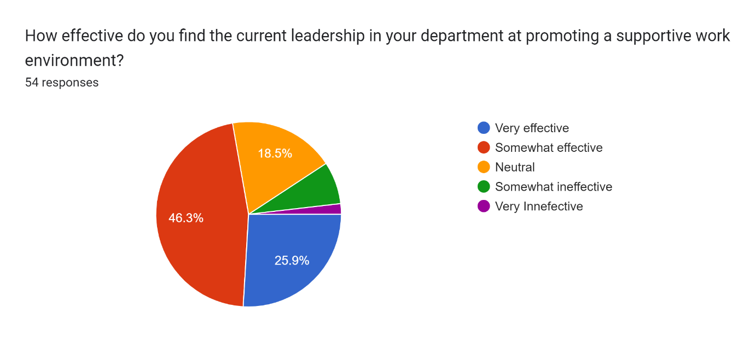
Only a tiny percentage of respondents disagree, as shown in Figure 3, indicating high satisfaction levels with promoting a supportive work environment.

Figure 4
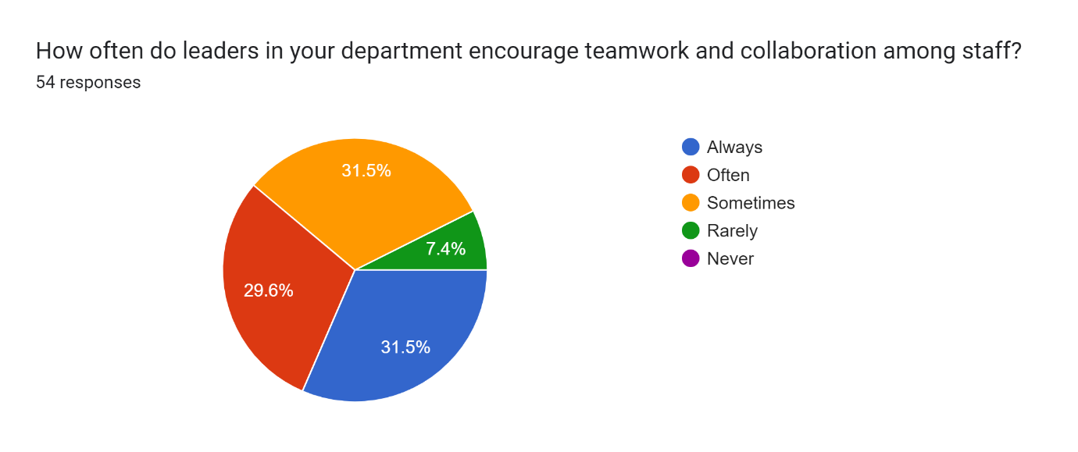
Figure 4 shows that 31.5% of respondents think their team leaders constantly support them, 29.5% believe this occurs frequently, 31.5% think it happens occasionally, and only 7.4% think it happens rarely.

Figure 5

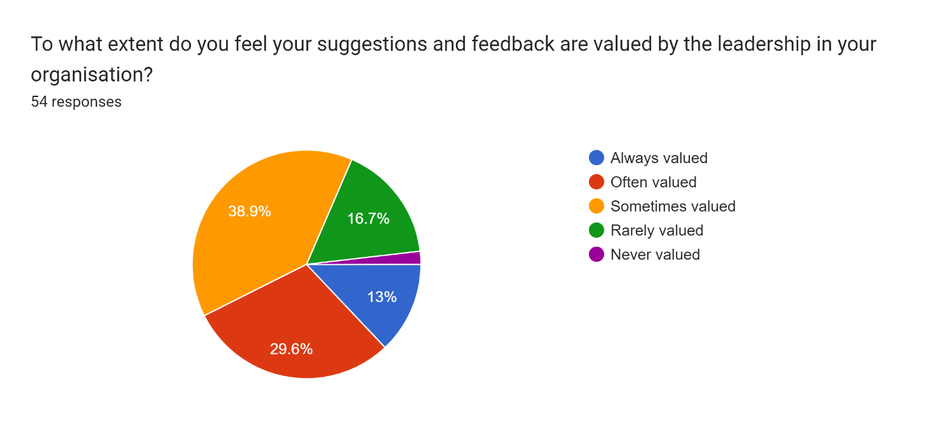
Figure 5 demonstrates that just 38.9% of respondents believe their leaders value their proposals. In comparison, 29.6% believe their suggestions matter more frequently, 13% believe their suggestions are always valued, and 16% believe they are rarely valued.

Figure 6
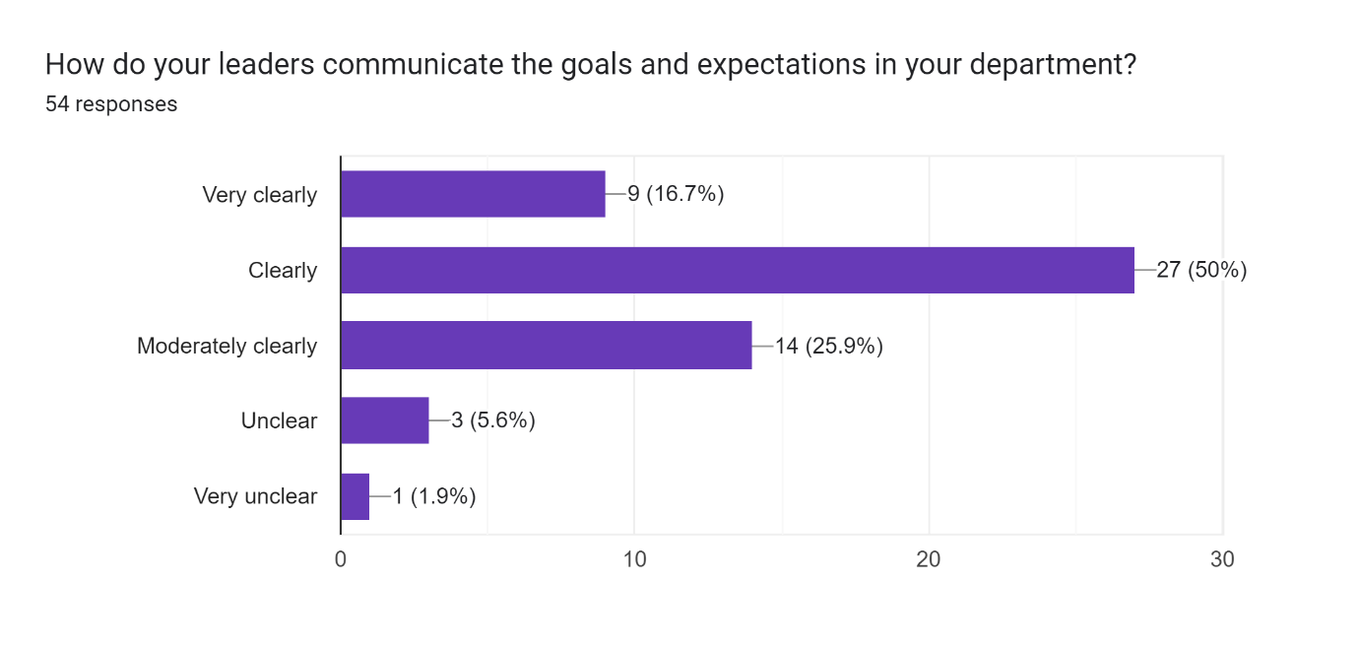
Figure 6 demonstrates that goals and expectations are well communicated, with most respondents finding the communication clear.

Figure 7

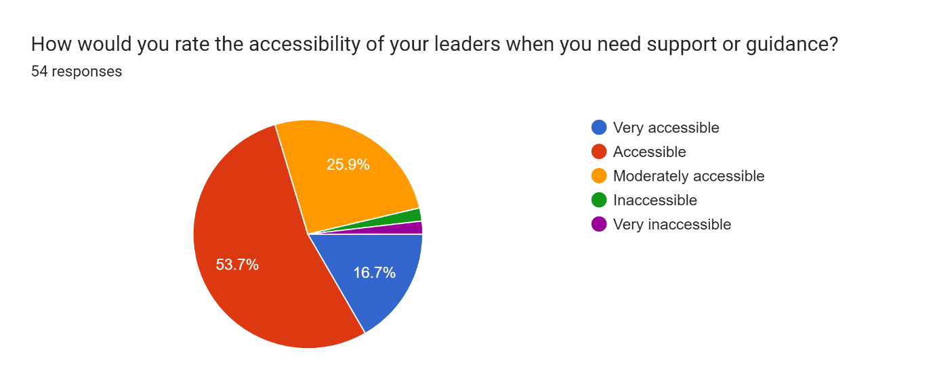
Figure 7 reveals a high percentage of respondents who state that their leaders are accessible for support and guidance.

Figure 8
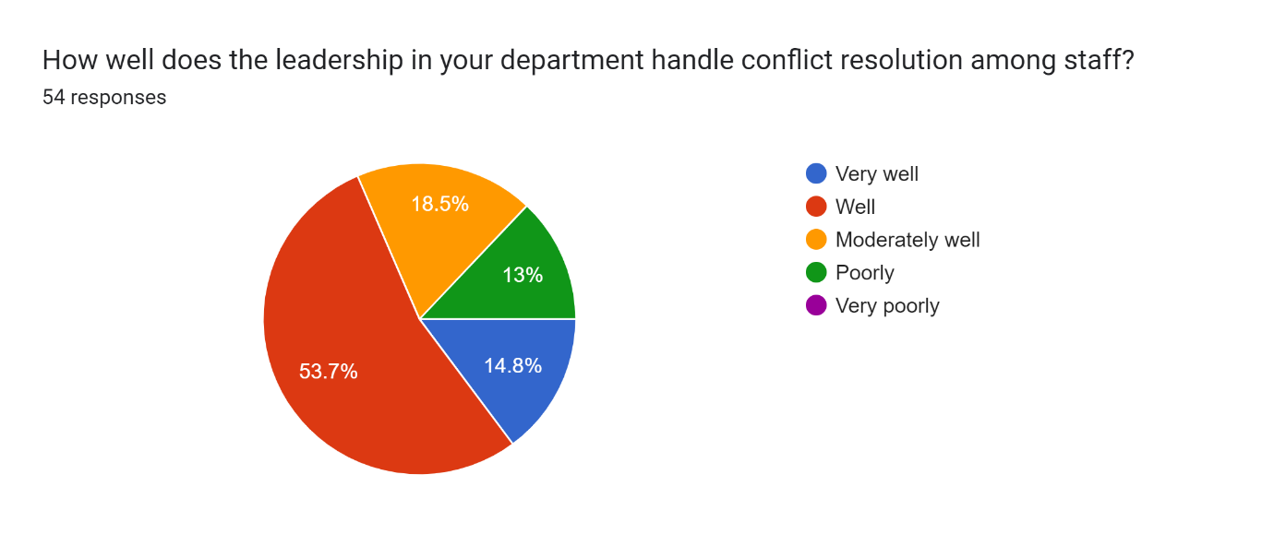
While 13% of respondents think staff conflicts are handled poorly, Figure 8 respondents think their leaders effectively resolve disputes.

Figure 9
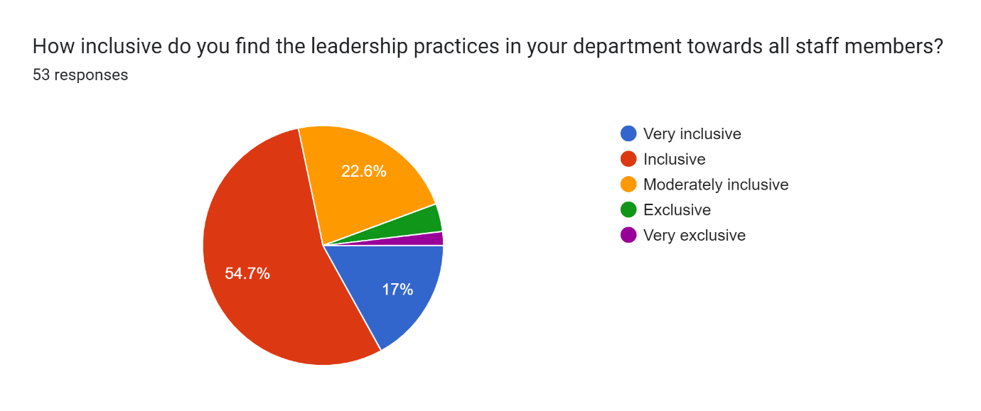
Figure 9 reveals that inclusive practices work well, and a few respondents feel excluded.

Figure 10
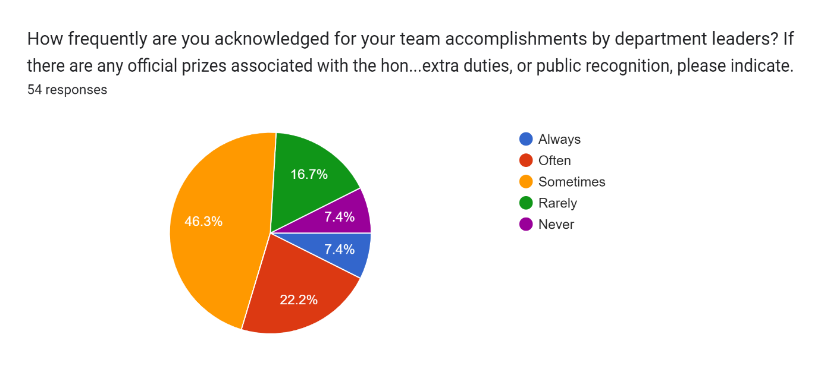
While about one-third of respondents profit from acknowledgement more frequently or constantly, quite a number do not benefit, or it occurs infrequently, as Figure 10 demonstrates. A significant portion of respondents only occasionally gain recognition for their efforts.

Figure 11

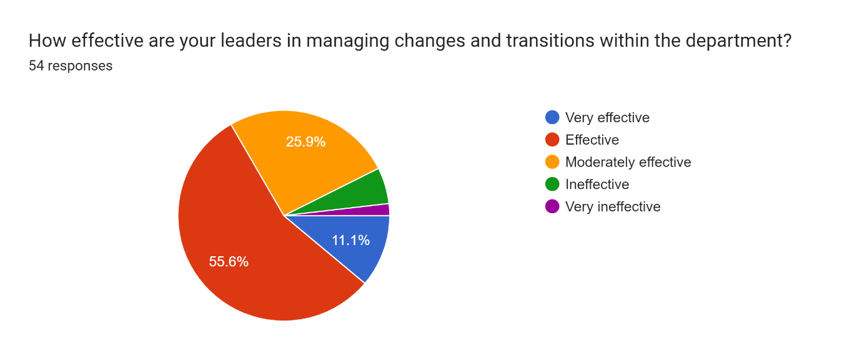
Figure 11 reveals that change and transitions are managed well, according to many respondents, while the inefficiency percentage is low.

Figure 12
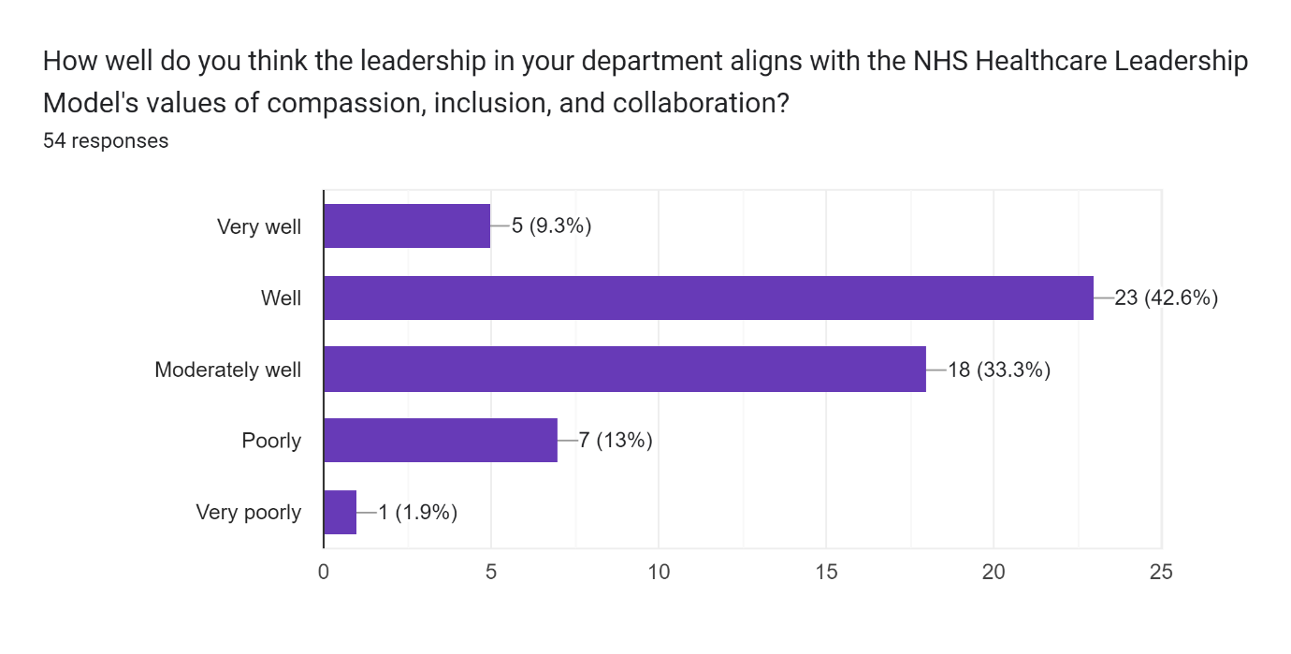
Figure 12 shows a high sentiment for compassion, inclusion, and collaboration; one-third consider that it can be improved, but some respondents consider the alignment to HLM poor.

Figure 13
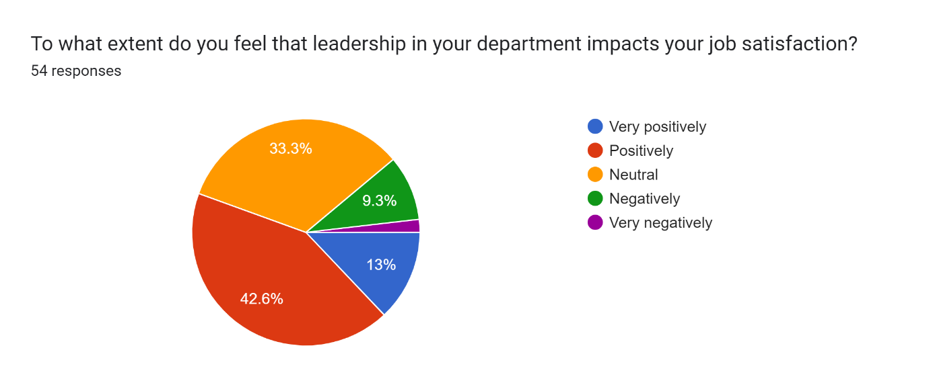
In Figure 13, high numbers highlight positive job satisfaction due to leadership, and approximately 10 percent consider that their leaders harm their job satisfaction.

Figure 14
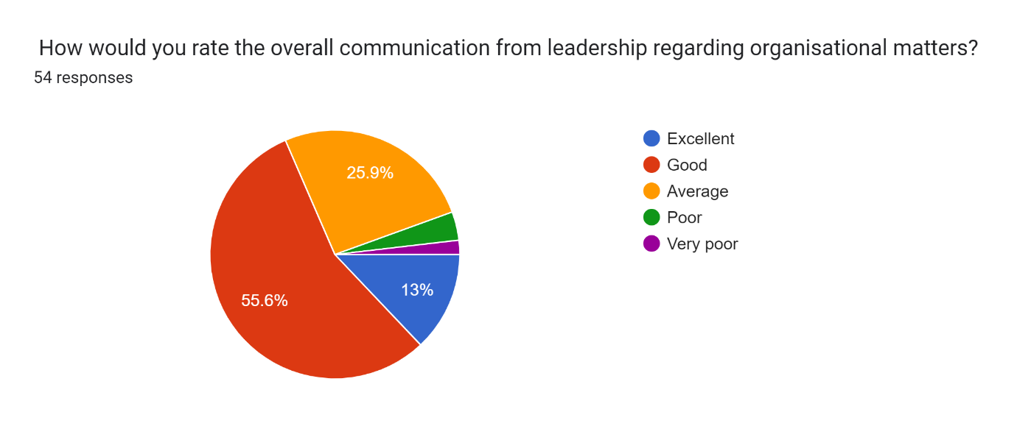
Figure 14 highlights that a high percentage consider communication regarding organisational matters effective; however, approximately one-third think it requires improvement.

Figure 15
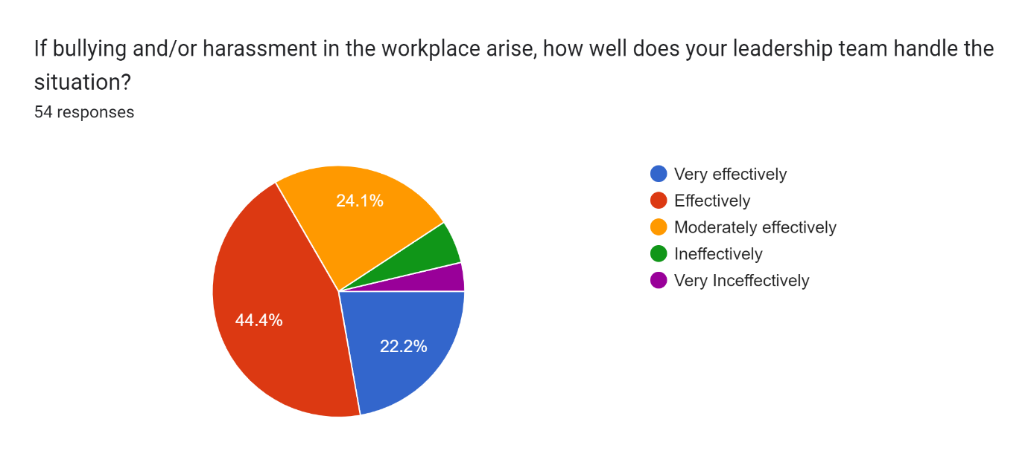
Although bullying and harassment are dealt with successfully, as Figure 15 illustrates, some respondents believe this issue needs to be addressed.

Figure 16
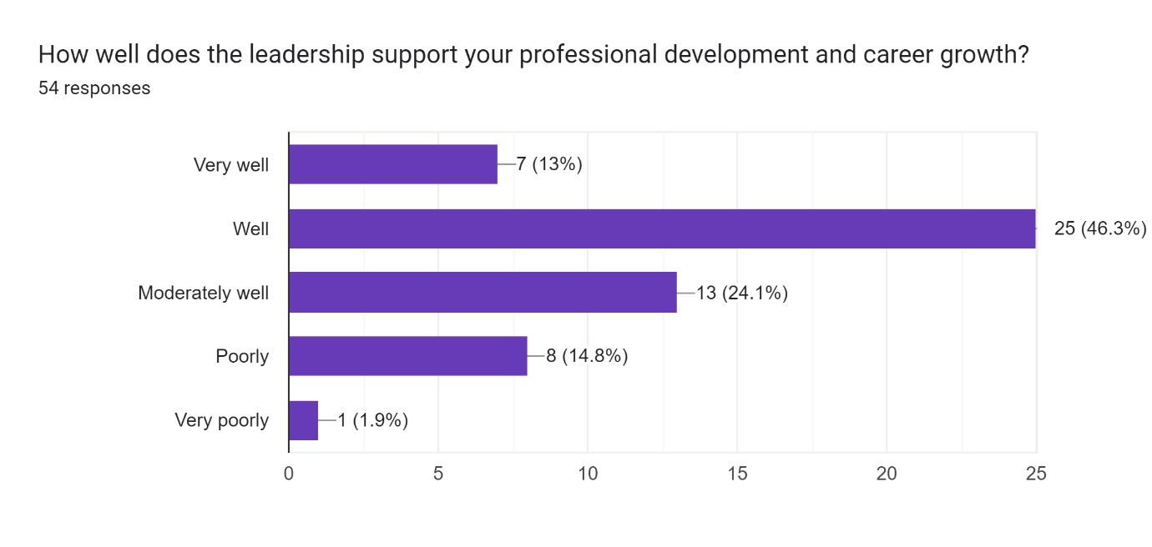
Figure 6 shows that professional development is supported by leaders efficiently. 24.1 per cent consider that improvement is required, and approximately 15 per cent feel unsupported.

Figure 17
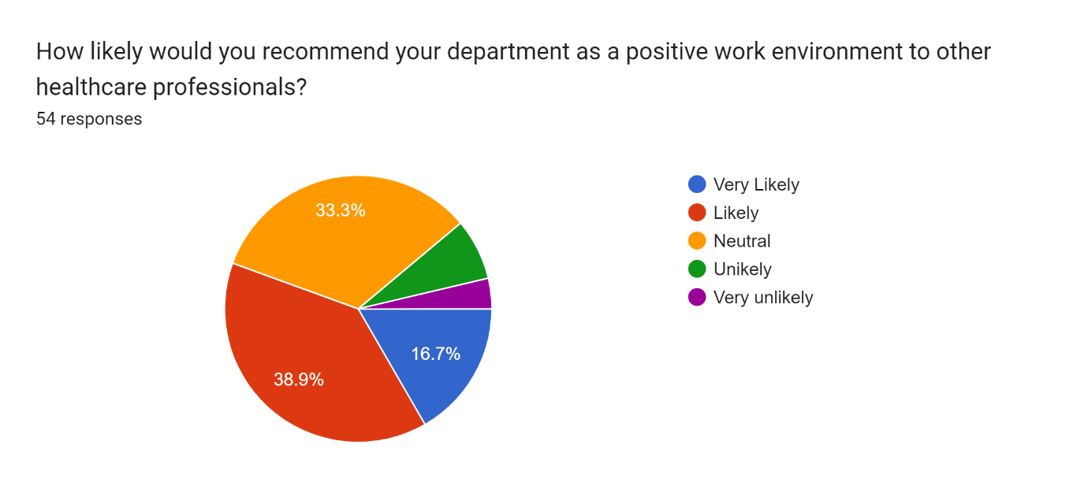
As Figure 17 reveals, over half of the respondents would recommend their department as a positive work environment, one-third are neutral, and very few would not recommend it.

Figure 18
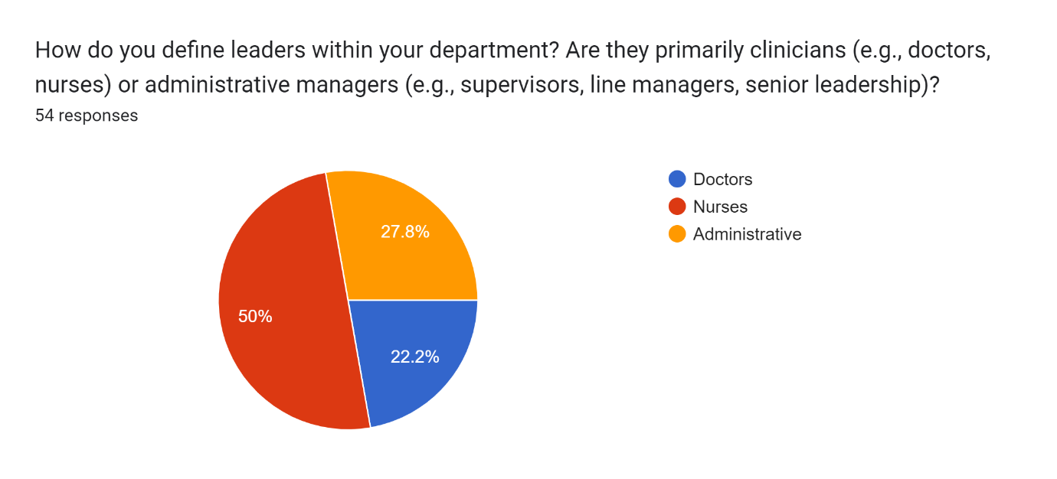
Figure 18 reveals that leaders within different departments also have care roles while 27.8 per cent are in administrative roles.

Figure 19
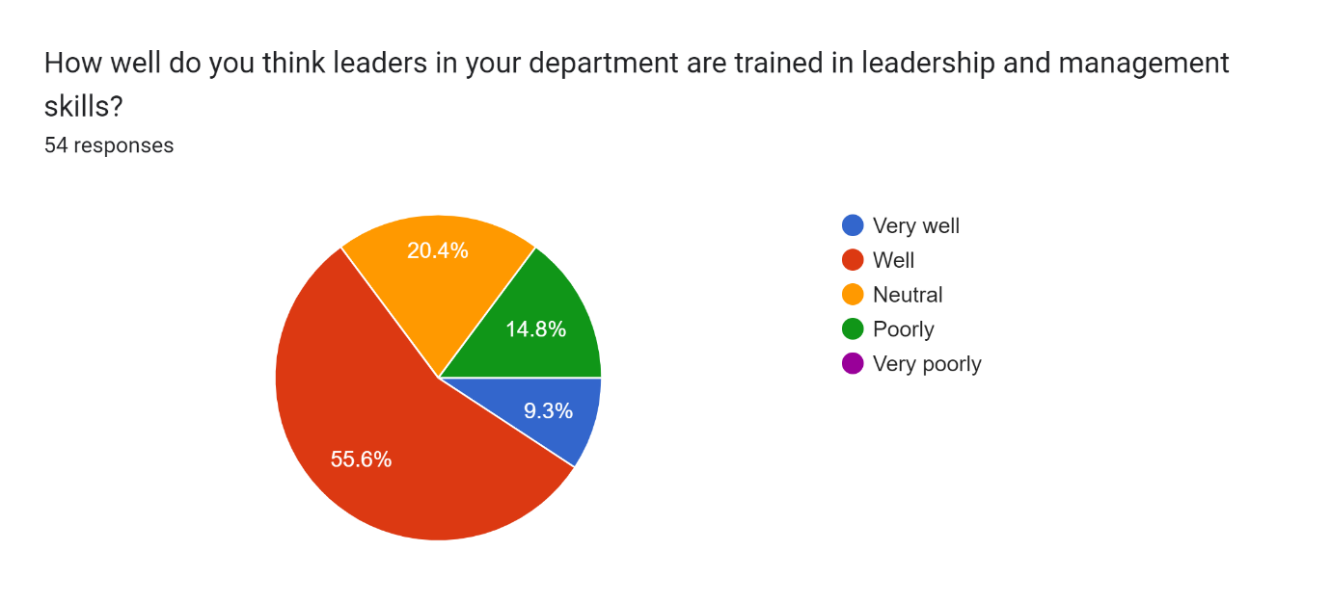
Figure 19 shows that many respondents consider their leaders to be well-trained, 20.4 percent are neutral, and 14.8 percent consider their leaders untrained.

Figure 20
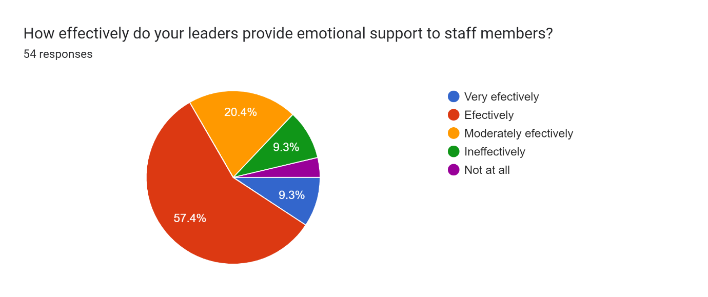
Figure 20 shows that emotional support is available to a reasonable extent. However, approximately one-third consider that they should benefit from more support or not as much.

Interviews
Interview one:
The interview offers a balanced viewpoint on NHS leadership. The participant notes that her immediate superiors were encouraging, approachable, motivating, and patient with her as she moved from Romania to the UK. However, she notes that approaching higher-ranking leaders becomes more complex, suggesting a communication breakdown as one moves up the leadership ladder. The participant highlights the presence of different nationalities and genders and expresses appreciation for the department's inclusive and diverse atmosphere. She recognises management's efforts to help employees and keep an eye on work hours to prevent weariness and mistakes, even in light of the well-known problem of personnel shortages.
Although it appears to be underutilised, formal well-being support is available; instead, practical solutions like regular breaks are more prevalent.
Although staffing concerns may restrict these chances, The participant loves the yearly training and support for additional study in terms of professional growth. She gives reasonable leadership assistance in trying times, such as seeing a coordinator prepare for a more senior role and getting fast assistance in a surgical theatre emergency. NHS principles are followed when managing conflicts, focusing on objectivity and prudence. According to this participant, a strong sense of people orientation, empathy, organisation, and communication skills are essential for good leadership. As high-level leaders occasionally become less available due to administrative tasks, she advises them to connect to the clinical side and enhance their accessibility and contact with personnel.

Interview two:
According to the interview, the participant stated that while they saw problems with availability and motivation, overall, the leadership in their department was helpful. Although supervisors commend patients' families when they provide positive comments, a staffing shortage frequently lowers morale and compromises health. The workplace is inclusive, giving appropriate jobs to coworkers with disabilities and encouraging a sense of importance and belonging among all employees.
Although there are issues because of personnel shortages, the flexibility of agency work enables the interviewee to successfully manage their commitments in terms of work-life balance. Private conversations are used to resolve conflicts, albeit their efficacy varies. There are opportunities for professional growth, and both required and optional training is offered. But there is room for development. Management should listen more intently, roles should be defined more clearly, and communication should be improved. These things would probably help create a more motivated and cohesive work atmosphere.

Interview three:
The participant's description of a leadership style that prioritises goal achievement through resource allocation and time management was based on the third interview. While communication problems were identified as a hindrance to reaching goals, support and motivation were seen as inconsistent and occasionally made possible by training opportunities. The crew exhibited excellent feedback regarding the specific training activities for particular skills.
It was said that the workplace welcomed people of different nations and genders. Structured scheduling helped enhance work-life balance, although the participant pointed out that balancing skill levels across shifts was crucial. Management intervention and possible retraining were required to resolve conflicts, focusing on communication as a vital leadership skill. More staffing and improved communication were suggested to improve overall work performance and care quality.

Interview four:
According to the final interview results, the participant had a bad leadership experience marked by a lack of support and poor communication, mainly when it came to managing professional growth and training. They complained about what they saw as racism and disrespect from management, which led to them working fewer hours and looking for other work.
Work-life balance was maintained on an individual basis rather than by the company. The participant cited insufficient responses to training and COVID-19 safety issues in their report of ineffective measures for staff well-being. Inattentive leadership hindered prospects for growth and failed to handle conflicts appropriately.
The three main attributes lacking in leaders are empathy, communication, and motivation. A better working environment and HR procedures were the leading improvement suggestions, suggesting that these adjustments could increase employee happiness and retention.

Conclusion
A comprehensive view of leadership within the NHS is revealed by the quantitative and qualitative data study, indicating strengths in areas like professional development commitment, constructive conflict resolution, and supportive work environments. However, problems like poor communication, erratic leadership, and apparent differences in acceptance and acknowledgement still exist. These results provided the framework for the debates, conclusions, and suggestions made in the following chapters regarding improving employee well-being and leadership effectiveness in the NHS.

6.0 Discussion
This study's results, consistent with previous research, point out both the advantages and disadvantages of NHS leadership. Positive features that have been noted include attempts to promote inclusivity and diversity, supportive work environments, and efficient techniques for resolving conflicts. These results are consistent with earlier studies (Mosadeghrad and Mojbafan, 2019; Davis, 2021) that highlighted the significance of these elements in raising employee happiness and organisational effectiveness.
However, the study also highlights issues like poor communication and unequal leadership support, similar to worries expressed in the literature about poor leadership training and communication hurdles (Brown, 2020). These difficulties can weaken organisational cohesiveness and impede efficient decision-making procedures (Hauser, 2019).
Several recommendations are made to improve NHS leadership practices in light of these findings and insights from previous knowledge. First and foremost, strengthening communication tactics is essential to closing gaps and facilitating better information flow at all organisational levels (James, 2021; Patel, 2022). Second, funding specifically designed leadership development programmes for the healthcare industry can better prepare leaders with the abilities required to manage difficult situations and assist their staff successfully (Hermosura, 2022).
Moreover, encouraging diversity training and mentorship programmes are examples of inclusiveness activities that can help create a more welcoming and encouraging work environment (Le, 2021). To boost morale and prevent burnout, it's also critical to prioritise employee well-being through programmes like wellness initiatives and regular feedback systems (Daniels et al., 2022). Lastly, the NHS will be able to track its success and modify its plans in response to changing organisational requirements, thanks to establishing metrics for continuous improvement (Johnson, 2021).

Chapter Five

7.0 Conclusions and Recommendations

In conclusion, developing a positive organisational culture, raising employee happiness, and improving patient care outcomes depend on effective leadership within the NHS. The research provides crucial new information about the advantages and disadvantages of the NHS's existing leadership practices.
The report highlights several positive traits of the NHS's present leadership, such as a dedication to professional growth, the ability to resolve conflicts constructively, and the creation of encouraging work environments. These results are consistent with earlier studies, highlighting the significance of these elements in raising worker satisfaction and improving organisational efficacy. Qualitative information from interviews reveals situations in which leaders fostered a varied and inclusive environment while offering crucial support in times of need.
Despite these advantages, the study identifies several areas that still require development. The results align with past research and highlight problems like poor communication and uneven leadership support. These difficulties can potentially weaken organisational unity and obstruct efficient decision-making procedures. Quantitative statistics show that respondents are significantly dissatisfied with the frequency and calibre of communication from leaders. Additionally, some interviewees expressed sentiments of irritation and neglect because of perceived racism and lack of support.
Some participants recognised the inclusive character of their work settings and the provision of possibilities for professional growth; nevertheless, a few highlighted the constraints imposed by a lack of staff. The thematic analysis revealed that while formal well-being support is available, it is frequently underutilised, with more commonplace practical remedies being regular breaks.
The thorough investigation provides a detailed picture of NHS leadership today. The strengths show how good leadership may improve organisational success and employee well-being. However, the ongoing problems with poor communication and erratic assistance highlight the necessity of focused changes.
Resolving these issues is critical to building a more unified, driven, and contented staff, which is necessary for providing patients with high-quality treatment.
By acknowledging and resolving these highlighted strengths and deficiencies, NHS leadership may enhance employee support, resulting in increased job satisfaction and improved patient outcomes. The knowledge gathered from this study serves as a basis for further conversations and projects meant to improve leadership techniques in the NHS.

Recommendations:
Improve Communication Strategies: Establishing a culture of openness and trust requires implementing regular feedback systems and transparent communication channels. By bridging the communication gaps between frontline employees and senior leadership, this strategy will guarantee that issues are promptly resolved and well-informed decisions are made.
Boost Inclusivity Initiatives: Creating an inclusive workplace requires promoting diversity via thorough training and strong regulations. Ensuring fair treatment and professional growth chances would improve organisational perspectives and innovation while increasing staff engagement.
Invest in Tailored Leadership Development: Using targeted leadership development programmes to close particular skill gaps in empathy, motivation, and communication is critical. Giving leaders the skills and resources to manage complicated healthcare situations successfully will help them support their teams and advance organisational success.
Encourage Employee Well-being: Reducing burnout and raising job satisfaction among healthcare workers requires growing programmes that promote resilience, mental health, and work-life balance. Putting employee well-being first enhances patient care experiences while also increasing retention rates.
Establish Metrics for Continuous Improvement: To achieve continuous improvement, methods must be refined, and the impact of leadership initiatives on patient outcomes, employee satisfaction, and retention rates must be monitored and evaluated.
The NHS can monitor progress over time and modify treatments based on data-driven insights if they establish clear benchmarks.
By following these suggestions, NHS organisations will be able to develop a culture of leadership that is both supportive and efficient, placing equal emphasis on the well-being of staff members and the quality of patient care. Healthcare leaders can foster an environment favourable to accomplishing organisational objectives and providing high-quality healthcare services by addressing communication challenges, improving inclusivity, investing in leadership development, promoting well-being, and establishing metrics for continuous improvement.

8.0 Bibliography
Archibong, U., Kline, R., Eshareturi, C. and McIntosh, B., (2019). Disproportionality in NHS disciplinary proceedings. British Journal of Healthcare Management, 25(4), pp.1-7. https://doi.org/10.12968/bjhc.2018.0062. (Accessed: 1st June 2024).
Assarroudi A, Heshmati Nabavi F, Armat MR, Ebadi A, Vaismoradi M.,(2018). Directed qualitative content analysis: the description and elaboration of its underpinning methods and data analysis process. Journal of Research in Nursing. 2018;23(1):42-55. doi: https://doi.org/10.1177/1744987117741667.
Baruch, Y., & Holtom, B. C. (2008). Survey response rate levels and trends in organisational research. Human Relations, 61(8), 1139-1160. https://doi.org/10.1177/0018726708094863.
Brown, S.F., (2020). Strategies Health Care Leaders Use to Implement Strategic Change Initiatives Successfully, Walden University. Available: https://www.proquest.com/dissertations-theses/strategies-health-care-leaders-use-implement/docview/2417795398/se-2?accountid=130472.
Bryman, A., (2016). Social research methods. Oxford University Press. [Online]. Available:https://books.google.co.uk/books?hl=en&lr=&id=N2zQCgAAQBAJ&oi=fnd&pg=PP1&dq=Bryman,+A.+(2016).+Social+Research+Methods+(5th+ed.).+Oxford+University+Press.&ots=dqJzJQI7ql&sig=R2H-gt0OiB2K_eFQ2Jd031qm8xM#v=onepage&q=Bryman%2C%20A.%20(2016).%20Social%20Research%20Methods%20(5th%20ed.).%20Oxford%20University%20Press.&f=false. (Accessed: 18th June 2024).
Birks, M., Hoare, K., & Mills, J. (2019). Grounded Theory: The FAQs. International Journal of Qualitative Methods, 18. https://doi.org/10.1177/1609406919882535. (Accessed: 23rd June 2024).
Busetto, L., Wick, W. & Gumbinger, C. (2020). How to use and assess qualitative research methods. Neurol. Res. Pract. 2, 14 (2020). https://doi.org/10.1186/s42466-020-00059-z. (Accessed: 19th June 2024).

Cakiroglu, O.C. and Unver, G.T. (2023) 'Toxic leadership, mental well-being and work engagement among nurses: a scale adaptation study and structural equation model approach,' Journal of Health Organization and Management, 38(1), pp. 49–69. https://doi.org/10.1108/jhom-10-2022-0291.
Castleberry, A. and Nolen, A. (2018) 'Thematic analysis of qualitative research data: Is it as easy as it sounds?' Currents in Pharmacy Teaching and Learning, 10(6), pp. 807–815. https://doi.org/10.1016/j.cptl.2018.03.019.
Cole CL, Waterman S, Stott J, Saunders R, Buckman JEJ, Pilling S, Wheatley J.(2020). Adapting IAPT services to support frontline NHS staff during the Covid-19 pandemic: the Homerton Covid Psychological Support (HCPS) pathway. Cogn Behav Therap. 2020 28th April;13:e12. https://doi.org/10.1017%2FS1754470X20000148. (Accessed: 16th June 2024).
Couper, K., Murrells, T., Sanders, J., Anderson, J.E., Blake, H., Kelly, D., Kent, B., Maben, J., Rafferty, A.M., Taylor, R.M. and Harris, R., (2022). The impact of COVID-19 on the well-being of the UK nursing and midwifery workforce during the first pandemic wave: A longitudinal survey study. International journal of nursing studies, 127, p.104155. Available: https://www.sciencedirect.com/science/article/pii/S002074892100300X.
Creswell, J.W. (2021) A Concise Introduction to Mixed Methods Research, Google Books. SAGE Publications. Available at: https://books.google.co.uk/books?hl=en&lr=&id=2s0IEAAAQBAJ&oi=fnd&pg=PT8&dq=Creswell. (Accessed: 24th June 2024).
Daniels, K., Connolly, S., Woodard, R., van Stolk, C., Patey, J., Fong, K., France, R., Vigurs, C. and Herd, M., (2022). NHS staff well-being: Why investing in organisational and management practices makes business sense. IPPO: London. Available: https://eppi.ioe.ac.uk/cms/Portals/0/IPPO%20NHS%20Staff%20Wellbeing%20report_LO160622-1849.pdf.

Davis, A.M.,( 2021). Increasing Organisational Performance Through Employee Engagement, Leader Behaviour, and an Inclusive Work Environment, Cornerstone University. Available: https://www.proquest.com/dissertations-theses/increasing-organizational-performance-through/docview/2531176320/se-2?accountid=130472.
Dillman, D.A., Smyth, J.D. and Christian, L.M., (2014). Internet, phone, mail, and mixed-mode surveys: The tailored design method. John Wiley & Sons. Available: https://books.google.co.uk/books?hl=en&lr=&id=fhQNBAAAQBAJ&oi=fnd&pg=PR11&dq=Dillman,+D.+A.,+Smyth,+J.+D.,+%26+Christian,+L.+M.+(2014).+Internet,+Phone,+Mail,+and+Mixed-Mode+Surveys:+The+Tailored+Design+Method.+John+Wiley+%26+Sons.&ots=JxL1qhYHAO&sig=Xf_H3Nw5_FHFzN2jEV170FKTwMg#v=onepage&q=Dillman%2C%20D.%20A.%2C%20Smyth%2C%20J.%20D.%2C%20%26%20Christian%2C%20L.%20M.%20(2014).%20Internet%2C%20Phone%2C%20Mail%2C%20and%20Mixed-Mode%20Surveys%3A%20The%20Tailored%20Design%20Method.%20John%20Wiley%20%26%20Sons.&f=false. (Accessed: 23rd June 2024).
Dunwoodie, K., Macaulay, L. and Newman, A., (2023). Qualitative interviewing in the field of work and organisational psychology: Benefits, challenges and guidelines for researchers and reviewers. Applied Psychology, 72(2), pp.863-889. Available: https://iaap-journals.onlinelibrary.wiley.com/doi/full/10.1111/apps.12414. (Accessed: 16th June 2024).
Glegg, SMN (2018) 'Facilitating Interviews in Qualitative Research with Visual Tools: A Typology', Qualitative Health Research, 29(2), pp. 301–310. Available at: https://doi.org/10.1177/1049732318786485. (Accessed: 19th June 2024).

Ham, C. (2023). Improving health and care at scale. [Online]. Available: https://www.nhsconfed.org/system/files/2023-11/Improving-health-and-care-at-scale-Chris-Ham.pdf. (Accessed: 29th June 2024).
Hauser, M., (2019). The Effects of Leader-Driven Organizational Alignment on Organizational Performance: A Multiple Case Study, Northcentral University. Available: https://www.proquest.com/dissertations-theses/effects-leader-driven-organizational-alignment-on/docview/2217093242/se-2?accountid=130472.
Hermosura, B.J., (2022). Learning to Lead: A Multi-Faceted Study of Leadership Skills Development and Use by Dietitians (Doctoral dissertation, Université d'Ottawa/University of Ottawa). Available: https://ruor.uottawa.ca/items/c4290576-7b75-4978-9989-e504b76dabed.
Hill, C. J., Barrasso, A. P. and Spilios, K. E. (2023) 'A Mixed-Methods Analysis of Perspectives Toward Learning Assistant-Faculty Relationships', Journal of College Science Teaching, 52(3), pp. 3–5. https://doi.org/10.1080/0047231X.2023.12290703. (Accessed: 23rd June 2024).
Iqbal, K., Fatima, T. and Naveed, M. (2019) 'The impact of Transformational leadership on nurses' organisational Commitment: a multiple mediation model,' European Journal of Investigation in Health, Psychology and Education/European Journal of Investigation in Health, Psychology and Education, 10(1), pp. 262–275. https://doi.org/10.3390/ejihpe10010021.
Jamal, K., Usman, M., Manzoor, S.R., Ayaz, M.Q. and Safi, A.Q., (2023). How Does The Dark Side Of Leadership Affect The Workers' Emotions And Creativity? Journal of Positive School Psychology, 7(5), pp.1407-1426. Available: https://www.journalppw.com/index.php/jpsp/article/view/17656.

JAMES, L., (2021). Motivational Interviewing: A Strategy to Improve Health Professional's Communication, Walden University. Available: https://www.proquest.com/dissertations-theses/motivational-interviewing-strategy-improve-health/docview/2501235216/se-2?accountid=130472.
Johnson, M.R., Raitt, M., Asghar, A., Condon, D.L., Beck, D. and Huang, G.D., (2021). Development and implementation of standardised study performance metrics for a VA healthcare system clinical research consortium. Contemporary Clinical Trials, 108, p.106505. Available: https://www.sciencedirect.com/science/article/pii/S155171442100241X.
Jones, B., Horton, T. and Home, J. (2022) Strengthening NHS management and leadership - The Health Foundation, www.health.org.uk. The Health Foundation. Available at: https://www.health.org.uk/publications/long-reads/strengthening-nhs-management-and-leadership. (Accessed: 19th June 2024).

European Union (2016). Regulation (EU) 2016/679 of the European Parliament and of the Council of 27th April 2016 on the protection of natural persons with regard to the processing of personal data and on the free movement of such data, and repealing Directive 95/46/EC (General Data Protection Regulation) (Text with EEA relevance). [online] Europa. EU. Available at: https://eur-lex.europa.eu/eli/reg/2016/679/oj. (Accessed: 24th June 2024).
Field, A., (2024). Discovering statistics using IBM SPSS statistics. Sage Publications Limited. Available:https://books.google.co.uk/books?hl=en&lr=&id=83L2EAAAQBAJ&oi=fnd&pg=PT8&dq=+Discovering+statistics+using+IBM+SPSS+statistics+(5th+ed.).+SAGE+Publications.&ots=UbJZEpAKyH&sig=F_uB5YpXCAWUmymK1OzJUQaFqOE#v=onepage&q=Discovering%20statistics%20using%20IBM%20SPSS%20statistics%20(5th%20ed.).%20SAGE%20Publications.&f=false.
Jangsiriwattana, T., (2020). Transformational and Transactional Leadership Styles: A Conceptual Framework of Their Relationship with Organisational Performance. KASEM BUNDIT JOURNAL, 21(2), pp.181-192. Available: https://so04.tci-thaijo.org/index.php/jkbu/article/view/246892.
King's Fund. (2024). Siloed, unsupported and hindered – the reality of innovation in the NHS and social care. [Online]. Available: https://www.kingsfund.org.uk/insight-and-analysis/blogs/siloed-unsupported-hindered-innovation-nhs-social-care. (Accessed: 18th June 2024).
Kircher, R. and Zipp, L.,( 2022). Questionnaires to elicit quantitative data. Research Methods in Language Attitudes, pp.129-144. Available: https://books.google.co.uk/books?hl=en&lr=&id=y-ZwEAAAQBAJ&oi=fnd&pg=PA129&dq=quantitative+questionnaire+research+methods+&ots=D6ermQGbiH&sig=WfClO9N2rOHdgaf3IcdhXWeopdk#v=onepage&q=quantitative%20questionnaire%20research%20methods&f=false. (Accessed: 16th June 2024).
Kleinheksel, A.J., Rockich-Winston, N., Tawfik, H. and Wyatt, T.R., (2020). Demystifying content analysis. American Journal of Pharmaceutical Education, 84(1), p.7113. Available: https://doi.org/10.5688/ajpe7113.

Kline, R. (2020). The "Snowy White Peaks" of the NHS: A survey of discrimination in governance and leadership and the potential impact on patient care in London and England. Middlesex University. Online resource. https://doi.org/10.22023/mdx.12640421.v1MJ. (Accessed: 1st June 2024).
Kumar, J. (2020). Leadership in a crisis: the importance of courage and caring. [Online]. Available: https://www.nhsconfed.org/articles/leadership-crisis-importance-courage-and-caring. (Accessed: 16th June 2024).
Le, M., (2021). Health Care Leader Strategies for Cultural Diversity in the Workplace, Walden University. Available: https://www.proquest.com/dissertations-theses/health-care-leader-strategies-cultural-diversity/docview/2620821658/se-2?accountid=130472.
Lee J-T. (2019). Book Review: Designing and conducting mixed methods research. HERD: Health Environments Research & Design Journal. 2019;12(1):164-166. doi: https://doi.org/10.1177/1937586719832223. (Accessed: 29th June 2024).
Levin, K.A., (2006). Study design III: Cross-sectional studies. Evidence-based dentistry, 7(1), pp.24-25. Available: https://www.nature.com/articles/6400375. (Accessed: 23rd June 2024).
MacDougall, M.,( 2021). Ten tips for statistical educators in response to a constructive review of the book How to Analyse Data. Journal of University Teaching & Learning Practice, 18(2), p.08. https://doi.org/10.53761/1.18.2.8.
Mannion, R. and Davies, H., (2018). Understanding organisational culture for healthcare quality improvement. Bmj, 363. https://doi.org/10.1136/bmj.k4907. (Accessed: 1st June 2024).
Michalis, M. et al. (2018) Network infrastructure as commons, Deliverable Number D5.4. Edited by D. Boucas, p. 48. https://netcommons.eu/sites/default/files/d5.4_survey_v1.0.pdf. (Accessed: 16th June 2024).
Morgan, B. (2022). NHS staffing shortages. [Online]. Available: https://assets.kingsfund.org.uk/f/256914/x/151509726c/nhs_staffing_shortages_engage_britain_2022.pdf. (Accessed: 29th June 2024).
Mosadeghrad, A.M. and Mojbafan, A. (2019) 'Conflict and conflict management in hospitals,' International Journal of Health Care Quality Assurance, 32(3), pp. 550–561. https://doi.org/10.1108/ijhcqa-09-2017-0165.
Neuman L., W., (2014). Social research methods: Qualitative and quantitative approaches. Available:http://194.164.49.16:8080/jspui/bitstream/123456789/156/1/Social%20Research%20Methods%20%28Eng%29%205MB%282%29.pdf. (Accessed: 24th June 2024).
Leavy, P., (2022). Research design: Quantitative, qualitative, mixed methods, arts-based, and community-based participatory research approaches. Guilford Publications. pp.9 Available: https://books.google.co.uk/books?hl=en&lr=&id=qUiKEAAAQBAJ&oi=fnd&pg=PP1&dq=Research+Design:+Qualitative,+Quantitative,+and+Mixed+Methods+Approaches+&ots=RxKjFmGv7J&sig=KxSWQC170irkxni-6bytrOwvHco#v=onepage&q=Research%20Design%3A%20Qualitative%2C%20Quantitative%2C%20and%20Mixed%20Methods%20Approaches&f=false. (Accessed: 24th June 2024).
NHS Confederation, (2020). NHS Staff Survey 2020. [Online]. Available: https://www.nhsconfed.org/publications/nhs-staff-survey-2020. (Accessed: 16th June 2024).
NHS Confederation, (2023). Key statistics on the NHS. [Online]. Available: https://www.nhsconfed.org/articles/key-statistics-nhs#:~:text=World's%20largest%20employers&text=The%20full%2Dtime%20equivalent%20(FTE,under%20150%2C000%20within%20general%20practice. (Accessed: 18th June 2024).
NHS England. (2020). NHS Workforce Race Equality Standard: 2019 Data Analysis Report for NHS Trusts. Available: https://www.england.nhs.uk/wp-content/uploads/2020/01/wres-2019-data-report.pdf. (Accessed: 1st June 2024).
NHS Leadership Academy. (2024). The Healthcare Leadership Model. Available: https://www.leadershipacademy.nhs.uk/healthcare-leadership-model/explore-the-healthcare-leadership-model/. (Accessed: 28th May 2024).
Orb, A., Eisenhauer, L. and Wynaden, D. (2001) 'Ethics in Qualitative Research', Journal of Nursing Scholarship, 33(1), pp. 93–96. Available at: https://doi.org/10.1111/j.1547-5069.2001.00093.x. (Accessed: 20th June 2024).
Pindar, J. (2023) 30 Employee morale statistics for 2023 to show how teams feel. https://championhealth.co.uk/insights/low-employee-morale-statistics/. (Accessed: 29th June 2024).
Patel, R., (2022). Nurses' Perception of Quality in Communication when Communicating with Providers, Regis College. Available: https://www.proquest.com/dissertations-theses/nurses-perception-quality-communication-when/docview/2688028684/se-2?accountid=130472.

Tashakkori, A. and Teddlie, C., (2021). Sage handbook of mixed methods in social & behavioural research. SAGE publications. Available: https://books.google.co.uk/books?hl=en&lr=&id=fwc0EAAAQBAJ&oi=fnd&pg=PT3&dq=Tashakkori,+A.,+%26+Teddlie,+C.+(2010).+SAGE+handbook+of+mixed+methods+in+social+%26+behavioral+research+(2nd+ed.).+SAGE+Publications.&ots=8XusiVOfLR&sig=Q71nWnyQwyyXaqeTxI2CSRXqBKI#v=onepage&q=Tashakkori%2C%20A.%2C%20%26%20Teddlie%2C%20C.%20(2010).%20SAGE%20handbook%20of%20mixed%20methods%20in%20social%20%26%20behavioral%20research%20(2nd%20ed.).%20SAGE%20Publications.&f=false. (Accessed: 23rd June 2024).
Tavanti, M. (2008). Transactional leadership. Leadership: The key concepts, 166-170. Available: https://d1wqtxts1xzle7.cloudfront.net/32231105/2008_Transactional_Leadership-libre.pdf?1391511236=&response-content-disposition=inline%3B+filename%3DTransactional_Leadership.pdf&Expires=1716931155&Signature=ad4-xggpyuIHkKa-~FfyDyJmnNAgIDISbltvrmqlIn9j-oYv5YqwpYXUamu6XkOR1Lda~6usKaFFjnNUaSXxncgs3PnCsvGp5zY4J0LTT4dIra9KkNCkywVa0b5~DdYq4UxrsHmCgK99lINWOcsZx7QhXQDNsYFlHFDrBf4aZevS6Qt~730H7r4ybyS3i7vkcZrRqpHoFuxbPKLKERtO4Uk28q9-9G2XF-uz0A29lNBgoqzw8aL6zGx1r9oVabpGADmCcVn2GrC1C0LgkxgT4wANGn9~~crJ9roQyrJ8WogCUmPBHhbDTpvp0E75uHyTm-eehylS8S5ID~Tf4apC9g__&Key-Pair-Id=APKAJLOHF5GGSLRBV4ZA (Accessed: 28th May 2024).
Terry, G., Hayfield, N., Clarke, V. and Braun, V., (2017). Thematic analysis. The SAGE Handbook of Qualitative Research in Psychology, 2(17-37), p.25. Available: https://books.google.co.uk/books?hl=en&lr=&id=AAniDgAAQBAJ&oi=fnd&pg=PA17&dq=Using+thematic+analysis+in+psychology.+Qualitative+Research+in+Psychology,+&ots=dphajnAfO1&sig=o2zYMTGsp5DoW2GuBUgsZfAGEFM#v=onepage&q=Using%20thematic%20analysis%20in%20psychology.%20Qualitative%20Research%20in%20Psychology%2C&f=false. (Accessed: 23rd June 2024).
Thomas, D. R. (2006). A General Inductive Approach for Analysing Qualitative Evaluation Data. American Journal of Evaluation, 27(2), pp. 237-246. https://doi.org/10.1177/1098214005283748. (Accessed: 23rd June 2024).
Thorlby, R. (2020). International Health Care System Profiles England. [Online]. Available: https://www.commonwealthfund.org/international-health-policy-center/countries/england. (Accessed: 18th June 2024).
Saunders, M., Lewis, P. and Thornhill, A., (2009). Research methods for business students. Pearson education. [Online]. Available: https://books.google.co.uk/books?hl=en&lr=&id=u-txtfaCFiEC&oi=fnd&pg=PA2&dq=Saunders,+M.,+Lewis,+P.,+%26+Thornhill,+A.+(2009).+Research+Methods+for+Business+Students+(5th+ed.).+Pearson+Education.&ots=DyGYHgH97H&sig=CQszswZw0EZ7OB4g8egbk6TYdZs#v=onepage&q=Saunders%2C%20M.%2C%20Lewis%2C%20P.%2C%20%26%20Thornhill%2C%20A.%20(2009).%20Research%20Methods%20for%20Business%20Students%20(5th%20ed.).%20Pearson%20Education.&f=false. (Accessed: 18th June 2024).
Saravo, B., Netzel, J., & Kiesewetter, J. (2017). The need for strong clinical leaders–Transformational and transactional leadership as a framework for resident leadership training. PloS one, 12(8), e0183019. Available: https://journals.plos.org/plosone/article?id=10.1371/journal.pone.0183019 (Accessed: 28th May 2024).

Sfantou DF, Laliotis A, Patelarou AE, Sifaki-Pistolla D, Matalliotakis M, Patelarou E. (2017). Importance of Leadership Style towards Quality of Care Measures in Healthcare Settings: A Systematic Review. Healthcare (Basel). 2017 Oct 14;5(4):73. doi: https://doi.org/10.3390%2Fhealthcare5040073. ( Accessed: 1st June 2024).
Smith, L. (2024). How to Overcome Resistance to Change in Healthcare. [Online]. Available: https://www.linkedin.com/pulse/how-overcome-resistance-change-healthcare-laurie-fc2ic/. (Accessed: 1st June 2024).
Streeton, A.-M., Kitsell, F., Gambles, N. and McCarthy, R. (2021), "A qualitative analysis of vertical leadership development amongst NHS healthcare workers in low to middle-income country settings", Leadership in Health Services, Vol. 34 No. 3, pp. 296-312. https://doi.org/10.1108/LHS-11-2020-0089. (Accessed: 1st June 2024).
Storey, J., & Holti, R. (2013). Towards a New Model of Leadership for the NHS. Available: https://www.leadershipacademy.nhs.uk/wp-content/uploads/2013/05/Towards-a-New-Model-of-Leadership-2013.pdf (Accessed: 28th May 2024).
Sawatsky, A.P., Ratelle, J.T. and Beckman, T.J., (2019). Qualitative research methods in medical education. Anesthesiology, 131(1), pp.14-22 Available: https://pubs.asahq.org/anesthesiology/article/131/1/14/18053/Qualitative-Research-Methods-in-Medical-Education. (Accessed: 22nd June 2024).
Webber, A.(2024). Study: Leadership absence during crisis leads to burnout. Available: https://www.personneltoday.com/hr/leadership-absence-during-crisis-burnout-study/. (Accessed: 1st June 2024).
West, M., Armit, K., Loewenthal, L., Eckert, R., West, T., & Lee, A. (2015). Leadership and leadership development in health care: the evidence base. Available at: https://www.kingsfund.org.uk/insight-and-analysis/reports/leadership-development-health-care (Accessed: 28th May 2024).
West, M., Eckert, R., Collins, B. and Chowla, R., (2017). Caring for change. How compassionate leadership can stimulate innovation in health care. London, UK: The King's Fund. Available: https://www.elft.nhs.uk/sites/default/files/import-news/Caring_to_change_Kings_Fund_May_2017.pdf. (Accessed: 29th June 2024).
Wiles, R., Crow, G., Heath, S., & Charles, V. (2008). The Management of Confidentiality and Anonymity in Social Research. International Journal of Social Research Methodology, 11(5), 417–428. https://doi.org/10.1080/13645570701622231 (Accessed: 24th June 2024).
Woolnough, S. (2024). Challenge and change: what does 2024 hold for the health and care system? [Online]. Available: https://www.kingsfund.org.uk/insight-and-analysis/blogs/challenge-change-what-does-2024-hold-for-the-health-and-care-system. (Accessed: 29th June 2024).
Young, H. R., Glerum, D. R., Joseph, D. L., & McCord, M. A. (2021). A Meta-Analysis of Transactional Leadership and Follower Performance: Double-Edged Effects of LMX and Empowerment. Journal of Management, 47(5), 1255-1280. https://doi-org.ezproxy.uwtsd.ac.uk/10.1177/0149206320908646. (Accessed: 29th May 2024).

Appendices
INTERVIEW QUESTIONS
Can you describe your experience with the leadership style practised in your department?
How would you characterise the approach your direct superiors take towards leadership?
How do you feel about the level of support and motivation provided by your leaders?
Could you give some specific examples of when you felt particularly supported or motivated?
Do you feel that your workplace promotes an inclusive environment?
Can you share any experiences that support your view?
How would you describe your work-life balance?
How do your leaders support or hinder this balance?
What measures are in place to support staff well-being in your department? Are these measures effective? Why or why not?
Do you have any opportunities for professional
development?
Can you describe any specific programs or initiatives?
Can you provide an example of a challenging situation you faced at work and how leadership helped you navigate it?
What was the outcome of this situation?
How do leaders in your department handle conflicts or disagreements among staff?
Can you give an example of how a specific conflict was managed?
What are the key qualities you think are important for effective leaders?
Do you see these qualities in your current leaders?
What changes, if any, would you suggest improving leadership and working conditions in your department?
How do you think these changes would impact your work environment?

Survey Questions
- What is your current job role within the NHS?
- Which department do you work in?
- How effective do you find the current leadership in your department at promoting a supportive work environment?
- 4. How often do leaders in your department encourage teamwork and collaboration among staff?
- To what extent do you feel your suggestions and feedback are valued by the leadership in your department?
- How do your leaders communicate the goals and expectations of the department?
- How would you rate the accessibility of your leaders when you need support or guidance?
- How well does the leadership in your department handle conflict resolution among staff?
- How inclusive do you find the leadership practices in your department towards all staff members?
- How frequently are you acknowledged for your team accomplishments by department leaders? If there are any official prizes associated with the honour, such as bonuses, extra duties, or public recognition, please indicate.
- How effective are your leaders in managing changes and transitions within the department?
- How well do you think the leadership in your department aligns with the NHS Healthcare Leadership Model's values of compassion, inclusion, and collaboration?
- To what extent do you feel that leadership in your department impacts your job satisfaction?
- How would you rate the overall communication from leadership regarding organisational matters?
- If bullying and/or harassment in the workplace arise, how well does your leadership team handle the situation?
- How well does the leadership support your professional development and career growth?
- How likely would you recommend your department as a positive work environment to other healthcare professionals?
- How do you define leaders within your department? Are they primarily clinicians (e.g., doctors, nurses) or administrative managers (e.g., supervisors, line managers, senior leadership)?
- How well do you think leaders in your department are trained in leadership and management skills?
- How effectively do your leaders provide emotional support to staff members?

Ethics Form


APPLICATION FOR ETHICAL APPROVAL – BA level

CAIS AM GYMERADWYAETH MOESEGOL – Lefel BA

Mae'r ffurflen hon i'w chwblhau gan bob BA myfyrwyr. Rhaid i bob ffurflen gael ei ystyried gan diwtor y modiwl.  Dylai un copi o'r ffurflen yn cael ei roi ar y ffeiliau Gyfadran ac un copi cadw ar y ffeil myfyrwyr. |  | This form is to be completed by all BA Leadership and Management students conducting independent projects. This form should be completed by the student. All forms must be considered by the Module Lead- Maria Heffernan. A copy of the form must be kept centrally and on the student file.
ADRAN 1 – MANYLION MYFYRIWR |  | SECTION 1 - STUDENT DETAILS
Enw Llawn  Full Name | Constantin-Ovidiu Polgar
Ysgol/Cyfadran/  School/Faculty | University of Wales Trinity Saint David |  |  | Rhif Myfyriwr Student Number | 2116259
Cydlynydd prosiect / Tiwtor  Module Tutor/ Programme Co-ordinator | Ffion Cumberpatch |  |  | Enw'r Gradd  Name of Degree | BA  Developing Leadership and Management
Teitl dangosol yr Traethawd Hir: |  |  |  | Indicative Title of the Independent Project:
RESEARCH ON THE LEADERSHIP STYLE USED BY THE NHS

ADRAN 2 – MANYLION CYFRANOGWYR / CYNULLEIDFA |  |  | SECTION 2 - PARTICIPANT / AUDIENCE DETAILS
Pwy yw’r cyfranogwyr arfaethedig? |  | Who are the intended participants? |  |  | Ydw / Yes | Na / No
Myfyrwyr / staff Y Drindod Dewi Sant |  | Students / staff of Trinity Saint David |  |  |  | No
Oedolion (dros oed 16 ac yn gymwys i gydsynio) |  | Adults (over the age of 16 and competent to give consent) |  |  | Yes
Plant a phobl ifanc dan oed |  | Children / legal minors |  |  |  | No
Cleifion neu gleientiaid gweithwyr proffesiynol |  | Patients or clients of professionals |  |  |  | No
Rhywun sy’n cael ei gadw yn y ddalfa neu y mae’r llys wedi cymryd cyfrifoldeb amdano |  | Anyone in custodial care or for whom the court has assumed responsibility |  |  |  | No
Aelod o unrhyw sefydliad lle mae’n bosibl bod angen i unigolyn arall hefyd gydsynio. |  | A member of any organisation where another individual may also need to give consent. |  |  |  | No
Eraill: Nodwch: / Others: please identify:

Nifer, Oed a Ffynhonnell y Cyfranogwyr  Rhowch fanylion yr demograffeg y cyfranogwyr / gynulleidfa. |  |  |  | Participant / Audience Number and Age  Provide details of the demographics of the participants / audience.
Nifer o Gyfranogwyr / yn y Gynulleidfa | Participant/ Audience number |  |  | 100
Grŵp oedran y Cyfranogwyr/y Gynulleidfa | Participant/ Audience age group |  |  | Over the age of 18

ADRAN 3 – GWEITHGAREDD YMCHWIL |  |  | SECTION 3 – RESEARCH ACTIVITY
1. | Ydy’r prosiect yn cynnwys: | Does the project include: |  | Ydy / Yes | Nac ydy/No
Defnyddio holiadur neu offeryn ymchwil tebyg |  | Use of questionnaire or similar research instrument |  | Yes
Defnyddio prawf ysgrifenedig neu gyfrifiadurol |  | Use of written or computerised test |  |  | No
Cyfweliad (cysylltwch gwestiynau posibl) |  | Interview (attach provisional questions) |  | Yes
Dyddiaduron |  | Diaries |  |  | No
Arsylwi ar gyfranogwyr a hwythau'n ymwybodol o hynny |  | Participant observation with their knowledge |  |  | No
Arsylwi ar gyfranogwyr a hwythau ddim yn ymwybodol o hynny |  | Participant observation without their knowledge |  |  | No
Recordio fideo neu sain |  | Video or audio-taping |  | Yes
Mynediad i wybodaeth bersonol neu gyfrinachol heb gydsyniad penodol y cyfranogwyr |  | Access to personal or confidential information without the participants specific consent |  |  | No
Defnyddio unrhyw gwestiynau, ysgogiadau prawf, cyflwyniad y gallai rhai cyfranogwyr eu profi fel rhywbeth sy'n achosi niwed / tramgwydd corfforol, meddyliol neu emosiynol |  | Administration of any questions, test stimuli, presentation that may be experienced as physically, mentally or emotionally harmful / offensive |  |  | No
Cyflawni unrhyw weithredoedd allai achosi embaras neu effeithio ar hunan-barch |  | Performance of any acts which may cause embarrassment or affect self-esteem |  |  | No
Ymchwilio i gyfranogwyr sy’n ymwneud â gweithgareddau anghyfreithlon |  | Investigation of participants involved in illegal activities |  |  | No
Gweithdrefnau lle defnyddir twyll |  | Procedures that involve deception |  |  | No
Gweini unrhyw sylwedd, cyfrwng neu blasebo |  | Administration of any substance, agent or placebo |  |  | No
Dull arall o gasglu data neu fformat cyflwyno (esboniwch) |  | Other method of data collection or presentation format (please explain) |  |  | No

2. | Restru eich dull o gasglu data | List your method of data collection:
Describe your methods of data collection

Primary research
Interviews over Teams and only the transcript will be used.
Questionnaires that include only relevant questions, and no personal data will be collected.

3. | Risg Posibl:  (corfforol, seicolegol, cyfreithiol, cymdeithasol neu economaidd) | Potential Risk:  (physical, psychological, legal, social or economic)
A oes unrhyw risg bosibl i: |  | Is there any potential risk to: | Ydw / Yes | Na / No
A | Cyfranogwyr? | Participants? |  | No
B | Ymchwilydd? | Researcher? |  | No
C | BrifYsgol/Cyfadran? | University? |  | No

4. | Rheoli Risg:  Os oes, beth yw'r risg a sut y bydd yn cael ei reoli? | Management of Risk:  If yes, what is the risk and how will it be managed?
NA

5. | Os ydych yn delio â phlant a / neu oedolion agored i niwed, rhaid i chi gyflwyno eich tystysgrif DBS i'ch tiwtor goruchwylio i'w cymeradwyo cyn i unrhyw gysylltiad â cyfranogwyr hyn. | If you are dealing with children and/ or vulnerable adults you must present your DBS certificate to your supervising tutor for approval before any contact with these participants.
 |  |  |  | Ydw / Yes | Na / No
A | Ydych chi wedi gwneud cais am dystysgrif DBS? |  | Have you applied for a DBS certificate? |  | No
B | A yw eich tiwtor weld a'i gadarnhau eich tystysgrif DBS? |  | Has your tutor seen and approved your DBS certificate? |  | No

6. | A fyddwch yn cael cydsyniad gwybodus ysgrifenedig gan eich cyfranogwyr? |  | Will you obtain written informed consent from your participants?
 |  |  |  |  |  | Ydw / Yes | Na / No
A | Os na fyddwch, pam hynny? |  |  | If no, why not?
B | Os byddwch, sut byddwch yn sicrhau cydsyniad gwybodus? |  |  | If yes, how will you secure informed consent?  Via email. |  | Yes
Rhowch eglurhad / Please explain: Data collection will take place via interviews and Questionnaires via social media or email, no other data will be collected such as an address, or date of birth. However, the data collected will be kept on a password-protected document.

Cynhwyswch gopi o’r ffurflen gydsynio os ydych yn defnyddio un. |  |  |  | Please include a copy of the consent form if you are using one.

ADRAN 4 |  | SECTION 4
CEFNOGWYD /APPROVED |  | NIS CEFNOGWYD/  NOT SUPPORTED
Datganiad  Mae'r wybodaeth a gynhwysir yma yn gywir, hyd eithaf fy ngwybodaeth a’m cred. Rwyf wedi ceisio dynodi unrhyw risgiau a phroblemau sy’n gysylltiedig â’r prosiect / ymchwil neu gynhyrchiad ac rwyf yn cydnabod f’ymrwymiadau innau a hawliau’r cyfranogwyr. |  |  | Declaration  The information contained herein is, to the best of my knowledge and belief, accurate. I have attempted to identify any risks and issues related to the project/research or production and acknowledge my obligations and the rights of the participants.
Llofnodau  Dylai'r ffurflen hon gael ei chwblhau a'i llofnodi gan y myfyriwr a'r Cydlynydd y prosiect /Twitor |  |  | Signatures  This form should be completed and signed by the student and the Module tutor/Programme Co-ordinator.
Myfyriwr / Student Constantin-Ovidiu Polgar |  |  |  |  | Dyddiad: / Date: 16/02/2024
Cydlynydd y prosiect /Twitor  Project co-ordinator / Supervisor |  |  |  |  | Dyddiad: / Date:
Sefydliad / Organisation |  |  |  |  | Dyddiad: / Date:


Cyfranogwr Rhif Adnabod:
Participant Identification Number:
CWESTIYNAU CYFWELIAD SAMPL | SAMPLE INTERVIEW/ SURVEY QUESTIONS
TEITL Y PROSIECT: / PROJECT TITLE:

1 | Sample of questionnaire or interview questions you need at least 6.
2 | For how long you have been working for NHS?
3 | Do you feel like your opinion matters in your workplace?
4 | Do leaders in your workplace communicate efficiently?
5 | Do you consider that well-being at work is important?
6 | Did you have any time off work due to stress or similar situations?
7

8

9

10

ENW A CHYFEIRIAD YR YMCHWILYDD | NAME & ADDRESS OF RESEARCHER  Constantin Polgar  5 Weobley Court  Swansea  SA5 5JW

Cyfranogwr Rhif Adnabod:
Participant Identification Number:
FFURFLEN GANIATÂD CYFRANOGIAD | PARTICIPATION CONSENT FORM
TEITL Y PROSIECT: / PROJECT TITLE:
RESEARCH ON THE LEADERSHIP STYLES USED BY THE NHS

Name of Researcher: CONSTANTIN POLGAR
Please initial box

1. I confirm that I have read and understand the information sheet dated XXXX for the above study. I have had the opportunity to consider the information, ask questions and have had these answered satisfactorily.

2. I understand that my participation is voluntary and that I am free to withdraw at any time, without giving any reason.

3. I understand that any information given by me may be used in future reports, articles or presentations by the research team.

4. I understand that my name will not appear in any reports, articles or presentations.

5. I agree to take part in the above study.

________________________ ________________ _____________________________
Name of Participant Date Signature

CONSTANTIN POLGAR
_________________________ ________________ _____________________________
Researcher Date Signature

You may decline to participate in this study. You may end your participation in this study at any time. If you decide to remain anonymous, maintaining your anonymity will be a priority and every practical precaution will be taken to disguise your identity. If you prefer anonymity, there will not be any identifying information on audiotapes or transcripts of this or any interview. No-one will hear any audiotapes or see any transcripts without your prior consent. All materials generated from this or any interview will remain confidential.

When completed, please return in the envelope provided (if applicable). One copy will be given to the participant and the original to be kept in the file of the research team at: PLACE:

ENW A CHYFEIRIAD YR YMCHWILYDD | NAME & ADDRESS OF RESEARCHER  CONSTANTIN POLGAR  5 WEOBLEY COURT  SWANSEA  SA5 5JW

Cyfranogwr Rhif Adnabod:
Participant Identification Number:
FFURFLEN GANIATÂD CYFRANOGIAD | SAMPLE PARTICIPANT INFORMATION SHEET
TEITL Y PROSIECT: / PROJECT TITLE: RESEARCH ON THE LEADERSHIP STYLES USED BY THE NHS

*THIS FORM IS TO BE AMENDED AND ADAPTED AS NECESSARY

Dear Participant:

My name is Constantin Polgar and I am studying in the School of University of Wales Trinity Saint David.

I would like to invite you to participate in my research project. This project will research the leadership styles used by the NHS and aims to critically analyse and compare leadership styles in the NHS, public vs private sector and asses the impacts on staff wellbeing and service quality.

*Attached to this letter is a short questionnaire developed by Constantin Polgar which will assess the impact of management on the quality of services and the staff. I believe your opinions will be extremely helpful to me.

Through your participation in the questionnaire and/or interviews, I hope to ascertain if the Leadership style adopted by the NHS is fit for the purpose.

All questionnaires will be kept strictly confidential to the researchers involved and at NO time will individual questionnaires be released to the general public. This gives you a chance to express your views on your programme a confidential and anonymous forum and still be able to make a difference. Your participation in this study is completely voluntary so you can withdraw from the questionnaire at any stage.

Our questionnaire should take about 15 minutes to complete, but there is no time constraint. There are also no right or wrong answers. Attached to this letter along with the questionnaire is a consent form (e.g. an instruction sheet / a consent form /a feedback sheet). As this is a new project, your feedback is also important to us and we would be much obliged if you could also complete the feedback sheet along with the questionnaire. We understand that your time is at a premium but your opinions are very valuable to us.

After careful and precise analysis of the data obtained from this questionnaire, I will be happy to provide you with a copy of the findings at your request. The results of this questionnaire will hopefully enhance my understanding of the leadership styles used by the NHS and their suitability and will be stored on a document. The results of the research will be fed back to the researcher.

We thank you in advance for your time and participation. If any questions do arise, feel free to contact me at your convenience.
ENW A CHYFEIRIAD YR YMCHWILYDD | NAME & ADDRESS OF RESEARCHER  Constantin Polgar  5 Weobley Court  Swansea  SA5 5JW

