How can youth workers use sports and fitness to positively impact young people’s well-being.

Gethin Cardy
2105599

21th May.2026

ECGE6003Q
Yr Athrofa: Education and Humanities

DECLARATION FORM


Dissertation Declaration Form.

1. This work has not previously been accepted in substance for any degree and is not being concurrently submitted in candidature for any degree.
Signed: Gethin Cardy
Date: 18.05.2026

2. This dissertation is being submitted in partial fulfilment of the requirements for the degree of Young People, Communities and Youth Work.
Signed: Gethin Cardy
Date: 18.05.2026

3. This dissertation is the result of my own independent work/investigation, except where otherwise stated.
Other sources are acknowledged by footnotes giving explicit references.
A reference list is appended.
Signed candidate: Gethin Cardy
Date: 18.05.2026

4. I hereby give consent for my dissertation, if accepted, to be available for photocopying, inter- library loan, and for deposit in the University’s digital repository.
Signed (candidate): Gethin Cardy
Date: 18.05.2026

5. Supervisor’s Declaration.
I am satisfied that this work is the result of the student’s own efforts.
Signed:
Date:

AI DECLARATION

I confirm that I have not used any AI tools in the research and creation of this assignment. I confirm that I have not presented any AI generated materials as my own work. I confirm I have copies of my drafts, notes, and other resources I used, which I may be asked to provide in evidence.

CONTENTS
DECLARATION FORM & AI DECLARATION 2
CONTENTS 4
ACKNOWLEDGEMENTS 5
ABSTRACT 6
1. INTRODUCTION 7
2. LITERATURE REVIEW 12
3. METHODOLOGY/METHODS 20
4. PRESENTATION OF DATA 25
5. DISCUSSION OF RESULTS 32
6. CONCLUSION AND RECOMMENDATIONS 39
7. REFERENCES 44
8. APPENDICES 49
8.1. Appendices 1 Ethics Form 50
8.2. Appendices 2 Information sheet and consent form for Professionals 63
8.3. Appendices 3 Information sheet and consent form for Young People……......68

ACKNOWLEDGEMENTS

I would firstly like to acknowledge the Youth Worker who supported me for a period of time when I was a young person and for inspiring me into the world of Youth Work and its opportunities, along with the support throughout my studies at university to the completion of my degree.

Secondly, I would like to acknowledge the University of Wales Trinity St. Davids for allowing me to undertake this research in my final year. I would also like to acknowledge the lecturers at this university for the guidance and knowledge in Youth Work and for the guidance of this academic year which has helped me produce this piece of research.

Thirdly, I would like to acknowledge my academic study support mentor for grammatical advice and academic consideration in my work and ethics towards my studies.

I would like to acknowledge all the participants who gave up their time to answer questions in relation to this research and for giving me the knowledge presented for this piece of research.

I would also like to acknowledge the organisation’s in South/West Wales who have given me guidance and knowledge during my academic years, helping me grow into a professional Youth worker.

Lastly, I would like to acknowledge all the professionals I have meet whilst training to become a professional Youth Worker. These professionals have given me knowledge, support and guidance throughout these academic years.

ABSTRACT

The main purpose for this research was to find proactive ways in sports and fitness that youth workers could use in practice, and how these could positively impact young people’s over all wellbeing in relation to theoretical models, including the Five ways of wellbeing and the Well-being of Future Generations (Wales) Act 2015. The methodology chosen for this piece of research was a qualitative approach and the methods were questionnaires to other professionals including youth workers, sport coaches and parents of young people who were engaged in sport and fitness activities. There was also a focus group with young people to gather feedback in a safe and professional environment. The findings from this research showed a positive impact from participating in sports and fitness such as, physical health improvements, cognitive improvements and the social aspect of creating a community for young people to develop social needs and understanding. To contrast this, the research found negative impacts of participating in sports and fitness such as, health complications from excessive exercising, resulting in body dysmorphia and other health relation impacts. Secondly, the research showed a decline of young people’s participation in sporting activities. Thirdly, findings showed the lack of accessibility of sports and fitness and barriers which prevented young people taking part in these events, including the rising cost of living, discrimination, disabilities and historical events. From the raw data collected, there was evidence that Youth Workers do use sports and fitness as an intervention, however to what extent this is tailored to the individual needs further investigation. Furthermore, the raw data noted that sports coaches, due to not having an understand of youth work practises and policies, could not link their practice to youth work theory.

- INTRODUCTION
The topic for this independent research was chosen to highlight the importance of sports and fitness on the mental health and wellbeing of young people. The purpose of research is to find proactive forms of sports and fitness that youth workers can use in practice as an intervention and how this can positively impact young people over all wellbeing. The independent project will include a review of theoretical models, including the Five ways of well-being (Aked et al., 2008) and the Well-being of Future Generations (Wales) Act (2015).
Studies show that levels of mental well-being and physical well-being among young people in the UK are in decline. These effects have been high-lighted post pandemic especially. In research conducted by Montero-Marin et al. (2023) it was concluded that in the “cohort study, across the broader context of deteriorating mental health in UK students, we observed that the COVID-19 pandemic considerably exacerbated this trend”
Along with the wellbeing research, my experience of youth work has provided the impetus for the research in this independent project. The research will be conducted in a rural area of South/West Wales. In this area, it could be argued that there may be less opportunities for Young People to participate in Sports and Fitness due to several reasons. Stated by Department for Culture, Media & Sport “Participation in youth activities decreases with age. The YPS analysis found length of participation is lower for females, those on free school meals, ethnic minorities and those with a limiting disability” (GOV.UK, 2025). The connection the researcher has to this area of interest is both personal and professional which may mean that observations will introduce bias to the research therefore, other works of this topic will be looked at in a more widen scope then one’s lead opinion showing integrity to the research. Having participated in sports and fitness for several years, this has given the researcher an insight into the impact exercise has on mental health wellbeing and physical wellbeing. With the researcher also having studied Youth Work for the last five years and having been given the opportunity to work in both the statutory and charity sector, this has also given insight. In particular how young people use their leisure time, the affordability that young people are faced with in the rise of the cost of living and how accessible sports and fitness is.
The issue in hand is that sports and fitness come at a cost, and that this may be a barrier to young people taking part and experiencing the benefits of exercise. The accessibility for young people with additional needs to take part is a struggle. BBC Sports stated that “a network of almost 3,000 community sports groups, says it expects financial pressures on families will see fewer children accessing even free sessions in the coming months” (BBC Sport,2022).
This issue if left unsolved, will arguably have an impact on the mental health and well-being of young people for a number of reasons, for example, the physical and social benefits to sports. Youth Sport Trust suggest that “The power of physical activity to improve wellbeing is neglected, contributing to increasing mental health problems and a treatment versus prevention-first approach” (Youth Support Trust, 2025).
It is the hope of the researcher that young people and Youth Work practitioners will benefit from this research. This report will give an understanding of the impact of sports and fitness on the mental health and well-being of young people and how Youth Workers and other practitioners or coaches can implement strategies to widen the access to sports and fitness allowing those with additional needs to take part. Practitioner’s will benefit from having knowledge and understanding of the impact a healthy lifestyle has on young people. This research will also demonstrate knowledge that youth workers can make activities more accessible for those with additional needs. Young people will also benefit from the study as professionals in Youth Work and the fitness industry can give a better service and imply more knowledge and skills when delivering opportunities in the community and field work.
It is widely understood that sports and fitness has benefits around mental health and wellbeing. As stated by the World Health Organisation in their Global status report on physical activity “Physical activity also benefits mental health, including prevention of cognitive decline and symptoms of depression and anxiety, and improves children’s educational attainment” (World Health Organization (WHO), 2022).

Another source has suggested that:
For those with less severe forms of mental illness, such as depression and anxiety, regular physical exercise may be a crucial part of their treatment and management. Exercise and physical activity might improve depressive symptoms in a way that is comparable to, if not more effective than, traditional antidepressants.
(Mahindru, Patil and Agrawal, 2023).
This study will enhance this knowledge and give a better understanding of how Youth Workers and practitioners can implement sports and fitness as a form of intervention to improve mental health and well-being. This will ultimately give a new perceptive to what we already know and we can improve.
The methods of this research will be conducted in two parts. There will be a research questionnaire for professionals and for young people, there will be a focus group on their opinion of the subject. Focus groups have been found to be an effective means of gathering data from young people. Written in the cambridge handbook of research methods and statistics for the Social and Behavioral sciences it suggests that focus groups “use group dynamics and encourage communication among research participants. Thus, focus groups are particularly useful for brainstorming ideas and to understand the reasons for differing opinions” (Edlund and Nichols, 2024).

Once this is completed, the data will be analysed along with pre-existing data. There will be restrictions on this research due to time, small data collection, ethical barriers and the participation’s from professionals and young people involved.

- LITERATURE REVIEW
In this chapter of the research, there will be a critical review of data collection outlining research and discoveries previously conducted around the subject. The dissertation refers to the way in which youth workers can use sports and fitness as a means of intervention to passivity impact young people’s mental health and wellbeing. The research will cover different sections as to why sports and fitness is important to our wellbeing, how sports and fitness impact mental health and well-being, how accessible sports and fitness is to all young people and how youth workers play a role in delivering interventions around sports and fitness in accordance’s with polices such as the Five ways of well-being (Aked et al., 2008) and the Well-being of Future Generations (Wales) Act (2015). The structure of this section will align and follow the topics above.

Why sports and fitness is important to our well-being.
In recent studies it is proven that sports and fitness has an impact on young people’s overall mental health and wellbeing.
Due to the studies of Côté and Fraser-Thomas (2007, cited in Laurier et al., 2024), there is evidence that physical activity is “undoubtedly” beneficial to physical health, whilst also boosting self-esteem and other areas of well-being in all people. The Global Health Organisation published a report in 2022 stating that “physical activity also benefits mental health, including prevention of cognitive decline and symptoms of depression and anxiety, and improves children’s educational attainment” (WHO, 2022).
These studies suggest that sport and fitness has positive impacts on the mental health and welling of all people however, what does this mean for young people and adolescence? Herting and Chu’s (2017) study shows that only a few young people in their adolescent stage take part in the recommended level of physical exercise. Not only that, but physical exercise “drastically decreases” within this age group. The World Health Organization (WHO, 2022) also emphasise the impact on the lack of physical activity with young people, including statistics that state 81% of adolescents are not participating.
From the results of a survey undertaken by Manchester Metropolitan University on behave of the Youth Sport Trust and The Heads Conference, Youth Sport Trust (2023) suggest that the encouragement of sports participation in school should be promoted in young people’s time at school, including the exam period.
Other studies such as Lesco and Razmiert (2024) conclude that “these activities not only improve physical and mental health, but also contribute to the development of discipline and important values in life”. Not only does sports and fitness have an impact on the physical and wellbeing of young people but also their education, as Youth Trust (2002)stated “physically active children achieve higher levels of academic attainment than their less physically active peers”. There are other reduced risk factors such as substance misuse as mentioned in the Youth Sport document (2020).
In the Journal of Sports Sciences document, Haverkamp et al. (2020) state “that there are positive effects of physical activity interventions on cognitive outcomes in both acute and chronic studies in adolescents and young adults”. Haverkamp et al. (2020) also states, “furthermore, the meta-analysis showed that chronic physical activity interventions have a positive effect on processing speed, attention, cognitive flexibility, working memory and language”.
To conclude, there are many reasons behind the importance of sport and fitness in the lives of not just young people but adults too. Whilst this is an ongoing field of research, there are also impacts on those lacking in knowledge on the well-being of taking part in sport and exercise. To follow to the next chapter, there will be highlights of the positive impacts that sports and fitness may include as well as the negative side as suggested by other researchers/authors.

How sports and fitness impacts mental health and well-being.
Sports and Fitness can have a positive impact on young people’s mental health, however how do we know this?
The Royal College Of Psychiatrists (2022) mention that the “feel-good” chemicals in the human brain are released when people participate in physical activity. Whilst other sources, for example The Mental Health Foundation (2026) state that “Physical activity lowers the level of stress hormones (called adrenaline and cortisol) in your body, which makes one feel less stressed”. Furthermore, Rodriguez-Ayllon (2019) emphasizes the importance of “regular physical activity for children and teenagers' mental health, as well as the negative outcomes associated with sedentary behavior”. Also research conducted by Paolucci et al. (2018) states that “That moderate-intensity continuous exercise may be an optimal intensity when prescribing exercise as medicine for mental health”.
Sports Wales (2023) conducted research in the report Social Return on Investment (SROI) of Sport in Wales 2021-22, illustrating that there were positive impacts on the subjective wellbeing from the social aspect of sports of people living in Wales. Sports Wales (2023) stated “the social outcomes, as developing feelings of belonging and community contributed to positive feelings about oneself, feeling happier and developing confidence”. Also stating that Sports Wales have taken a similar approach to youth workers as they incorporate The Well-being of Future Generations (Wales) Act (2015) into their work .
Research Conducted by VanKim and Nelson (2013) highlights “a specific relationship between vigorous sports activities and reduced perceived stress. He emphasizes that intense exercises can improve psychological well-being by lowering stress levels and promoting positive social interactions”. However, in contrast, Golshani et al.’s (2021) report suggests that whilst physical activity has a positive impact, there are also negative impacts, such as stress or lack of sleep, especially when people take part in excessive amounts of physical exercise.
In similar reports in the Journal of Affective Disorders, Wang et al. (2026) also show the negative impact of excessive physical exercise, stating this as “morbid exercise behaviour” and physical exercise can have a negative impact on the physical aspects on the human body. Mind (2023) states that the negative impacts on mental health are also apparent.
This shows there are positive and negative response from sports and fitness, one massive impact was COVID-19. The Mental Health Foundation (2024) implies that
Recent research suggests that existing inequalities in inactivity have been further widened by the Covid-19 pandemic, and that this gap is most significant for some people from minority ethnic communities and people from lower socio-economic groups.
(The Mental Health Foundation, 2024)
To conclude, many research papers and organisations suggest that the impact of sports and fitness is vital to the physical and well-being of young people. While excessive exercise states otherwise, resulting in eating disorders, body dysmorphia and those that impact mental health within adolescences. In the next section of this chapter there will be researched gather on the accessibility of sports and fitness, also there will be an examination of other factors that may impact someone’s participation with sports and fitness.

How accessible is sports and fitness to young people?
Do additional needs, cost of living and geographical area take part in this impact?
Whilst many young people can participate in physical activities, there are still those who are unable, as Cronin (2025) states, families from a low-income background face challenges in not being able to afford such costs for their children. Cronin (2025) also points out that “many communities, especially in rural or underprivileged urban areas, suffer from a lack of accessible and affordable sports facilities”.
Other barriers stem from the past generations in society, as in the National Library of Medicine review, Dodd-Reynolds et al. (2025) suggest that young people face barriers in modern day sport, which stem from historical impacts throughout the years of sports history. Rowinska et al. (2025) also suggests that “the feelings of discomfort and unsafety are preventing some young people from being physically active”.
Barber (2021) argues that whilst sports and fitness is inclusive there are also barriers, as whilst there is inclusion there have been consequences for those who target others in a discriminating way. This was shown in a worldwide sporting event with “UEFa sanctioning seven of the 24 teams due to racist or discriminatory behavior by fans”.
Katsarova (2021) also made the suggestion that whilst some barriers are spoken about in more contexts, there are some that are less spoken of such as, religion and disabilities.
Stated in the Full Lives Equal Access report by the Children’s Commissioner for Wales (2018), a number of accessible sports activities were planned for a sports day within a school in South Wales, promoting inclusivity for pupils and this school had also attended the Disability Sport Wales In-sport series. Also, Sports Wales (2010) document states:
We also want to see the continued development of a diverse range of opportunities to participate to ensure that everyone is able to get involved in sport regardless of age, gender, sexuality, ethnicity or disability.
(Sports Wales, 2010)
To conclude, whilst there is more of an open mind today regarding the accessibility in the sports and fitness industry, there is still a need for further research on how accessible this can be to young people, especially those in different geographical areas and from different ethnic backgrounds. There is research out there suggesting that sports and fatness is accessible and inclusive but there is also research that contract this, when looking at external factors to the young person.

To close this chapter, there is important research out there on these topics but can also find conflicting arguments from researchers, practice or theories suggesting that whilst there is a positive impact there is also a negative impact on not just the physical health of a young person but the mental health and well-being, making a suggestion that more research needs to be done to minimise this risk to project young people.

- METHODOLOGY/METHODS
In this chapter there will be discussions on the Methods and Methodology used when conducting this research. In order to gain better understanding into the impact of sports and fitness on young people’s wellbeing, the researcher had taken a qualitative approach methods such as, focus groups and questionnaires.
The purpose of the research is to find proactive ways in sports and fitness that youth workers can use in practice and how this can positively impact young people’s over all wellbeing in relation to theoretical models, including the Five ways of well-being (Aked et al., 2008) and the Well-being of Future Generations (Wales) Act (2015). Procedures had to be put in place such as ethical approval and other considerations which will be looked at within this chapter. There were also challenges when conducting the focus group with young people and this will also be looked at in more detail. The question for this research is “How can youth workers use sports and fitness to positively impact young people’s well-being?” Firstly, research was carried out on how sports and fitness can impact young people’s wellbeing. This was the main focus of the methods being of a qualitative approach.
Proposed methods for the research were questionnaires to other professionals including youth workers, sport coaches and parents of young people who are activity engaged with sports and fitness. This scale of research allows the researcher to obtain more qualitative data (Denscombe, 2017). There will also be a focus group with young people to gather feedback in a safe and professional environment. Verification depends on the participant and will be more accurate to the age group to ensure that the research in conducted in a safe environment. The researcher believes that with these chosen methods there would be a better understanding of individuals around the topic. Flores (2008, p105), suggests that the “benefits of focus groups come in many forms such as building trust, promotes understanding of the topic and those involved and for people to think more deeply on the topic”. Flores (2008, p120) also states the advantages of surveys/questionnaires is a “good approach for understanding different perspectives of the induvial and is also good for collecting data that should be kept confidential”. Lim (2024) suggests that the qualitative approach in research stands out for a uniqueness of being able to capture the quality of social phenomena’s involving that of human experiences and perspective. This is needed to suit this research question and process, as it will capture the meaningful opinion of other professionals and young people, giving them a way of expressing their thoughts within a research capacity.
The sample size for this research was a small group of young people and a collective number of professionals in rural towns in South/West Wales. This was the chosen area due to the towns being rural and was local to the researcher. There was a significant amount of young people who were less likely to be able to afford to take part in sports and fitness due to their financial background and living in a rural area (Cronin, 2025).
Faber and Fonseca (2014) state “more people than needed are exposed to the new therapy. Potentially, this implies increased hassle and risk”. This suggests that a large sample size may come with a risk of needing a longer time period due to the implementation of a higher volume of research work.
Crouch and McKenzie (2006) make suggestions that for qualitative research, the researcher needs to be immersed within the field of research to establish relationships with the respondents, and have a continuous relationship in the research process. Along with this, Crouch and McKenzie (2006) suggest that with established relationships, the result of the research is in more depth. Following that, the data analysis method chosen was of a qualitative approach due to timing restrictions into the research and that the topic was more personal to each individual. There were practical elements to consider when taking part in the research, such as timing, location and the young people taking part in the raw data collection process. The researchers own personal skills and knowledge on the subject of sports and fitness, acted as an advantage to the process, such as when looking for certain information around the topic. This was also an opportunity for the researcher to broaden knowledge of how to transfer skills of sports to the practical side of youth work.
Due to the importance of confidentiality, it was best to seek ethical guidance (UWTSD, 2022; BERA, 2024) considerations due to the nature of the research. Other elements to this research had to be informed consent due to some participants being under the age of eighteen. The participants also needed to know what was involved with the research methods as this may have brought a negative response with individuals being trigged by the subject chosen. As stated in the BERA document there was also the need to keep the research confidential with anonymity. Voluntary participation was the key success to this research, as this is the heart of Youth Work being one of the five pillars of youth work (CWVYS, 2022). There was an emphasis on the right to withdraw as stated in the BERA (2024) document following guidelines of youth work.
When looking over the research limitations, there was pressure on the collection of raw data within a time frame of the university’s deadlines. Due to other restrictions such as the researcher’s personal matters the deadlines were delayed which resulted in a rushed process. This had taken an impact on the focus group which resulted in the focus group not being achieved. The reliance on the young people to complete their consent forms and hand them back to the researcher on time was also an issue. Moving forward, the researcher took into consideration that a more direct approach was needed to make sure the young people were regularly reminded of the urgency of completing forms before the deadline dates, as being away from the group led to a lack of presence from the researcher.
In reflection to the research collection process and the need to carefully construct the data collection, it was an insightful experience for the researcher, and they ultimately gained the knowledge to understand and take part in such processes. Note that if there was to be research undertaken again, there would be slight changes including the time frame, the ability to manage the data collection correctly and the needs and understanding of young people in order to make an effort when collecting data. The researcher has ultimately gained experience from this research process which can be transpired into the practical field of youth work.
To conclude the research methodology and methods were thought of when constructing the independent project. The ethical boundaries were taken into consideration, and the collection of raw data was though out precisely. Apart from the limitations, the whole process was carried out given raw data to the researcher to analysis and articulate. When conducting research again, there will be a more thoughtful process in the hope that this will have a better impact on the research process. There will also be a research done on data collection to ensure and more accurate conclusion.

- PRESENTATION OF DATA
In this section the researcher will present the data that was found on how sports and fitness made an impact on young people. It was evident that young people do take part in such groups however, research showed there were also negative aspects. When collecting raw data and having the returned questioners from professionals, there was evidence to support that these individuals would incorporate sports and fitness into the lives of young people, nonetheless the wide scoop research a gap in how youth workers would utilise this.
Why sports and fitness is important to our well-being.
Research found that sports and fitness had a profound impact on young people’s well-being. There was extensive research found from the (NHS, 2024; WHO, 2022) to the benefits of sports and fitness, not only to the physical body but also to the mental health and wellbeing of young people. The social improvement of taken part in such groups was also highlighted. On the other hand it was also noted that the majority of young people did not take part in such activities (Herting and Chu’s, 2017). It was important to note when collecting raw data, that many of the professionals who answered the questionnaire only worked with ages eleven to eighteen.
The answers from the questionnaires were not surprising due to the roles of the professionals within the sport and fitness industry who took part in the study, with one participant explaining: Participant A explained:
“I feel it gives young people a focus and purpose to be part of a sport and to strive to improve and get better. Also, the physical element improves mood and appearance. It also gives them the confidence to go and play sport in their communities with affiliated clubs”.

Also all professionals answered yes to the question: “Do you see the impact that sports and fitness has on young people”
Whilst this is apparent it may be hard to record such impact. Whilst may seem straight forward, gathering data of the impact on such events that the young people face has always been a challenge for youth workers. The process is getting easier when collecting data but there is still data that is unable to be recorded.

How sports and fitness impacts mental health and well-being.
Many would suggest that sports and fitness has a positive impact on young people lives, such as The Royal College Of Psychiatrists (2022) stating the feel good hormones felt after exercise. The Mental Health Foundation (2026) also mention the balance of stress in relation to well-being.
Participant F in the research stated:
“Sport, physical activity and fitness have a positive impact on young people’s ability to recognise positive change when they commit to something. Positive change includes social skills, interacting with people that they may not have interacted with as a result of not being active, the ability to recognise the impact and importance of being active on their health, which makes them more conscious of their future”.
Participant E explained:
“Within the youth club we have a whole spectrum of abilities/disabilities/behavioural/ASN. So the outdoor youth club really allows them the freedom to be outdoors and really connect in a way a classroom/indoor youth club can’t provide”.
One powerful statement is from participant G about the impact of sports and fitness on mental health and the wellbeing. This adds a real sense to a qualitative research method. Participant G states
“If have seen how it can really have a positive impact on people’s lives. My childhood was difficult and sport was my save space to play, learn and grow. I would not have developed the empathy, compassion and skills I have today if I didn’t have sporting opportunities growing up. I have seen how young people feel visibly better after exercising, often leaving with smiles on their faces from a sense of achievement”.
Youth Workers and practitioners follow what is called the Five ways of well-being (Aked et al., 2008). As you can see in (Figure 1) below that there is a noticeable connection with sports and fitness and the Five ways of well-being (Asked et al., 2008).
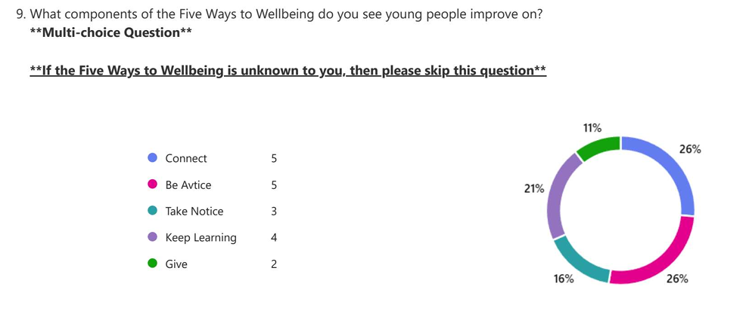
(Figure 1)

However, whilst there are many benefits to taking part in sports and fitness such as increased well-being, there can be negative effects as Golshani et al. (2021) states taking part in an excessive amount of exercise, can lead to the lack of sleep, while Wang et al. (2026) explains it can lead to “morbid exercise behaviour”.

How accessible is sports and fitness to young people?
When researching the accessibility that young people have to taking part in sports and fitness, Cronin (2025) states that whilst there is access, family’s from low-income backgrounds may not be able to afford this luxury. Dodd-Reynolds et al. (2025) suggest that the barriers to sports and fitness can also be historical, while Rowinska et al. (2025) states the uncertainty of feeling safe when participating in sports.
Whilst this is apparent, the researcher had sent questioners to those who may work with such individuals to gain their insight. Participant F had stated
“Ensure that you work with partners who have experience and expertise in offering adapted sessions in order to ensure their needs are met and offer mixed ability sessions to promote inclusion. Ensure that you have the correct equipment and people delivering the sessions to promote equal opportunities and adapt sessions where possible”.
Whilst participant B stated:
“By understanding the condition of the individual I’m working with and speaking to other professionals, I can generally differentiate actives, so the aim or target is achievable for the participants eg. a young person with Celebral Palsy may use sponge balls for rugby and play tag instead of contact sport”.
Other finds from the questioner on accessibility was that participant C has stated “Know your audience, tailor sessions which is open and adaptable to all needs”. And participant D mentioned “Learning aids, specialist access to facilities, adapted games”.
One aspect that is considered to be a barrier with young people taking part in sports activities is the rising cost of living that is currently a crisis. Participant G stated
“Absolutely, rising costs of accessing sports clubs is something that worries me, especially with the cost of living crisis. I am worried those most vulnerable will be priced out of being able to play sport regularly”.
This is a reoccurring theme when asked “Do you, as a professional believe that Sports and Fitness should be accessible to all young people?” in the questioner. Participant A states “Yes, at a low or no cost” whilst participant C suggest that
“Yes I feel that all sporting and fitness activity should be a free option for all children and young people from a very young age to encourage belonging, teamwork and communication”.
When it comes to how much sports and fitness is available as an intervention with the participants who answered this questioner three of them stated that they offer sports and fitness more than three times a week.

To conclude, there is research and data available to support on sport for all young people, however youth workers need to manage and utilise this to make it accessible to all young people, to learn from each other and to improve the support available. Especially for the young people who may not be able to afford extra curriculum sporting activities or those who may had additional needs.

- DISCUSSION OF RESULTS
In this chapter, the researcher will interpret and make links through the gathered research data, followed by creating discussion points for the final chapter corresponding back to the research question, ‘how youth workers can use sports and fitness to positively impact young people’s well-being’.
Whilst there are similar links of why sports and fitness have an impact on the wellbeing of young people, there was evidentially a lack of knowledge around how youth workers can use this as an intervention in a setting such as, a sports group and/or youth club. Following a structure, there will be links made to the existing literature interpreted by others, followed by links with the raw data collected as part of this research process. To finish, there will be an overall summary stating key factors of this conducted research and this will be the starting point for the discussion in this final chapter, suggesting important factors that can be used to implement practice around sports, fitness and the overall well-being of young people, as well as the limitation to this research.

Links made between exciting literature.
In the research gathered, there were similar links between existing data of the importance of sports and fitness for the well-being of young people, cited by many authors including Côté and Fraser-Thomas (2007, cited in Laurier et al., 2024) and WHO (2022), who suggested that the impact of well-being on the adolescence brain was of a positive effect. This was a clear link throughout the research already present. Another theory was the decline of adolescence taking part in sports and fitness, noted by Herting and Chu (2017) and WHO (2022), again making similarities. The Royal College Of Psychiatrists (2022) and The Mental Health Foundation (2026) also made similarities about the impacts of sports and fitness and through-out their research data all made similar links with Sports Wales (2023) who stated the social impacts of sports had a positive impact on the well-being of young people.
However, negative impacts were also found in Golshani et al.’s (2021), Wang et al. (2026) and Mind’s research (2023), who all stated there could be a mental health decline of over exercising, which could result in body dysmorphia and eating disorders, posing a serious health concern within young people.
The accessible needs of young people to take part in sports and fitness discussed in Dodd-Reynolds et al. (2025) and Rowinska et al.’s (2025) research, both highlighted the historical impacts of young people involving the cost of living. Cronin (2025) and Rowinska et al. (2025) also had similar links with the feeling of being unsafe whilst participating in sporting activities. Barber (2021) and Katsarova (2021) suggested that whilst sports and fitness was inclusive, there were still aspects that made an impact such as, discrimination, religion and disabilities, this hindered the participation of young people taking part in sporting activities.
Whilst there was evidence which supported the subject of sports and fitness making clear links between the physical aspects and the mental health and wellbeing of adolescence, there was a lack of evidence of how youth workers could use sports and fitness as an intervention. Whilst it is often seen in a sports setting with young people or a youth club which have sports activities available, there is space for further research. This suggests to the researcher that sports and fitness is not primarily used as an intervention.
Links made in the raw data.
When collecting raw data, the researcher used a qualitative approach of getting feedback through the form of a questionnaire, this was particularly useful for identifying the links within the research questions and the relation to youth work practice.
One noticeable similarity was the age group of the young people the sport professionals worked with. As seen below (Figure 2), the graph suggests that 75% of the participates worked within the age range of eleven to eighteen.
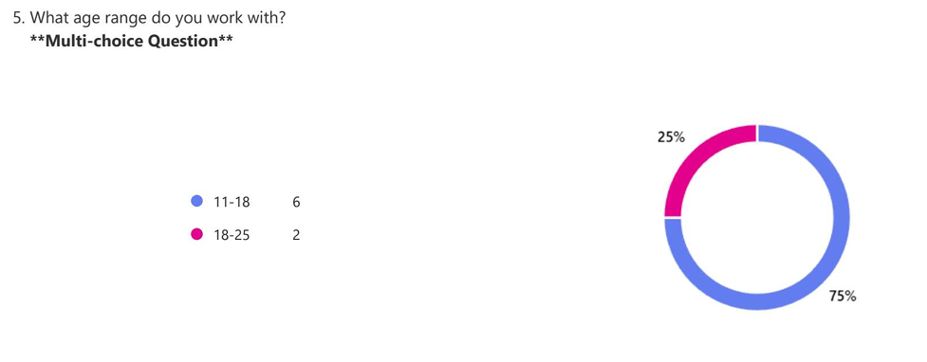
(Figure 2)
With that being said, there was a gap with the eighteen to twenty-five year olds taking part in sporting activities, leaving out transition of adolescent to adulthood. Youth workers use the framework of the Five ways of well-being (Aked et al., 2008) and in accordance’s to this, one of the questions asked was what components do you see young people improve on in relation to the five ways of wellbeing?
As the graph below (Figure 3) shows, only five out of the seven professionals answered this question and with that being said, only connect and be active were voted five times. This shows a consistency of results when engaging young people in sports and fitness activities. This leaves for further research into the lack of noticeable changes with the sections of take notice, keep learning and give. Whilst this is down to one’s own view and perceptive, the graph does suggest that these sections are still seen throughout.
(Figure 3)
The last similar findings were that of the impact that sports and fitness had on young people. As shown in the graph below (Figure 4), three of the major impacts were physical health, mental health and the social development between peers. This is what most of the research from Sports Wales (2023), Côté and Fraser-Thomas (2007, cited in Laurier et al., 2024) and WHO (2022) found. The Royal College Of Psychiatrists (2022) and The Mental Health Foundation (2026) also implied that young people gain benefits from these activities. However, close behind is the social development with adults and the interpersonal skills.
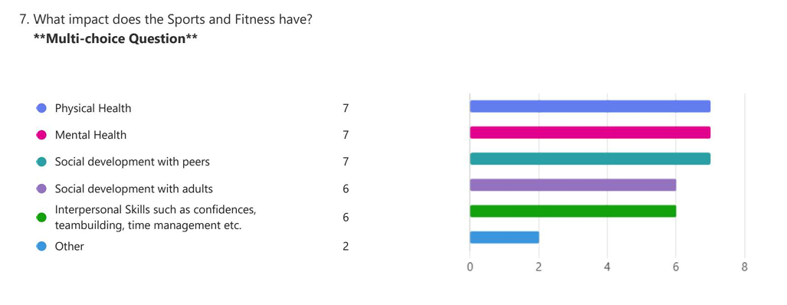
(Figure 4)

Summary of key findings and Limitations.
There were many limitations to this research process. To begin, the sample size of this research was of a small quantity, there were seven out of twelve professionals who responded to the questionnaire and there was a focus group of young people that did not commence.
Moving forward, the suggestion’s to the researcher is to remain consistent with young people when it came to explaining the paperwork of the research, also to give the young people enough time to engage with the researcher to maintain a professional relationship. These in return will improve the delivery of the research focus group.
Other limitations were the time scale of the research. Giving a longer time period, there would be more scope for further research allowing participants to get acquainted with the process of a research project. This leads for further research on how to conduct a research project, how to manage participants and the limitations of the researcher.
Another suggestion would be to carry out deeper analysis and research methods in order to construct a more powerful research project to inspire change for framework.
To summaries, this chapter shows there were gaps within the research around how youth workers could use sports and fitness as a intervention. There were similar links between sports and fitness on the wellbeing and mental health issues of young people, and this was a strong lead moving forward for further research. More so within the field of youth work, there were similarities between sports and fitness and the use within youth work practice where, that be in a youth club setting or sports group. However, the lack of youth work knowledge by two sports coaches was clear as they did not answer question nine of the questionnaire on the Five ways of well-being (Aked et al., 2008).

To conclude, there is a need for further research within the links of sports and fitness and youth work. Potentially making a framework that supports the needs of young people in a safe environment to encourage growth and knowledge around these subjects. This links in with the Well-being of Future Generations (Wales) Act (2015) working to create a healthier Wales.

- CONCLUSION AND RECOMMENDATIONS
In this final chapter there will be a summary of the main findings, revisiting the aim and objectives of the research and an interpretation of the significant findings. Secondly, there will be a discussion point of what has been learned from the research, highlighting the implications that can correspond to theory, practice and policy. This section will also highlight recommendations on the next stages for further research. Thirdly, there will be recommendations illustrating how this research should be used, recommendations linked to what has been found within the research and who this can be interpreted for, be that policy makers, practitioners, youth originations and researchers. This chapter will then finish with a reflection of the researcher in their professional contexts of what they may conduct differently.
The main findings of this research was that Côté and Fraser-Thomas (2007, cited in Laurier et al., 2024) and WHO (2022) produced research on the impact of sport and fitness on the brain and development of adolescents. Also, Herting and Chu’s (2017) and WHO (2022) suggested that there was a decline of participation in sports and fitness of young people. Furthermore, Golshani et al.’s (2021), Journal of Affective Disorders, Wang et al. (2026) and Mind (2023), made findings of the negative impact of over exercising and mental health issues around the subject of sports and fitness.
The aims of this research were to find ways that sports and fitness could be used in practice and how this could positively impact young people’s over all wellbeing in relation to youth work theories. The objectives were for the researcher to hand out questionnaires to other professionals in order to collect individual responses before gathering findings from other research pieces. The researcher also conducted a focus group with young people to seek feedback on how sports and fitness could impact their mental and physical wellbeing.

This ultimately challenged the researcher to gather data and present findings for arguments within the discussions in a set time limit. Interpreting the findings is a base layer of information needed in order for youth workers to implement sports and fitness as a means of intervention. The researcher found, there was potentially a lack of knowledge from some participants on the impact or theory needed, such as the Five ways of well-being (Aked et al., 2008) and The Well-being of Future Generations (Wales) Act (2015), as these are used in youth work practice, unless the youth worker or practitioner is in targeted provision or settings that allow for such interventions to happen. This leaves a gap of young people without access to particular interventions they may benefit from.
What has been learned from this research? To begin with, the benefits of sports and fitness is profound on young people however, can be harmful under certain circumstances. Also, there is a decline of young people taking part in sports and fitness activities. With this, there are also a number of barriers that prevent young people from taking part.
The implications to theory is that there is not enough knowledge on the negative impacts of sports and fitness within the area of choice being South/West Wales, as raw data collection shows that practitioners only focus on the benefits. Similar links with practice, is that there needs to be more of an understanding of the negative impacts of participating in sports and that young people are becoming less engaged with sports and fitness within this area. This could impact other areas of a young person’s life such as turning to substance misuse, anti-social behaviour or youth offending. In regard to policies, the impact is not of a mass scale however, there needs to be more understanding of the importance of sports and fitness and how this can be used as an intervention for young people to improve their lives linking to the main policies such as, the Five ways of well-being (Aked et al., 2008) and The Well-being of Future Generations (Wales) Act (2015).
The recommendation for further research is that there needs to be investigations into the decline of young people’s participation in sports and fitness. Also, how to prevent the negative impacts of over exercising on the mind and physical health of young people. Other recommendations could be to design a framework or programme which could implement sports and fitness as an intervention. Other recommendations would be to have more participants within the research, have a longer time frame in order to collect more data and to have a more critical view on the data to shape a more improved conclusion.
This research could be used to improve what already has been discovered with the importance of young people’s wellbeing as a priority, including improving the services they can acquire and used by practitioners, policy makers and organisations to improve services. In order to improve interventions, this research could be a starting point for researchers and organisations to have more of an understanding of the benefits sports and fitness has on young people and their wellbeing. In order to improve this research, there has to be deeper research within this field to enhance the knowledge that is available to all, including practitioners, young people and their families. In regard to the barriers young people face within sports and fitness, policy makers could make use of the findings to ensure that there is more of an inclusive priority when it comes to young people’s activity spaces such as sports halls, sports clubs, schools and local gyms. This should link and include other policies that are already known to youth work practitioners such as Youth Work in Wales: Principles and Purposes (2022) and The National Youth Work Strategy for Wales for a better understanding and knowledge to improve services.
In regard to further research, the researcher will take a deeper look into the methodology of research to enhance a deeper knowledge of methodology within the subject area of research. The time scale of what can be achieved will also be looking are to improve the data collection and analysis, this in turn will promote a more confident conclusion within the research fiel. Lastly the critical thinking of such proposals will also be read upon to enhance the thinking and understanding of authors/researches or the tended outcome of such research. These are just some of what could be revised for the future, intrigued by the scope for better improvements resulting in a more widespread effete of the research within the Youth Work sector.
To end this conducted research, the researcher asks, ‘what could change or improve to better the services of young people’? With the pressure that young people face within modern society this could be beneficial. The purpose and significance of this research is to inspire others to make changes to their practice when young people’s mental health and wellbeing are affected. Also, to spread awareness and information that is already available to improve practice. The significance is to make change in order to help and improve the welfare of young people. These findings contribute to the youth work field by illustrating that the needs of young people can improve with interventions which are not in frame works or policies as much as other interventions.

- REFERENCES
Activity Alliance (2025) A game of inequality: The reality of sporting dreams for young disabled people. Available at: 27837_Activity_Alliance_Paralympic_Dream_Deficit_Report_Accessible_original.pdf (Accessed: 17 April 2026).

Aked, J., Marks, N., Cordon, C. and Thompson, S. (2008) Five ways to wellbeing. Available at: Microsoft Word - Five_ways_to_well-being the evidence.doc (Accessed: 22 April 2026).

Barber, W. (2016) ‘ Inclusive and accessible physical education: rethinking ability and disability in pre-service teacher education’, Sport, Education and Society, pp.1357-3322. Available at: http://dx.doi.org/10.1080/13573322.2016.1269004

BBC Sport (2022) Cost of living crisis: Young will miss out on sport, community groups warn. Available at: Cost of living crisis: Young will miss out on sport, community groups warn - BBC Sport (Accessed: 22 April 2026).

Benefits of Youth Sports (2020) Benefits of Youth Sports: Developed by the PCSFN Science Board. Available at: Benefits of Youth Sports (Accessed: 16 May 2026).

BERA (2024) Ethical Guidelines for Educational Research, fifth edition. Available at: Ethical Guidelines for Educational Research, fifth edition (2024) | BERA (Accessed: 9 May 2026).

Children’s Commissioner for Wales (2018) Full lives: Equal Access. Available at: Full-Lives-Equal-Access.pdf (Accessed: 16 May 2026).

Cronin, K. (2025) Challenges and barriers to Young People Accessing Sport: Perspective - What can we do? Available at: Challenges and Barriers to Young People Accessing Sport: An Academic Perspective – What can we do? – Graduate School of Sport and Professional Practice Blog (Accessed: 2 May 2026).

Crouch, M. and McKenzie, H. (2006) ‘The logic of small samples in interview-based qualitative research’, Sage Journals, 19(4), Available at: https://journals.sagepub.com/doi/pdf/10.1177/0539018406069584?download=true

CWVYS (2022) Youth Work in Wales: Principles and Purposes. Available at: Youth Work in Wales – CWVYS Youth Work in Wales – CWVYS (Accessed: 9 May 2026).
Denscombe, M. (2017) The Good Research Guide: For Small-Scale Social Research projects. London: Open University Press.
Dewis Cymru (2023) Taking part in sport. Available at: Taking part in sport - Dewis Wales (Accessed: 9 May 2026).

Dodd-Reynolds, C., Griffin, N., Kyle, P., Scott, S., Fairbrother, H., Holding, E., Crowder, M. and Woodrow, N. (2024) ’Young people's experiences of physical activity insecurity: a qualitative study highlighting intersectional disadvantage in the UK’, BMC Public Health 24(813). Available at: https://doi.org/10.1186/s12889-024-18078-9

Edlund, J.E. and Nichols, A.L. (2024) The Cambridge Handbook of Research Methods and Statistics for the Social and Behavioral Sciences: Volume 2: Performing Research. Cambridge: Cambridge University Press.

Faber, J. and Fonseca, L/M/ (2014) ‘How sample size influences research outcomes’, Dental Press Journal of Orthodontics, 19(4), pp. 27-29. Available at: https://pmc.ncbi.nlm.nih.gov/articles/PMC4296634/

Flores, K.S. (2007) Youth Participatory Evaluation: Strategies for Engaging Young People. London: John Wiley & Sons.

Future Foundation (n.d.) Acting Today for a n Active Tomorrow: Trends which will transform sport in Wales. Available at: Sport Wales future foundation.pdf Accessed: 27 April 2026).

Future Generations Commissioner for Wales (n.d.) Breaking barriers to inclusive sports. Available at: Breaking barriers to inclusive sports - Future Generations Wales (Accessed: 27 April 2026).

Glamorgan Newsletter (2026) Welsh Sports Leaders Warn Forcing Children to Choose Between Sports Could Harm Participation Story. Available at: Welsh Sports Leaders Warn Forcing Children to Choose Between Sports Could Harm Participation Story (Accessed: 27 April 2026).

Golshani, S., Najafpour, A., Hashemian, S.S., Goudarzi, N., Shahmari, F., Golshani, S., Babael, M., Firoozabadi, K., Dursteler, K.M. and Bruhl, A.B. ‘When Much Is Too Much- Compared to Light Exercises, Heavey Exercises Report More Mental Health Issues and Stress, but Less Sleep Complaints’, Healthcare, 28(9-10), pp.1298. doi: 10.3390/healthcare9101289

GOV.UK (2025) Barriers and enables to participation in youth activities: executive summary. Available at: Barriers and enablers to participation in youth activities: executive summary - GOV.UK (Accessed: 27 April 2026).
Haverkamp, B.F., Wiersma, R., Vertessen, K., van Ewiji, H., Oosterlaan, J. and Hartman, E. (2020) ‘Effects of physical activity interventions on cognitive outcomes and academic performance in adolescents and young adults: A meta-analysis’, Journal of Sports Sciences, 38(23),, pp. 2637-2660. Available at: https://doi.org/10.1080/02640414.2020.1794763
Herting, M.M. and Chu, X. (2017) ‘Exercise, cognition, and the adolescent brain’, Birth Defects Res, 109(20), pp.1672-1679. Available at: doi: 10.1002/bdr2.1178.

Katsarova, I. (2021) Fighting discrimination in sport. Available at: Fighting discrimination in sport (Accessed: 4 May 2026).

Kilvington, D. (2024) ‘Understanding and challenging discrimination in sport’, Cogent Social Sciences, 10(1), pp. 1-5. Available at: DOI:10.1080/23311886.2024.2422011
Laurier C, Pascuzzo K, Jubinville V, Lemieux A. (2024) ‘Physical activity and its benefits on adolescents' mental health through self-esteem’, Front Child Adolesc Psychiatry, 16(3), pp. 1503920. Available at: doi: 10.3389/frcha.2024.1503920

Leșco, V. and Razmiret , V. (2024) ‘The Importance of Sports Activities in the Formation of Skills for an Active and Healthy Lifestyle in Young People’, Sciences of Human Kinetics, 17(66), pp.47-54. Available at: DOI:10.31926/but.shk.2024.17.66.2.5 Available at: (PDF) The Importance of Sports Activities in the Formation of Skills for an Active and Healthy Lifestyle in Young People

Lim, M.W. (2024) ‘What is Qualitative Research? An Overview and Guidelines’, Sage Journals, 33(2). Available at: https://journals.sagepub.com/doi/10.1177/14413582241264619

Mahindru, A., Patil, P. and Agrawal, V. (2023) ‘Role of Physical Activity on Mental Health and Well-Being: A Review’, Cureus, 15(1), pp: e33475. Available at: doi: 10.7759/cureus.33475

Mental Health Foundation (2024) Moving More is Good for our Mental Health so, What’s Stopping Us? Available at: MHF - MHAW Movement - Report 2024.pdf (Accessed: 16 May 2026).

Mental Health Foundation (2026) How to improve your mental health using physical activity. Available at: How to improve your mental health using physical activity | Mental Health Foundation (Accessed: 2 May 2026).

Mind (2023) Over-exercising and exercise addiction. Available at: Over-exercising and exercise addiction (Accessed: 4 May 2026).

Montero-Marin, J., Hinze, V., Mansfield K., Slaghekke, Y., Blakemore, J., Byford, S., Dalgleish, T. and Greenberg, M.T. (2023) ‘Young People’s Mental Health Changes, Risk, and Resilience During the COVID-19 Pandemic’, JAMA Netw Open, 6(9), pp. 2335016. Available at: doi:10.1001/jamanetworkopen.2023.35016

NHS (2024) Physical activity guidelines for children and young people. Available at: Physical activity guidelines for children and young people - NHS (Accessed: 10 May 2026).

Paolucci, E.M., Loukov, D., Bowdish, M.E. and Heisz, J.J. (2018) ‘Exercise reduces depression and inflammation but intensity matters’, Biological Psychology, 133, pp.78-84. Available at: Exercise reduces depression and inflammation but intensity matters - ScienceDirect
Rodriguez-Ayllon, M., Cadenas-Sánchez, C., Estévez-López, F., Mora-Gonzalez, J.M., Migueles, J.H., Molina-García, P. and Henriksson, H. (2019) ‘Role of Physical Activity and Sedentary Behavior in the Mental Health of Preschoolers, Children and Adolescents: A Systematic Review and Meta-Analysis’, Sports Med, 49, pp. 1383–1410. Available at: Role of Physical Activity and Sedentary Behavior in the Mental Health of Preschoolers, Children and Adolescents: A Systematic Review and Meta-Analysis | Sports Medicine | Springer Nature Link
Rowinska, K., Siembab, K., Bednarczyk, D., Bialeta, J., Napieralska, A., Cernohorska, A., Garbarczyk, W. and Jurkiewicz, M. (2025) ‘Effectiveness of Sports-Based Interventions for Mental Health in At-Risk Youth: A Systematic Review’, Quality in Sport, 38(58095), pp. 2450-3118. Available at: https://doi.org/10.12775/QS.2025.38.58095

Royal College of Psychiatrists (2022) Physical active, exercise and mental health for children and young people. Available at: Physical activity, exercise and mental health for young people (Accessed: 4 May).

Smith, K.A., Huebner, C., Loughran, T., Eichhorn, J. and Mycock, A. (2025) ‘Young people’s engagement in online research: challenges and lessons from conducting focus groups with young people online’, Journal of Youth Studies, 28(4), pp. 586-600. Available at: Full article: Young people’s engagement in online research: challenges and lessons from conducting focus groups with young people online

Sports Wales (2023) Social Return on Investment (SROI) of Sport in Wales 2021-22. Available at: Social Return on Investment (SROI) of Sport in Wales 2021-22 | Sport Wales (Accessed: 4 May 2026).

Sports Wales (2026) Sport and Active Lifestyles: State of the Nation report 2024-25. Available at: Sport and Active Lifestyles: State of the Nation report 2024-25 | Sport Wales (Accessed: 17 April 2026).

Street Games (2025) The Health and Wellbeing of Young People in Low Income Areas in England and Wales. Available at: The health and wellbeing of young people in low income areas in England and Wales - StreetGames (Accessed: 9 May 2026).

The Pulse (2025) Issues facing grassroots sport and the communities and young people it serves. Available at: Winter-2024-Pulse-Wales.pdf (Accessed: 9 May 2026).
UWTSD (2022) Research Ethics & Integrity Code of Practice. Available at: REICoP-July-2022.pdf (Accessed: 9 May 2026).
VanKim, N.A. and Nelson, T.F. (2013) ‘Vigorous Physical Activity, Mental Health, Perceived Stress and Socializing among College Students’, Am J Health Promot, 28(1), pp. 7-15. Available at: doi: 10.4278/ajhp.111101-QUAN-395

Wang, X., Yang, X., Tao, T., Dong, D., and Yu, D. (2026) ‘The association between exercise addiction and mental health problems: A systematic review and meta-analysis’, Journal of Affective Disorders’, 393, pp. 120026. https://doi.org/10.1016/j.jad.2025.120026

Well-being of Future Generations (Wales)Act 2015 (anaw 2). Available at: Well-being of Future Generations (Wales) Act 2015 (Accessed: 17 April 2026).

Welsh Government (2022) Wellbeing of Wales, 2022: children and young people’s wellbeing. Available at: Wellbeing of Wales, 2022 (children and young people’s wellbeing): a Wales of vibrant culture and thriving Welsh language [HTML] | GOV.WALES (Accessed: 22 April 2026).

Welsh Government (2025) National Youth Strategy for Wales. Cardiff: Welsh Local Government Association.

Welsh Parliament (2022) Levelling the playing field: A report on participation in sport and physical activity in disadvantaged areas. Available at: Levelling the playing field: a report on participation in sport and physical activity in disadvantaged areas (Accessed: 22 April 2026).

World Health Organization (WHO) (2022) Global status report on physical activity 2022. Available at: The Global Status Report on Physical Activity 2022 (Accessed: 22 April 2026).

Youth Sport Trust (2022) Evidence Paper – The Link Between Physical Activity and Attainment in Children and Young People. Available at: pe-and-attainment-evidence-paper-january-2022.pdf (Accessed: 16 May 2026).

Youth Sport Trust (2023) The benefits of sport participation and physical activity in schools. Available at: - Youth Sport Trust (Accessed: 2 May 2026).

Youth Support Trust (2025) Class of 2035 report. Available at: yst_class_of_2035_report_2025_final.pdf (Accessed: 27 April 2026).

Youth Work in Wales Review Group (2022) Youth Work in Wales: Principles and Purposes. Wales: CWVYS.

- APPENDICES

  - Appendices 1 Ethics Form

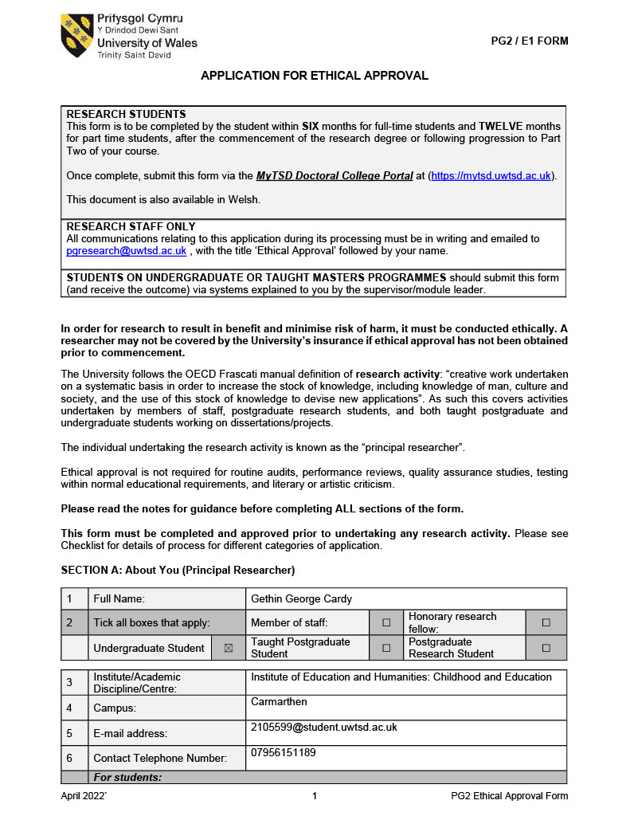
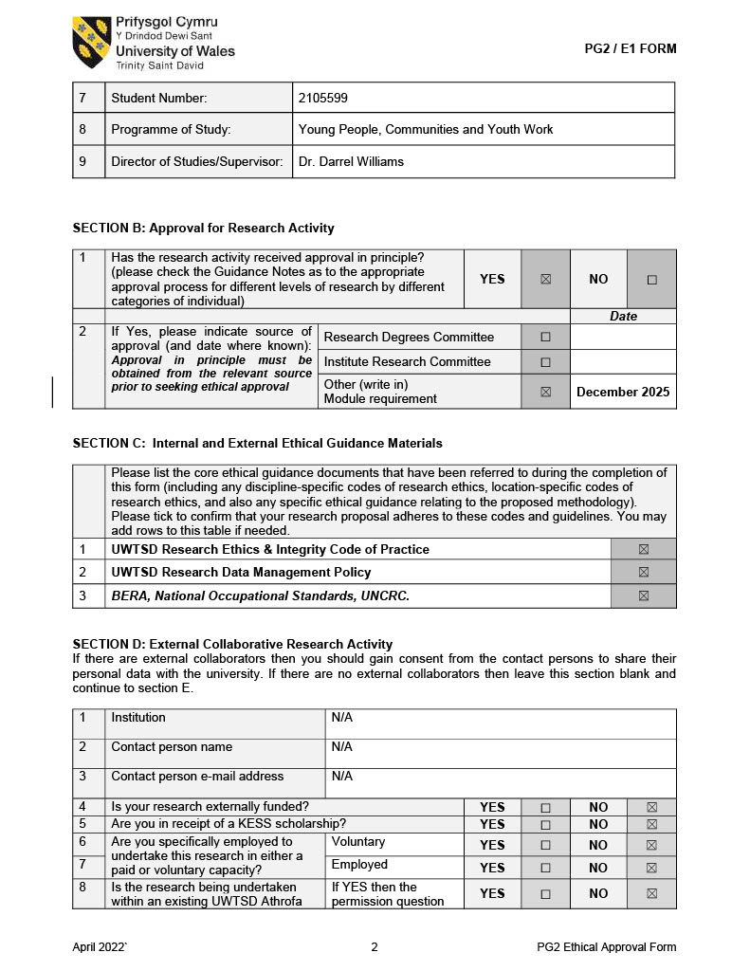

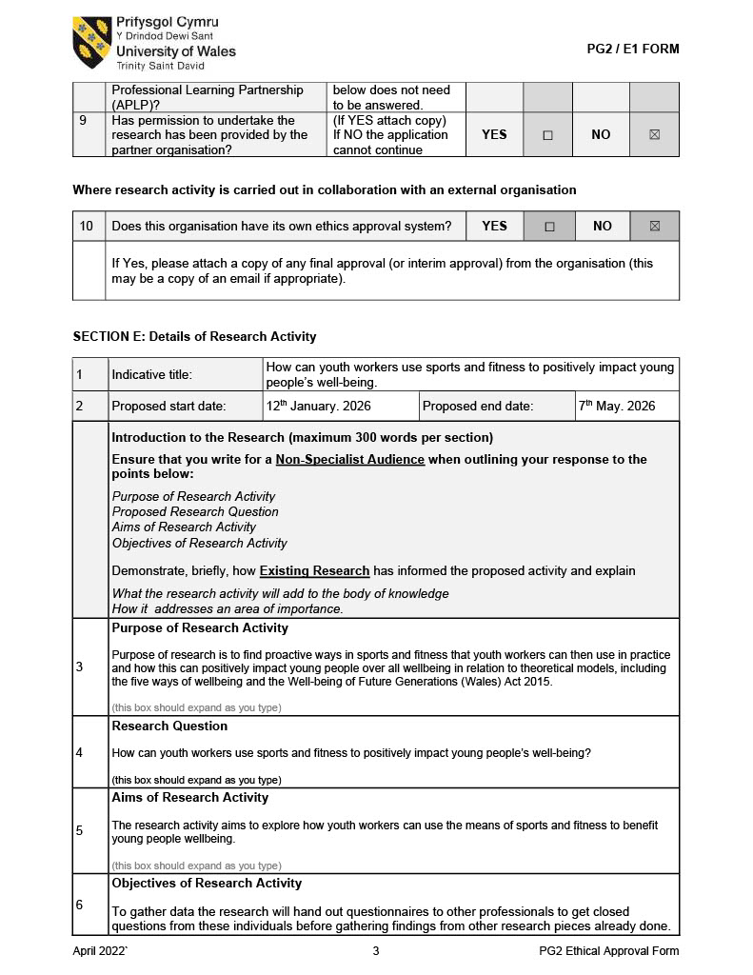

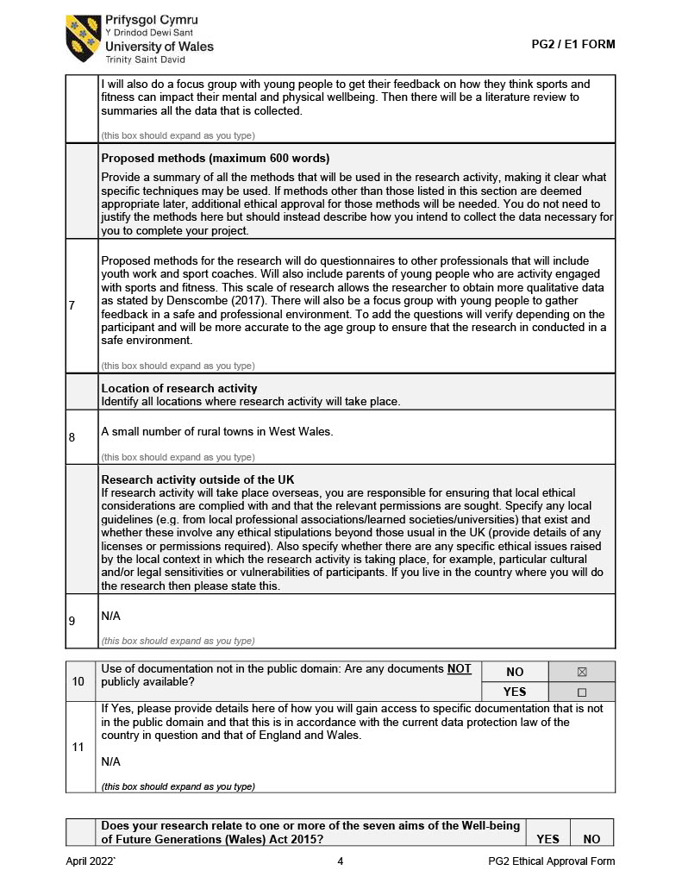

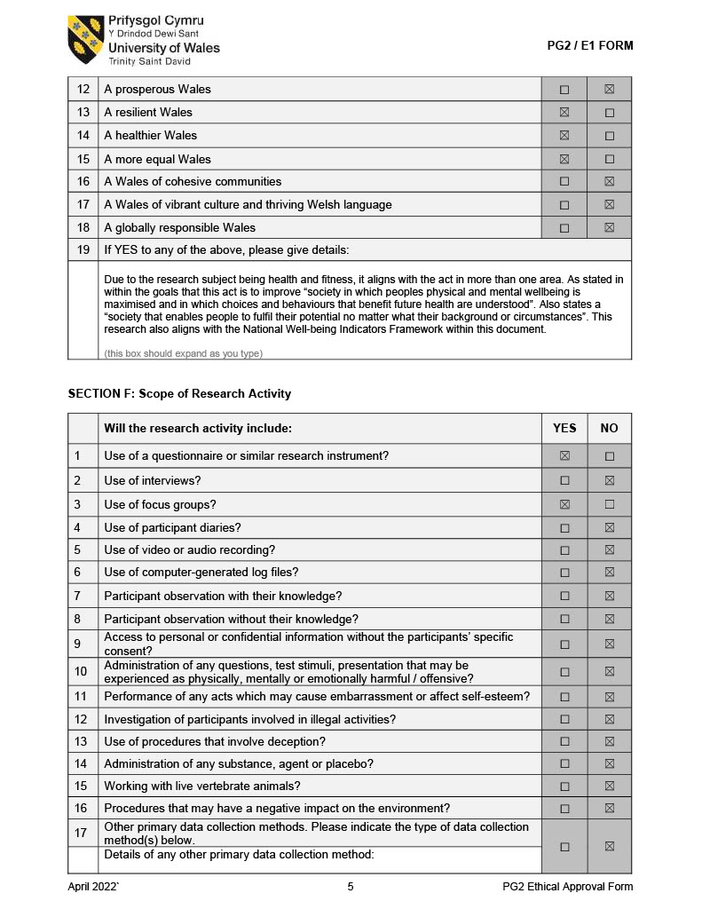

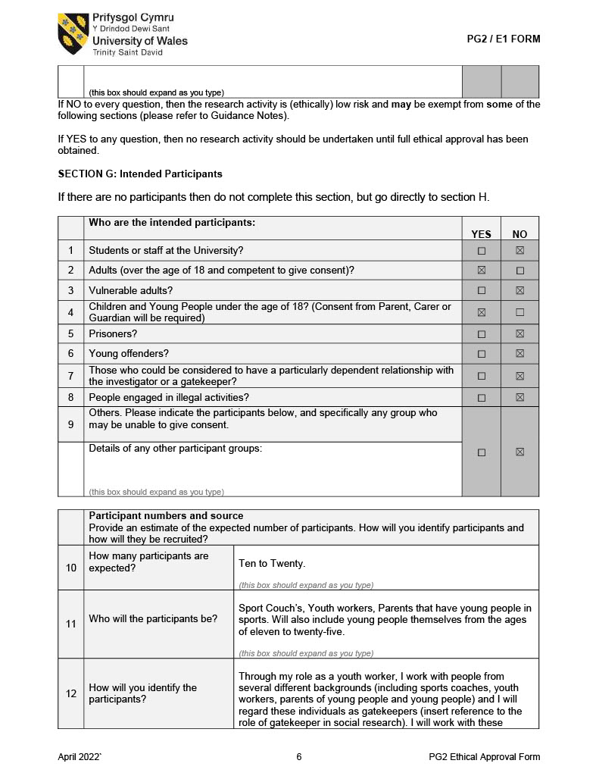

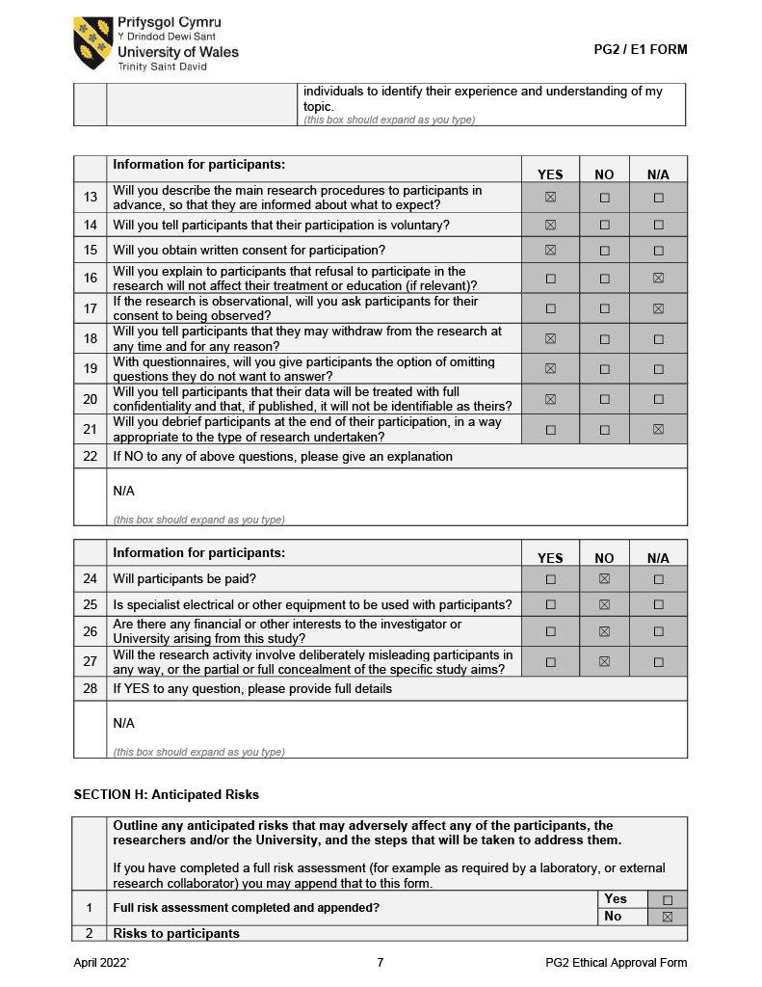

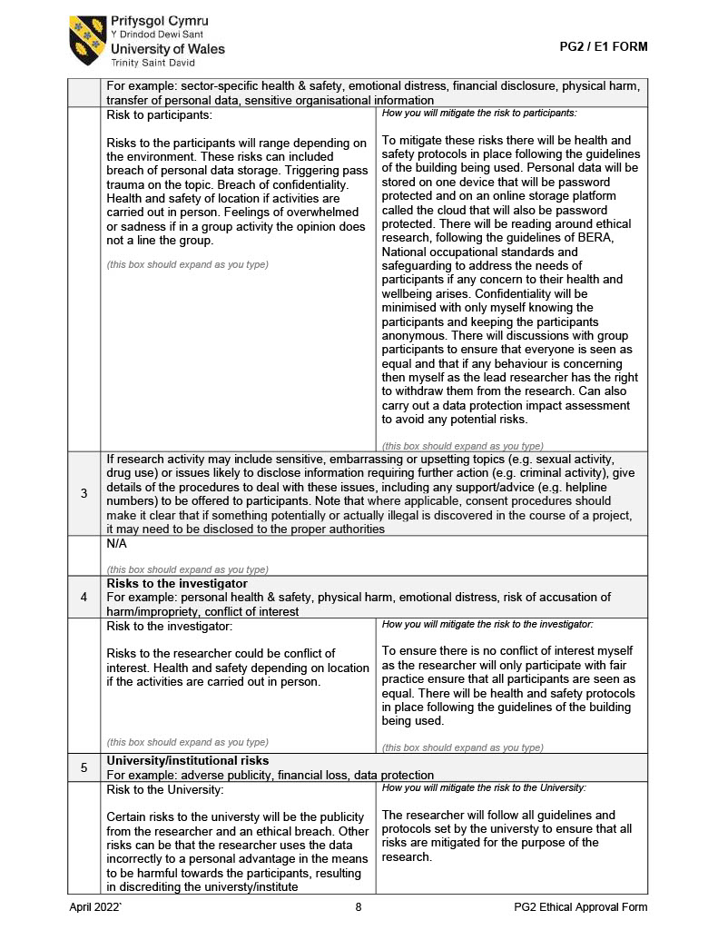

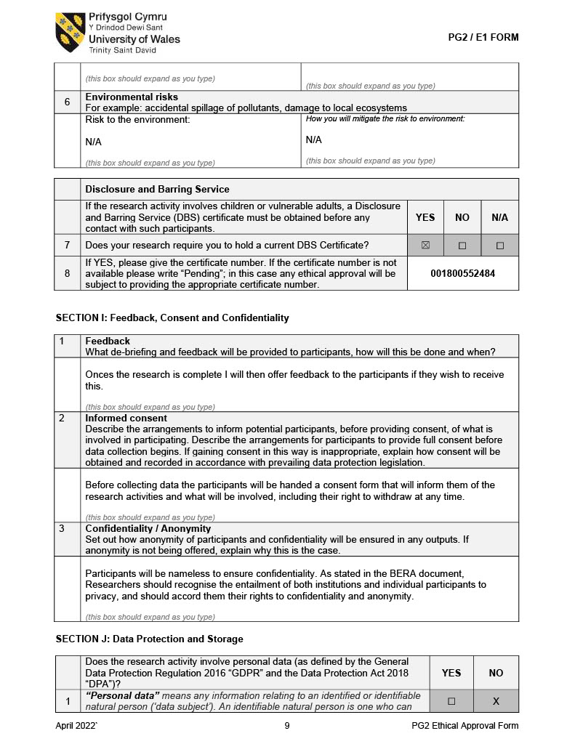

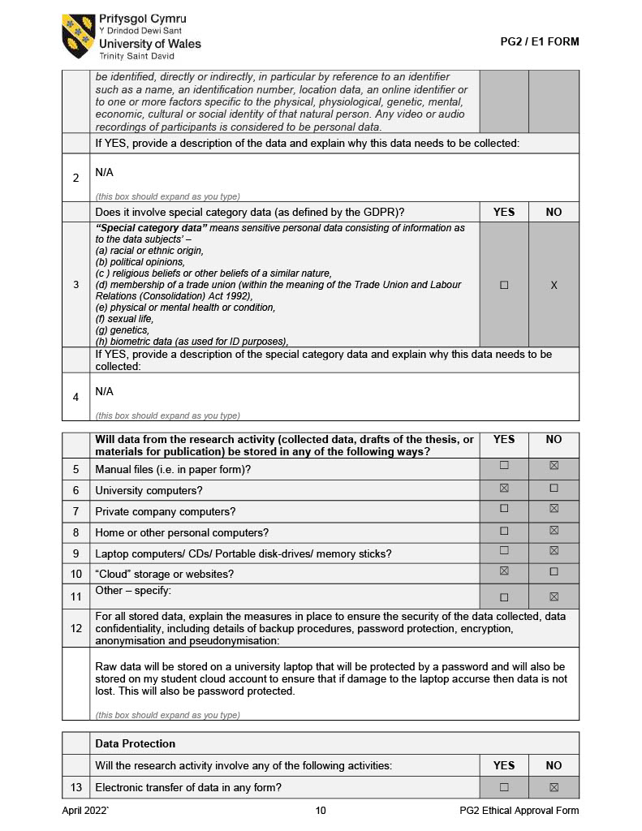

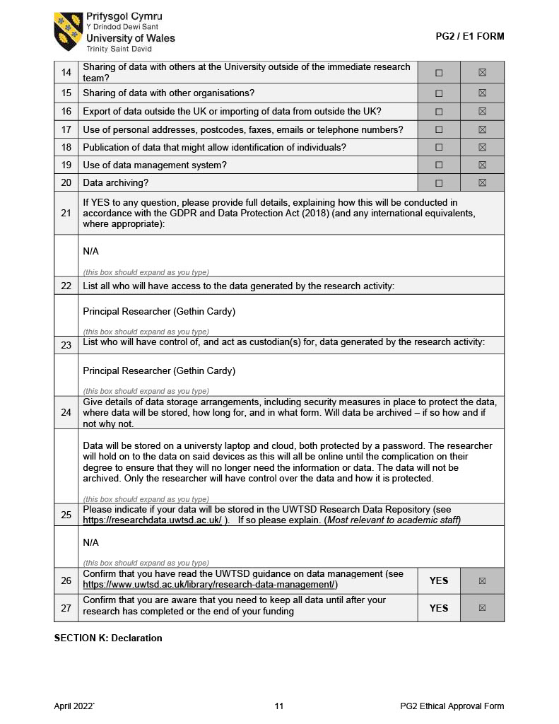

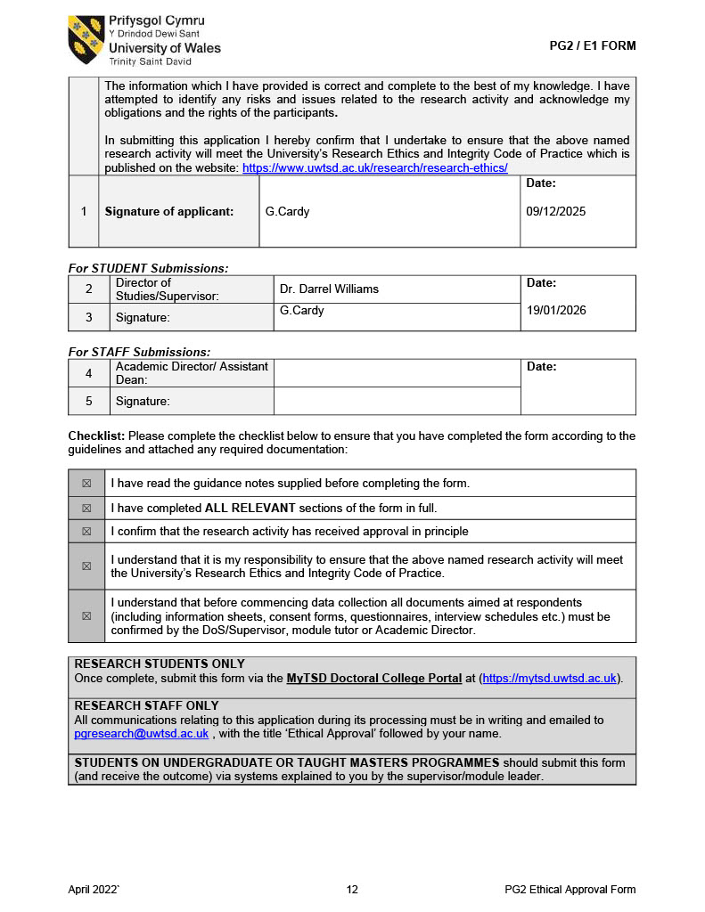

  - Appendices 2 Information sheet and consent form for Professionals.

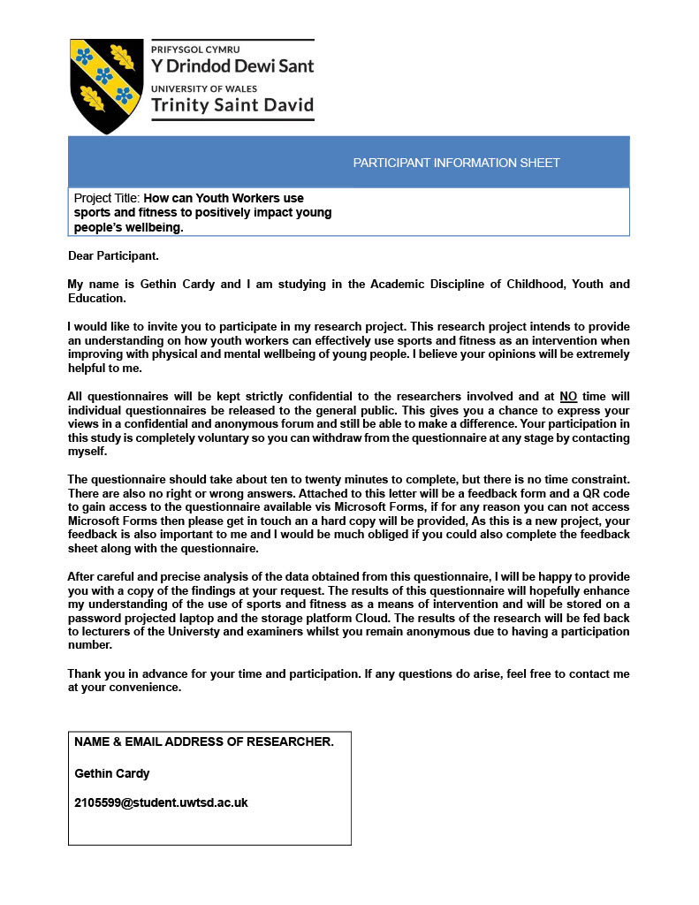
Information Sheet For Practitioners Page One.

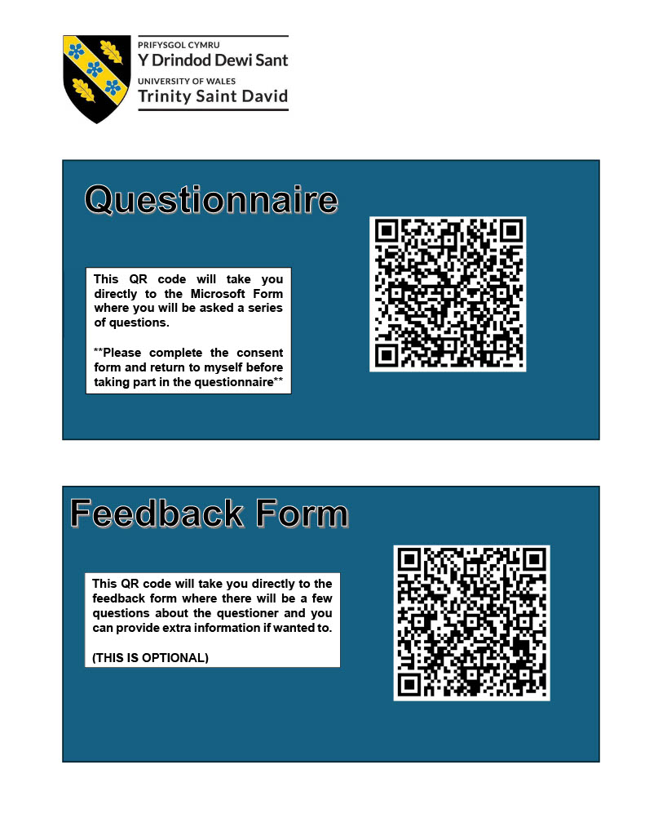
Information Sheet For Practitioners Page Two.

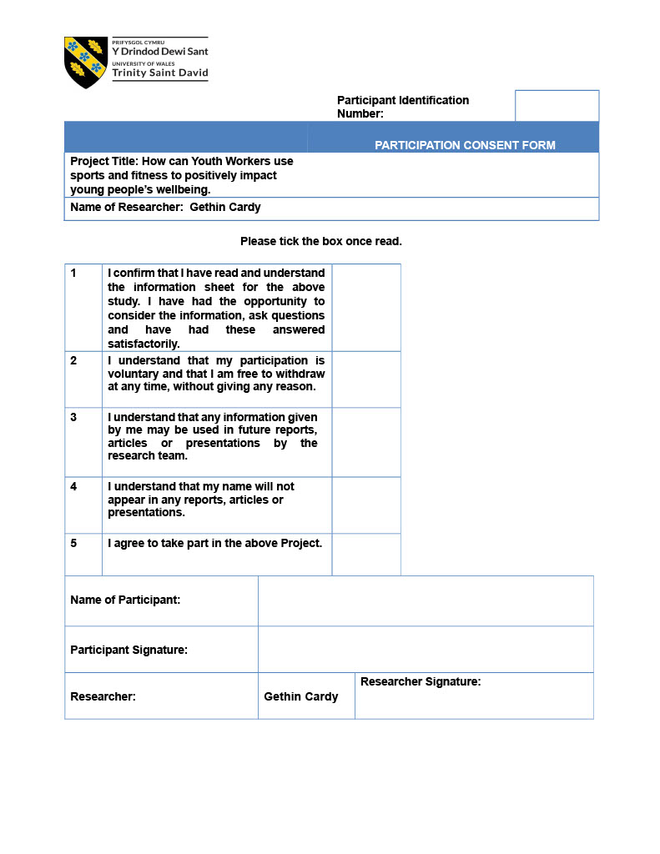
Consent Form For Practitioners Page One.

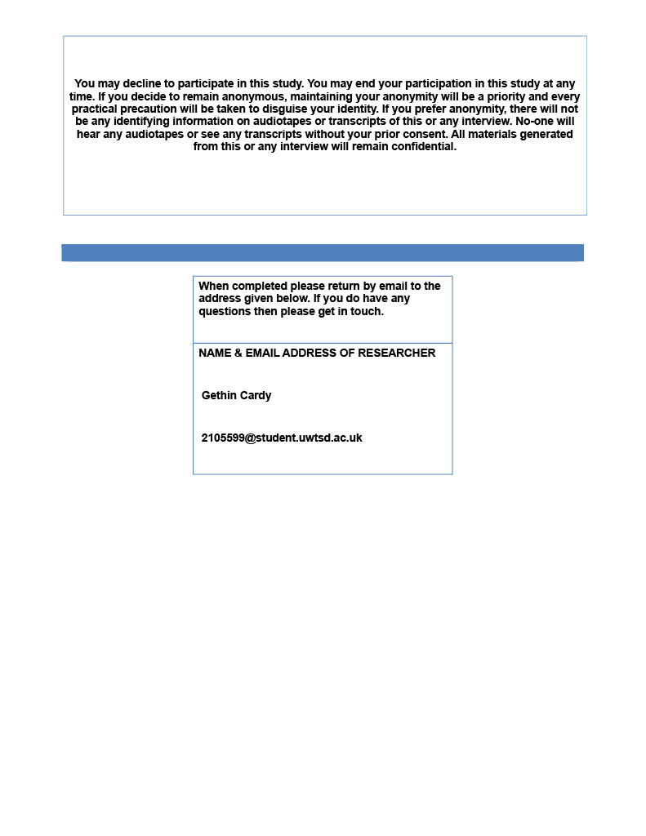
Consent Form For Practitioners Page Two.

  - Appendices 3 Information sheet and consent form for Young People

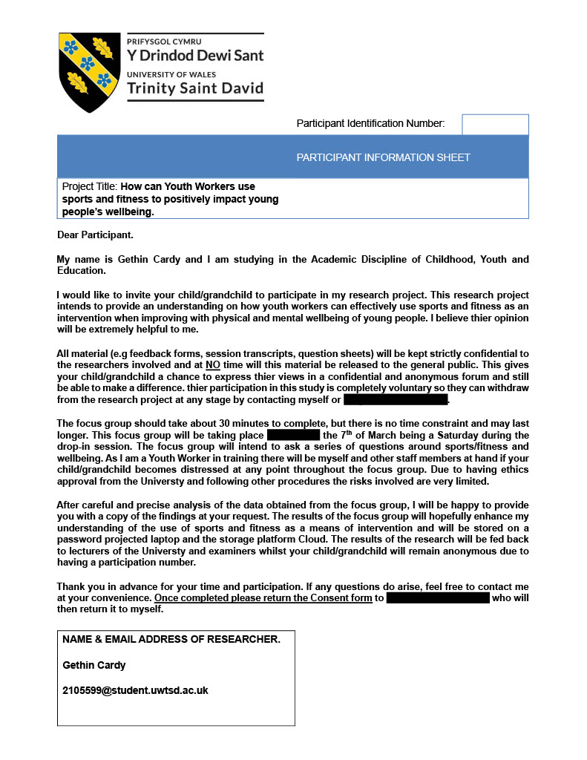
Information Sheet For Young People Page One.

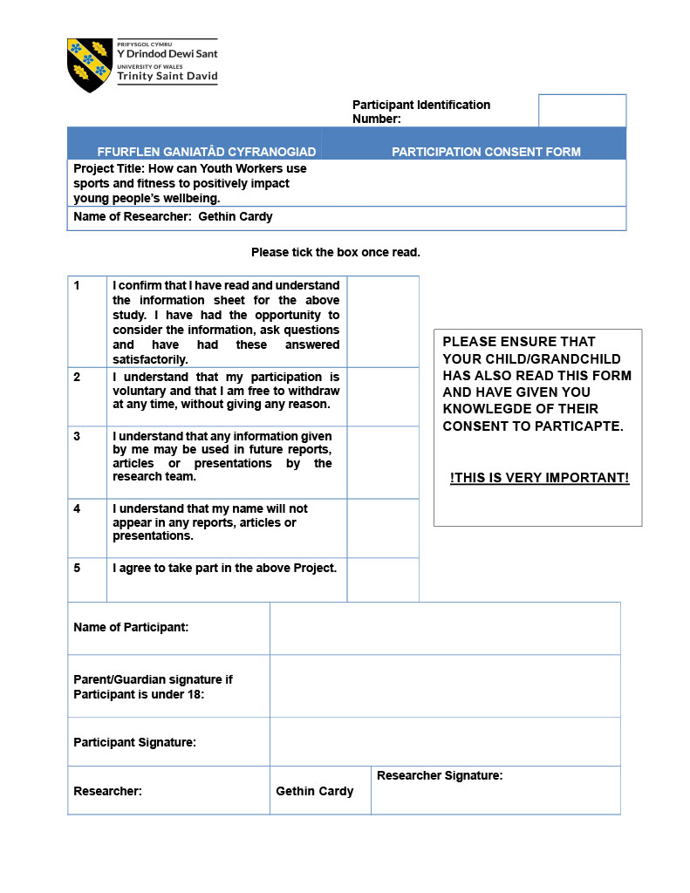
Consent Form For Young People Page One.

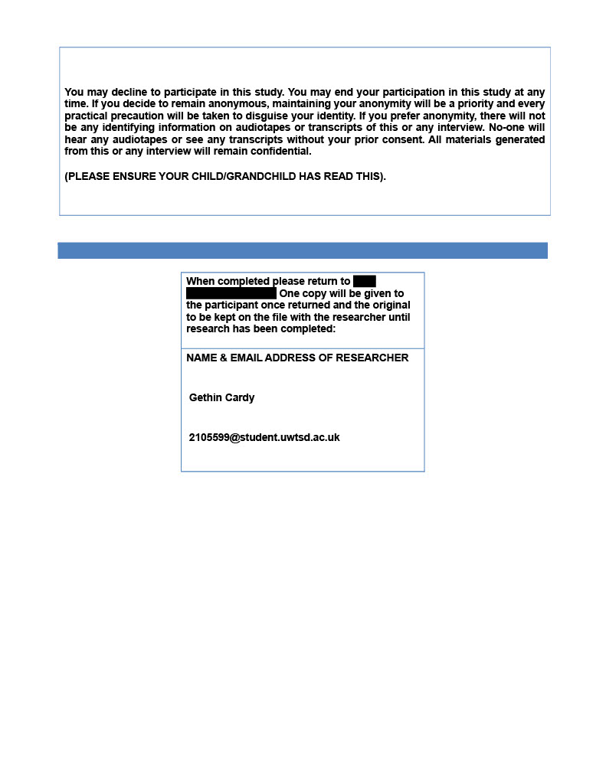
Consent Form For Young People Page Two.

