Person-Centred Care and Partnership Working in Dementia Care

STUDENT NAME:ANILA MANSOOR
STUDENT ID:2433628
Module Code: BMHP5016
ASSIGNEMEN Title: CRITICAL EVALUATION OF PERSON CENTRED CARE AND PARTNERSHIP WORKING
LECTURER:RIZWAN NADIM

Table of Contents
1. Introduction 1
2. Person-Centred Care: Conceptual Foundations, Benefits and Limitations 1
2.1 Definition and Key Principles 1
2.2 Benefits of Person-Centred Care 2
2.3 Critical Limitations 2
3. Critical Examination of a Theory Underpinning Person-Centred Care 3
3.1 Explanation of Kitwood’s Theory 3
3.2 Strengths of the Theory 3
3.3 Limitations and Critical Evaluation 3
4. Ethical Foundations of PCC and Partnership Working 4
4.1 Autonomy, Protection and Best Interests 4
4.2 Justice, Equality and Information Sharing 4
5. Critical Evaluation of Partnership Working 4
5.1 Definition and Theoretical Basis 4
5.2 Benefits of Partnership Working 5
5.3 Challenges and Critical Evaluation 5
6. Application to Dementia Care Practice 5
6.1 Person-Centred Care in Dementia Practice 5
6.2 Partnership Working in Dementia Practice 6
6.3 Critical Evaluation 6
7. Critical Analysis of Policy and Legislation 6
7.1 Rights, Autonomy, and Protection 6
7.2 Wellbeing, Personalisation and Equality 6
7.3 Integrated Working 7
7.4 Synthesis 7
8. Recommendations for Future Development 7
8.1 Staff Development and Communication 7
8.2 Service User Involvement and System Integration 7
8.3 Workforce Sustainability 8
9. Conclusion 8
References 9
Appendices 12

1. Introduction
Health and social care services work in a changing context due to population ageing, dementia, long-term conditions, and fragmented provision (Gubert, 2025). The key principles of person-centered care (PCC) are to focus on the person receiving care and to give them choice, control and support. Partnership working (PW) is about working with other professionals, agencies, families and carers to provide coordinated provision. This report critically examines theory, ethics, legislation, policy and practice of PCC and PW in the context of dementia care. Both are acknowledged as indicators of good-quality care, but may be hindered by staffing levels, lack of resources, and organizational fragmentation, thereby creating a gap between policy and practice.

2. Person-Centered Care: Conceptual Foundations, Benefits and Limitations
This section critically reviews the concept of person-centered care (PCC), its principles, advantages, and disadvantages in health and social care and relates this to individual's dementia care.

2.1 Definition and Key Principles
Person-centered care (PCC) is based on the premise that the needs, values, preferences, and lived experience of the person is at the heart of the care plan (Islam, 2022). Person-centered coordinated and enabling care is a focus of the NHS and Health Foundation, and also features in the approach to dementia care of Kitwood (Brooker, 2022). So PCC is more than clinical care; it takes a holistic approach to care, values and respects individuality, choice, empowerment and care.
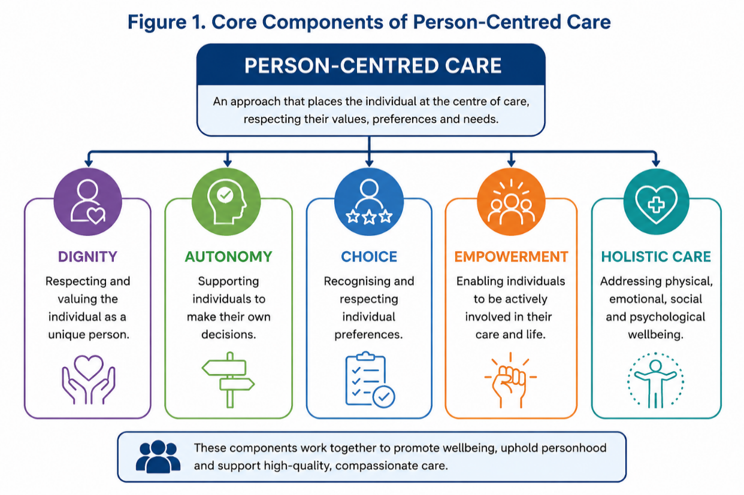
Figure 1 Core components of person-centred care

2.2 Benefits of Person-Centered Care
PCC provides benefits for the clinical, psychological and organizational level (Gustavsson et al., 2025). In practice, it can have a positive impact on well-being and outcomes as support is not delivered via a standardized model. Psychologically, it builds self-esteem, self-worth, dignity and independence, particularly when meeting the needs of people with dementia who may be challenged in their identity and their control. It can enhance trust, satisfaction and alleviate complaints when it involves families and service users in decision-making, organizationally.

2.3 Critical Limitations
PCC has its advantages but is hard to maintain in practice. Limiting care to physical support can be due to staff shortages, time and task pressures (Richter et al., 2022). True choice may also be curtailed by risk management issues when professionals see safety as paramount to choice (Ebert and Morreau, 2022). Thus, PCC may turn into rhetorical, rather than actionable. In theory, PCC is convincing but in practice it is difficult, and will not succeed unless organizations are committed to its implementation, not just in words.

3. Critical Examination of a Theory Underpinning Person-Centered Care
This section of the report explores the person-centered dementia theory by Kit wood and is used as a model to directly support PCC in dementia care practice critically.

3.1 Explanation of Kit wood’s Theory
Kit wood’s person-centered theory of dementia goes against the grain of the biomedical perspective which attempts to explain dementia as solely a decline in cognitive functioning, diagnoses and clinical symptoms (Kitwood and Brooker, 2019). Rather, Kit wood suggests, people with dementia are people; they can be recognized as having a personhood, identity, and emotional needs that need to be safeguarded in respectful relationships and meaningful interactions (Kitwood and Brooker, 2019). The model emphasizes the psychological aspects of comfort, attachment, inclusion, and occupation/identity as well as the need to manage the progression of the disease, and suggests that care needs to be received by the whole person rather than solely for the management of the disease.

3.2 Strengths of the Theory
An important feature of the theory of Kit wood is that it de-medicalizes dementia care and thus puts emphasis on the experience of living with dementia. This contributes towards dignity, autonomy, and empowerment, that are key to PCC. It also enhances the relationship-based approach to care as staff are encouraged to learn more about the individual's past, likes and dislikes and how they communicate. This can have a positive impact in practice in terms of emotional well-being, and can decrease the amount of depersonalized, task-oriented care. But critics say that person centered approaches can be challenging in situations where staffing levels make it more important to get a job done rather than maintaining good relationships.

3.3 Limitations and Critical Evaluation
Kit wood’s theory is not straightforward to put into practice in low resource dementia services. To be able to provide meaningful interaction, the staff must be trained, have time and continuity of care, but this can be restricted by issues of workforce shortages and organizational pressures. The theory also only considers limited structural barriers like funding, service fragmentation and clinical risk. While a clinical assessment, or medication management or safeguarding decision cannot be supplanted, Kit wood’s approach does provide a more specific emphasis on identity, dignity and personhood than a biomedical model approach. Where it is needed is a balance of person-centered practice and clinical judgement (Kitwood and Brooker, 2019).

4. Ethical Foundations of PCC and Partnership Working
This section explores some of the ethical dilemmas that impact on the implementation of the use of PCC and partnership working in dementia care.

4.1 Autonomy, Protection and Best Interests
Caring for people with dementia is an ethically complex role, in which there is a tension between promoting autonomy while ensuring protection (Valeska Delineau et al., 2025). This may be for a variety of reasons, for instance, someone may wish to stay at home even though there are risks of falls, self-neglect or medication error. There is a range of professional responsibilities to ensure wellbeing and to prevent harm, in addition to the right to individual choice, which PCC supports. This causes conflict between respecting independence and making best interest decisions (Tieu et al., 2022).

4.2 Justice, Equality and Information Sharing
Justice is ensuring that the services are equitable to individuals of all ages, cultures and disabilities and not based on a diagnosis (Bhugra, Tribe and Poulter, 2022). But inequalities in funding and eligibility and local provision can constrain the scope for person-centred provision. Additionally, there are confidentiality and/or information-sharing issues that arise with partnership working. Collaboration needs to be relevant and information needs to be shared, but at the same time respect the dignity and privacy of others (Simonette, Queiroz and Spina, 2023). So, caring is a balance of rights, risk, safety and independence – ethical care.

5. Critical Evaluation of Partnership Working
This section considers partnership working as an important method of providing coordinated, safe and person centred dementia care.

5.1 Definition and Theoretical Basis
Partnership working is working together between health professionals, social care practitioners, service users and carers and external agencies to tackle complex needs, together planning and deciding how to do this (Glasby, 2026). It embraces the concepts of 'integrated care', 'multidisciplinary working' and 'collaborative practice' - that is the care and services should revolve around the person, not the organization.

5.2 Benefits of Partnership Working
Collaborative working can enhance the continuity of care for people with dementia by ensuring that the GP, nurses, social workers, care staff, and families have access to and can access information and coordinate support (Johannes Osterholm, Asa Larsson Ranada and Ann-Charlotte Nedlund, 2023). This minimises the risk of duplication, duplication of interventions and improve safeguarding by earlier detection of risk factors such as neglect, medication errors, and/or breakdown in carers. It could also help to achieve better outcomes by supporting a more streamlined discharge from hospital, better community care planning and preventing a crisis earlier.

5.3 Challenges and Critical Evaluation
Policy encourages partnership working, but in practice, this is not as strong. There can be delays, repeat assessments, and unsafe transitions between services due to communication gaps, particularly at the point of hospital discharge or referrals to a care home. The power imbalance can also marginalise service users and carers, and can be professionally managed rather than truly participative, as is termed a partnership. Additional barriers to integration include funding pressures, organizational silos and information-governance barriers (Muir et al., 2026). So partnership working can only benefit PCC if there is clear accountability, shared aims and good resources available, it is likely to be words and not action.

6. Application to Dementia Care Practice
This section brings in PCC and partnership working to dementia care offering a link between theory and practice and acknowledging factors that are a barrier to practice.

6.1 Person-Centered Care in Dementia Practice
PCC can be implemented in dementia care practice in a variety of ways, including life history work, individualized care plans, supportive activities that include opportunities to make choices (Marulappa et al., 2022). Kitwood's attention to the person is helpful as it empowers staff to look beyond behavior as an illness or symptom, and consider it as a form of communication (Kelly et al., 2023). For instance, agitation could be a sign of pain, fear, boredom or anything else that is a trigger. This will work towards the person's dignity and autonomy, by making changes to care to fit the person, their routine and preferences.

6.2 Partnership Working in Dementia Practice
Staff from GP, nurses, social workers, care homes, occupational therapists, within a family, and as an advocate are needed to provide effective dementia care. This collaboration can allow for a comprehensive service, increase continuity and decrease unnecessary hospitalizations by proactively recognizing potential issues and working together to plan services.

6.3 Critical Evaluation
But, the application is generally complicated. There might be capacity issues which are restricting any direct decision making, or family members and professionals could have conflicting views on what would be the most person-centered and/or safest option. Failure to communicate between care homes, hospitals and community teams can have a negative impact on continuity as well (James et al., 2023). Thus, PCC theory is successful if there is time, training and shared information but in practice, there are barriers in the form of staffing pressures, fragmented systems, and a risk-oriented approach to practice.

7. Critical Analysis of Policy and Legislation
This section examines the role that policy and legislation in the UK can play in helping to support PCC and partnership working, whilst identifying the difference between the legal requirements and practice.

7.1 Rights, Autonomy and Protection
These are key values of PCC that are reflected in the Human Rights Act 1998 and encompass dignity, privacy and protection from degrading treatment. Likewise, the Mental Capacity Act 2005 gives greater protection to individuals' autonomy by giving the presumption of capacity to professionals unless they are proven to lack it and by encouraging professionals to involve individuals in decisions wherever possible (Stanley, 2016). In dementia care, though, the opposite is the case; protection is restriction if the practice is risk adverse, and few choices are available.

7.2 Wellbeing, Personalization and Equality
The Care Act 2014 is very relevant to planning for PCC and social care as it encourages wellbeing, prevention and personalization (Stewart and Livanou, 2025). However, it will be effective based on the availability of funds, staffing and services at the local level. The Equality Act 2010 also promotes inclusive care as it requires the provision of fair access and reasonable adjustments; however, there is potential for inequalities to remain by the way of older adults, ethnic minorities and those who have complex dementia needs.

7.3 Integrated Working
Joined up services both between health and social care and between health, social care and community organizations, are being promoted in the Health and Social Care Act 2012, NHS Long Term Plan and Integrated Care Systems (Bramwell et al., 2023). This helps to promote coordination around the individual for partnership working. Most importantly, however, integration is challenging when agencies use separate data systems, eligibility criteria and organizational priorities, and have their own budgets.

7.4 Synthesis
Legislation and policy have provided a good framework in total for PCC and PW. However, there are still implementation challenges as there is a need for resources, stability of workforce, shared accountability and organizational commitment to implement rights-based, personalized and integrated care.

8. Recommendations for Future Development
The following section recommends enhancements to be made in dementia care to build the implementation of PCC and partnership working.

8.1 Staff Development and Communication
All staff to be provided with mandatory training annually to build understanding of personhood, communication and ethical decision making – with dementia focus (Moenke, Handley and Goodman, 2023). This can improve the quality of care, but can be costly and will need protected training time. Multidisciplinary team (MDT) meetings should also be strengthened to ensure the sharing of information and care coordination, but may be difficult to do due to staffing issues.

8.2 Service User Involvement and System Integration
Greater involvement of service users and carers in care planning may increase autonomy and satisfaction, but it can be difficult for service users and carers to make a decision as there may be conflicting views. The adoption of integrated digital care records would facilitate continuity of care across health and social care services, but would be complex to implement, and there are data governance issues.

8.3 Workforce Sustainability
In order to overcome staffing shortages and enhance continuity of care, investment in workforce recruitment and retention over a long period of time needs to be made. However, these enhancements cannot be achieved without significant financial investment and change of organization in order to produce sustainable results.

9. Conclusion
Person centered care (PCC) and partnership working (PW) are key to the provision of effective dementia care. This report has shown that these benefits of PCC and PW are those of dignity, autonomy, personhood and individualized support and coordinated care through collaboration between professionals, carers and agencies. In addition, both approaches have a good basis in current health and social care practice, on the grounds of ethical principles and legislation. But, the ongoing challenges with rights, risk and safety in resource-limited systems are emphasized in dementia care. However, the effective implementation of PCC and PW relies on a commitment of the organization, sufficient resources, training of staff and good inter-agency working and collaboration to bring policy into fruition.

References
Bhugra, D., Tribe, R. and Poulter, D. (2022). Social justice, health equity, and mental health. South African Journal of Psychology, [online] 52(1), p.008124632110709. doi:https://doi.org/10.1177/00812463211070921.
Bramwell, D., Checkland, K., Shields, J. and Allen, P. (2023). 2010–2015: The Health and Social Care Act, NHS Fragmentation. Community Nursing Services in England, [online] pp.75–82. doi:https://doi.org/10.1007/978-3-031-17084-3_7.
Brooker, D. (2022). Person-Centered Dementia Care: The Legacy of Tom Kitwood. International Journal of Person Centered Medicine, [online] 12(2), pp.21–36. doi:https://doi.org/10.5750/ijpcm.v12i2.1114.
Ebert, P.A. and Morreau, M. (2022). Safety in numbers: how social choice theory can inform avalanche risk management. Journal of Adventure Education & Outdoor Learning, 23(3), pp.340–356. doi:https://doi.org/10.1080/14729679.2021.2012216.
Glasby (2026). Welcome To Zscaler Directory Authentication. [online] Bristoluniversitypressdigital.com. Available at: https://bristoluniversitypressdigital.com/display/book/9781447379430/9781447379430.xml.
Gubert, E. (2025). Seeking long-term care in old age: overcoming the barriers within fragmented policy frameworks. Ageing and Society, pp.1–26. doi:https://doi.org/10.1017/s0144686x25000169.
Gustavsson, K., Fors, A., Diepen, C. van, Axelsson, M., Bertilsson, M., Bångsbo, A., Gunnel Hensing and Qarin Lood (2025). Higher levels of person-centred care are associated with lower levels of stress of conscience in hospital and municipal care: cross-sectional findings from the PCC@Work project. BMC Health Services Research, 25(1). doi:https://doi.org/10.1186/s12913-025-13077-x.
Islam (2022). Person-Centred Care and Health Justice in a Multicultural World: Holistic Perspectives From Context, Care, and Capabilities - ProQuest. [online] Proquest.com. Available at: https://search.proquest.com/openview/050d6666a7dedcc7cfef5fc94b7b99d6/1?pq-origsite=gscholar&cbl=18750&diss=y.
James, I.A., Reichelt, K., Shirley, L. and Moniz-Cook, E. (2023). Management of agitation in behaviours that challenge in dementia care: Multidisciplinary perspectives on non-pharmacological strategies. Clinical Interventions in Aging, [online] 18, pp.219–230. doi:https://doi.org/10.2147/cia.s399697.
Johannes Österholm, Åsa Larsson Ranada and Ann-Charlotte Nedlund (2023). Mapping Collaboration and Coordination of Health and Care Services for Older People with Dementia: A Scoping Review. Health & Social Care in The Community, 2023, pp.1–25. doi:https://doi.org/10.1155/2023/8858773.
Kelly, L., Ahessy, B., Richardson, I. and Moss, H. (2023). Aligning Kitwood’s Model of Person-Centered Dementia Care with Music Therapy Practice. Music Therapy Perspectives, [online] 41(2), pp.198–206. doi:https://doi.org/10.1093/mtp/miad015.
Kitwood and Brooker (2019). Dementia Reconsidered Revisited: The Person Still Comes First. [online] Google Books. Available at: https://books.google.com/books?hl=en&lr=&id=psgvEAAAQBAJ&oi=fnd&pg=PA193&dq=Tom+Kitwood+personhood+dementia&ots=ARSrUpdXFu&sig=6Qbjh8aIK9TfL1SFjLWFU01hyRM [Accessed 22 Jun. 2026].
Marulappa, N., Anderson, N.N., Bethell, J., Bourbonnais, A., Kelly, F., McMurray, J., Rogers, H.L., Vedel, I. and Gagliardi, A.R. (2022). How to implement person-centred care and support for dementia in outpatient and home/community settings: Scoping review. BMC Health Services Research, [online] 22(1). doi:https://doi.org/10.1186/s12913-022-07875-w.
Moenke, L., Handley, M., and Goodman, C. (2023). The Influence of Care Home Managers’ Leadership on the Delivery of Person-Centred Care for People Living with Dementia: A Systematic Review. Journal of Nursing Management, 2023, pp.1–12. doi:https://doi.org/10.1155/2023/9872272.
Muir, D., McLarty, L., Drinkwater, J., Bennett, C., Birks, Y., Broadway-Parkinson, A., Cooksey, V., Gleeson, P., Holland, C., Ledger, L., Lowe, D.-J., McGoverin, A., Nixon, J., Perry, T., Rawson, B., Rawson, Y., Sandoz, H., Stubbs, N., Walker, K. and Whitaker, H. (2026). Pressure Ulcer Prevention at Home for People with Long-term Neurological Conditions, Carers and Personal Assistants: Synopsis – a Participatory, Qualitative study (PUP@Home1). Health and Social Care Delivery Research, [online] pp.1–46. doi:https://doi.org/10.3310/gjsc0721.
Richter, C., Fleischer, S., Langner, H., Meyer, G., Balzer, K., Köpke, S., Sönnichsen, A., Löscher, S. and Berg, A. (2022). Factors influencing the implementation of person-centred care in nursing homes by practice development champions: a qualitative process evaluation of a cluster-randomised controlled trial (EPCentCare) using Normalization Process Theory. BMC Nursing, [online] 21(1). doi:https://doi.org/10.1186/s12912-022-00963-6.
Simonette, M., Queiroz, V. and Spina, E. (2023). ETHICS IN COLLABORATIVE EDUCATIONAL ENVIRONMENTS: A REFLECTION PAPER. EDULEARN Proceedings, [online] 1, pp.693–698. doi:https://doi.org/10.21125/edulearn.2023.0275.
Stanley, T. (2016). A practice framework to support the Care Act 2014. The Journal of Adult Protection, [online] 18(1), pp.53–64. doi:https://doi.org/10.1108/jap-07-2015-0020.
Stewart, I. and Livanou, M. (2025). Care-Planning Co-Production Legislation, Policy and Guidance Implications for People Affected by Dementia in England: A Scoping Review. Social Policy and Society, pp.1–30. doi:https://doi.org/10.1017/s1474746425101164.
Tieu, M., Mudd, A., Conroy, T., Pinero de Plaza, A. and Kitson, A. (2022). The trouble with personhood and person‐centred care. Nursing Philosophy, 23(3). doi:https://doi.org/10.1111/nup.12381.
Valeska Delineau, Duarte, I., Ferreira, A.R. and Fernandes, L. (2025). Ethical challenges related to capacity, competence and autonomy in individuals with dementia. Acta Bioethica, [online] 31(1), pp.35–48. Available at: https://revistas.uchile.cl/index.php/AB/article/view/78365.

Appendices
Appendix A: Summary of Key Legislation Relevant to PCC and PW
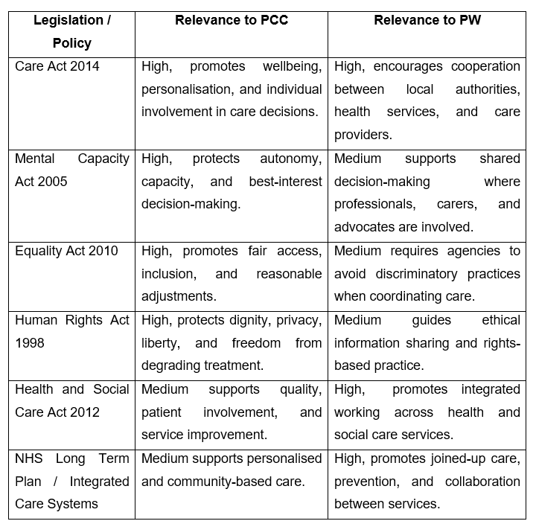

Appendix B: Multidisciplinary Team Structure in Dementia Care
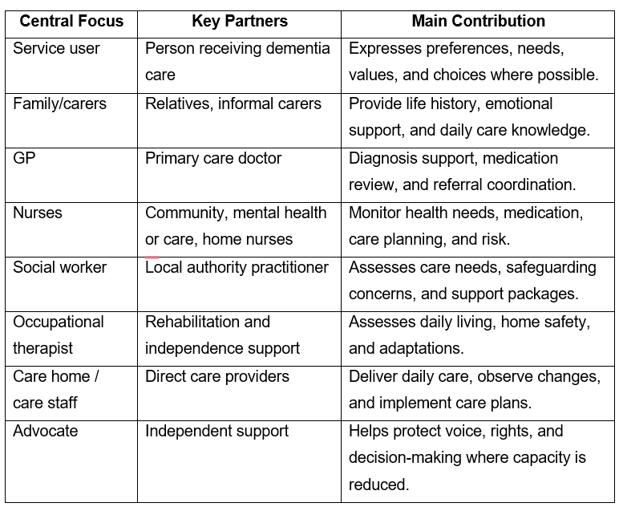

Appendix C: Benefits and Challenges Matrix for PCC and PW


