Jordan Mitchell

Section One

(AC 1.1) Evaluate the concept of evidence-based practice and assess how approaches to evidence-based practice can be used to provide insight that supports sound decision-making across a range of people practices and organisational issues.

Evidence-based practice (EBP) is the idea that optimal decision-making comes from a thorough evaluation of relevant evidence from multiple sources. ‘Evidence’ refers to data, facts or information that either endorses or challenges a particular idea (CIPD, 2023a). The principle behind evidence-based practice is to justify outcomes by ensuring that decisions are based on solid evidence rather than on intuition or untested assumptions. Gary Latham wrote that management without some form of evidence based-practice is like baking a cake without a recipe, while it can be possible it is worth consulting extra guidelines to ensure the desired outcome (Charlier, 2014).

The CIPD have outlined a six step approach to EBP: asking, acquiring, appraising, aggregating, applying and assessing (CIPD, 2023b). This method encourages thinking about the problem, and putting forth an answerable question. It ensures that the practitioner is critically evaluating the evidence gathered, and highlights the importance of obtaining it from multiple sources.

The implementation of EBP offers several advantages. HR practices grounded by evidence are more likely to achieve the desired outcome, this can be used for recruitment, training or performance based management (Rynes, Giluk, & Brown, 2007). An example of EBP in practice, is people analytics, this uses high quality-data and metrics in order to make better decisions (Ledet et al., 2020). The Financial Times have shown how this works in an organisation, by using staff engagement surveys in order to understand and improve productivity (CIPD, 2021). This approach involved using measuring drivers of the staff’s engagement, such as equality, growth, reward and recognition. By using quantitative and qualitative data the survey helped identify areas for improvement such as career growth, which helped implicate initiatives like cross-functional training opportunities and skill development frameworks. These initiatives resulted in improved engagement and career growth scores for over four years (CIPD, 2021).

It can be difficult to use EBP if there is no high-quality evidence available. In cases involving new technologies or novel management techniques, the lack of sufficient evidence may hinder the decision-making process. Evidence based upon past experience may no longer be relevant or fit the context. In this case the practitioner is forced to use critical reflection in order to decide what works and what does not (Barends et al., 2018a).

Evidence-based practice is crucial for bridging the gap between research and practical experience. Using EBP effectively can lead to more favourable outcomes, improved organisation performance and can create a culture in the organisation for continuous learning and innovation. The case of the Financial Times illustrates the effectiveness of EBP, and how it can be used successfully in an organisation, leading to improvements in practices and employee engagement.

(AC 1.2) Evaluate one appropriate analysis tool and one appropriate analysis method that might be applied by organisations to recognise and diagnose issues, challenges, and opportunities.

Analysis Tool:
SWOT stands for Strengths, Weaknesses, Opportunities, Threats (CIPD, 2023c). The purpose of the SWOT analysis is to assess both internal and external factors impacting an organisation. Strengths and weaknesses are considered internal factors which is under the organisation’s control, like resources, processes and capabilities. Opportunities and threats are external factors, this is market trends, competition and regulatory environments, all of which are outside the organisation’s control (Peterdy, Undated).

SWOT analysis is typically constructed with multiple individuals, which can work best with a diverse group to provide fresh perspectives and new ideas (Investopedia, Undated). To start, understand the objective and purpose of the SWOT analysis, such as exploring new initiatives. When preforming a SWOT analysis, it is essential to brainstorm ideas and gather important information, such as employee feedback, customer surveys, market research and financial reports. With this information, it is possible to understand the SWOT, which will show how an organisation is doing well, and where it needs to improve. This allows for the development of an action plan to assist the organisation, and help achieve the goal it has set out.

Amazon has used SWOT effectively; after a successful SWOT analysis, Amazon was able to identify the company’s strengths, which was logistics and e-commerce. Amazon was also able to identify weaknesses, the reliance on third-party sellers which cut into their profits, this allowed for the development of a action plan to push their strengths (Zebra Bi, 2023).

As business environments change rapidly, it can make it difficult to anticipate future developments, this makes the SWOT analysis outdated unless carried out frequently (CIPD 2023c).
Analysis Method:
The Delphi Method can be used to gather qualitive data. The method relies on a panel of experts who are given a questionnaire to reply anonymously to (Barends et al., 2018b). The method involves multiple rounds of questions in order to build a consensus from the panel, this is achieved by taking in the initial feedback, and developing better ideas until an agreement has been reached (Indeed, 2022).

The Delphi Method played a pivotal role in public health during the Covid-19 pandemic. It engaged experts across multiple fields of health care to address key issues. The repetition of the method allowed for further advances in medical research (Villegas, 2023).

The Delphi Method’s effectiveness lies in the use of expert panellists and the anonymity it offers. This reduces bias and allows panel members to introduce their ideas freely without fear of criticism (Villegas, 2023). However, this method is a time-consuming process. This can lead to panellists losing interest, and over the course of the questionnaire opinions may change which can cause problems with consensus building (Shariff, 2015).

SWOT offers a structured way to identify and address challenges and opportunities within and outside an organisation, it is simple to use and widely applicable but needs frequent updating to stay relevant. The Delphi Method gathers qualitive information from experts, but can be a lengthy process. Both tools are effective when identifying and diagnosing issues organisations face.

(AC 1.3) Explain the main principles of critical thinking and describe how these might apply to your own and others’ ideas to assist objective and rational debate.

The author, Sir Arthur Conan Doyle, frequently highlights the importance of critical thinking in his Sherlock Holmes books. In the books, Sherlock carefully observes the evidence presented and thinks logically about what the details mean, he asks informed questions to gather more information. The character does not jump to conclusion and instead analyses the evidence to see how it fits together. This is an example of observing, analysing and making logical conclusions based on solid evidence which can be applied to scenarios in an organisation.

The main principles of critical thinking are:
- Critical Reflection
This involves the questioning of ideas, opinions and arguments, both your own and others. The purpose of this is to analyse and evaluate what is being presented (Howlett & Coburn, 2019).
- Effective Questioning
Critical thinking involves asking questions. This helps to portray the full picture of any issue or situation presented. In doing this, the understanding of the situation is based on solid and factual information (Howlett & Coburn, 2019).
- Constructing Logical and Sound Ideas
It is important to communicate a point of view in a logical way to avoid common errors such as poor articulation when presenting the idea, or causing it to be taken in the wrong context (Howlett & Coburn, 2019).
- Inclusive and Collaborative Intelligence
This principle emphasizes the importance of considering different opinions and perspectives. Collective intelligence is often more effective then individual intelligence, taking various ideas into account allows for a collaborative and inclusive conclusion (Howlett & Coburn, 2019).

By using the principles outlines by Howlett & Coburn in the CIPD podcast, it can assist in an objective and rational debate. Critical reflection teaches that ideas and arguments are not taken at face value but questioned and analysed to understand the positives and negatives. By asking fact-based and evidence-supporting questions, it allows for the debate to be based on a clear and objective problem. Presenting ideas logically and clear ensures that arguments are evaluated on merit and not disregarded due to poor communication. To achieve an outcome which is both inclusive and fair, it is essential to embrace the inclusive and collaborative intelligence approach.
Using these steps, which emphasises critical examination, grounded by facts, logical coherence and inclusivity, can lead to productive discussions and further collaborative outcomes.

(AC 1.4) Explain three decision-making processes that can be applied to ensure that effective outcomes are achieved.

- Six Thinking Hats
Edward De Bono created a unique way to look at decisions from multiple perspectives, telling a decision-maker to put on ‘thinking hats’ to see the outcome from all perspectives in an organisation (De Bono, 1991). Each hat represents a different style of thinking:
White Hat focuses on the objective facts, data and information available.
Red Hat represents emotion and intuition without having to explain why.
Black Hat applies caution, and allows the decision-maker to assess potential problems, or what could go wrong.
Yellow Hat is the opposite to the black hat, an optimistic approach which allows the decision-maker to only consider positive outcomes and benefits.
Green Hat promotes creative thinking, allowing for new ideas or solutions to the problem.
Blue Hat is for control and organisation of the thinking methods, allowing the decision-maker to summarise what has been covered, and to refocus on the objective (De Bono, 1991).
The organisation Siemens have adopted the Six Thinking Hat method into their decision-making process, and hired 37 certified Six Hats Instructors to work with it’s employees, as well as developing an ‘innovation unit’ for each department based on this method (De Bono, 2016).

- Pareto Analysis
The Pareto Analysis uses the Pareto Principle, this was introduced by Vilfredo Patero. The idea came from Patero noticing that 20% of his pea pods produced 80% of the total yielded peas, leading him to discover that he could apply this method in many different scenarios (Tardi, 2023).
Here is a diagram of how the Pareto Principle works:
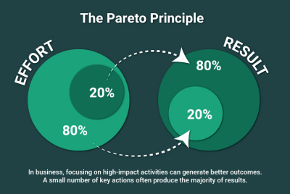
Figure 1: A Diagram Showing the Concept of the Pareto Principle (Peddi, 2023)

To apply the Pareto Principle, first conduct a Pareto Analysis. This is done by listing problems and finding their causes. Score each problem based on impact, such as frequency or cost. Then organise and rank these problems by their score (Peddi, 2023). This process should highlight the Pareto Principle, indicating that few causes typically amount to the most problems.

- Stakeholder Analysis
The Stakeholder Analysis focuses on identifying and understanding key individuals or groups to an organisation, these are known as stakeholders. Stakeholders are employees, customers, suppliers or government bodies outside of the organisation, each being able to impact or be impacted by decisions made by the organisation (CMI, 2022).
After identifying stakeholders, the next step assesses their level of influence and importance to the organisation (CMI, 2022). The assessment is to understand how different groups might react to organisational decisions. This insight allows for the creation of targeted strategies and decisions that specifically address the concerns of the most influential stakeholders.
Organisations must periodically review the stakeholder analysis. This process helps in anticipating reactions to organisational changes or new initiatives and fosters better relationships with key stakeholders, thereby enhancing the effectiveness of organisational strategies and operations.

(AC 1.5) Assess three different ethical perspectives and explain how understanding of these can be used to inform and influence moral decision-making.

When making decisions, it’s important to understand and implement ethical perspectives into the decision-making process, this can build trust among stakeholders and have a positive impact on workplace culture.
Utilitarianism
Utilitarianism is a results based approach which focuses on creating the best result for the majority of parties involved, even at the risk of affecting the few. It can be achieved by analysing the impact decisions have on stakeholders and choosing the decisions which yield the highest overall benefits while minimising the harm (Velasquez et al., 2021).
This approach is straight-forward to use, and fosters a collective perspective. However, making decisions which neglect the minority and individual needs may lead to unjust outcomes (Austin, 2015).
Justice
Justice is about fairness and treating others the way they deserve to be treated. The idea is that similar cases should be handled with consistency, such as disciplinaries, or promotions irrespective of race, gender or subjective bias (Velasquez et al., 2014). Implementing justice into decision-making creates an environment where decisions are based on merit and fairness rather than personal preferences or prejudices.
Decisions made by the justice approach ensures fairness and equality, however it can sometimes lead to individual circumstances being overlooked which may not account for unique needs.

Virtue
Virtue in ethics is based upon the teachings of Aristote who wrote about the concept ‘Phronesis’ meaning ‘Practical Wisdom’ (Provis, 2010). This ethical perspective involves around using moral judgement and intuition, rather than rigidly following rules. There are times where situations may not have a straightforward conclusion, this ethic teaches that the best result can be achieved by following intuition and one own moral compass.
An example of this, a manager may face a situation where they need to balance team opinion and organisational goals. Instead of relying solely on established procedures, they would use their understanding of fairness, empathy and responsibility to make a decision that considers the well-being of the team and the organisational objectives (Provis, 2010).
A virtue based ethic can lead to character development among employees, and lead to further contribution towards the organisation’s goals (Moore, 2017). However, as the virtue ethic is subjective person-to-person, it can lead to inconsistent management.

(AC 3.1) Appraise two different ways organisations measure financial and non-financial performance, providing one example of each.

Financial Performance Measurement
- Return on Investment (ROI)
Return on investment (ROI) is a financial metric used to measure the efficiency and profitability of an investment relative to the cost. To calculate the ROI, subtract the initial cost of the investment from the current value generated by the investment, this calculation is the net profit. Divide the net profit by the initial cost of the investment, multiply this number by one hundred to express a percentage (Fernando, 2023).
Example: An investment of £50,000 which yields £80,000 equals a 60% ROI.
ROI strength comes from being able to be applied in a wide range of investments, but organisations which focus solely on the ROI may miss the bigger picture, such as marketing campaigns which may not show an immediate positive impact (Carleton, 2011).
- Working Capital
Working capital shows the money an organisation has available to use on day-to-day operations. The calculation is ‘Working Capital = Current Assets – Current Liabilities’ (BDC, undated). Current assets refers to inventory, cash, and accounts receivable which can all be converted into cash within a year. Current liabilities are obligations that need to be paid such as debt and accounts payable.
Example: £50,000 in assets minus £25,000 in liabilities results in £25,000 working capital to use on daily operations.
A large working capital can lead to better negotiations with suppliers by receiving discounts for paying early, this can increase purchasing power. However, organisations with a lot of working capital can be prone to overspending (Parikh, 2018).

Non-Financial Measurement
- Customer Satisfaction Surveys
Customer satisfaction surveys are used to measure the quality of products, services and overall experience with an organisation. It can be key in finding out what is being done right, and what is not.
The surveys aim to gather demographic information and feedback by using a series of questions relating to the customer, products, and general service received (Indeed, 2023). The results from the feedback and general demographic information from the customer, allow for trends to be identified.
Customer satisfaction surveys is excellent for benchmarking improvement and identifying trends in the market, but customers who are apprehensive about giving out information may have privacy concerns (DeFranzo, 2023).

- Employee Turnover Rate
Employee Turnover Rate allows an organisations to monitor the number of employees, and be able to investigate the reasons why employees leave. To calculate the employee turnover rate, first define the period (30 days or one year for example), then identify the number of leavers during that time, divide this by average number of employees for that period, times this by one hundred to express as a percentage (CIPD, 2023d)
Example: 7 out of 40 employees leaving is a 17.5% employee turnover rate.
Employee turnover rate is useful for developing retention strategies but does not distinguish between short-term (cause for concern) and long-term leavers (possibly natural career progression).

Working capital is crucial to gauge an organisation’s financial health and the ability to meet immediate obligations. ROI effectively measures investment success but might overlook long-term benefits like brand loyalty. Customer satisfaction surveys shows product performance and the public’s image of the organisation, while employee turnover rates can be used to develop retention strategies. Each measurement has its limitations, but used together offer a comprehensive view of the organisations strengths and weaknesses.

(AC 3.2) Explain how people practices add value in an organisation and identify two methods that might be used to measure the impact of people practices.

People practices adds value to an organisation by focusing on employer-worker relationships. There are several different ways this can be achieved.
Training and Development
People practice understand the objectives of the organisation, and can add value by selecting and recruiting individuals with the necessary skills and experience for the role (Wilton, 2022). Developing training programmes ensures new and existing employees are capable of performing a satisfactory standard.

Employee Motivation
Motivating employees in the workplace can significantly contribute to job satisfaction. This can be done through reward schemes, which can include both non-financial and financial benefits (Wilton, 2022).
Managing Performance
Setting target and goals for employees ensures that there is an even distribution in contribution to tasks, this can be discussed at performance reviews, or appraisals (Wilton, 2022).
Employee Engagement
Ensuring that employee voice is listened to, and taking into consideration in organisational decision-making (Wilton, 2022). This also encompasses well-being, and employee grievances.

The value of people practices can be measured by Key Performance Indicators, and Employee Satisfaction Surveys.
Key Performance Indicators
Key performance indicators (KPI) measures the targets set out for individuals and teams within an organisation (CIPD, 2022), it is also used to see other aspects such as employee turnover rate.
An example of using KPI: a team in an organisation is responsible for scanning items onto a database, with the use of KPI, we can see which members of the team are responsible for scanning the most items in an hour, this will also highlight potential underperformers, and will be the grounds to work out an average scan rate, which will be a main target for new hires. In this example, people practice can be measured itself by how well it deals with underperformers, and how it manages to ensure that targets are reached.

Employee Satisfaction Surveys
In a study done by the University of Warwick, employees who are happy in work are on average 12 per cent more productive than employees who are not (University of Warwick, 2014). This figure highlights the importance of employee satisfaction. Surveys typically ask about an employees job satisfaction, working environment and management (Indeed, Undated). To obtain objective feedback, the surveys are usually anonymous, this allows employees to feel safe answering honestly.
People practice can be measured by the results of these surveys, as it will potentially show an improvement as more strategies come into practice.

(Word Count: 3,077)

References:
Barends, E. and Rousseau, D.M. (2018a) ‘Evidence Based Management: The Basic Principles’, in Evidence-based management: How to use evidence to make better organizational decisions. London: Kogan Page, pp. 56–56.
Barends, E. and Rousseau, D.M. (2018a) ‘Evidence Based Management: The Basic Principles’, in Evidence-based management: How to use evidence to make better organizational decisions. London: Kogan Page, pp. 15–15.
BDC (Undated) ‘What is working capital?: Formula, ratio and examples’ Available at: https://www.bdc.ca/en/articles-tools/entrepreneur-toolkit/templates-business-guides/glossary/working-capital (Accessed: 22 November 2023).
Bono, D.E. (2016) in Six thinking hats. London, UK: Penguin Life, an imprint of Penguin Books, pp. 6–7.
Carleton, P. (2021) Return on investment: ROI Formula &amp; Meaning, InvestingAnswers. Available at: https://investinganswers.com/dictionary/r/return-investment-roi (Accessed: 22 November 2023).
Charlier, S.D. (2014) ‘Incorporating evidence-based management into management curricula: A conversation with Gary Latham’, Incorporating Evidence-Based Management Into Management Curricula: A Conversation With Gary Latham, 13(3), pp. 470–471. doi:10.5465/amle.2013.0364.
CIPD (2021) Solving business problems with people analytics: Financial Times. Available at: https://www.cipd.org/uk/knowledge/case-studies/financial-times/ (Accessed: 15 November 2023).
CIPD (2022). CIPD | Performance Management | Factsheets. [online] CIPD. Available at: https://www.cipd.org/uk/knowledge/factsheets/performance-factsheet/ (Accessed 23 Nov. 2023).
CIPD (2023a) Evidence-based practice for effective decision-making: Factsheet. Available at: https://www.cipd.org/uk/knowledge/factsheets/evidence-based-practice-factsheet/#what-is-evidencebased-practice (Accessed: 16 October 2023).
CIPD (2023b) Evidence-based practice for effective decision-making. Available at: https://www.cipd.org/uk/knowledge/factsheets/evidence-based-practice-factsheet/ (Accessed: 15 November 2023).
CIPD (2023c) SWOT analysis: Factsheet. Available at: https://www.cipd.org/uk/knowledge/factsheets/swot-analysis-factsheet/ (Accessed: 15 November 2023).
CIPD (2023d) Employee turnover and retention: Factsheets. Available at: https://www.cipd.org/uk/knowledge/factsheets/turnover-retention-factsheet/ (Accessed: 23 November 2023).
CMI (2022) Stakeholder analysis and Management. Available at: https://www.managers.org.uk/knowledge-and-insights/resource/stakeholder-analysis-and-management/ (Accessed: 20 November 2023).
De Bono, E. (1991) in Six thinking hats for schools: 3-5 resource book. Logan, IA: Perfection Learning Corp., pp. 8–29.
DeFranzo, S. (2023) Advantages and disadvantages of Customer Satisfaction Surveys, SnapSurveys Blog. Available at: https://www.snapsurveys.com/blog/advantages-disadvantages-customer-satisfaction-surveys/ (Accessed: 23 November 2023).
Fernando, J (2023) ‘Return on investment (ROI): How to calculate it and what it means.’ Investopedia. Available At: https://www.investopedia.com/terms/r/returnoninvestment.asp (Accessed: 22 November 2023).
Howlett, W. and Coburn , T. (2019) Critical thinking. [Podcast], CIPD. Available at: https://www.cipd.org/uk/knowledge/podcasts/critical-thinking/ (Accessed: 18 November 2023).
Indeed (2022) What is the delphi method? (definition, Pros and stages) Available at: https://uk.indeed.com/career-advice/career-development/delphi-method (Accessed: 18 November 2023).
Indeed (2023) What are customer satisfaction surveys? | indeed.com UK. Available at: https://uk.indeed.com/career-advice/career-development/customer-satisfaction-surveys (Accessed: 23 November 2023).
Indeed (Undated). What Are Employee Satisfaction Surveys? (With Sample Survey). [online] www.indeed.com. Available at: https://www.indeed.com/hire/c/info/employee-satisfaction-surveys-important-for-business [Accessed 23 Nov. 2023].
Investopedia (Undated) Strength, weakness, opportunity, and threat (SWOT) analysis (no date) 9. Strength, Weakness, Opportunity, and Threat (SWOT) Analysis - Investopedia 0.0.1 documentation. Available at: https://investopedia.readthedocs.io/en/latest/invest/Ch5/Chapter509.html# (Accessed: 15 November 2023).
Ledet, E. et al. (2020) How to be great at people analytics, McKinsey &amp; Company. Available at: https://www.mckinsey.com/capabilities/people-and-organizational-performance/our-insights/how-to-be-great-at-people-analytics (Accessed: 15 November 2023).
Moore, G (2017). Virtue at Work : Ethics for Individuals, Managers, and Organizations. Illustrated ed. Oxford University Press -06-15, pp.68–69.
Parikh, V. (2018) Advantages and disadvantages of working capital. Available at: https://www.letslearnfinance.com/advantages-disadvantages-working-capital.html (Accessed: 22 November 2023).
Peddi, N. (2023) Pareto principle in business - definition, examples, &amp; more, Startupsavant.com. Available at: https://startupsavant.com/startup-basics/pareto-principle-in-entrepreneurship (Accessed: 19 November 2023).
Peterdy, K. (Undated) SWOT analysis, Corporate Finance Institute. Available at: https://corporatefinanceinstitute.com/resources/management/swot-analysis/ (Accessed: 15 November 2023).
Provis, C. (2010) ‘Virtuous decision making for business ethics’, Journal of Business Ethics, 91(S1), pp. 3–16. doi:10.1007/s10551-010-0564-4.
Rynes, S. L., Giluk, T. L., & Brown, K. G. (2007). The very separate worlds of academic and practitioner periodicals in human resource management: Implications for evidence-based management. Academy of Management Journal, 50(5), 987-1008.
Shariff, N. (2015) Utilizing the delphi survey approach: A review - aga khan university. Available at: https://ecommons.aku.edu/cgi/viewcontent.cgi?article=1037&amp;context=eastafrica_fhs_sonam (Accessed: 18 November 2023).
Tardi, C. (2023) The 80-20 rule (aka pareto principle): What it is, how it works, Investopedia. Available at: https://www.investopedia.com/terms/1/80-20-rule.asp (Accessed: 19 November 2023).
University of Warwick (2014). New study shows we work harder when we are happy. [online] Warwick.ac.uk. Available at: https://warwick.ac.uk/newsandevents/pressreleases/new_study_shows/ (Accessed 23 Nov. 2023).
Velasquez, M. et al. (2014) Justice and fairness, Markkula Center for Applied Ethics. Available at: https://www.scu.edu/ethics/ethics-resources/ethical-decision-making/justice-and-fairness/ (Accessed: 22 November 2023).
Velasquez, M. et al. (2021) A framework for Ethical Decision making, Markkula Center for Applied Ethics. Available at: https://www.scu.edu/ethics/ethics-resources/a-framework-for-ethical-decision-making/ (Accessed: 20 November 2023).
Villegas, F. (2023) Delphi method: Definition, steps, Pros, Cons, uses &amp; examples, QuestionPro. Available at: https://www.questionpro.com/blog/delphi-method/ (Accessed: 18 November 2023).
Wilton, N. (2022). Introduction To Human Resource Management. 5th ed. Sage Publications, pp.2–12.
Zebra Bi (2023) SWOT analysis. Available at: https://zebrabi.com/guide/swot-analysis/ (Accessed: 15 November 2023).

Section 2

(AC 2.1) With reference to a people practice issue, interpret analytical data using appropriate analysis tools and methods.

People analytics will be used in order to analyse the quantitative data provided in the ‘General Employee Data’ spreadsheet, this will allow for the implantation of any strategies based on any problems highlighted in the presented data (CIPD, 2022). By using excel, graphs can be created to show the data in a way that can be more easily interpretated. The initial findings have been presented below:

- Percentage of each gender by type

The organisation comprises of Males, Females and Non-Binary staff members. The split is 140 Males, 118 Females and 2 Non-Binary. This is represented as a percentage in the pie-chart below:

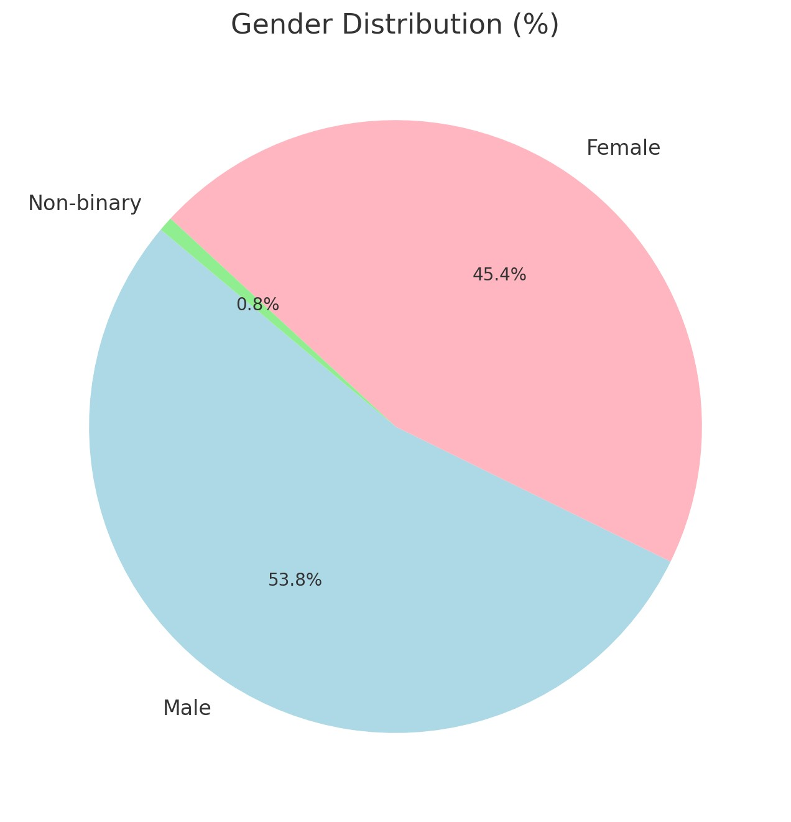

A graph has also been created to see the gender distribution by team:

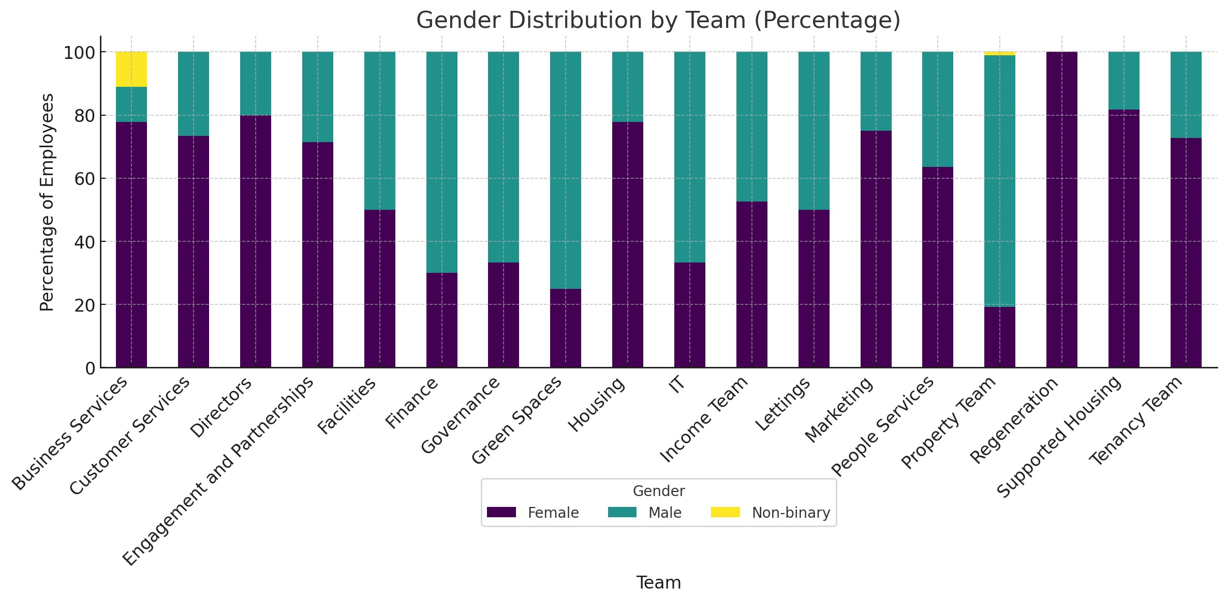

- Ethnicity and a percentage per team
Below is a stacked bar-graph showing the ethnicity distribution per team. To make it easier to label, ‘Community Engagement and Partnerships’ has been changed to ‘Engagement and Partnerships’, this is also true for later graphs when mentioning this team.
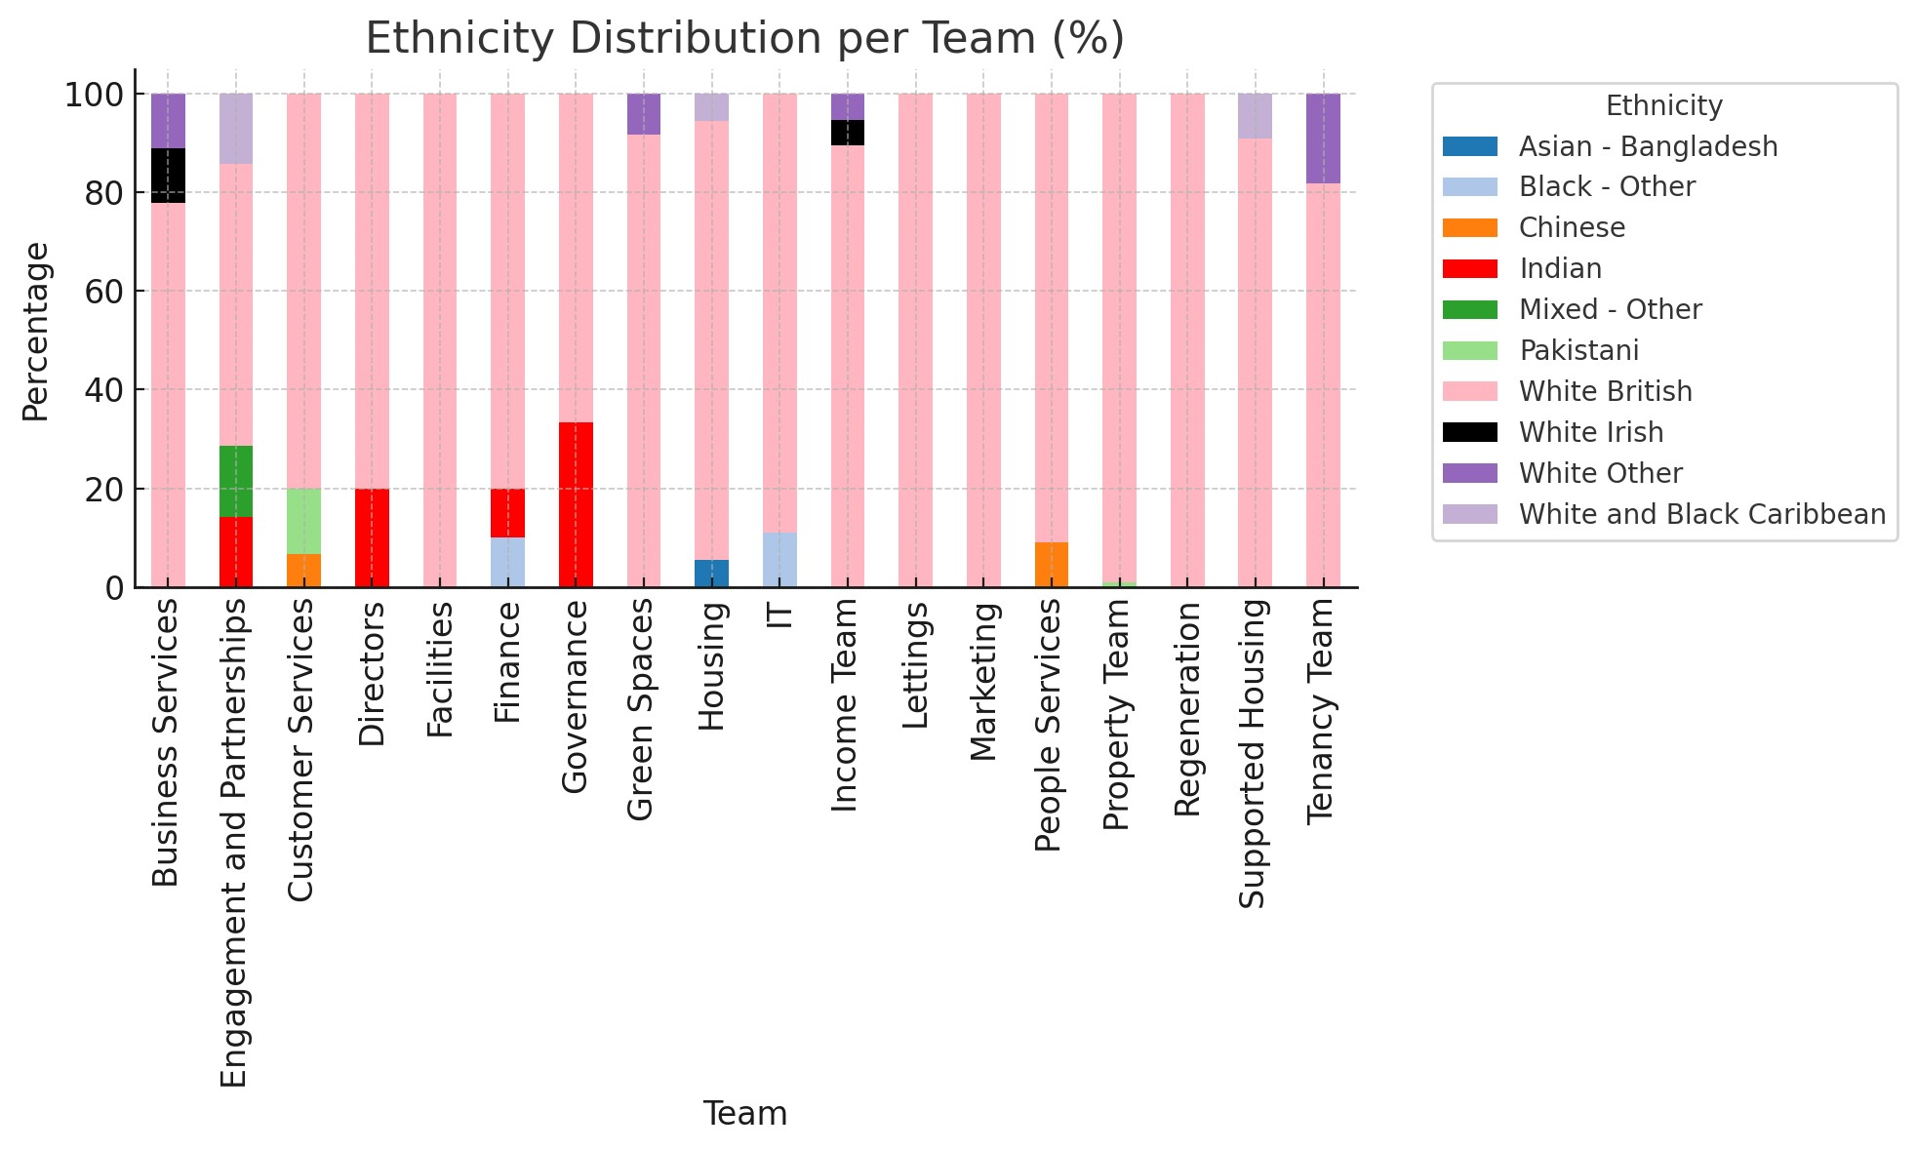

- disability percentage as an organisational whole and by teams.

The total number of staff in the organisation is 260. 21 members of staff have a disability, this is represented as 8.8% of total members of staff. Below is a bar graph which shows at a glance the percentage of disabled employees per team:

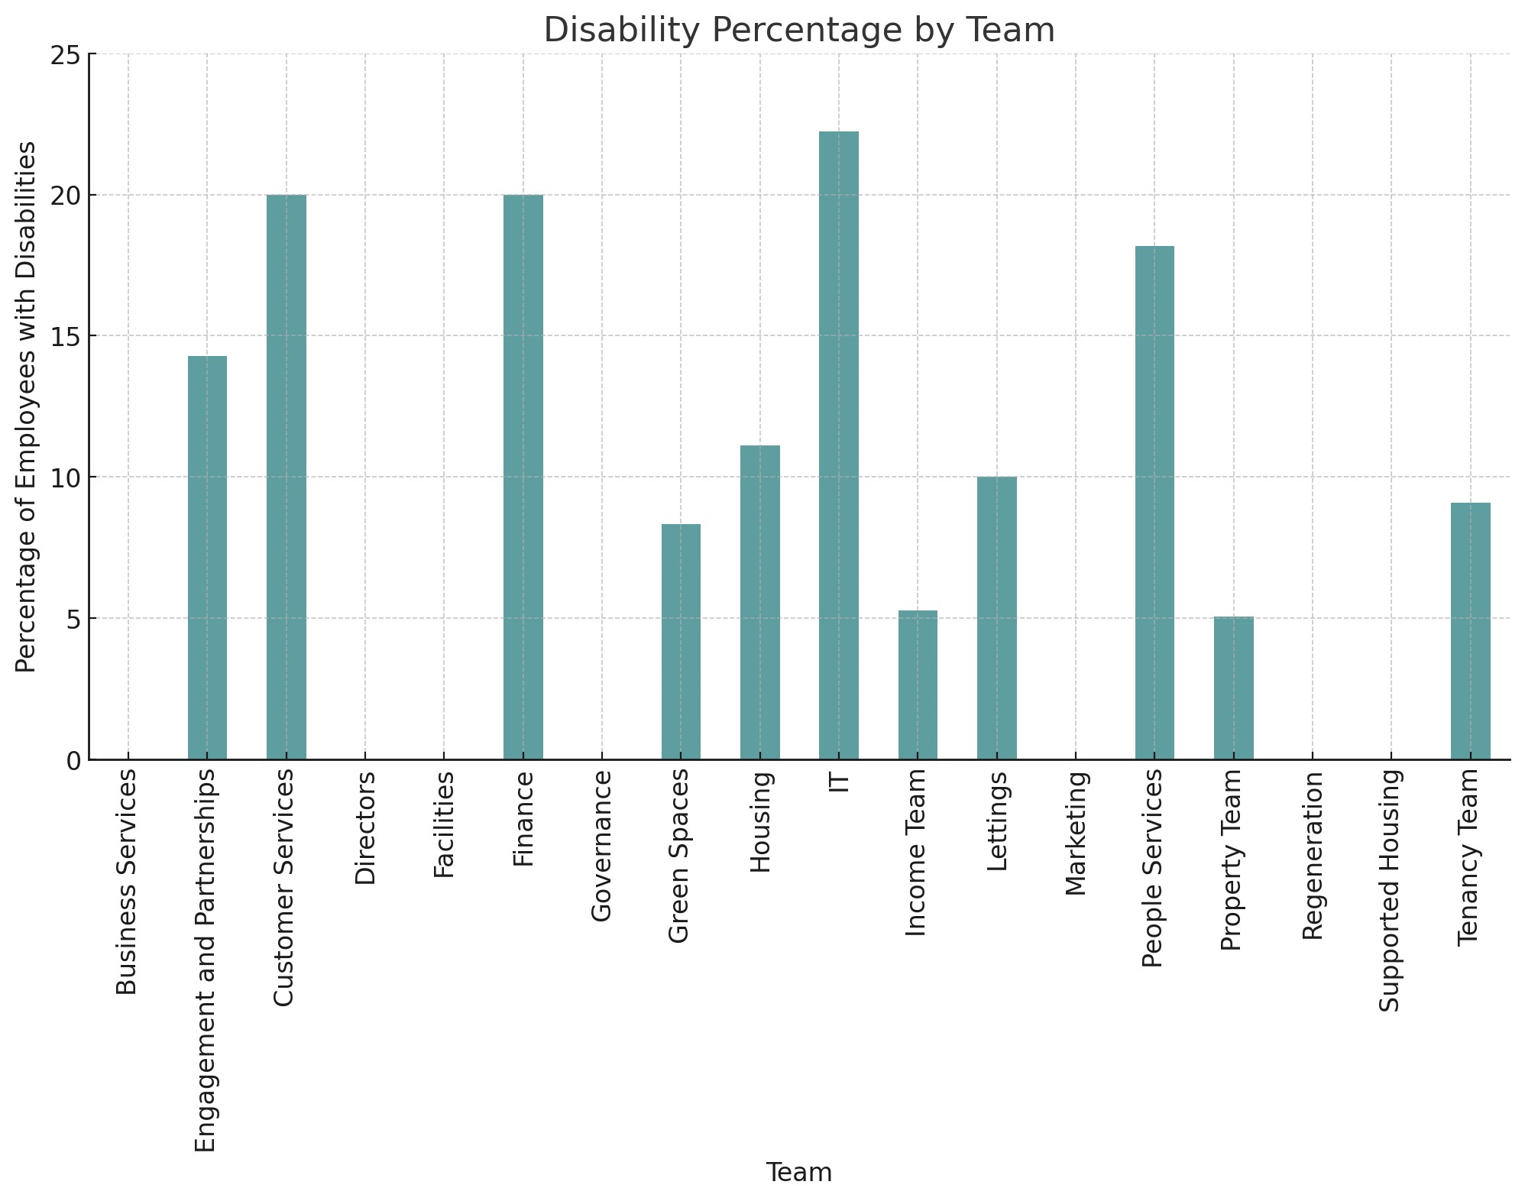

- Salary difference across genders

The average salary by genders are:
Female = £31,900.30
Male = £31,812.18
Non-Binary = £19,500.00
Which can be shown in the following bar graph:
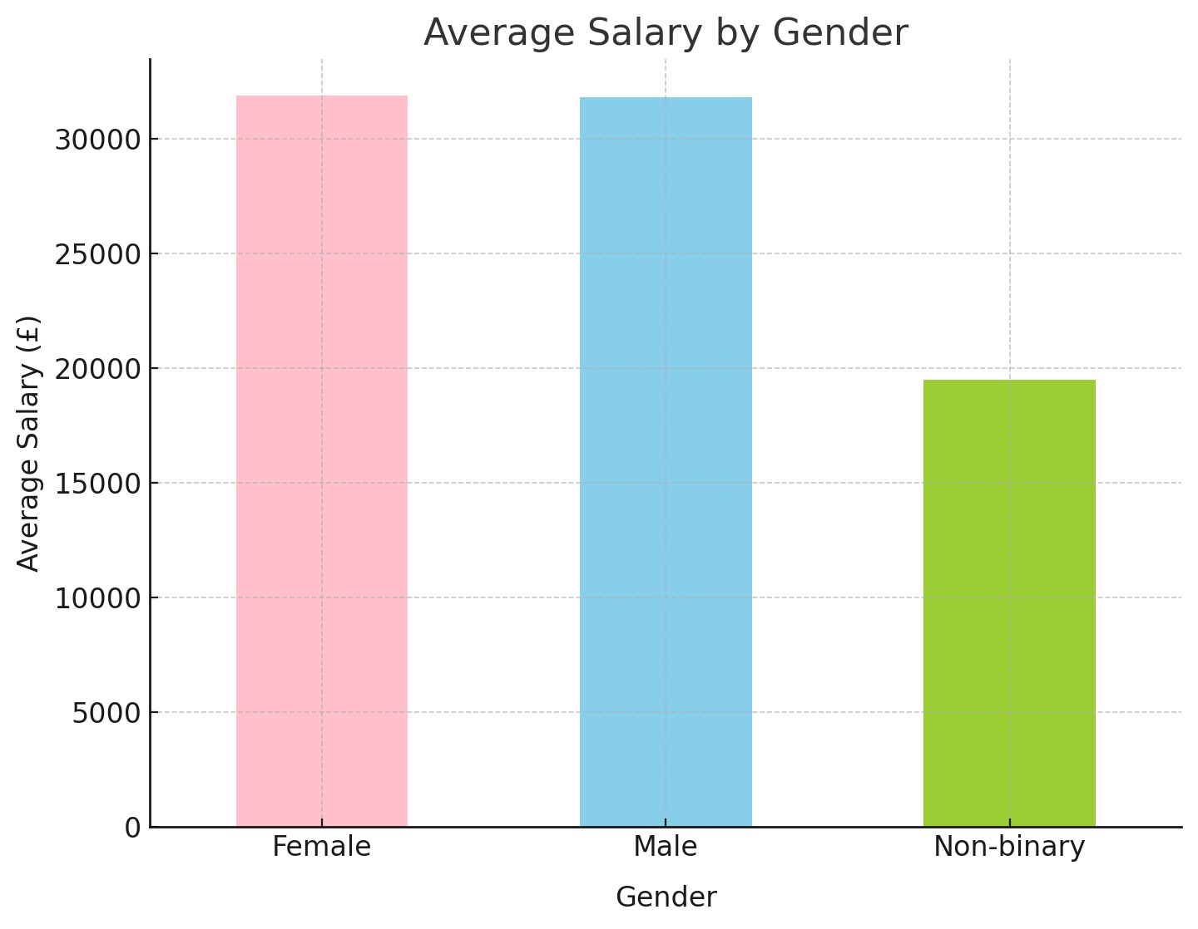

- Overall average salary paid by the organisation.

The overall average salary paid by the organisation is £31,757.46. A box plot has been created to see the salary range below. Using a box plot to show this offers several advantages, first we can see that the median salary is £29,500, it also displays the interquartile range (IQR), which is showing the 25th percentile to 75th percentile.

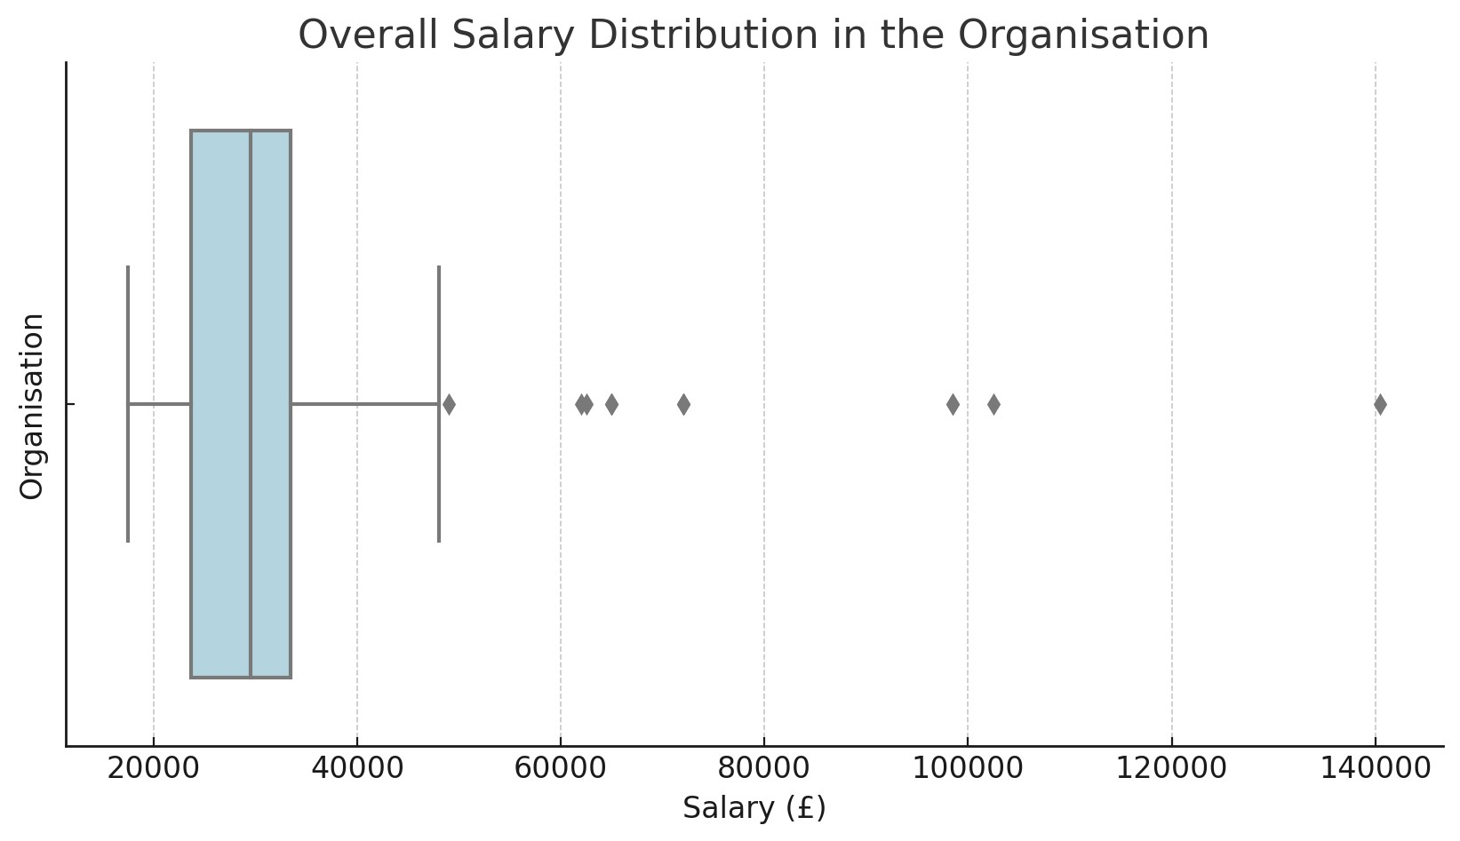

(AC 2.2) Present key findings for stakeholders from people practice activities and initiatives.
As a result of the activities preformed from people practice, an employee survey has been provided which allow for the analysis of the qualitive data of the feedback from 300 employees, this will allow us to build upon employee engagement and motivation (Young, 2023). The questions asked in the spreadsheet shows that the organisation took an initiative to move towards hybrid working.
A significant majority of employees (247) agree that hybrid working supports their work-life balance and well-being, and 186 agree that they feel more connected to the company culture. This would suggest that there is a positive perception for hybrid working for personal well-being, as well as a better sense of belonging to the organisation.
The majority of employees (249) do not miss engaging with their colleagues, this may show that the remote working tools put in place are replacing the need for in-person interactions, this could also mean that there is less value placed on interaction with colleagues.
The survey shows that many employees (240) feel unsupported when at the workplace, indicating potential gaps in on-site support or resources, it can also highlight potential mismanagement issues.
There is concern over hitting targets when working remotely with the majority (199) feeling that they are unable to, it is possible this may be attributed to 159 employees stating that they feel under-recognised for their work when working from home.
While many of the employees agree (177) that working from home removes conflict, 255 employees state that they feel more stressed when away from the workplace. This can indicate that working from home may reduce interpersonal conflict but increases stress.
By using the quantitative data provided, and the graphs that have been created above we can see that the workplace is mostly comprised of males, with 140 males compared to 118 females, this can suggest a reasonably equitable workforce in terms of gender. Teams like IT and Property are predominantly male, while Customer Service and People Services have a higher proportion of females in comparison to males. Teams such as Income and Lettings show more balance, which could suggest effective diversity practices among these teams.
21 of the employees identify as disabled, this group forms a small but significant part of the workforce, with IT comprising of 22% of employees with a disability. While this shows positive inclusion, there may be room for improvement in other teams.
An overwhelmingly majority of employees (237 out of 260) are White British, which may suggest a lack of ethnic diversity in the workplace.
In some roles the salaries does appear to be consistent with one another, for example ‘Administration Assistant’ and ‘Administrator’ all have salary of £21,500. However, ‘Performance Officer’ has the highest disparity with Alastor Moody being paid £28,500 compared to Albert Runcorn who is paid £10,000 more at £38,500. Equally, Development Managers have a high disparity, Onaconda Farr has a salary of £42,500 compared to Gregar Typho who is being paid £46,200 for the same role.

(AC 2.3) Make justified recommendations based on evaluation of the benefits, risks and financial implications of potential solutions.
Based on the quantitative and qualitative data provided in the two spreadsheets, here are some recommendations.

Address Salary Disparities
In the case of Alastar Moody (Male) and Albert Runcorn (Female), the pay disparity is £10,000. This is a large gender pay gap for the same role. The data does not show experience, or education, however it is recommended that a salary analysis is preformed, this can prevent any surprises and ensure pay disparities are addressed proactively (Pfeffer & Langton, 1988).
Disability Inclusion
While the IT team in the organisation is commendable for its inclusivity, it is worth reviewing the equality, diversity and inclusion strategies in order to ensure the majority of the roles meets the needs of disabled workers (CIPD, Undated). This can include diversity recruitment strategies. While there is some cost in doing this, the reward can lead to further commitment and loyalty from staff for having an inclusive workplace (CIPD, Undated).
Hybrid Working
In the case of Hybrid Working, many of the employees feel it supports their work-life balance, and many agree that they prefer it on some days. This feedback suggests that most employees would prefer a flexible working environment.
The notable concern of employees working hybrid is their inability to hit the targets set out by the organisation. This can be improved upon by training managers for hybrid work, which is a unique skillset, using online tools to improve performance management and communication (such as regular check-ins and feedback) can increase the recognition the employees desire (CIPD, 2023).
While the training does incur a cost, according to these survey results it can yield significant benefits in the form of a more engaged and productive workforce.

By undertaking regular surveys and analysing both quantitative and qualitative data, will allow for further recommendations in the organisation. The data collected have been a valuable resource, and by trusting the method of people practice can enhance the workforce further.

(Word Count: 1,087)

References:
CIPD (2022). CIPD | People Analytics | Factsheets. [online] Available at: https://www.cipd.org/uk/knowledge/factsheets/analytics-factsheet [Accessed 26 Nov. 2023].
CIPD (2023). Hybrid working: Guidance for people professionals. [online] CIPD. Available at: https://www.cipd.org/uk/knowledge/guides/planning-hybrid-working/ [Accessed 26 Nov. 2023].
CIPD (Undated). CIPD | Disability at work. [online] CIPD. Available at: https://www.cipd.org/uk/views-and-insights/cipd-viewpoint/disability-work/ [Accessed 26 Nov. 2023].
Pfeffer, J. and Langton, N. (1988). Wage Inequality and the Organization of Work: The Case of Academic Departments. Administrative Science Quarterly, 33(4), p.588. doi: https://doi.org/10.2307/2392645.

