

Addressing the problem of staff shortages in proper care uk

ATHENE HAMILTON
2120033
BMSW4002_BIRM
PROBLEM SOLVING AND DECISION MAKING
CHARLES NIMOH

Introduction
Staff shortages
This report is based on the care industry and the problem facing because of shortages of staff. Using Pestel analysis framework focus on the external problem within an organization together with the fish bone diagram and try to come up with solutions, based on these complex needs. Professor Kaoru Ishikawa was the first person to describe this visual analysis in 1950’s, this diagram for cause and effect.” Ishikawa Diagram: Guide on How to Use It | Safety Culture." 26 May. 2022, https://safetyculture.com/topics/ishikawa-diagram/.

The NHS and social care services is facing their worst workforce crisis in history this is because of chronic staff shortages Binns, D. (2022). ‘NHS is on its Knees’, Metro, 27 July, p.2.states that the Nh’s ‘’pressure on staff is unsustainable and almost every part of the nhs is now suffering shortages and as waiting list at a record of almost 6.5million in April after Covid lockdown lifted’’. staff shortages in the NHS and care homes have been under immense pressure to maintain staff levels within NHS in the UK and the EU. The pressure that cares worker are facing because of shortages of staff are unbearable. During the Coronavirus Disease 2019 COVID -19) pandemic there was a high number in staff shortages. While doctor, nurses, porters, clerks and other care staff are quitting jobs to work for agencies this add up to lot of vacancies. With all these shortages here could be a Review of funding and the impact on care workers and mental health Mental health regarding shortages of staff.
Using the Pestel analysis is a framework used to analyses the external factors in an organization this allows to analyses the problems whether it be Political, Economic, Social, Technological, Environmental and the Legal influences. This technique is known to be very effective when analyzing and assessing External factor that influenced a large organization and their staff shortages. When trying to solve particular problems key one has to know the impact, by weighing up the pro and cons, as effective decision making is important when implementing ideas to achieve and manage business objectives. Therefore, using the fishbone diagram could be used to achieve these objectives.
Staff shortages could be seen worldwide in many industries, and with staff shortages it is most likely to cripple these industries that are being affected. but as the shortages of staff in these industries worsen it is also affecting the wider population geographically.one of this industry that is being affected by the shortages of staff is the NHS care industry that was first established in the 1948.which was supported by a workforce of around 144,000 staffs (NHS digital 2018b).
It is also known worldwide that the care industry is facing enormous challenges. What is also clear is that these severe problem and challenges facing the care industries it is known geographically in UK. within the year 2019 the covid pandemic which is a virus that affect the immune system, which had a severe impact health lifestyle choice on the population and with this ripple affect staff shortages not only in the UK but worldwide. with this impact the care industry and worker are severely challenged. with majority of the population had to stay at home.as people being unwell this has an impact on staff shortages. other challenges faced were labor shortages this could be because of the ageing population where people ages differ. Difficulties the population are facing financially this could be because the losses of jobs. Another major impact was the rule of Brexit which affect carers rights to live and work from the EU in the UK. It already reported that a NetFlow of nurses from the EU have left. we could say this is because of Brexit which led to lot of cuts. Brexit rules including migration government policies, spending cuts, and inflations rates are affecting everyone. unemployment’s and mental health are also an issue in care UK. as the NHS and reporting shortage in the community workforce is struggling to cope. But in addition to that the care services and care workers including, GP, Doctor, Psychiatry, porters and nurses are leaving their post making these spaces vacant. with all these other services are on the decline. Another significant and worldwide problems the care industries are facing today are number of NHS trusts in England have declared “critical incidents” because of staff absences caused by covid-19.
Health leaders said the “rapidly increasing” number of staff absences was exacerbating the already severe pressure on hospitals from increasing covid admissions and wider pressure on urgent and emergency services. The NHS is struggling to recruit and retain nursing and midwifery staff in a time of high turnover rates and low morale. The problems are most acute in inner cities and teaching trusts. The government is tackling the crisis, but the reasons behind the staffing shortages are complex
shortages of staffs, job losses, cost of living tuition fees over worked staff, waiting list growing, vacancies need filling medication problems, and financial support cuts. We can also see that development and training for under graduate nurses as declined. And as technology is advancing rapidly, government should adapt to changes as it is important. based on these issues severe or non-severe problems Economically there should be ways/ alternatives solutions, interrelationships, reformed policies improvements, developments, recruitments and environmental ethics with the right support develop and training individual need to do their work effectively without being bias or with cultural normality’s. some of these main issues need addressing, so the long-term working together as a society whether it be team or group coming up with ideas and implementing a plan to focus on in long term could benefit all of society.

POLITICAL PROBLEMS
Based on the political issues face in the proper care UK. according to Ham C. BMJ (2020) Political crisis in NHS. Perhaps Brexit is if not the biggest significant question mark in current UK policies. As there is already a net inflow of nurses from the EU INTO THE NHS has turned into an out flow, a major argument of leave campaign that Brexit would allow more control over the flow of migrant to the UK’’ between July of 2017 and July 2018, 1,584 more EU nurses and health visitors left their roles in the NHS than joined. With this new system there is a very significant controls on migration. Another political factor is that there is an initial sharp drop in immigration movements. in the trading industries we have seen energy prices, labour shortages, supply chains affected, global trade restrictions this could be more tariff on importing and exporting of goods, we have also seen Government policies change and broken the time has come when services are struggling to cope, promises has broken because of political politics. Thus, we know that these problem and unfulfilled promises will affect everyone.
ECONOMICAL PROBLEMS
Economically are a key issue for nursing doctors, carers, and other professionals, not having enough training, or during training cannot go further because of unaffordable tuition fees. Despite these, the increasing economy is facing economic growth decline. The care sector as well as the economy is facing a significant high volume of job loses which contributes to shortages of staff. Unemployment’s rates on the increase which are a combination of reasons Weede and KYKLOS (1983)’’it has often been maintained that political problem /democracy has a negative impact on the economy growth’’, been it Economical, Financial crisis, Global recession and many more which led to high poverty rates, there is a poor health care system which is failing. Another problem people faced is economical problem, with this student loans, bursaries, tuition fees being and means-tested, maintenances loan cut. On the back of all these costs of living hitting the roof with inflation rising significantly. exchange rate can be seen up and down with the effect globally affecting economic growth with this could cause a big issue on everyone mental health.
SOCIAL FACTORS
With the social and cultural factors issues facing our care system social determinants can be a factor. Based on life style choices. Individual wellbeing, living conditions and income play a vital part. Not creating more opportunities for flexible working hour could leave to staff shortages based on life style choices. Staff need to re-energized not feeling overworked. Taking on more agency work could provide that flexibility to balance family life. Another social factor is that of the size and age of the population, with the rising burden of Chronic disease people health may deteriorate.so it would be a patient do have equal access to healthcare and as the population ages there could be more health problems, and with rapid patient needs. not having the access to medical treatment, services or even the quality care needed. education can be another factor whereby there is not enough education and training, and apprenticeship, with the right training this would help to tackle some of the issues the care industry is facing. One of the areas is that of the treatment of diversity and equality. Recruiting and training new staff, treating everyone fairly regardless of gender, race or cultural differences. cultural normalities that can lead to lack poor or bad decision making. Where organisation show there is a gender pay gap. Another social factor that contributes to the problem is that people buying attitude has changed as cutting back and making different life style choices. making their spending cause by chain of factor throughout.
TECHNOLOGICAL FACTORS
Technology factors the care industries are facing is that of technology is advancing and constantly improving. The impact of digital technology in the workforce could be more understood As care industry and that of the digital aspect is failing and progress is too slow, as not investing in technology can affect working practises( Hutchings R,27-08-2020) even before impact of Covid-19 there was a drive for the NHS to make better use of digital technology on the centre stage use of technology in the NHS The department of health and social care own the NHS website, with technology it helps the way we communicate professional or socially NHS website are delivered by NHS digital In the care industry professional uses technology for medical reasons, researches, diagnosis using equipment’s and many more substantial reasons.
This will also help GP practices supporting care and researches collecting data. Putting pressures on the system storages can affect data storing. An as new advances in Robotics and an opportunity to improve clinical system it would be good to invest in technology and innovations outcomes. Investing in analytics scanning systems by doing this would help the care system/workers to make more precise and make accurate decisions. But lack of incentive and innovation unavailable, services are unable to improve. investing in technology can help as we do researches on the internet as recently there was a pandemic where there was a resurge of online activities as people were unable to physically shop in stores, it is also known that medical practitioners use these services to book appointments, order prescription and different online services within the care industry. Data and research provided new way for the care services and improve and generates research getting more faster results. Scanning tool which are being used can be developed digital tools for treating patients’ conditions. thing can be eliminated because of technology alongside these matter lack of innovation which is affecting any development or improvement in the care sector, lack of productivity. (Xu Et al., 2020) research on Artificial Intelligence (AI), revealed that when it comes to customer service, consumers prefer the problem-solving ability of AI rather than that of human intervention in the case of resolving low-complexity challenges, whereas in resolving high-complexity challenges, they find human customer service as more valuable and are more likely to embrace it in such situations rather than the use of AI. This goes to show the relevance of human labour irrespective of introduction of ground-breaking, dynamic technology. Human labour remains vital and cannot entirely be done without, hence the need to remain invest more in human labour as well as training more humans especially in delivering more problem-solving customer services
Environmental
Climate change is one of the biggest environmental factors. with a combination of climate change there is a severe problem with the environment. With climate change it affects care industry as well as the livelihood of society. With air pollution people get ill this an also contribute to short shortages as staff being overworked, as well as growing population airborne diseases weather changes can the spread of diseases as well as natural disasters. So, in order to maintain it is known for policies for recycling
LEGAL
Regarding the legal part of the care services, the health department it is known that discrimination against others can also relates to staff shortages. this is where trust can join a tribunal where staff seem fit to voice their opinion without being judged. with proposed sanction, medical devices and surgery equipment could affect the flow of treatments for patient. The health regulation’s purpose to protect the public from risk failure to follow this law could see the legal implications also broken as adult social care is under extreme pressure allowing staff to work competently

In conclusion it is clear that using the Pestel analysis and the fishbone diagram it can be seen that starting with political with that of Brexit there is a need for government to be effective firstly by sorting the migration problem in the care industry has this is affecting the staffing issues being that there is a lot of shortages which lead to lot of decision, making

Fishbone Diagram

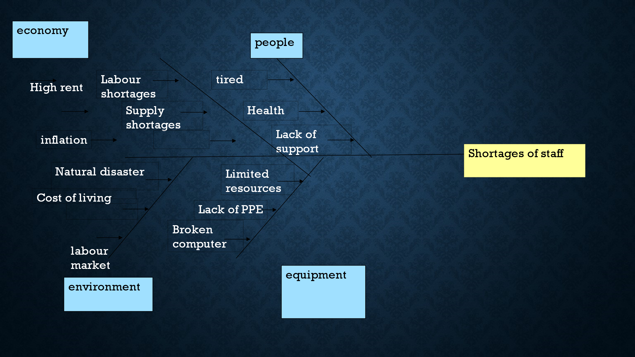
It is shown on the fish diagram that shortages of staff in the care industry with this impact the health and wellbeing of staff become very tired which can lead shortages of staff. with the political factor that affect migration and limited resources government can solve this matter more effectively by sorting out Brexit deals. As outflow of nurses increase between (2017-2018 July) combination with the cost of living, labour market shortages increase shortages of staff. With all these factor government to should invest in the economy giving workers option by better wages so that people can live a longer life making better lifestyle choices. invest in technology this could reduce the workload of many healthcare professionals, and reduce staff shortages. And while doing other researches using technology, patient could have more choices in the care needed.

REFERENCE:
Binns, D. (2022). ‘NHS is on its Knees’, Metro, 27 July, p.2.
Erich Weede and kyklos 36(1),21-39,1983 The impact of democracy on economic growth.
Covid-19: NHS trusts declare “critical incidents” because of staff shortages of staff BMJ 2022; 376 doi: https://doi.org/10.1136/bmj.o3 (Published 04 January 2022) Cite this as: BMJ 2022;376: o3

Ham C POLITICAL crisis in the NHS-BJM.2017 JAN.17;356: j218.doi: 10.1136/bmj.j218.PMID;28096096
Ishikawa Diagram: Guide on How to Use It | Safety Culture." 26 May. 2022, https://safetyculture.com/topics/ishikawa-diagram/
J Phillips L Simmonds -nursing times, 2013-europepmc.org using the fishbone diagram to investigate problem.

NHS DIGITAL (2018b)’nurse and health visitor joiners and leaver from the NHS; NHS DIGITAL website. Available at; http// digital.nhs.uk/data/find-data-and-publication/supplemantary-information/2018-supplemantary-information-files/leaver-joiners/nurse-and-health-visitors-joiners-leavers-from-the nhs_ah2359(accessed on 5March2019).
"[PDF] Shortages of Staff in Nursing Homes During the COVID-19 Pandemic ...." 11 Aug. 2020, https://www.semanticscholar.org/paper/Shortages-of-Staff-in-Nursing-Homes-During-the-What-Xu-Intrator/cc0186cc17d32fe503759020287c052f2933cff5.

Shortages of staff during the COVID-19pandemic: what are the driving factors? Journal of the American Medical Director Association21(10).1371-1377,2020.

“Rachel Hutching The Nuffield Trust “https; www.nuffieldtrust.org.uk/person/rachael-hutchings. The impact of covid-19 and the use of digital technology in the NHS 27/08/2020

‘’NHS ENGLAND Digital transformation. https;//www.england.nhs.uk/digitaltechnology/.

Digital, data and technology standard-NHS Digitals’ https;//digital.nhs.uk/about-nhs- digital/our/work/nhs-digital-data-technology-standards
Xu, Y., Shieh, C.-H., van Esch, P. and Ling, I-Ling. (2020). AI customer service: Task complexity, problem-solving ability, and usage intention. Australasian Marketing Journal (AMJ), 28(4). doi: 10.1016/j.ausmj.2020.03.005.

