Application Development (Games)
  - Lecture 2 Lab Tutorial Exercise

Perky Penguin Game Part III

Objectives
The aim of this lab exercise is to introduce you to game development in Unity. You will create a basic 2D Game, Perky Penguin, which is a Jetpack Joyride-based game.
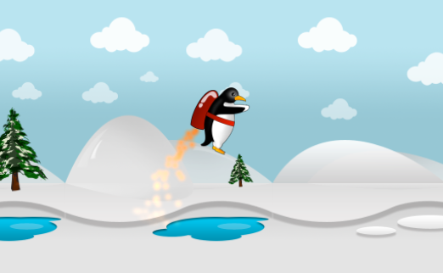

Creating a 2D Animation from a SpriteSheet
In this exercise, you will be feeding Perky some fish, I do apologise in advance
- You will need an animated gif and a tool such as https://www.piskelapp.com/ to convert your gif to a sprite sheet.
- For the gif, you have a number of options:
  - Search Google for some animated fish gifs
  - Search Giphy for options
  - Use the options I have provided on Moodle – I have done all the hard work for you – see image above.
Note:
- The first two options require that you convert the animated gif to a sprite sheet first.
- Also, if you are creating your own sprite sheet, try as much as possible that:
  - The width and height are divisible by 4
  - The width is preferably a multiple of 32 i.e. 32, 64, 128, 256, …, 8192.
- Download your chosen sprite sheet(s) and add it to the graphics folder of your project.
- For each of the imported sprite sheets, you need to tell Unity that the image file is made up of sprite images and the size of each sprite image.

Slicing the Sprite Sheet
- Select your sprite image from the graphics window and from the Inspector window, set:
  - Texture Type: Sprite (2D and UI)
  - Sprite Mode: Multiple
  - Click the Sprite Editor Button when done and when prompted, Apply the changes.
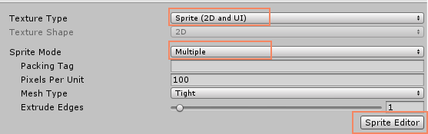
- If your sprite editor window is tiny, expand it so that you can see the menu options.
- Click the little Slice button at the top of the screen
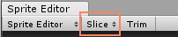
- In the window that opens, you need to change the slice method from Automatic to Grid By Cell Size as shown. This will then give you options to specify the size of each sprite image.
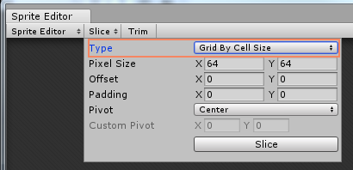
- Note: If you are using your own images, you will need to work this out. For the images I have provided on Moodle, the sizes are:
  - Fish Sprite 1: 256 x 236
  - Fish Sprite 2: 242 x 348
- Specify the size in the window (leave the other defaults) and click the Slice button. You should see faint white lines separating each of the sprite images (see snapshot below).
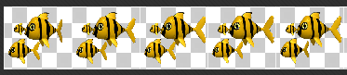
- If you are happy with the slicing and dicing, click the Apply button in the top-right corner of the Sprite Editor window.
- Now repeat the same for the other image.

Creating the Game Object
- Add an empty game object to your scene and rename it to Fish1 or whatever you like.
- Add a sprite renderer component to it: Add Component Rendering Sprite Renderer
- Now in your graphics folder, you will notice that you can expand your sprite image now that you have sliced int.
- Drag the first frame into the Sprite field of the Sprite Renderer component – that is setting the first image for your animation.
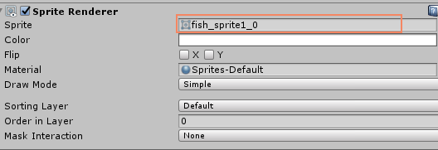
- Set the Sorting Layer to an appropriate layer so it is not invisible behind the background.
- Now, you want to make the fish game object a Trigger Collider, that is, it will be able to detect when another collider enters, but it will not cause a collision.
  - Because the fish shape is not a regular shape, you may want to add multiple collider components to it. Note: you should avoid using Polygon or Mesh colliders, which although give a more accurate shape definition, are much more processor intensive. See more.
  - The common practice is to use a combination of the primitive colliders around the key edges of the game object.
  - If you like at my example, I have used a combination of a box collider (for the tail) and circle collider (for the body) – the faint green lines. Give it a go on your game object and make yours more accurate than mine . You may need to adjust the Offset and Radius/Size of the collider.
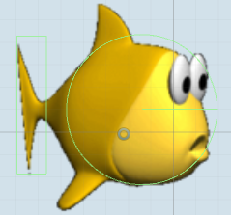
- Mark all the colliders added to the game object as trigger colliders – check the Is Trigger box.
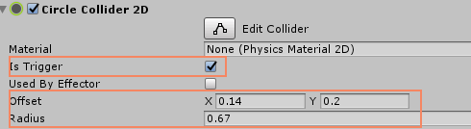

Creating the Animation in Unity
- Add an Animator component to the game object from Add Component Miscellaneous
  - Uncheck Apply Root Motion if checked
  - Change the Update Mode to Animate Physics
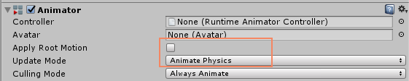
- Create a new folder for your Animations or whatever you like. Normally, you will have a folder for the different animation types but we are creating a simple one.
- Right-click and select Create Animator Controller and rename it to Fish1AnimatorController.
- Select your game object in the scene and in the inspector window, set the Controller to the animator controller that you have just created.
- Double-click the animator controller to open it. It should presently have just one state called Any State and an Entry point.
- From the main menu, go to Window Animation to open the animation window.
- Important! Select the game object that you want to create animations for from the hierarchy window. You should get a message similar to the following with the name of the game object you are animating.

- Click the create button:
  - The first state of an animation is usually called Idle. If you are using different folders for each fish, you can name your animation initial state as Idle, otherwise use Fish1_Idle to distinguish between the two
  - Save the file in the Animations folder created earlier.
- Go back to the graphics window and expand the sprite you are animating and select all the sprite images and drag them into the animation window.
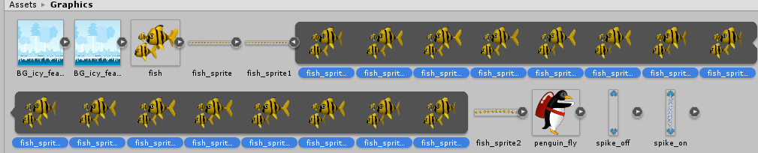
Drag here

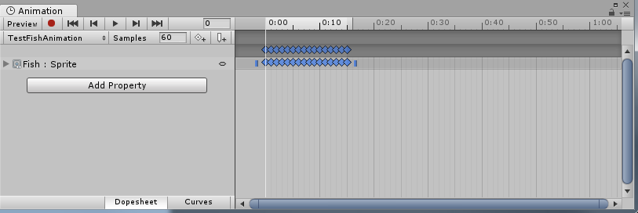
- You also need to change the frame rate per second (FPS). Change the size of the sample size. If you are using my sprites, set as follows:
  - Fish 1: 16
  - Fish 2: 12
Note: we are creating a very basic animation with only one state. For a good video on how to create animations with multiple states, see https://unity3d.com/learn/tutorials/topics/2d-game-creation/2d-character-controllers
- Now play your scene and test. If your animation appears blurred:
  - Check the size of the sprite sheet you imported
  - Go to the graphics folder and select the sprite
  - Check that Unity has not scaled down your image too much – change the Max Size to closely match your file size and click the Apply button.
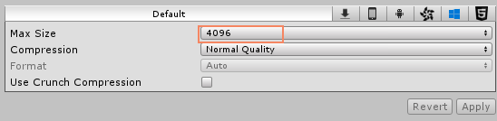
- Repeat the same for the other fish.

Scripting the Fish Behaviour.
- It is time for some coding

Adapted from: Mastering Android Game Development with Unity, Packt (2017), By Siddharth Shekar, Wajahat Karim.

