2022
Learning & Reflection
THE Sports development entrepreneur bMSM6008
Self & Peer Review
Section 1 Self Analysis

The questionnaire statements are focused on your preferences so there are no right or wrong answers. For each statement, circle one of the numbers on the 4-point Likert scale. Personal reviews should consider the reflective
process (e.g. Gibbs Cycle) and consider the available literature in setting future action plans. Evidence of contribution should be included in the appendix. This should include photographic, scanned or screen shot evidence of tasks,
meetings and activities. A list of references can also be included at the rear, to complement any citations to literature made during the completion of this report card.

Entrepreneurial Intention

Intention

 | Not like me at all |  | Somewhat like me |  | Exactly like me
I am ready to do anything to be an entrepreneur | 1 | 2 | 3 | 4 | 5
My professional goal is to become an entrepreneur. | 1 | 2 | 3 | 4 | 5
I am determined to create a business in the future. | 1 | 2 | 3 | 4 | 5
I have very seriously thought about starting a firm | 1 | 2 | 3 | 4 | 5
I have got the intention to start a firm one day | 1 | 2 | 3 | 4 | 5
I intend to start a firm within five years of graduation | 1 | 2 | 3 | 4 | 5
I see the possibility of starting a business as a potential opportunity to pursue | 1 | 2 | 3 | 4 | 5
If I do not start my own business, I may be missing a great opportunity | 1 | 2 | 3 | 4 | 5
Overall I would label the option of starting a business as something positive | 1 | 2 | 3 | 4 | 5

Please describe in your own words how the Module learning has affected your entrepreneurial intentions.

The module has overall had a positive impact on my entrepreneurial intentions, giving me a more realistic understanding of what starting and running a business involves. Before this project, I mainly focussed on the idea itself, but now I am able to recognise the importance of market research, financial planning, and a clear value proposition. The module has shown me that successful entrepreneurship requires adaptability, critical thinking, and the ability to respond to challenges.

As a result, I feel more confident in my ability to contribute or develop a business in the future, as I now have a strong understanding of how to assess opportunities and make informed decisions. That being said, I am also now much more aware of the risks involved in starting a business, meaning I would approach the task in a much more strategic way.

Due to the nature of my career trajectory, I do not see myself attempting to start a business in the coming years, as it would be very difficult to identify a gap in an over saturated market, however, maybe one day it is something I will feel equipped to delve into.
Contribution Summary
Please use the space below to outline your contribution for the entire duration of the module, from the initial
opportunity recognition and ideation phases, through to the business pitch and business planning, and eventual submission of the business plan and promotional resources.
You are encouraged to use the appendices section to evidence your contribution via photographic, scanned or
screen shot evidence of tasks, meetings and activities.

At first, our group wanted to create a sports day camp. I suggested we make it a high-performance sports camp instead and helped guide the business direction. Drawing on my experience in leisure management and operations, I led the planning for operations, health and safety, and how we would deliver the camp. I stayed involved from the start to the final submission.

I designed camp’s structure and made a daily schedule that balanced activities such as strength and conditioning, speed and agility, skill work, and tactical sessions. This helped to keep the programme organized, engaging, and focused on developing athletes. I also created systems for group assignments, rotations, attendance, and sign-in and sign-out to keep everything safe and organized.

A key part of my work for the group was building the health and safety framework. I used my IOSH and First Aid at Work training and qualifications, as well as my knowledge of safeguarding, to plan for risk assessments, emergency plans, incident reporting, and injury protocols. I also made sure our business followed UK laws and safeguarding rules, which made our plan more professional and credible.

I designed the staffing structure by defining roles like camp director, head coach, coaching staff, and support staff, and made sure we had the right staff-to-athlete ratios for safety. I also helped plan the facility layout and delivery, figuring out what spaces, equipment, and logistics we needed so the camp could run smoothly at different locations with a traveling model.

I also created the equipment plan, making sure we had everything needed for both performance and operations, like sports gear, strength and conditioning tools, and admin and safety supplies. I helped with the operations and service plan too, describing how the business would run each day, including session structure, working with suppliers, and keeping services consistent.

Throughout the project, I joined group discussions, planning, and decisions to keep our business idea realistic, organized, and in line with industry standards. I supported my work with documents such as planning materials, schedules, frameworks, and meeting records, showing my active role during the module.

I also contributed to the group by producing a range of visual media to display what we want our camp to look like, uploaded them to YouTube, and attached them to our marketing materials document, so prospective investors can see what we hope to achieve with our business.

Identifying Ideas and Opportunities – Self Appraisal

 | Not like me at all |  | Somewhat like me |  | Exactly like me
I am excellent at finding new opportunities to generate value for others. | 1 | 2 | 3 | 4 | 5
I am excellent at recognising new opportunities to address problems and challenges. | 1 | 2 | 3 | 4 | 5
I am excellent at seizing and shaping opportunities to respond to challenges and create value for others. | 1 | 2 | 3 | 4 | 5

Creativity

 | Not like me at all |  | Somewhat like me |  | Exactly like me
I am excellent at developing multiple ideas that create value for others. | 1 | 2 | 3 | 4 | 5
I am excellent at testing and refining ideas that create value for others. | 1 | 2 | 3 | 4 | 5
I am excellent at transforming ideas into solutions that create value for others. | 1 | 2 | 3 | 4 | 5

Vision

 | Not like me at all |  | Somewhat like me |  | Exactly like me
I am excellent at imagining a desirable future. | 1 | 2 | 3 | 4 | 5
I am excellent at building an inspiring vision that engages others. | 1 | 2 | 3 | 4 | 5
I am excellent at using my vision of the future to guide strategic decision-making. | 1 | 2 | 3 | 4 | 5

Valuing Ideas

 | Not like me at all |  | Somewhat like me |  | Exactly like me
I am excellent at understanding and appreciating the value of my ideas. | 1 | 2 | 3 | 4 | 5
I understand that ideas can have different types of value, which can be used in different ways. | 1 | 2 | 3 | 4 | 5
I am excellent at developing strategies to make the most of the value generated by ideas. | 1 | 2 | 3 | 4 | 5

Ethical & Sustainable Decision Making
 | Not like me at all |  | Somewhat like me |  | Exactly like me
I can recognise the impact of my choices and behaviours. | 1 | 2 | 3 | 4 | 5
I consistently consider ethical and sustainable principles when making decisions. | 1 | 2 | 3 | 4 | 5
I am excellent at making sure that ethical and sustainability goals are considered and met. | 1 | 2 | 3 | 4 | 5

Identifying Ideas and Opportunities – Self-reflection

Step 1 : Description of Process
The process began with identifying if there were any gaps in the market surrounding children’s sporting day camps. The reason that we chose this area of the industry was because several members of our group had previous experience in working at facilities which provided these types of sporting opportunities. The initial plan was to operate a day camp that provided young people in deprived communities with the opportunity to participate in sport, however, as a group we decided that this would not be a financially viable decision if we hoped to make a profit. As such, we transformed our initial idea of creating an accessible day camp, into a high-performance day camp giving our business a competitive edge and unique selling point.

Step 2: Personal Contribution to the Process

My personal contribution to the process was initially pointing out that all the members of our group had similar experiences working with children in sporting environments, which led the group to decide on this idea as the basis for our business. I also contributed the idea of turning our business into a high-performance sports camp instead of the initial deprived communities sports camp we had planned, after a member of the group pointed out it would be hard to turn a profit.

Step 3: What I have learned

I have learnt the importance of adapting ideas to ensure that they are both practical, and financially viable. While the initial aim was to create an accessible sports camp for young people in deprived communities, the process showed me that good intentions alone are not enough to create a sustainable business. Through group discussions and evaluation, I was able to develop a better understanding of market demand, profitability, and unique selling points, and how they influence decision making. This also taught me the value of teamwork, as listening to my other group members perspectives helped us to refine our idea into something more competitive.

Step 4: Personal Action Plan (based on experience and self-reflection).

From this experience, I plan to further develop my ability to evaluate business ideas by considering both social impact and financial viability from the beginning. In future projects, I hope to take a more structured approach to market research, including analysing competitors and identifying a clear target before committing to an idea. I also aim to improve my confidence in conveying and contributing my ideas early in group discussions, instead of waiting to offer my ideas as a solution. This will help me to form a better idea for my business plan early on, rather that relying solely on initial opinions from other group members.

Mobilising and Managing Resources – Self-appraisal

 | Not like me at all |  | Somewhat like me |  | Exactly like me
I am confident in my ability to generate ideas and value for others. | 1 | 2 | 3 | 4 | 5
I am excellent at making the most of my strengths and weaknesses. | 1 | 2 | 3 | 4 | 5
I am excellent at compensating for my weaknesses by teaming up with others and by further developing my strengths. | 1 | 2 | 3 | 4 | 5

Motivation and Perseverance

 | Not like me at all |  | Somewhat like me |  | Exactly like me
I want to follow my passions and create value for others. | 1 | 2 | 3 | 4 | 5
I am willing to put effort and resources into following their passion and create value for others. | 1 | 2 | 3 | 4 | 5
I am excellent at staying focused on my passion and can keep creating value despite any setbacks. | 1 | 2 | 3 | 4 | 5

Mobilising Resources

 | Not like me at all |  | Somewhat like me |  | Exactly like me
I am excellent at finding and using resources responsibly. | 1 | 2 | 3 | 4 | 5
I am excellent at gathering and managing different types of resources. | 1 | 2 | 3 | 4 | 5
I am excellent at defining strategies to mobilise the resources needed to generate value for others. | 1 | 2 | 3 | 4 | 5

Financial & Economic Literacy

 | Not like me at all |  | Somewhat like me |  | Exactly like me
I am excellent at drawing up a budget for a simple activity. | 1 | 2 | 3 | 4 | 5
I am excellent at finding funding options and managing a budget for a new value-creating activity. | 1 | 2 | 3 | 4 | 5
I am excellent at making a plan for the financial sustainability of a new value-creating activity. | 1 | 2 | 3 | 4 | 5

Mobilising others
 | Not like me at all |  | Somewhat like me |  | Exactly like me
I am excellent at communicating my ideas clearly and with enthusiasm. | 1 | 2 | 3 | 4 | 5
I am excellent at persuading, involving and inspiring others. | 1 | 2 | 3 | 4 | 5
I am excellent at inspiring others and getting them on board for new ideas. | 1 | 2 | 3 | 4 | 5
Mobilising and Managing Resources – Self-reflection

Step 1: Description of Process

The process of mobilising and managing resources involved identifying what was needed to successfully develop and present our business idea, including the time, skills, knowledge, and financial planning it would take. As a group, we considered how we could allocate tasks based on individual strengths, ensuring each member could contribute effectively. We also explored the potential funding options and how we could use the available resources efficiently. Throughout the process, we did have to adapt our approach, making decisions on how best to organise and manage our resources to support the success of our project.

Step 2: Personal Contribution to the Process

I took responsibility for allocating the roles to the group, dividing sections of the business plan to those who would be best suited for them. Due to my background in operational management, I took business operations as my topic area, and dealt with every area of the project that involved that. Because of my strong communication, I was able to share ideas effectively and clearly to keep the group organised. I also led discussions on how we could effectively utilise the resources available to us, supporting decision making so everyone’s ideas and voices felt heard, and maintained motivation to ensure we stayed focussed on our goal.

Step 3: What I have learned

This experience taught me how important it is to manage both people and money well to make a business idea work. I learned that teamwork helps cover individual weaknesses by bringing together different strengths. I also saw that, even though I am good at communicating and motivating others, I still need to work on budgeting, financial planning, and managing resources strategically. Overall, this process showed me that being flexible and organised is key when resources are limited.

Step 4: Personal Action Plan (based on experience and self-reflection).

After reflecting on my experience, I want to get better at managing resources, especially when it comes to financial planning and budgeting. I plan to practice creating and managing budgets and learn more about funding options for business ideas. In future group projects, I will try to take on more responsibility in strategic planning to improve my decision-making. I also want to keep building my communication skills by leading discussions and helping my team work well together. These steps will help me become more skilled at managing and using resources in future projects.

Turning Ideas into Action – Self-appraisal

 | Not like me at all |  | Somewhat like me |  | Exactly like me
I am interested in solving problems that affect my chosen industry/communities. | 1 | 2 | 3 | 4 | 5
I am excellent at initiating new value-creating activities. | 1 | 2 | 3 | 4 | 5
I am excellent at looking for opportunities to take the initiative to add or create value. | 1 | 2 | 3 | 4 | 5

Planning & Management

 | Not like me at all |  | Somewhat like me |  | Exactly like me
I am excellent at defining goals for a simple value-creating activity. | 1 | 2 | 3 | 4 | 5
I am excellent at creating an action plan, which identifies the priorities and milestones for the achievement of my goals. | 1 | 2 | 3 | 4 | 5
I am excellent at refining priorities and plans to adjust to changing circumstances. | 1 | 2 | 3 | 4 | 5

Coping with Uncertainty and Risk

 | Not like me at all |  | Somewhat like me |  | Exactly like me
I am not afraid of making mistakes while trying new things. | 1 | 2 | 3 | 4 | 5
I am excellent at evaluating the benefits and risks of alternative options and can make effective choices. | 1 | 2 | 3 | 4 | 5
I am excellent at weighing-up risks and making decisions despite uncertainty and ambiguity. | 1 | 2 | 3 | 4 | 5

Working with others

 | Not like me at all |  | Somewhat like me |  | Exactly like me
I am excellent at working in a team. | 1 | 2 | 3 | 4 | 5
I am excellent at working with a wide range of individuals and groups. | 1 | 2 | 3 | 4 | 5
I am excellent at building a new team and networking | 1 | 2 | 3 | 4 | 5

Learning Through Experience
 | Not like me at all |  | Somewhat like me |  | Exactly like me
I am excellent at recognising what I have learnt by taking part in activities. | 1 | 2 | 3 | 4 | 5
I am excellent at reflection and judging my achievements and failures and can learn from these. | 1 | 2 | 3 | 4 | 5
I am excellent at improving my abilities by building on their previous experiences and interactions with others. | 1 | 2 | 3 | 4 | 5
Turning Ideas into Action – Self-reflection

Step 1 : Description of Process

We started by noticing there was a need for a high-performance day camp that helps children build physical skills, confidence, and teamwork. Our group looked at other camps to see what made them successful. After that, we created our own plan, deciding on the camp’s structure, activities, pricing, and who we wanted to reach.

We set clear goals, made a pitch, and wrote a business plan to help launch our idea. Along the way, we checked our progress, used feedback from our team and lecturer, and made changes to keep the camp practical, attractive, and financially sound.

Step 2: Personal Contribution to the Process

I helped by creating the daily schedule for the camp, making sure it was organized, interesting, and realistic. I also used my health and safety training (IOSH and First Aid at Work) to improve our safety and risk management plans.

I also used what I learned from UK Coaching Safeguarding to make sure the camp followed best practices for working with children. My past experience running leisure facilities in Swansea helped me with team organization, planning, and making sure the business idea could work.

Step 3: What I have learned

This project taught me how to turn an idea into a real and workable business plan. I learned that careful planning is key, especially when matching creative ideas with practical needs like safety, operations, and finances.

I also got better at working with others and saw how combining different viewpoints can make the final result stronger. The project showed me how important it is to be flexible, since feedback from the group and lecturer helped us improve our ideas.

I also became more confident using what I already know in a new setting, especially in health and safety and operations. This helped make our business plan more realistic and higher quality.

Step 4: Personal Action Plan (based on experience and Self Reflection below).

Looking ahead, I want to get better at judging and improving ideas so they are both creative and practical. I also plan to build my decision-making skills by learning to assess risks and make good choices, even when under pressure.

I also want to improve my planning and organization by setting clear priorities and timelines for future projects. I will keep working on my teamwork and communication by joining in discussions and helping the group make decisions together.

Finally, I plan to keep using my professional experience in my studies, making sure my input is realistic and valuable for future projects.

Section 2: Individual Peer Review Reports for Team Members

There are six categories to assess your peers for the group work and presentations. For each item, rate each person in your group using the 4-point scale given. Please think hard and honestly, about each of the categories and how each group member performed - different people will have different strengths and will have made different contributions. Space for comments has been provided to explain your ratings allowing the marker to understand your views.

Please do your evaluations independently – do not share or discuss your scoring or come to a decision based on a group opinion. I want a rating from each of you, based on your perceptions and experiences.
Complete one form for each of your group members with their name on each form.

Peer Review

Name of Team Member: TJ

Scoring:
For each assessment criteria, award each member of your group a score using this scale.
0 – No help at all to the group in this respect
1 – Not as good as most of the group in this respect
2 – About average for the group in this respect
3 – Better than most of the group in this respect
Assessment Criteria | Score | Example/Explanation
Group Participation: Attends meetings regularly and on time. | 3 | TJ always showed up for meetings, communicated well about scheduling, and was on time throughout the project. He took part in discussions and helped keep the group organized and moving forward.
Time Management & Responsibility: Accepts fair share of work and reliably completes it by the required time. | 3 | TJ showed strong responsibility by taking charge of one of the most complex parts of the project, finance, and finishing it to a high standard on time. His reliability helped make sure important parts of the project were done efficiently and stayed on schedule.
Adaptability: Displays or tries to develop a wide range of skills in service of the project, readily accepts changed approach or constructive criticism. | 2 | TJ was willing to take part in different parts of the project and responded well to feedback. He adapted when needed, but there was less evidence of him going beyond his main role to build more skills in other areas.
Creativity/Originality: Problem-solves when faced with impasses or challenges, originates new ideas, initiates team decisions. | 3 | TJ shared useful ideas throughout the project and played a key part in solving problems at important moments. He helped guide decisions and shape the overall direction of the business concept.
Communication Skills: Effective in discussions, good listener, capable presenter, proficient at diagramming, representing, and documenting work. | 3 | TJ led several discussions about how the business should develop and move forward. He explained his ideas clearly, encouraged others to share their thoughts, and was open to trying and improving different approaches. This helped the group make good decisions together.
General Team Skills: Positive attitude, encourages and motivates team, supports team decisions, helps team reach consensus, helps resolve conflicts in the group. | 2 | TJ kept a positive and professional attitude during the project and helped create a team-focused environment. He supported group decisions and progress, but there was less focus on motivating others or helping solve group challenges.
(adapted from Goldfinch, 1994; Lejk & Wyvill, 2001)

Peer Review

Name of Team Member: IR

Scoring:
For each assessment criteria, award each member of your group a score using this scale.
0 – No help at all to the group in this respect
1 – Not as good as most of the group in this respect
2 – About average for the group in this respect
3 – Better than most of the group in this respect
Assessment Criteria | Score | Example/Explanation
Group Participation: Attends meetings regularly and on time. | 2 | They attended several scheduled meetings and contributed when they were there. However, their attendance was not consistent, and they missed the final meeting to review and consolidate documents. This limited their ability to help with the final revisions.
Time Management & Responsibility: Accepts fair share of work and reliably completes it by the required time. | 1 | They did not always finish assigned tasks by the agreed deadlines, which meant other team members had to pick up extra work on short notice. For example, their sections of the Business Plan were not completed before submission, which affected the team’s workflow.
Adaptability: Displays or tries to develop a wide range of skills in service of the project, readily accepts changed approach or constructive criticism. | 1 | They showed some willingness to take part in the project, but there was little sign of adapting to changes or responding to feedback. They did not often try to develop new skills or adjust their approach when needed.
Creativity/Originality: Problem-solves when faced with impasses or challenges, originates new ideas, initiates team decisions. | 1 | They contributed few ideas or solutions during important parts of the project. When challenges came up, they were not very involved in problem-solving or suggesting new ways to improve the business plan.
Communication Skills: Effective in discussions, good listener, capable presenter, proficient at diagramming, representing, and documenting work. | 2 | Their communication was inconsistent, and delayed responses made it harder for the team to make decisions on time. This sometimes disrupted the workflow, especially when the team needed clarification on important parts of the project.
General Team Skills: Positive attitude, encourages and motivates team, supports team decisions, helps team reach consensus, helps resolve conflicts in the group. | 2 | They usually had a neutral attitude in the group, but there was little sign of actively supporting, motivating, or helping the team work together. Their involvement in group efforts was not consistent.
(adapted from Goldfinch, 1994; Lejk & Wyvill, 2001)

Peer Review

Name of Team Member: SPO

Scoring:
For each assessment criteria, award each member of your group a score using this scale.
0 – No help at all to the group in this respect
1 – Not as good as most of the group in this respect
2 – About average for the group in this respect
3 – Better than most of the group in this respect

Assessment Criteria | Score | Example/Explanation
Group Participation: Attends meetings regularly and on time. | 3 | Attended meetings regularly and took part in discussions. Was reliable, always present, engaged, and prepared, which helped the group keep making steady progress during the project.
Time Management & Responsibility: Accepts fair share of work and reliably completes it by the required time. | 3 | Finished assigned tasks on time and to a good standard, showing strong organization and reliability. Took care of their share of the work, met deadlines, and helped the group work efficiently.
Adaptability: Displays or tries to develop a wide range of skills in service of the project, readily accepts changed approach or constructive criticism. | 2 | Was eager to take part in different parts of the project and responded to feedback. Showed some flexibility when changes were needed, but did not often take the lead in adapting or expanding their role.
Creativity/Originality: Problem-solves when faced with impasses or challenges, originates new ideas, initiates team decisions. | 2 | Shared some ideas during the project and helped the group make decisions. Their input was helpful, but they did not often come up with new or creative solutions during tougher parts of the project.
Communication Skills: Effective in discussions, good listener, capable presenter, proficient at diagramming, representing, and documenting work. | 2 | Communicated well with the group and joined discussions when needed. Stayed engaged, but usually responded to others instead of leading or starting group conversations.
General Team Skills: Positive attitude, encourages and motivates team, supports team decisions, helps team reach consensus, helps resolve conflicts in the group. | 2 | Kept a positive and cooperative attitude during the project. Supported team decisions and helped create a good team environment, but did not often take the lead or motivate the group.
(adapted from Goldfinch, 1994; Lejk & Wyvill, 2001)

Peer Review

Name of Team Member: AT

Scoring:
For each assessment criteria, award each member of your group a score using this scale.
0 – No help at all to the group in this respect
1 – Not as good as most of the group in this respect
2 – About average for the group in this respect
3 – Better than most of the group in this respect

Assessment Criteria | Score | Example/Explanation
Group Participation: Attends meetings regularly and on time. | 2 | Attended several scheduled meetings and contributed when there. Participation was sometimes inconsistent, which limited overall involvement in group discussions and decisions.
Time Management & Responsibility: Accepts fair share of work and reliably completes it by the required time. | 2 | Completed some assigned tasks and contributed to the workload, although consistency in meeting deadlines could have been improved. At times, progress required follow-up from other team members to ensure tasks were completed.
Adaptability: Displays or tries to develop a wide range of skills in service of the project, readily accepts changed approach or constructive criticism. | 1 | Showed little engagement in adapting to changes or responding to feedback during the project. There was not much evidence of trying to develop new skills or adjust their approach when needed.
Creativity/Originality: Problem-solves when faced with impasses or challenges, originates new ideas, initiates team decisions. | 2 | Contributed some ideas during the project and engaged in problem-solving when prompted. However, there was limited evidence of initiating new ideas or taking a leading role in overcoming challenges.
Communication Skills: Effective in discussions, good listener, capable presenter, proficient at diagramming, representing, and documenting work. | 2 | Kept up basic communication with the group and replied when needed. However, communication was sometimes inconsistent, which affected how well the group worked together and made decisions.
General Team Skills: Positive attitude, encourages and motivates team, supports team decisions, helps team reach consensus, helps resolve conflicts in the group. | 1 | Demonstrated a neutral approach to group work; however, there was limited evidence of actively supporting or motivating other team members. Contribution to team cohesion and collaborative progress was minimal.
(adapted from Goldfinch, 1994; Lejk & Wyvill, 2001)

References

Institution of Occupational Safety and Health (IOSH) (n.d.) Managing Safely. Available at: https://iosh.com/qualifications-and-courses/courses/managing-safely

UK Coaching (n.d.) Safeguarding and Protecting Children. Available at: https://www.ukcoaching.org/courses/safeguarding-and-protecting-children

Appendices

Appendix A

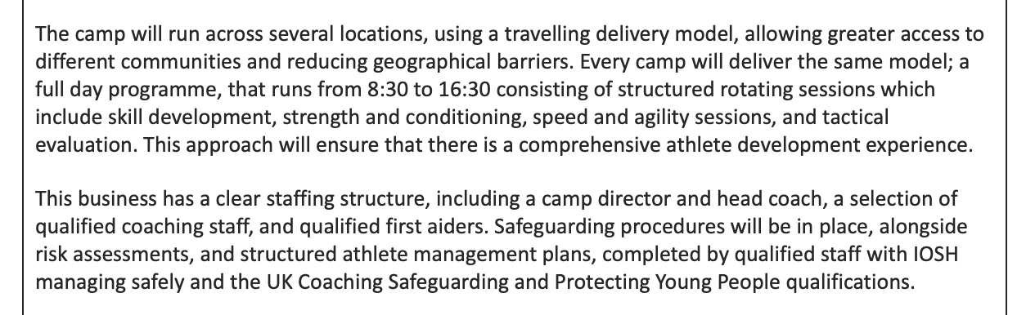

Appendix B

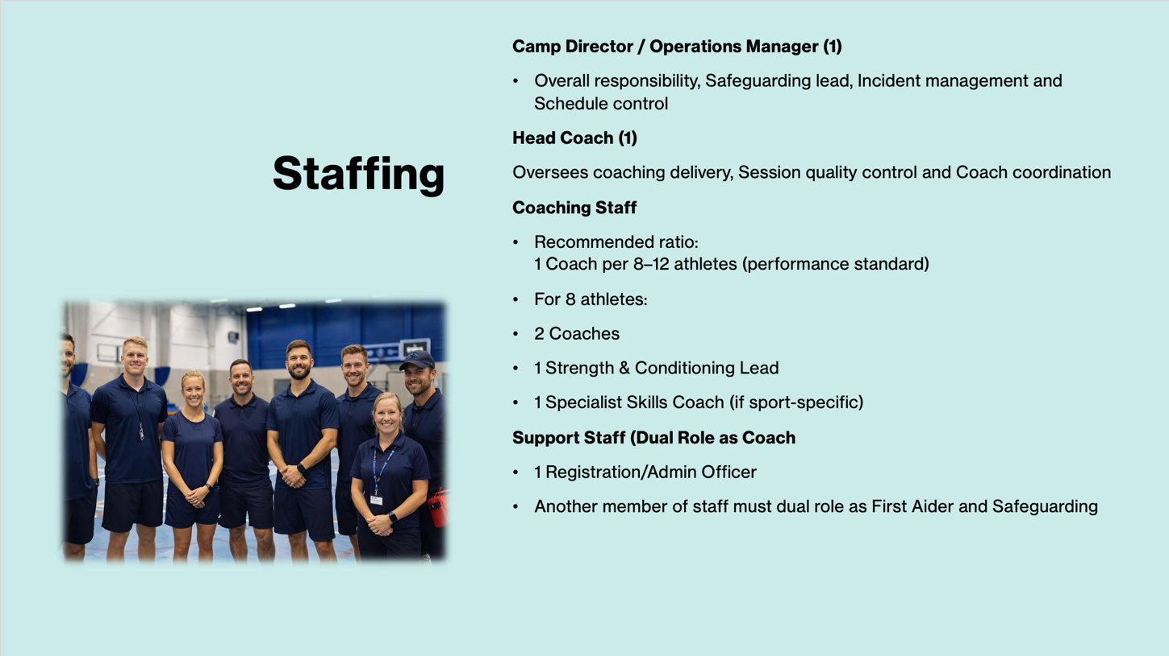

Appendix C

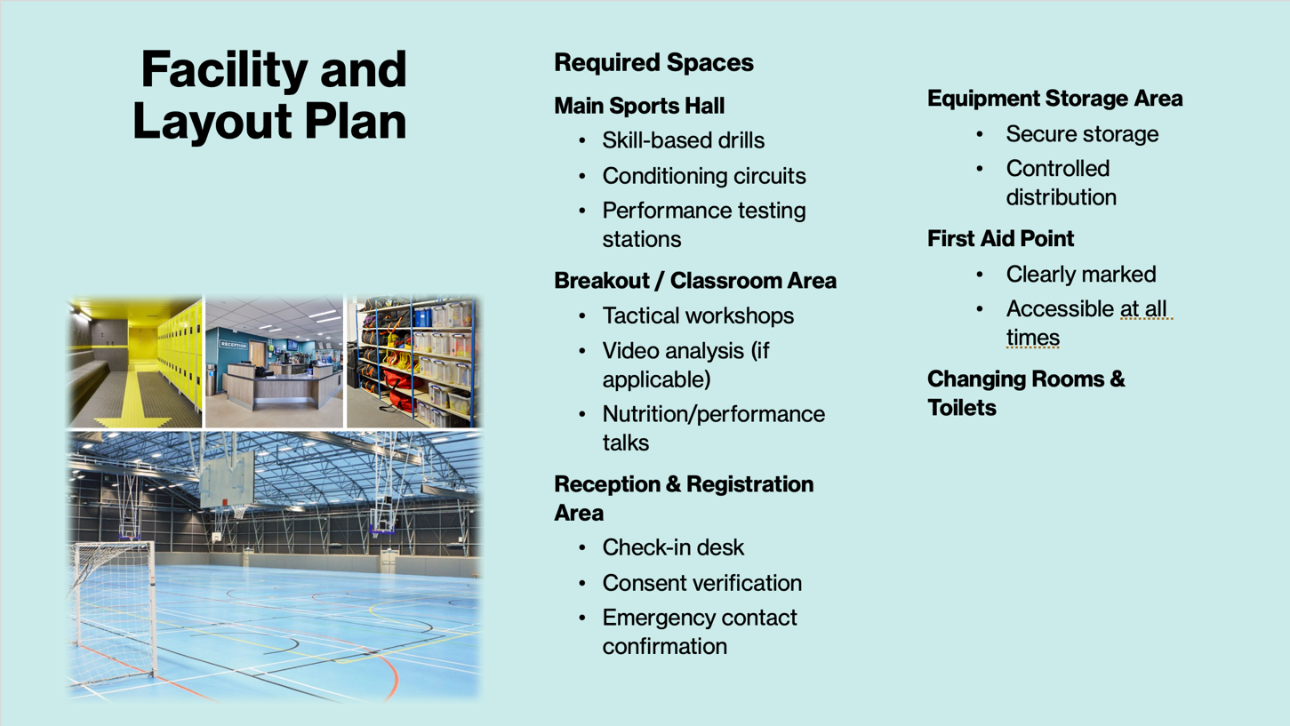

Appendix D

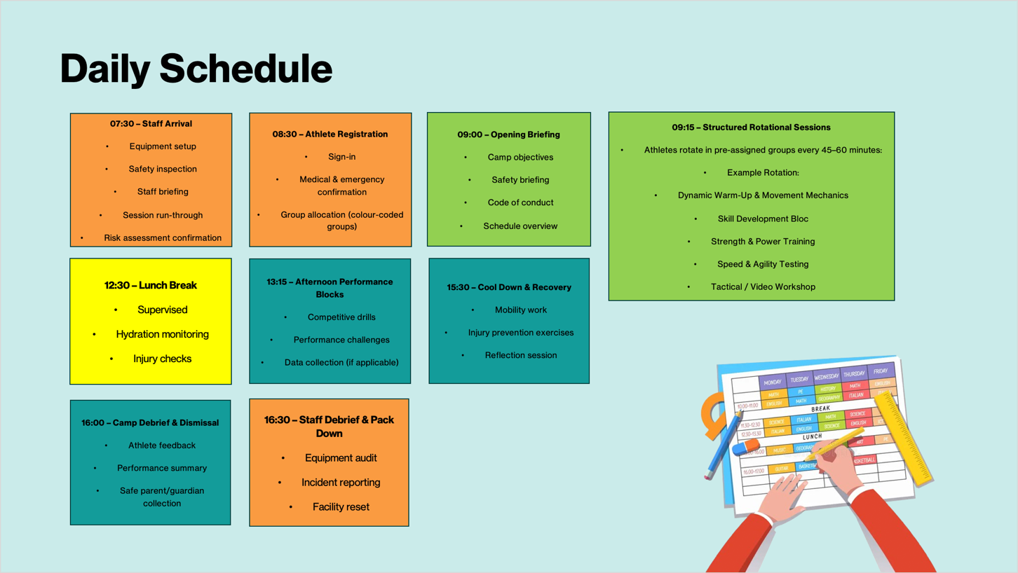

Appendix E

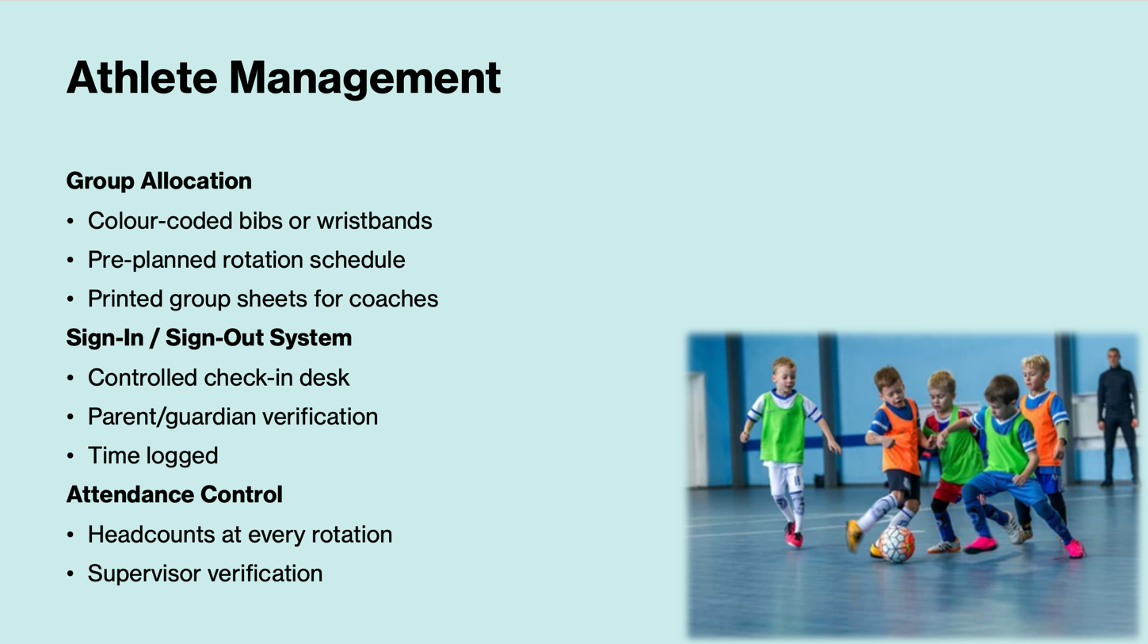

Appendix F

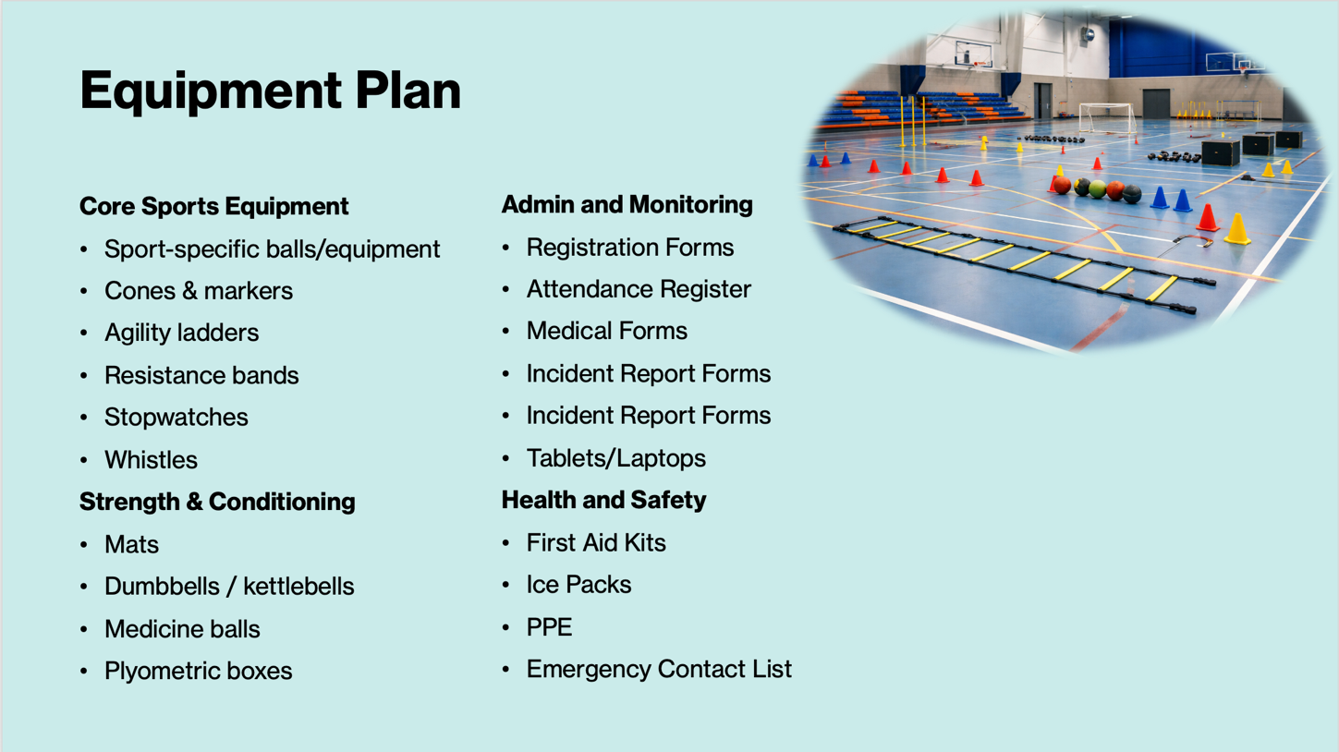

Appendix G

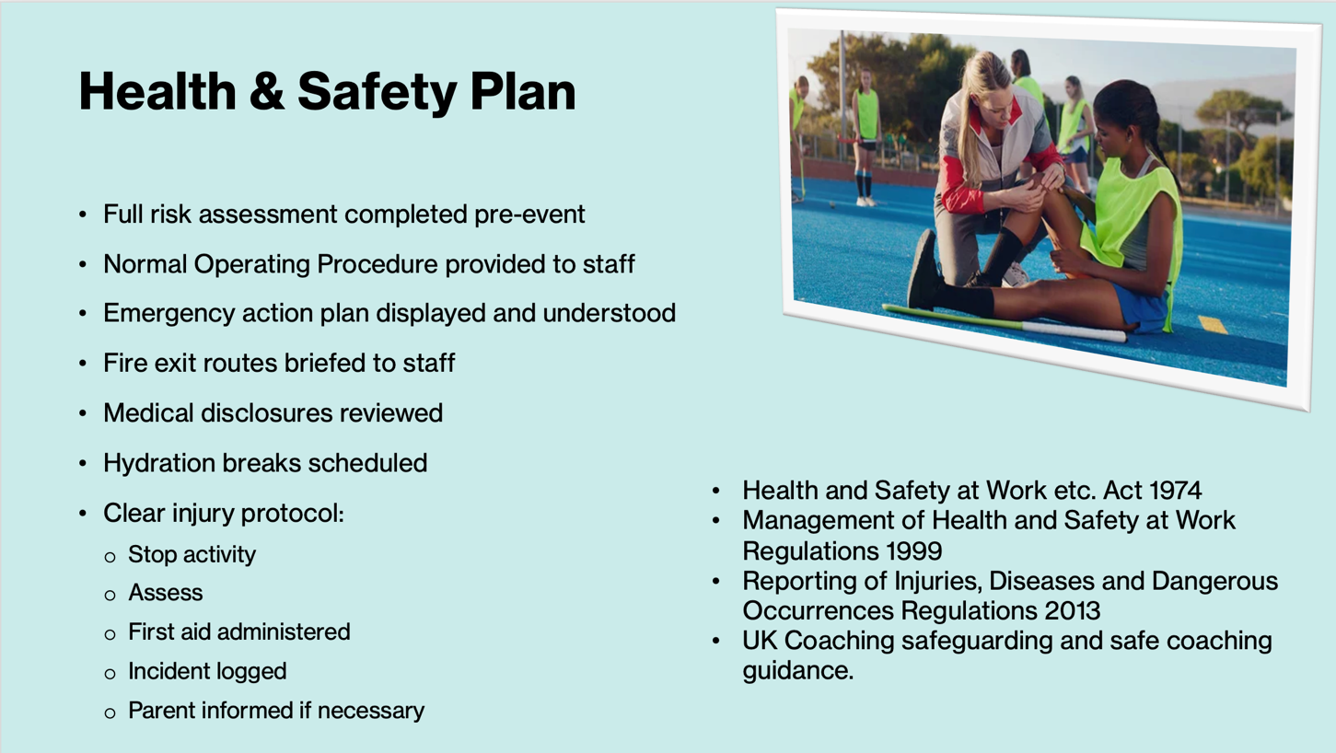

Appendix H

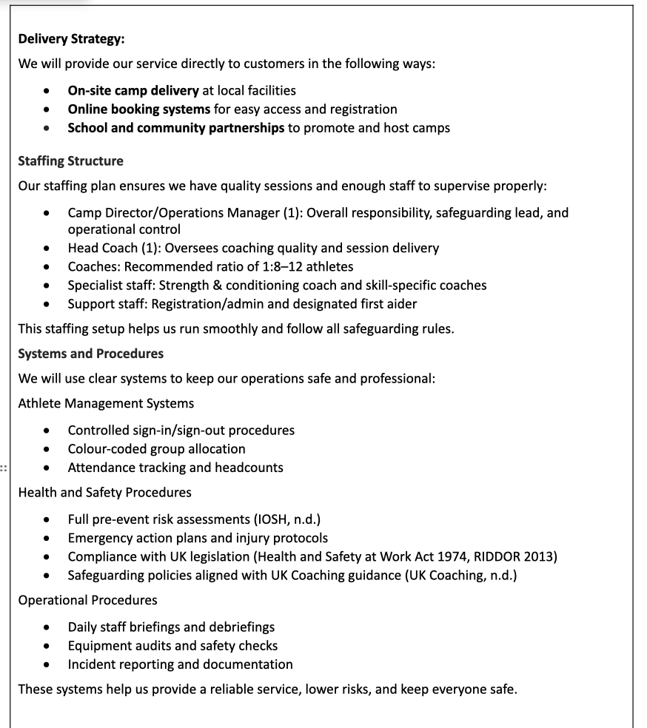

Appendix I

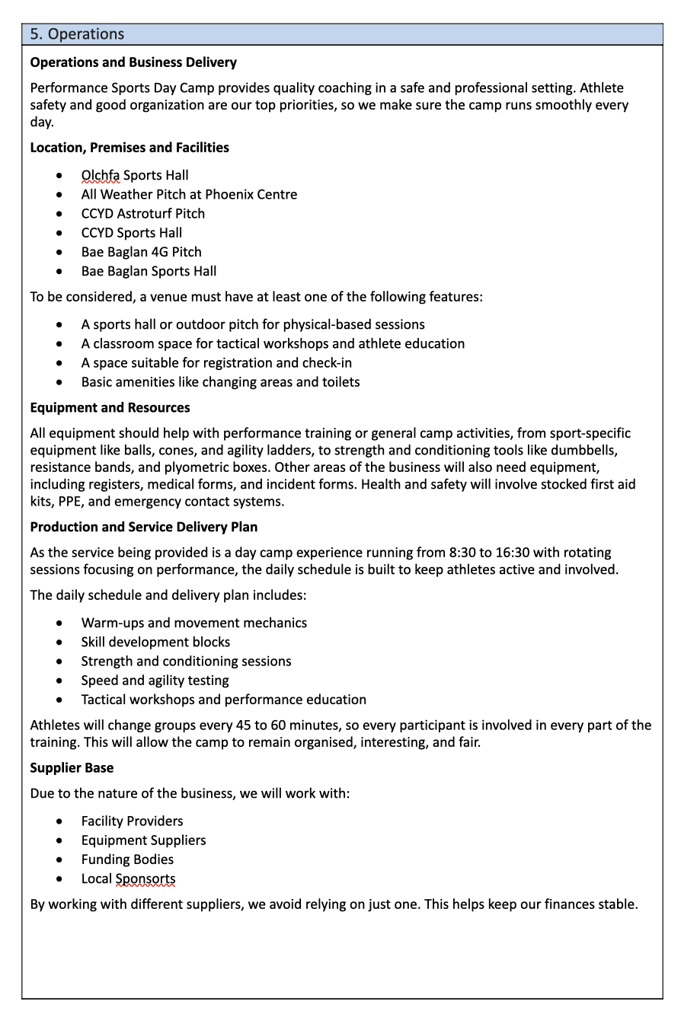

Appendix J

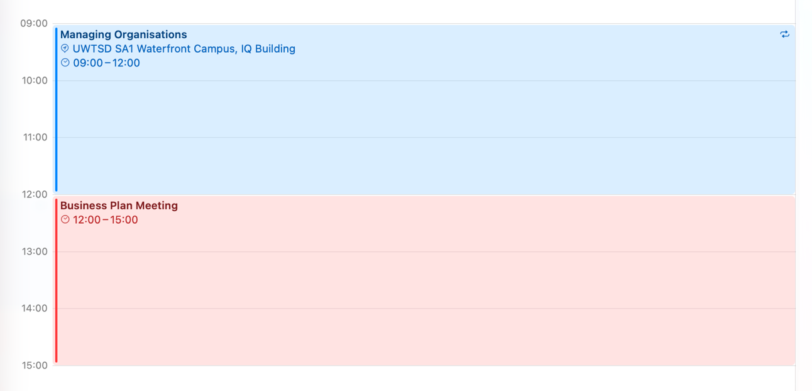

Appendix K

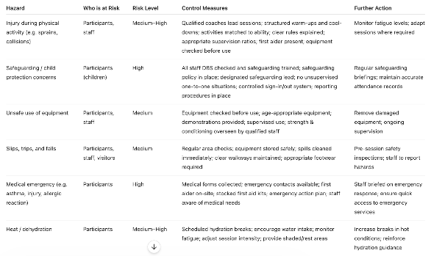

Appendix L

https://youtube.com/shorts/a65xRqC7QQM

Appendix M
https://youtube.com/shorts/DJAV6FVadeg

Appendix O

https://youtube.com/shorts/I8VI3ea-OpE

