Student name Mohammed Amir Hussain Chaudhary Student registration Number 1711710 Module code MBALCMB7001 Group number One Lecturer’s name dr Olu adegbite Module name MARKETING MANAGEMENT

Executive summery.

The Marketing management’s Tesla’s objective is to exploit customer satisfaction, assist in take appropriate decisions and focus on capitalizing on the goals, objective and the profitability of the company. To scrutinise the external macro environment of Tesla and assess its impact on Tesla, various types of diverse marketing management methodologies has been applied, such as SWOT and Pest analysis and competitor’s analysis ( in Appendix 1 porters five forces in the appendix), these analytical marketing methods will assist in evaluating the present static of Tesla and which section Tesla needs to focus more on, this is very vital for Tesla to understand, as this will aid Tesla to recognise it current requires situation and how Tesla can improve themselves in the future.

Followed by examining the principles of green marketing strategy that is applied by Tesla, as pollution is damaging the atmosphere, it is essential for automobile companies for focus more on green marketing and play their part in safeguarding the planet for the present and future generation, in appendix 2 a comparison of Tesla’s competitors and their efforts to maintaining the green marketing approach. Furthermore, a close examination of how Tesla is applying artificial intelligence to create a competitive improvement over their competitors in the motor industry, as the future of all automobile companies are based around artificial intelligence. Finally, recommendations for a way forward for Tesla and to improve interaction with consumers and a way to advance into the future for Tesla.

Contents
Contents 3
Critical analysis of Tesla and its adoption of AI. 5
Introduction: 5
Overview of Tesla Motors. 5
S W O T analysis of Tesla. 7
PEST analysis. 8
Competitors analysis. 9
Green marketing of Tesla. 10
How Tesla Is applying Artificial Intelligence (AI). 11
Recommendations. 12
Appendix 1 16
Porter’s five forces strategy. 16
Appendix 2. 18
Competitors Analysis. 18

Table of Figures:

Figure 1: Image of Tesla Cars…………………………………………………………5
Figure 2: SWOT analysis of automobile industry.……………………………………6
Figure 3: Image of PEST Analysis in Marketing……………………………………...8
Figure 4: Business Model and Strategic Analysis……………………………………9
Figure 5: Principle of Green Marketing……………………………………………….10

Critical analysis of Tesla and its adoption of AI.

Introduction:
Marketing management’s objective is to exploit customer satisfaction and capitalize on the companies’ profitability. According to Park (2020), marketing management is focused on developing, creating and applying strategies that will support in accomplishing the wider business objectives like increasing brand awareness, boosting profits etc. To scrutinise Tesla motors external macro environment, various marketing management methodologies has been applied such as SWOT, Pest analysis and competitor’s analysis (Porters five forces in the appendix1). Followed by examining the principles of green marketing strategy that is applied by Tesla. Furthermore, a close examination of how Tesla is applying artificial intelligence to create a competitive advantage over their competitors in the automobiles industry. Finally, recommendations for a way forward for Tesla and to improve interaction with consumers and a way to advance into future for Tesla

Overview of Tesla Motors.
Tesla motors was founded in 2003, an American based motor company, its headquarters are in California's Silicon Valley. According to Hardman. et. al. (2015), the total amount of full-time workers at Tesla and its companies is over 70,757 ending 2020 and it is the fastest increasing automobile business, focusing on the 5-year annual revenue growth rates, as of June 30, 2020. Also, in January 2021 Tesla become iconic and a precious brand, the iconic Automobile company became the highest appreciated American automobile company in history.

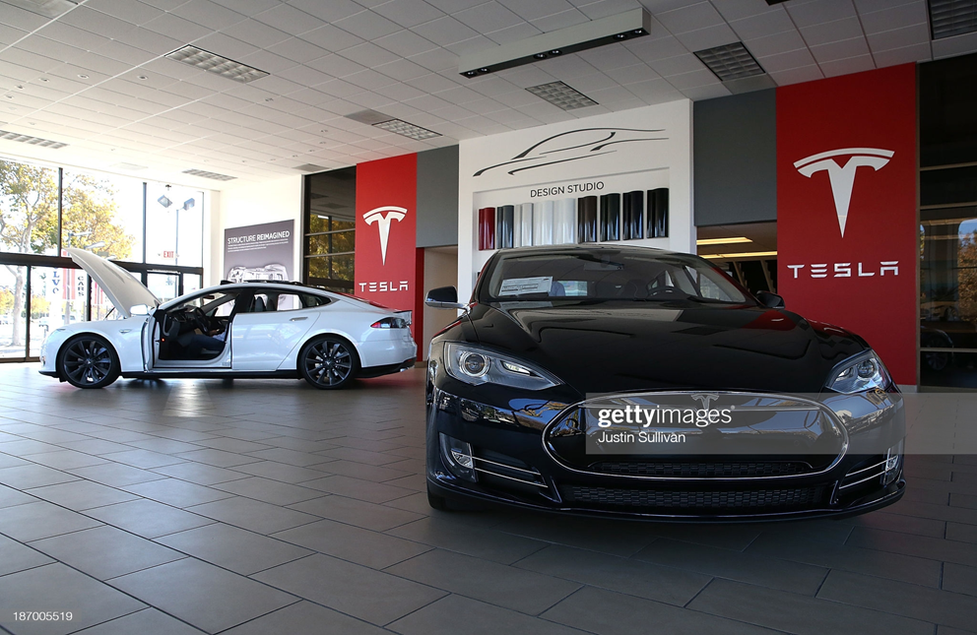
Figure 1: Image of Tesla Cars
(source: gettyimages).

Tesla motors operates in over 30 different countries in the world and also has partner operations in many additional places. Tesla enjoys a substantial share of the markets in a numeral of the different countries where it operates. Tesla motors operates 3,059 Supercharger locations in over 41 countries’ world-wide. The amount of Supercharger sites has grown by 86.07% over the last two years (chen.et. al.2016).

Macro environment analysis.
To analyse the macro environment of Tesla, SWOT and PEST analysis have been conducted. According to Leigh (2009), SWOT and PEST are analytical tool that scrutinises the internal environment of a business.

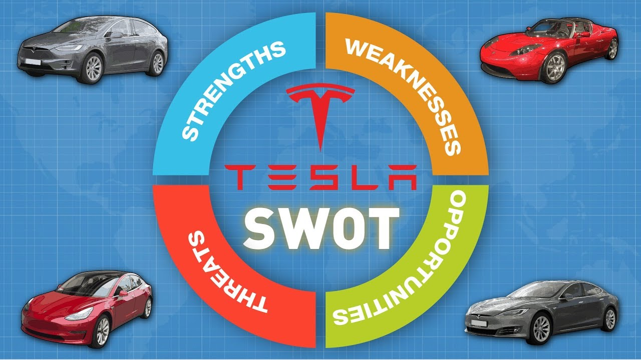
Figure 2: SWOT analysis of automobile industry.
(source: businesswire).

S W O T analysis of Tesla.

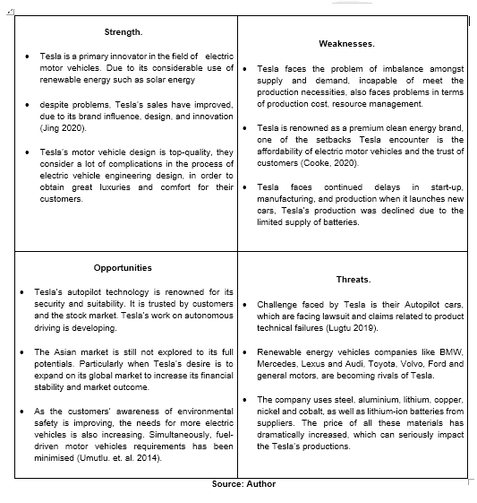

PEST analysis.

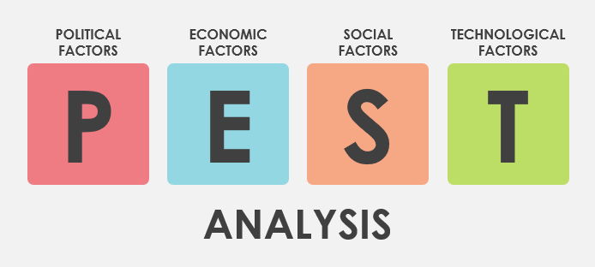
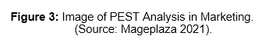

Political.
Tesla motors is effected by several trade procedures, that are innate to a specific province of the globe. Political insecurity and changing economic have a substantial impact on Tesla’s processes. According to Matthews et. al. (2020), numerous threats related with global business laws that increases in production costs, which eventually effects its capability to vend Tesla’s products. There are particular needs that Tesla motors requires to addressing, as well as certain international safety regulation and necessities for the vehicles. Also, the charging stations and additional electric infrastructures, changes applied by foreign government such as taxes, regulations and permit needs for export and export, customs regulations, trade restrictions, tariffs and price and partialities of overseas countries for nationally factory-made products.

Economic.
Automobiles is treated as luxury merchandises in major evolving countries. At present, Tesla vehicles in these evolving provinces are treated as a costly luxury. Government indorsing the sale of electric vehicles, by giving incentives, is a positive step for Tesla. According to Truong et. al. (2016), renewable energy is a much-disputed subject across the globe. Tesla’s maintainable sources of energy for their automobiles are a necessity for certain countries. For Tesla, to decrease the cost of the vehicles, Tesla requires working on decreasing the cost of its engine, therefore decreasing the general cost of the automobile, this will assist Tesla to fulfil the desires of the society. As the state of the economic is improving, as the recession period ending, improved sales of SUV, Tesla stands a very good chance of cumulating its yearly trades and brand value.

Social.
As the globe is concentrating on ‘Sustainable societies’ individuals desire to make their contributions towards reducing the pollution. Therefore, electric automobile sound more encouraging for the future, it is saves costs in terms of fuel usage and looking after as comparison to conventional vehicle. According to Long et. al. (2019), Tesla focuses on make cars that looks smarter and performs better than conventional car, this will assist Tesla to capitalise on a larger section of the market and entice customers who are willing to pay good price for prominence as brand value and service. Continuously moving with the trends and adjusting to the desires of the individuals, Tesla has created an optimistic mark in the fields of electric motor cars. Already having a recognised brand image in the minds of the public.

Technological.
Tesla has been the pioneering several tech progressions in the market. According to Liu (2021), Tesla’s new innovation is the “smart summon” software that Tesla has launched on an experimental base. The software can be imputed into all Tesla’s full autonomous vehicles that have competence or superior autopilot. This technology advances past just driving the vehicle backward and forward. In reality, you can set it to reach you from where its parked, only if it is within your eyesight. This technology appears impeccably advanced and exciting. Tesla is work on making enhancements to decrease the limit of being in eyesight of the vehicle. Additional new exciting trait that Tesla has conveyed out is caroke and Netflix, caroke is a device that will transport a bundle of songs and lyrics in various languages to the automobiles main console.

Competitors analysis.

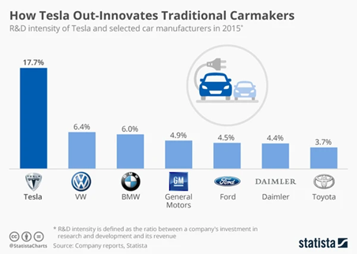
Figure 4: Tesla: Business Model and Strategic Analysis
(source:medium.com).

Tesla Model S is addressed as the impeccable electric automobile, in comparison to other competitor’s car model. Tesla Model S has several advantages over the BMW i3. Tesla Model S is also highly praised for its charging competences. Likewise, the automobile has significantly longer range than the BMW i3 which makes it more effective in comparison to the BMW. Furthermore, Model S is highly sophisticated and simple to drive which has enticed the praise of customers. (KARAMITSIOS,2013).

Toyota’s Mira has been introduced in the market with a completely new technology and its fuel cells are superior than electricity- storing batteries. Toyota Mira’s main advantage is that it uses hydrogen as energy storage and is capable of quickly refill the tank inside 3 minutes, while to fully charge the Tesla Model S it takes hours. Though, Tesla’s s model’s exterior is far more avant-garde in comparison to Toyota Mira. (KARAMITSIOS,2013).

Although, the Mercedes EV Benz's range matches favourably with the German rivalry (BMW), it is behind start-up like Tesla. Yet the Benz can't go near the Tesla Model S Long Range's impressive 405-mile number; neither it come close to the Lucid Air Dream R AWD's 520 miles of EPA range. (KARAMITSIOS,2013). It is assessed by Karamitsios that Tesla's software is years ahead of their competitors, providing Tesla with a huge advantage.

Green marketing of Tesla.
Green marketing is the marketing of products that are environmentally friendly. It consists of taking wider range of actions such as product modification, production process changing, sustainable packaging (Stafford and Graul 2020).

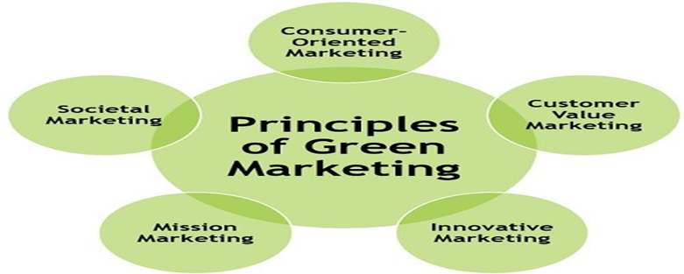
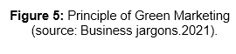

Customer oriented and value marketing is applied by Tesla is an authentic marketing network of trade directly and promoting their product primarily through word of mouth and media coverage. This methodology has aided Tesla to decrease their marketing cost along with increasing customers trust to boost their revenue, also. This has enabled Tesla to obtain customers feedback and be more their focuses on satisfaction. Customer oriented marketing is a principle of maintainable marketing that Tesla view & organise its marketing strategy’s from the client’s viewpoint. According to Weinstein (2020), rivalry within the market has aided Tesla to speeds up technological development and innovation in all parts of Tesla to meet client desires. It also embraces product innovations focuses on cumulating consumer interest through innovative marketing methods. From a microeconomic viewpoint the client approval can be understood as a factor of product effectiveness, assessment that can fulfil client necessities.

Societal and Innovative marketing of Tesla is to takes into account key factors like the social welfare, the desires and interest of customers in line with Tesla’s requirements. Therefore, Tesla views green marketing products and services which are not only eco-friendly but also beneficial for society. According to Bruijl (2017), Tesla uses one of the most efficient approaches of marketing, which is word-of-mouth. Tesla’s brand’s referral package rewards individuals who share their involvements with others. Customers tend to trust recommendations from other individuals they know and trust like family members, friends, colleagues, more than brand-owned networks. Tesla also focuses on technological development and innovation in all parts to meet client desires (Kim, 2020).

How Tesla Is applying Artificial Intelligence (AI).
How Tesla Is applying Artificial Intelligence (AI). Tesla is a pioneer in electronic motor vehicles, the motive for Tesla’s achievement is that they are essentially a technology firm. Tesla’s main focus is on artificial intelligence technology, and it is a key factors for Tesla’s achievement. At present, the crucial objectives for Tesla is making their vehicles fully self-directed and Tesla is leveraging vast information and AI to achieve this success. According to Benzidia. et. al. (2021), Tesla utilises AI to comprehend and anticipate the following actions of cars. The data supports Tesla to design their movements within a split of second, and choose what Tesla is going to do from instant to instant. For instance, must the vehicle stay in the existing lane or does it alteration lanes, must the Tesla pass the vehicle in front of it, or maintain its present course, when must the Tesla automobile accelerate or brake. In order to create a vehicle that is fully self-directed, Tesla requires gather the right information to train the procedures and feed it into their Artificial Intelligence. Further training information will certainly create better performance. This is how Tesla shines.

According to Verganti (2020), Tesla gains advantage over their competitors by collecting all their information from thousands of Tesla automobiles that are presently on the streets. External and internal sensors monitor what Tesla’s are up to in all kinds of circumstances, and also accumulate information on driver activities, what is the response in different circumstances as well as information like how often a driver hands are on the steering wheel or on the dashboard. This approach by Tesla is named “imitation learning.” Tesla’s procedures of understanding from the reactions, judgements and actions of thousands of drivers around the globe. All those miles interpret converted to create a fantastic smart self-directed motor automobile. The tracking system radar of Tesla is extremely advanced and knowledgeable. For instance, when a Tesla automobile makes a mistake in predicting regarding the performance of an another automobile or cyclist, Tesla takes a snapshot of the data of that instant, adds it to the information collection, then duplicates a conceptual image of the scene with colour-coded features that Tesla’s network can be trained from. Tesla future plans is AI and big information will remain top priority for Tesla.

Recommendations.
- Tesla has never taken the approach of advertising on major platforms like TV, Newspaper and radio. Tesla requires to apply this processes, as this will enable Tesla to reach out to a larger audience.

- Tesla requires allow individuals to lease their products more effortlessly and cost effectively. According to Liu and Meng (2017), in comparison to their competitors like Toyota, Mercedes, Audi etc. the process of leasing Tesla cars is much more complicated and expensive then their competitors.

- It is important for Tesla evaluate the market and compare the price with their competitor, so it is more purchasable for the average working class, this will improve the brand image and boost Tesla’s revenues.

- Researches indicate that Tesla has limited charging stations and showrooms, Tesla requires more charging stations and nearby every charging stations they can operate a showroom, this will entice customers to purchase Tesla cars.

- Tesla requires to capitalise in on the market of the south Asian countries, as these countries have not been exploited by their rivals. As this will no dough be beneficial move for Tesla (Benzidia. et. al.2021).

Conclusion.
Tesla motors tasted success within the past couple of years by introducing disruptive innovation in the form of electric autonomous automobile. Even thou Tesla was able to emerge with this disruptive innovation production, Tesla was incompetent in completely achieving this, as Tesla’s electric autonomous automobile had numerous defaults and in 2020 Tesla evokes six thousand cars over threat of loose bolts. This was due to the deficiencies in ensuring distinguished policies to examine the final production. Tesla has failed to exploited the international global market as they are mainstream providers of electric autonomous automobile, this can be a massive potential for Tesla, as competitor like Mercedes, BMW, Toyota, Volkswagen and Audi are trailing behind Tesla in the field of electric autonomous automobile. Tesla’s annual sales report indicated that Tesla is slow in embracing to environmental changes as Tesla was ineffective in capitalising on the globe pandemic of coronavirus. Whereas, their competitor where offering flexible financial option to lease or purchase their products. Tesla requires to restructure their business infrastructure to be able to achieve the success they deserve.

Reference:
      - Alec Furrier, medium.com. 2020.Tesla: Business Model and Strategic Analysis (Online) Available at:https://alecfurrier.medium.com/tesla-business-model-strategic-analysis-c7d00bdc0339 Accessed on 16-11-2021.
      - Benzidia, S., Luca, R.M. and Boiko, S., 2021. Disruptive innovation, business models, and encroachment strategies: Buyer's perspective on electric and hybrid vehicle technology. Technological Forecasting and Social Change, 165, p.120520.
      - Bruijl, G.H.T., 2017. Tesla Motors, Inc.: Driving digital transformation and the digital ecosystem. Inc.: Driving Digital Transformation and the Digital Ecosystem (October 14, 2017).
      - Business jargons, 2021. Principle of Green Marketing (online) Available at:
https://businessjargons.com/green-marketing.html Accessed on 20-11-2021.
      - Businesswire (2021) SWOT analysis for companies in the automobile industry (online) Available at. https://www.businesswire.com/news/home/20191118005582/en/How-Will-the-Automobile-Industry-Shape-Up-in-2020-A-Comprehensive-SWOT-Analysis-by-SpendEdge%E2%80%99s-Experts. Accessed on 3-11-2021.
      - Chen, S., 2016. Selling the environment: Green marketing discourse in China׳ s automobile advertising. Discourse, Context & Media, 12, pp.11-19. Chen,
      - Yurong, Shamsud D. Chowdhury, and Carole Donada. 2019. "Mirroring hypothesis and integrality: evidence from tesla motors." Journal of Engineering and Technology Management 54-41-55.
      - Cooke, P., 2020. Gigafactory logistics in space and time: Tesla’s fourth gigafactory and its rivals. Sustainability, 12(5), p.2044.
      - Danciu, V., 2018. The Changing Focus of Green Marketing: From Ecological to Sustainable Marketing (III). Romanian Economic Journal, 21(68), pp.121-144.
      - Gettyimages (2021) pictures of Tesla cars (online) Available at: https://www.gettyimages.co.uk/photos/teslacar?assettype=image&page=3&phrase=tesla%20car&sort=best&license=rf,rm Accessed on 28-10-2021.
      - Hardman, S., Shiu, E. and Steinberger-Wilckens, R., 2015. Changing the fate of Fuel Cell Vehicles: Can lessons be learnt from Tesla Motors? international journal of hydrogen energy, 40(4), pp.1625-1638.
      - Jing, N., 2020, December. Research on Tesla’s Customer Care Innovation. In 2020 Management Science Informatization and Economic Innovation Development Conference (MSIEID) (pp. 469-478). IEEE.
      - Karamitsios, A., 2013. Open innovation in EVs: A case study of Tesla Motors.
      - Kim, H., 2020. Analysis of How Tesla Creates Core Innovation Capability. International Journal of Business and Management, 15(6), pp.42-61.
      - Liu, S., 2021, March. Competition and Valuation: A Case Study of Tesla Motors. In IOP Conference Series: Earth and Environmental Science (Vol. 692, No. 2, p. 022103). IOP Publishing.
      - Liu, Y.E., Kang, Y., Wu, H., Chen, C. and Hon, E., 2014. Tesla Motors Inc. Case Synopsis.
      - Liu, J.H. and Meng, Z., 2017. Innovation model analysis of new energy vehicles: taking Toyota, Tesla and BYD as an example. Procedia engineering, 174, pp.965-972.
      - Long, Z., Axsen, J., Miller, I. and Kormos, C., 2019. What does Tesla mean to car buyers? Exploring the role of automotive brand in perceptions of battery electric vehicles. Transportation Research Part A: Policy and Practice, 129, pp.185-204.
      - Lugtu Jr, R.C., 2019. Tesla: Testing a Business Model at its (R) Evolutionary Best (Doctoral dissertation, DE LA SALLE UNIVERSITY-MANILA).
      - Mageplaza, jade. (2021) Image of PEST Analysis in Marketing (online) Available at:
https://www.mageplaza.com/blog/pest-analysis.html Accessed 0n 13-11-2021.
      - Matthews, T., Hirve, M., Pan, Y., Dang, D., Rawar, E. and Daim, T.U., 2020. Tesla Energy. In Innovation Management in the Intelligent World (pp. 233-249). Springer, Cham.
      - Park, S., 2020. Marketing management (Vol. 3). Seohee Academy.
      - Stafford, E.R. and Graul, A.R., 2020. Turning consumers green: From green marketing myopia to our 2020 vision. Sustainability: The Journal of Record, 13(1), pp.10-21.
      - Russo, A., Morrone, D. and Calace, D., 2015. The green side of the automotive industry: A consumer-based analysis. Journal of Marketing Development and Competitiveness, 9(2), p.59.
      - Stringham, E.P., Miller, J.K. and Clark, J.R., 2015. Overcoming barriers to entry in an established industry: Tesla Motors. California Management Review, 57(4), pp.85-103.
      - Truong, C.N., Neumann, M., Karl, R.C., Müller, M., Jessen, A. and Hesse, H.C., 2016. Economics of residential photovoltaic battery systems in Germany: The case of Tesla’s Powerwalk. Batteries, 2(2), p.14.
      - Tumult, L., Ladd, M.E., Forsting, M. and Lauenstein, T., 2014, February. 7 Tesla MR imaging: opportunities and challenges. In RöFo-Fortschritte auf dem Gebiet der Röntgenstrahlen und der bildgebenden Verfahren (Vol. 186, No. 02, pp. 121-129). © Georg Thieme Verlag KG.
      - Umutlu, L., Mark E. Ladd, M. Forsting, and T. Lauenstein. "7 Tesla MR imaging: opportunities and challenges." In RöFo-Fortschritte auf dem Gebiet der Röntgenstrahlen und der bildgebenden Verfahren, vol. 186, no. 02, pp. 121-129. © Georg Thieme Verlag KG, 2019.
      - Verganti, R., Vendraminelli, L. and Iansiti, M., 2020. Innovation and design in the age of artificial intelligence. Journal of Product Innovation Management, 37(3), pp.212-227.

Appendix 1

Porter’s five forces strategy.

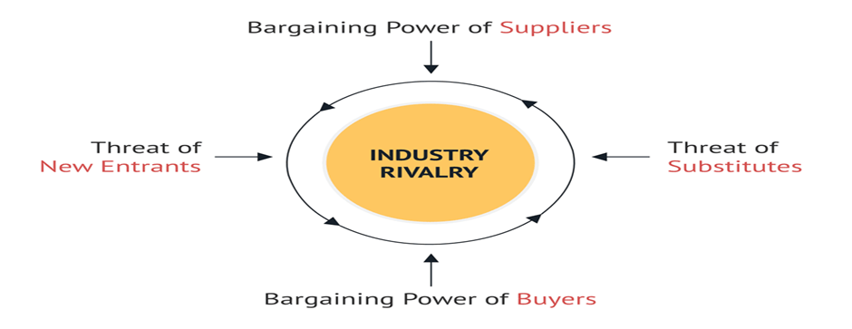
Figure: Michael porter's five forces framework.
(source: consulterce.com)

Bargaining power of suppliers is moderate to low in Tesla’ business to a certain extent depends on the consistency of their suppliers, as Tesla requires material for their products. According to Liu. et. al. (2014), suppliers of Tesla have little or low level of influence on Tesla’s products. Suppliers don’t have any power in the distribution or the trading of Tesla’s products. For example, many traders utilise third parties to distribute their resources to Tesla, whereas others directly trade with the Tesla, so they having inadequate impact on the automotive manufacturing environment.
Treat of substitutes is reasonable at Tesla this allows clients to switch from Tesla to other supplier’s. therefore, there is high competition. According to Lugtu (2019), low moving costs allow substitutes, such as public transport, to effortlessly entice clients. This levies a strong force against Tesla’s manufacture environment. Though, the reasonable obtainability of substitutes limits such effect of traders. For instance, clients have only a reasonable and restricted amount of substitute selections in the market. In reality, numerous substitutes have only a reasonable level of enactment in sustaining clients’ specific requirements. For example, public transportation is not as adaptable as a private vehicle. This situation restricts substitutes’ force against Tesla. Therefore, the threat of substitution as a subordinate management thought in Tesla’s approaches.
Bargaining power of customers is moderate at Tesla, as Tesla’s clients are a direct factor that defines Tesla sales revenues. According to Jing (2020), low moving costs decrease obstacles for Tesla clients to obtaining vehicles from different car manufactures. This levies a tough force against Tesla and other participants in the automotive manufacturing atmosphere. Though, the obtainability of substitutes is only reasonable in many cases, so this limits clients’ bargaining power in contrast to Tesla. For instance, many clients in out-of-town regions and have limited availability to public transportation, making it useful to commute their own vehicle. Therefore, the low volume of sales (each client buys and keeps only one vehicle) this decreases the impact of clients on Tesla. this indicates that the bargaining power of clients is moderate and a secondary management significance.
Threat of new entrants is low for Tesla as automotive company cost millions of dollars to operate and at present Tesla is the first company to launch a fully electric motorcar. According to Stringham. et. al. (2015), Tesla’s motors is challenging to contest with, particularly due to high cost of brand improvement. For instance, it is challenging for new competitors to match the Tesla’s robust brand. Even though, motor vehicle industries have high costs, which levy a barrier to new competitors. Likewise, well-known companies like Tesla has an advantage from accumulative economies of scales, which new entrants can only attain upon beyond a production approach, the threat of new admission is only a marginal strategic management worry for Tesla business environment.
Industry rivalry is very high for Tesla as they operate in a highly competitive market. There are number of very large companies operating in the automotive market, such as Toyota, BMW, Mercedes, Volkswagen act. According to Cooke (2020), these businesses are usually very destructive in innovating and indorsing their products. For instance, a large locomotive businesses have destructive marketing operations. Tesla’s marketing mix or 4Ps partly chances such fierceness, this strengthens the impact of rivals against the industry. Likewise, the low impairments for clients to purchase the vehicle from other car companies (minimum moving costs) strengthen the industry rivalry. This indicates that competitive rivalry is high-priority strategic management of Tesla.

Appendix 2.

Competitors Analysis.
In comparison to Tesla, these are four of the largest automobile manufactures in the world, who are concentrating on safeguarding the environment, when they are producing their products.

BMW  - BMW aims to decrease 80% in CO2 emissions produced of automobile by 2030. BMW apply influence during the development and manufacture of their automobiles. BMW’s objective is a sustainable value chain that shields its own needs with recycles and renewable raw materials, as well as energy supply (chen,2016). | Mercedes  - The technology and resources are basically radical. Mercedes-Benz is one of the main forces for the green rebellion in the locomotive manufacturing and has promised to go all-electric by 2030, which refer to as its range of internal ignition and engines is requiring more time (Russo. et. al 2015).
Toyota  - Toyota is working on decrease CO2 emissions within their automobiles by enhanced fuel competence and utilisation of hybrid technology as well as electrification. Toyota’s decrease CO2 emissions by applying innovative developments that cut energy and fuel consumption and escalates Toyota’s utilising of renewable energy (Russo. et. al 2015). | Volkswagen  - Volkswagen improves its productions and facilities in the most environmentally well-matched way possible. Volkswagen reflect not only the manufacture and utilise stages, but also the raw materials, predecessors and suppliers, and the end-of-life reprocessing procedure (chen,2016).

