

An Introduction to Microsoft PowerPoint 2007: Creating a PowerPoint Presentation
Angela Masurier

Introduction:
PowerPoint is one of the most commonly used software presentation programs. Presentations can come in all shapes and sizes, both formal and informal, and many organisations make extensive use of presentations to provide effective communication of ideas, concepts and factual data.
Typically presentations are used as an addition to tasks such as product marketing, training, education, product sales and board meetings, basically any situation where a speaker needs to deliver information to an audience.
Used wisely, PowerPoint can give your presentation a clean, professional look that gets your point across in a clear and effective manner.
Creating a New PowerPoint Presentation
PowerPoint will automatically create a new slide show once you open the program. You can also create a presentation manually, and PowerPoint provides many templates to choose from. To create a presentation manually, follow these steps:
- Click the Office button.
- Click New. The New Presentation dialog box will open, showing a list of available templates.
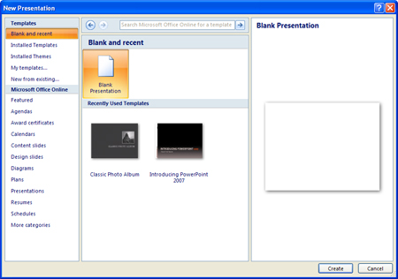
- Select the template you want from the list. If you want to build a presentation from scratch with no preset graphics or formatting, select the Blank Presentation template.
- Click Create.

Inserting a New Slide
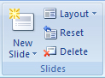
To insert a new slide in your presentation, follow these steps:
- Click the Home tab.
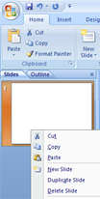
- Click the New Slide button in the Slides group.

You can also insert a new slide by following these steps:
- Right-click in the Slides and Outline pane on the left of the screen.
- Click New Slide.

Changing Slide Layouts
PowerPoint will automatically give the first slide in your presentation a “Title Slide” layout. Every other slide you add will be given a "Title and Content" layout by default. To change the layout of a slide, do one of the following:
- Right-click the slide you want to change, choose Layout from the shortcut menu. A window will open, showing the available slide layouts. Choose the layout you want for the slide or
- Select the slide you want to change in the Slide View. Click the Layout button in the Slides group on the Home tab. The button will expand, showing the available slide formats. Choose the layout you want for the slide.
Hint: Be sure to choose a slide layout that is appropriate for the content of your slide. For example, the "Title and Content" layout would work well for a slide with a bulleted list while "Title Only" or "Picture with Caption" may work best for a slide with only an image.

Reordering Slides
To reorder slides in your presentation, do one of the following:
- Click Slide Sorter on the View tab, and then click and drag the slides to their new location.
- Select the Slides tab in the Slides and Outline pane, and then click and drag the slides to their new location.

Hiding Slides
If you do not want a slide to appear during the slide show, but do not want to delete the slide as it may be used in a future presentation, the slide can be hidden.
- In either the Normal or Slide Sorter views, right-click the thumbnail of the slide you want to hide.
- Select Hide Slide from the shortcut menu. A hidden slide is indicated in the Slides and Outline pane by a number in a box with a line through it:
To add the slide back into your slide show, do the following: Right-click on the hidden slide, choose Hide Slide.

Inserting Text
If the slide layout includes textboxes, click inside the textbox and type your text. You can edit text in PowerPoint the same way you edit text in Microsoft Word. The text editing tools can be found on the Home tab.
Most layouts will automatically place your text within a bulleted list. The bulleted list format is recommended because it promotes short, informational sentences, which allow for a clear presentation of points
Text Boxes
To add a new textbox to a slide, follow these steps:
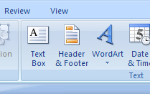
- Click the Insert tab.
- Click the Textbox button in the Text group.
- Click the slide where you want the textbox to appear .An empty textbox will appear with a cursor inside it, and you can begin typing.

Moving a Textbox
To move a textbox, follow these steps:
- Click inside the textbox to select it.

- Hold the mouse over the dotted outline until the pointer changes to a
- Click and drag the textbox to its new location.
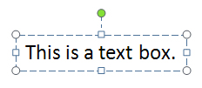

Resizing a Textbox

To resize a textbox, follow these steps:
- Click inside the textbox to select it. A border with nine handles appears around the textbox. The circles in the corners allow you to resize both the length and width of the box at once. The squares on the sides allow you to resize the box either horizontally or vertically.
- Click and drag a handle to resize the textbox.

Deleting a Textbox
To delete a textbox, follow these steps:
- Click the border of the box.
- Press the Delete key on your keyboard.

Formatting Text
You can format text by highlighting the portion you wish to edit and making changes using the options available on the Home tab. To give your text more visual appeal, you can use the Format Text Effects option from the shortcut menu. To access this feature, right-click on the selected text. In the following example, the Texture Fill and Inner Shadow formatting options have been applied.

WordArt
To make your text even more elaborate, you can use WordArt. To insert WordArt, follow these steps:
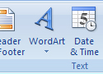
- Click the WordArt icon on the Insert tab. The button will expand to show the available WordArt styles.
- Select the style you want. A textbox will appear on the slide. Click inside the box, and type your text.
You can edit text created with WordArt using the Drawing Tools bar. To access the Drawing Tools bar, Click the text created with WordArt. The Drawing Tools bar will appear on the Ribbon.
PowerPoint allows you to insert many different types of media into your presentation. You can insert media in two ways: selecting options from the Insert tab, or clicking one of the icons shown below. The icons are displayed in the content area of a slide:


Tables
To insert a table in your slide, follow these steps:
- Click the Table icon on the Insert tab. A dialog box will open.
- Select the number of columns and rows you want in your table.
You can edit and customize your table using the Table Tools bar. To access the Table Tools bar, select the table by clicking it. The Table Tools bar will appear on the Ribbon.

Images and Clip Art
To insert an image from your files, follow these steps:
- Click the Picture icon on the Insert tab.
- Double-click the image you want to insert.
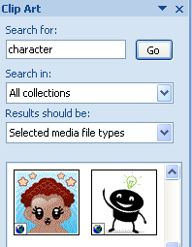
To insert a Clip Art image, follow these steps:
- Click the Clip Art icon on the Insert tab. The Clip Art pane, shown below, will open on the right of the screen.
- Search for an image you like using the Search For feature in the pane.
- Click and drag the image into your presentation.
To change the size of an image, follow these steps:

Click the image to select it. A border with nine handles will appear around the image box, as shown below. The circles in the corners allow you to resize both the length and width of the box at once. The squares on the sides allow you to resize the box either horizontally or vertically.
Click and drag a handle to resize the image.
To move an image to another location on a slide, follow these steps:
Click the image to select it. Hold the mouse over the dotted outline until the pointer changes to a Click and drag the image to its new location.
To delete an image, follow these steps: Click the image to select it. Press the Delete key on your keyboard.
You can edit and customize an image using the Picture Tools bar. To access the Picture Tools bar, select the image by clicking it. The Picture Tools bar will appear on the Ribbon.
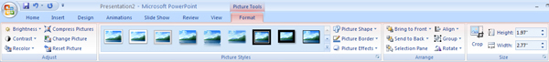These tools allow you to make a number of changes to an image, for example brightening and darkening an image, adding a border, changing the size, or placing an image in front or behind text.

Shapes
The Shapes feature allows you to draw a number of geometrical shapes, arrows, flow chart elements, stars, and other graphics on a slide. To add shapes, follow these steps:
- Click the Shapes icon on the Insert tab. A dialog box will open, showing the available shapes.
- Click the shape you want.
- Click the slide where you want the shape to appear.
You may want to connect shapes together in order to make a flowchart. You can do this by adding a line between shapes. To add a line, follow these steps:
- Click the Shapes icon on the Insert tab. A dialog box will open, showing the available shapes.
- Select a line from the lines menu.
- Click the slide where you want the line to appear.
To move a shape to another location on a slide, follow these steps:
- Click the shape to select it.
- Hold the mouse over the dotted outline until the pointer changes to a
- Click and drag the shape to its new location.
To delete a shape, follow these steps: Click the shape to select it. Press the Delete key on your keyboard.

SmartArt
SmartArt is an easy way to create diagrams and flowcharts. To insert SmartArt, follow these steps:
- Click the SmartArt icon on the Insert tab. A dialog box will open, showing the available SmartArt options.
- Select the diagram you want.
- Click Ok.
You can further customize your SmartArt using the SmartArt Tools bar. To access the SmartArt Tools bar, follow these steps:
- Click inside the SmartArt box in your presentation.
- Click SmartArt Tools above the Format tab on the Ribbon.
The SmartArt tools allow you to add a new shape to your art by clicking the Add Shape button in the Create Graphic group. If you expand the Add Shape button by clicking on the arrow, you can choose to insert the shape before or after the shape that is currently selected. If you need to change a shape's position in a hierarchy, click the Promote button to move it to a higher level and the Demote button to move it to a lower level. You can also use the Text Pane in the Create Graphic group to edit text.

Charts
To insert a chart, follow these steps:
- Click the Chart icon on the Insert tab.
- Select the type of chart you want.
- Click OK.
Don't Panic! Unlike previous versions of PowerPoint, PowerPoint 2007 will automatically open your chart as an Excel file. This allows you to input your data and make changes to your chart with more ease.
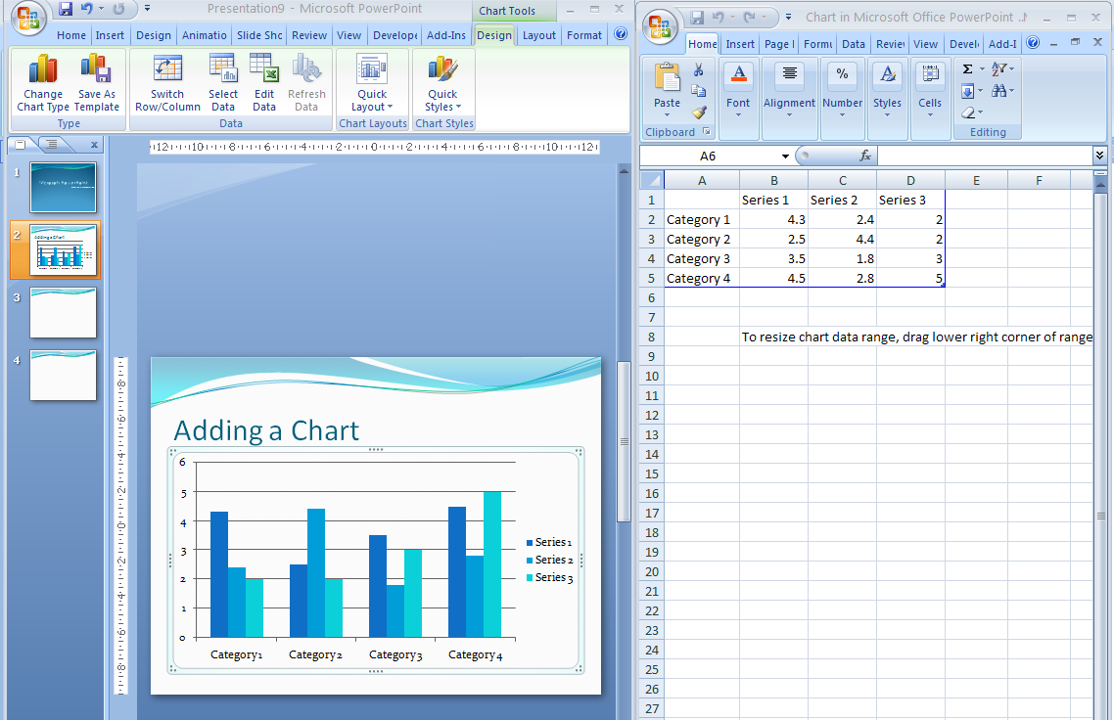
When you are finished editing your data, close Excel. The chart will appear in your PowerPoint presentation.
To edit the data at a later time, follow these steps:
- Select your chart by clicking it. The Chart Tools bar will appear on the Ribbon.
- Click the Edit Data icon.
You can also use the Chart Tools bar to change other aspects of your chart such as layout, style, and type.

Video
To insert video in your presentation, follow these steps:
- Click the Movie icon on the Insert tab.
- Select the video you want to insert.
- Choose whether you want the video to automatically begin playing when the slide is shown or when the video is selected.
- Click OK.
Other options for video can be found in the Movie Options group on the Movie Tools bar that appears on the Ribbon when a video is selected.
Warning: When you insert a video into your presentation, it is important to remember that the video file is linked to your presentation, and not embedded within it. This means that if you move the location of your presentation, you need to move your video with it. We recommend saving your presentation and video in the same folder, and moving the entire folder.

Audio
To add sound to your presentation, follow these steps:
- Click the Sound icon on the Insert tab.
- Choose the audio file you want to insert.
- Choose whether you want the sound to begin playing when the slide is shown or when the sound icon is selected.
- Click OK.
Other options for sound can be found in the Sound Tools bar that appears on the Ribbon when the sound icon is selected

Slide Design
You can make your presentation more visually appealing by applying a document theme or a background image. You can also add elements such as headers and footers, the date and time, or numbers to your slide.

Adding a Theme
A theme is a set of elements that allows you to give your presentation a more unified, professional look. To add a theme to your presentation, follow these steps:
- Click the Design tab on the Ribbon. PowerPoint will display the available themes as thumbnails in the Themes group. You can expand the list of themes by clicking the arrow to the right of the thumbnails.
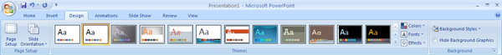
- Click the thumbnail of the theme you want to apply to your presentation. PowerPoint will apply the theme to all of the slides in your presentation by default.
To apply a theme to selected slides in your presentation, follow these steps:
- Hold down the Ctrl key.
- Click the slides you want to select in the Slides and Outline pane.
- Click the theme you want to apply.
PowerPoint also allows you to see a preview of what a specific theme will look like if applied to your presentation. To see the preview, follow these steps:
- Click the Design tab on the Ribbon.
- Hold the mouse over a thumbnail theme, but do not click it. Your slide will appear to have that theme applied. The slide will revert back to its previous appearance once you move the mouse away.

Adding a Background Image
You may be happy with a plain color background for your slide, but you can also add an image to the background. To add one of Powerpoint's preset images, follow these steps:
- Click the Design tab on the Ribbon.
- Click the Background Styles button in the Background group. PowerPoint will display the preset background images as thumbnails.
- To see a preview of what an image will look like in your presentation, hold the mouse over the thumbnail option.
- When you find the image you want, click the thumbnail option to apply it to your presentation.
If you want to add your own image to the background of a slide, follow these steps:
- Click the Design tab on the Ribbon.
- Click the Background Styles button in the Background group.
- Click Format Background. A dialog box will open.
- Click the Fill tab.
- Select Picture or Texture Fill.
- Click the File button.
- Select the file you want to upload as your background image. This option will only allow you to change the background for one slide at a time. To apply the image to all of your slides, click the Apply to All button.

Keep the background simple
Don't splash a bunch of distracting clip art on the background unless it is essential. The purpose of the background is to provide a well-defined visual space for the slide's content. All too often, presenters put up slides that have text displayed on top of pictures of the mountains or city skylines, which makes the text almost impossible to read.

Colour Schemes
You may find a theme you like but wish it was in a different color. To change the color scheme of your theme, follow these steps:
- Click the Design tab on the Ribbon.
- Click the Colours button in the Themes group, located to the right of the thumbnail options. PowerPoint will display the available color schemes for the theme that is currently applied to your presentation.
- Click the color scheme you want to apply.
If you want to remove a color scheme, follow these steps: Click the Colours button on the Design tab on the Ribbon. Click Reset Slide Theme Colours.
You can create custom color schemes by clicking Create New Theme Colours.

Headers and Footers
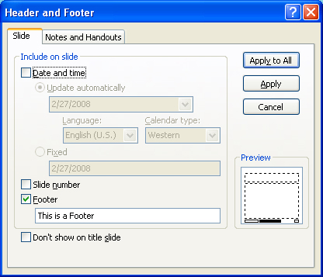
To insert footer, follow these steps:
Click the Insert tab on the Ribbon.
Click the Header and Footer button in the Text group. A dialog box will appear.
Click the Slide tab.
Select the Footer checkbox.
Type the text you want in your footer.
Click Apply. The footer will be applied to the selected slide only. If you want to apply the footer to all of your slides, click Apply to All.

If you want to add the date and time or slide numbers to your presentation, you can do so by checking the appropriate boxes in the Header and Footer dialog box.

The Slide Master
If you want to make changes to all of the slides in your presentation at once, you can use the Slide Master. When using the Slide Master, it is important to remember that this slide is a template, not an actual slide in your presentation. Any changes made to the slide master will affect the regular slides.
To access the slide master, follow these steps:
- Click the View tab on the Ribbon.
- Click the Slide Master button 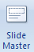in the Presentation Views group. The screen will change to display the Slide Master in the main area of the window. The Slides and Outline pane on the left of the screen will display the available Slide Layouts for your presentation.
- You can now edit the slide master the same way you would edit a regular slide.
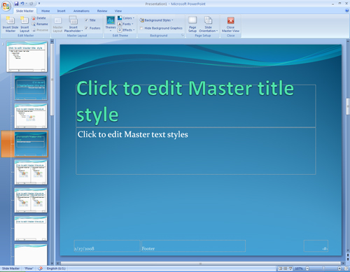

To exit Slide Master view, click the Close Master View button on the right of the Ribbon.
Animation
Using animations such as slide transitions and element animations can add visual interest to your presentation.
Transitions between PowerPoint Slides
In PowerPoint-speak, a transition is a little bit of excitement that occurs as one slide leaves the screen and the next slide appears. Transitions include the dissolve, the wipe up, and the cover down. Don't worry —you do get a chance to test-drive these transitions before you attach them to slides.
Before you know anything about transitions, however, you should know that they can be distracting and time-consuming. The purpose of a presentation is to communicate with the audience, not display the latest, busiest, most dazzling presentation technology.
Slide transitions are used to animate the entrance or exit of a slide. To add transitions, follow these steps:
- Select the slide whose entrance you want animated.
- Click the Animations tab on the Ribbon. Animation options for the slide will appear as thumbnails in the Transition to This Slide group. More animation options can be viewed by clicking the arrow to the right of the thumbnails. To see a preview of a transition, hold the mouse over the thumbnail option.
- When you have selected a transition you like, click the thumbnail to apply it to the selected slide. To apply a transition to all of your slides, click the Apply to All button to the right of the transition thumbnails.
Slides with animations are indicated in the Slides and Outline pane by a small star icon next to the slide number, as shown below:
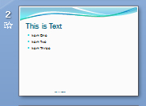

To customize a slide transition, choose from the following options:
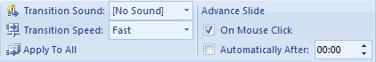
- Transition Sound - You can add a sound to announce the entrance or exit of your slide. To add a Transition Sound, click the drop-down menu to the right of where it reads “Transition Sound” in the Transition to this Slide group. PowerPoint will present you with a variety of sounds to choose from. To hear a preview of a sound, hold the mouse over the option you are interested in. To apply a sound to all of the transitions in your presentation, click the Apply to All button.
- Transition Speed - You can change the speed of the transition between slides by clicking the drop-down menu to the right of where it reads “Transition Speed” in the Transition to this Slide group. To apply this speed to all the transitions in your presentation, click the Apply to All button.
- Advance Slide - There are two options for slide advancement: On Mouse Click and Automatically After. On Mouse Click will advance your presentation to the next slide when you click your mouse or hit an arrow key. Automatically After will advance your presentation after a specified amount of time. Both options are located in the Transition to this Slide group. If you choose Automatically After, you must set the amount of time for each slide to be displayed. You can do this by clicking the arrows to increase or decrease the time.

Element Animations
You can animate individual elements of each slide. For example, you can animate only your text, or only your images. Below, you will find two different ways to animate individual elements of a given slide: The Easy Way (for beginners) and the Hard Way (for those who like more control over their animations).

The Easy Way
- Select the slide with the elements you want to animate.
- Click the Animations tab on the Ribbon.
- Click the Custom Animations button in the Animations group.
- PowerPoint will open the Custom Animations pane to the right of the window.
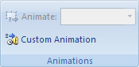
- Select the element you want to animate.
- Click the drop-down menu next to the Animate option in the Animations group.
- Select the animation you want from the pre-set animations in the drop-down list. To see a preview of an animation, hold the mouse over the animation option you are interested in.

The Hard Way
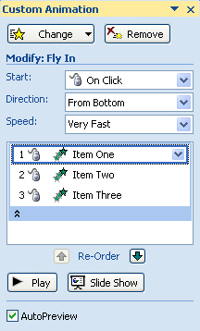
If you want to animate specific elements of a slide, for example only a portion of your text or a single image, you can use the Custom Animation Pane.
- Click the Custom Animation button in the Animations group. The Custom Animation Pane will open on the right of the screen.
- Select the element that you want to animate. If you want to animate only a portion of your text, highlight only that portion.
- Click the Add Effect button in the Custom Animation pane.
- Select the animation that you want to apply. The animations are grouped into different types, Entrance, Exit, Emphasis and Motion Paths. More animation techniques can also be found by clicking the More Effects option at the bottom of each group.

Slide Show View
Slide Show view presents your slide show on the full computer screen. To enter Slide Show View, do one of the following:
- Click the View tab, and click the Slide Show button.
- Click the Slide Show tab, and click either the From Beginning button or the From Current Slide button. From Beginning will start your slide show at the first slide. From Current Slide will start your slide show at the slide that is currently selected or alternatively press F5.
You can move to the next slide by pressing the space bar or right arrow key on your keyboard, or by clicking the left mouse button. To go back to the previous slide, press the left arrow key on your keyboard.

Slide Show view also has a toolbar to aid you through your live presentation, located at the bottom of the screen. The toolbar has the following tools:The blue Left and Right arrows allow you to move to the next or previous slide respectively.
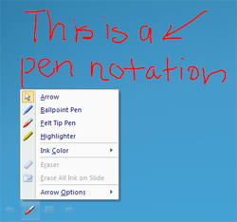
The Pen tool allows you to draw and make notations on a slide during a presentation. For example, if you want to emphasize an important point to your audience, you can circle it with the pen. When you exit Slide Show View, PowerPoint will ask if you want to save the ink notations you have made. If you choose to keep them, they will appear on your slide in Normal view as an image element.
The Slide icon gives you more control over the progression of slides in your presentation. For example, it allows you to jump ahead to a slide by selecting it from the Go to Slide list. The Screen option allows you to switch to a blank black or white screen. This is useful if you need to temporarily pause your presentation to use another projecting device. If you need to switch to another program, the Switch Programs option allows you to enter another program without leaving Slide Show View. The End Show option allows you to exit Slide Show View before you get to the end of your presentation. You can exit Slide Show view at any point in your presentation by pressing the Esc button on your keyboard

Adding Links
While giving your PowerPoint presentation, you have more options than simply advancing through your slides. You can create links within your presentation that will allow you to jump to another slide or presentation, open a website or file, or add automatically updating material from another program.
PowerPoint provides two ways to create links, each of which serves a different function. You can add linked objects to your presentation, which allows you to display an object that was created in another program (such as an Excel graph). When the object is updated in its original program, those changes will be reflected in the object in your presentation. You can also link objects such as text or graphics to other pages or slides, allowing you to bring up new information by clicking the link.

Placing Linked Objects
This option allows you to place a dynamically linked object, which was created in another program. The dynamic link means that when the object is updated in its native program, the linked object in your presentation is also updated. For example, a linked Excel chart in your presentation will be automatically updated whenever the spreadsheet data is updated in Excel.
In order for an object to be linked, the program used to create the original object must support object linking and embedding (OLE). All Microsoft Office programs support OLE, unless you are working in compatibility mode (e.g., OLE will not be supported if you are linking to an Excel 2003 chart in a PowerPoint 2007 presentation). OLE is the feature which allows information changed in another program (e.g., a changed chart in Excel) to be updated automatically in PowerPoint.
WARNING: If you create a link to an object, that object must be on the computer when you give your presentation. If the object is renamed, moved, or deleted, it will not be available when you give or work with the presentation.

Placing linked objects: copy and paste
This option works best when working with graphical elements such as a chart or graph. You can place the linked object itself, or an action button or icon which will open the original program when clicked.
- In the program that was used to create the object, open the file containing the object
EXAMPLE: A chart created in Excel
- Select all of the data that you want to link to your presentation (e.g., the chart)
- Right click the selection » select Copy
- Open your PowerPoint presentation and display the slide into which you want to insert the linked object
- From the Home tab, in the Clipboard group, click thebelow PASTE » select Paste Special...
The Paste Special dialog box appears.
- Select Paste Link
The dialog box refreshes to display the Paste Link options.
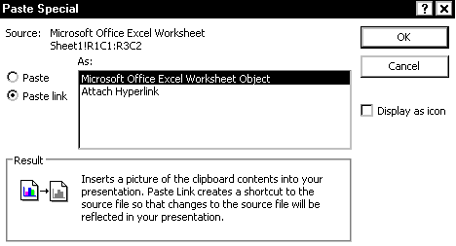
- In the As list, verify that the type of file that you are linking to is selected.

- OPTIONAL: To display the linked object as an icon, select Display as icon
HINTS: You can add a hyperlink for this icon which will open the file containing your object in the original program when you click the icon.
When working with your presentation in Normal view, you can double click this icon to bring up the original file in its source program.
- Click OK the linked object is displayed.

Placing linked objects: Insert dialog box
This approach is most useful when placing a file such as a spreadsheet.
- From the Insert tab, in the Text group, click OBJECT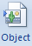the Insert Object dialog box appears.
- Select Create from file The Insert Object dialog box refreshes.
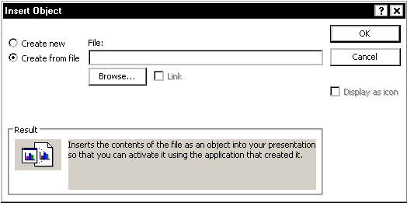
- To select a file,
  - Click BROWSE...
The Browse dialog box appears.
  - Using the Look in pull-down list, navigate to and select the desired file
  - Click OK
- To create the dynamic link, select Link
- OPTIONAL: To display the linked object as an icon, select Display as icon
HINTS: You can add a hyperlink for this icon which will open the file containing your object in the original program when you click the icon.
When working with your presentation in Normal view, you can double click this icon to bring up the original file in its source program.
- Click OK the linked object is displayed.

Updating a Link
When an object is updated in its native program, the linked object in your presentation is automatically updated.
You can also choose to open the linked object in the original application through PowerPoint.
- Select the linked object
- Right click the object » select Linked Object » Edit the object opens in its source program and can be edited.
- When finished editing the original file, save and close the file. Your object in PowerPoint is updated.

Linking to a File or Website
You can create a link that will open the application to display a specific file or website. This link can be created from text or a graphic.
- If necessary, from the View tab, in the Presentation Views group, click NORMAL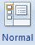
- Display the slide on which you want to create a link
- Select the text, image, or shape which will be the link
- From the Insert tab, in the Links group, click HYPERLINKthe Insert Hyperlink dialog box appears.
- In the Address text box, type the path and filename or the complete URL
OR
To browse for the file or web page, using the Look In pull-down list, navigate to and select the desired file
- Click OK

Linking to Slides in the Same Presentation
You can create links to different slides within your presentation, even if the slides are hidden or would not normally be displayed next in the presentation. For example, if you have some hidden slides that contain extra material, you can link to those slides and then come back to your original slide. You can use text or any graphic as your link.
- Select the text, image, or shape that you want to be the link
- From the Insert tab, in the Links group, click HYPERLINK the Insert Hyperlink dialog box appears.
- From the Link to section, click PLACE IN THIS DOCUMENT
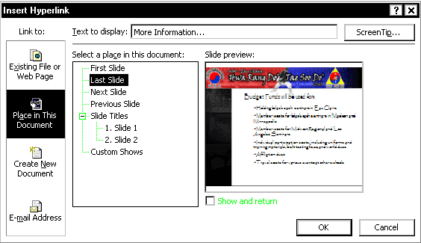
- In the Select a place in this document section, select the desired slide
HINT: If you would like to link to a specific slide and the list of slides is not available, click the plus sign (+) next to Slide Titles.
- Click OK

Changing a Link
If you would like to change a link to open a different slide, you can do so.
- Right click the linked text, image, or shape » select Edit Hyperlink...
The Edit Hyperlink dialog box appears.
- From the Link to section, click PLACE IN THIS DOCUMENT
- From the Select a place in this document scroll list, select the desired slide
NOTE: If you choose First Slide, Last Slide, Next Slide, or Previous Slide, these are relative links and may link to different slides if the order of the slides is changed or if more slides are added. To guarantee that you link to the specific slide you want, you should select a specific slide from the list.

Linking to Slides in another Presentation
It is often convenient to reference another PowerPoint presentation that provides pertinent information to your current presentation.
- Select the text, image, or shape you want to be the link
- From the Insert tab, in the Links group, click ACTION the Action Settings dialog box appears.
- Select Hyperlink to
- From the Hyperlink to pull-down list, select Other PowerPoint Presentation...
The Hyperlink to Other PowerPoint Presentation dialog box appears.
- From the Look in pull-down list, navigate to and select the desired file
- Click OK the Hyperlink to Slide dialog box appears.
- Select the desired slide
- Click OK
- In the Action Settings dialog box, click OK

To return to the parent presentation during the presentation:
- Right-click anywhere on the slide » select Last Viewed

Saving Your Presentation
There are several ways to save your presentation. Click the Office button and choose one of the following options:
- Save As
  - PowerPoint Presentation - This option saves your presentation as the default file format for PowerPoint 2007. This format cannot be opened with previous versions of PowerPoint.
  - PowerPoint Show - This option saves your presentation so that it can only open in Slide Show view. You will not be able to edit your presentation using this file format.
  - PowerPoint Presentation 97-2003 Presentation - This option saves your presentation in the file format used by previous versions of PowerPoint. Using this format will allow you to work on your presentation with older versions of PowerPoint.
- Publish
  - Package for CD - This option copies your presentation and media links to a new folder that can be burned to a CD. One advantage of using this option is that it allows you to give a PowerPoint presentation using a computer that does not have PowerPoint installed.
  - Publish Slides - This option saves your slides to a Slide Library or other location so you can reuse them later.

Printing Your Presentation

Printing Individual Slides
To print just the slides in your presentation, follow these steps:
- Click the Office button.
- Click Print. A dialog box will open.
- Select Slides from the Print What dropdown list. You can also choose to print your slides in Color, Grayscale or Pure Black and White.
- Click OK.
Printing your Presentation in Handout, Notes or Outline Format
You can also print your presentation in formats that are better for editing or taking notes.
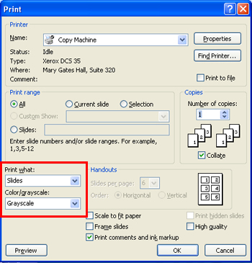
- Click the Office button.
- Click Print. A print dialog box will open.
- Select a format from the following options under the Print What drop-down menu:
- You can also choose to print your slides in Color, Grayscale or Pure Black and White.
- Click OK.

Handouts - Prints multiple slides per page. You can customize the number of slides to be printed per page in the Handouts section to the right of the Print What dropdown menu. Selecting three slides per page will leave additional space for notes on the right of the page.
Notes Page - Prints each slide in the top half of the page with space for notes in the bottom half.
Outline View - Prints the outline created in the Outline tab.

