Introduction

This research will predominantly focus on whether the use of Organic Architecture and its principles can improve the health and well-being of residents in communities in Wales. It will also consider how Gaia Education and the Housing Standards and Design Guides can also contribute to this improved health and well-being. Case studies on rural housing developments within Wales will be included, identifying where Organic Architecture could be applied.

Health and well-being are high on the agenda for the future generations who live in Wales (Well-Being of Future Generations Wales Act (FGA), 2015). It has been deemed necessary to emphasize the effects of positive health and wellbeing as it adds years to life, improves recovery from illness and influences the well-being and mental health of those around us (GOV.UK, 2021a, pg. 3). It is important for this to also be considered when concerning housing developments. This is because health and well-being can be affected by our living environment and we tend to spend most of our time in our homes or enclosed spaces. This is exemplified in the work undertaken by Neil (2001), highlighting that we spend approximately 76.6% of our time indoors.

Wales is a beautiful country. However, due to loss of industry over the last five decades owed to a decline in farming because of cheaper imports, decreased tourism, and the COVID-19 pandemic, some areas have high unemployment rates (BBC, 2020). These are widely believed to be the catalyst for deprivation and inequality leading to divisions in society and loss of communities. Many families have become reliant on social housing, which can lead to them reducing their life prospects and not being part of their community (Holt and Butcher, 2021). This has been exasperated by the implementation of poor housing and living environments, which has led to a cycle of despair and hopelessness felt by many.

The importance of Organic Architecture has gained greater prevalence since the Welsh Government (WG) introduced the FGA to improve social, cultural, environmental, and economic well-being in Wales. It is thought that Organic Architecture has a part to play in changing the way we live in Wales, to create a different and better future; one which can incorporate sustainable natural environments, overall creating a better environment for the population of Wales. This is emphasised by Önal (2019, pg. 6), who states that... “buildings need to be inspired by nature not only for innovations in materials and building techniques but also for space design, façade design, and their future environment and sustainable function of buildings”. Meaning that, designs need to incorporate nature in order to create better living environments and communities.

Sack (2019) offers a useful analysis of the principles of Organic Architecture; the principles consist of several elements (such as space, light, nature, separation, shelter, peacefulness, language, ornamentation, simplicity, and mechanical components) - all of which are the universal principles of Organic Architecture. However, these principles have been developed and adapted by multiple academics. Sack lists these developed elements, consisting of- simplicity and repose, multiple styles of houses, correlation of nature, topography, colours of nature, sustainability, nature of materials and spiritual integrity. It could be argued that an implementation of existing and new principles of Organic Architecture will lead to recreating natural environments, allowing them to thrive, which will contribute to improving residents’ health and well-being. It could also be argued that implementing such principles within existing and new housing developments could improve social, cultural, environmental, and economic well-being in Wales, therefore fulfilling some of the aims of the FGA, as set out by the WG.

This research will explore how Organic Architecture can have a major part to play in changing the way we live in Wales, to create a different and better future; one which can incorporate natural environments and sustainability into everyday living. It will investigate how implementing Organic Architecture would not only be better for the environment of Wales, but it would bring back a sense of community and increase health and well-being overall. In turn, various aims of the FGA would be met (Generations Commissioner for Wales (FGC), 2020).

1. What does Organic Architecture mean?

Mirzaei (2013) describes Organic Architecture as an approach to design that embraces more elegant and subtle spaces, shapes, and atmospheres within its structures. The use of nature as a meaning of structure, space and form is a key element behind Organic Architecture. Mirzaei also states that when incorporating this method of design into structures, it often represents a “…reinterpretation of principles of nature, that build more natural shapes than nature itself, highlighting that Organic Architecture in structural design can have significant consequences for health and welfare”. This topic area of nature is discussed by various academics and professionals in architecture today. Tran (2018) for example, states that “nature has been a key inspiration for human beings in the design and construction of building.” Taking this into account, this study will examine if Organic Architecture can create better communities in Wales and whether the health and well-being of people in wales can be improved?

Frank Lloyd Wright (1914) was one of the first people who spoke of the terminology Organic Architecture. Anapur (2016) quotes Wright as saying that “nature and architecture should be in harmony”, which implies that man-made structures and nature itself can grow and develop together. Starr (2019, pg. 2-7) emphasises this relationship, stating that “…Organic Architecture is a philosophy in which through numerous design methodologies, it promoted harmony between living space and the natural world”.

In line with these views, this research submits that structures and designs should be more reflective of the natural surrounding elements. Starr (2019) reinforces this argument, stressing that structures should be “sympathetic and well-integrated” in life. Put differently, building developments should better connect and flow with their natural surroundings. Starr further emphasises this point, stating that “buildings, decorations, and environment” need to become part of a “unified, interconnected composition” (p, 2-7). Therefore, these elements should be considered in the architectural design processes today and in the future.
Shumaker (2019, pg. 7) also considers these aspects of Organic Architecture, expressing that ... “architectural designs have an impact on social interactions between families and within the community”, therefore “inclusion, needs more attention and further correlation”. Thus, it could be argued that the need for this additional consideration should be included within the design approach for family residences, as social interaction between families and the community is key to achieving a community that thrives, which will subsequently achieve better health and well-being.

Furthermore, sustainability, another element of Organic Architecture has become part of the 21st century rhetoric. Cordero (1992, pg. 17) covers civil engineer, Jean-Lou Chameau’s visions, who states that “the concept of sustainable development is ethical in nature and requires a conscious choice to provide for the needs of present and future generations”.

With regards to this discourse, WG published The Business of Becoming a Sustainable Nation (2016). This strives to support the green growth economy by investing £6million into a Government Nature Fund which will be used to support projects such as those aimed at increasing biodiversity in rural and coastal areas. The intention is to use the natural assets of Wales, such as water, wind, and woodlands, to develop sustainable energy, thus increasing long term employment opportunities, by creating a better future for communities in Wales. This is a good example of the principles of Organic Architecture being utilised to strive towards improving the quality of life and developing an improved way of living, which would have positive impacts on the health and well-being of Wales’ population. The green growth economy also links in with the aims of the FGA, which finds sustainable development and becoming a low-carbon economy key, both being crucial to Wales' development. The aims of the FGA will also be achieved through the five working methods and the seven welfare targets. This will be explored in greater detail in section 2.1.

1.1. What are the benefits of Organic Architecture?

Pearson (2001, pg. 8) emphasizes that by achieving the ‘inside and out’ relationship through the implementation of natural forms, it allows us as humans to feel “better and freer”. This reinforces that Organic Architecture can create a positive movement towards developing architecture, that can connect more with mother nature. This idea is further developed by Pearson (2001, pg. 10), where he refers to the visions of the Hungarian architect, Imre Makovecz, who states “Organic Architecture strives to connect the parts of the building which are nearest to the earth. The foundations of the walls in particular- closely to the earth. It also strives to construct them from materials that have been extracted from the earth itself. The upper structures should be light as if heaven were descending upon the earth”.

Furthermore, there are multiple elements that Organic Architecture can offer to society today in the way we build homes, such as hope and respect for our environments. Pearson (2001, pg. 9) emphasises this when he states that “the re-emergence of organic design, represents a new freedom of thought, an expression of hope for the future”. It could also be expressed that having more “respect for nature”, can lead to the “celebration of the beauty and harmony of natural forms, flows and systems”. This will increase health and well-being as this greater appreciation and celebration of the natural environment will lead to greater interaction with nature which can have a positive impact on how we feel; happier and healthier (Coles, 2016). This can have a positive effect on us mentally and physically. For example, a better sense of neighbourhood was “associated with better physical and mental health, lower stress, better social support” (Young, 2004, pg. 2634).

1.2. How can rural housing developments incorporate organic architecture?

There are many elements of design that can be used in housing developments, that would reflect organic architectural principles. For example, free-flowing plans that can create more natural light inside homes and the use of natural forms such as arches, vaults, domes, and spheres. Korean architect Yoon (2009) emphasises these elements and they can be identified in the Haesley Nine Bridges Golf Club House (Illustrated in Figure 1-2).
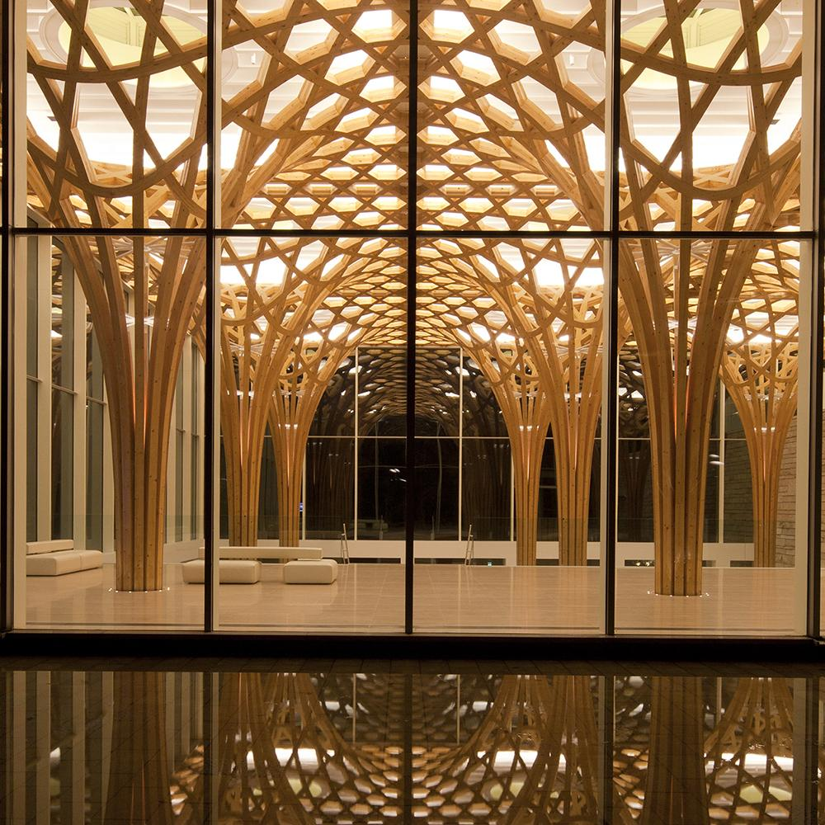
  - Figure 1- Haesley Nine Bridges Golf Club House, Korea (2009). By Kyeongsik Yoon. Credit- Jongoh Kim.

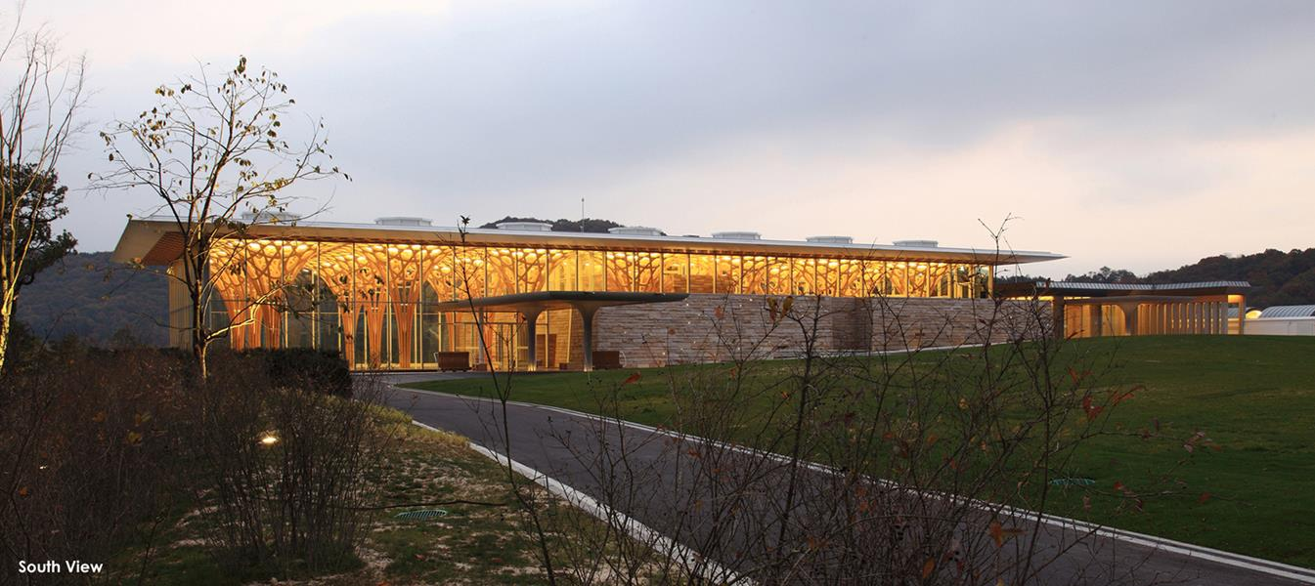
  - Figure 2- Haesley Nine Bridges Golf Club House, Korea (2009). By Kyeongsik Yoon. Credit- Jongoh Kim.

This could be achieved within limited building costs. Nevertheless, it could be argued that the benefits to health and well-being would outweigh the issue of cost anyhow. A good example of rural architecture can be seen in the Finnish architect, Alvar Aalto’s designs; a leader in the modernist movement, who promoted the notion that human emotion and natural forms could be used as a source of Organic Architecture (Pearson, 2001, pg. 10). Aalto’s designs embedded the use of natural materials, particularly wood, which was used in “new and creative ways to allow the materials to express themselves”. This is particularly applied in Villa Mairea (Illustrated in Figure 3-4). Another way Organic Architecture can be used in housing developments, is by using open plan areas (to achieve better fluidity and air circulation and the feeling of freedom), elongated plinths (to create more sheltered areas), and floor to ceiling windows (to allow greater use of light and connectivity with the outside environment). Examples of these Organic Architecture principles are demonstrated in the design of Falling Water by Wright (1935) (Figure 5). Overall, with the implementation of Organic Architecture principles to new and existing developments, improved living environments will be created as there would be better consideration for the surrounding natural elements and the idea of community. In turn, this would lead to better health and well-being of residents.
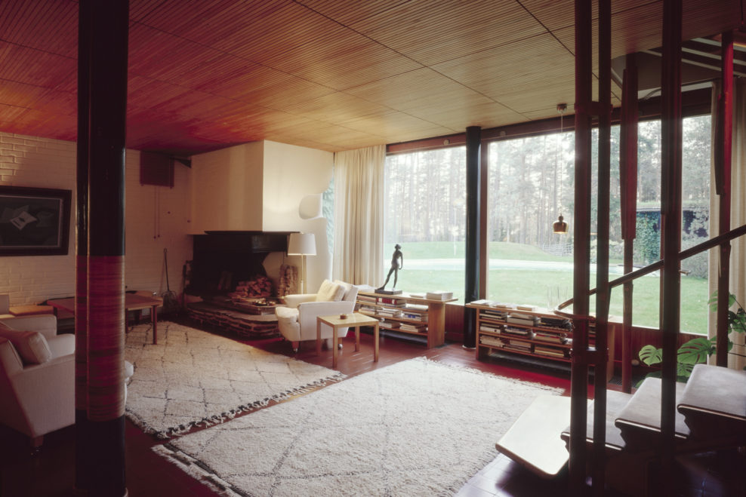
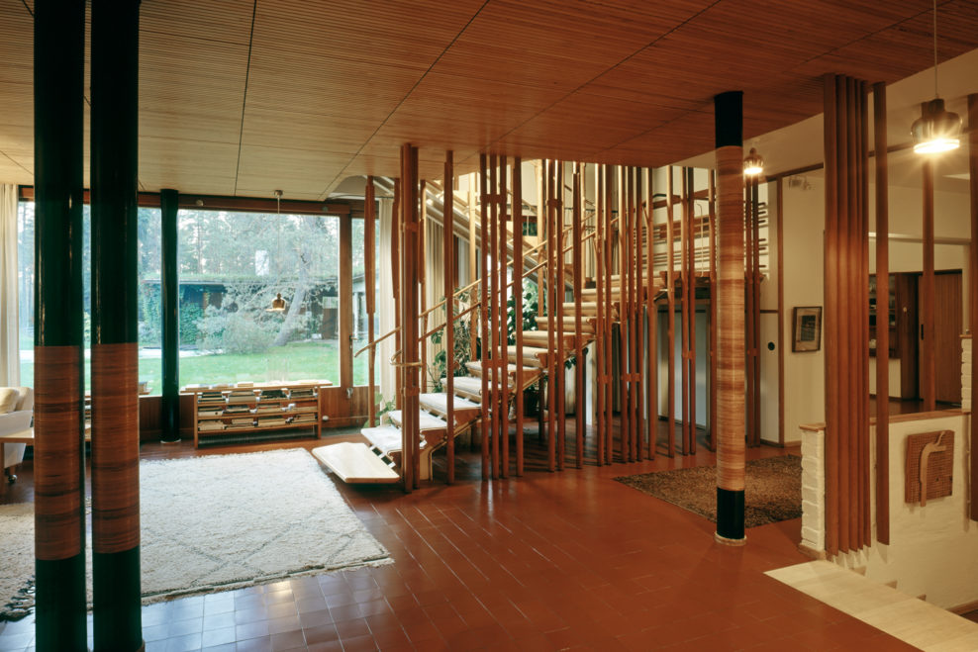
  - Figure 4- Villa Mairea, Finland (1939). By Alvar and Aino Aalto. Credit- AlvarAalto.fi.

  - Figure 3- Villa Mairea, Finland (1939). By Alvar and Aino Aalto. Credit- AlvarAalto.fi.
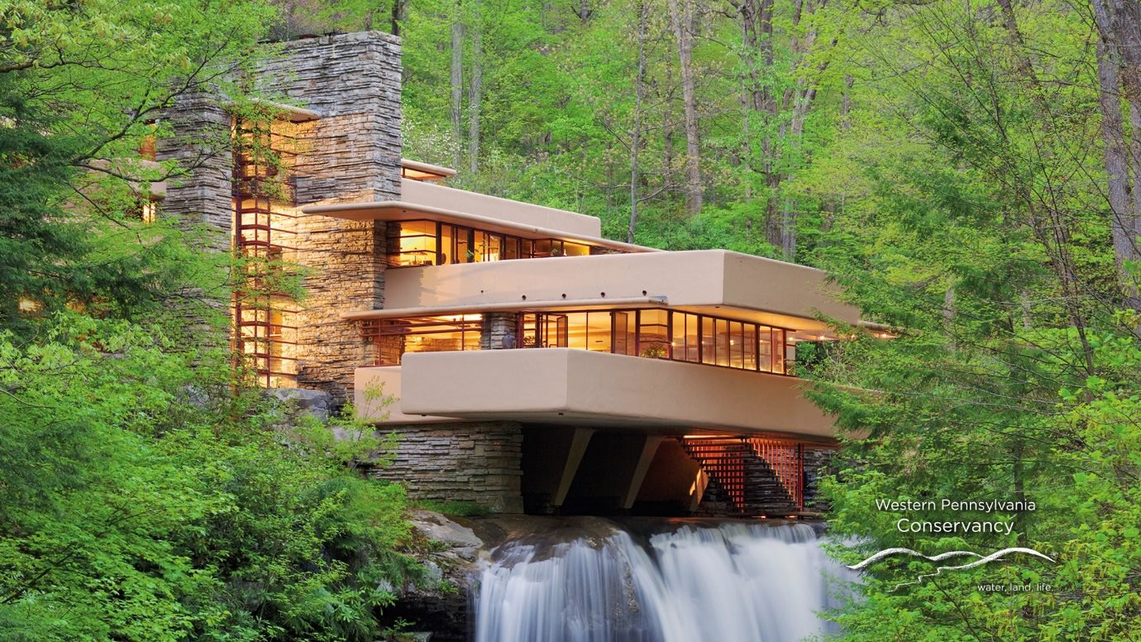
  - Figure 5- Falling Water, Pennsylvania (1937). By Frank Lloyd Wright. Credit- FallingWater.org.

2. The Well-Being of Future Generations (Wales) Act (2015)

The FGA (2015) requires public bodies in Wales to plan for the long-term; enhance their collaboration with people, communities, and each other and avoid unresolved problems such as poverty, health inequalities and climate change. The Act is unique to Wales, attracting global attention as it provides the present and future generations an opportunity to make a lasting, positive change to areas such as health and well-being and poverty. Several other areas are identified, such as skills, health and wellness, adverse experience with children, land use and planning, housing, and transport. Therefore, the FGA focuses on the future of how we live, including elements such as social, economic, environmental, and cultural challenges. These challenges are addressed through several goals that are also unique to Wales. This comprises of the objectives of seven well-being goals and ‘Five Ways of Working’, all in which positive opportunities and developments for communities can be created (Illustrated in Figure 6-7). Such positive opportunities and developments can be furthered when combined with the implementation and collaboration of the Organic Architecture and Gaia Education principles.

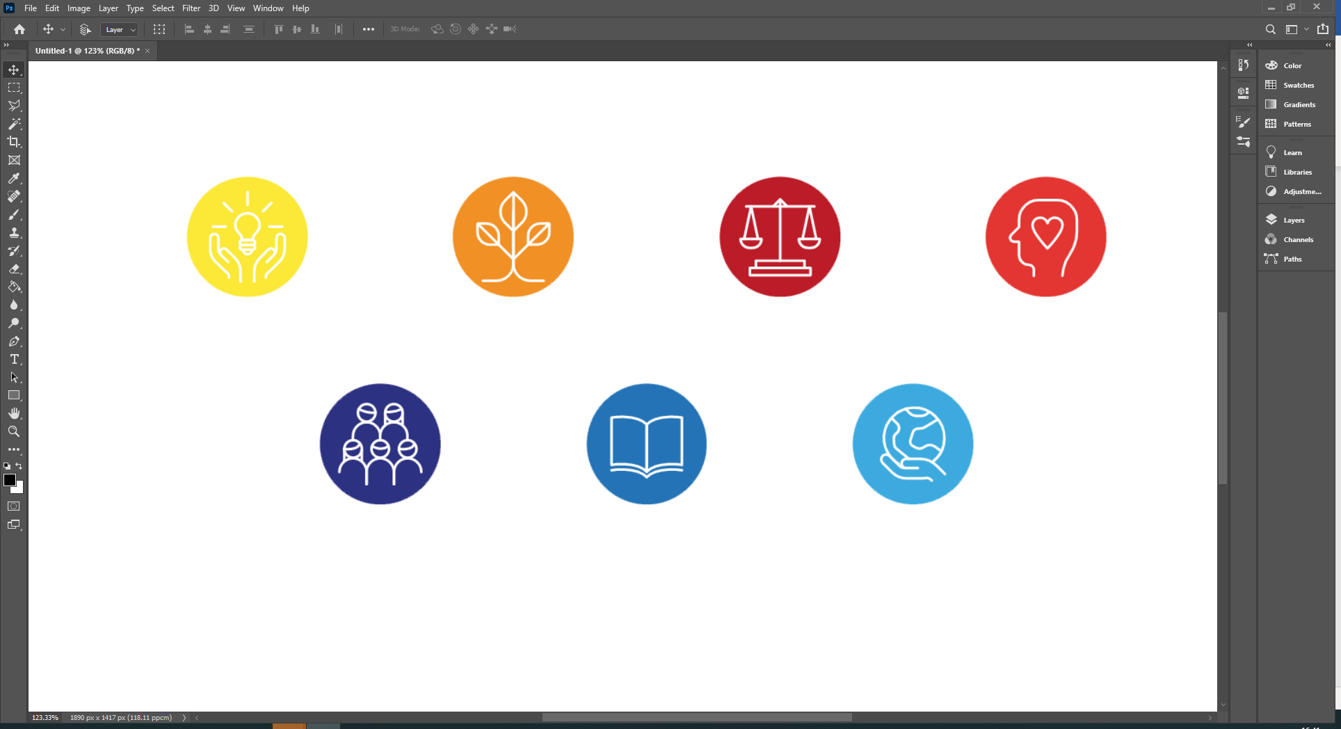

A Prosperous Wales

A Prosperous Wales

A Prosperous Wales

A Prosperous Wales

A Prosperous Wales

A Prosperous Wales

A Prosperous Wales

A Prosperous Wales

A Prosperous Wales

A Prosperous Wales

A Prosperous Wales

A Prosperous Wales

A Prosperous Wales

A Prosperous Wales

A Prosperous Wales

A Prosperous Wales

A Healthier Wales

A Healthier Wales

A Healthier Wales

A Healthier Wales

A Healthier Wales

A Healthier Wales

A Healthier Wales

A Healthier Wales

A Healthier Wales

A Healthier Wales

A Healthier Wales

A Healthier Wales

A Healthier Wales

A Healthier Wales

A Healthier Wales

A Healthier Wales
A Globally Responsive Wales

A Globally Responsive Wales

A Globally Responsive Wales

A Globally Responsive Wales

A Globally Responsive Wales

A Globally Responsive Wales

A Globally Responsive Wales

A Globally Responsive Wales

A Globally Responsive Wales

A Globally Responsive Wales

A Globally Responsive Wales

A Globally Responsive Wales

A Globally Responsive Wales

A Globally Responsive Wales

A Globally Responsive Wales

A Globally Responsive Wales
A Wales of Vibrant Culture & Thriving Welsh Language

A Wales of Vibrant Culture & Thriving Welsh Language

A Wales of Vibrant Culture & Thriving Welsh Language

A Wales of Vibrant Culture & Thriving Welsh Language

A Wales of Vibrant Culture & Thriving Welsh Language

A Wales of Vibrant Culture & Thriving Welsh Language

A Wales of Vibrant Culture & Thriving Welsh Language

A Wales of Vibrant Culture & Thriving Welsh Language

A Wales of Vibrant Culture & Thriving Welsh Language

A Wales of Vibrant Culture & Thriving Welsh Language

A Wales of Vibrant Culture & Thriving Welsh Language

A Wales of Vibrant Culture & Thriving Welsh Language

A Wales of Vibrant Culture & Thriving Welsh Language

A Wales of Vibrant Culture & Thriving Welsh Language

A Wales of Vibrant Culture & Thriving Welsh Language

A Wales of Vibrant Culture & Thriving Welsh Language
A Wales of Cohesive Communities

A Wales of Cohesive Communities

A Wales of Cohesive Communities

A Wales of Cohesive Communities

A Wales of Cohesive Communities

A Wales of Cohesive Communities

A Wales of Cohesive Communities

A Wales of Cohesive Communities

A Wales of Cohesive Communities

A Wales of Cohesive Communities

A Wales of Cohesive Communities

A Wales of Cohesive Communities

A Wales of Cohesive Communities

A Wales of Cohesive Communities

A Wales of Cohesive Communities

A Wales of Cohesive Communities
A More Equal Wales

A More Equal Wales

A More Equal Wales

A More Equal Wales

A More Equal Wales

A More Equal Wales

A More Equal Wales

A More Equal Wales

A More Equal Wales

A More Equal Wales

A More Equal Wales

A More Equal Wales

A More Equal Wales

A More Equal Wales

A More Equal Wales

A More Equal Wales
A Resilient Wales

A Resilient Wales

A Resilient Wales

A Resilient Wales

A Resilient Wales

A Resilient Wales

A Resilient Wales

A Resilient Wales

Figure 6- Seven Well-Being Goals. Credit- Well-Being of Future Generations (Wales) Act (2015).A Resilient Wales

A Resilient Wales

A Resilient Wales

A Resilient Wales

A Resilient Wales

A Resilient Wales

A Resilient Wales

A Resilient Wales

  - Figure 6- Seven Well-Being Goals. Credit- Well-Being of Future Generations (Wales) Act (2015).


  - Figure 7- Five Ways of Working. Credit- Well-Being of Future Generations (Wales) Act (2015).

Long-term

Long-term

Long-term

Long-term

Long-term

Long-term

Long-term

Long-term

Long-term

Long-term

Long-term

Long-term

Long-term

Long-term

Long-term

Long-term
Prevention

Prevention

Prevention

Prevention

Prevention

Prevention

Prevention

Prevention

Prevention

Prevention

Prevention

Prevention

Prevention

Prevention

Prevention

Prevention
Collaboration

Collaboration

Collaboration

Collaboration

Collaboration

Collaboration

Collaboration

Collaboration

Collaboration

Collaboration

Collaboration

Collaboration

Collaboration

Collaboration

Collaboration

Collaboration
Integration

Integration

Integration

Integration

Integration

Integration

Integration

Integration

Integration

Integration

Integration

Integration

Integration

Integration

Integration

Integration
Involvement

Figure 8- UK unemployment has risen to 5% for the first time since 2016- By Richard Partington. Credit- Guardian graphicInvolvement

Figure 8- UK unemployment has risen to 5% for the first time since 2016- By Richard Partington. Credit- Guardian graphic

Figure 8- UK unemployment has risen to 5% for the first time since 2016- By Richard Partington. Credit- Guardian graphicInvolvement

Figure 8- UK unemployment has risen to 5% for the first time since 2016- By Richard Partington. Credit- Guardian graphicInvolvement

Figure 8- UK unemployment has risen to 5% for the first time since 2016- By Richard Partington. Credit- Guardian graphic

Figure 8- UK unemployment has risen to 5% for the first time since 2016- By Richard Partington. Credit- Guardian graphic

Figure 8- UK unemployment has risen to 5% for the first time since 2016- By Richard Partington. Credit- Guardian graphic

Figure 8- UK unemployment has risen to 5% for the first time since 2016- By Richard Partington. Credit- Guardian graphicInvolvement

Figure 8- UK unemployment has risen to 5% for the first time since 2016- By Richard Partington. Credit- Guardian graphicInvolvement

Figure 8- UK unemployment has risen to 5% for the first time since 2016- By Richard Partington. Credit- Guardian graphic

Figure 8- UK unemployment has risen to 5% for the first time since 2016- By Richard Partington. Credit- Guardian graphicInvolvement

Figure 8- UK unemployment has risen to 5% for the first time since 2016- By Richard Partington. Credit- Guardian graphicInvolvement

Figure 8- UK unemployment has risen to 5% for the first time since 2016- By Richard Partington. Credit- Guardian graphic

Figure 8- UK unemployment has risen to 5% for the first time since 2016- By Richard Partington. Credit- Guardian graphic

Figure 8- UK unemployment has risen to 5% for the first time since 2016- By Richard Partington. Credit- Guardian graphic

Figure 8- UK unemployment has risen to 5% for the first time since 2016- By Richard Partington. Credit- Guardian graphic

Figure 8- UK unemployment has risen to 5% for the first time since 2016- By Richard Partington. Credit- Guardian graphic

Figure 8- UK unemployment has risen to 5% for the first time since 2016- By Richard Partington. Credit- Guardian graphic

Figure 8- UK unemployment has risen to 5% for the first time since 2016- By Richard Partington. Credit- Guardian graphic

Figure 8- UK unemployment has risen to 5% for the first time since 2016- By Richard Partington. Credit- Guardian graphicInvolvement

Figure 8- UK unemployment has risen to 5% for the first time since 2016- By Richard Partington. Credit- Guardian graphicInvolvement

Figure 8- UK unemployment has risen to 5% for the first time since 2016- By Richard Partington. Credit- Guardian graphic

Figure 8- UK unemployment has risen to 5% for the first time since 2016- By Richard Partington. Credit- Guardian graphicInvolvement

Figure 8- UK unemployment has risen to 5% for the first time since 2016- By Richard Partington. Credit- Guardian graphicInvolvement

Figure 8- UK unemployment has risen to 5% for the first time since 2016- By Richard Partington. Credit- Guardian graphic

Figure 8- UK unemployment has risen to 5% for the first time since 2016- By Richard Partington. Credit- Guardian graphic

Figure 8- UK unemployment has risen to 5% for the first time since 2016- By Richard Partington. Credit- Guardian graphic

Figure 8- UK unemployment has risen to 5% for the first time since 2016- By Richard Partington. Credit- Guardian graphicInvolvement

Figure 8- UK unemployment has risen to 5% for the first time since 2016- By Richard Partington. Credit- Guardian graphicInvolvement

Figure 8- UK unemployment has risen to 5% for the first time since 2016- By Richard Partington. Credit- Guardian graphic

Figure 8- UK unemployment has risen to 5% for the first time since 2016- By Richard Partington. Credit- Guardian graphicInvolvement

Figure 8- UK unemployment has risen to 5% for the first time since 2016- By Richard Partington. Credit- Guardian graphicInvolvement

2.1. The Seven Well-Being Goals, The Five Ways of Working and key elements the FGA

To address climate change, adapting the way we live is vital so that society can be more self-sufficient and less wasteful. A particular effect of climate change in Wales is flooding. Such flooding occurs frequently within Wales as the topography of the land varies, consisting of floodplains and fast-flowing rivers. This unfortunately leads to damage of the natural environments (FGC, 2020). As indicated by the Commissioner of the FGA, to protect homes, damage caused by future and more frequent flooding is expected to cost around “£200 million a year with so many homes and properties in Wales close to the water”. Therefore, the evidence is clear that action needs to be taken⁷.

Additionally, the Act outlines other issues affecting lives, such as social issues impacting communities in Wales. For example, many people feel disengaged from society, feeling left out of “decisions that most affect them”. Particularly, young people have emphasised that they “feel isolated or even excluded” which is an increasing problem in society today. It is reported that only “15% of 18-24-year-olds trust the government to put the needs of the UK first”. This uncovers that young individuals feel as if they are not cared for and their futures are not considered. Therefore, it could be said that there is a need for a better understanding to build better communities and “the way people live to give them a stronger voice” (FGC, 2020).

Moreover, the development of economic trends in processes such as advancements in technology and automation, will inevitably lead to more people without jobs in the future. It could then be suggested that those people would need to seek alternative methods of employment. It is extremely important, therefore, that the green growth economy referred to above will provide alternative sustainable employment (FGC, 2020).

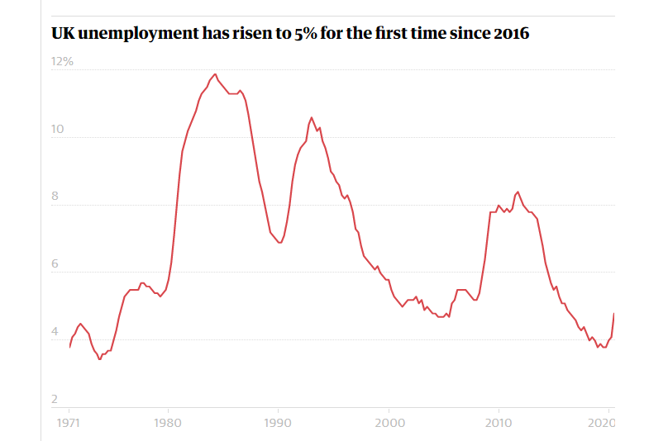
If no action is taken, social issues such as loss of jobs and reduction in community activities will worsen, result in an increasing number of people out of work. This is a worrying prospect when due to Covid-19, unemployment has already reached 5% for the first time since 2016, as shown by Economics respondent Richard Partington (2021) via the graph in figure 8 below.

Figure 8- UK unemployment has risen to 5% for the first time since 2016- By Richard Partington. Credit- Guardian graphic.

Figure 8- Unemployment rates. Credit- Richard Partington (2021)

Figure 8- Unemployment rates. Credit- Richard Partington (2021)

Figure 8- Unemployment rates. Credit- Richard Partington (2021)

Figure 8- Unemployment rates. Credit- Richard Partington (2021)

Figure 8- Unemployment rates. Credit- Richard Partington (2021)

Figure 8- Unemployment rates. Credit- Richard Partington (2021)

Figure 8- Unemployment rates. Credit- Richard Partington (2021)

Figure 8- Unemployment rates. Credit- Richard Partington (2021)

Figure 9- Bart Prince Residence and Studio, New Mexico (1984). By Bart Prince Architects. Credit- Andrew Boyne ArchitectFigure 8- Unemployment rates. Credit- Richard Partington (2021)

Figure 8- Unemployment rates. Credit- Richard Partington (2021)

Figure 8- Unemployment rates. Credit- Richard Partington (2021)

Figure 8- Unemployment rates. Credit- Richard Partington (2021)

Figure 8- Unemployment rates. Credit- Richard Partington (2021)

Figure 8- Unemployment rates. Credit- Richard Partington (2021)

Figure 8- Unemployment rates. Credit- Richard Partington (2021)

Figure 8- Unemployment rates. Credit- Richard Partington (2021)
However, this issue can be overturned if the FGA goals are met soon. This is because self-sufficiency can significantly improve this problem, and the aspect of sustainability being implemented within communities will better the knowledge of sustainable development. This will lead to ensuring the health of our planet, and that our communities are fit for future generations. Such self-sufficiency and greater knowledge can be achieved by “improving the economic, social, environmental and cultural wellbeing of Wales by taking action, following the sustainable development principle, aimed at achieving the well-being goals” (FGC, 2020).

Meeting the FGA goals can be worked towards through the “five ways of working”, which if properly emphasised and implemented by public bodies… “will help deliver the fundamental changes required to achieve the Wales we want. Each of these will be described separately below:

Taking a long-term view:

This involves working towards a real insight “as to what the future might look like if we achieve the goals” set out by the FGA, “with the assistance of the public bodies and what they plan for the future” (FGA, 2015).

Taking an integrated approach:

This involves the collaboration of public bodies and communities so they can develop their understanding of each other’s requirements to meet the goals, whilst also contributing to all seven well-being goals and not focusing on just one or two (FGA, 2015).

Involving people with an interest in achieving well-being goals:

This emphasises that the collaboration and integration between… “communities, individuals and their public services” is a vital segment of achieving the goals. Therefore, the FGA highlights that if we are to successfully meet the “needs of the current generation, without compromising the ability of the future generations to meet their needs” we need contribution from various categories of society (FGA, 2015).

Collaboration:

This reinforces that for the FGA goals to be met, as a society, we need to… “create a better understanding of what true partnership looks and feels like, along with breaking down barriers and building understanding of the benefits” (FGA, 2015).

Preventing problems from occurring or getting worse:

This focusses on the importance to prevent current problems from occurring again. The FGA shows that as a nation, Wales has been developing… “concepts of prevention and early intervention” to take action to “improve the lives of citizens and public services are to manage the challenges now and, in the future” (FGA, 2015).

3. Organic Architecture and the Well-Being of Future Generations (Wales) Act (2015)

In this section the links between Organic Architecture and the FGA will be discussed, identifying the common threads embedded into both and critically analysing the aims of each and how they can complement each other.

The FGA (2015) emphasizes that young people… “feel uniquely isolated or even excluded”. However, this can be tackled by creating a greater sense of ‘community’ around them. During the recent period of COVID-19, various physical and mental stresses have become a daily challenge to the many in the population. Therefore, it is imperative to place focus on achieving a greater feeling of community within rural areas of Wales. Having this sense of a strong ‘community’ will be “vital for the health and well-being of us all” ¹¹ during one of the most challenging times in history

Likewise, as previously mentioned, having greater “respect for nature” can also lead to having better health and well-being (Pearson, 2001, pg. 9). This greater respect would result in people having a new connection to nature, re-engaging individuals back into society. Therefore, combining the idea of ‘better communities’ from the FGA and respect for nature from the principles of Organic Architecture, it could be said that giving communities a “stronger voice” to implement ideas of Organic Architecture within housing developments and structural design will allow public bodies to “build better communities”. In turn, this will seemingly improve the way we live today and ensure that “communities are fit for future generations”.

Fundamentals such as structure, shape, light, and form are key in the development to “build better communities” ¹¹. In addition to these, features such as ‘sustainability and ‘self-sufficiency’ (which are developing into a segment of the Organic Architecture and Gaia Education principles) are deemed necessary to build better communities within the views of the Commissioner for the FGA, which in turn will increase health and well-being. These features will also lead to “ensuring the health of our planet” as communities will be more self-sufficient and self-sustaining, enabling a healthier planet for future generations to come.

Furthermore, as intended by the FGA, demanding more of a relationship between public bodies and communities will enable a sense of collaboration between the two. If public bodies then apply the principles of Organic Architecture through the design of communities to improve and recreate existing spaces by including components such as inside and out and natural forms, this will naturally lead to humans feeling “better and freer”.

If a greater collaborative relationship is achieved between public bodies and communities, this will also “help deliver the fundamental changes required to achieve the Wales we want” ¹¹. As a result of the fundamental changes, communities will be enabled to give back to society, as they will have more functional abilities through aspects such as the “five ways of working” and the “seven well-being goals”. However, it could be argued that if these requirements are not met, then issues such as a lack of a connection between communities and public bodies could deteriorate. Consequently, the isolation and exclusion that the FGA claims that young people currently feel, will further exacerbate in the future. Unless the requirements are met imminently, “concepts of prevention and early intervention” will be pointless when working towards “improving the lives of citizens and public services” now and in the future (FGC, 2021).

Architect, Andrew Boyne, states that "our environments have an impact on our moods and that buildings themselves play a key role" (Boyne, 2014). Considering this quotation in light of the FGA’s reference to the importance of land use, planning and housing, how we construct homes today and in the future is important since the design and construction methods of architecture will be key to achieving the FGA’s goals and increasing health and well-being. Boyne’s work accentuates how this can be done, examples of which are given below (Figures 9-12).
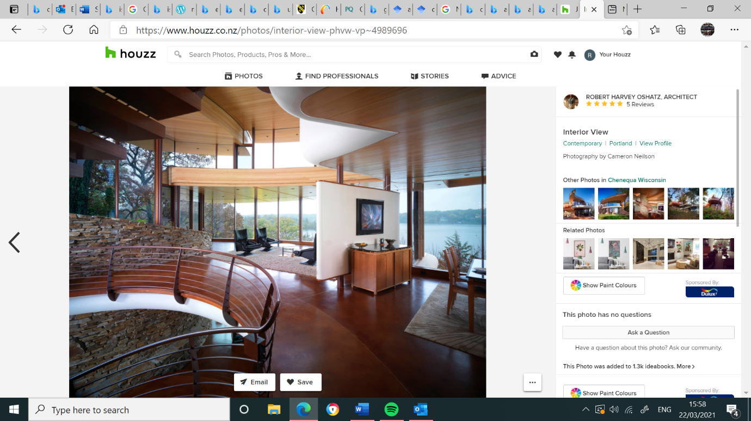
  - Figure 9- Bart Prince Residence and Studio, New Mexico (1984). By Bart Prince Architects. Credit- Andrew Boyne Architect

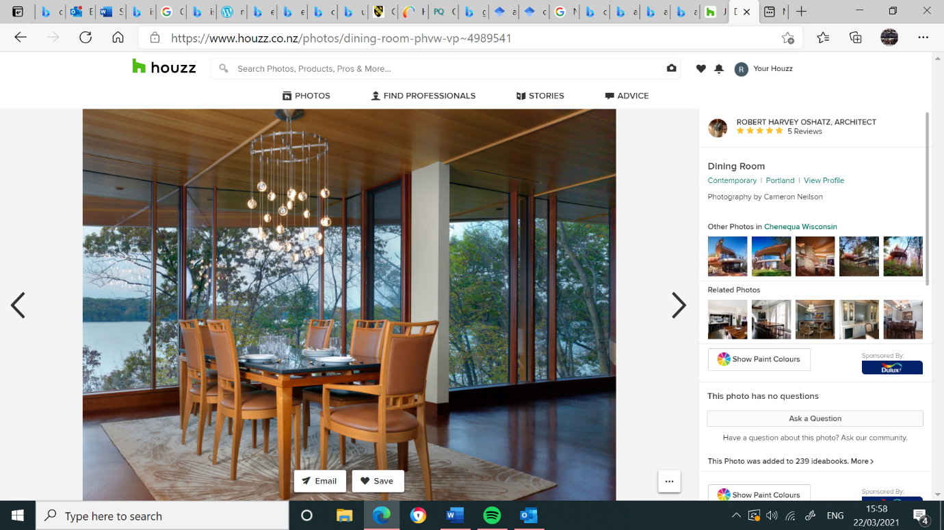
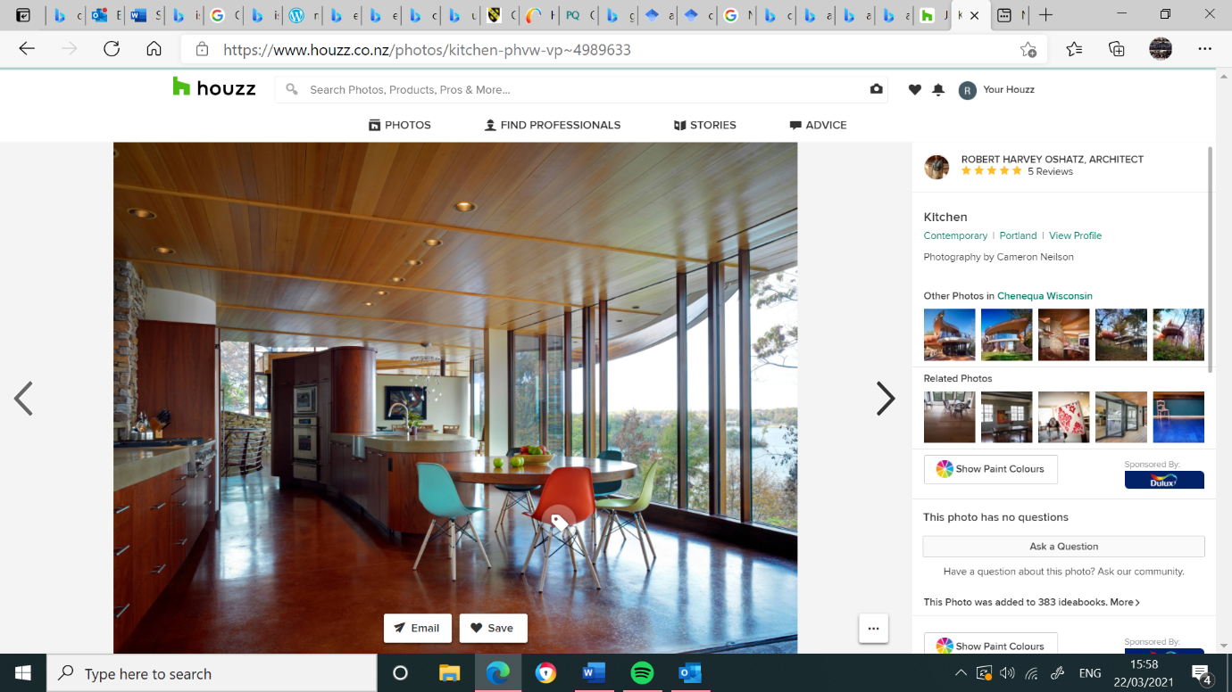
  - Figure 11- Bart Prince Residence and Studio, New Mexico (1984). By Bart Prince Architects. Credit- Andrew Boyne Architect

  - Figure 11- Bart Prince Residence and Studio, New Mexico (1984). By Bart Prince Architects. Credit- Andrew Boyne Architect

  - Figure 11- Bart Prince Residence and Studio, New Mexico (1984). By Bart Prince Architects. Credit- Andrew Boyne Architect

  - Figure 11- Bart Prince Residence and Studio, New Mexico (1984). By Bart Prince Architects. Credit- Andrew Boyne Architect

  - Figure 11- Bart Prince Residence and Studio, New Mexico (1984). By Bart Prince Architects. Credit- Andrew Boyne Architect

  - Figure 11- Bart Prince Residence and Studio, New Mexico (1984). By Bart Prince Architects. Credit- Andrew Boyne Architect

  - Figure 11- Bart Prince Residence and Studio, New Mexico (1984). By Bart Prince Architects. Credit- Andrew Boyne Architect

  - Figure 11- Bart Prince Residence and Studio, New Mexico (1984). By Bart Prince Architects. Credit- Andrew Boyne Architect

  - Figure 11- Bart Prince Residence and Studio, New Mexico (1984). By Bart Prince Architects. Credit- Andrew Boyne Architect

  - Figure 11- Bart Prince Residence and Studio, New Mexico (1984). By Bart Prince Architects. Credit- Andrew Boyne Architect

  - Figure 11- Bart Prince Residence and Studio, New Mexico (1984). By Bart Prince Architects. Credit- Andrew Boyne Architect

  - Figure 11- Bart Prince Residence and Studio, New Mexico (1984). By Bart Prince Architects. Credit- Andrew Boyne Architect

  - Figure 11- Bart Prince Residence and Studio, New Mexico (1984). By Bart Prince Architects. Credit- Andrew Boyne Architect

  - Figure 11- Bart Prince Residence and Studio, New Mexico (1984). By Bart Prince Architects. Credit- Andrew Boyne Architect

  - Figure 11- Bart Prince Residence and Studio, New Mexico (1984). By Bart Prince Architects. Credit- Andrew Boyne Architect

  - Figure 11- Bart Prince Residence and Studio, New Mexico (1984). By Bart Prince Architects. Credit- Andrew Boyne Architect
  - Figure 10- Bart Prince Residence and Studio, New Mexico (1984). By Bart Prince Architects. Credit- Andrew Boyne Architect

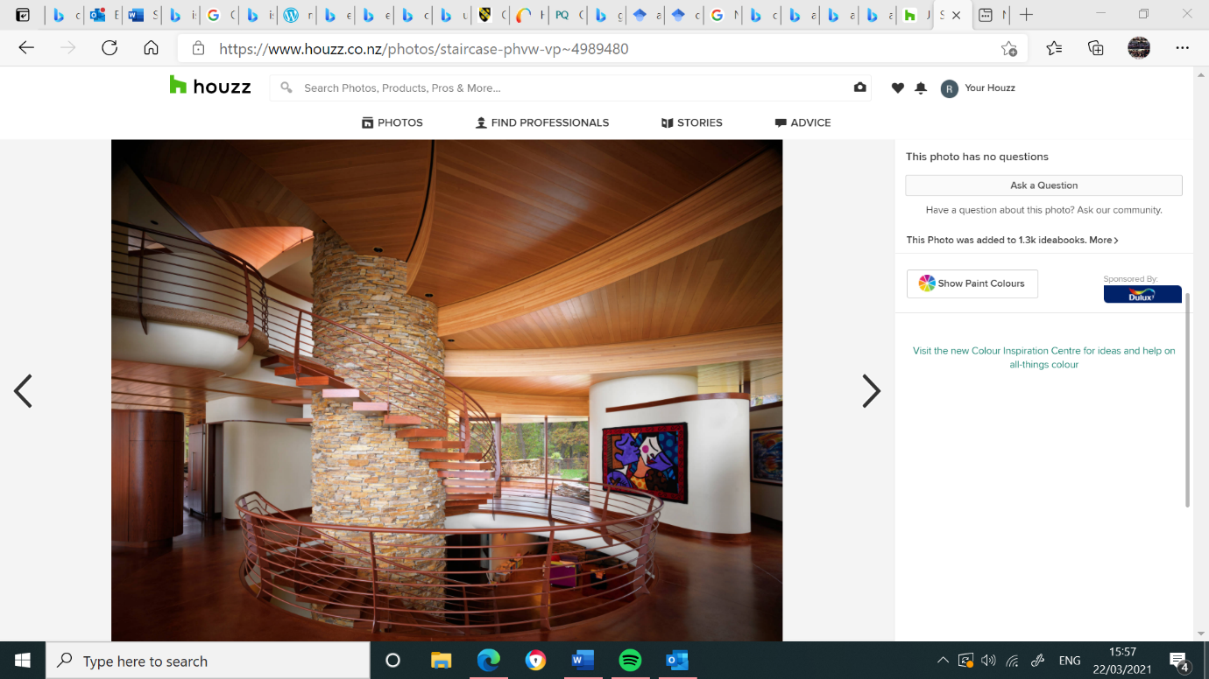
  - Figure 12- Bart Prince Residence and Studio, New Mexico (1984). By Bart Prince Architects. Credit- Andrew Boyne Architect

4. What is Gaia Education?

Gaia Education is an organisation that provides online courses which allow you to “learn and create elegant solutions carefully adapted to the biocultural uniqueness of place” (Gaia Education, 2020). The name of the Gaia Education organisation is of Greek origin…” from Khaos emerged Gaia – the mother of all. She created the first Gods of the Greek Pantheon and then mated with Uranos – the God of the sky – to give birth to the 12 Titans. Gaia is the “personification of life’s fertility to give birth to more life”.

This organisation is also the “leading provider of education for sustainable development”, embodying the newer incarnations of Organic Architecture. They are an international Non-Governmental Organisation (NGO), providing students of all ages, backgrounds, and skills with the ability to design a newly recreated thriving community. They teach their students how to utilize “energy and resources with greater efficiency”, enabling their “learners to become changemakers, capable of playing active roles in transitioning their communities to sustainable and regenerative practices, lifestyle and infrastructures” (Gaia Education, 2020).

Gaia Education has taken on multiple projects. A particularly interesting project is their Sustainable Management of Cultural Landscape (SUMCULA). It focuses on… “landscape management viewpoint, the need to preserve natural, cultural and intangible values, and develop them from an evolutionary perspective into sustainable living environments”. Another key aspect that is relatable to this research, is that the project focusses on encompassing the cultural and natural resources of the landscape in question. Whether this be… “thousands of hectares of rural tracts of land to a small homestead with a front yard of less than one hectare”. Gaia Education also highlights that “European society is demanding a greater voice in decision making to ensure the greater equity and prosperity in their communities and to contribute to a more biodiverse and healthier environment”. Therefore, communities that allow individuals to make more decisions will also allow individuals’ greater contribution to their surrounding environments and society to enable them to be more sustainable. In response to the challenges of sustainability, “localised sustainability projects" are also being implemented through Gaia Education into societies, striving towards more “appropriate and cost-effective public policies and projects to support resource-efficient low-carbon and climate-resilient European societies”. When considering these ideas (community contribution to surrounding environments to achieve greater sustainability, localised projects, cost-effective policies, and efficient European societies) in conjunction with the journey towards a more “resilient Wales”, it could be said that such journey can be aided by the ideas behind Gaia Education as they also embody the need for “citizen participation towards the strengthening of community resilience” (FGA, 2015).

4.1. How can the elements of Gaia Education be implemented in all communities within Wales?

Gaia Education (2020) highlights that “the need to preserve natural, cultural and intangible values, and develop them from an evolutionary perspective into sustainable living environments, has always been of great importance”. Creating more creative and collaborative communities can have many positive impacts, including aspects such as social, economic, and environmental. “Preserving the natural environments “enhances the connection between ‘man-made’ and ‘natural’ structures, therefore enabling communities to have greater insight into “Understanding the impact and developing resilience to climate change in food, land, biodiversity and water systems, bringing culture back to agriculture, appreciation of the diversity of cultural influences on food patterns” ¹⁸. Consequently, this will lead to communities recognising the advantages of self-sufficiency and sustainability. This will certainly connect the gap between “producers and consumers” within our societies today. How structural and housing developments can embody this idea of self-sufficiency sustainability can be seen in figures 13-15 below.

The main principles of Gaia Education consist of the following:
- Ability to design a newly recreated thriving community.
- Teaching their students how to utilize “energy and resources with greater efficiency”.
- Playing active roles in transitioning their communities to sustainable and regenerative practices, lifestyle and infrastructures”.
- European society is demanding a greater voice in decision making to ensure the greater equity and prosperity in their communities and to contribute to a more biodiverse and healthier environment”.
- Citizen participation towards the strengthening of community resilience
- Connection between ‘man-made’ and ‘natural’ structures.
- Understanding the impact and developing resilience to climate change in food, land, biodiversity, and water systems, bringing culture back to agriculture, appreciation of the diversity of cultural influences on food patterns

It can be said that through the implementation of the principles and several design strategies of Gaia Education, (along with consideration of Organic Architecture and the FGA) any goals and requirements of how we should live today to increase health and well-being can be met.
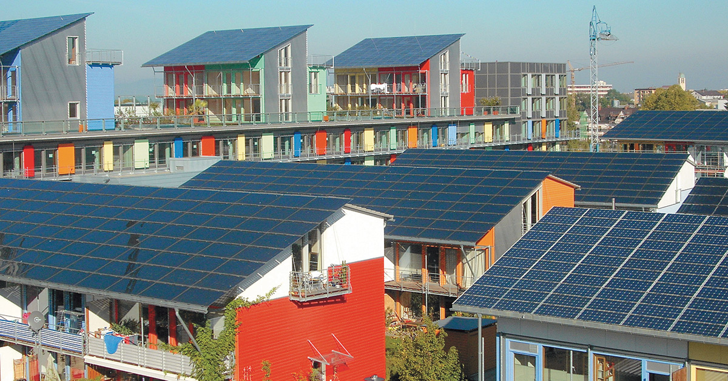
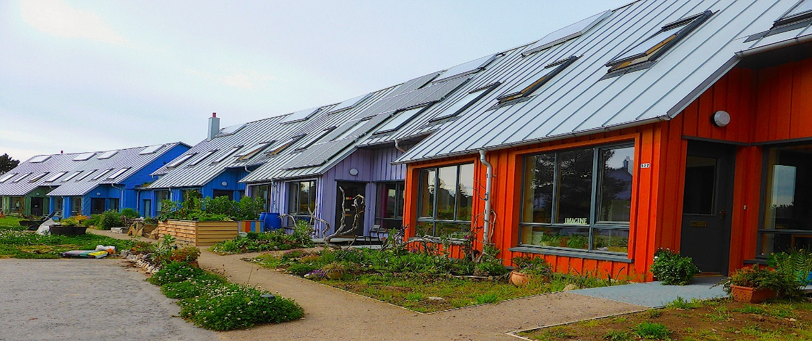
  - Figure 14- Gaia Education (2020). Credit- Gaia Education
  - Figure 13- Gaia Education (2020). Credit- Gaia Education

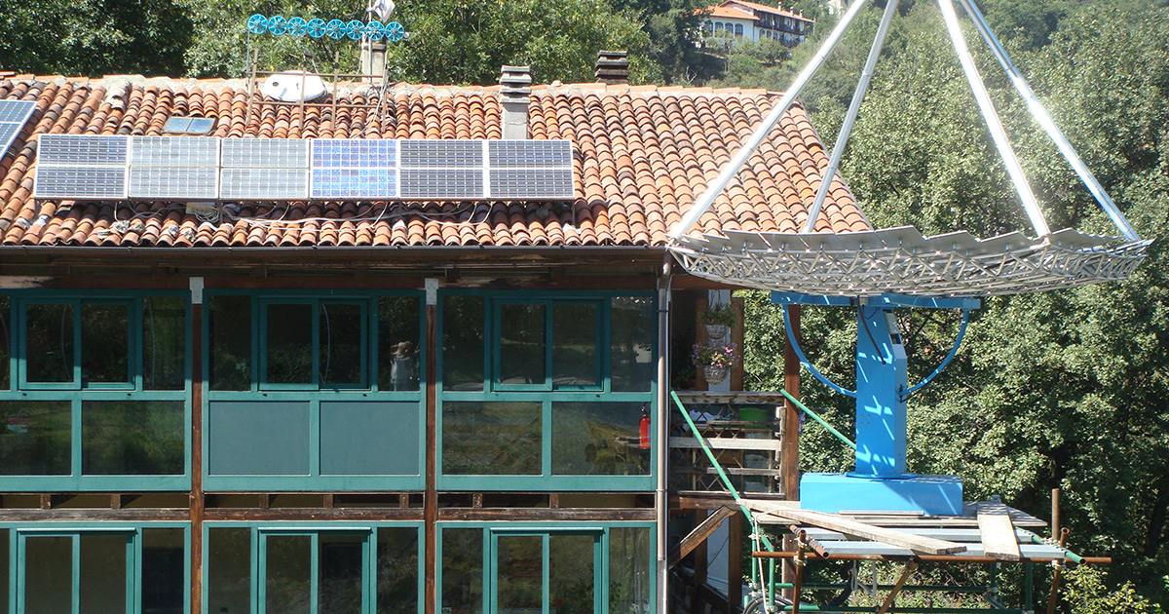
  - Figure 15- Gaia Education (2020). Credit- Gaia Education

5. Design Guides, Housing Standards, and the design approach for housing estates of the past, present, and future.

The National Design Guide and Technical Housing Standards (GOV.UK, 2021b) written by the Government are part of a series of documents that professional architecture practices must refer to, to meet the needs of domestic occupants and to comply with legislative regulations. The guide and standards reference the complete design approach towards the construction of buildings. The Design Guide also sets out specific characteristics and objectives that need to be met upon completion of each project. Furthermore, designs today are steered following the Technical Housing Standards (2015) to create internal spaces which are suitable for occupants within all dwellings.

The Housing Standards also illuminate the gross internal floor space which is required in each dwelling. Indeed, Park (2019) highlights that “housing space standards can be traced back almost exactly a century to the Tudor Walters report of 1918. The Tudor Walters Report was also said to be the “first time that housing quality was formally acknowledged to be a matter of national importance”, as at this time housing developments were constrained, only just fulfilling housing standards (GOV.UK, 2021c).

Furthermore, the Tudor Walters Report emphasised the inclusion of “essentials features” within developments such as the following:
- Minimum of three rooms on the ground floor
- Minimum of three bedrooms on the upper floors
- A bathroom + parlour space (storage space)

After 1919, British construction became a “national responsibility” (GOV.UK, 2021c). According to Stillwell (2014), Developments termed “new housing” were created that became known as “homes fit for heroes”. Demand for “working-class housing” was a high priority as it was apparent that “Britain faced a housing shortage” during this period. In addition to this, existing living conditions “were said to be “very poor”. The overwhelming need for recreated and revived residential areas was finally pushed up the social and political agenda. A large house-building programme, of over “200,000” buildings was erected and Park comments that between 1920-1938 “housing stock grew by 52%, compared with 1911”.

5.1. What is perceived to be the way forward?

As previously mentioned, the demand for new housing developments was evident, however it could be argued that the surge of housing developments after 1919 did not meet the needs of the occupants in terms of health and well-being. One reason for this is that the development did not connect with the natural environment. The Town & Country Planning Association Journal (2008) emphasises this stating that many of the occupants in “new housing built in London and the South East were dissatisfied with the space in their home”.

Furthermore, the occupants also felt that the new developments did not exceed expectations. This is underlined by Park (2017), who advises that the Technical Housing Standards of the time were met, but to a minimal standard and were “rarely exceeded”. Several other restrictive factors were evident after the First World War and post 1919 construction. For example, the inflation of prices by builders was a problem after the war, therefore tender prices had to be reduced by the architect to fulfil the council’s affordability requirements. Stillwell (2017) accentuates this, stating that the “skills and materials were in short supply”. Consequently, this reduced the quality of craftsmanship throughout the new housing developments that were built.

Moreover, throughout the 1960s, several housing ideas were proposed but were “far less successful” in terms of quality of living environments (Park, 2017). On the other hand, the affordability and tenders of these developments were achieved. This is listed in Stillwell (2017) who explains that there had to be a reduction of the “quality of fittings” and “reducing the size of the house down to a minimum” as ultimately, this would then force the builders to reduce their tender prices.

6. Case studies

This following chapter builds upon the previous sections on Design Guides, Housing Standards, and design approach for housing estates. It has been included to illustrate and explain the design approaches, types of structures used, use of materials and living environment of dwellings in 3 different Housing developments: with reference to their completion date. The case studies will also be explored and analysed, in order to identify how the principles of Organic Architecture, elements of Gaia Education, and the FGA can or have been applied to each of their structures

Each housing development has been selected within the locality of my home, due to COVID-19 travel restrictions. However, site visits were completed as the developments are easily accessible and the COVID-19 guidelines were able to be followed accordingly. The individual case studies have been carefully chosen and will consist of the following:
Housing development | Time period built | Construction period | Type
Parc Gwyn | 1920’s | Post-1919  Construction | Terraced
Maes Pedr | 2019 | Present construction | Semi-detached
Parc Hadau | Delayed until 2022 | Conceptual construction | Semi- detached

6.1. Parc Gwyn
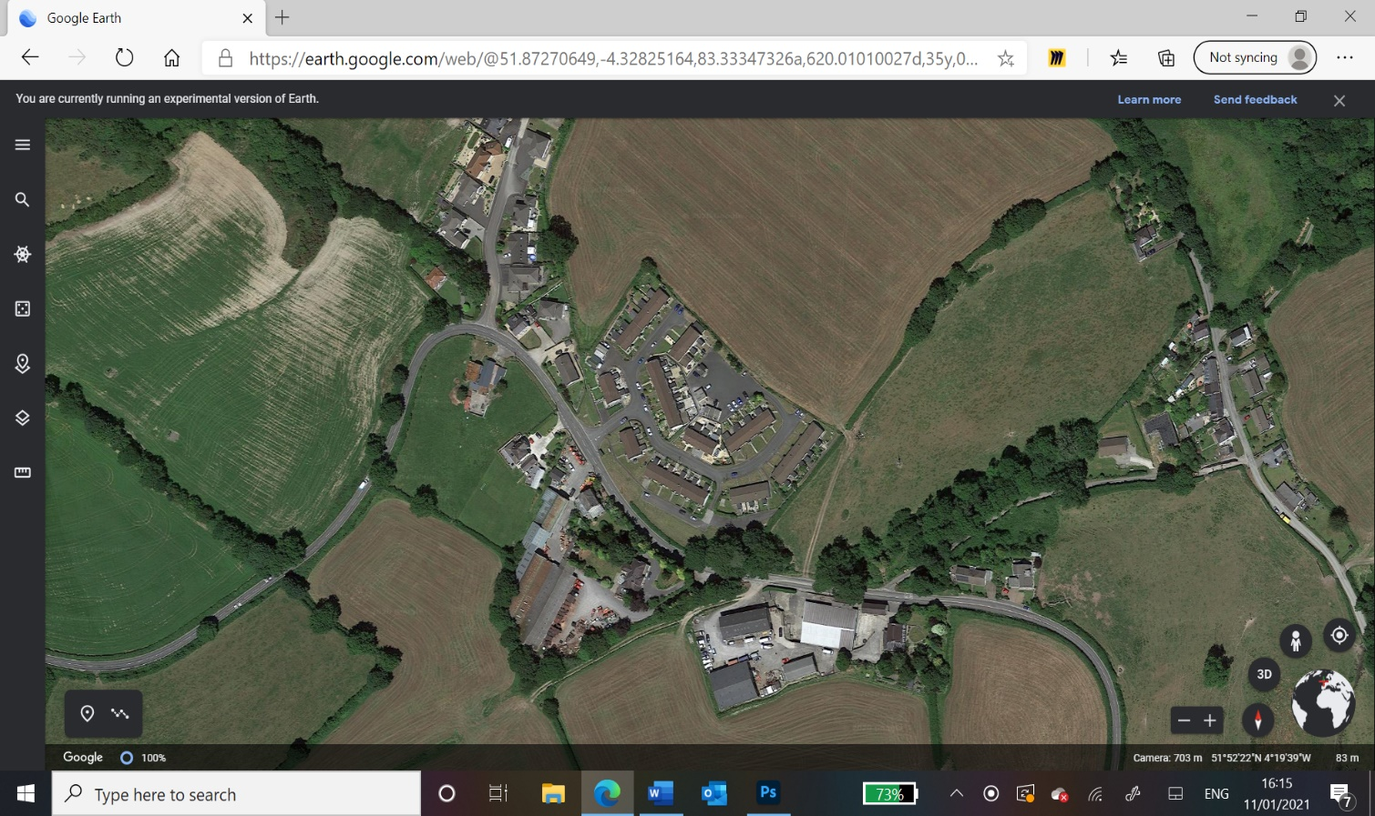

  - Figure 16- Parc Gwyn ariel view, Wales (2020). Credit- Google Earth 2020.

The first case study considered the rural development of Parc Gwyn, located in Tre-Vaughan, the outskirts Carmarthen. Designed in the 1920s, Parc Gwyn is mainly occupied by older residents, and comprises the following housing types (Street Check, 2021):
Type |  | No
Detached |  | 96
Semi-detached |  | 24
Terraced |  | 21
Flats/ Apartments |  | 3
Residence in commercial building |  | 2
Temporary (caravan) |  | 1
Type |  | %
Green space per dwelling (shown as % of whole development) |  | 5%
Parking spaces per dwelling (shown as % of whole development) |  | 15%
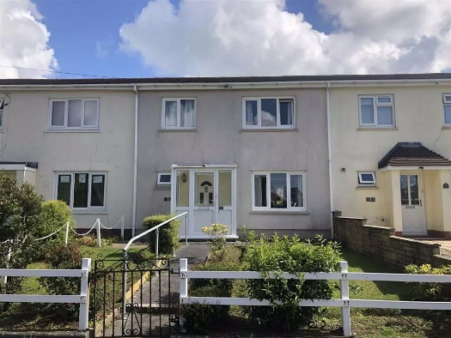
Below is an example of a 3-bedroom property at Parc Gwyn, with a sale price of £130,000 in 2020. The following images have been obtained from a local estate agent, John Francis Estate Agents.
  - Figure 17- Exterior views of 14 Parc Gwyn, Wales (2020). Credit- John Francis Estate Agents, Carmarthen.

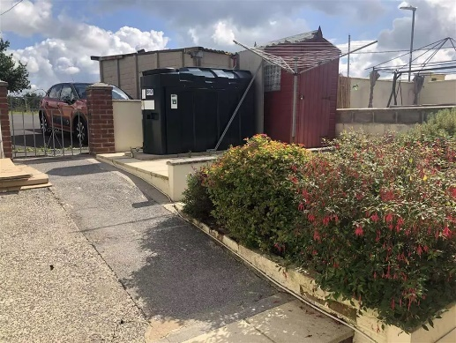
  - Figure 18- Exterior views of 14 Parc Gwyn, Wales (2020). Credit- John Francis Estate Agents, Carmarthen.

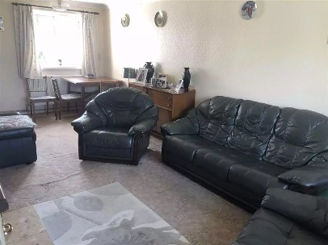
  - Figure 19- Interior views of 14 Parc Gwyn, Wales (2020). Credit- John Francis Estate Agents, Carmarthen.

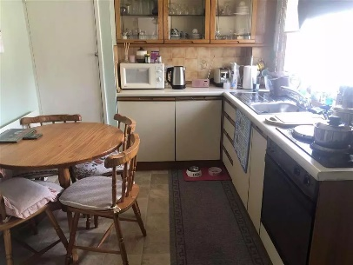
  - Figure 20- Interior views of 14 Parc Gwyn, Wales (2020). Credit- John Francis Estate Agents, Carmarthen.

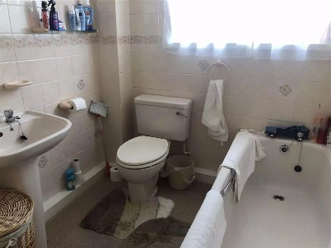
  - Figure 21- Interior views of 14 Parc Gwyn, Wales (2020). Credit- John Francis Estate Agents, Carmarthen.

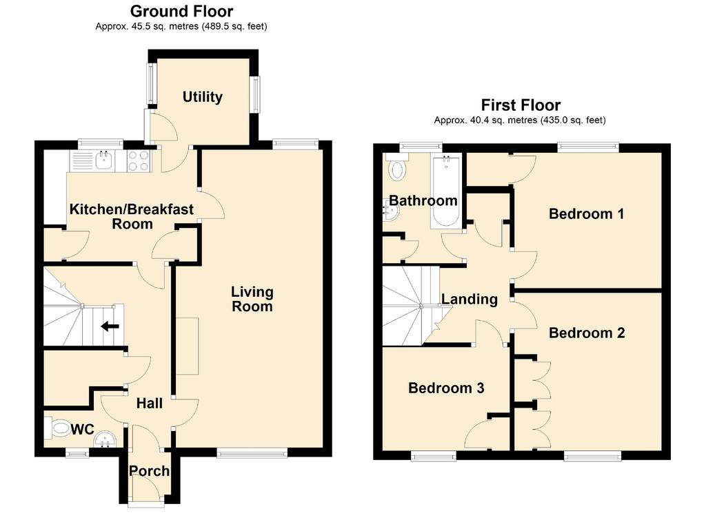
  - Figure 22- Floor plans of 14 Parc Gwyn, Wales (2020). Credit- John Francis Estate Agents, Carmarthen.

Parc Gwyn was a housing development built… “to improve the lives of the workers” (Sitwell, 2017). However, ‘improving the lives of the workers’ did not consider the Organic Architecture and Gaia Education principles, as this community was not thriving, collaborative and regenerative. Consequently, this reduced the sense of community resilience. Furthermore, this development did not permit for much natural light: interior spaces are restricted, allowing in minimal amounts of light and therefore, diminishing any opportunities of a connection to the surrounding natural environment.

Leading on, as these spaces are restricted, the occupants are constrained to certain layouts of the rooms, limiting their use of the crowded dark spaces. The room shown in Figure 19 highlights the function according to the amount of light allowed by the design into the circulation space. The element of functionality is covered by Kubba (2003, pg. 112), highlighting that “the real and final test is how it functions”. It could then be argued that this property does not function in response to its desired requirements as clearly illustrated within Figure 20, the space appears to be crammed, with minimal amounts of circulation. Therefore, utilising this space as a dining room appears to be confined and uncomfortable, particularly for a family of four.

Additionally, as previously mentioned, the use of low quality and unattractive materials within Parc Gwyn is clear (Illustrated in 17 and 21), which may impact the atmosphere and living environment of the interior spaces. This may also result in the spaces being uninviting and unpleasant to occupy, consequently harming the health and well-being of those within the interior spaces.

Considering the above, the need for better aesthetics and circulation of interior spaces of the Parc Gwyn development is apparent. This point is reinforced by the UK Green Building Council (2020), who stress that “good daylight levels” and the “provision of open space” can significantly improve the mental and physical well-being of the residents. Therefore, light, and open spaces should be considered within the design stages of new developments throughout Wales.

The design approach shown in Figure 23 also appears to be congested. The red highlight shown in Figure 23 accentuates the feeling of overcrowding, resulting in an unwelcoming entrance to the property. Furthermore, the lack of natural light entering the hallway area is minimal, producing an arguably dull and uninteresting interior space. Comparatively, the living room shown in Figure 23 has some interesting features, demonstrating some elements of Organic Architecture throughout the design. Such as light through the use of large windows and free-flowing spaces. This allows the creation of openness and freedom.

However, the correlation between the living room, utility room and the kitchen shown in Figure 23 and 24 shows that the internal spaces are not fluid and functional. This affects the overall living environment as the interiors appear to be dull and dark. It could therefore be argued that the interior space is not used correctly, limiting the resident to a less functional layout of the interior space. However, there is a clear opportunity for the living room, utility room and kitchen to be incorporated into the same space. This would allow more light into the interior spaces, creating more enjoyable interior space.

  - Figure 23- Ground floor plan of 14 Parc Gwyn, Wales (2020). Credit- John Francis Estate Agents, Carmarthen.

Considering the exteriors, Figure 17 uncovers a lack of integration between the man-made structure and garden. The garden space shown in Figure 18 indicates that there is also a lack of outside space which can be occupied, subsequently restricting the resident’s connection between their home and the natural environment. This does reduce the possibilities of satisfying the design principles of Organic Architecture and Gaia Education, as there is a lack of utilisation of resources, sustainability, and connection between man-made and organic structures. Components such as space, shelter, language, and ornamentation appear to not be considered (Moulton, 2017).
In terms of the upstairs, Figure 24 exemplifies the use of the interior spaces to a decent standard. Bedrooms 1-3 shown in Figure 24, exemplify space which allows a large amount of light into the interior. Moreover, within each room, there is a good amount of storage space. On the other hand, the lack of natural light entering the landing space presented in Figure 24 is nowhere near comparable, as the restriction of light is obvious with a lack of windows. Also, the bathroom space is very compact, constraining the occupant with the elements of circulation presenting as insignificant. This can be seen as problematic if the occupant is physically uncapable of manoeuvring through difficult spaces. The red highlight shown in Figure 24 demonstrates this.

  - Figure 24- First floor plan of 14 Parc Gwyn, Wales (2020). Credit- John Francis Estate Agents, Carmarthen.

Personal Appraisal and blueprint proposal:

My initial thoughts when visiting Parc Gwyn was that the area overall does not have a sense of community, nor is there enough use of outside space to better connect the houses to the surrounding environment. Figure 16 shows this, as the farming land surrounding this isolated site is in abundance. However, there are many opportunities to harness this surrounding ecosystem, to improve the community significantly through the implementation of the Organic Architecture and Gaia Education principles. For example, if the site can be reconfigured in a way that pedestrianised certain areas and has designated areas for parking, this will allow residents to use the outside spaces better, creating a better living environment for all the residents. This will also create a more fluent connection between their homes and nature.

Furthermore, a better design approach to this housing development should be considered. For example, the execution of open plan designs would inevitably allow the inside spaces to feel more spacious and freer flowing. Ultimately, this will generate a better living environment for the occupants to help increase their health and well-being. Moreover, with the element of design in mind, the needs for the orientation of the structures within the Parc Gwyn development, need to be reorganized. This will then allow the structures to be flooded with light, immediately improving the atmosphere within the inside spaces.

Also, the use of cheap, unpleasant exterior materials has added to the unpleasant appearance of the development (Illustrated in Figure 17). However, the resources, the availability and quality of materials around the time of the completion of this development, can be seen as ahead of its time, as materials, resources and skill sets were scarce (Park, J. 2017).

Nevertheless, the materials used throughout this development could also be unsustainable and unreliable due to their apparent lifespan. Considering this, the erosion of harsh weather events on the exterior can lead to issues internally as well. Accordingly, an influx of new, organic, and natural materials would resurrect the living environment, as well as the element of sustainability and material lifecycle. This would create a better appearance and atmosphere for the community overall. If these strategies and principles were applied to Parc Gwyn, a sense of community could resurface, making the area a pleasant place to live for existing and future occupants, thus contributing to their health and well-being.

Ground floor blueprint proposal for 14 Parc Gwyn, Carmarthen:

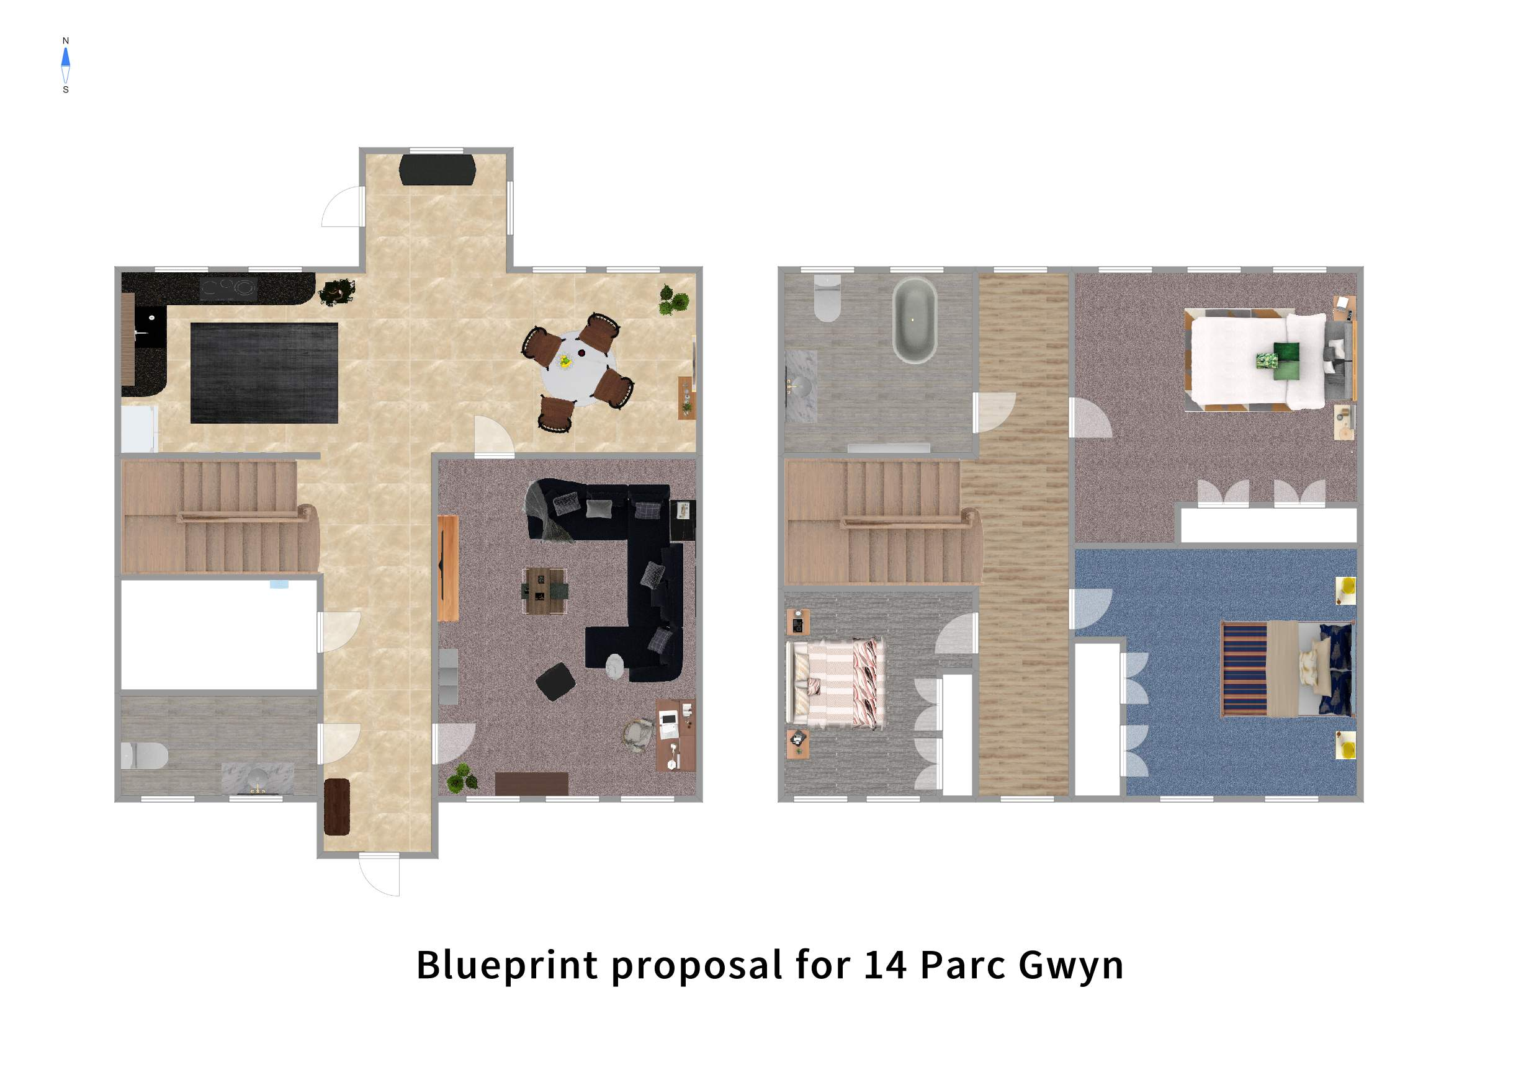
1
2
3
7
4
6
5
8
1. Hallway
2. WC
3. Storage/utility room
4. Living room
5. Kitchen
6. Dining/breakfast area
7. Office space
8. Stairs

  - Credit- Samassi Henderson-Crowther, 2021.

First floor blueprint proposal for 14 Parc Gwyn, Carmarthen:
1
7
2
3
6
4
6
6
5
  - Credit- Samassi Henderson-Crowther, 2021.
1. Landing space
2. WC
3. Bedroom 1
4. Bedroom 2
5. Bedroom 3
6. Storage space
7. Stairs

6.2. Maes Pedr
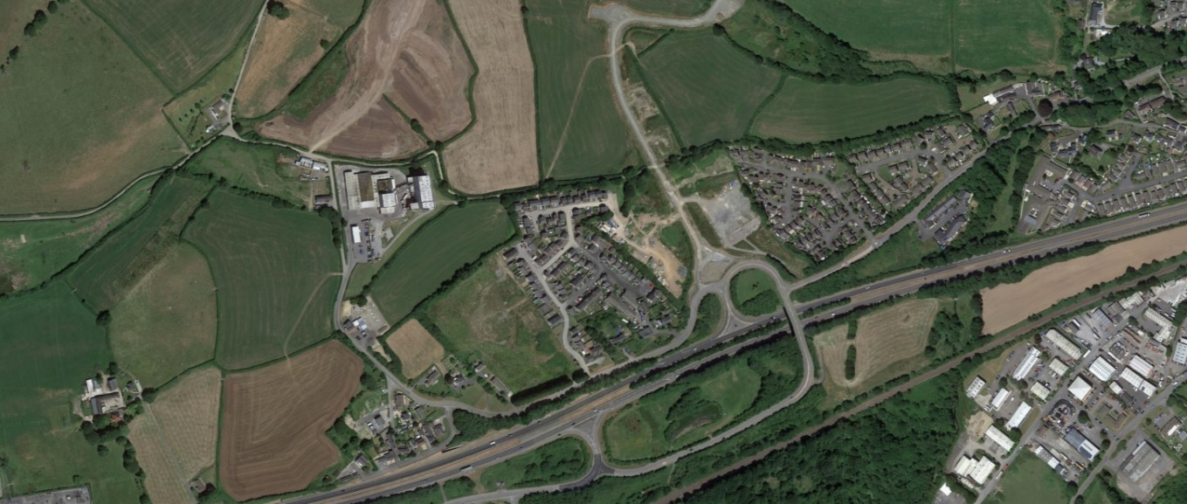
  - Figure 25- Maes Pedr ariel view, Wales (2020). Credit- Google Earth 2020.

The second case study considered is Maes Pedr in Johnstown, Carmarthen. Designed and constructed by Persimmon homes in 2019, this development is occupied mainly by individuals, with an age range of 30-45 years (Street check, 2021). The development comprises the following housing types:
Type |  | No
Detached |  | 61
Semi-detached |  | 14
Terraced |  | 1
Flats/ Apartments |  | 1
Residence in commercial building |  | 0
Temporary (caravan) |  | 0
Type |  | %
Green space per dwelling (shown as % of whole development) |  | 25%
Parking spaces per dwelling (shown as % of whole development) |  | 20%
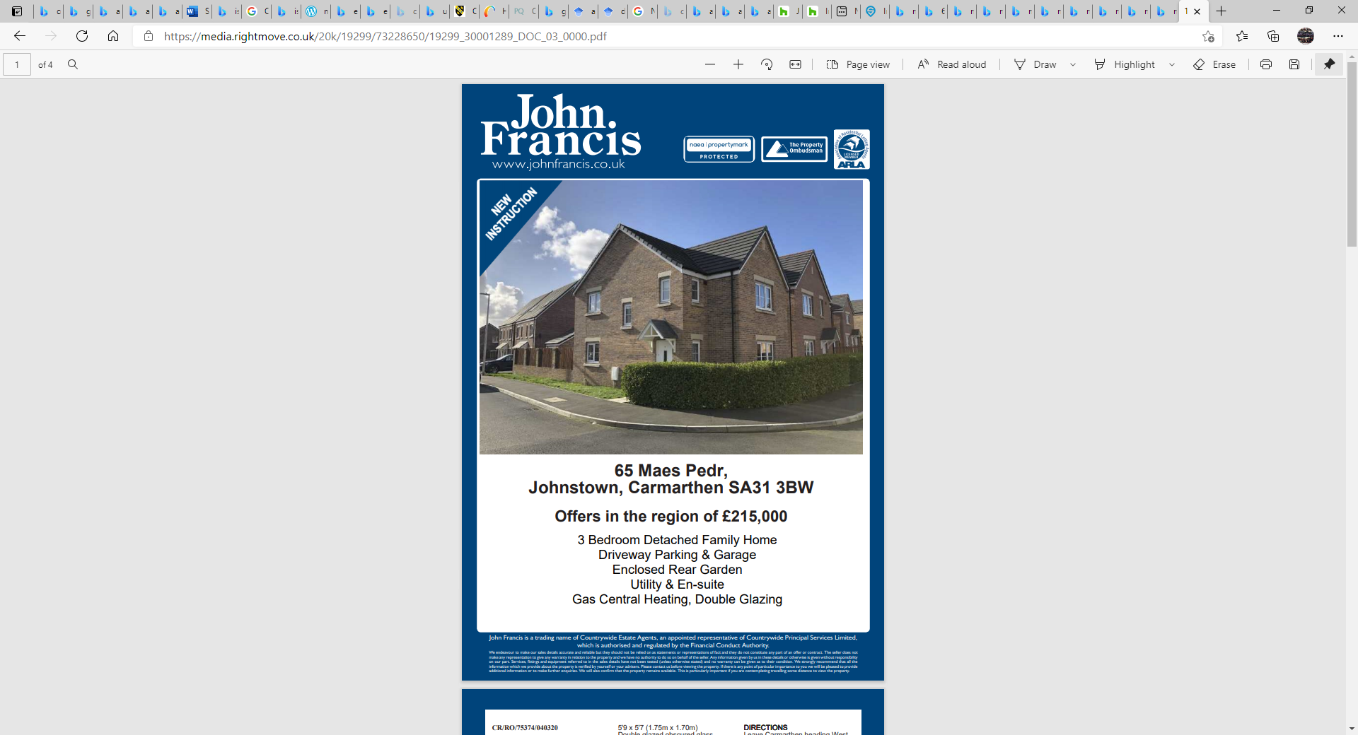
Using the following example of a 4-bedroom property at Maes Pedr, with a sale price of £236,000 in 2020, the following images have been obtained from a local estate agent, John Francis Estate Agents.
  - Figure 26- Exterior views of 65 Maes Pedr, Wales (2020). Credit- John Francis Estate Agents, Carmarthen.

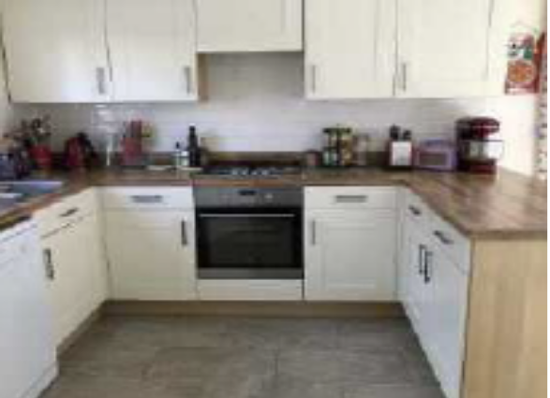
  - Figure 27- Interior views of 65 Maes Pedr, Wales (2020). Credit- John Francis Estate Agents, Carmarthen

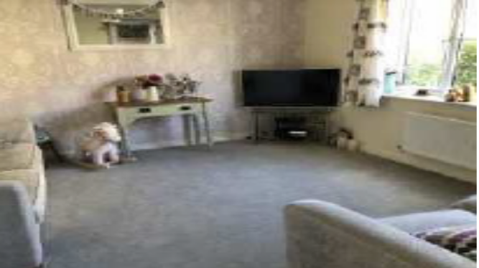
  - Figure 28- Interior views of 65 Maes Pedr, Wales (2020). Credit- John Francis Estate Agents, Carmarthen

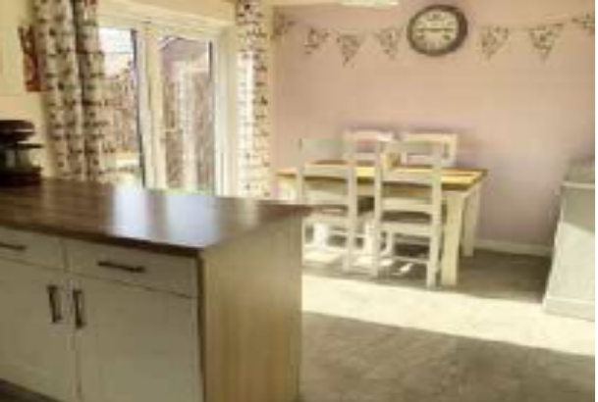
  - Figure 29- Interior views of 65 Maes Pedr, Wales (2020). Credit- John Francis Estate Agents, Carmarthen

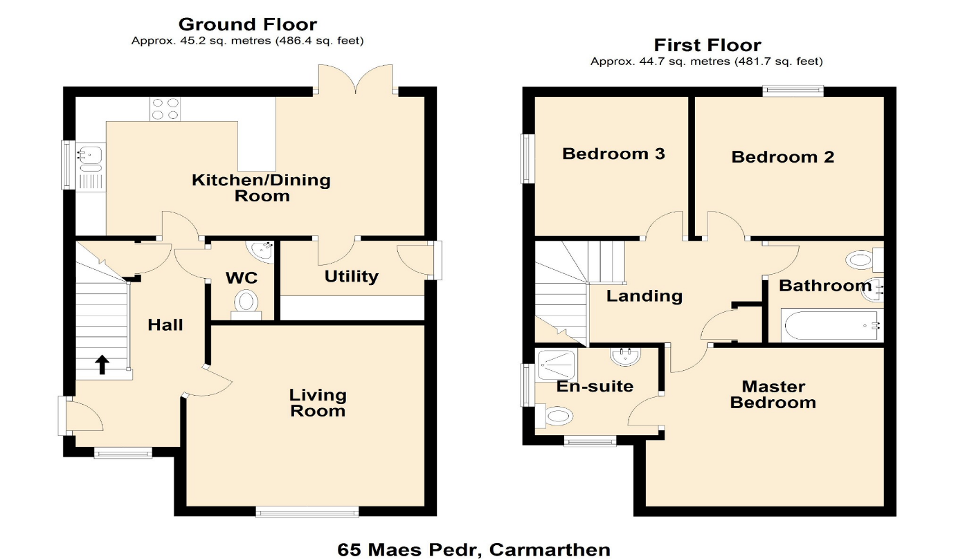
  - Figure 30- Ground floor plan of 65 Maes Pedr, Wales (2020). Credit- John Francis Estate Agents, Carmarthen

  - Figure 31- First floor plan of 65 Maes Pedr, Wales (2020). Credit- John Francis Estate Agents, Carmarthen

The layout of lounge area shown in Figure 28 emphasises a better use of space in comparison to that of Parc Gwyn, giving this interior living area a more welcoming atmosphere. Features such as light and space are combined to create a more “subtle space” (Mirzaei, 2013). This has also resulted in a more functional space. Clearly, the design encapsulates some features of Organic Architecture.
Moreover, as previously explored, the kitchen and dining space of Parc Gwyn shown in Figure 20, exhibits a space that is not fit for purpose; in terms of Organic Architecture there is a shortage of light, space, and separation (Sack, 2019). In comparison, Figure 29 of Maes Pedr illustrates a clear divide between the dining space and kitchen area making the room feel more spacious overall. In addition, through the use of patio doors a more open, light, and comfortable space for the residents has been achieved. It also connects the residents to the natural environment. The design approach for this layout can be seen as positive, as it creates a more enjoyable and habitable space which will positively impact peoples’ moods, therefore improving the health and well-being of the residents.
Figure 33- Interior view of 3-bedroom house at 65 Maes Pedr. Credit- John Francis Estate Agents, Carmarthen, 2020.

Additionally, the design approach demonstrated in Figure 30, shows signs of improvement from Parc Gwyn as the plans are less crowded. For example, there are not as many door openings crammed into a small area. Furthermore, the red highlight shown in Figure 30 illustrates that the hallway area allows a considerable amount of light to enter the structure.

In addition, the design methodology on the first floor shown in Figure 31 shows that there is some improvement in comparison in the use of space as each of the bedrooms is of good size. However, the size of the room in comparison to the amount of light entering the space is not viable as the interior spaces are not “making the most of natural light and ventilation” (Sennott, 2004, pg.123). For example, the red highlight in Figure 31 shows that there is not a window in the master bedroom, preventing daylight and natural air from entering the space. This suggests that this structure cannot be seen as a house that commemorates the “elements of earth and air” (Wilkinson, 2010, pg. 207).
From this analysis, it could be said that whilst elements of Organic Architecture and Gaia Education principles have been implemented fairly well on the ground floor of this Maes Pedr dwelling, there is a lack of this implementation into the design process of the upper floor of the structure. For example, as well as the issues of lack of light and ventilation discussed above, the connection between the natural environment is also not considered in comparison to the ground floor. This could negatively affect the health and well-being of the residents of this property as the continuity between structure and the natural environment is minimal (Wilkinson, 2010, pg. 207). As discussed above, greater connectivity with the natural environment can have beneficial outcomes physically and mentally.

Personal Appraisal and blueprint proposal:

When compared to Parc-Gwyn, there is a big improvement of use of space overall in the Maes Pedr development. Upon visiting, it was observed that the site is a lot more spaced. Moreover, the arrangement of dwellings is considered more carefully, and they are interconnected by a larger number of green areas. This careful utilisation of outside and green spaces around the dwellings also allows more external garden space to occupy for the residents. This achieves greater connectivity with the natural surroundings. Figure 25 identifies that development has a much more organic flow to the site master plan, and the site does not have such an isolated feeling about it in comparison to Parc- Gwyn. Moreover, there is a more natural transition from the surrounding land into the development, due to its layout and orientation.

The estate is also only a twenty-five-minute walk to the University of Trinity Saint David (Carmarthen campus) and only a thirty-five-minute walk into the town centre, along a newly built link road. This is ideal for workers, students, or shopping in general. From identifying these distances, the accessibility factors of this estate are a big improvement in comparisons to Parc Gwyn, which although is roughly similar distances, takes much longer to navigate as there are dangerous roads with no pavements for much of the way. Clearly, the placement of the Maes Pedr development was considered more carefully pre-build.

The utilisation of better materials is also clear, with a more aesthetically appealing appearance on the Maes Pedr dwelling. The implementation of better furnishings such as bricks has drastically improved the external aesthetic making it more attractive in comparison to the property in Parc Gwyn.

In addition, the use of natural furnishings and fittings has also improved the internal spaces of the dwelling, creating a more warm, welcoming, and comfortable atmosphere. Components of Organic Architecture principles such as light, space, nature, free-flowing and inside and out are clear from analysing the interiors (illustrated in Figure 30 and 31).

Nevertheless, there is still room for enhancement and improvement through several design approaches. For example, imputing a pedestrianised design strategy would allow nature to grow and interconnect with the man-made structures. In addition, implementing more organic materials, such as timber throughout the development would also create better working and living environments for children and adults. This is because these strategies would lead to a naturally immersed development which is better connected to the natural elements that surround it. A development as such will encourage people to make use of outside spaces more, leading to contact with other residents as well. Therefore, it could be argued that more of a connection to other residents will be achieved, thus gaining a greater sense of community; a community that can thrive. This combined sense of community and improved relationship between man-made and natural structures would lead to greater health and wellbeing for the residents.

Ground floor blueprint proposal for 65 Maes Pedr, Carmarthen:
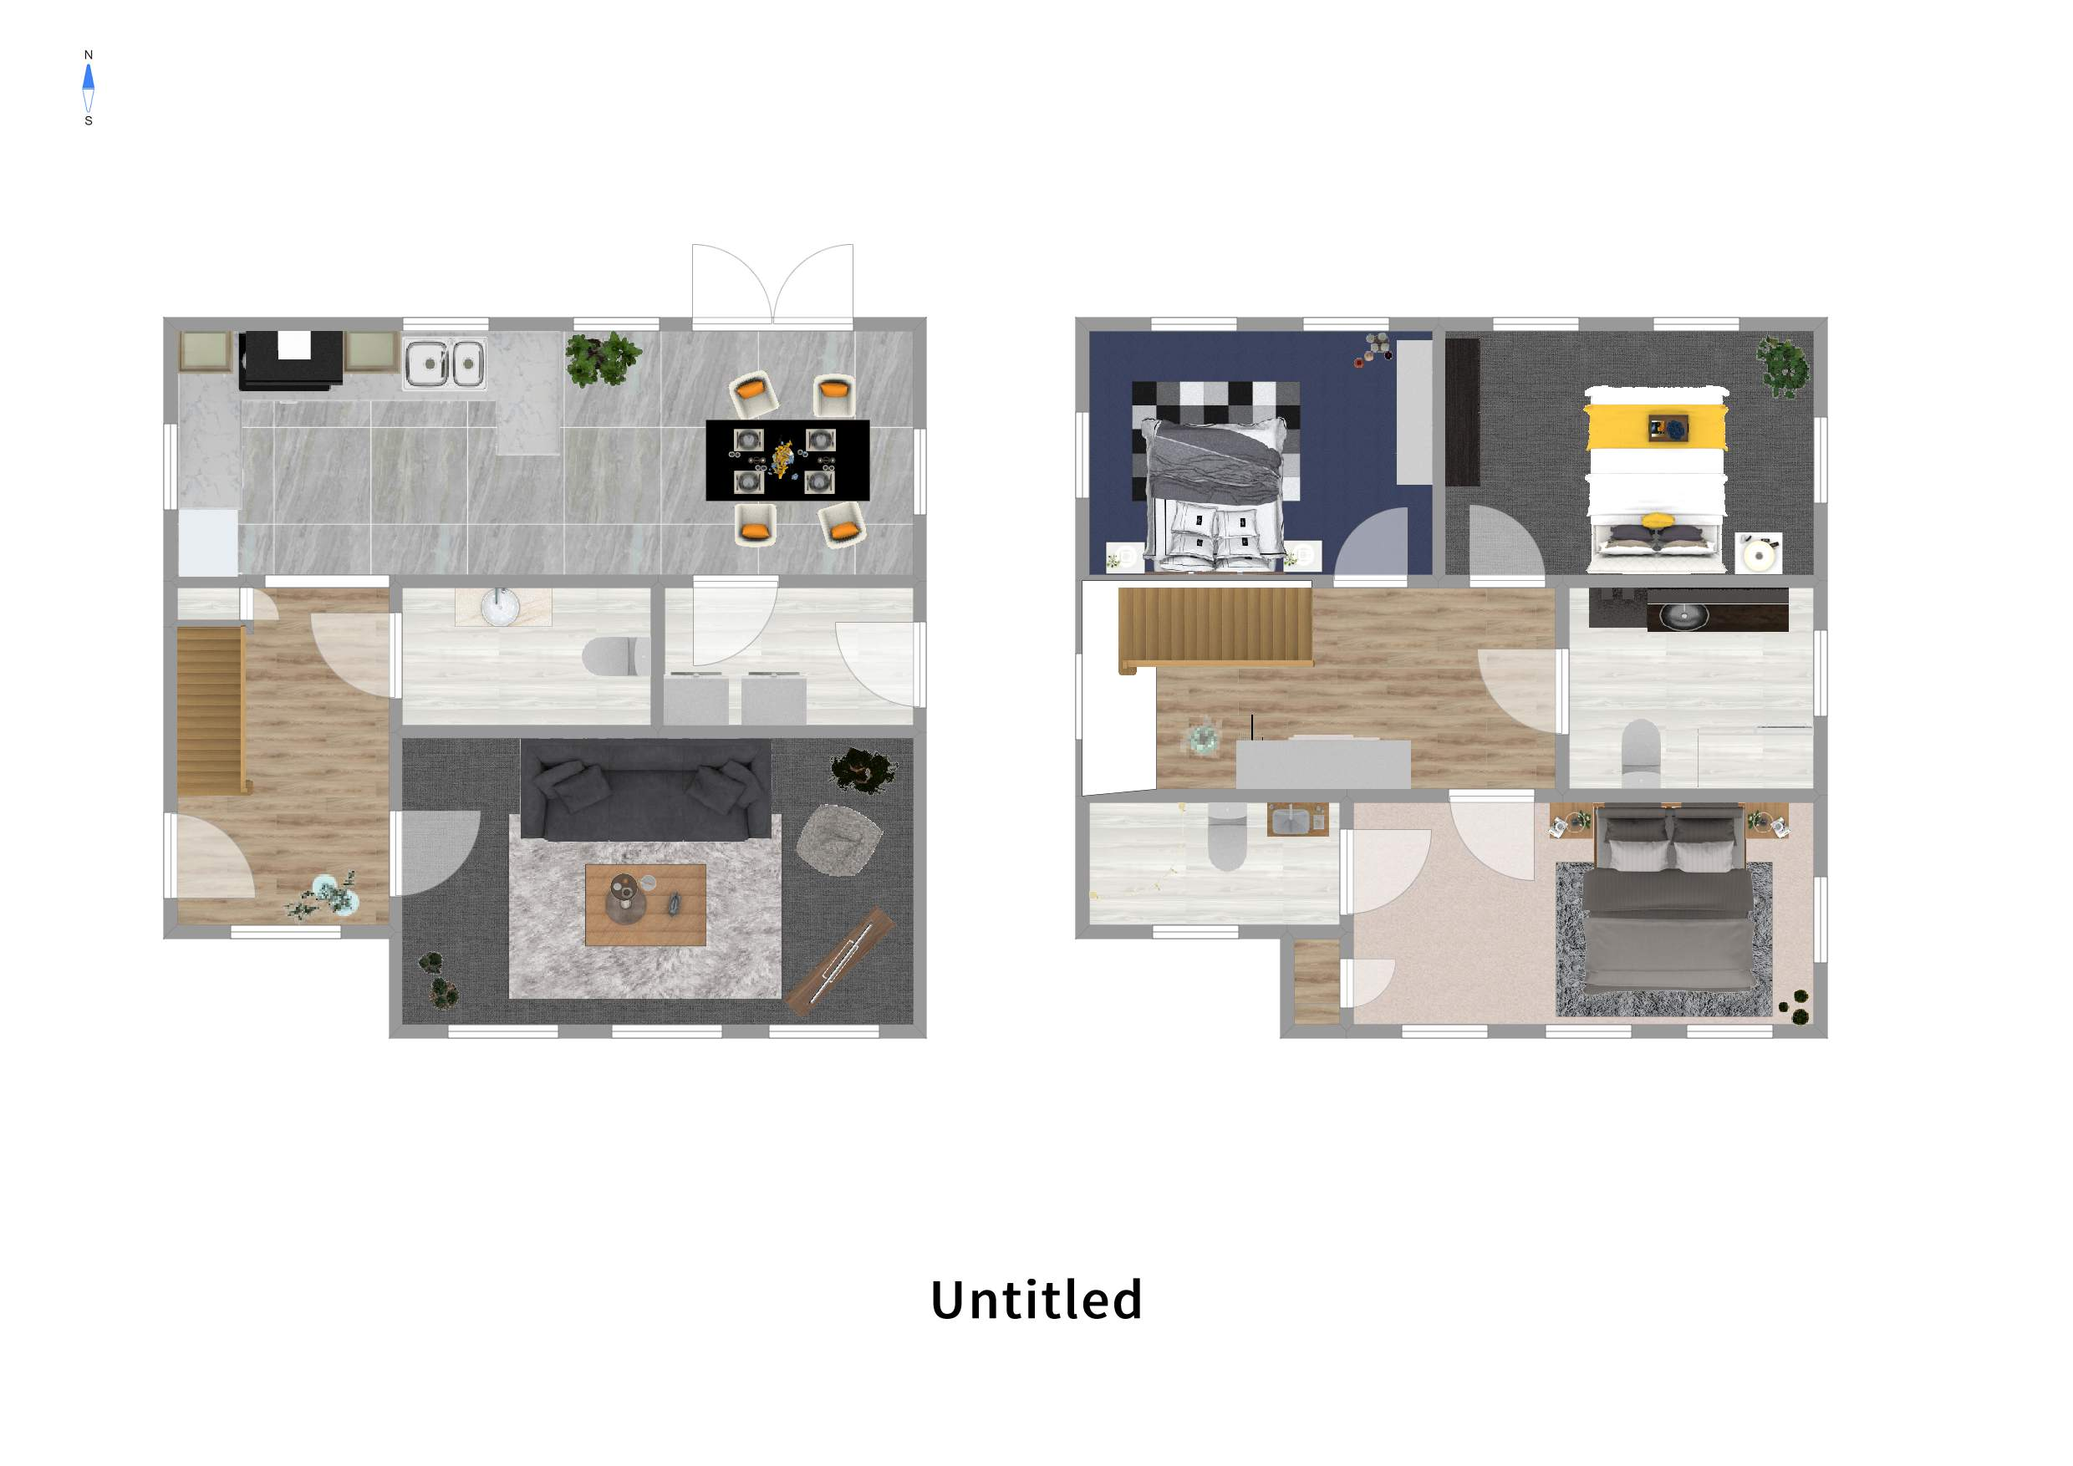
  - Credit- Samassi Henderson-Crowther, 2021.
1
4
2
3
5
6
7
8
1. Hallway
2. WC
3. Storage/utility room
4. Living room
5. Kitchen
6. Dining/breakfast area
7. Stairs
8. Storage space

First floor blueprint proposal for 65 Maes Pedr, Carmarthen:
3
4
1
6
2
5
9
8
1. Landing space
  - Credit- Samassi Henderson-Crowther, 2021.
2. WC
3. Bedroom 3
4. Bedroom 2
5. Master bedroom
6. Storage space
7. Stairs
8. En-suite
9. Storage space

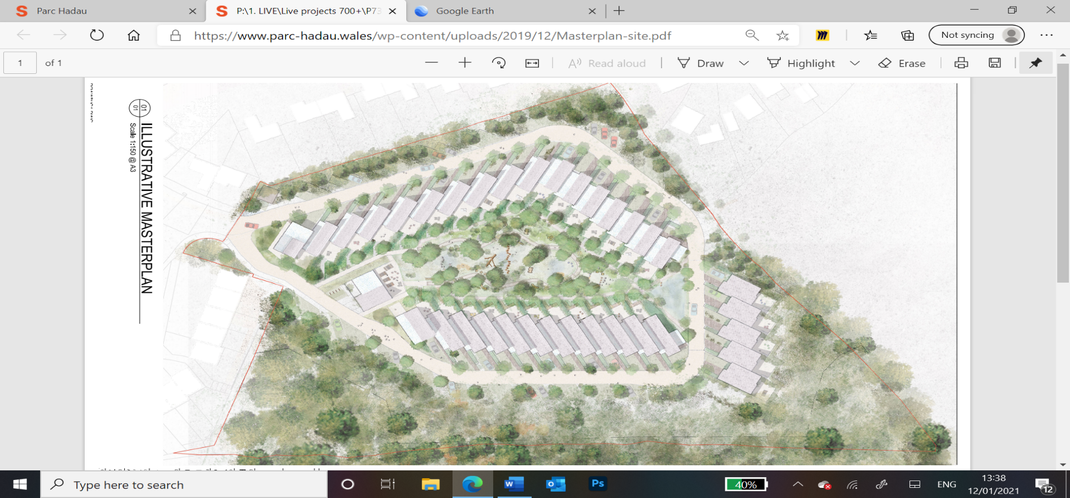
6.3. Parc Hadau
  - Figure 32- Parc Hadau view, Wales (2021). Credit- Loyn + CO.
Figure 37- Parc Hadau conceptual ariel view, Pontadawe. Credit- Loyn + CO, 2021. Location- Rhydyfro, Pontardawe, Wales SA8 SA9.
The ongoing conceptual development of Parc Hadau, located in Rhydyfro, Pontardawe, is set to be built in the summer of 2022 by developers Sero Homes, in collaboration with landscape architects Farrer Huxley and Chartered Architects Loyn + Co. It comprises the following housing types:
Type |  | No
Detached |  | 0
Semi-detached |  | 35
Terraced |  | 0
Flats/ Apartments |  | 0
Residence in commercial building |  | 0
Temporary (caravan) |  | 0
Type |  | %
Green space per dwelling (shown as % of whole development) |  | 40%
Parking spaces per dwelling (shown as % of whole development) |  | 30%
Two Specific objectives of this development scheme were the “social aspects of the scheme as well as its integration with the existing landscape” (Loyn, 2021). This will be achieved through “placing a large communal garden or park at the centre of the scheme” ³⁴ This is exemplified by Figure 32 which illustrates this pedestrianised area, which establishes a clear connection between the structures and surrounding environment. This will fulfil the Principles of Organic Architecture and Gaia Education as there is an engrained connection between man-made and natural structures. It will also provide a place for residents connect and build a thriving community.

Furthermore, there is also a minimal impact of the structures towards the surrounding environmental elements: such as the forest areas and green spaces (which will create greater sheltered and shaded spaces). It is almost as if the development grows from the natural surrounding as it is not out of context with such surroundings. It represents “the development of multi-dimensional sustainable human communities within harmonious and balanced built environments” (Ruano, 1999 pg. 2). To implement Organic Architecture and Gaia education, communities should function in relation to the resident’s requirements, as well as being subtly and generously built within the natural environment; The scheme for Parc Hadau achieves this.
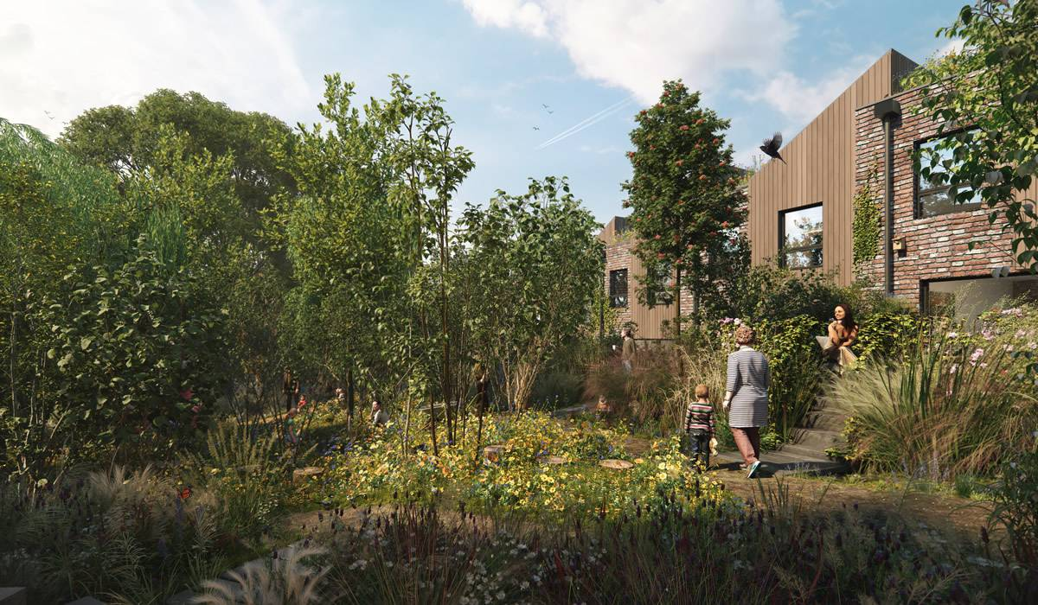
  - Figure 33- Exterior views of Parc Hadau, Pontadawe, Wales (2021). Credit- Loyn + CO.
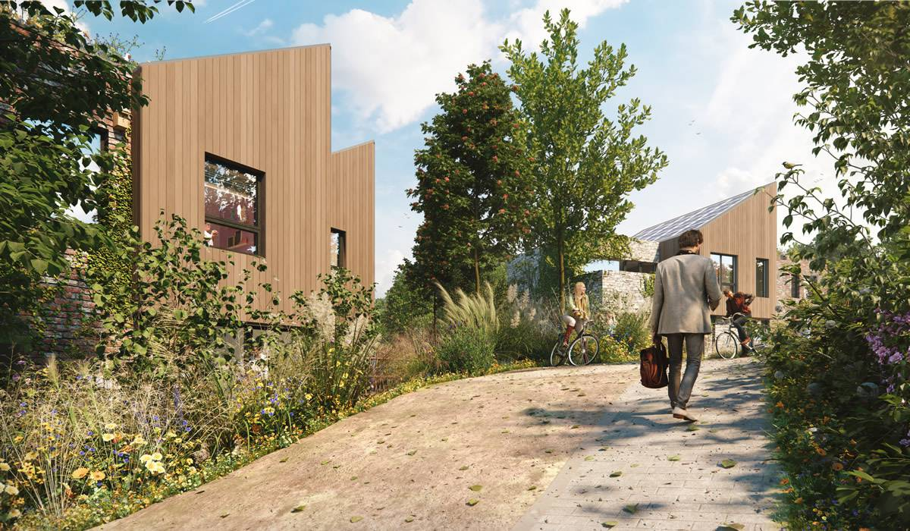
  - Figure 34- Exterior views of Parc Hadau, Pontadawe, Wales (2021). Credit- Loyn + CO.

Leading on, Figures 33 and 34 further exemplify the integration of the natural environment with the structures on site. It seems that Loyn + Co’s understanding of the Organic Architecture principles is resilient. This differs to Parc Gwyn where the design approaches have failed to address Organic Architecture principles as they lack reinforced connections to the organic environment. Whilst Maes Pedr does make some effort to achieve this with more green spaces, it is far from what Parc Hadau will offer.

Furthermore, the work of Loyn + Co exhibits “maximum diversity and robustness” (Jencks, 1997, pg. 108). This is achieved through their execution of several open events with the local community and also workshops at the local school to help get the community involved (Loyn, 2021). Loyn + Co have also lightened the ecological footprint of the individual dwellings by “involving increased incorporation and visibility of functioning natural systems and habitats” (Holden, 2015, pg. 12). This is through the implementation and preservation of large green forest areas.

Additionally, from studying Figures 32-36 several of the Organic Architecture principles have been applied to this community, such as:

Space and light:

The internal spaces are open plan, allowing large amounts of light enter the building. Resulting in brighter and more enjoyable internal spaces.

Materiality of nature, colours of nature and correlation of nature:

The site enhances the natural colours of nature through the urban greening of the site, implementing natural elements such as trees which makes the site attractive. Urban greening has also created a well-established connection between the dwellings and nature, as there is a magnitude of green spaces on site.

Ornamentation and sustainability:

Each of the dwellings has solar PV panels integrated into its design, improving the sustainability of the structures. Considering this, the ornamentation of the site had to be carefully analysed. To ensure the maximum gain of solar energy throughout the year.

Separation, shelter, and simplicity:

Not only do the external green spaces create a pleasant environment, but they also provide substantial amounts of separation through private garden spaces, pathways, and driveways. The green spaces also provide natural shelter through the implementation of trees, which have been carefully placed through simple design approaches. Entailing site analysis, circulation, and points of interest on site.

Peacefulness and Language:

From Figure 32-36, they clearly show that there is a sense of peacefulness and language between man-made structures and the surrounding environment. This has been achieved through the application of organic materials and large seamless windows.

As a result of this, the living environment is an immense improvement in comparison to Parc Gwyn and Maes Pedr. In light of this, could this be regarded as the way forward for all communities in Wales.
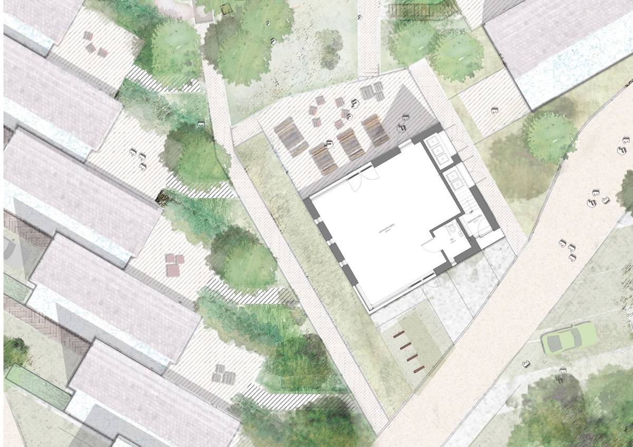
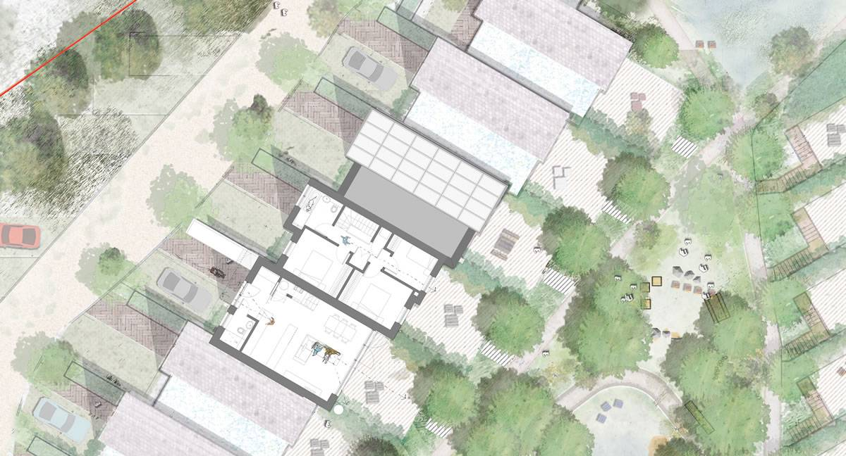
  - Figure 36- Ariel view of communal gardens of Parc Hadau, Pontadawe, Wales (2021). Credit- Loyn + CO.
  - Figure 35- Ariel view of communal gardens of Parc Hadau, Pontadawe, Wales (2021). Credit- Loyn + CO.
Regarding the dwellings’ interior, the open plan ground floor achieves simplicity and a light, free-flowing space, allowing adequate circulation space for the residents and fluidity of movement to occur throughout (Illustrated in Figure 37). Moreover, the red highlight in Figure 37 also shows several areas where light can penetrate the interior spaces, thus creating more of a connection to nature. Given the previous points, it could be argued that this design approach meets the needs of the occupants as well as the Organic Architecture principles, creating a healthier environment for the community to thrive within.

Leading on, the first floor shown in Figure 38 illustrates a light and spacious living environment. In comparison to Parc Gwyn and Maes Pedr, the use of minimal door entrances is clear, reducing the chance of this space being too congested (Illustrated in Figure 23). Additionally, the use of the space on the first floor is approached with consideration of the Organic Architecture principles. This is achieved through the individual rooms being designed sensitively, showing a clear demonstration, and understanding of space, light, and separation. This fulfils the need for residents to get adequate amounts of daylight entering the structure. The UK Green Building Council reinforce the importance of this, arguing that “good daylight levels” improve the mental and physical well-being of the residents (Green Space Index, 2020).

Moreover, the materiality of Parc Hadau is also highly considered, reflecting the surrounding natural environment through the implementation of natural materials such as timber. Thus, adding to the urban greening elements of the development. The topic of urban greening is covered in depth by Holden (2015) who refers to the ideas of Danish socialist, Anders Blok, who states that… “processes of urban greening is highly fragmented: whereas some areas of the city maintain their socio-material commitments to high-carbon economic development, other areas are redesigned in light of low-carbon, green, and sustainable urban visions” (pg. 11431).

Overall, it could be said that Parc Hadau has achieved a low-carbon, green and sustainable urban vision as the development has considered the Organic Architecture and Gaia Education principles.
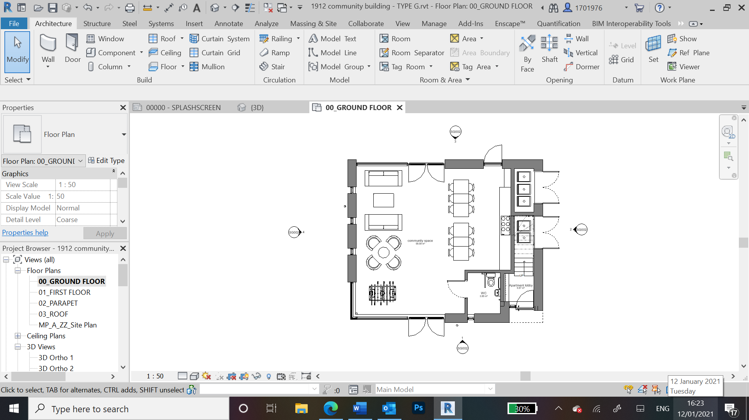

  - Figure 37- Ground floor plan of single dwelling in Parc Hadau, Pontadawe, Wales (2021). Credit- Loyn +CO

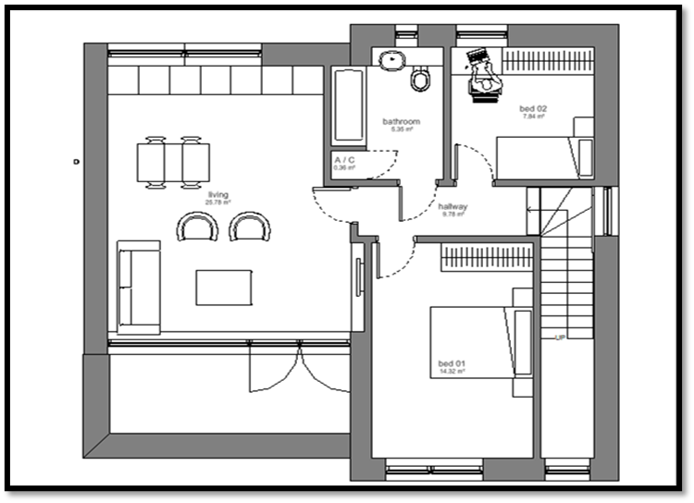

  - Figure 38- First floor plan of single dwelling in Parc Hadau, Pontadawe, Wales (2021). Credit- Loyn +CO

Personal appraisal:

This new development of 35 homes will include aspects such as on-site rooftop PV panels and time-of-use grid emission factors to demonstrate an annual net-zero carbon balance. Excess energy produced on-site will then be fed back into the grid. The homes have also been designed to comply with the “Welsh Social Housing Design Quality Requirements” through the Organic Architecture principles (Loyn + Co, 2021). This is demonstrated using high-performance natural materials and flexible layouts. This includes “blends of timber and masonry” which is either locally “quarried stone or recycled brick”, all in which will be reused at the end of the homes’ lives, lowering the carbon footprint output, increasing the sustainability element of the dwellings. Landscape architects Farrer Huxley and Chartered Architects Loyn + Co (2021) worked collaboratively to create a new naturally integrated community and “set out to prove that you can economically build better homes to the highest environmental standards” (Loyn, 2021).

In reference to Figure 32, the master plan encapsulates the natural elements of the surrounding environment, creating a much stronger relationship between nature and man-made structures. Orientation is well-thought-out, allowing each dwelling the maximum amount of light to penetrate the internal spaces. The shape of the structure also plays a huge part, the execution of size, shape and facades create a warm and welcoming feeling to the structures externally. Principles such as sustainability are also important, with the need to be more self-sufficient is highly apparent, especially when talking about global climate change.

The pedestrianised core of the site masterplan accentuates the harmony between parkland and structure. Connecting the entire site into a safe, enclosed centralised area creates a community feel to the development. The site has also been cautiously analysed, allowing the community to be a segment of the existing surrounding natural elements, creating a significantly more fluent connection between the land and the housing development is an improvement in comparison to the Parc- Gwyn and Maes Pedr developments.

The Parc Hadau development design also strives towards open-plan living-dining kitchens, which can become kitchen diners and separate lounges, then later lounge-diners and separate kitchens, and so on as preferences changes. This allows the internal spaces to be multifunctional, therefore improving the overall functionality of each dwelling. The large open plan areas are also free flowing, connecting the inside to the outside, allowing the sunlight to infiltrate the interior spaces, creating a comfortable, enjoyable, and habitable space for the community.

7. Conclusion

The predominant focus of this research was to establish whether the use of Organic Architecture and its principles could improve the health and well-being of residents in communities in Wales. In doing this, Gaia Education, Housing Standards and Design Guides were also considered in terms of their ability to contribute to this improved health and well-being.

After this exploration, it can strongly be concluded that the use of Organic Architecture (along with the consideration of Gaia Education, Housing Standards, and Design Guides) would have a positive impact on the health and well-being of rural communities in Wales. For example, elements such as light, which can be achieved through open plan areas and large window openings, creates more of a connection between man-made and natural structures around green open spaces, and space through the implementation of fluid interior and exterior spaces which connect the structure to the surrounding natural environments. As explored, this greater connectivity with nature has health benefits.

Particularly, implementing Organic Architecture can positively impact people’s moods, leading to a greater appreciation and connectivity towards nature, increased sustainability and self-sufficiency, and the resurfacing of a greater sense of community. All of this, in turn, would lead to increased health and well-being of the current population and the future generations to come. Accordingly, greater emphasis should be placed on implementing Organic Architecture (along with the consideration of Gaia Education and exceeding Housing Standards) into past, recent, and future housing developments. The analysis of the above case studies (especially Parc Hadau) illustrates that it is possible to do this. There should be a greater push towards this implementation, when considering the FGA has placed health and well-being high on the agenda for the future of generations who live in Wales. In line with the intentions of the FGA, implementing Organic Architecture within structural development could help lead to happier and healthier communities in Wales. Also, elements of sustainability emitted from Organic Architecture and Gaia Education will lead to a healthier environment.

The importance of the relationship between nature, citizens, and the built environment was a key finding in this study. As a result, additional research should be conducted to investigate the positive effects that Organic Architecture can have on people and the environment. This research should focus on how other new and existing developments can be improved in order to expand the use of Organic Architecture in Welsh developments and communities in general. These investigations should be carried out by professionals such as architects, governing bodies, and private developers, among many others.

