Assessment

On

Models of Communication and Skills of Communication

Module: Effective Team Working and Communication ( BMSW4002_LON)

Student: Farida Ahmed
Student ID : 2123556

Lecturer : Sobhan sadiq

Introduction
Giving, receiving, and sharing information is referred to as communication. This can be done via talking, writing, listening, or reading. Great communicators pay close attention, speak or type clearly, and value unique conclusions. The American College Dictionary defines communication as "the transmission or exchange of views, opinions, or information by speech, writing, or signs." There are several implications to the word "communication." It basically deals with interacting with people and their surroundings. One of the fundamental social skills needed for any person to survive in the world is communication. Effective communication ensures that you don't just deliver your message but also share your thoughts and emotions with the other person. There are several obstacles that can interfere with communication, including ones that are physical, perceptual, emotional, cultural, etc. Barriers and a lack of communication can lead to a number of issues, including miscommunication, missed opportunities, unneeded conflict, the spread of false information, mistrust, low morale, and a broken corporate culture at work.

Models of communication:
A "model's" purpose is to provide a visual picture of a topic in order to aid with comprehension. There are three common models of the communication process: linear, intuitive, and value-based. Each offers a slightly different perspective on the communication process.

Communication models explain how to prepare and handle the various elements of communication, such as the setting, sender, recipient, encoding, translating, channel, message, feedback, and noise. These nine communicational elements represent the entire communication process. Nevertheless, some communication models lack some of these elements. For instance, the direct demonstration of communication is unaffected by criticism. Additionally, the communication show highlights the elements—such as limits or turmoil in conversation—that predict successful communication. Communication barriers or conflicts prevent persuasive communication formats.

In broad communication models are mainly in three types:
- Linear Models of Communication
- Interactive Models of Communication
- Transactional Models of Communication
- Linear models of communication:
There has been some discussion regarding the linear communication model and how it handles the idea of feedback. The title of the linear model, which implies that a sender encrypts a message across a channel and that the recipient decodes the message, belies the behaviour of the model. It is the type of communication that is typically found in mass media, such as television, radio, daily newspapers, etc. According to this show, there is no implied expectation of rapid feedback.
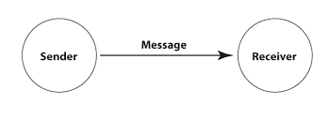

Shannon and Weaver model of communication:
The "mother of all models," as the Shannon-Weaver communication model has been dubbed, Information source, message, transmitter, signal, channel, noise, receiver, information destination, probability of error, encoding, and decoding are all integrated into this paradigm, according to social scientists.
The Scientific Theory of Communication, published in 1949, is credited with being the first book to present Shannon and Weaver's linear communication model. Let's just state that, in reverse, this hypothesis has become less important due to the advancements in communication, especially non-linear electronic communication models where the sender and the recipient are not always obvious.
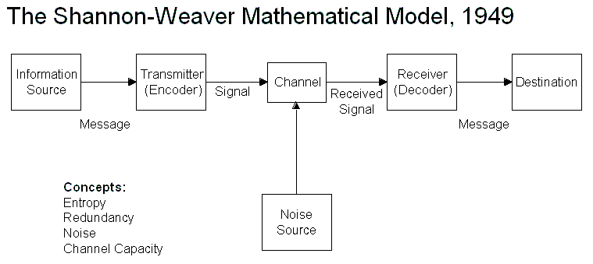
Concepts in Shannon Weaver model
Sender is the person who creates the message, decides on the delivery method, and sends the message.
Encoder (Transmitter) - The sender who utilises a machine to convert messages into signals or binary data is known as an encoder. It can refer to the machine too directly.
Channel: The channel is the means via which messages are sent. Decoder (Recipient) - A decoder is a device used to convert signals or parallel information into messages, or it can be a receiver that decodes signals to interpret messages.

Receiver (Destination) - The recipient is the person or location where the communication must arrive. The communication is accepted by the receiver once they respond.

Noise is the physical obtrusive influences, such as the environment, people, etc., that prevent the message from reaching the target as intended. The communication barrier is the same as noise.

Berlo’s SMCR Model of Communication
The Sender-Message-Channel-Receiver (SMCR) model of communication was created by David Berlo in 1960 from Shannon Weaver's Model of Communication (1949). He discussed the elements that determine how each part of communication works together to improve efficiency. The model also focuses on encoding and decoding, which take place prior to the sender sending the message and the recipient receiving it, respectively.
The communication process is essentially represented by four elements in Berlo's Show. There are four of them: sender, message, channel, and collector. Numerous factors have an impact on each component. To convey information, Berlo emphasises both verbal and nonverbal communication techniques.

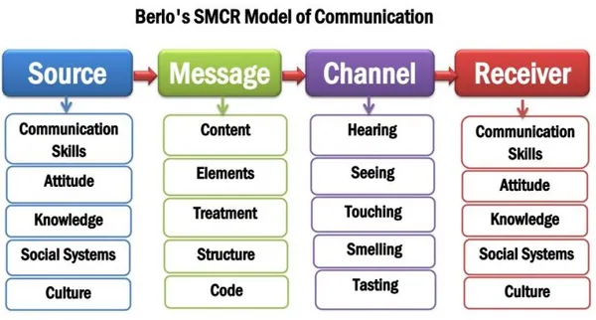
- Interactive Models of Communication
Communication that is two-way and includes feedback is referred to as interactive communication. As a result of feedback not being synchronous, it is delayed and indirect. Occasionally, if the recipients do not respond to the senders, the communication can become linear. According to the interactive communication model, communication is mediated and conducted online. Schramm's communication model serves as an illustration of interactive communication models.

Schramm’s model of communication
The communication model was put forth in 1954 by Wilber Schramm. Before being carefully put into words and shared with others, information is useless. Since it begins the process of communication by transforming the notion into material, encoding plays a very significant role. The primary obligation of the recipient is to understand what the speaker is trying to convey when the data is delivered to him. The message is truly useless unless and until the receiving party can comprehend or interpret the information that is being sent. As a result, the two most important factors in effective communication—encoding and translating—are those that allow information to flow between two persons. The over guideline is also the centre of rotation in Schramm's concept. According to Schramm's approach, efficient communication relies on two fundamental forms: coding and translating.
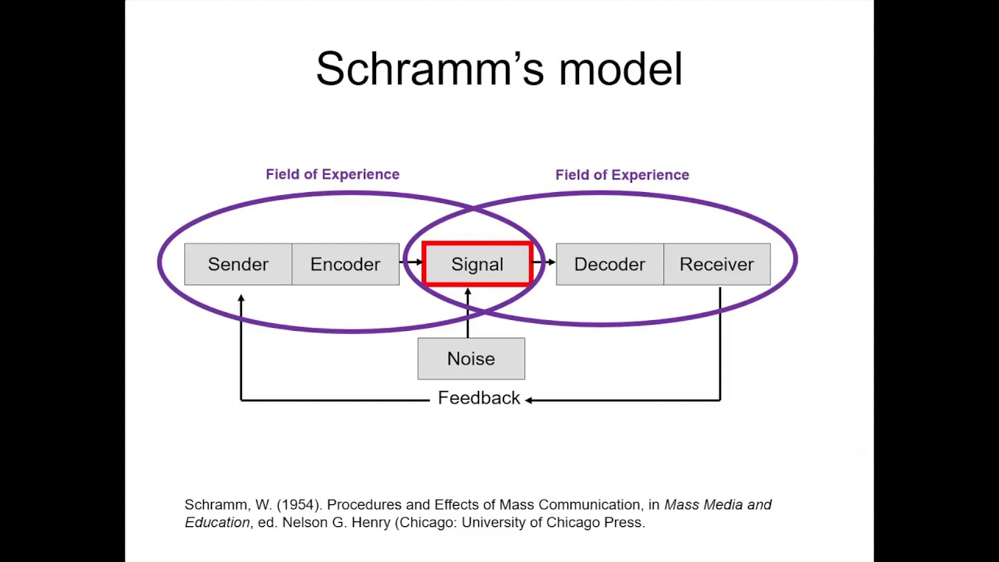

- Transactional Models of Communication
A two-way communication process with prompt critique seems to be the hallmark of the transitional model of communication. The core of transitional models of communication is concurrent feedback. Since there won't be any feedback, the communication process won't become value-based. Coordination and speedy feedback are both present. Instant feedback must be given by the recipient. Circular and direct feedback is a key difference between the interactive and transactional approaches.

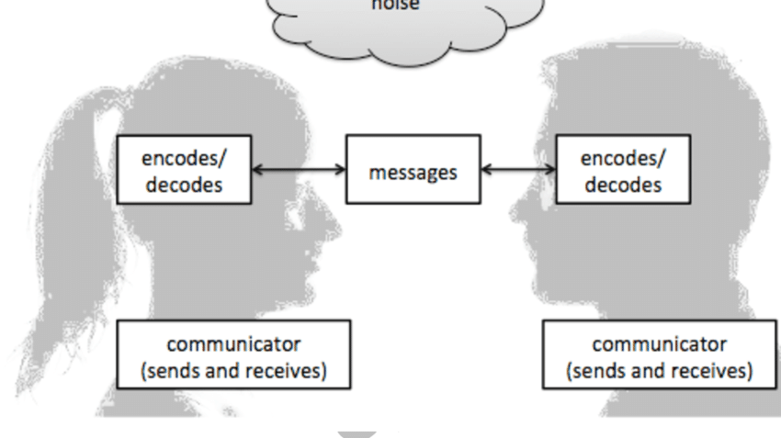

A fundamental tool for understanding communication processes is a communication model. In addition to outlining the information stream, communication models include specific information on the communication process. By providing a wide range of conceptual systems for communication formats, they have a tremendously favourable impact on the research. Furthermore, the demonstration shows the communication handle's components. Aside from that, the communication demonstration offers advice on how communicators might successfully communicate. They address the obstacle or disturbance that prevents communication. Their explanations of the communication system's intricacies are also helpful. In order to avoid disagreement, the programme finally suggests making changes to the communication process.

Communication Barrier:

One of the most prevalent impediments to communication is noise. Any persistent or arbitrary uncomfortable factor that lessens, obscures, or confuses the message's clarity qualifies. Physical barriers can impede communication transmission, which is why they are strongly related to noise. Poor listening skills, a lack of information exchange, disparities in interpretation and perception, and a failure to notice or pay attention to nonverbal clues are all examples of communication hurdles.

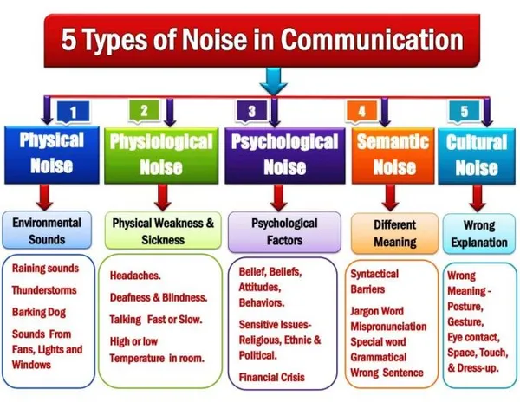

Example of a noise in communication: I remember having a terrible headache and staying home to rest that one day, which made me really ill. I dialled my husband's cellphone to ask him to bring me more medicine because my prescription was gone. Our lone child turned up the volume on his favourite TV show. As a result, I was unsure of whether or not my husband understood precisely the medication he needed to purchase. In order to be sure he understood me completely, I had to tell him again. In this instance, the physical noise in question is TV sound, and the physiological noise in question is my headache.
Communication Skills:
According to the message being sent and the context in which it is being received, people can communicate with one another in a variety of ways. Communication is also impacted by your choice of communication method and your communication style (Rutherford & Andrea J, 2007). There are 5 primary ways to communicate:
- Verbal communication
- Non-verbal communication
- Written communications
- Formal & informal communication
- Visual communication
Verbal communication: We express ourselves verbally through what we say. People frequently picture chatting when they think of the word "communication." To exchange messages with one another and to form new ideas as a species, we rely on verbal communication. Verbal communication is often associated with spoken communication, however written communication is also a part of verbal communication. Reading a book is nothing more than deciphering the authors' written communication in order to gain additional communication knowledge. Verbal communication can be expressed orally or in writing. Verbal exchanges might take place orally or in writing.
No-verbal communication: The process of conveying meaning without the use of written or spoken words is known as non-verbal communication. In other words, any communication that takes place between two or more individuals using hand gestures, body language, facial expressions, posture, tone of voice, and/or other visual or audible cues.

Listening: One more communication technique is listening. Almost half of what people hear on average can be remembered (Crockett,2011). The two types of listening are active and empathic, respectively. Assuming that the other person will say or finish their phrases, active listening entails paying attention and refraining from other activities like checking your phone or filing your nails. While listening empathically, on the other hand, you attempt to experience the speaker's emotions.

Types of communication:
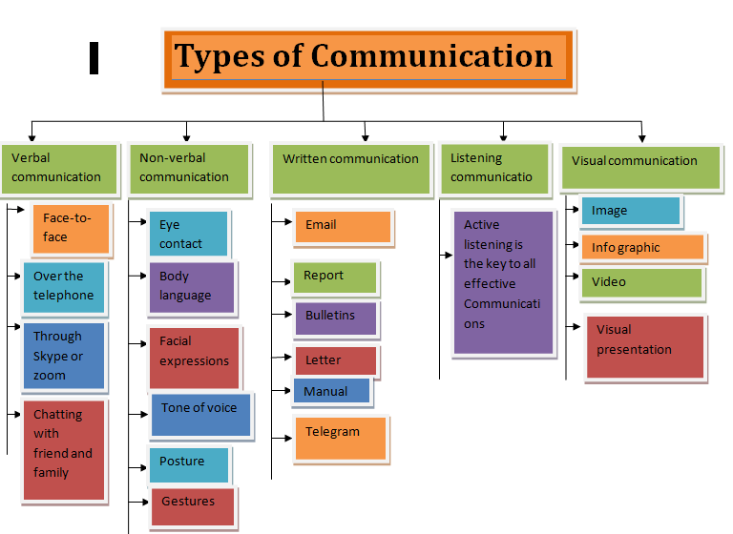

Our daily lives are severely impacted by poor communication, especially at work (Raman. 2011). Poor communication can lead to a number of issues, including misunderstandings, lost opportunities, unneeded conflict, the spread of false information, mistrust, low morale, and a potentially dysfunctional corporate culture in the workplace.

Example of a poor communication at work place: As an assistant teacher, I work in a primary school. There is some misunderstanding because English is not my native language. My co-workers come from a variety of non-English-speaking nations, including a couple of my own. One day, our head teacher convened a staff meeting and hastily provided a brief overview of the day's assignment. Scottish-born and with a rapid speech rate. She passed the message and exits the room because she was in a hurry that day. We ran out of time to speak with her further to gain clarification on her instructions. There were a few of my co-workers there as well, so I wasn't alone in that scenario. To ensure that we fully understood her message, we talked with a few other teachers. If my head teacher had taken her time and listened to our criticism to ensure that she communicated her point clearly, this uncertainty would have been prevented.

Conclusion:
One of the constitutional social skills needed for everybody to survive in the world is communication. Successful communication ensures that you don't just deliver your message but also share your thoughts and emotions with the other person. The Shannon Weaver model (1948), Berlo's SMCR model of communication (1969), and Schramm's communication model (1954) are significant communication models. Physical, perceptual, emotional, cultural, and other types of obstacles can all interfere with communication. Barriers or a lack of communication can create a few things, including miscommunication, missed opportunities, unneeded conflict, the spread of false information, mistrust, low morale, and a fragmented corporate culture in the workplace.

Reference:
Raman, Meenakshi & Sangeeta Sharma. Technical Communication: Principles and Practice. Second Edition. New Delhi: Oxford University Press, 2011.

Rutherford, Andrea J. Basic Communication Skills for Technology: Second Edition. Delhi: Pearson Education, 2007.

Kobiruzzaman, M. M. (2021). Models of Communication, 3 Types of Communication Models Linear, Interactive & Transactional.

Newsmoor- Educational Website For Online Learning. https://newsmoor.com/3-types-of-communication-models-linear-interactive-transactional/

7 problems good communicators are able to avoid:
https://fairygodboss.com/career-topics/lack-of-communication (Accessed: 23 October 2017).

