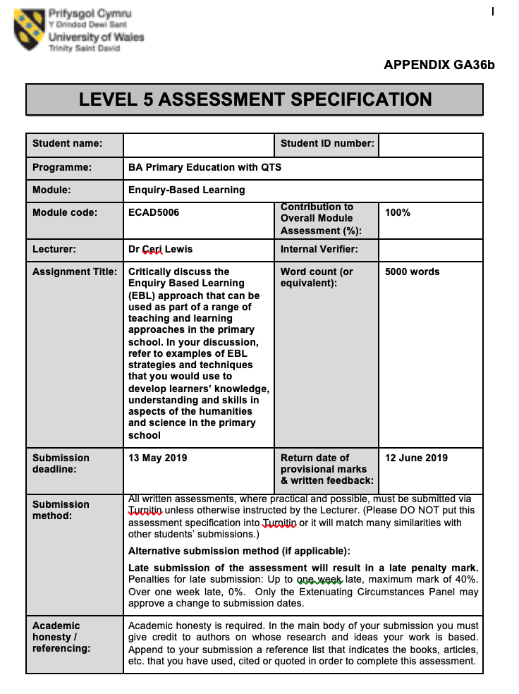
1700085
Emily Thomas
Discuss the nature and application of EBL strategies and techniques to develop learners’ engagement with knowledge and understanding and the models of enquiry skills in the humanities in the primary school (choose either FP or KS2 to show examples and discuss the application of EBL in this context.) Word Count: 5497 (5000 +/- 10%)

Part 1

The Welsh curriculum is changing, providing an opportunity for children to become “ambitious, capable learners, ready to learn throughout their lives” (Donaldson,2015:29) one of Donaldson’s many aims, becoming a purpose for all. This allows independent learning to occur, which is not a ‘traditional’ manner of teaching; it is based on process-oriented instruction. Regarding the epistemological outlook, it is essential independent-learning be aimed at fostering learning enabling active-knowledge construction as, “learning to learn is a major educational goal” (Vermunt&Verschaffel,2000). Meyer(2010) agrees advocating independent-learning enables pupils to be actively involved becoming lifelong-learners, corresponding with Donaldson. However, Dueck (2013) proposes, “The best learning is difficult to define” as there are various elements affecting individuals’ ability to learn, conveying the issue of interpreting how children learn. It is argued, when children are encircled with their own ideas and thinking processes learning is successful as Dewey (1916) states “give pupils something to do, learning naturally results” proving learning independently provides opportunities for pupils to acquire knowledge personally.

One method of incorporating active-learning when teaching, achieving Donaldson’s purpose is using “Enquiry-based Learning (EBL),” an umbrella-term describing an approach motivated by an enquiry process where teachers are facilitators and students pursue their own line of enquiry, drawing upon existing knowledge identifying subsequent learning needs (Kahn&O’Rourke, 2005) contrasting to approaches where children rely on teachers for information, being passive and uninvolved. It is argued educators and pupils share responsibility during EBL, comparable to guided enquiry (Early Learning,2015) implying pupils do not act alone. It is only when teachers and students work simultaneously successful EBL emerges as it depends on teacher guidance for students to develop good questions for investigation, monitoring their enquiry process and providing guidance when encountering difficulties, slightly opposing to O’Rourke and Kahn. Additionally, Bruner believed teacher intervention was important (Cremin&Arthur,2014) supporting pupils to apply current skills within new circumstances. Although, Bruner elaborates “children should not be presented with information in its final form, but should be active in processing information for themselves” (Pickford et al, 2013:9). Therefore, the teacher’s role is to guide learners to discover independently. Essentially, EBL should place children at the centre of learning stimulating them to produce individual questions executing the role as an active-contributor where teachers become facilitators. Piaget is amongst critics who disagree advocating children should learn independently comparing them to a “slate waiting to be written on” (Cremin&Arthur,2014). However, Pickford et al(2013) agrees with Bruner proposing enquiry represents a process where pupils actively-learn about the world by actively making sense of it themselves, making sense of information surrounding them, contrasting to learning where knowledge is “transmitted to us ready made” (Roberts,2003: 27). For pupils to become active-contributors and enquire independently, complete teacher intervention may not be the best approach. Nevertheless, EBL places student’s thoughts at the centre of learning encouraging children to become active-contributors in the absence of a teacher (Friesen&Scott,2013) contending with viewpoints where children should be submissive.
Scharaldi(2016) advocates EBL allows learners to consider, review and reflect on new ideas and solve problems, encouraging inquisitiveness building on knowledge through exploration allowing various skills to flourish including those significant to enquiry inlucding collaboration, communication and evaluation in an active-context (Harris and Jones,2012). Kuklthau, Maniotes and Caspari(2007:p.2) coincide, indicating enquiry requires more than merely answering questions, it embraces investigation, exploration and pursuit allowing children to strengthen numerous skills. Although it is proclaimed EBL is a “question driven, open-ended process…students must have experience to understand the fundamental aspects” (Edelson,Gordin&Pea,1999: p.2). This suggests students must have experienced EBL beforehand to become successful conveying EBL merely revolves around questioning, not stating any other skills. Roberts(2013) disagrees, insinuating EBL allows for a cross-curricular approach, therefore pupils will gain more skills alternatively to just questioning as Barnes(2015) suggests cross-curricular approaches provide teachers with the best chances of including all children in learning, providing inclusivity.
EBL is a constructivist learner centred approach where pupils analyse problems and the surrounding context, applying deductive and inductive approaches to identify problems discovering solutions using priori and post-priori knowledge becoming active-learners within small groups (Carroll et al, 2009). Harris and Jones(2012) emphasise communication is key to successful EBL, therefore, situating children within groups help ideas and understanding to thrive enabling personalised learning (Barshay,2018). The significance of group work follows social-constructivist thinking acclaimed by Vygotsky (1978). According to Knight(2010) these skills are achieved by children daily, yet often an invisible concept underpinning everyday practices. Additionally, Vygotsky(1978) suggests learning cannot be divided from social-circumstances arguing, cognitive functions initiate as products of social interactions stressing children learn best when interaction occurs, promoted through EBL. Piaget opposes, advocating children are “lone scientists” and should be self-supporting (Cremin&Arthur,2014) learning from activities they experience rather than through interactions. Additionally, Harland’s(2003) study conveys children may find difficulty in accepting classmates within a traditional teaching role, proving a challenge for EBL. Although, group work allows pupils to combine opinions corresponding with Vygotsky’s theory of the zone of proximal development alluding to what children achieve with guidance from others stressing the benefit of communication. Vygotsky concludes when pupils are within the ZPD, giving child-to-child feedback, it gives pupils a ‘boost’ to succeed in tasks, increasing motivation (Harland,2003).

EBL has various benefits, one being to enhance higher-order thinking skills within cognitive elements leading to improved gains in achievement (Pickford et al,2013) as EBL is surrounded with student’s questions. The enquiry process and increased thinking provide a shift towards “progressive educational ideology” as both aim to enhance increased autonomy in learners (Pickford et al, 2013:p.12) highlighting the importance of questioning for children to increase their thinking-skills, an advantage of EBL. Bloom’s taxonomy(1956) could be utilised when using EBL as it creates an array of questions, “from low-level thinking to open-ended high-level thinking questions” (Blakeney,2012), thus can differentiate questions suiting individuals. Black and Wiliam(1998) suggest the quality of questions and talk is important for successful learning as questioning allows for hasty and positive changes. Additionally, relevant questions help pupils simplify understanding and stimulate thinking, creating curiosity (Wiliam,2011) consequently putting students’ ideas at the centre of learning, allows them to become more engaged and motivated to complete work. Furthermore, Alvarado and Herr(2003) agree stating the quality of pupils’ work improves naturally, as they are more invested within their work as they are completing it for themselves producing their own questions and research, with a slight amount of teacher guidance. Vygotsky stresses the duty educators have in encouraging investigative behaviour in children (Pluck&Johnson,2011). Therefore, cognitive capabilities and inspiration can be enhanced through stimulation of childhood inquisitiveness. These benefits are recognised by Greenfield Primary(n.d) who possess an ‘enquiry curriculum’ as EBL allows a real-context for the application of basic skills simultaneously integrating learning empowerment as it is planned around the distinctive needs of children. Within an E.T.I(2014) study, children enjoy learning by ‘doing,’ contribute to planning, asking questions, group-work and when learning is responsive to their interests, which EBL promotes benefitting the process. Catling (2017:p.360) suggests learning is developed when teachers “encourage curiosity, questioning, investigations, hypothesising and problem solving, while balancing teacher-led and child-initiated learning” another advantage, as these are principles regarding EBL.
Evidently learners take “ownership” of their work within EBL, leading enquiry. However, individuals can be given ownership but not do anything about it, limiting learning and restricting the control of the teacher (Lakin,2013). This could be because children differ in their motivation to complete work, therefore EBL could come across as a laid back process to these learners as “motivation arises from learners themselves” (Lakin,2013: p.6) therefore an EBL disadvantage. It is acknowledged enquiry-skills must be taught beforehand as without prior knowledge of these skills, the demand on working memory would be too great to promote any kind of learning when required to use them (Atkinson,2016) therefore requires further planning, preparation and responsiveness from educators. Consequently, EBL is time-consuming and difficult to perform when “there is not enough hours in the day to support students” (Punton,2014) let alone try different learning approaches. Children take responsibility for their learning as EBL is child-led, although a challenge is ensuring pupils obtain accurate information as some may be misguided in information they research (Grigg&Hughes,2013). Therefore, it is recognised educators must be skilled in helping students learn how to ask ‘good’ questions (EdBlog,2015) which Blooms taxonomy can assist. Although, it is questioned why ‘knowledge’ and ‘remembering’ are the lowest within Bloom’s taxonomy (appendix-5) reducing their importance to improve higher-order thinking skills (Berger,2018). Critics contend arguing remembering and knowledge are more important within education. Nevertheless, educators must attempt for balance, as pupils require various skills to become fearless when learning.
Essentially, humanities explore human experience, making sense of the complex world we live in (Grigg&Hughes,2013) therefore important for children to fathom historical events, geography, local areas and religious-education. Donaldson(2015:17) advocates humanities promote fascinating contexts for children to learn about people, place, time and belief. Using EBL allows children to answer questions to which they find the answer however, rather than solely focusing on questions, children want lessons to be engaging and relevant with fun practical lessons and out-of-classroom activities, which EBL humanities allows (WG,2015). Catling(2017) agrees stating inspectors recognize expert humanity teachers use various methods involving children in practical activities and reflection generating depth in thinking and understanding conveying good practice by employing various approaches and resources. This practice can be utilised through differing models including the enquiry and questioning model (Pickford et al,2013), the 4 stage model: the investigative cycle (Samuel,2009), the 5 stages of enquiry model (Ofsted,2010), the Michael Storm 5 question model (Storm,1989 cited in Schoffham,2014) and the 6 question focused enquiry (Schoffham,2014). From analysing, most focus throughout the enquiry cycle of questioning, planning, analysing and sharing. A specific model recognised as “The S Model” (Grigg&Hughes,2013) (appendix-1) gives a clear structure on how to perform a realistic enquiry, utilised in the latter of the essay. This enables children to question, hypothesise, plan, research and handle information looking at various sources (Pickford et al, 2013), which is essential within humanities. Estyn(2017:3) acknowledges good practice where pupils enjoy various tasks and study current issues, therefore will enhance motivation within classrooms using differing EBL models, as it gives a framework that can adapt to suit the individual. Although, the key aspects when using models should be acknowledged including questioning, planning, analysing and sharing for successful EBL in humanities.
Donaldson(2015) proposed science and technology merge together as the learning area capitalises children’s curiosity regarding the natural and physical world through investigating, understanding and explanation whilst simultaneously communicating with others emphasising the importance of science. Turner(2011) states science-enquiry is what children do to answer scientific questions regarding the surrounding world and different types of questions/situations require different types of enquiry, suggesting there is a range of models that can be used for successful enquiry, depending on individuals and questions asked. One of these models can be the “plan, do and review ” (Turner,2011) as it engages learners helping them reflect scientifically. Reflection is emphasised by Murdoch(2015) suggesting students are engaged when ‘showing off’ what they have learnt. Murdoch elaborates implying when children reflect; it also benefits teachers as they detect if skills and understanding have been enhanced. A form of scientific enquiry is recognised within the 2008 curriculum where students pattern-seek, explore, classify, identify and test fairly (Turner,2011) to perform science, becoming active-contributors learning independent-skills that will last a life-time (Nuffield Primary science,1993) as essentially “science is about exploring, and the only way to uncover secrets of the universe is to go and look” (Loxley,2018:1). Therefore conveying to understand science, students must enquire independently. A strategy to encourage problem posing is the KWHLAQ strategy (appendix 2), where natural curiosity is promoted and breaks down steps for the enquiry process gaining successful scientific EBL.

Part 2
This project focuses on the history of Civil-Rights, building upon the humanity EBL approach. Pupils will understand the “differences in people’s daily lives in two contrasting periods of the twentieth century” (LW,2008a) thus can draw comparisons and contrasts between the beginning and end of Civil-Rights and compare Wales to America during this era. Simultaneously, children will gain chronological-awareness and historical knowledge enhancing historical-enquiry as pupils need to understand chronology as this is not performed successfully in schools (Ofsetd,2011). Foster et al(2015) argues the Civil-Rights Movement is today just as important topic wise as it was in 1954, emphasising its importance for year 6 children to gain understanding. Within Wales, children as young as six are telling parents that others in school are telling them to go home because they are not white or not originally from Wales (Williamson,2018) emphasising further how children need to learn about equality understanding the rights everyone has. The ‘S’ Model Grigg and Hughes(2013) can assist children’s enquiry as they can select, search, sift and synthesise and share. This model will be used alongside Storm’s (1989) 5-question model where an overarching question will arise with further subsidiary questions.
Select
Estyn(2017) proposes it is crucial for pupils to recall prior-knowledge skillfully applying this effectively to develop understanding regarding new situations thus is important for teachers to understand what pupils already know to formulate good-questioning. Individuals arrive at situations with knowledge gained from prior-experiences, this prior understanding influences what new knowledge they will construct from new learning experiences (Phillips,1995) benefiting teachers and pupils. Therefore, a ‘dig-box’ will be utilised with images and objects relating to the 1960s (appendix-3) hidden in sand for children to guess the era they will be enquiring about, sparking interest and motivation. This offers pupils a hands-on opportunity to explore the artefacts and their importance, learning about the context of the topic and stratigraphic association without teacher intervention, an aspect of EBL (Chrisholm,2007). This succeeds in completing discovery-learning, promoted by Bruner(1961) as the target information is being ‘discovered’ by individuals, with the teacher facilitating, providing them with what they need but not organising it for them. This stimulates children in developing their historical-enquiry as they can ask questions regarding the past, becoming aware of chronology successfully achieving the historical skill of “chronological awareness, using appropriate words to estimate and describe the passage of time” describing the 1960s (LW,2008a). The Assessment For Learning strategy of think, pair, share would be appropriate to use allowing children an abundance of thinking time which Bruer(1998) supports, as time for critical-thinking is crucial for brain development, consequently easier to process new information and work collaboratively. This is supported by Vygotsky, where capable peers benefit others’ learning as we live within a social world therefore activities should be “embedded within social-events and occurring as a child interacts with people, objects and environmental events” (Vygotsky,1986:p.287). Simultaneously, the teacher can guide learners addressing any misconceptions. This achieves Grigg and Hughes(2013) questions for successful “selecting,” as children understand the focus and what they know about this place and time.
Alternatively, this could be achieved through a ‘tardis’ activity where pupils analyse, infer and enquire about images relating to the Civil-Rights movement including different types of schools, facilities and differing statuses between black and white people looking at the continuity and change between then and now (appendix-4). This allows for role-play to occur as children can go into the tardis in groups, analyse images and pretend they are faced with these dilemmas, truly understanding what people endured during the 1960s, describing how they would feel provoking questions such as “why did this occur?” developing observational history skills (Grigg,2015). Role-playing is a significant process as children experience emotion, cognitive integration of effect and stimulates creative expressions (Russ&Wallace,2013) enhancing historical understanding as they are “identifying significant events across periods, understanding the consequences” (LW, 2008a) and communication within the LNF as they “listen and contribute” (LW, 2014) within different scenarios. Although, Snow et al(2014) advocates a 3-D stimulus is more memorable than mere images, therefore should reconsider artefacts used. Nevertheless, pupils are finding this information independently, understanding emotions endured by historical figures as education is a natural-process, spontaneously carried out by individuals, acquired by not listening to words but acting upon experiences (Montessori,1946), which the tardis activity promotes, further encouraging enquiry skills.
As this knowledge has been enhanced and children’s ideas are thriving a KWHLAQ grid can be produced (appendix-2) aiding the planning of enquiry, as you cannot expect children to know how to find good information (GHG, 2015) thus this chart will help students organise thoughts and subsidiary questions. Although, Heick(2018) proposes students do not know how to ask good questions, therefore the teacher’s role will be to model overarching questions that could be investigated including “what impact did Wales have on the Civil-Rights movement and why?” and “were there differences between Wales and America during the 1960s?” posing various questions regarding daily-life achieving Grigg and Hughes(2013) ‘selecting’ process as they decipher what they truly want to find out. Grigg and Hughes(2013) state practitioners should act as models, guides, observers and a friend therefore can use Bloom’s taxonomy (appendix-5) to aid children’s questioning, to elaborate on their ideas. This incorporates writing across the curriculum as children “use appropriate vocabulary including subject-specific words” (LW, 2014) additionally incorporating historical Welsh-life into lessons creating ethical informed citizens of Wales and the world, achieving Donaldson’s purpose (Donaldson,2015).
Search
As the overarching question has been decided by children: “what impact did Wales have on the Civil-Rights Movement and why?” along with subsidiary questions shown in appendix-2 the next aspect of enquiry is to ‘search’ (Grigg&Hughes,2013) therefore need to devise plans discussing what they will need to answer their questions deciphering how they can find out, where to look and who they can talk to to gather additional information understanding the Civil-Rights Movement further and how Wales impacted upon it.
In order for children to enquire further, asking themselves how they can find information independently, DeBono’s(1985) six thinking hats can aid the process at this enquiry stage. This will increase lateral thinking simultaneously enhancing creative minds as this strategy makes children think about a question from multiple perspectives (DeBono,1993). Children wanting to deal with facts and statistics they know prior to enquiry yet want to enhance this further will wear white hats and children wanting to fathom answers to new questions proposing innovative ideas will wear green hats eventually coming to conclusions in groups answering how and where they can find information and whom can they gather this from. Estyn(2015) has recognised good practice within Mynydd Cynffig School as pupils utilise thinking hats enabling them to work collaboratively, discussing a range of solutions to problems, making ‘thinking’ more focused. This enhances active-enquiry, requiring children to think outside the box securing a complete view of a situation additionally allowing for child-interaction advancing into Vygotsky’s ZPD. Although, Welham(2014) suggests too much group work crushes intellectual thoughts, a limitation to DeBonos hats and the aspect of collaboration within EBL. Nevertheless, Beyer(1995) suggests thinking critically means making clear, reasoned judgments therefore important for teachers to guide students to build critical-thinking skills through established structures and routines requiring students to analyse information. Henceforth, to structure their ideas a mind-map could be proposed by the teacher acting as a facilitator, to list all places and people they could speak to to gather information, example shown in appendix-6. Eventually, they may want to visit local libraries to identify secondary-sources to compare and contrast pictures of schools in the 1960s and find additional information.
Utilising a library for educational visits allows secondary-sources to be discovered, as when children learn about the past through secondary-sources children discover accounts differ and begin asking questions regarding their primary-sources and begin to discover why (Cooper,2000). Thus, being within a library surrounded by multiple books and old newspapers children have to discover information independently enhancing their reading skills especially the skill of “skim-reading” to retrieve information quickly (LW,2014). Additionally, Ofsted(2006) recognises the importance of children visiting libraries as they earn various cross-curricular skills, encourages independence and is vital in promoting pupils’ reading improving their literacy-skills. Catling(2017) acknowledges the best humanity teachers employ several approaches including observation and studies outside the classroom, thus achieving this through the handling of old artefacts and newspapers within a differing environment. Hoodless et al(2009) advocates learning outside the classroom has value in enhancing motivational power as children naturally absorb information learning from their surroundings. However, Grigg and Hughes(2013) state there is little evidence to suggest how influential public libraries are on children’s learning therefore another visit could occur to enhance enquiry regarding the impact Wales had on Civil-Rights, as within a library you cannot ask books first-hand questions.
Grigg and Hughes(2013) suggest a range of visitors assist children to understand the wider-world conveying children develop understanding from differing workplaces and varying roles of people within the local-area. The children can visit an art gallery in Carmarthen, asking questions and listening to a professional artist who understands the work of John Petts who lived in Llansteffan and impacted upon the Civil-Rights Movement as he created a stained glass window sending it to America in solidarity for equality in 1963. Therefore aspects of Curriculum Cymreig(2003) are achieved as children are learning about their local area and individuals. Ofsted(2010) recognise the importance of visitors as these first-hand experiences allow them to learn quickly from asking specific questions as they can receive answers from a professional immediately. This allows children to achieve oracy across the curriculum as they “listen carefully to speakers’ conclusions and opinions” (LW,2014) simultaneously enhancing historical knowledge and understanding as they “understand why people did things and consequences of events” (LW,2008a) in a first-hand active experience. However, Piaget(1964) believed children learn from objects encountered rather than through interactions and communicating, contrasting to the constructivist theory. However, children are learning both collaboratively and through objects encountered therefore communication, enquiry and observation operate as one, achieving EBL aspects.
Within these activities, the teacher’s role is to facilitate learning, whilst pupils enquire independently discovering sources and asking questions to the visitor. The teacher can guide learning by assisting them to find the correct books conducting a book hunt, thus the children know which books to find but it gives them a purpose which makes searching fun and motivating thus successful learning can occur (Wigfield et al,1998). Additionally, the teacher knows they are discovering the correct books, creating a safe environment.
Sift and Synthesise

Synthesising enables children to form an understanding regarding the chosen topic looking for connections between materials, artefacts and resources to enhance understanding (GCF,2012). This conveys children must reflect critically regarding the information and resources derived from the library, visitor and any prior knowledge they may have had considering the validity, reliability and functionality of newspapers, video entries and images they discovered.

To further enquiry, one group of children could become historians delving into the differing sources retrieved using magnifying glasses and tools they believe historians would use to enhance enquiry. They can sort sources in order of reliability or which give them the richest evidence regarding life in the past for black and white people concerning facilities, comparing it to life in Wales. This enables deliberation and discussion regarding their findings considering the reliability of sources against the richness of detail real-life offers acting as a character. Research states the relationship between play and children’s development strengthens creativity, understanding of others and social-competence with peers (Gleason,2016). Therefore, this role-play could motivate social-development as children are behaving as somebody else, thus increasing motivation to complete the task within a child-led activity enabling them to consider viewpoints from different perspectives simultaneously understanding how to be critical regarding resources they have found. Kaufman(2012) and Donaldson(2015) agree advocating role-play holds cognitive benefits as it possesses various language opportunities and is a beneficial AFL strategy to see if children can delve deep into historical sources independently. Although, this role-play requires two ways of being at once, thus may be confusing and difficult for children (Gleason,2016). However, the teacher’s role is to facilitate learning thus can utilise De Bono’s (1985) white thinking hat to urge learners to focus on the facts, details and proof asking questions such as “what information do we have?” and “what information is missing?” to produce a detailed enquiry guided by the teacher. To further this, a word bank can be provided to improve vocabulary regarding the reliability of sources, using subject-specific terminology for description. Ofsted(2011:50) advocate outstanding teaching in history enables pupils to utilise ICT, further supported by Donaldson(2015) making it a cross-curricular responsibility. Children can put this information onto a digital-database developing enquiry simultaneously critically reflecting upon the resources, working collaboratively by debating peers ideas on which source best answers the EBL question.
Children conducting a database and using role-play to further enquiry creates a cross-curricular approach covering skills including data skills to “represent data using various charts and tables,” (LW,2014) stimulating oracy “expressing issues and ideas clearly” (LW,2014) and concurrently developing historical enquiry “asking and answering relevant questions about the past” (LW,2008a).

However, it is the individuals choice how they want to record their enquiry strengthening independence as essentially children should have opportunities to make decisions within education and have their voice heard (Kohn,1993). These could include mind maps, video diaries and podcasts discussing each source enhancing independent learning encouraging decisiveness.

Although the teacher could promote another role-play situation including the pupils ‘becoming’ John Petts, working collaboratively to create a stained glass window in favour of Civil-Rights. Children gain an abundance of art-skills as they are inspired by an artist simultaneously investigating the world of imagination using a range of materials (LW,2008b). Additionally, this will enhance historical-enquiry as from analysing each source and hearing first-hand about John Petts’ work from the visitor they will discuss the reasoning behind helping America regarding the need to create solidarity and promote equality, strengthening their knowledge concerning the impact Wales had on Civil-Rights. Children can learn through creativity here as integrating art within activities harmonises with thought (Marshall,2005) suggesting children’s thoughts generate through creativity. This associates with Bloom’s Taxonomy (appendix-5) depicting creativity at the top of the pyramid, suggesting it is the most important element to promote questions. Therefore children can discuss information and their EBL questions in a creative innovative way through hands-on learning. Dewey(1916) stresses how hands-on experiential learning is essential as it helps children become reflective through action which children endure within this task as they experience a hands-on creative task yet reflecting on why John Petts helped America asking themselves “but what else could have been done to assist America?” to further enquire.

Share

Prior to children sharing their enquiry, they will have analysed sources and information from the visitor and library in detail specified above, therefore can finally share and reflect upon information collected. Teachers need to promote reflective classrooms as this ensures pupils are thoroughly engaged within the EBL practice that is ‘making meaning’ (Costa&Kallick,2008). Therefore, the role of the teacher will be the ‘facilitator of meaning making’ consequently, pupils will be the producers of knowledge, not merely a consumer of knowledge. Hence, children can independently answer questions including “how can we tell others about our work, who may be interested, what worked well/not so well and what questions remain” (Grigg&Hughes,2013) critically reflecting as independent individuals. Reflecting is integral to learning as Dewey(1916) states “we don’t learn from experience, we learn from reflecting on experience” thus emphasising active learning where children need to be hands-on working independently to reflect successfully. This is recognised in Kahn and O’Rourke’s(2005) study where children reflected upon work and were astounded by how much was learnt regarding the EBL problem and group-skills conveying the importance of group collaboration when reflecting. However, individuals differ considerably regarding learning styles (Pashler et al, 2008) therefore the teacher’s role within this enquiry stage is to include a choice of activities children can encounter to reflect and share their information, suiting each individual need as “reason, intelligence and knowledge are not synomous” since children have ‘Multiple Intelligences’ (Gardner,1983). Prior to them sharing information the teacher needs to give them time to create a plan giving them the opportunity to consider what they want to do and why acting as an extension of the mind (Gershon,2013).
Some children possess the linguistic-verbal intelligence where children succeed in reading and writing (Cherry,2019). Therefore, to share their enquiry they could write a poem possibly in a Haiku or descriptive format to discuss how injustice and cruelty affected those of another race or how an individual could feel living in the 1960s discussing the differences within education and facilities. It is important for children to write poetry as it aids language development, self-expression and writing skills (Sands,2017) thus giving an opportunity for learners to “empathise and describe producing poetic writing, using imagery and devices e.g rhyme and form” (LW,2008c) simultaneously “identifying the ways in which the past is represented and interpreted” (LW,2008a). A linguistic-verbal child could also benefit from writing two diary entries of opposing races or countries- America and Wales, one on a torn piece of paper and one on a clean sheet of paper describing the different attitudes to learning in schools as a child during 1960s America and Wales. Therefore, visual-learners can peer assess (another AFL strategy) and analyse their work identifying the differences in education solely by visually analysing it, adding to the visual effect. This allows children to compare and contrast how different people lived (LW,2008a).
Another is the body-kinaesthetic intelligence where individuals learn through performing actions (Cherry,2019). Therefore, a dance could be created in a group portraying the differences in treatment between people in the 1960s being inspired by Frantic-Assembly movements portraying a story through dance, example shown in appendix-7 conveying the segregation and impact it had on people’s feelings and emotions simultaneously producing simple sequences and movements (LW,2008d). Montessori(1946) proposes children learn through movement, thus independence, active learning and collaboration can be achieved. Reflection can occur as they are identifying significant individuals’ feelings, analysing history from differing perspectives. Another activity provided from the teacher for these learners is a video-diary activity becoming John Petts discussing Civil-Rights stating why he wants to help. This assists learners analyse the impact of a significant individual and the thought process behind his reasoning, analysing the problem and possible solutions identifying his significance (LW,2008a). Pupils are able to enhance digital-competency skills as they can record with a green screen within an artist’s environment, video edit, change backgrounds and positioning of the camera therefore “selecting sound, animation and video to produce an outcome for a selected purpose” (LW,2016) developing pupils’ ICT skills across the curriculum. Estyn(2018) recognises good practice within Johnstown Primary as they “further pupils’ acquisition of skills facilitating learning across the curriculum” thus effectively a good activity to promote independence, historical-thinking and digital-competency essentially answering and reflecting upon the question “what impact did Wales have on Civil-Rights?”
Interpersonal-Intelligence individuals are good at communicating verbally (Cherry,2019). Therefore a podcast or radio discussion could aid them discussing all the information gathered regarding the differences compared to then and now and the impact Wales had on America. Other members of the class can listen in on this ‘podcast’ as audience members ‘phoning in’ to ask further questions regarding the topic, almost like a child led hot-seating activity as it puts members of the class on the spot developing both drama and literacy skills “responding to others with questions and comments which focus on reasons” developing communication skills (LW,2008c). This allows the teacher to facilitate learning simultaneously assessing knowledge through a child-led question and answer approach. However, this can only occur within a trustworthy environment therefore the atmosphere needs to feel comfortable and safe, which the teacher should facilitate therefore pupils can reveal their insights, understandings and knowledge truthfully (Costa&Kallick,2008).
Children could send their ‘sharing’ videos and work to humanity officers conveying to them the understanding they have gained for the need of equality and human-rights after enquiring about Civil-Rights. As children are working independently, if a teacher emphasises they are sending their work off this can raise expectations regarding behaviour and attainment levels as pupils may feel they can ‘show off’ their learning obtaining an additional purpose as to why they are completing EBL.

These EBL ‘sharing’ activities allow various learners to demonstrate their achievement. However, critics argue Gardner’s definition of intelligence is too broad and merely represent talents (Cherry,2019). Nevertheless, all activities allow for communication, role-play and ICT to occur therefore allowing various learners to engage within at least one aspect making it inclusive and enjoyable for all. Pupils can fill in the KWHLAQ grid (appendix-2) and reflect upon their enquiry asking themselves “what have I learned?” and “what new questions do I have?” as reflecting on work “enhances its meaning” (Costa&Kallick,2008).

Concluding, the S-Model promoted by Grigg and Hughes(2013) enables a cross-curricular approach to teaching and learning as children have an opportunity to strengthen focus, deepen knowledge enabling independent-investigation and reflection within the activities which essentially stimulates learning (Catling,2017). Throughout the enquiry, there are opportunities to gain various skills from the National Curriculum differing from historical to creative either as a group or as an individual supported by peers, to improve skills for future development. Essentially, EBL promotes personal-research and although time-consuming regarding preparation for teachers, the skills gained are invaluable to children, fulfilling Donaldson’s purpose of being “ambitious, capable learners ready to learn throughout their lives” (Donaldson,2015).

Reference List

Alvarado, A.E. and Herr, P.R., 2003. Inquiry-based learning using everyday objects: Hands-on instructional strategies that promote active learning in grades 3-8. Corwin Press.

Armstrong, P. (2019). Bloom’s Taxonomy. [online] Vanderbilt University. Available at: https://cft.vanderbilt.edu/guides-sub-pages/blooms-taxonomy/ [Accessed 12 May 2019].
Atkinson, E. (2016). The impact of teaching an inquiry-based scheme of work on pupils’ attainment and critical thinking skills; and on the pupils’ and teachers’ perceptions of inquiry-based teaching in science. MA by research: University of York. [online] Available at: http://etheses.whiterose.ac.uk/17276/1/Merged%20Word%20V6.pdf (Accessed May 9th 2019).
Barnes, J. (2015). Cross-curricular learning 3-14. London: Sage publications.

Barshay, J. (2018). Working in a group might be the best way to help kids meet individual goals, study says. The Hechinger Report. [online]. Available at:

Berger, R. (2018). Here's What's Wrong With Bloom's Taxonomy: A Deeper Learning Perspective. [online] Education Week - Learning Deeply. [online]. Available at: http://blogs.edweek.org/edweek/learning_deeply/2018/03/heres_whats_wrong_with_blooms_taxonomy_a_deeper_learning_perspective.html [Accessed: May 9th 2019).

Beyer, B.K. (1995). Critical Thinking. Fastback 385. Phi Delta Kappa, 408 N. Union, PO Box 789, Bloomington, IN 47402-0789.
Black, P. and Wiliam, D. (1998) Inside the Black Box: Raising Standards Through Classroom Assessment. London: GL Assessment.
Blakeney. (2012). Bloom’s Taxonomy and Inquiry-Based Learning. Wow for IBL. [online]. Available at: https://mrsblakeney2012.wordpress.com/blog-stage-2/blooms-taxonomy/ (Accessed: May 9th 2019).

Bloom, B.S., 1956. Taxonomy of educational objectives. Vol. 1: Cognitive domain. New York: McKay, pp.20-24.
Bruer, J.T., 1998. The brain and child development: time for some critical thinking. Public Health Reports, 113(5), p.388.

Bruner, J.S., 1961. The act of discovery. Harvard educational review, 31, pp.21-32.

Carroll, K. Clark, J. Kane, J. Sutherland, L. Preston, C. (2009). Problem-based learning. Pedagogy and practice: Proceedings of the Second International Symposium on Problem Solving, Singapore. (pp. 1-8). Retrieved: http.www.kaycarroll.org/uploads/3/0/4/6/3046475/pbl_pedagogy_practice_carroll.pdf
Catling, S. (2017) High quality in primary humanities: insights from the UK’s school inspectorates, Education 3-13, 45:3, 354-364, DOI: 10.1080/03004279.2017.1296923
https://www.theguardian.com/teacher-network/teacher-blog/2014/jun/10/longer-school-day-more-support-students-teachers (Accessed: May 9th 2019).

Cherry, K. (2019). Gardner’s Theory of Multiple Intelligence. Very Well Mind. [online]. Available at: https://www.verywellmind.com/gardners-theory-of-multiple-intelligences-2795161 (Accessed: May 11th 2019).
Chisholm, et al. (2007). Archaeology in the classroom: Using a dig box to understand the past. Social Education, 71(5), pp.272-277.
Cooper, H. (2000). The Teaching of History in Primary Schools. Implementing the Revised National Curriculum. 3rd Edition. London: Fulton Publishers.

Cooper, H. (2000). The Teaching of History in Primary Schools. Implementing the Revised National Curriculum. 3rd Edition. London: Fulton Publishers.

Costa, A and Kallick, B (2000). Habits of Mind: A Developmental Series. Alexandria, VA: Association for Supervision and Curriculum Development.
Cremin, T. and Arthur, J. (2014). Learning to Teach in the Primary School 3rd Ed. Routledge: Oxon.

De Bono, E. (1985). Six Thinking Hats. Boston: Little, Brown and Company.
De Bono, E. (1993). Serious Creativity: Using the Power of Lateral Thinking to Create New Ideas. USA: Harper Business.

Dewey, J. (1916). Democracy and Education. New York: Macmillan.
Donaldson, G. (2015). Successful Futures: Independent Review of Curriculum and Assessment Arrangements in Wales. Wales: Welsh Government.
Dueck, M. (2013). The Best Learning is Difficult To Define. [online]. Available at: https://myrondueck.wordpress.com/2013/01/17/the-best-learning-is-difficult-to-define/ (Accessed May 8th 2019).
https://hechingerreport.org/working-in-a-group-might-be-the-best-way-to-help-kids-meet-individual-goals-study-says/ (Accessed: May 9th 2019).

Early Learning. (2015). Engaging Young Learners Through Inquiry Based Learning. [online]. Available at:
https://www.oxfordlearning.com/engaging-young-learners-through-inquiry-based-learning/ (Accessed May 8th 2019).

Edelson, D.C., Gordin, D.N. and Pea, R.D., 1999. Addressing the challenges of inquiry-based learning through technology and curriculum design. Journal of the learning sciences, 8(3-4), pp.391-450.
EdBlog. (2015). Positives and Drawbacks of Active Learning. [online]. Available at: https://blog.edlounge.com/active-learning/ (Accessed: April 9th 2019).

Estyn. (2015). Employing multiple strategies to improve pupils’ thinking skills. [online]. Available at:
https://www.estyn.gov.wales/effective-practice/employing-multiple-strategies-improve-pupils’-thinking-skills (Accessed: May 10th 2019).

Estyn. (2017). Good practice in the humanities. Estyn: Cardiff. [online]. Available at: https://www.estyn.gov.wales/thematic-reports/good-practice-humanities (Accessed: 9th May 2019).

Estyn. (2018). Using Technology and Developing Pupils’ ICT Skills. [online]. Available at: https://www.estyn.gov.wales/effective-practice/using-technology-and-developing-pupils’-ict-skills (Accessed: May 11th 2019).

(E.T.I. 2014, 20). E.T.I. 2014. An Evaluation of the Implementation of the World Around Us in Primary Schools. [online]. Available at: http:// www.etini.gov.uk/index/surveys-evaluations/surveys-evaluations-primary/surveys-evaluations-primary-2015/an- evaluation-of-the-implemenation-of-the-world-around-us.pdf (Accessed May 9th 2019).
Foster et al (2015). Teaching Young Children about the Civil Rights Movement- Applying Effective & Developmentally Appropriate Strategies. [Online]. Available at: https://files.eric.ed.gov/fulltext/EJ1078765.pdf (Accessed: May 9th 2019).
Friesen, S. and Scott, D., 2013. Inquiry-based learning: A review of the research literature. Alberta Ministry of Education.
Gardner, H. (1983). Frames of Mind. New York: Basic Books Inc.
GCF. (2012). Synthesizing Information. [video]. Available at: https://www.youtube.com/watch?v=7dEGoJdb6O0 (Accessed: April 10th 2019).

Genius Hour Guide. (2015). The KWHLAQ Chart Helps Students Organize 21stC Learning. [online]. Available at: http://www.geniushourguide.org/the-kwhlaq-chart-helps-students-organize-21stc-learning/ (Accessed: May 9th 2019). (GHG)

Gershon, M. (2013) How To Use Differentiation In The Classroom: The Complete Guide. Great Britain: Amazon.
Gleason, T. (2016). Why Make-believe Play is an Important Part of Child Development. The Spoke. [online]. Available at: http://thespoke.earlychildhoodaustralia.org.au/make-believe-play-important-part-childhood-development/ (Accessed: May 10th 2019).

Greenfields Community Primary School. (n.d) Enquiry Curriculum. GCPS. [online]. Available at: http://www.greenfieldsprimary.co.uk/enquiry-curriculum/ (Accessed: 9th May 2019).

Grigg, R. (2015). Becoming an Outstanding Primary School Teacher. (2nd Ed). Abingdon: Routledge.

Grigg, R. Hughes, S. 2013. Teaching Primary Humanities. Oxon: Routledge.

Harland, T., 2003. Vygotsky's zone of proximal development and problem-based learning: Linking a theoretical concept with practice through action research. Teaching in higher education, 8(2), pp.263-272.
Harris, A. Jones, M. (2012). Connecting professional learning: leading effective collaborative enquiry across teaching school alliances. National College for School Leadership. [online]. Available at: https://assets.publishing.service.gov.uk/government/uploads/system/uploads/attachment_data/file/335719/Connecting-professional-learning-leading-effective-collaborative-enquiry-across-teaching-school-alliances.pdf (Accessed: May 9th 2019).

Heick, T. (2018). 8 Strategies To Help Students Ask Great Questions. Teach Thought. [online]. Available at:

Hoodless, P., McCreery, E., Bowen, P. and Bermingham, S., 2009. Teaching humanities in primary schools. Learning Matters.
https://www.teachthought.com/critical-thinking/8-strategies-to-help-students-ask-great-questions/ (Accessed: May 9th 2019).

Kahn, P. and O’Rourke, K., 2005. Understanding enquiry-based learning. Handbook of enquiry and problem based learning. Galway: CELT, pp.2005-2.

Kaufman, S B. (2012). The Need for Pretend Play in Child Development. Psychology Today. [online]. Available at: https://www.psychologytoday.com/us/blog/beautiful-minds/201203/the-need-pretend-play-in-child-development (Accessed: May 10th 2019).
Knight, R., 2010. A theorist in every classroom. Primary Science, 114, pp.16-18.

Kohn, A. (1993). Choices for Children: Why and How To Let Children Decide. [online]. Available at: https://www.alfiekohn.org/article/choices-children/ (Accessed: May 10th 2019).
Kuklthau, C.C., Maniotes, L.K., & Caspari, A.K. (2007). Guided inquiry: Learning in the 21st century. Westport, CT & London: Libraries Unlimited.
Lakin, L., 2013. Developing Independent Learning In Science: Practical Ideas And Activities For 7-12 Year Olds: Practical ideas and activities 7-12 years. McGraw-Hill Education (UK).

Learning Wales, Curriculum for Wales: (2014) National Literacy and Numeracy Framework. Welsh Assembly Government, Available at: http://learning.gov.wales/resources/browse-all/nlnf/framework?lang=en (LW) (Accessed: May 10th 2019).

Learning Wales, National Curriculum: (2008) Art and Design in the National Curriculum for Wales. Cardiff: Welsh Assembly Government, Available at: http://learning.gov.wales/docs/learningwales/publications/130424-art-and-design-in-the-national-curriculum-en-v2.pdf PG 12-14. (Accessed: May 10th 2019). (LWb).

Learning Wales, National Curriculum: (2008) English in the National Curriculum for Wales. Cardiff: Welsh Assembly Government. Available at: https://s3-eu-west-1.amazonaws.com/hwb-live-storage/58/3b/33/5a/8e5c4c088b27480d80d27a90/english-programme-of-study.pdf (Accessed: May 11th 2019). (LWc)

Learning Wales, National Curriculum: (2008) History in the National Curriculum for Wales. Cardiff: Welsh Assembly Government, Available at: https://s3-eu-west-1.amazonaws.com/hwb-live-storage/b0/fc/09/ba/29244972b0f62a9f7ecbca49/history-in-the-national-curriculum-for-wales.pdf PG 12-14. (Accessed: May 9th 2019). (LWa).

Learning Wales, National Curriculum: (2008) Physical Education in the National Curriculum for Wales. Cardiff: Welsh Assembly Government. Available at: https://s3-eu-west-1.amazonaws.com/hwb-live-storage/af/1f/4d/7a/f5184776ac77e1e9b94dc48f/physical-education-inthe-national-curriculum.pdf (Accessed: May 11th 2019). (LWd).

Learning Wales. (2016). Digital Competence Framework. Cardiff: Welsh Assembly Government. [online]. Available at: https://learning.gov.wales/resources/browse-all/digital-competence-framework/framework?lang=en&year=year_6&selectedYear=col_12&lang=en (Accessed: May 11th 2019). (LW)

Loxley, P. (2018). Practical Ideas for Teaching Primary Science. Oxon: Routledge.

Marshall, J. (2005). Connecting art, learning, and creativity: A case for curriculum integration. Studies in Art Education, 46(3), pp.227-241.
Meyer, W R. (2010). ‘Independent learning: a literature review and a new project,’ British Educational Research Association Annual Conference. University of Warwick 1-4th September 2010. Warwick: Evaluation and Research Department, LSN. Available at: http://www.leeds.ac.uk/educol/documents/193305.pdf (Accessed May 8th 2019).
Montessori, M. (1946).Education for a New World. Madras, India: Kalakshetra Publications.

Murdoch, K. (2015). Overview of an Inquiry Journey. [online]. Available at: http://www.sgischools.com/cms/images/PDF/conference2015/kath-murdoch-inquiry-journey.pdf (Accessed May 9th 2019).

Nuffield Primary Science SPACE. (1993). Teachers’ Handbook. London: Collins Educational. [online]. Available at: https://moodle.uwtsd.ac.uk/pluginfile.php/156949/mod_resource/content/0/Nuffield%20SPACE%20Series_%20Teachers%20handbook.pdf (Accessed: May 9th 2019).

Ofsted. (2006). Good School Libraries: Making a difference. [online]. Available at: https://dera.ioe.ac.uk/5792/1/Good%20school%20libraries%20making%20a%20difference%20to%20learning%20(PDF%20format).pdf (Accessed: May 10th 2019).

Ofsted. (2010). Transforming Religious Education. London: Ofsted.

Ofsted. (2011). History For All. History in English Schools 2007/2010. Manchester: Ofsted. [online]. Available at: https://assets.publishing.service.gov.uk/government/uploads/system/uploads/attachment_data/file/413714/History_for_all.pdf (Accessed: May 9th 2019).

Pashler, H., McDaniel, M., Rohrer, D. and Bjork, R., 2008. Learning styles: Concepts and evidence. Psychological science in the public interest, 9(3), pp.105-119.

Phillips,D.C. (1995). The good, the bad, and the ugly :The many faces of constructivism. EducationalResearcher,24(7),5-12
Piaget, J., 1964. Part I: Cognitive development in children: Piaget development and learning. Journal of research in science teaching, 2(3), pp.176-186.

Pickford et al. (2013). Primary Humanities Learning Through Enquiry. Sage: London.

Pluck, G. and Johnson, H. L. (2011) Stimulating curiosity to enhance learning. Sheffield: GESJE ducation Sciences and Psychology. [online]. Available at: http://eprints.whiterose.ac.uk/74470/1/Pluck_and_Johnson_2011_Curiosity.pdf (Accessed: 9th May 2019).

Punton, R. (2014). Not enough hours in the day: more time means more support for students. The Guardian. [online]. Available at:
Roberts, M. (2003). Learning Through Enquiry. Sheffield: Geographical Association.
Roberts, M., 2013. The challenge of enquiry-based learning. Teaching Geography, 38(2), p.50.

Russ, S.W. and Wallace, C.E., 2013. Pretend Play and Creative Processes. American Journal of Play, 6(1), pp.136-148.

Samuel, E. (2009). Investigating Our World: Developing Investigation Skills in KS2 Geography. Caerphilly: G. Ap. Publishers.

Sands, C. (2017). Why Children Need Poetry. HuffPost. [online]. Available at: https://www.huffpost.com/entry/why-children-need-poetry_b_5988612fe4b0bd8232029903?guccounter=1&guce_referrer=aHR0cHM6Ly93d3cuZ29vZ2xlLmNvbS8&guce_referrer_sig=AQAAALVr7HRUTLOjPUmXMsGlBPfIWMmLMtEba1IAktE6ppae7eNjDR5MWwH_Nr_5WWTeOjDusx3QZE2D2VbsgyDRVbGdXiDwf7_1LL5W3jxyecO0DEv1v68C6wLXM0mDf6aC3vqIg88fwD3tU4O0d_r1pKZEs6ClbjtJKi29N068O1K (Accessed: May 11th 2019)
Scharaldi, K. (2016). 5 Ways To Encourage Enquiry Based Learning. Getting Smart. [online]. Available at: https://www.gettingsmart.com/2016/05/5-ways-to-engage-shy-studentsinquiry-based-learning-blog/ (Accessed: May 8th 2019).
Schoffham, S. (2014). Primary Geography Handbook. Sheffield: Geographical Association.

Snow et al. (2014). Real-world objects are more memorable than photographs of objects. Frontiers in human neuroscience, 8, p.837.

Storm, M. (1989). Cited in Chapter 7, Schoffham, S. (2014) Primary Geography Handbook. Sheffield: Geographical Association.

Turner, J. et al. (2011) It’s not fair or is it?. Sandbach. MHE

Vermunt J., Verschaffel L. (2000) Process-oriented Teaching. In: Simons RJ., van der Linden J., Duffy T. (eds) New Learning. Springer, Dordrecht. https://doi.org/10.1007/0-306-47614-2_11
Vygotsky LS (1986) Thought and language. The MIT Press, Cambridge.
Welham, H. (2014). Groupwork is overused in schools and in my experience it stifles good ideas. The Guardian. [online]. Available at: https://www.theguardian.com/teacher-network/teacher-blog/2014/sep/21/group-work-school-quiet-reflection (Accessed: May 10th 2019)

Welsh Assembly Government. (2003) Developing the Curriculum Cymreig. Surrey: ACCAC Publications.

Welsh Government. (2015). A Curriculum for Wales- A Curriculum for Life. Cardiff: Welsh Government. [online]. Available at: https://dera.ioe.ac.uk/24680/1/151021-a-curriculum-for-wales-a-curriculum-for-life-en_Redacted.pdf (Accessed: 9th May 2019). (WG)
Wigfield, A., Eccles, J.S. and Rodriguez, D., 1998. Chapter 3: The development of children’s motivation in school contexts. Review of research in education, 23(1), pp.73-118.
Wiliam, D (2011). Embedded formative assessment. Bloomington: Solution Tree Press.

Williamson , D. (2018). How Wales has been inspired by Martin Luther King’s Life of Courage and Dreams. Wales Online. [online] Available at: https://www.walesonline.co.uk/news/politics/how-wales-been-inspired-martin-14488599 (Accessed: May 9th 2019).

Appendices

Appendix 1- The ‘S’ Model: An EBL Approach.

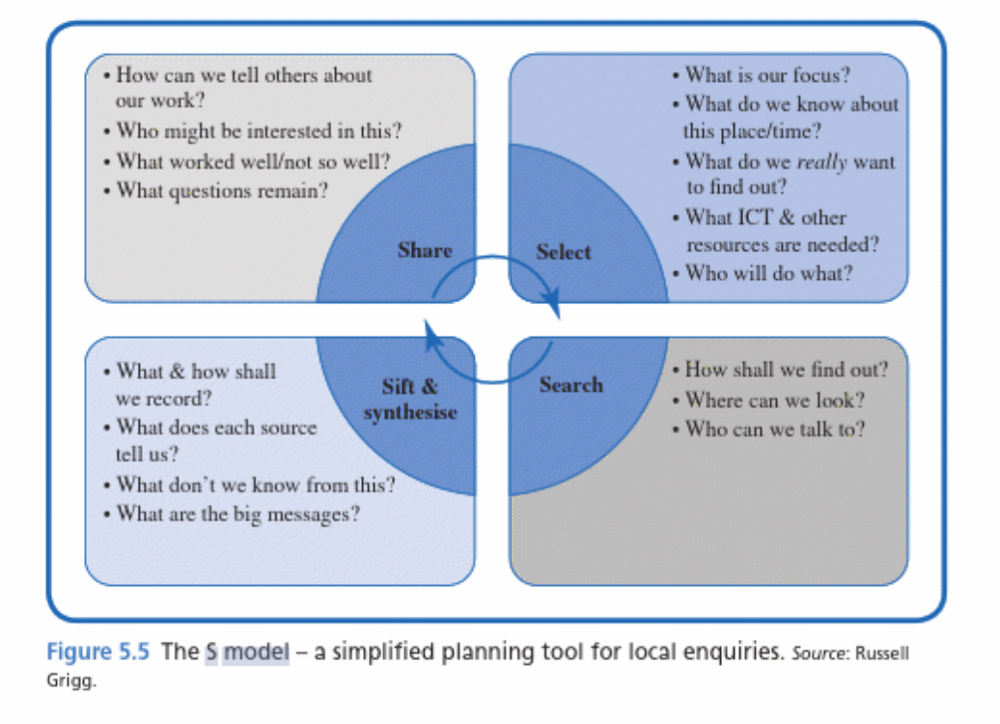
Grigg, R. Hughes, S. 2013. Teaching Primary Humanities. Routledge.

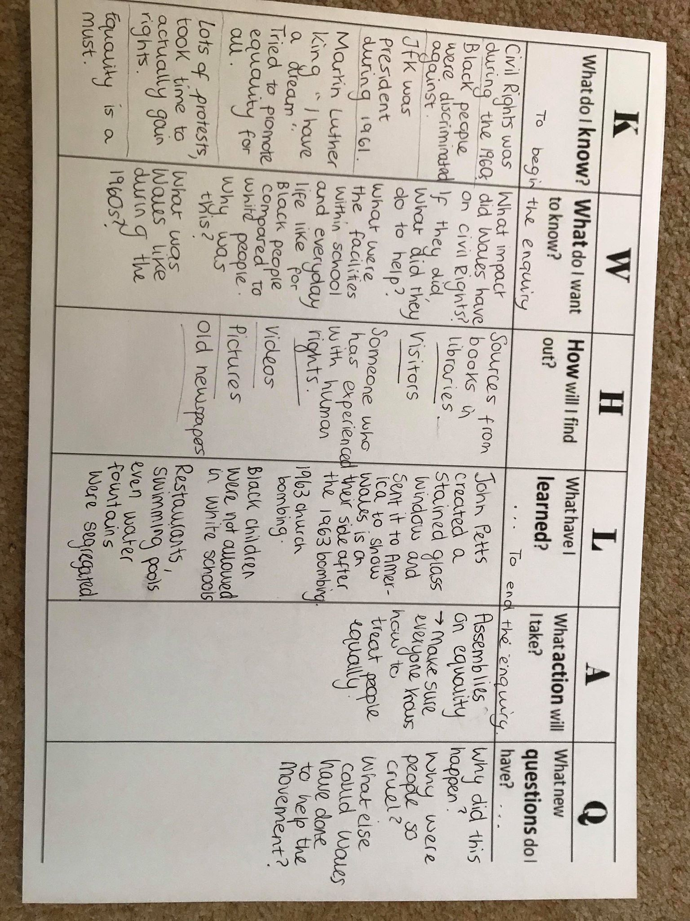
Appendix 2- An example of what a child’s KWHLAQ grid could look like to aid the enquiry process, appendix 2 cont on p.32,33,34.

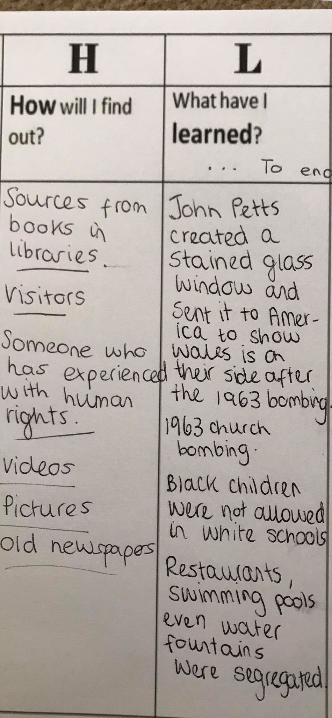
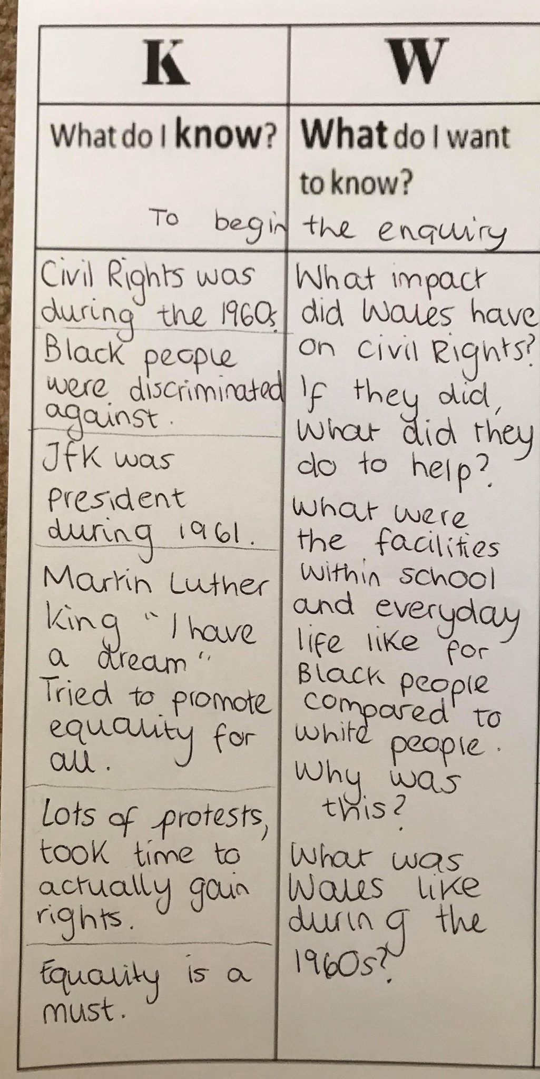

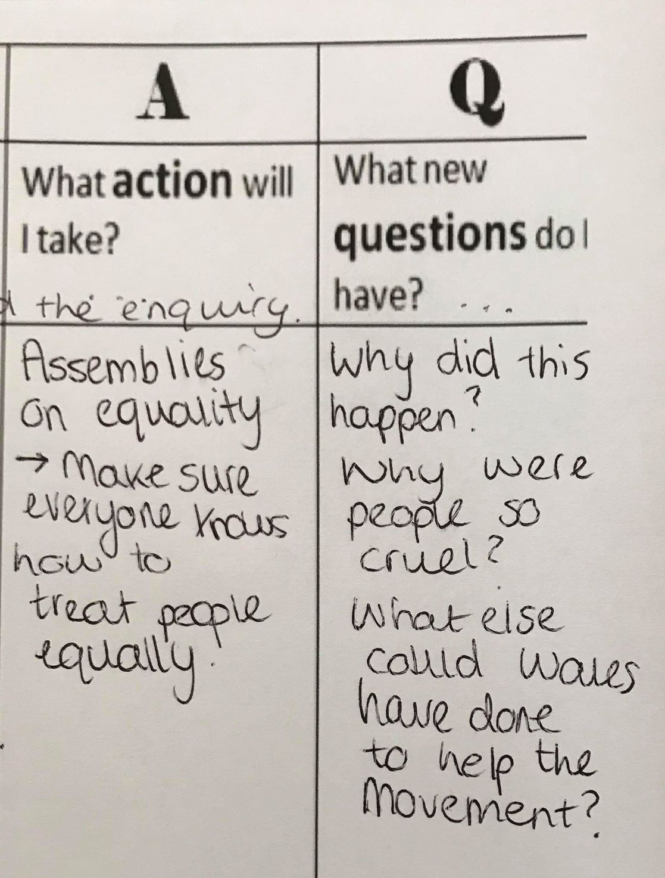

K What do we think we already know about the subject?
W What do we Want/ Need to find out about it?
H How and where will we search for answers? How will we organise our investigations? (e.g. Time, access to resources, and reporting?)
L What do we expect to Learn? What have we Learned?
A How will we Apply what we have learned to other subjects? To our personal lives? To our next projects?
Q What new Questions do we have after our enquiry?
Observe objectively – Think reflectively – Question frequently

Appendix 3- Examples of some images/objects relating to 1960 America that could be used within a dig box.

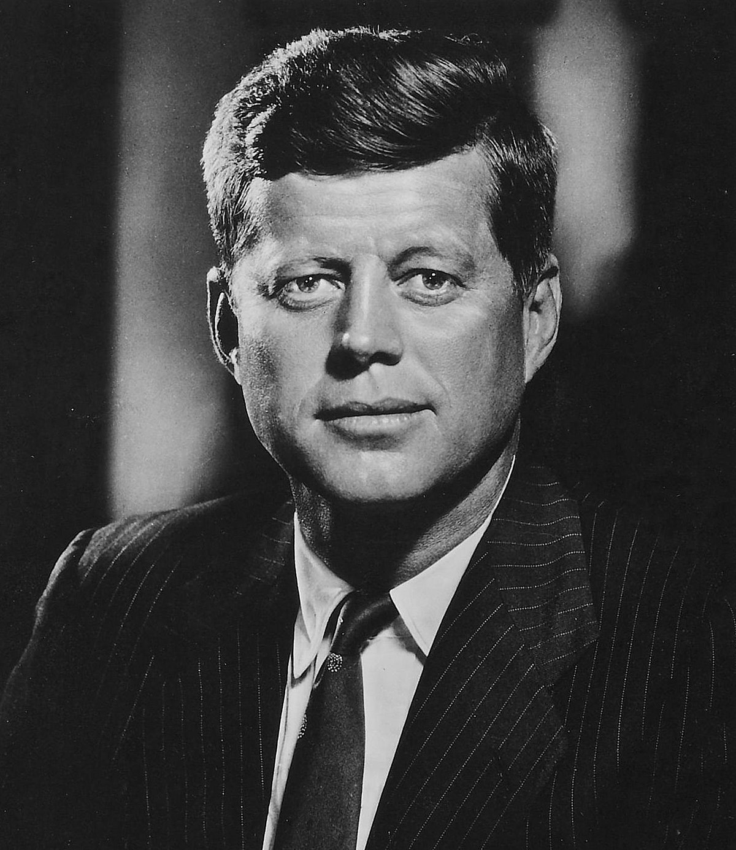

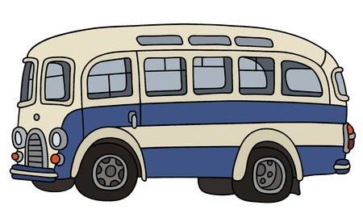
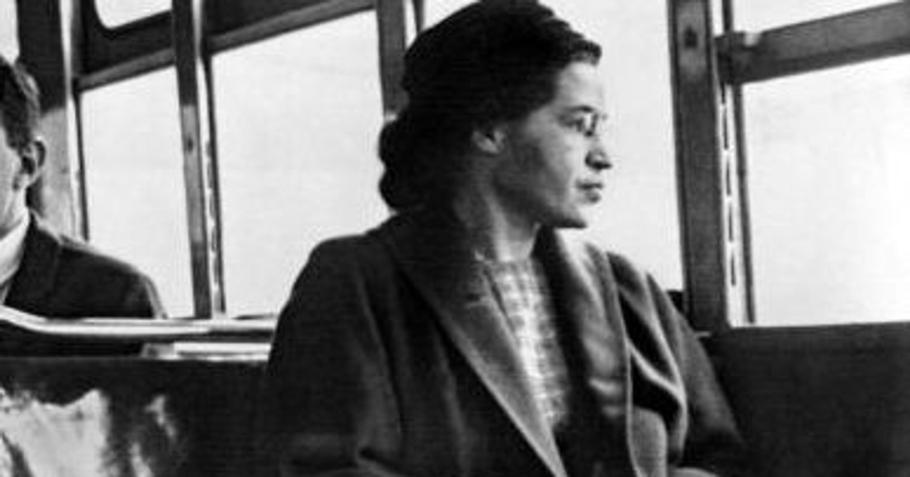

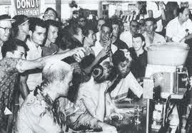

Appendix 4- Examples of different schools facilities and status between black and white people. Children can identify the continuity and change between then and now.
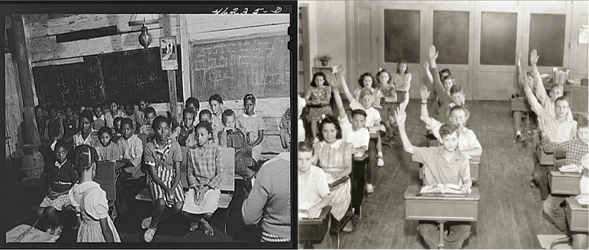

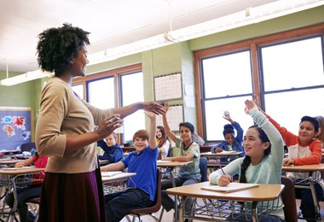
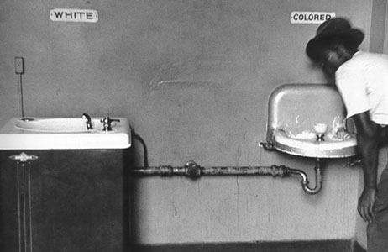
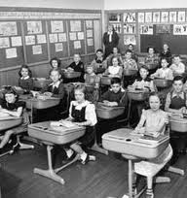
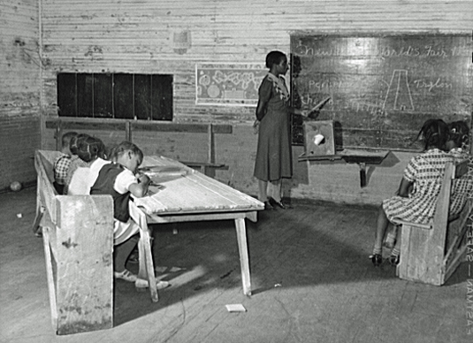

Appendix 5- Bloom’s Taxonomy
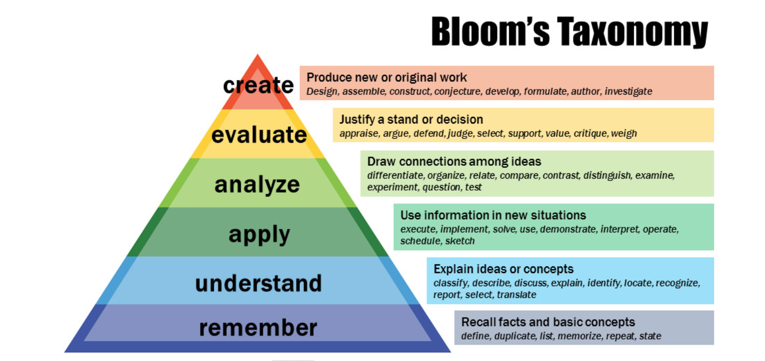
Armstrong, P. (2019). Bloom’s Taxonomy. [online] Vanderbilt University. Available at: https://cft.vanderbilt.edu/guides-sub-pages/blooms-taxonomy/ [Accessed 12 May 2019].

Appendix 6- An example of a mind map that could be completed regarding who they can speak to where they can go to enhance their enquiry.
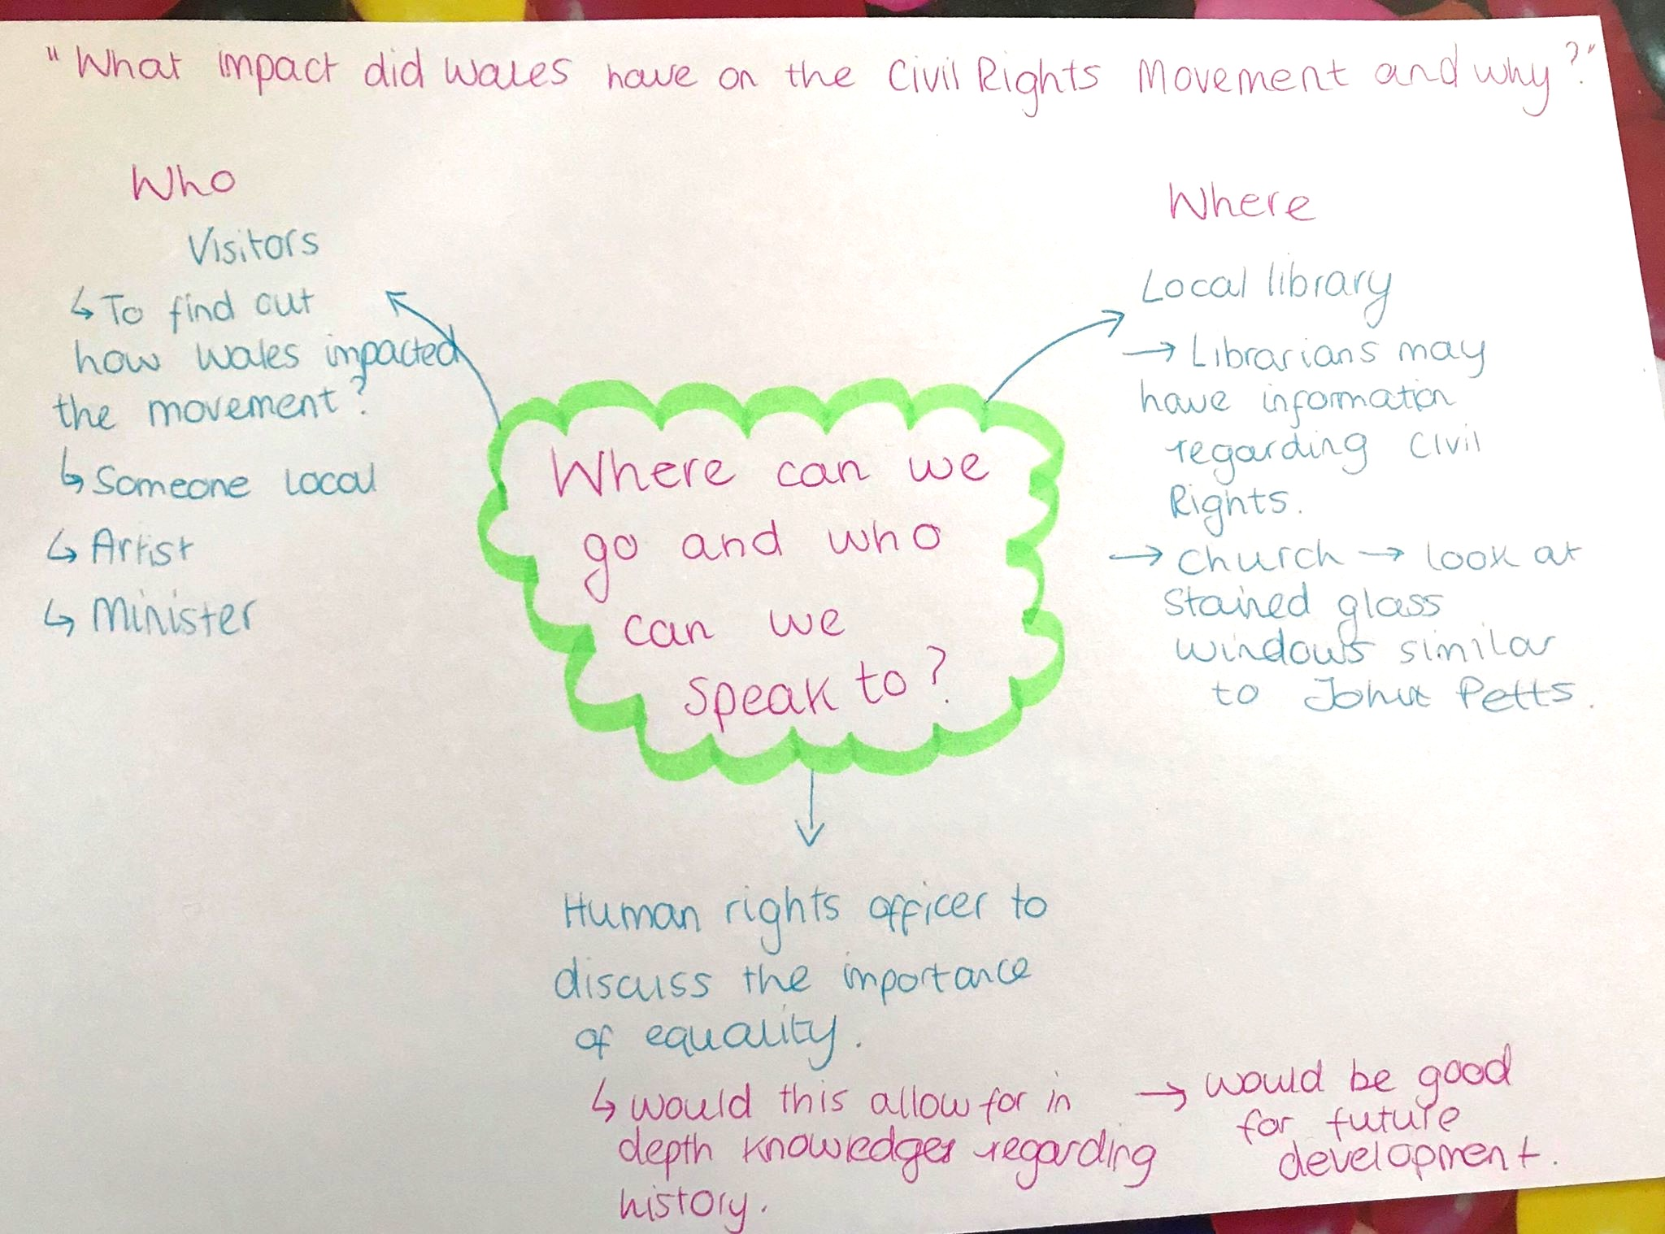

Appendix 7- Example of Frantic-Assembly movements.

https://www.youtube.com/watch?v=8_bWWazhSak

