Smart Pillbox
BSc(Hons) Applied Computing Major Project Proposal
James Holmson - P150037

Supervisor – Dr Nik Whitehead
Table of Contents
Introduction 1
Proposed Research 1
Industrial Content 1
Background Literature 1
Conclusion 6
Aims and Objectives 7
Methodology 8
Research and Development 8
Analysis and Deliverables 9
Project Management 10
Risks 10
Physical Resources 11
Timeline 12
Appendix 17
A – The Research Proposal mindmap. 17
B – Current Products 17

Introduction
It is acknowledged that the mismanagement of an individual’s medication regime has negative implications, which results in attempts have been made to assist patients with remembering to take the required dosage at the correct time.
This paper proposes the development of a prototype pillbox, for the major project of an undergraduate degree. The pillbox itself will use a microcontroller that operates an alarm system, and it is designed in conjunction with a mobile device, for which the appropriate software will be created. The final application will be built in Xcode using the Swift 4 programming language. The proposals mind map is avaiable in Appendix A

Proposed Research
In this section, we determine why this project is necessary. Firstly, there is a brief overview of where the project originates. Secondly, there is an analysis of the background literature, and it concludes with the direction of the project. Finally the aims, objectatives and outcomes of the project will be detailed. The working title is ‘The development of medication support system for Parkinson's disease dementia’.

Industrial Content
The project will be undertaken in accordance with the guidelines set out by Dr Thomas McKinnell, who is a General Practitioner for the National Health Service in Durham. His request relates to the health of patients with Parkinson’s disease, with a focus on those who have been identified as being at high risk of developing dementia. Thus, creating a device for patients who have demanding routines and reduced cognitive abilities, should positively impact upon their health and well-being.

Background Literature
In not adhering to the recommended daily dose routines, patients could be hospitalised and in the most extreme instances die [1], [2]. Studies confirm that those with chronic diseases and those who take a higher number of tablets are less likely to conform to guidelines provided [1][3].
The National Institute for Health and Care Excellence (NICE) defines Parkinson's disease as a neurological disorder affecting the brain. Dopamine assists with muscle control, and with Parkinsons patients, not enough is produced, and the symptoms associated with this will occur. They note that it is a degenerative condition, although there is a variation between individuals, in the speed, that they will decline [4]. In relation to the target group, it was observed that the “disease can sometimes cause symptoms of dementia, including memory loss and confusion. This is known as 'Parkinson's disease dementia'” [5]. However, there are complications with managing the symptoms of Parkinson's disease and those related to dementia, inasmuch that “Parkinson’s medication can make the symptoms of dementia worse”[6]. Evidently, it is about reaching a balance and patients will regrettably have a deterioration in the symptoms of their Parkinson’s, in order to manage those of their dementia.
Current solutions include software for smart-phones, self-dispensing pillboxes and electronic devices that offer audio and or visual reminders [1]. Therefore, it should be questioned, how capable are these systems?
It is recognised that a smartphone application can assist with medication adherence [7]. However, Mondol, Emi and Stankovic accept that reliance on the application itself is “not convenient and effective enough for medication reminder and tracking” [8]. Bartrakov et al. [9] consider the reasoning for this and assert that medication reminders may not be noticed or may even be answered prematurely and later forgotten about, which is a serious issue and will only be exacerbated further by those with degenerative conditions. With the correct management, the problems outlined are avoidable, albeit there are still many difficulties to overcome. In doing so, there is a vastly reduced need for medical intervention, and consequently, money will be saved and the pressure reduced on staff who provide this care [10].
The finished device shall incorporate Self-Monitoring, Analysis and Reporting Technology (SMART), with an emphasis placed on the application to control the alarm. At the time of writing, there are around 240 applications in the Google Play store, which relate to the administration of medication [11]. Moreover, there are approximately 150 applications available for iOS devices [12].
With such a high number available, it is worth considering which features are most valued by the end users. Due to the importance of the system’s daily function, Varshney [1] details the principal characteristics of a smart medical device which is that it should be “reliable, robust unobtrusive”. Mohammed et al. [13] add further noteworthy features, detailing that it should incorporate “design simplicity, user-friendly, cost-effectiveness, small size, lightweight & mobility”. The onus, may be on the caregiver to setup and manage the device. Thus, by incorporating these features, the objective should be to reduce the work-load of the said individual, which was affirmed as being an important factor [14]. It is not without its difficulties with forgetfulness, regimen complexity, change in routine, and challenges in the logistics being highlighted [10]. Ergo there must be flexibility to personalise the regime to the patient's needs.
Singh and Varshney [15] list three interventions that promote medication adherence, each of which has been explored in the context of the case-study.
- Motivation and Support – Although an individual may provide most of the support in the role of caregiver, it may be possible to offer some form of motivation and support via the application.
- Reminders to take Medications – The reminders can alert the user via two of the senses sight and hearing, with touch being an additional option.
- Improved scheduling - For this project, any adjustments to the schedule would be handled by the pharmacy service, who may able to adjust dosages as required.
In figure 1 Varshney [1] outlines how each of three specific factors impacts upon medication adherence. He shows a sharp decrease in adherence as the number of medications taken increases.
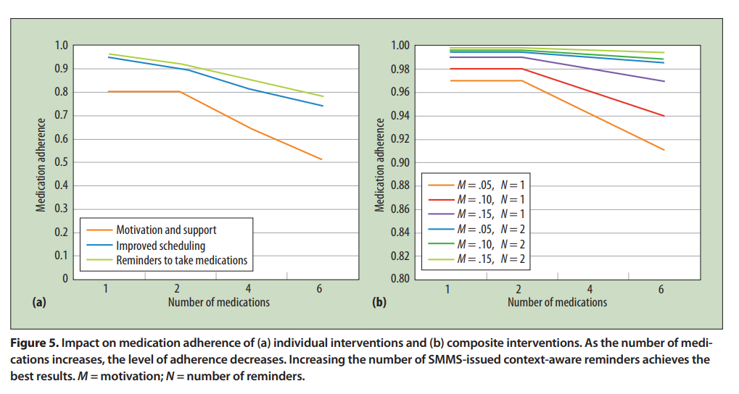
Fig 1. An overview of medication adherence with elements deemed beneficial and the number of medications taken [1].
Moreover in figure 2 Varshney [1] reveals the highest level of adherence is achieved from patients who are the most motivated (M), and who receive the highest number of persistent reminders (N).
Fig 2. A comparison of medication adherence achieved through motivation and reminders [1].

Clearly elements highlighted in point one, and two on page 3 could be used in the development. In figure 3, Silva and França [16] present a visualisation of the benefits of motivation. They note there is a correlation between staying motivated and completing the task, which in turn adds to the individual's well-being.

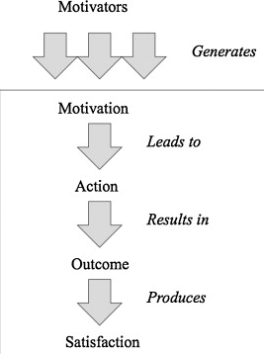
Fig 3. A visualisation of how motivation can assist, in meeting targets [16].
With regard to support, the program could make suggestions to the caregiver with the type of encouragement that they can give the patient. An example of this could be that provided by the NHS, who inform “Regular exercise is particularly important in helping relieve muscle stiffness, improving your mood, and relieving stress” [17]. Conversely, a system to aid with memory training was highlighted as being of possible benefit, as the studies focus was to “increase patients ability” [18].

The symptoms and side-effects of the medication can potentially cause distress. Thus, the system should be designed to be a comfort to the person living with Parkinson’s. The pillbox element serves to help the patient remember the correct timings, and dosage and Lee et al. inform us that when actualising a new medication system, it should be clearly apparent to users as to the device’s function [10]. It should not be intrusive, and instead, it should offer gentle reminders and take any limitation with their dexterity into account if they have to operate any buttons. In an implementation plan for Dementia by the department of health [19], they refer to a case-study in Walsall where the patient and career have control of the support they receive. Therefore, it would be useful to be able to turn off or on any support for example relating to support. The study frequently highlights the benefit of support groups and befrienders, and this could be accomplished using maps on a users location to display location and contact details [19].

There are several areas where the perception could be used to maximise the effectiveness of the system. The user interface of the application will primarily convey this wealth of different information. Although, Bai, Chan, and Yu [18] (2015) found that “there are no smartphone applications designed with a friendly user interface for Parkinson's disease patients”. To overcome this With each selection, they suggest stepping through one at a time. Also, they believe in “using simple language when interacting with PD patients” and “Repeating instructions several times” where necessary [18].
Dhukaram and Barber [3] note that patients use the pills themselves as a visual reminder, regarding the size, shape and colour. This feature would make it conspicuous for users should a visual reminder be displayed on-screen. Mondol et al. [8] consider patients that take two or more medications and devised a system to present these effectively by being “bigger in size and require very little attention or effort from the user”. It would be of value to include this, due to Parkison’s patients often taking multiple medications [4] [Check Ref]. It was observed there are often changes made to the appearance by the manufactures [3]. Therefore, the system requires the ability to adapt to any changes, inasmuch that it does not cause distress/confusion [18].
Instructions are valued, and medication is prescribed with guidelines for patients. Firstly there is frequency a pill should be taken throughout a day. Secondly, there are time intervals in-between dosages, with certain drugs being more effective if they are taken on an empty stomach, or with meals [1]. Thus, specific times will have to be set for each medicine, with adjustments made to reflect the new time should a user miss taking the pills within the specified time-frame. Furthermore, interactions and side effects should be included as these were deemed beneficial [1].
As the use of an application alone does not achieve the required conformance, the development of additional features linked to the microcontroller is necessary. Bai and Kuo [20] managed to construct a portable device that incorporated a buzzer, and with a light emitting diode as a reminder, which proved useful to have a combined visual and audio reminder.
Electronic devices that relate to health are a continually growing market, due to ageing populations [21], [22]. As previously mentioned there are many different types of devices, and an overview is available in Appendix B. The pillbox will be subsidiary to the program and will only use pre-existing electronic solutions designed for this purpose.

Conclusion
It was highlighted by Chan, and Yu that there is a shortage software development projects that consider Parkinson’s patients. Furthermore, as this project specifically targets patients with ‘Parkinson’s Dementia’, there are opportunities to interact with the user via different mediums. Whether patients will be able to handle the device is a challenge due to the symptoms of their conditions, and this is a serious consideration when designing the app. The primary aim is to assist patients with their medication schedule, which will be programmable by users. It will have many predefined fields about the medication for Parkinson's disease which provides the relevant information on demand. A secondary objective should be to encourage and support users to continually follow the routine’s advice, as highlighted in a way that is sympathetic.

The pillbox element should be portable, which emphasises the need for a module that is small in size. Device reliability is of paramount importance as it needs to function continually.

Aims and Objectives
This section outlines the aims and objectives that are formulated, based upon the background reading and the requirements from the industrial partner.
The primary aim is for a practical medication reminder application which operates an audio-visual alarm/reminder system at times specified. This involves:
- An examination of similar products using Arduino, to pertain how current electronic components can be controlled using iOS devices.
- Creating functional requirements of the system, using static unified modelling language design.
- Using the details from the previous point to design, build and test the medication reminder application and smart pillbox.
- Usability testing for the finished program.
- An evaluation of the final system, with analysing the strengths and weakness and areas for further development.

Expected Outcomes
From the aims and objectives, we can further break down the system's capabilities, and the deliverables. The user interaction and operation of the iOS application and Arduino device will consider the needs of patient and caregiver, for which usability guidelines will be followed. There will be an investigation of current products used to refine the delivered project. The outcome being a realistic schedule for ‘test patients’ based on the routines of real patients. The appwill include the most requested information, signposting to the leading providers, and care and support mechanisms.
Testing observations include including synching the pillbox to the app and measuring the success of the alarm schedule and recorded of alarms that receive confirmation and those that are not acknowledged. There will be device testing over a longer peroid to confirm device reliability and accuracy of its daily function.
In the report, there will be a documentation of the process, including a technical review and device testing. The assessment conducted by users on the completed design testing provides feedback which can be analysed to make improvements, from which objective recommendations can be made.

Methodology
This section discusses the research and development methodology with the most appropriate for this project will be identified and analysed.

Research and Development
The research strategy is software development with the philosophy used in the development of this project will be positivism as the underlying design principles match that of the University environment. Since the design process will be carried out in a “linear sequence of steps”, requiring a “separate formulation and implementation” for each problem that has to be overcome to create a functioning program. In software development, there are different methodologies practised in the industry. Agile is widely used, and the process can make programs more adaptable and flexible in their design [23]. Dyba and Dingsoyr [24] advise that the “theoretical and/or philosophical roots” for Agile are in “action learning, John Dewey’s pragmatism, phenomenology”. While this brings benefits, it uses frequent communication between the client and the software development team, something that may not be practical for an individual project. Fournier[25], indicates that there are a number of Agile methodologies each with its own set of practices. He determines that the common feature is the “continuous integration of new components into the working product” [25]. Perhaps this is a feature indicative of many development projects, and one that should be implemented. It was highlighted in the aims section that UML could be used in this process as it is widely adopted in the industry throughout the project development lifecycle [25].
The research method will be deductive, being the more specific of the two that aims to narrow down theories through validation which is suitable for the development of software [26].

Analysis and Deliverables
The final product created, will work by delivering a minimum viable product (MVP). Additional features can be developed and integrated once this stage has been reached. As identified in figure 4 ‘Newtons simple project lifecycle’ should be used.
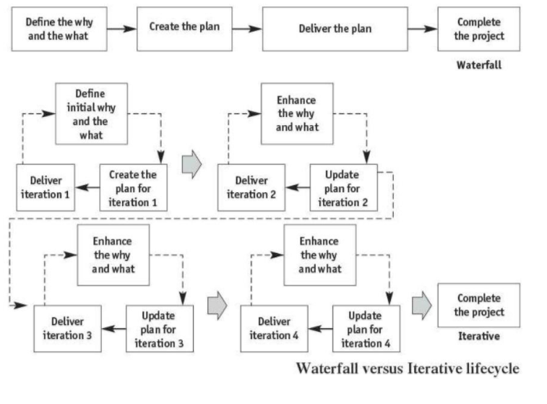
Fig 4. Newton’s simple project lifecycle [27].
A requirments analysis will be produced from based on the requirement of the patient which will be fully indentified and those of the industrial partner. The questionaire will be produced from the viewpoint of the patient and caregiveer.

There are many relevant organisations which should be consulted further, to deliver a device that will be valuable to the target audience. Initially, the author has joined the Parkinson’s research group, to investigate the current studies that are currently on-going.

Project Management
As with any software development venture, with foreplanning it will help deliver a project on-time. In this section firstly, the risks that are likely to be encountered throughout the time-span must be managed efficiently. It includes managing relevant legislation and ensuring the project is moral. Secondly, there should be a breakdown of all the resources required for each stage, which assists keeping a project on track.

Risks
Newton [27] provides the following four elements that are considered during a project:
- Scope
- Quality
- Time to Compete
- Cost
If the scope is not adequate it can have a direct impact on the quality of the finished product, for example, the security features could be inadequate. Furthermore, if the proposed project is untenable due to the author's technical knowledge; it could leave the program having sections that are incomplete [27]. Uncompleted projects are still prevalent, hence ascertaining the scope is of utmost importance [28].
As with all projects, there are pressures with the amount of time available. Thus, all work done on the major project must be balanced with other commitments, these include allocating time to complete the necessary work required for the units in Year 3. Moreover, as this will run concurrently extra time set aside for any issues that could arise.
Legal Considerations
The storage of records pertaining to personal information regarding one’s health is data that should be treated as confidential [29]. It was identified that there are laws, ensuring that data can only be accessed by those healthcare professionals involved with the patients care. There are two laws in place that are directly related to this, the Data Protection Act (1998) and the Human Rights Act of (1998) [29]. To which end no patient’s records will be used, instead, realistic records will be created to simulate patient’s data.
Ethical Issues
Background research revealed the dangers of medication mismanagement. Varshney [1] reveals there are two user groups at high-risk, these include those taking opioids for pain management, and those mental health problems. Therefore, this situation will be avoided as the system will not be trialled on any patients.

Physical Resources
This section outlines the possible resources required and their application for the planning, development, and analyses phases of the project.
Planning
Resource Name or Type | Application
Mindview | To create mind maps to provide a clear overview of all stages of major projects.
Microsoft PowerPoint | For storyboarding the user interface.
Microsoft Word | To develop the client's requirements for example with use case diagrams and tests plans for unit testing.
Microsoft Visio | To create Class and Sequence diagrams.
Medical literature | Parkinson’s disease medication information.

Table 1. Resources needed for the planning phase
Development
Resource Name or Type | Application
Books and online resources | They will relate to the project and are going to be used for reference and developing existing skills.
Academic Journals | A notable source is from the IEEE explore and access is currently provided by the university.
Apple Mac computer | To use IDE XCode to build the application.
An Arduino Microcontroller | An LCD Display module, buzzer, and an LED light display will be trialled as part of the development.

Table 2. Resources required during the development of this project

Analyses
Resource Name or Type | Application
Staff and students | To complete surveys using the program to perform usability testing.

Table 3. Resources needed to complete the analyses.
In summary, the software and hardware that come at the highest cost have already been met. Thus, comparatively speaking, the funds required for the Arduino components are relatively small. However, it was noted that an ‘Educational Bursary’ through the university is available should the cost be burdensome for this, or any additional books [30].

Timeline
In this section, the proposed timeframe is created in Microsoft Project in XCode. Issues about the management of one's time were identified in the risk section of this report. Weaver [31] advises starting early as if unexpected problems are encountered adjustments can be made to the schedule enabling a project to finished on time. To this effect, the project will start in July 2018 where skills development and project planning will commence. The Gantt chart screenshots are provided in figures 5 – 8.
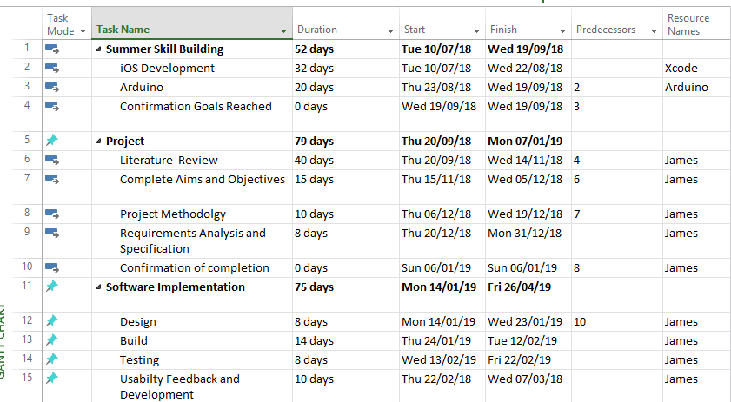
Fig 5. Full project Task list.
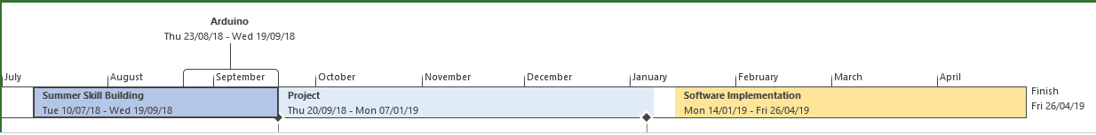
Fig 6. Full timeline overview.
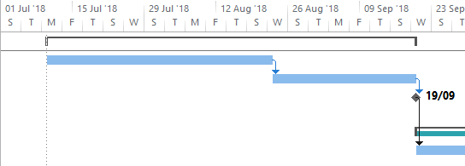
Fig 6. Preparation time for work over the summer break.
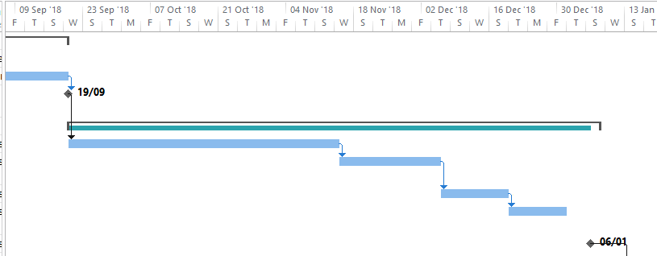
Requirements analysis
Methodology
Aims and Objectives
Literature Review
Fig 7. Project work Gantt chart for semester 1.
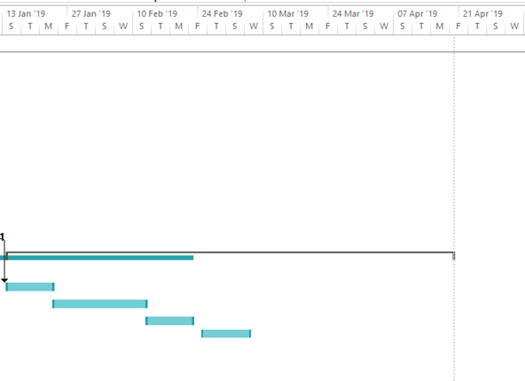
User feedback
Test
Build
Design

Fig 8. Development work Gantt Chart Semester 2.

Reference List
[1] U. Varshney, “A smart approach to medication management,” Computer (Long. Beach. Calif)., vol. 46, no. 1, pp. 71–76, Jan. 2013.
[2] D. Rosner, A. T. Jurba, A. Dumitrof, and S. Vasile, “PillBuzz -Medication enforcement architecture for assisted living,” in 2014 RoEduNet Conference 13th Edition: Networking in Education and Research Joint Event RENAM 8th Conference, 2014, pp. 1–6.
[3] A. V. Dhukaram and C. Baber, “Elderly Cardiac Patients’ Medication Management: Patient Day-to-Day Needs and Review of Medication Management System,” in 2013 IEEE International Conference on Healthcare Informatics, 2013, pp. 107–114.
[4] NICE, “What is Parkinson’s Disease?,” 2017. [Online]. Available: https://www.nice.org.uk/guidance/ng71/ifp/chapter/What-is-Parkinsons-disease. [Accessed: 10-Apr-2018].
[5] NICE, “What medicines might help?,” 2017. [Online]. Available: https://www.nice.org.uk/guidance/ng71/ifp/chapter/What-medicines-might-help. [Accessed: 10-Apr-2018].
[6] “Dementia.” [Online]. Available: https://www.parkinsons.org.uk/information-and-support/dementia?gclid=EAIaIQobChMIt8ynroq32gIVCp3tCh0M8gUOEAAYAiAAEgIoyPD_BwE. [Accessed: 11-Apr-2018].
[7] A. Imteaj and M. K. Hossain, “A smartphone based application to improve the health care system of Bangladesh,” in 2016 International Conference on Medical Engineering, Health Informatics and Technology (MediTec), 2016, pp. 1–6.
[8] Mondol, Emi, and Stankovic, “MedRem: an interactive medication reminder and tracking system on wrist devices,” in 2016 IEEE Wireless Health (WH), 2016, pp. 1–8.
[9] A. Batrakov, P. Merida, N. Bartels, E. Chabot, P. Burbank, and Y. Sun, “Medication reminding activity analyzer for guided independent living environments (MRAAGILE): Implementing Motion Dependent Medication Reminders,” in 2014 40th Annual Northeast Bioengineering Conference (NEBEC), 2014, pp. 1–2.
[10] Y. S. Lee, J. Tullio, N. Narasimhan, P. Kaushik, J. R. Engelsma, and S. Basapur, “Investigating the potential of in-home devices for improving medication adherence,” in Proceedings of the 3d International ICST Conference on Pervasive Computing Technologies for Healthcare, 2009.
[11] “Google Play,” 2018. [Online]. Available: https://play.google.com/store?hl=en. [Accessed: 06-Apr-2018].
[12] “Apple App Sotre,” 2018. [Online]. Available: https://www.appstore.com/. [Accessed: 06-Apr-2018].
[13] M. N. A. Mohammed, A. H. M. Ahmed, and T. M. Salih, “Designing low cost digital dose reminder system,” in 2013 INTERNATIONAL CONFERENCE ON COMPUTING, ELECTRICAL AND ELECTRONIC ENGINEERING (ICCEEE), 2013, pp. 357–362.
[14] R. Baranyi, S. Rainer, S. Schlossarek, N. Lederer, and T. Grechenig, “Visual Health Reminder: A Reminder for Medication Intake and Measuring Blood Pressure to Support Elderly People,” in 2016 IEEE International Conference on Healthcare Informatics (ICHI), 2016, pp. 432–438.
[15] N. Singh and U. Varshney, “Patterns of effective medication adherence: The role of wireless interventions,” in 2014 Wireless Telecommunications Symposium, 2014, pp. 1–10.
[16] F. Q. B. da Silva and A. C. C. França, “Towards understanding the underlying structure of motivational factors for software engineers to guide the definition of motivational programs,” J. Syst. Softw., vol. 85, no. 2, pp. 216–226, Feb. 2012.
[17] NHS, “Living with Parkinson’s disease.” [Online]. Available: https://www.nhs.uk/conditions/parkinsons-disease/living-with/. [Accessed: 10-Apr-2018].
[18] Y.-W. Bai, Chun-Cheng Chan, and Chia-Hao Yu, “Design and implementation of a user interface of a smartphone for the Parkinson’s disease patients,” in 2015 IEEE International Conference on Consumer Electronics (ICCE), 2015, pp. 257–258.
[19] “Prime Minister’s Challenge on Dementia 2020 Implementation Plan,” 2016.
[20] Y.-W. Bai and T.-H. Kuo, “Medication adherence by using a hybrid automatic reminder machine,” in 2016 IEEE International Conference on Consumer Electronics (ICCE), 2016, pp. 573–574.
[21] M. Ramljak, “Smart home medication reminder system,” in 2017 25th International Conference on Software, Telecommunications and Computer Networks (SoftCOM), 2017, pp. 1–5.
[22] S. Ronglong, C. Sookplang, C. Arpnikanondt, and V. Vanijja, “Design of a medication reminder and feedback system for Thai elders,” in 2012 International Conference on Computer and Information Science, ICCIS 2012 - A Conference of World Engineering, Science and Technology Congress, ESTCON 2012 - Conference Proceedings, 2012, vol. 1, pp. 44–49.
[23] D. McLaughlin, Brentt; Pollice Gary; West, Head First Object-Oriented Analysis & Design. O’Reilly, 2006.
[24] T. Dyba and T. Dingsoyr, “What Do We Know about Agile Software Development?,” IEEE Softw., vol. 26, no. 5, pp. 6–9, Sep. 2009.
[25] G. Fournier, Essential Software Testing A Use-Case Approach, 1st ed. CPC Press, 2008.
[26] W. Trochim, “Deduction & Induction,” Social Research Methods, 2006. [Online]. Available: https://socialresearchmethods.net/kb/dedind.php. [Accessed: 12-Apr-2018].
[27] R. Newton, Project Management Step by Step: How to Plan and Manage a Highly Successful Project. Pearson Education M.U.A., 2016.
[28] M. S. Dobson and T. Leemann, Creative project management: innovative project options to solve problems on time and under budget. McGraw-Hill USA, 2010.
[29] NHS, “Your health and care records,” 2016. [Online]. Available: https://www.nhs.uk/NHSEngland/thenhs/records/healthrecords/Pages/overview.aspx.
[30] UWTSD, “Scholarships and Bursaries 2018/19,” 2018. [Online]. Available: http://www.uwtsd.ac.uk/bursaries/other-general/. [Accessed: 08-Apr-2018].
[31] P. L. Weaver, Success in Your Project: a guide to student system development projects. Financial Times/ Prentice Hall - M.U.A, 2004.

Bibliography
B. Greetham, How to Write Your Undergraduate Dissertation, 2nd ed. Palgrave, 2014.
D. Verwer, “iOS Dev Weekly,” 2018. [Online]. Available: https://iosdevweekly.com/. [Accessed: 07-Apr-2018].
S. Krug, Don’t make me think, revisited: a common sense approach to web usability. Berkeley : New Riders, 2014.
“Examples of BSc Project Proposals,” Univer. [Online]. Available: https://www2.le.ac.uk/departments/informatics/undergraduate/experience/bscprojects. [Accessed: 07-Apr-2018].

Appendix

A – The Research Proposal mind map.
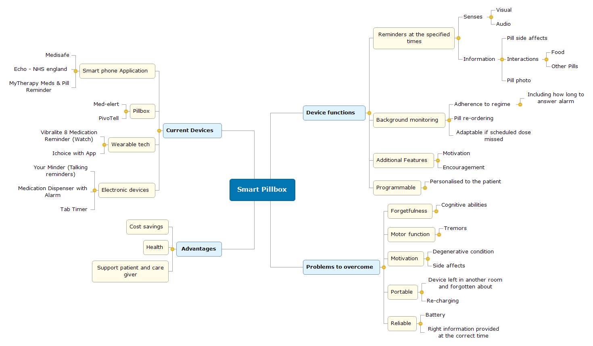

B – Current Products
As previously mentioned there are an array of different apps available for download. The app Echo is one of those which is in accordance with NHS England and will reorder the medication at the correct time to be delivered by post. Another example is MyTherapy which prompts users for different information for example blood pressure checks aiming to provide health professionals with an overview as to an individual’s health.
The electronic pillbox available will be loaded up with the correct medication in the various compartments and dispense these at the specified time. There are also those with just an alarm and a container for the pills.
There are several wearable devices, such as the Viralite 8, which is a digital watch, and the iChoice, which is an electronic strap that interacts with an application. It was noted that there is an abundance of electronic devices on the market, including those that are like alarm clocks, that value usability with large colour coded buttons and those that offer voice reminders.
From this summary, there are many devices and elements which could be used to improve the ‘Smart Pillbox’ and Application. They vary widely in price, the more complex options such as the pillboxes and devices linked with smartphones being the more expensive. Although some devices have similar functionality to an alarm clock, many have been designed for the target group. Finally, the majority of apps on the market are free to download and would require further analyses to assist with planning this device. To conclude, the end device should be as cost effective and user-friendly as possible to match or improve upon current devices.

