Report Case Study: The City Hotel

Student Name: Bianca Beatrice Matal
Student ID: 2244785
Module title and code: Financial Management for the Hotel Industry BMIH5007
Lecturer’s Name: Kathryn Roberts
Word count: 2078 Words

I acknowledge the use of Grammarly (https://www.grammarly.com) on 12 November 2024 to check my whole work.
I confirm that I have not presented any AI generated text as my own work. I confirm I have copies of my draft, notes, and other resources I used before, and after the use of AI tools which Imay be asked to provide in evidence.
EXECUTIVE SUMMARY
The overall study has measured the profitability, liquidity, and solvency ratios for the City Hotel to understand its financial health and performance in the competitive market. The measurement shows its continuous and drastic reduction in the overall revenue and profitability which hamper its operations and business management. The key reasons for the decline in profitability of the city hotel has been identified including labour shortage, inflation rate, poor investment in technology, economic uncertainty, and changing market dynamics. These have been hampering the profitability and revenue of the company which require comprehensive turnaround strategy for mitigation that as suggested in the study.

Table of Contents
1. Introduction 4
2. Discussion 4
2.1 Trends and Patterns in the Hotel’s Financial Performance 4
2.1.1 Revenue 4
2.1.2 Expenses 5
2.1.3 Profitability Ratios 5
2.1.4 Liquidity Ratios 7
2.1.5 Solvency Ratios 9
2.2 Primary Factors Contributing to Profitability Decline in light of Recent Events and the Current Economic Climate 11
2.3 Recommendation for improving the Financial Health of the Hotel 13
4. Conclusion 15
5. References 16
6. Appendix: Ratio Analysis 20

1. Introduction
The City Hotel is associated with various restaurants, bars, and event facilities located in the urban landscape. The report is going to describe the measures of the financial performance concerning the economic fluctuation and the market tendency for operating the business within the context of The City Hotel to understand the reason for declining in profitability. Evaluation of the economic shift and the dynamic situation of the business is the underlying reason for the business shift. The development of a comprehensive turnaround strategy will be considered in the study to revitalize the financial health and performance of the hotel along with re-storage of its reputation.

2. Discussion

2.1 Trends and Patterns in the Hotel’s Financial Performance

2.1.1 Revenue
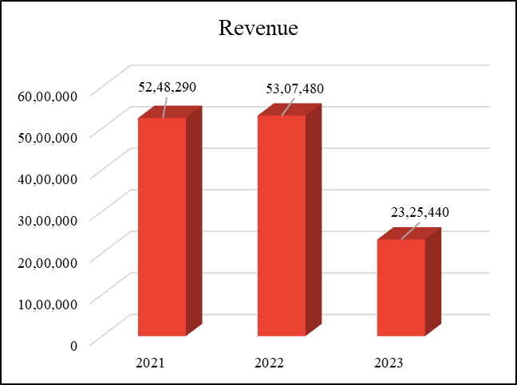
Figure 1: Revenue of the City Hotel
(Source: Self-Developed)
The above figure showcases the financial performance of the City Hotel using the revenue analysis of the past three years. It has been identified that the company’s revenue has been reduced from $52,48,290 in 2021 to $23,25,440 in 2023 [Refer to Figure 1]. As stated by Cindiyasari (2022, p.1889), a drop in the revenue stream of the company affects the cash flow, profitability, and the ability to invest in growth initiatives. Here, the City Hotel has faced a drastic drop in the financial stability of the business.

2.1.2 Expenses
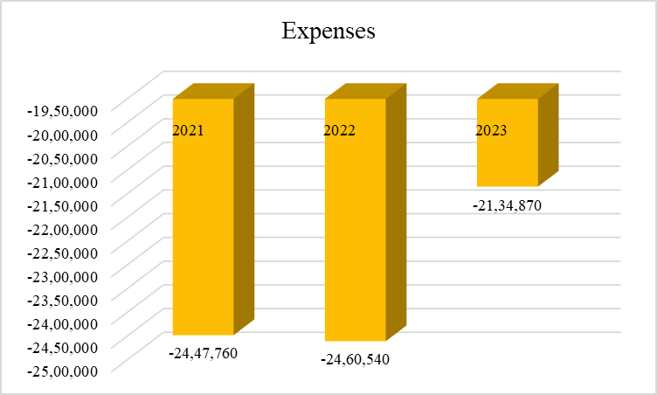
Figure 2: Expenses of the City Hotel
(Source: Self-Developed)
According to Park (2020, p. 2), the decline in expenses improves the overall business efficiency and health of the company. The above figure shows the drastic drop in expenses cost of the company from -24,47,760 GBP in 2021 to -21,34,870 GBP in 2023.

2.1.3 Profitability Ratios
Operating Profit Margin
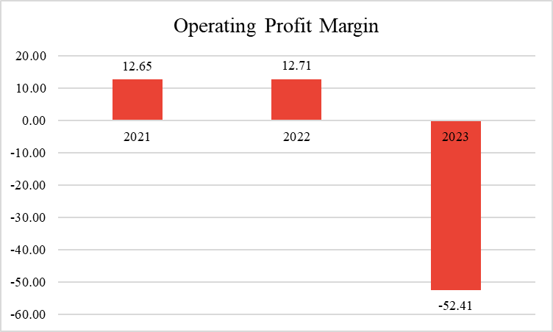
Figure 3: Operating Profit Margin of the City Hotel
(Source: Self-Developed)
According to the statement of Budianto (2023, p.2), operating profit margin is the phenomenon used to measure the profit generated by the company from its operation. Here, the City Hotel has drastically reduced its operating profit margin from 12.65% in 2021 to -52.41% in 2023 [Refer to Figure 3]. A reduction in the operating profit margin of the business creates inefficiency in the growth rate. High inflation rates and interests in the hospitality industry might be the reason for the reduction in the overall profit margin of the company (Meita, 2023, p.564).
Net Profit Margin
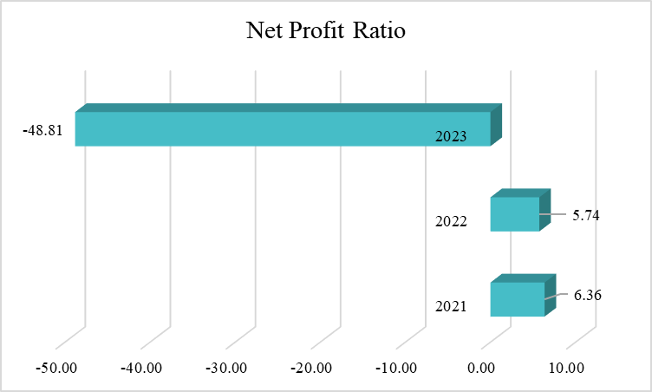
Figure 4: Net Profit Margin of the City Hotel
(Source: Self-Developed)
A decline in the net profit ratio of the company leads to financial distress, inefficient management, and poor cost management that affects the overall operations and revenues (Dirman, 2020, p.17). The above figure shows the major decline in the net profit ratio of the company from 6.36% in 2021 to -48.81% in 2023 [Refer to Figure 4]. Economic uncertainty can be the reason for the drastic reduction in the overall net profit margin of the company which affects its operations and financial performance.

2.1.4 Liquidity Ratios
Current Asset Ratio
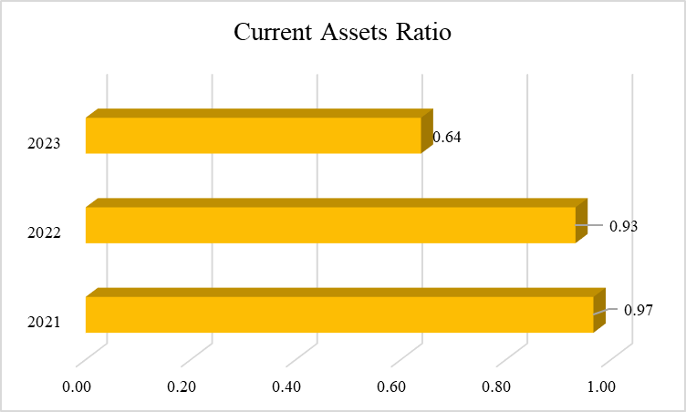
Figure 5: Current Asset of the City Hotel
(Source: Self-Developed)
A decline in current assets causes a drastic decrease in the working capital of the business and leads to potential losses (Hussain et al. 2022, p.4). In the above figure, the current assets ratio of the City Hotel has decreased from 0.97 in 2021 to 0.64 in 2023 which hampered the financial health of the company [Refer to Figure 5]. Focus on understanding and managing the changes in financial stability including assets and liabilities can be crucial to maintain the healthy cash flow of the city hotel.
Quick Ratio
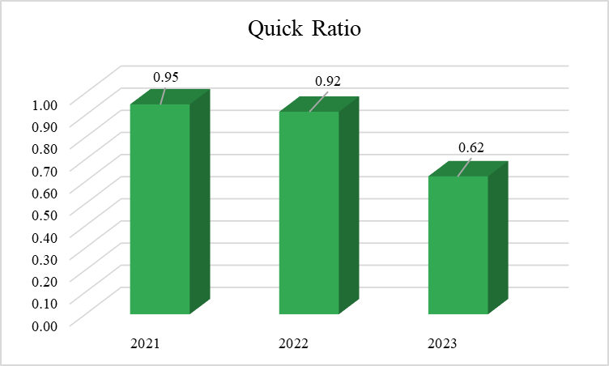
Figure 6: Quick Ratio of the City Hotel
(Source: Self-Developed)
As stated by Derestiyani (2023, p.99), the quick ratio is the particular analytical measures of the performance of the business that is engaged for judging the payoff capability of the business through its current debts. Here, the tendency of the company to pay off its debt has been reduced from 0.95 in 2021 to 0.62 in 2023 which increases the cash to pay its creditors [Refer to Figure 6]. High debt and decreased sales might be the major reasons for the reduction in the quick ratio of the company in the competitive market.

2.1.5 Solvency Ratios
Debt-to-Equity Ratio
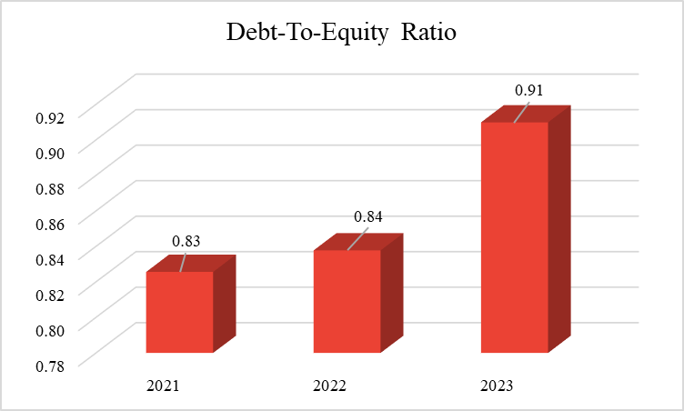
Figure 7: Debt-to-Equity Ratio of the City Hotel
(Source: Self-Developed)
Saputri (2024, p.699) stated that the debt-to-equity ratio depicts the company’s debt compared to its assets or equity. Here, the debt-to-equity of the company has increased from 0.83 in 2021 to 0.91 in 2023 which creates financial risks and hampers business profitability [Refer to Figure 7]. Paying down loans and improving inventory management might be the major reasons for the reduction in the debt-to-equity ratio of the company.
Debt-to-Assets Ratio
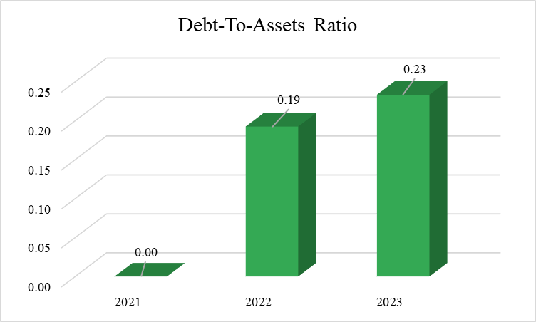
Figure 8: Debt-to-Assets Ratio of the City Hotel
(Source: Self-Developed)
Chairunisa et al. (2023, p.555) stated that the phenomenon of the debt-to-asset ratio involves the measurement of the company’s debt compared to the total assets. The debt-to-asset ratio of the company has also increased from 0.00 in 2021 to 0.19 in 2022 to 0.23 in 2023 which creates the risk of investing in the company compared to another [Refer to figure 8].

2.2 Primary Factors Contributing to Profitability Decline in light of Recent Events and the Current Economic Climate
The decline in the profitability of the company has been attributed to different reasons including changes in the market dynamics has been the major reason. The preferences of consumers have also been changing in the business environment of the hospitality sector due to remote work options and extended stays (Bondarenko et al. 2020, p.1133). In the ratio analysis, it has been evaluated that the revenue of the company has drastically declined from 52,48,290 GBP in 2021 to 23,25,440 in 2023 might be due to poor operational management and changes in customer preferences [Refer to Figure 1]. Intense competition in the global market has been hampering the profitability of the City Hotel.
An increase in competition leads to rising costs of operations and erodes the profit margins of the company as inflation has been particularly affecting the hospitality sector. According to the statement of Hang et al. (2020, p.2282), inflation has been the major reason affecting the revenues and profitability of hotels and restaurants in the global market. Labor shortage might be the reason for the decline in net profitability of the company and the inflation rate is also the reason hampering the business profits and revenue streams which is reduced from 6.36% in 2021 to -48.81% in 2023 [Refer to Figure 4]. Moreover, the labour shortage has also been considered the major reason for the decline in the profitability of the hotel industry leading to increased labour costs and reduction in service quality.
The decline in business profit of the City Hotel takes place due to increasing operational costs in the hospitality sector worldwide. After the pandemic, jobs in the travel and tourism sector have still been below pre-pandemic levels at the end of 2023 at a projected 320 million jobs (Hospitalityinsights, 2024). Thus, it has been identified that changing market dynamics, rising costs, inflation, and labour shortage are the major reasons behind the lower profitability of the hospitality sector.
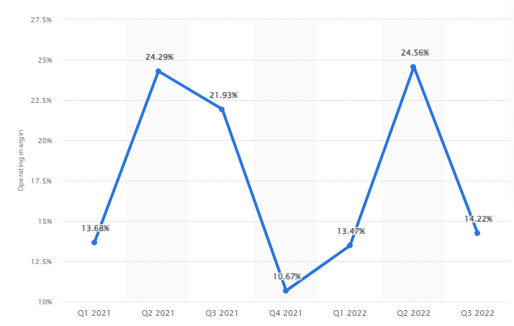
Figure 9: Operating profit margin of the hotel sector
(Source: Statista, 2024)
The above figure shows the decline in the overall profit margin of operation within the hotel and tourism industry. The operating profit margin of the industry has decreased from 22.56% in quarter 2 of 2022 to 14.22% in quarter 3 of 2022 (Statista, 2024). Economic uncertainty such as rising interest rates and reduction in disposable income are other main reasons for the reduction in profitability of the City Hotel. For example, Marriott Hotel has also been facing the challenge of economic uncertainty due to the high inflation rate and taxes in the competitive marketplace (Marriott, 2024). New regulations regarding environmental sustainability and health and safety are creating major barriers to the growth opportunities for the city hotel. International organisations and agreements, Codex Alimentarius Commission create the standard to protect consumers and ensure fair practices in the sales of food within the hotel industry. Around 1% of the global carbon emission has been generated by the hotel sector which leads to the responsibility of managing its impact (Sustainable Hospitality Alliance, 2024). Hotel companies have been facing major challenges in establishing and investing in technology to meet the needs and expectations of customers and reduce operating costs. Thus, the major reasons for the reduction in profitability of the City Hotel are the high inflation rate, labour shortage, changing market dynamics, intense competition, economic uncertainty, regulations, and poor ability to invest in technology.

2.3 Recommendation for improving the Financial Health of the Hotel
Definition: A comprehensive turnaround strategy is a phenomenon that involves planning to help a company that has been facing a struggle to manage its financial stability and performance. As stated by Nyagiloh (2020, p.13), a turnaround strategy involves modification of the operational measures of the business to reverse the performance decline and focus on the profitability of the business. It involves cost-cutting, asset liquidation, and revamping business abilities.
Operational Efficiency: The City Hotel can focus on considering the thorough view of operational costs for the identification of areas for improvements. According to Gomes (2021, p.978), focusing on equilibrium theory helps the business to manage the financial health and performance of the organisation by improving the operational processes. Negotiating with suppliers for better rates and streamlining business services can be helpful to improve operational efficiency. For example, Britannia Hotels in the UK offers superb value accommodation to streamline its business operations to generate better revenue (Britanniahotels, 2024). The company can assess staffing levels and cross-train employees to address the challenge of labour shortage and improve the net profit margin of the hotel. It can be helpful for employees to improve flexibility and enhance employee engagement to reduce turnover rates.
Revenue Generation: The company can consider the implementation of a dynamic pricing model to improve rates of services based on demand, seasonality, and local events. For example, Easy Hotel has been effectively focusing on the strategy of adjusting room rates based on demand, market trends, and benefits to maximise revenue (Easy Hotel, 2024). Moreover, investment in a property management system for the optimisation of bookings, inventories, and revenue management can be helpful for the company to enhance customer experience and reduce operational costs effectively. Revamp the website of the hotel to improve the user experience and encourage direct bookings.
Marketing and Branding: The city hotel can consider effective social media marketing to reflect the modern, inviting atmosphere among consumers. It can be beneficial for the hotel to differentiate itself from competitors through a focus on unique aspects. For example, Premier Inn has been effectively investing in social media platforms to raise its consumer engagement by providing easy-to-use ability and convenience (Premier Inn, 2024). Implementation of targeted marketing strategies such as social media, email campaigns, and partnerships can help the business to reach specific customers. The establishment of robust channels for guests can be effective in addressing concerns for the improvement in service quality of the company and increasing customer engagement.
Financial Management: Implementation of strict cash flow monitoring practices using blockchain technology can be effective for the company to ensure meeting operational expenses and obligations effectively. It can be beneficial for the company to explore short-term financing options to improve the financial health of the company. According to Abdou et al. (2020, p.9624), effective investment in sustainable practices helps companies reduce their costs in the long term and potentially qualify for tax incentives. The promotion of sustainability practices in the business environment of the City Hotel can reduce waste and mitigate regulatory compliance effectively.
Monitoring and Adjustment: The City Hotel can establish key performance metrics in the business environment to regularly measure its financial performance in the competitive market and identify areas for improvement.

4. Conclusion
The above discussion effectively concluded the trends and patterns observed in the financial statement and balance sheet of the City Hotel. There has been a drastic drop in the overall financial stability and profitability of the company in the competitive market. The operating profit and net profit margin along with revenue has been drastically dropped from 2021 to 2023. The major and key reasons for the decline in profitability of the City Hotel have been identified including labour shortage, high inflation rate, changing market dynamics, intense competition, poor investment in technology, and economic uncertainty. Focus on operational efficiency, revenue generation, marketing, and financial management can be the comprehensive turnaround strategy suggested to the company.

5. References
Abdou, A.H., Hassan, T.H. and El Dief, M.M. (2020) ‘A description of green hotel practices and their role in achieving sustainable development.’ Sustainability, 12(22), p.9624. Available at: https://doi.org/10.3390/su12229624
Bondarenko, S., Robul, Y., Dyshkantiuk, O., Mohylova, A., Salamatina, S. and Komarnitskyi, I. (2020) ‘The dynamic model of customer focus management in the hotel business based on markov chains.’ International Journal of Scientific & Technology Research, 9(3), pp.1132-1139. Available at: https://www.academia.edu/download/78203250/The-Dynamic-Model-Of-Customer-Focus-Management-In-The-Hotel-Business-Based-On-Markov-Chains.pdf (Accessed: 26 October 2024)
Britanniahotels (2024) ‘Our Latest Offers’ Available at: https://www.britanniahotels.com/ (Accessed: 28 October 2024)
Budianto, E.W.H. and Dewi, N.D.T. (2023) ‘Research Mapping the Operating Profit Margin (OPM) Ratio in Sharia and Conventional Banking: VOS viewer Bibliometric Study and Library Research.’ Available at: https://www.researchgate.net/profile/Eka-Wahyu-Hestya-Budianto/publication/375596243_Research_Mapping_the_Operating_Profit_Margin_OPM_Ratio_in_Sharia_and_Conventional_Banking_VOSviewer_Bibliometric_and_Library_Research/links/65518e02b1398a779d7f4a70/Research-Mapping-the-Operating-Profit-Margin-OPM-Ratio-in-Sharia-and-Conventional-Banking-VOSviewer-Bibliometric-and-Library-Research.pdf (Accessed: 23 October 2024)
Chairunisa, S.S., Digdowiseiso, K. and Karyatun, S. (2023) ‘The Effect of Total Assets Turnover, Debt to Assets Ratio, Cash Ratio and Current Ratio on Financial Performance of Companies The Hotel, Restaurant and Tourism Subsector in IDX for The Period 2016-2020.’ Journal Syntax Admiration, 4(3), pp.548-558. Available at: https://jurnalsyntaxadmiration.com/index.php/jurnal/article/view/907 (Accessed: 30 October 2024)
Cindiyasari, S.A., Junarsin, E. and Septiani, E. (2022) ‘Does Intellectual Capital Affect Financial Performance?’ An Empirical Evidence from Financial Companies in Indonesia. Available at: https://ieomsociety.org/proceedings/2022malaysia/322.pdf (Accessed: 20 October 2024)
Derestiyani, A. and Susetyo, D.P. (2023) ‘The Effect of Quick Ratio and Return on Equity on Tobin's Q.’ Jurnal Ekonomi, Manajemen dan Akuntansi, 1(2), pp.99-110. Available at: https://orcid.org/0000-0001-8874-268X
Dirman, A. (2020) ‘Financial distress: the impacts of profitability, liquidity, leverage, firm size, and free cash flow.’ International Journal of Business, Economics and Law, 22(1), pp.17-25. Available at: https://www.ijbel.com/wp-content/uploads/2020/08/IJBEL22_205.pdf (Accessed: 17 October 2024)
Easy Hotel (2024) ‘Easy Hotel’ Available at: https://www.easyhotel.com/ (Accessed: 29 October 2024)
Gomes, J.F. and Schmid, L. (2021) ‘Equilibrium asset pricing with leverage and default.’ The Journal of Finance, 76(2), pp.977-1018. Available at: https://doi.org/10.1111/jofi.12987
Hang, T.T.B., Nhung, D.T.H., Huy, D.T.N., Hung, N.M. and Pham, M.D. (2020) ‘Where Beta is going–case of Viet Nam hotel, airlines and tourism company groups after the low inflation period.’ Entrepreneurship and Sustainability Issues, 7(3), p.2282. Available at: https://doi.org/10.9770/jesi.2020.7.3(55)
Hospitalityinsights (2024) ‘Hospitality industry statistics to have on your radar 2024’ Available at: https://hospitalityinsights.ehl.edu/hospitality-industry-statistics. (Accessed: 25 October 2024)
Hussain, S., Hoque, M.E., Susanto, P., Watto, W.A., Haque, S. and Mishra, P. (2022) ‘The quality of fair revaluation of fixed assets and additional calculations aimed at facilitating prospective investors’ decisions.’ Sustainability, 14(16), p.10334. Available at: https://doi.org/10.3390/su141610334
Marriott (2024) ‘Annual Report’ Available at: https://marriott.gcs-web.com/static-files/b82978a6-9d28-4e38-9855-fc4ae2cebe11 (Accessed: 23 October 2024)
Meita, I. and Nurdiniah, D. (2023) ‘The Effect Of Changes In Corporate Income Tax Rates, Inflation And Interest Rates On Income Tax Revenues.’ Jurnal Pajak dan Keuangan Negara (PKN), 4(2), pp.563-570. Available at: https://jurnal.pknstan.ac.id/index.php/pkn/article/view/2033 (Accessed: 23 October 2024)
Nyagiloh, K.A. and Kilika, J.M. (2020) ‘Theoretical review of turnaround strategy and its organizational outcomes.’ Available at SSRN 3514730. Available at: https://dx.doi.org/10.2139/ssrn.3514730
Park, S., Woo, M. and Nicolau, J.L. (2020) ‘Determinant factors of tourist expenses.’ Journal of Travel Research, 59(2), pp.267-280. Available at: https://journals.sagepub.com/doi/abs/10.1177/0047287519829257 (Accessed: 19 October 2024)
Premier Inn (2024) ‘About Us’ Available at: https://www.premierinn.com/gb/en/business.html (Accessed: 20 October 2024)
Saputri, A.F. and Naryono, E. (2024) ‘The effect of debt to equity ratio and current ratio on return on equity: Case study at PT. Duta Pertiwi Tbk, on the Indonesia Stock Exchange for the 2016-2023 Period.’ Jurnal Ekonomi, Manajemen Dan Akuntansi, 2(04), pp.699-710. Available at: https://orcid.org/0000-0002-7024-3062
Statista (2024) ‘Operating profit margin of the hotel and tourism industry worldwide from 1st quarter 2021 to 3rd quarter 2022’ Available at: https://www.statista.com/statistics/1346659/hotel-tourism-industry-operating-profit-margin-worldwide/ (Accessed: 18 October 2024)
Sustainable Hospitality Alliance (2024) ‘Hotel Carbon Measurement Initiative (HCMI)’ Available at: https://sustainablehospitalityalliance.org/our-work/climate-action/#:~:text=The%20hanet. (Accessed: 19 October 2024)

6. Appendix: Ratio Analysis
Profitability Ratios
 | 2021 | 2022 | 2023
Operating Profit Margin
Operating Profit | 6,64,160 | 6,74,730 | -12,18,850
Sales | 52,48,290 | 53,07,480 | 23,25,440
Operating Profit/Sales*100 | 12.65 | 12.71 | -52.41
Net Profit Ratio
Net Profit | 3,33,930 | 3,04,650 | -11,34,950
Sales Revenue | 52,48,290 | 53,07,480 | 23,25,440
Net Profit/Sales Revenue*100 | 6.36 | 5.74 | -48.81
Liquidity Ratios
 | 2021 | 2022 | 2023
Current Assets Ratio
Current Asset | 18,91,970 | 19,65,340 | 12,85,880
Current Liabilities | 19,57,360 | 21,07,750 | 20,14,600
Current Assets/Current Liabilities | 0.97 | 0.93 | 0.64
Quick Ratio
Current Assets-Inventories | 18,56,740 | 19,28,990 | 12,56,410
Current Liabilities | 19,57,360 | 21,07,750 | 20,14,600
Current Assets-Inventories/Current Liabilities | 0.95 | 0.92 | 0.62
Solvency Ratio
 | 2021 | 2022 | 2023
Debt-To-Equity Ratio
Total Liabilities | 1,06,84,940 | 1,33,38,050 | 1,42,43,390
Total Shareholder's Equity | 1,29,41,110 | 1,59,21,080 | 1,56,53,970
Total Liabilities/Total Shareholder's Equity | 0.83 | 0.84 | 0.91
Debt-to-Assets Ratio
Total Debt | 0 | 30,66,780 | 36,54,480
Total Assets | 1,29,41,110 | 1,59,21,080 | 1,56,53,970
Total Debt/Total Assets | 0 | 0.19 | 0.23

