
Enterprise & Innvation group project Report
LEVEL 5

March 16, 2020
uwtsd
SWANSEA CAMPUS

Table of Contents Page

Introduction 2

Main Body

2.0 Development 3
- Homepage 3
- Fig 1
- Service/product landing page 3
- Fig 2 4
- Login/Log off 4
- Fig 3 4
- Website security 4

Marketing Plan 5
- Product/service benefits 5
- Target Market 5
- Fig 5
- Product 6
- Price 6
- Promotion 6
- Place 6
- Fig 6

Financial Plan 7
- Financial Management 7
- Funding 7

Management and Operations 8
- Teamwork and collaboration 8
- Group skill requirements 8
- Requirements for Business Premises ? 8
- Continuous team collaboration 8

Conclusion 8

References 9

Appendix (A-E) 10-17

1 :Introduction

Swansea Freshers Connect (SFC) is a student Tech Start-up Partnership, with registered business interest domiciled in Swansea City. It is in the process of developing an app/responsive e-commerce website for utilisation by Swansea Tertiary Students to access services/products from Swansea business community, with services/products tailor made to suit tertiary students` needs. The development of the prototype product is a culmination of business planning that included environmental analysis, marketing, financial planning and effective communication. The aim of the partnership is to attain a quota of expected deliverables. As part of the build up phase, consultation and attendance of tech start-up events was done, as aide in the progression of achieving set goals and objectives. The Partnership forecast a project profit after deployment of the App. An adherence to set goals and objectives from the planning stage of the project will be utilised in detection and prevention of any possible challenges that may arise and may be detrimental to the success of the Project. In any modern business undertaking success is underpinned on the use of effective communication skills. Business challenges are easier solved through teamworking and utilisation of diversified skills within a team.

2 : Tasks
2.0 : Development-The prototype development is a work in progress, project alterations and changes to the initial requirements being constantly done and assessed against the projected time of project completion. The groups` skills set and competency in the manipulation of coding languages to develop the product has been a challenge. A prototype is a built test or processor concept and is a thing to be replicated or learned from[13]. The product development goes through phases, the SFC initial onset business plan and product concept evolved within the screening phase, as a skills and depth of resources assessment entailed narrowing and streaming the idea towards Specific, Measurable, Achievable Realistic and Time (SMART) goals and objectives[14]. The progression on product/website development was pursued using the SMART framework.

2.1Home Page -The homepage was designed to enhance user experience, allowing the user navigation experience through the App. Each new browse at the home page critiques the interface and establishing an opinion of your business to determine authenticity and value [5] A well-designed user interface provides credibility of the service to SFC would be clientele. The navigation pane is designed to be intuitive and coherent to meet the user needs. Contact information has been pasted clear on the homepage with phone number, mailing address and email and clearly stated help hours. Testimonials and service ratings backed with awards and certification if you have any it would be ideal to slot them on the homepage as a way of authenticating and validating your capabilities[5] Any future certification and awards that are related to SFC business will be displayed on the homepage.

Fig 1
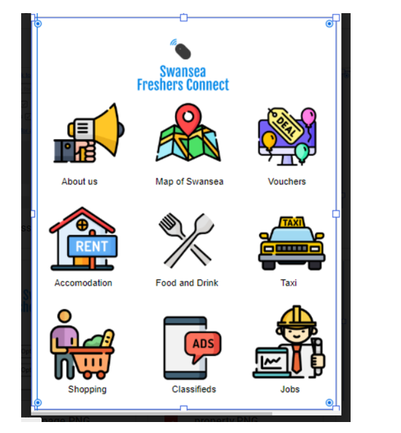
Prototype homepage for SFC

2.2Service/Product Landing Page -The SFC landing page allows and caters for new client’s registrations and existing customer login portal. This is a validation part of the website that ensures that only those registered with the service get access to the offered product range. The customers benefit, as the cache cookies from previous logs can be used to establish and offer customer product preferences based on historical purchases or data [7]. Freedom is what the customers need and on the login page they get access to tools that allows them to set personalised preferences.

Fig 2

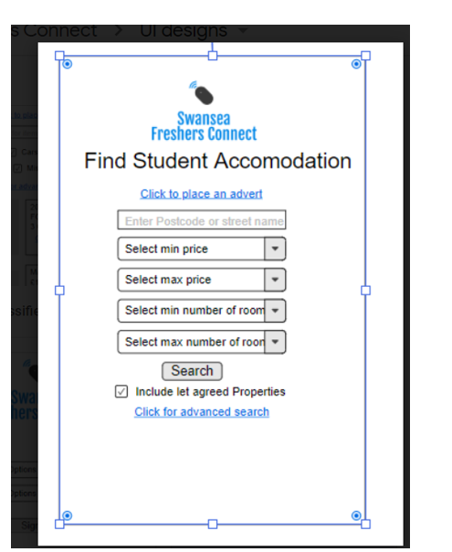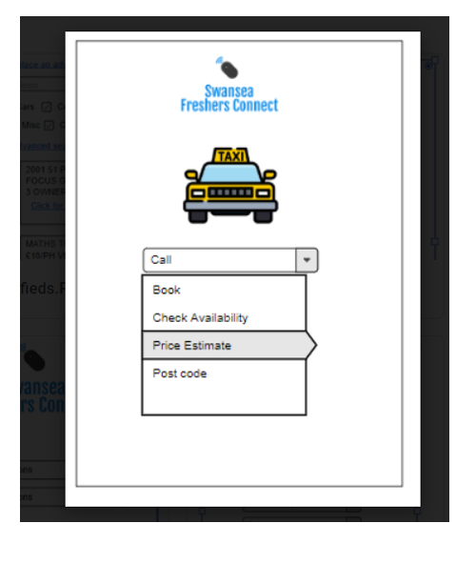

2.3 Log on/off -Security.-The continuous rise in cybercrime required SFC to be vigilant in the protection of customer data and ensure the hardening of the website security .The site allows users to log on/off if they are registered and signed up for the service with SFC. New customer registrations are approved through a 2-factor authentication system as an identity verification process. The backend login HMTL code used in form design uses POST as security measure because POST request is not bookmarked or cached[6]. SFC has designed their forms and data policy to comply with GDPR (General data protection regulation)requirements.
.
Fig 3
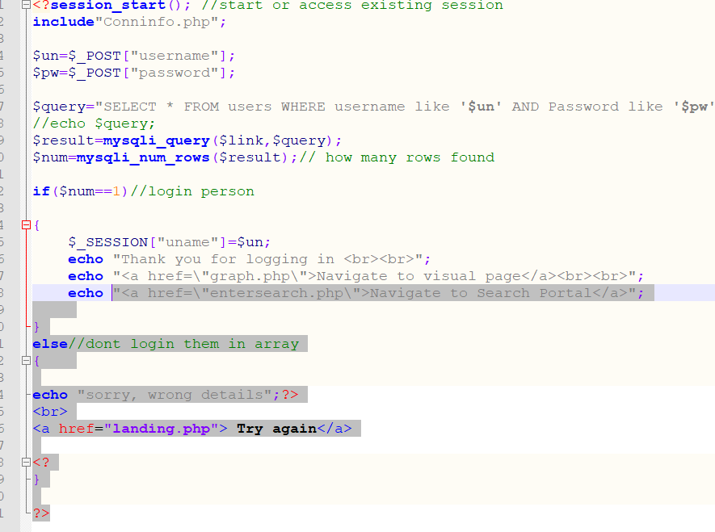

Code extract for user to input their password that allows existing users to log on

2.1:Marketing Plan

Marketing is a process where business entities accomplish business objectives through identification of customers’ needs and wants that they can satisfy profitably[8]. A general audit of the Swansea City business opportunities and the precise identification of students unsatisfied needs and wants was undertaken by SFC to pave way for the prototyping of an effective e-commerce website/App that can be utilised by the Swansea business community to efficiently distribute and place their product on the market.

App Benefits:
- Provision of a 24/7 online Sales opportunity, as normal shopping hours are defined. Time is set dependent on business.
- Efficiency in storage as business owners can leverage through adopting just in time storage method, reducing the storage and holding cost.
- Realtime feedback and update, business owners can benefit from real time product or service rating on the website.
- Reduced cost on advertisement and promotion of the Swansea business community products and services
- Reduction in the cost of labour as the website will reduce the need for Salespeople in the business store.
- Guaranteed instant access to the student market

Target market – The target market for the Website is primarily Swansea City Business community. A target market is referred to as a group of customers that a business aims to sell its products and services to[2] the e-commerce website will avail a platform for business to advertise the service and products to students. The secondary target market for the website are the tertiary students of Swansea as the website will avail an on-line shopping platform for goods/services tailor made to suit them. The SFC partnership segmented the market through a process of establishing a Geographic location and specific demographic consideration were done.

Fig 5



The Diagram depicts some of the parameters used in market segmenting used by SFC to establish their target market.[2]

Marketing Mix

The Marketing mix is the use of controllable variables such as price, product, promotion and place in pursuance of sought level of sales in a target market[12]. SFC as a partnership has done a market research of the tertiary student market. A marketing mix was devised by SFC that is projected to satisfy the needs and wants of the primary and secondary target market at a profit

Product/Service-The product on offer from SFC is an app/responsive e-commerce website that shall be used to host a trading platform of goods and services tailor made to suit the needs and wants of Swansea City tertiary education students

Price- Dependent on the time period the business intends to place their advert and utilise the platform, with peak periods being the semester time and off-peak being the students Semester breaks. Competitor analysis of advertising on billboards in Swansea had prices ranging from £170-£625 and newspapers ranging £25-£80[3]. The ideal market entry price for business placement of their advert on Fresher connect platform would be £5.50p Off-peak and £10.0p per day on the peak periods

Promotion – Publicity of the app will be done using different Swansea publications such as local tabloids and business magazines detailing the benefits of the app to the business community . Advertising-of the app will be done on student’s communication boards such as MyDay and sharing the link of the app on popular social interactive platforms such as Facebook and WhatsApp

Place- Dependent on the funding secured, GoDaddy web hosting platform will be used by SFC. They have varied plan packages designed to suit different needs, the basic plan costing £3.99 per month and comes with 1 website, free office 365 email, free domain and 100GB storage. SFC have settled for the Ultimate package that cost £14.99 per month if a full year`s subscription is paid the cost will be £8.99 per month. The Ultimate plan supports Deluxe features, 2* processing power and memory, a years free SSL certificate, Free premium DNS and unlimited databases[15]

Fig 6



Swansea Freshers Connect logo N.B may be subject to change.

.

2.2 :Financial Plan

Financial planning is critical in defining the budget of a project undertaking. The budget is an estimated costing that considers the projected cost of executing a business undertaking[1]. SFC did a research of the expected fixed and variable cost to determine a workflow budget and as such a bottom up approach was used in determining the project cost.

Financial software Management- SFC will use excel spreadsheet in the management of their finances to keep track of any receipts and outgoings. The size and turnover of the company shall not warrant the services of an Accountant but will utilise the services of a bookkeeper doing end of year financial returns to HM Revenue and Customs. The hired bookkeeper will do SFC Balance sheet, Profit and loss account to ensure the business adheres to business financial ethics.

Funding- this shall be drawn from personal savings and once viability has been assessed and need for a full rollout becomes necessary crowd funding will be the first option and bank loan application as a back-up plan. As partnership the cost associated with all the business tasks were compiled to determine the cost and the expected revenue from projected sales. In determining the cost, the following were considered administration and legal expenses and expected cash flow from the market. A cash flow statement was used in the first instance in the management and analysis of the finances.[See Appendix C ]

2.3 :Management & Operations

Teamwork and Collaboration- SFC teamwork and collaboration was sustained through various methods that were based on ethos of integrity, selfless commitment and respect of team members. Clear SMART goals and objectives were fundamental in the planning and organisation of the required resources for project achievement. Effective communication done through regular scheduled meetings at UWTSD campus and Skype video conferencing, with purposes of undertaking peer to peer allocated task sanity checks, brainstorming on the best strategies on achieving set goals and objectives. Partners were allocated roles and task based on the areas of strength and ability with the team utilising the Gantt Chart in determination and setting of time completion on specific assigned task. [See Appendix B]

Group Skills Requirement – besides the interpersonal skills, the group had a need of an array of technical skills and these included web design, software engineering and security fundamental in development of the front and back end of the e-commerce website. Communication (oral and written )as skill is a requirement in team collaboration. Listening as skill is critical in the evaluation of team member`s opinions. Continuous professional development as a skill is vital as technology is dynamic, with benefits of keeping at pace with new and current standards[12].Self-motivation as skill entails the ability to self-manage time, goals and objectives all are a necessity in their contribution towards team effort. As a group in areas of skill shortages expert help was sought through attendance of PASS class and research.

Requirement for Business Premises?- Until and when the project has been deemed a success and the need arises to hire employees the business will be run and operated from home as rentals are overhead expenses that can be avoided, with the main requirements being a host server for the Website
.
Continuous team collaboration- The operations of the Partnership shall bound the legal requirements of the UK Laws and these would include Data protection, tax declarations, business responsibilities and reliabilities. Communication through meeting to assess performance and sustainability of the services provision will be a requirement[12]. The need for business continuity will be dependent on the Website return on investment, as the partnership can only sustain to incur loses in the short term and that being a year.

CONCLUSION

The success of launching a tech start-up is an exciting intricate process, as it requires a diversified pool of skills. The skills range is not limited to but includes management skills, technical skill, projection skills and financial management. Perfection of product/service is/will remain an ongoing process as changes and adjustments are done based on the trading standards, customer feedback, competitor analysis and dynamics of technology. They available tools and software available such as Gannt chart that can make difference with easing the tasks of group project management.

References

[1] | L. N, How Companies Manage R & D, London: Institute of cost and Management Accounts, 1984.
[2] | visual flagler, 5 April 2017. [Online]. Available: https://volusiaflagler.score.org/blog/steps-identifying-your-target-market. [Accessed 14 March 2020].
[3] | Billboard Advertising , [Online]. Available: http://www.billboardadvertising.org.uk. [Accessed 10 March 2020].
[4] | Investopedia, [Online]. Available: http://www.investopedia.com. [Accessed 11 March 2020].
[5] | Impact, 2017. [Online]. Available: https://www.impactbnd.com/blog/11-crucial-elements-every-homepage-should-have. [Accessed 10 March 2020].
[6] | w3schools.com, [Online]. Available: https://www.w3schools.com. [Accessed 23 02 2020].
[7] | Kibo, [Online]. Available: http://www.kibocommerce.com/blog/account creation.. [Accessed 12 March 2020].
[8] | Teamwork, October 2016. [Online]. Available: http://www.teamwork.com/project management-software. [Accessed 10 March 2020].
[9] | MindTools, [Online]. Available: https://www.mindtools.com/pages/article/newSTR_94.htm. [Accessed 10 March 2020].
[10] | Cyngor Abertawe, 20 March 2018. [Online]. Available: https://www.swansea.gov.uk/businessfactsandfigures. [Accessed 11 March 2020].
[11] | Primal space, 2016. [Online]. Available: www.primalspace.co.uk/client-requirements-website-design. [Accessed 10 March 2020].
[12] | Promo Media, [Online]. Available: https://www.promo-media.co.uk. [Accessed 08 March 2020].
[13] | JC MetalWorks, 13 October 2016. [Online]. Available: https://www.jcmetalworks.co.uk/knowhow/the-importance-of-prototyping. [Accessed 8 March 2020].
[14] | "www.professionalacademy.com /blogs-and -advice/what-are-smart-goals," Professional Academy , [Online]. Available: www.professionalacademy.com /blogs-and -advice/what-are-smart-goals. [Accessed 8 March 2020].
[15] | GoDaddy, [Online]. Available: https://uk.godaddy.com. [Accessed 12 March 2020].

APPENDIX

Appendix A:

REFLECTION

I have learned and have worked on perfecting my technical and employability skills through improvement in my communication, through interaction with peers from other programmes in gaining insight and understanding in areas of skills deficiency. In general planning and time management was improved using project management tools such as Gantt chart to monitor progression and adherence to set targets.

NETWORKING

Networking is an important element as in our daily discharge of duties we are interdependent in progression and success, in the chosen field or profession. During the semester I attended a talk by Shaun Varney on Visual fx and Virtual production on the 26th February 2020. On the 22nd February 2020 I attended Swindon Computer fair hosted at the Village Hotel in Swindon Wiltshire England and on display were tech gadgets ranging from Laptops to micro spy cameras. It was an eye opener that show cased different tools and gadgets that can be used in undertaking the different task. On the 6th of February 2020 at 7pm -6pm I attended a RAF at 614 Sqn Royal Air Force Reserve Centre in Cardiff to get further understanding on the Reserve trades such as Cyber Security and the minimal service commitment.

TEAMWORKING

Primary success in achieving group projects lays in teamworking and division of labour in achieving a common goal and objective. I have learned to effectively use the social communication platform Teams and skype in holding team meeting and administering tasks that may need peer review. Through sharing Computer screen, I was able to do mutual correction and review of team documents. Conflicts of interest do arise within team and groups, I have learned of different conflict management and resolution techniques.

Appendix B: GANTT CHART
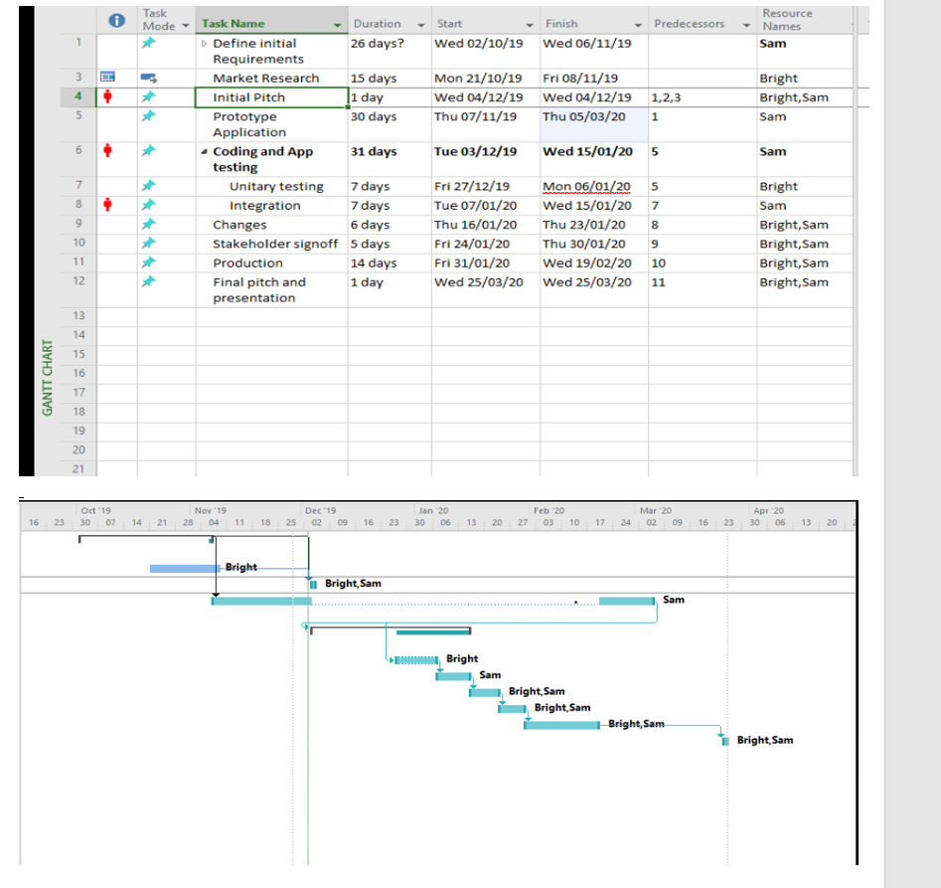

Appendix C: SFC Cash flow statement projection for per annum

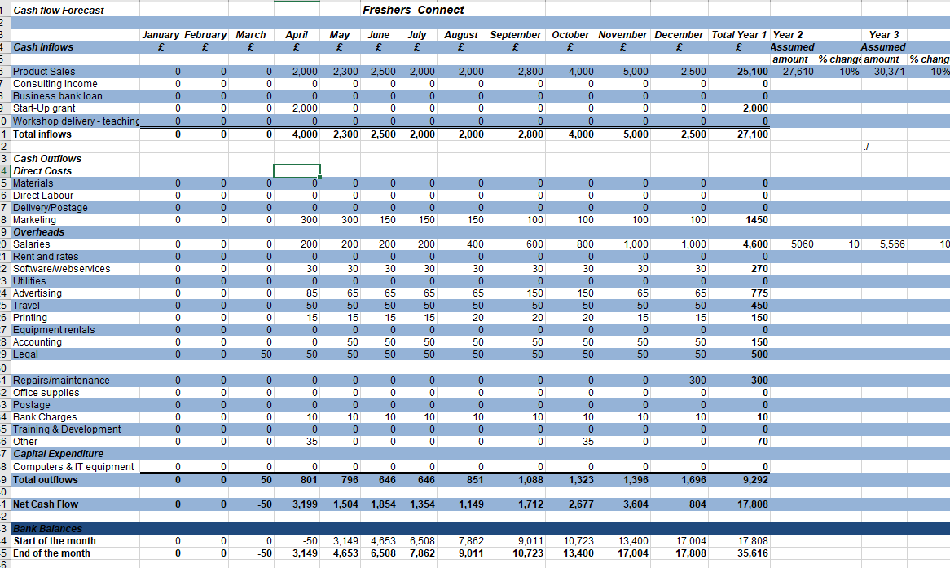

Appendix D: Code Extract

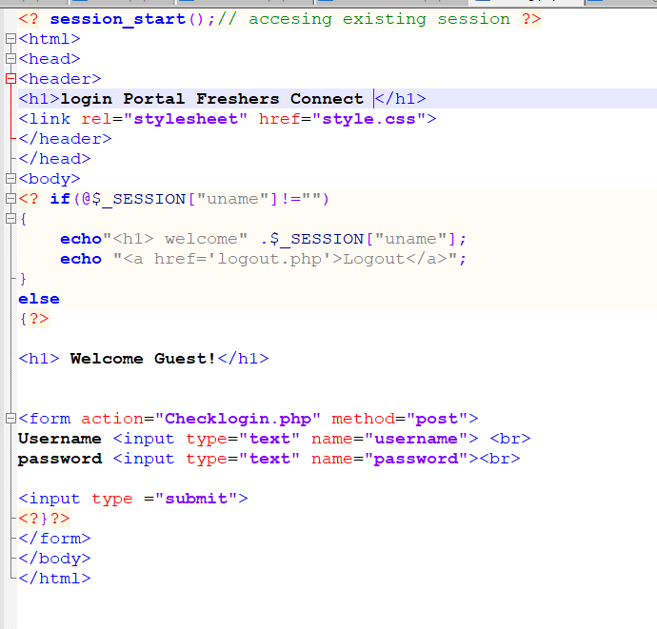

Appendix E
TEAM PROGRESS SHEET [SWANSEA FRESHERS CONNECT]
Team Member Names & Roles:
BN. Bright Nyakamha- Marketing and - Research
SW. Sam Wattis - Security and Development
Product Idea
To produce a mobile web application for Freshers students to help them navigate around Swansea city with point of interest, local services with the clientele being local businesses that benefit from selling their products to students. The platform can and may be used by businesses to promote offers and discounts
Initial Requirements
- Logo
- Sign up and login
- App analytics
- Navigation Menu
- Content material
- UI
- Native map
- Device hardware and access
- Roadmap
- Feasibility studies
Developer Tools
- PhoneGap
- Visual Studio
Mission Statement
To promote Swansea local business to tertiary students and foster attachment and responsibility in promoting business in the city of Swansea.
Values
- Integrity
- Confidentiality
- Availability
- Respect
- Informative
Objectives
- To create an app that serves as a gateway for students to local information about points of interest.
- To give business community an interactive platform to advertise their services and products
- To allow classified advertisement of student products and services
.Team Goals:
- Complete Initial Requirements For project.
- Identify the information needed for 1st year students.
- Restaurants and Pubs
- Taxi and commuting services
- Accommodation and spare room adverts Weekly Progress report 1:Date: 13/11/2019In-Attendance: BN - a preliminary report and feedback on the market and feasibility of the app
SW- An assessment of the app development and User interface
ER- An initial rough draft and insight on the UIDate : 20/11/2019
BN- team pest analysis, SW- team pest analysis, ER- Team pest analysis
PEST Analysis
Political and legal- GDPR, copyright, sale of goods act, Patent product design
Economic & Competition- Student services hub, group on, social media, Gumtree, Uber will be some of the competitors. The environmental challenges are the current cropping of distance learning services and apprenticeship schemes.
Social & Customer- Target market are the businesses that offer student products and services.
Technology- Android or Swift
Market Research background
The combined student population in Swansea is estimated at 24000
A new study shows that Welsh Universities has knock on impact on Welsh economy of over 5 Billion and support over 50000 jobs. https://www.swansea.ac.uk/press-office/news-archive/2018/theeconomicimpactofhighereducationinwalesuniversitieswalesreport.php

27/11/2019
A team discussion on the progress and set up of the team initial pitch presentation
In attendance
BN
Initial pitch discussion and allocation of individual team member tasks - will be responsible for market research & planning and production.
SW
Initial pitch discussion an allocation of individual team member task - will be responsible for business and teamwork and management
ER
Initial pitch discussion and allocation of individual team member tasks -Ideation
Wed 4 December
Initial Pitch presentation at Swansea IQ building 001
Bright N- {Presentation first part of the slides} & Sam- W { Presentation second part of the slides}
After team deliberation Ethan was removed from the group through mutual consent as a team conflict management move
Wed 11th December 2019
Bright Nyakamha- & Sam Wattis-
Prototyping and design - The team had discussion on the product and prototyping of the app. Decision on the group name and assessment of the pros and cons of partnership.
Wed 19th December 2019
Bright Nyakamha-
Sam Wattis -
Marketing and branding, group research on branding and marketing
Wed 22nd January 2020
Bright Nyakamha & Sam Wattis
Refinement and try and error on the different web/ app builders suitable to meet the goals and needs of creating an ecommerce responsive app. Experimentation with Django web builder
Wed 29th January 2020
Bright Nyakamha- {competitor analysis} & Sam Wattis- {Market research}
Market Analysis and Innovation the group discussed the best possible marketing strategies and techniques.
Wed 5th February 2020
Bright Nyakamha {colour scheme} & Sam Wattis {logo design}
Online Marketing and Branding
Brainstormed on the marketing techniques and logo design of the group .
Wed 12th February 2020
Bright Nyakamha- & Sam Wattis -
Cost analysis, there was a team assessment of the start-up financial requirements in undertaking the project.
Wed 19th February 2020
Bright Nyakamha & Sam Wattis
Monetization and E commerce discussed about the requirements of an e commerce responsive web page viz a viz creating an app
Wed 26 February 2020
Bright Nyakamha- Cash flow statement
Sam Wattis-Funding options
Financial management and funding of the group, rolling out a budget forecast for the group.
Wed 5th March 2020
Bright Nyakamha & Sam Wattis
Web design and coding, designing website using HTML and PHP landing page, login and product search.
Wed 11th March 2020
Bright Nyakamha & Sam Wattis- {Validation}
Website validation test and error debugging, strengthening of the security features of the e-commerce web page.

