

STRATEGIC MANAGEMENT AND SUSTAINABILITY
LCBB6015
Component 1

STRATEGIC ANALYSIS OF ROLLS-ROYCE IN THE UK AUTOMOTIVE INDUSTRY

Student Name: Gabriel Chirosca
Student ID: 2244324
Lecturer: Dr Nerys Dosseh
Submission Date: 20/03/2026
Word Count: 2080 words

Executive Summary
This report critically analyses the impropriety of the Strategic management in the organisation. Further, this also evaluates the importance of the automotive industry within the UK's overall GDP. In addition to this report, forced on Rolls-Royce Motor and analyses its internal and external factors by using the different frameworks. The PESTEL framework provides the external factor that influence the strategic decision of the organisation. Further, Porter’s Five Forces as well as the Value Chain Analysis and Resource-Based View model also provide the internal view of the organisation.

Table of Contents
1. Introduction 4
2. Strategy Analysis 5
2.1 External Environment Audit 5
2.2 Internal Environment Audit 9
2.3 SWOT Analysis 10
3. Strategy Formulation 10
4. Conclusion and Recommendations 11
References 12

1. Introduction
Strategic management is the key component of the organisation this help the company to operate within a highly competitive environment and further provides the strategic decision. Further, this also helps to analyse the organisation various factor, such as the internal factors as well as the external environment. Based on those condition Strategic management helps to make long-term decision-making and provide the sustainable growth opportunities. In the automation industry, strategic management is very much necessary; this helps in decision-making. Further the sector is undergoing rapid change and the integration of digital technology. The technological innovation, as well as the change in customer preference and environmental factors, is reshaping the overall sector. The organisation also must adopt the various strategic decision which help to provide the comparative advantage.
The UK automation industry plays a significant role in the country, which also helps to generate more than 782,000 jobs, and further, this also contributes more than £14.1 with in the country's GDP (statista.com, 2025). In addition to this, the EU’s car market is expected to showcase a 0.8 growth rate in the year 2024 and slide up to 10.6 million units (acea.auto, 2025). however, the industry is going through significant changes, such as technological advancement. Furthermore, the sector is also undergoing the adoption of the electric vehicle. In recent times, environmental awareness as well as carbon emission is one of the crucial company which is changing the customer preference. The need for electric vehicles leads to technological advancement and helps in sustainability practices.
Rolls-Royce Motor Cars is the globally recognised brand in the luxury automobile industry. The organisation is famous for its advanced engineering marvels as well as its strong brand heritage. The organisation is founded in the year of 1904 in the UK and is undergoing the continuous development process. The organisation has also set a clear vision, aim, and objective to fulfil the market change and ensure sustainable practices.
Vision: To create a highly advanced, autonomous, and luxury electric vehicle and ensure net-zero emissions.
Aim: The main aim of Rolls-Royce Motor Cars is "Inspiring Greatness" by making ultra-luxury cars and integrating with advanced technology (rolls-roycemotorcars.com, 2026).
Objectives
- To expand the various innovations within the electric vehicle sector and add artificial intelligence to the vehicle.
- Maintain the sustainability as well as the carbon emissions and follow the ethical manufacturing process.

2. Strategy Analysis

2.1 External Environment Audit
PESTLE Analysis
The external factor plays a critical role in the organisation's strategic decision-making, specifically within the automobile industry. The comprehensive PESTEL framework helps to find out the various macro-environmental factors that provide the various impact of Rolls-Royce Motor Cars. further this framework also evaluates the various environmental factors such as the Political (P), Economic (E), Social (S), Technological (T), Legal (L), as well as the Environmental (E).
Political Factors
Government policies such as the various treads regulation is play a direct impact on the automotive industry. The government of the UK is adopting various new initiatives to incentivise the electric vehicle; the country is also aiming to achieve the net zero goal by the year of 2030(smmt.co.uk, 2025). Further, the government also provides £650 million of grant funding (Department for Transport, 2025). In addition to this, the UK government also declared a massive £120 million investment for the adoption of electric vehicles. Further, it also offers £5,000 in grants for small vans as well as the larger vans (openaccessgovernment.org, 2025). This effective government policy is helping the organisation to invest in electric vehicles. The organisation is adopt the EV first policy and launched their first fully electric luxury vehicle, called “Spectre”. The political stability in various market such as Europe, the United States, and China supports the organisation's growth and expansion.
Economic Factors
Economic conditions are the key performance of the organisation's growth, which is directly linked with the customer purchasing power, as well as raising the demand for the luxury vehicle. In recent times, the global economy has been undergoing various uncertainties. Despite all these facts, the Luxury Cars industry is showcasing a strong growth rate. It is also anticipated that in the year 2026, the market size will reach US$26 bn. Moreover, it’s also shows that it will reach 246.9k vehicles in the year 2030. In addition to this, the luxury car sale is also booming in China, which has opened a massive gateway for Rolls-Royce Motor Cars (statista.com, 2026).
Social Factors
In recent time the customer preference has changed very much, now-a-days customer are preferring the electric vehicle over the traditional vehicle. In addition to this customer also prefer the advanced technology integrated vehicle as well as personalised car. The High-net-worth customers also prefer the EV and prefer the luxury product. In addition to this, Rolls-Royce have their brand value and provides personalised design, which also increases customer loyalty and brand value.
Technological Factors
Technological advancements are one of the key factors that shape the overall automotive industry. Various innovation process with the electric vehicle sector is also improved the car quality (oica.net, 2025). Further, the autonomous driving systems is creating a massive impact on the industry. On the other hand, digital connectivity as well as future technology, is changing customer preferences. In order to fulfil those customer demands, Rolls-Royce is strengthening its research and development unit and inventing various advanced engineering solutions.
Legal Factors
The strict regulation policy, as well as the hard emission standards and obstacles in the international trade laws, are hampering the overall automation industry (Jørgensen et al., 2025). This uncertainty of the legal framework is slowing down the manufacturing process and hampering the distribution units. On the other hand, the global safety compliance as well as the environmental factor require the various investment process along with the continuous investment, research, and innovation.
Environmental Factors
The global climate change issue, along with environmental concerns, is helping in the EV adoption process. Further, the concern about the environment is pushing the car manufacturers to follow sustainability and help to adopt sustainable mobility solutions. Furthermore, Rolls-Royce’s strategy also reduces carbon use and aim the net zero by the year of 2025(rolls-royce.com, 2026). Moreover, the organisation also focused on the lower-carbon technologies, as well as improvise there research and development field.
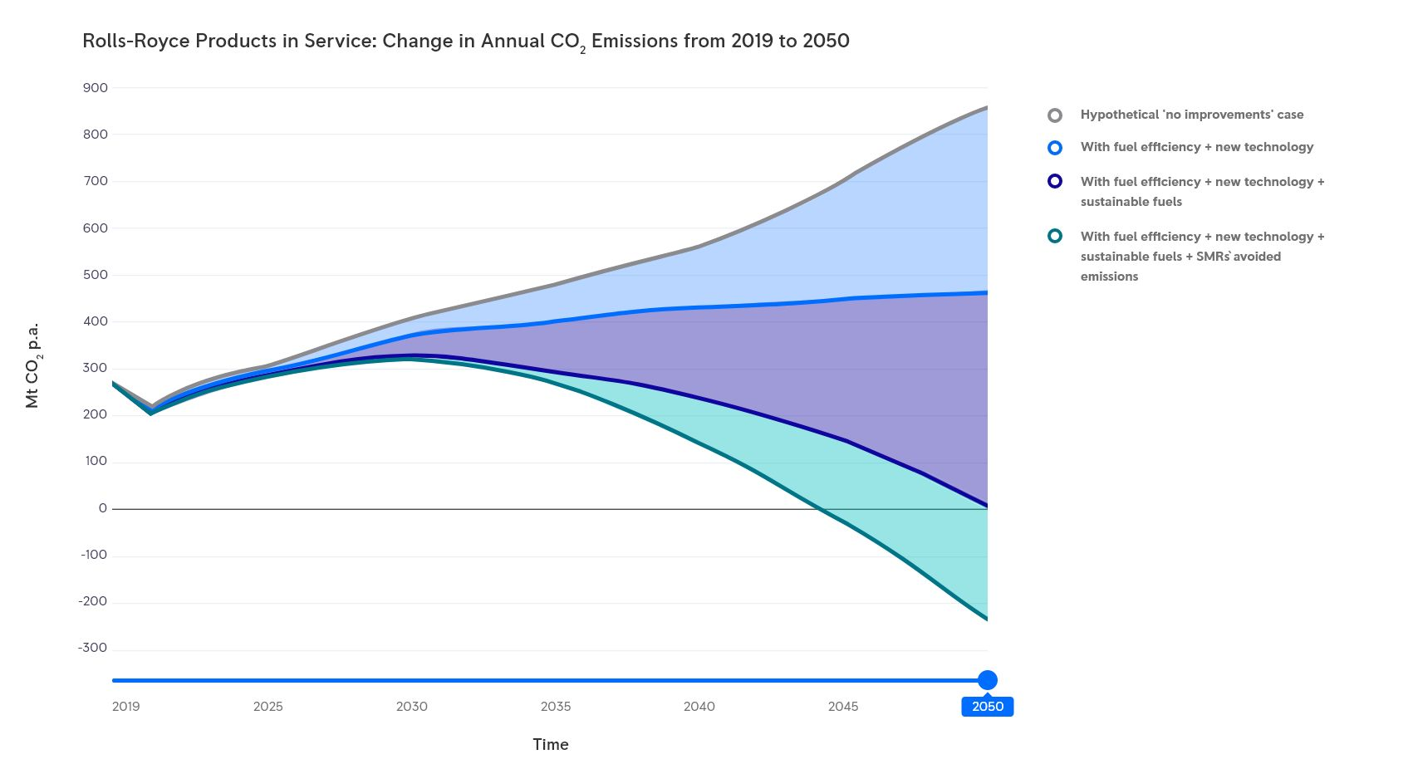
Figure1: Rolls-Royce reduces carbon
(source: rolls-royce.com, 2026)

Porter’s Five Forces
Porter’s Five Forces framework helps to identify the various business aspect this also helps to analyse the profitability of the organisation as well as the attractiveness and also finds out the market competition of organisation (Obu et al., 2022). This framework also interacts with the five key factor those are primary buyer power, supplier power, competitive rivalry, threat of substitutes, and the threat of new entrants. This comprehensive framework is helping to analyse the market risk as well as provide the various opportunities (Chinta et al., 2025).
Competitive Rivalry
The Competitive rivalry of the organisation is very moderate due to the high quality of the product as well as the strong brand reputation, innovation process, and exclusivity of the product. Despite those various other brands such as Bentley, Mercedes-Benz, Maybach, and Lamborghini, providing tough competition for the organisation.
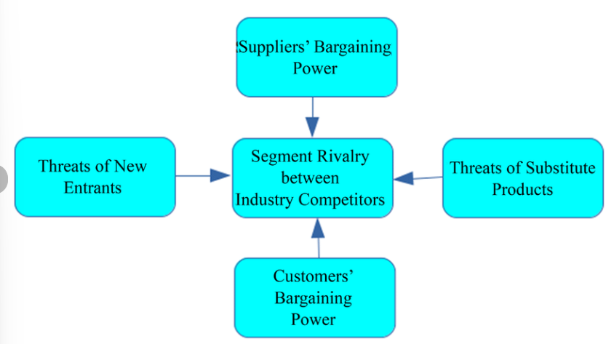
Figure 2: Porter’s Five Forces
(source: Rahman et al., 2019)
Threat of New Entrants
The organisation has already established a strong distribution network all over the world, and the Threat of New Entrants is very low. The ultra-luxury brands is requiring the strong brand reputation as well as engineering marvels and also have to build a global distribution network.
Threat of Substitutes
The threat of substitutes is very low because of the organisation's technical barrier and the engineering marvel. Further, it also monitors the high-quality regulatory certifications and does not share its technology. Various other luxury brands, such as Tesla, are somehow grabbing the customer, but the segment is completely different, which makes the organisation number one ultra luxury brand.
Supplier Power
Supplier power is moderate due to the high-quality material used by Rolls-Royce, and all components are very advanced. Furthermore, the organisation is led by the BMW group, which is known for their high quality supply chain facility.

Buyer Power
The buyer’s power is very low, because the organisation operate within a luxury segment and also targets the high value ultra rich category who prefer the luxury vehicle as well as the personalised option and comfort. The organisation also maintains the brand position in the luxury market and promotes the luxury.

2.2 Internal Environment Audit
Value Chain Analysis
The Value Chain Analysis framework is first introduced by Michael Porter in the 1980s (Bejleri et al., 2024). This comprehensive framework helps to break down the various factors, such as the internal operation as well as support the activities to find out the various process such as cost reduction, as well as process optimisation. The external factor of the organisation is helping to provide the high-quality product. Further, the design as well as the engineering marvel creates the unique market value. On the other hand, manufacturing is also an asset of the organisation. In addition to this, the organisation is following the strong prestige and brand value.
Resource-Based View model
The Resource-Based View helps to identify the internal factors of the organisation and helps to gain a comparative advantage. Rolls-Royce is mainstage the very strong brand quality in the field of the luxury automotive industry.
Luxury Brand Reputation
Rolls-Royce is very well known in the global luxury automobile sector, and this also came with the prestige as well as the personalised care. Further, customer loyalty also provides a comparative advantage.
Technology Capability
The organisation is focused on R&D very much and creates engineering marvels; furthermore, the organisation is under the BMW group, this is helping to provide high-performance and advanced luxury vehicles.
Skilled Workforce
Rolls-Royce has high-skilled designers, engineers, and craftsmen who help to produce high-quality vehicles.

Innovation Capacity
The organisation also focused on a continuous innovation process as well as new technology, research, and development. Furthermore, the organisation also focused on the advancement of the electric vehicle which helps to maintain the long-term sustainability and provides competitiveness and continuous growth opportunity.
VRIO
Value: Rolls-Royce is positioning itself within the ultra-luxury segment, and the organisation is strong in customer value and follows the premium pricing strategy.
Rarity: The organisation is making the hand-crafted vehicle, which also allows personalised rising and services, which helps to grab the attention of the customer.
Imitability: The competitor company is facing various issues in mimicking Rolls-Royce’s heritage as well as the brand legacy. In addition to this, the craftsmanship of the organisation is positioning the organisation in a very different segment.
Organisation: Rolls-Royce has the reach organisation culture and management, and BMW supports the strategic decision.

2.3 SWOT Analysis
Strengths: The organisation has strong brand value and expertise in craftsmanship, which are its major strengths.
Weaknesses: the cost of the raw material is increasing rapidly, and the organisation is produced very limited products, with the reduce the market expansion process.
Opportunities: In recent time there are the rapid demand for luxury vehicles, and the electric vehicle has also expanded rapidly.
Threats: There is various other organisation is providing better pricing and offer advanced technology, which attracts the customer base.

3. Strategy Formulation
Rolls-Royce must expand its market in the electric vehicle and has to maintain its sustainability practices. Furthermore, the organisation also must invest in the sustainable manufacturing process as well as the AI-based advanced technology (King et al., 2025).

4. Conclusion and Recommendations
The comprehensive analysis of Rolls-Royce shows that the organisation is operating in the automotive industry. Further, the industry is reshaped by the adoption of the electric vehicle as well as technological advancements. Customers are now demanding the sustainability produce and consider the suitability of the product. Further, the organisation has the strong brand reputation as well as engineering excellence make the organisation a market giant in the ultra-luxury automotive segment. Further, the organisation has to ensure the long-term growth as well as the technological advancement to attract the customer base.

References
acea.auto (2025). Economic and Market Report: Global and EU auto industry – Full year 2024. [online] ACEA - European Automobile Manufacturers’ Association. Available at: https://www.acea.auto/publication/economic-and-market-report-global-and-eu-auto-industry-full-year-2024/.
Bejleri, E., Kraja, E.B. and Memaj, G., 2024. Porter Framework vs A More Extended Framework. International Journal of Religion, 5(9), pp.115-24.
Chinta, R. and Chinta, R., 2025. Tesla-Porter Five Forces Analysis & Competitive Rivalry. Tesla-Porter Five Forces Analysis & Competitive Rivalry (September 24, 2025).
Department for Transport (2025). Electric Car Grant launched. [online] GOV.UK. Available at: https://www.gov.uk/government/speeches/electric-car-grant-launched.
Jørgensen, B.N. and Ma, Z.G., 2025. Impact of EU laws on the adoption of AI and IoT in advanced building energy management systems: a review of regulatory barriers, technological challenges, and economic opportunities. Buildings, 15(13), p.2160.
King, K.A. and Cnop, A., 2025. Transformation in the automotive sector: the management challenges of AI and the digital revolution. In Navigating the 21st Century Business World. LSE Press.
Obu, O.C., 2022. The determinants of the attractiveness of an industry: an extension of the porter’s five-forces framework. Available at SSRN 4218820.
oica.net (2025). Industry Topics - International Organization of Motor Vehicle Manufacturers. [online] International Organization of Motor Vehicle Manufacturers. Available at: https://oica.net/industry-topics/.
openaccessgovernment.org (2025). The UK Government support the transition towards electric vehicles. [online] Open Access Government. Available at: https://www.openaccessgovernment.org/the-uk-government-support-the-transition-towards-electric-vehicles/188999/.
Rahman, M.S., Jahan, B., Nipu, Md.A.-A., Nahar, S., Aktar, Mst.N., Islam, N., Hossain, M.M. and Arif, Md.F.H. (2019). An Analysis of Smart-Phone Industry in Bangladesh Using Porter’s Five Forces Model. OALib, 06(09), pp.1–5.
rolls-royce.com (2026). Decarbonising complex and critical systems. [online] www.rolls-royce.com. Available at: https://www.rolls-royce.com/sustainability/our-approach-to-decarbonisation/decarbonising-complex-critical-systems.aspx.
rolls-roycemotorcars.com (2026). The future in the making: Rolls‑Royce 103EX: Vision Next 100. [online]. Available at: https://www.rolls-roycemotorcars.com/en_US/inspiring-greatness/vision/103ex.html.
smmt.co.uk (2025). SMMT Automotive Sustainability Report 2025 - SMMT. [online] SMMT.Available at: https://www.smmt.co.uk/smmt-automotive-sustainability-report-2025/.
statista.com (2025). Topic: Automotive manufacturing industry in the United Kingdom. [online] Statista. Available at: https://www.statista.com/topics/5457/automotive-manufacturing-industry-in-the-uk/?srsltid=AfmBOoq7kK-w-RDklnkW2tWMq4RvQ7JEnJbLMfQ5IZIvizpN03annczO [Accessed 10 Mar. 2026].
statista.com (2026). Luxury Cars - Worldwide | Statista Market Forecast. [online] Statista.Available at: https://www.statista.com/outlook/mmo/passenger-cars/luxury-cars/worldwide?srsltid=AfmBOorYTJ4C2d4qxC-flPDJ_yuysqtHTeTDp1DTgBQ59_ljDCUGP5Kl [Accessed 10 Mar. 2026].

