Name | Student Number | Date | Lecturer’s Name | Your score
ANCUTA BATISTA | 2434846 | 25.06.2025 |  | To be filled by the marker  ___/40
You will have 75 minutes to complete this assessment. It is divided into three sections: note-taking, paraphrasing and writing a paragraph.
---------------------------------------------------------------------------------------------------------------------
1. Take diagrammatic notes from the passage below using the space provided:

It's difficult to know whether undergraduate study is right for you until you've experienced it first-hand. Many first-year students have second thoughts on their decision to go to university for a number of reasons. For example, you may have changed your mind about the career you'd like to pursue, and the course you're enrolled on is no longer suitable. Another common reason is that you're struggling to cope with the workload or aren't being challenged enough on the course; perhaps you don't respond well to the teaching and assessment methods or it's simply not what you expected. Thirdly, it might well be that the university you have chosen is too big or too small; you've stayed close to home and would like to move away or you moved further away and are feeling homesick. There might also be financial reasons. Maybe you cannot afford the tuition or accommodation fees, living costs are out of your budget or you're not comfortable with the idea of accumulating and dealing with student debt. Finally, let us not underestimate personal circumstances. You may have a disability or health issues that make university life difficult to cope with, you have a delicate family situation or you're finding it challenging to balance your studies with other commitments.
Adapted from: https://www.prospects.ac.uk/applying-for-university/changing-or-leaving-your-course

Space for your notes (max 12 marks):
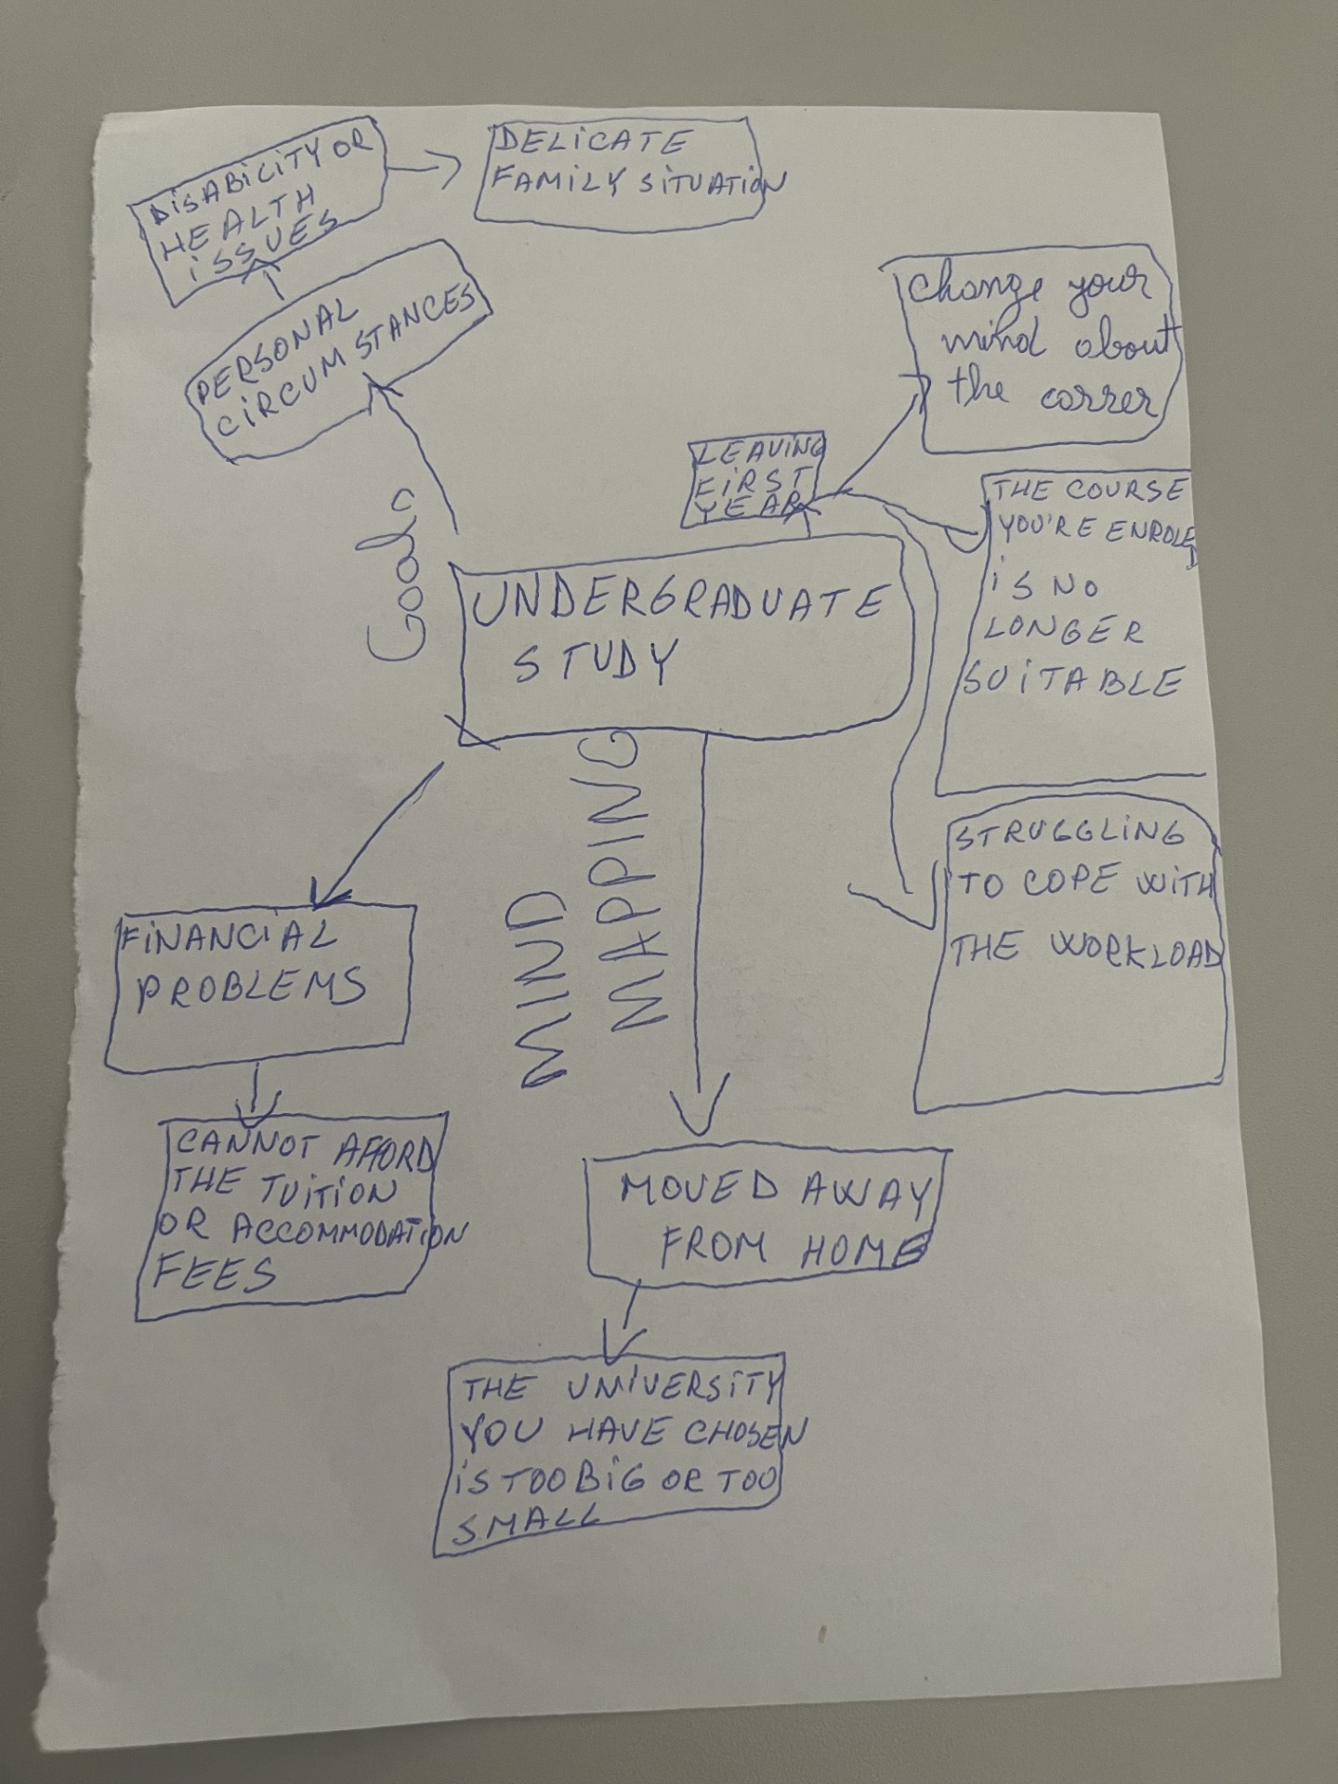

2. Paraphrase the following sentences (max 3 marks for each, max 12 marks in total):

- It's difficult to know whether university study is right for you until you've experienced it first-hand.

a) It might be difficult and challenging to know if attending university is right for you, until you’ve experienced it first-hand.
b) Developing good study habits is essential for academic success
b) For academic success is essential to develop a good study plan,note-taking,research,reading and writing.

c) When you feel overwhelmed with your studies, consider adopting strategies to manage stress more effectively

c)When I feel stressed about my studies, I consider that I have to relax, to boost my motivation and to focus.

d) Consistent reading practice can improve your writing skills.

d)Reading regularly helps developing writing skills.

3. Write a well-structured paragraph (8 sentences) on the following topic:

The challenges of studying at a UK university.

Your paragraph must be written in full sentences (no bullet points) and in an academic style.

(max 16 marks in total)

The challenges of studying at a UK university

Sometimes is challenging to start to be a new student in a UK university. In the first time you must think about the career that you want to succeed after you graduate. Another challenge for a student is the accommodation, the daily expenses and the student funding. To be a good student you must manage your commitments, to submit your assessments and to have accessibility to new challenges. For some people is more stressful to be a student, because they have children, a job and they find it harder than others.UK universities give to the students lots of opportunities, financial help, health and wellbeing help. To succeed like a student in a UK university you must be open to new challenges every day. If a student is present at his lessons and do his homework he will succeed like a student to a UK university.

