Integrated Working Environment
  - MSc Property and Facilities Management

  - Date:| Author: Robyn Edwards, P144993


Energy Efficiency Plan

Contents
2 Introduction 2
2.1 Energy 2
2.2 PDCA Cycle 2
3 Energy Management Plan 3
3.1 Organization 3
3.1.1 Management Commitment/Scenario 3
3.1.2 Energy Policy Development 3
3.2 Energy Assessment 5
3.2.1 Data Analysis 5
3.2.2 Future Performance 7
3.3 Energy Review 8
3.3.1 Consumption Per Source 8
3.3.2 Significant energy use (SEU) 8
3.3.3 Energy Performance Indicators (EnPIs) 8
3.3.4 Energy Baseline 9
3.4 Energy Efficiency Plan 10
3.4.1 Aims and Objectives 10
3.4.2 Action Plans 10
3.5 Energy efficiency plan further actions: 14
3.5.1 Implementation 14
3.5.2 Monitoring 14
3.5.3 Future Actions 14
4 Conclusion 15
5 References 16
6 Appendices 17
6.1 Appointment of energy manager and team sheet. 17
6.2 Gas 18
6.3 Electricity 20

Introduction

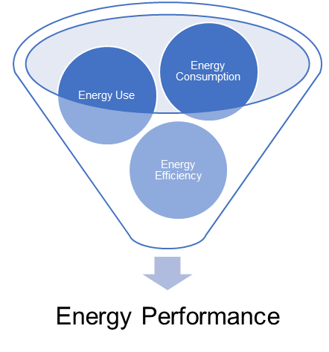
Energy
Energy is power which has been created from a resource. There are two main conditions of energy: how energy has been created; and how energy is being used. These two conditions generally define energy. Renewable energy is created from sources that are constantly providing energy from a continuous source. I.e. Solar and wind power. Non-Renewable energy is created from a limited resource. I.e. Fossil fuels and nuclear. How energy is being used is directly linked to energy performance. The better an organizations energy performance the more energy efficient the company. “Energy performance is a concept which is related to energy efficiency, energy use and energy consumption” (BSI, 2018).

PDCA Cycle
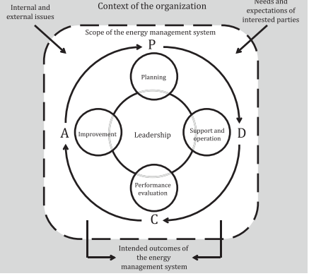
The British standards institute recommends that energy managers follow the PDCA cycle when creating an energy efficiency plan (BSI, 2018). The energy Management structure PDCA stands for Plan-DO-Check-Act. This structure provides a foundation for energy management framework within organizations. The “plan” stage is vital for the success of the framework, it is where the company takes responsibility, creates or reviews policies and appoints energy management representatives. These representatives will then complete an energy efficiency plan where they will interpret collected data, create aims and objectives and plan for future changes. The second stage “do” is the implementation of the plan created, whether this be training, awareness, communication and operational control. The third stage “check” is the monitorization, analysis, auditing, and corrective/preventative action. The final stage “act” is where the whole process is reviewed and presented to higher management where new strategic goals can be created for the cycle to restart and the optimization of the previous actions. This framework is continually improving. The PDCA framework is adapted throughout multiple businesses however the primary fundamentals of the framework still exist. This report will follow this framework.
Fig. 1: -PDCA Cycle

Energy Management Plan

Organization
The organization is a higher education facilitator, providing numerous undergraduate and postgraduate qualifications. The business campus itself is located on high street within Swansea and facilitates academic teaching, staff offices, student hospitality and learning resources. The University aims to achieve the 2030 and 2050 goals for carbon emission reduction. Which aims to bring all greenhouse gas emissions to net zero (Department for Business, Energy & Industrial Strategy and The Rt Hon Chris Skidmore MP, 2019).

Management Commitment/Scenario
The University Board has appointed the researcher as the energy manager at the UWTSD Swansea Business campus, With a targeted approach to the business school campus. They have communicated the importance of energy management towards the current employees and have appointed an energy team which will aid the energy management plan to act towards the aims and objectives set by the energy manager.

Energy Policy Development
The University have numerous policies and procedures in place to aid in them with the management of the facility. The policies that are most relevant to this research are as follows: Environment Policy; Sustainability strategy 2014; and Carbon management policy 2014.
HEFCW Carbon Management Policy 2014 | Sustainability strategy 2014 | Environmental Policy version 2.0
- “Carbon management should include institutional risk review process”  - “Require an appropriate carbon management strategy in place”  - “improvements to their metering infrastructure as part of their carbon management strategies”  (HEFCW, 2014) | - “Flagship initiative (INSPIRE)”.  - “A sense of History, A sense of purpose”  - “Values, Character and strategic priorities”  - “Faculty plans for sustainability”  (Hughes, 2014) | - “carbon management plan, pollution prevention”  - “improve resource efficiency with waste hierarchy”  - “Biodiversity policy”  - “Group Sustainable Procurement Policy”  - “Reduce water consumption by implementing a water management plan”  (UWTSD, 2019)
The policies have all support the energy efficiency plan and demand the improvement of the energy usage within the facility. Including certain actions such as improvements to their metering system, INSPIRE initiative and efficiency of procurement, resource and waste. The university has previously implemented various procedures and technology to improve these matters since their policies have been issued. This includes energy data management.
Links to other policies/procedures:
- Sustainable procurement policy (UWTSD, 2019)
- Biodiversity policy (UWTSD, 2019)
- Carbon management action plan (UWTSD, 2019)
- Waste management policy (UWTSD, 2019)
- Strategic Plan 2017-2022 (UWTSD, 2019)

Energy Assessment

Data Analysis
The Data collected from the electricity meter readings within the business campus were between and 01/01/2018-29/10/18. The First noticeable data to mention is the missing data links. These are as follows:
Missing data for:
- 01/01/2015- 16/02/2015
- 09/06/2017-31/12/2017
- 6-10/04/2018 and 30/09/2018
These data units are not found and concrete evidence for why this data sets are missing are unknown although the analysis of data will take this into consideration. The data sets are also generally lower around the months of June through until September due to the university being closed for the holidays. I.e. non-term times.

Top 10% analysis
The university data as seen in the appendix, was analyzed by highlighting the highest 10% of the entire data per year, to see where the highest energy usage was. This was displayed in the red coloring system. From this data analysis we can identify that between the times 9:00-17:00 there was the highest 10% of values. This was ultimately put down to the opening times of the university being around those exact times. With lectures and staff offices being in prime use time. These are the times the university should focus on cutting down to maximize the efficiency within the opening period. Collecting the total sum of energy used within the year for each half hourly data. The top 10% analysis shows that between 10:30-12:30 there was the highest amount of electricity used. Narrowing the data to a more specific time within the day to maximize efficiency. There are a few reasons why this data could show this analysis, therefore the researcher has concluded that during these times most lectures/ student will be at the university with lectures overlapping and lunches/breaks. Some students may only have morning lecturers while others may only have afternoon lectures. Therefore, the middle of the school day will be where there would be the most students and staff present. Similarly, there is also a student canteen within the facility and with students taking lunch breaks around this time there would be a lot more usage of electricity within the canteen between this period.
Using the same method, the total amount of electricity used per day for the year, taking the top 10% again for analysis showed that the most usage was collected for electricity within the first few months of the year. Between January-March. This statistic can be linked towards the environmental factors. With the winter months there is more likely people will stay indoors to study instead of taking to the outdoors or alternative locations as well as general electrical heating. Similarly, there could be a link towards the cold weather causing students and staff to have more hot drinks, therefore putting the canteen in more use and personal kettles for the staff room. This could see the electricity Usage rise.

Regression
The regression linear tread line for the 2018 electricity data shows that the usage although varied throughout the year the data displays an inverse linear relationshi. This could conclude that there has been a decrease in the amount of the energy consumed within the past year however the data can still be improved. The past years data shows that the business campus should consistently improve the energy performance and minimize the amount of energy used.
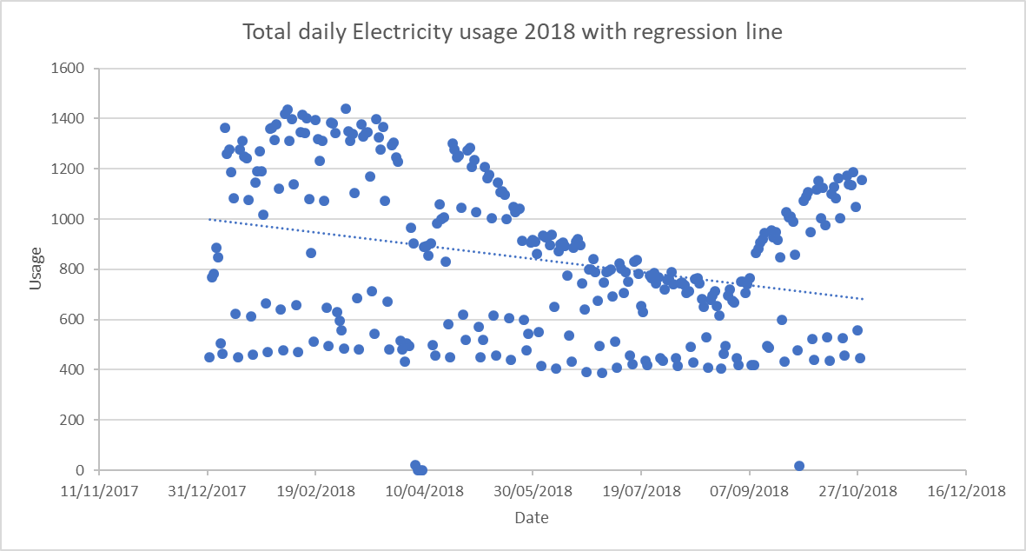

Energy Predictions
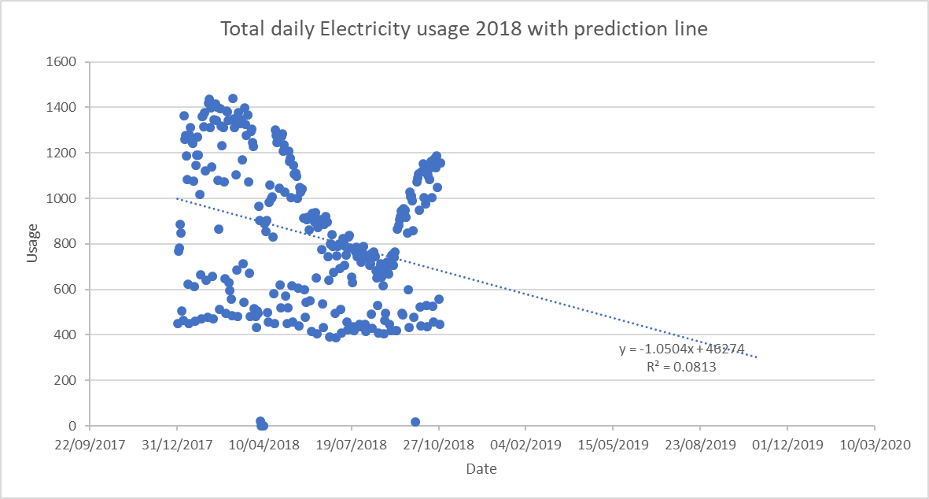
Following the regression trends of the 2018 data set the predictive data can be predicted to continue decreasing however this is only If the staff and students continuously work among this effort. The prediction line follows the regression line until the 01/11/2019. The energy prediction is only a regression line-based analysis and does not consider variables.

Future Performance
Basing off the previous two years of data the researcher has concluded that the average decrease percentage per year is -1.9%. From this analysis the researcher has predicted the future energy consumption rates per year and per month. The researcher capped the decrease percentage at 20% due to variable differences. However, this is likely to change when the action plan is implemented. To keep this review up to date the energy review including this future performance “shall be updated at defined intervals, as well as in response to major changes in facilities, equipment, systems or energy-using processes” (BSI, 2018).
 | Past Data |  | Future Predictions
 | 2017 | 2018 | 2019 | 2020
Yearly | 309,299.02 | 253,524.2 | 202,819.36 | 162,255.48
Monthly | 25774.92 | 21,127.02 | 16,901.62 | 13,521.3
Decrease percentage | 16.16 | 18.03 | 20% | 20%

The business campus is one of many throughout the university and recently the university has opened a new waterfront campus. This will have an impact in the usage at the business campus. With less students and staff attending the business campus and moving to the new campus. However, this move has not directly affected the business campus (i.e. the staff offices and departments are still going to be located at the building) it will still affect the student independent study, additional seminars and/or additional lectures may be preferred at the new facilities. Especially if the location of the other facility is more beneficial for the individual than the business campus.

Top data Variables
Environment
-Weather
-Temperature
Facilities
-New facility
-Library opening times
Time
-Term-times
-Lecture times
-Lunch times
The top data variables that have been mentioned are as follows:

Energy Review
The university uses two primary sources. Electricity and Gas.

Consumption Per Source
The university has got data relating to gas and electricity. These are the two primary sources of energy usage at the uwtsd business campus in Swansea. The university is not open out of term times. i.e. between June and September. The data for these for both the sources is lower around this time of year as expected to be. The data accessed to complete the analysis, varies per source due to the dates differentiating (i.e. The university term times and a lot of missing data). However, the researcher has taken an average reading of the energy sources per term time for the 2018 year to show the contrast in the consumption per source. The term times are between the months of September-May

GAS
Current Consumption: 246,480 Annually (2017/18)
20,540 Average Monthly (2017/18)

Electricity
Current Consumption: 253524.2 Annually (2018)
21,127.02 Average Monthly (2018)

Significant energy use (SEU)
From The data collated. The researcher will focus upon the electricity consumption/efficiency. This is because the electricity values for the consumption are higher than that of gas. Due to the lack of separate energy monitors the data collected does not specify where the data is most used within the business campus building. This is considered for the future development of the energy efficiency review/plan. The energy monitors would be beneficial to provide more concrete evidence of the larger SEU’s within the facility, including the determined variables and people responsible/relevant to the SEU’s. However, the researcher is aware some variables such as term-times and opening times would affect this data.

Energy Performance Indicators (EnPIs)
The energy performance indicators are a tool that is used in order to focus the effectiveness of an energy management plan. It is the main indicators that the energy plan will identify in order to simplify and define the energy performance. “Energy performance measurement through use of one or more Energy Performance Indicators (EnPIs) is based on a quantitative relationship between energy consumption and one or more relevant variables” (Goldstein & Almaguer, 2013). The energy performance indicators provide a basis to measure the success of the plan. They define what will be measured.
1 | kWh consumed per Monthly
2 | kWh consumed per Sub-Meter
3 | kWh Consumed per term-time HH system
The energy performance indicators chosen to be investigated are time based and suitable when the sub-metering system is in place. This will be the first action completed in order to provide suitable energy data that can be acted upon in further energy efficiency plans. The first energy performance indicator chosen to be monitored is the energy consumption per month, this will be able to help identify if the consumption is lower during term and non-term times and similarly the third energy performance indicator will help identify the energy consumption per term time, identifying half hourly slots. This will help aid in identifying where the energy is being used most during peak times, and whether the efficiency plan is effectively targeting these peak uses efficiently. The second Energy performance indicator will look directly at the sub metering system, by implementing this system as the energy performance indicator the energy representatives will be able to discover which rooms, locations, equipment is using the most electricity, this will help the efficiency of the plan as the researchers know the target areas.

Energy Baseline
The Baseline created for the energy efficiency plan is based on the average yearly data collected in the 2018 data set. The set average data amount was KWh 920.25 per day. This average was constructed from the peak time data only to give an accurate representation of the energy use based on occupancy.
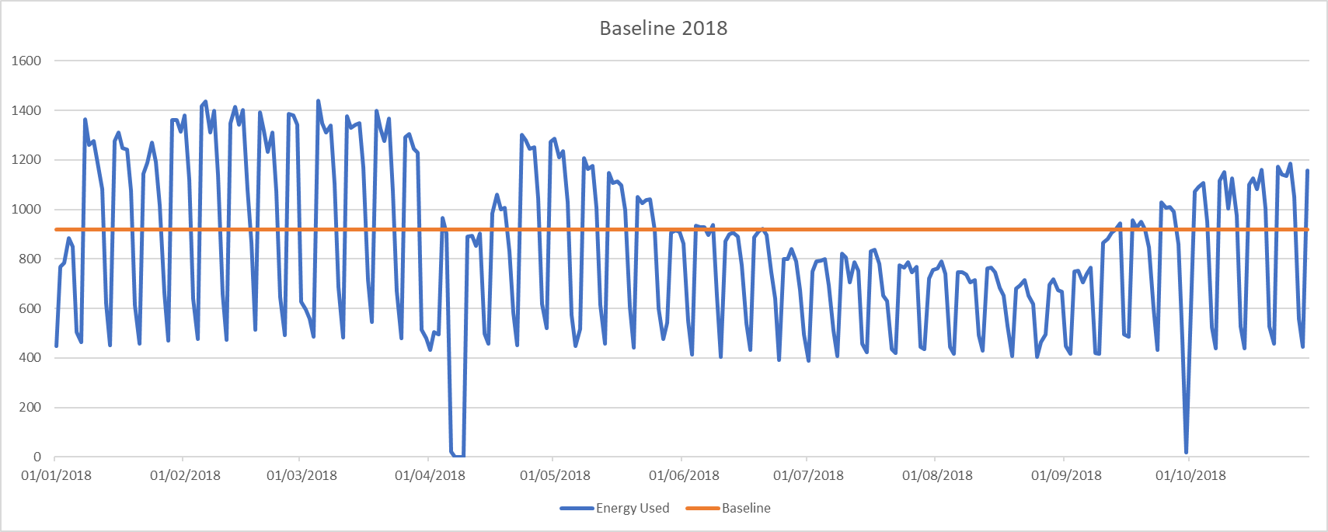

Energy Efficiency Plan

Aims and Objectives
This energy efficiency plan aims to reduce the overall electricity usage per year down to 200,000kw by the end of 2020. To achieve this ambitious goal this energy efficiency plan has four main objectives:
- Install and maintain sub-meters data collection
- Maintain constant data collection throughout the year
- Reduce the energy usage between the hours of 10:30-12:30 to 40kwphh
- Source Lighting fixtures to become all Energy saving bulbs

Action Plans
The action plan below targets what has been identified to be completed by the energy manager. This action plan is to be constantly maintained and altered in order to maintain organization. The cost implications section of the action plan is rated on a scale of 1-4 (1 being no cost implications needed, 2 being low-mid cost needed, 3 being high cost required and 4 being investment needed) The action plan works of a code-based system this is referenced below:
A-Awareness/ Knowledge
B- Training / Monitoring
C- Reviews/ Maintenance and assessments
D- Installation
Action Plan code | Action to be taken | Cost | When  (M) | By Whom? | on time? | Further maintenance/ Actions required?
A1 | Install separate energy monitoring systems (sub-meters) | 2 | 1 | EM
A2 | Staff meeting- Initiate conversation about energy management within lectures with other staff members, stressing importance of individual impact | 1 | 1 | EM
A3 | Energy Team- Organize and appoint energy team. Including staff that are interesting in aiding the team/ volunteers | 1 | 1 | EM
A4 | Plan training- Plan the training of staff/ employees on energy management team | 1 | 1 | EM
A5 | Review energy contracts - with suppliers to engage in an agreed cost reduction and work together to lower the energy consumption. Argue better tariffs for off-peak hours | 1 | 2 | EM
B1 | Train staff accordingly- Individual staff to be trained to the standard required. Individual CPD can also be included within training. | 2 | 2 | ET/ EM
C1 | Review all equipment - for maintenance checks, locations, faults, works properly, settings are power/ consumption friendly. | 1 | 2 | ET
A6 | Outline Indicators- Define the indicators for the performance per equipment for data collection | 1 | 2 | EM
A7 | Review – Look into the Sensor lighting systems, or timed lighting. To make sure lights are off when not in use. | 1 | 3
D1 | Source - energy efficiency bulbs | 2 | 3
D2 | Install - energy efficiency bulbs within all lighting | 1 | 4
A8 | Appoint - someone from the energy team to audit the facility at the end of every month | 1 | 4
C2 | Create - an energy audit procedure/ inventory consumption checks every 2 years | 1 | 4
A9 | Research - Operating costs and energy cost - check the costings of the energy usage per sub meter | 1 | 5
D3 | Adjust - thermostat/boilers for timed intervals/ specific times of years/ peak time | 1 | 5
B2 | Training- Refrigeration and catering staff about correct protocols and temperatures of refrigeration | 1 | 6
B3 | Training - staff to turn off non-essential catering equipment when not in use | 1 | 6
C3 | Audit - Check all equipment and refrigeration’s for any defrosting requirements, repairs, faults and sealings | 1 | 7
A10 | Research - light requirements for activities required | 1 | 7
D4 | Install - dimming switches | 2 | 7
C4 | Evaluate - the efficiency of all internal and external doors and windows | 1 | 8
C5 / D5 | Evaluate - the condition of all the roofing i.e. guttering, issues, foliage not meant to be there. Repair and remove if necessary | 1-4 | 10
C6 | Do a thermographic analysis of the outer and inside building | 1 | 10
A11 | Research - the potential for plant life regulation, whether just indoor plants to the green walls, spaces and roofs | 1 | 10
A12 | Research - the ability to implement renewable energy, searching funding, incentives and green contracts | 1 | 11
C7 | Reviews - Light fittings and sub-meters accordingly | 1 | 12
C8 | Review – Outdoor building and fittings via thermographic analysis | 1 | 12
C9 | Review- Staff competencies and training | 1 | 12

Energy efficiency plan further actions:
These sections have not been mentioned within this report due to the nature of the report however, the researcher thought that it would be important to include a quick summary of what would usually happen after the construction of the action plan.

Implementation
The implementation stage is where the Energy efficiency plan would highlight how the training, communication and method behind putting the plan into practice would go ahead. This stage would implement the action plan. The energy team would assemble, the research would be complete, and the installation of different equipment would happen. This section of the energy efficiency plan should highlight how the manager is going to complete the action plan if required.

Monitoring
The energy efficiency plan should highlight the significant energy uses, energy performance indicator and baseline. The energy manager will continue to monitor them and compare to the plan making changes if required. Similarly, the plan would highlight how to deal with any non-conformities and any corrective actions the energy manager should have in place. The manager will continuously monitor all these changes and the action plan.

Future Actions
The energy management plan would also highlight management proposition, intentions to review and continually improve the energy plan to further the energy efficiency of the facility.

Conclusion
There are several factors about the efficiency plan which directly ties to the British standards (ISO 50001:2018). The PDCA cycle, their structure and procedures. The energy efficiency plan overall is a way to plan, implement and improve upon the organization’s energy usage, efficiency and consumption to overall improve their energy performance. The energy manager was able to complete an action plan, which should be able to improve the facilities energy performance. This energy efficiency plan shows that the energy consumption is improving as seen throughout the previous years at an increasing percentage each year. This is estimated to improve the consumption of the facility by 20% at the end of 2020. However, there are variable factors such as occupancy, term times and weather that cannot be controlled. Conversely, the baseline from the daily averages would be able to provide a standard in which the energy manager can reference during the monitorization stage.
The Energy was seen to be higher amongst term times and between the hours of opening. This was expected. Similarly, there are several implementations that the action plan highlights that could improve the energy performance of the business campus during these times such as the energy efficient light bulbs. The main being to implement separate monitoring stations around the facility to monitor which area, equipment or activity is using the most amount of energy. This will in turn provide a much more accurate energy efficiency plan. By training staff, communicating, improving the facilities equipment (such as monitors, lighting, automatic shut off) the facility has the potential to improve their energy performance. The report will however need continuous improvement and monitoring to consistently improve or to stay at its best when the time comes.
The report has summarized that if the action plan is to be carried out and continuously monitored by the energy manager and team, there is a high chance that the energy performance of the building could achieve the aims and objectives highlighted within the plan. Considering the variables, the data provides a solid baseline that would provide an improvement regardless to the common variables.
There are also several other articles that can be analyzed to improve the general knowledge of energy performance and efficiency. There are multiple approaches that could change the way energy efficiency is dealt with. Krakowski, T and Ruta, H are investigating the approach to lift efficiency classifications, which could lead to the development of more efficient lifts and elevator structures alike (Krakowski & Ruta, 2019). Similarly, New initiatives for renewable energy sources re continuously being brought out due to demanding government pressures to meet targets, leading to a more accessible and cheaper energy consumption. However, the issue with renewable energy is the storage that it requires unless given to the grid. The efficiency however of energy can be directly changed by future research.

References
BSI, 2018. Energy Management Systems - Requirements with guidance for use (ISO 50001:2018). BSI Standards Publication, pp. 1-44.
Department for Business, Energy & Industrial Strategy and The Rt Hon Chris Skidmore MP, 2019. UK becomes first major economy to pass net zero emissions law. [Online]
Available at: https://www.gov.uk/government/news/uk-becomes-first-major-economy-to-pass-net-zero-emissions-law
Goldstein, D. B. & Almaguer, J. A., 2013. Developing a suite of Energy performance Indicators (EnPIs) to optimize outcomes. Energy Efficiency in Industry, pp. 1-7.
HEFCW, 2014. Carbon Managemnt Policy, s.l.: Welsh Government.
Hughes, M., 2014. Sustainbility strategy , Swansea: University of Wales Trinity St Davids.
Krakowski, T. & Ruta, H., 2019. Application of fuzzy logic in lift energy efficiency classification. Energy Efficiency, 12(8), pp. 1973-1985.
UWTSD, 2019. Biodiversity Policy. [Online]
Available at: https://www.uwtsd.ac.uk/media/uwtsd-website/content-assets/documents/strategies-policies/UWTSD-Biodiversity-Policy-2017-18.pdf
UWTSD, 2019. Carbon Management Action Plan. [Online]
Available at: https://www.uwtsd.ac.uk/media/uwtsd-website/content-assets/documents/strategies-policies/Carbon-Management-Action-Plan_Jun-16.pdf
UWTSD, 2019. Environmental Policy. [Online]
Available at: https://www.uwtsd.ac.uk/media/uwtsd-website/content-assets/documents/environment-unit/uwtsd-environment-policy.pdf
UWTSD, 2019. Procurement Policy. [Online]
Available at: https://www.uwtsd.ac.uk/media/uwtsd-website/content-assets/documents/strategies-policies/V2.1-Procuremnet-Policy-26.04.16.pdf
UWTSD, 2019. Strategic Plan 2017-2022. [Online]
Available at: https://www.uwtsd.ac.uk/media/uwtsd-website/content-assets/documents/strategies-policies/UWTSD-Strategic-Plan-2017-22_English_FINAL.pdf
UWTSD, 2019. Waste Management Policy. [Online]
Available at: https://www.uwtsd.ac.uk/media/uwtsd-website/content-assets/documents/strategies-policies/2.1-UWTSD-Waste-Management-Policy-20.06.17.pdf

Appendices

Appointment of energy manager and team sheet.
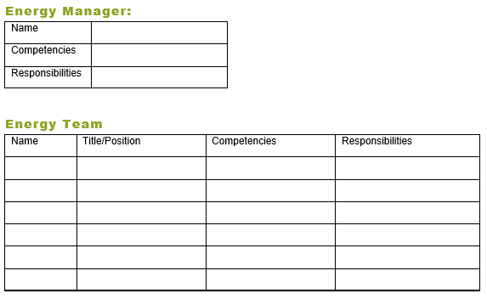

Gas
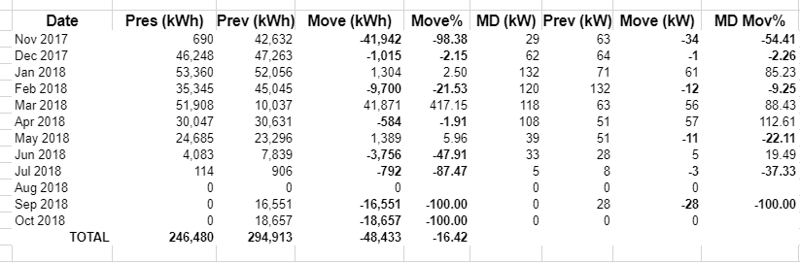
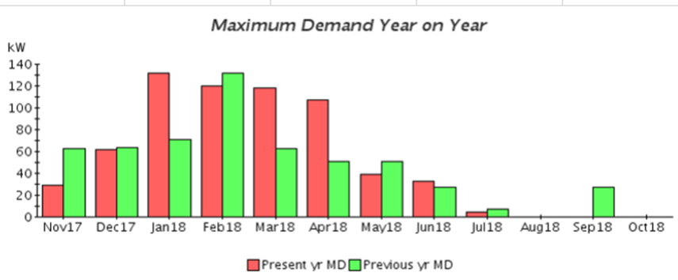
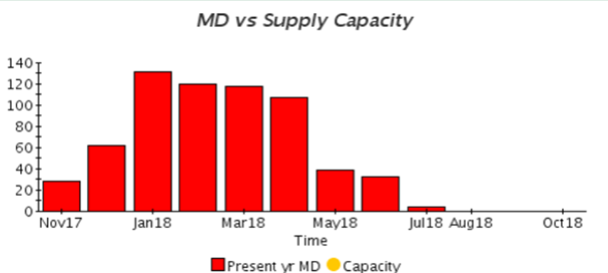
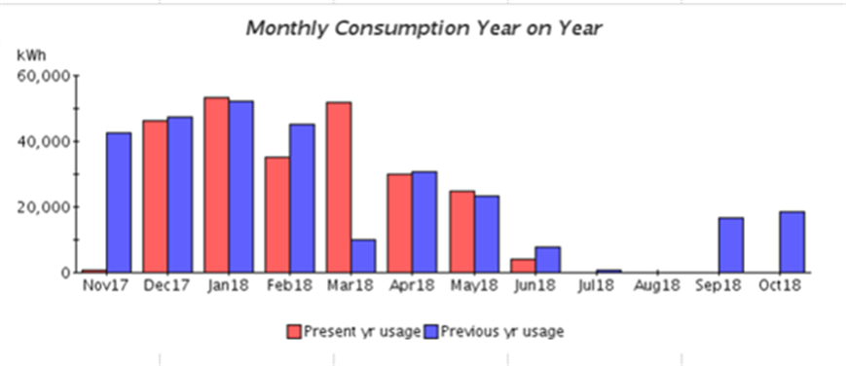

Electricity
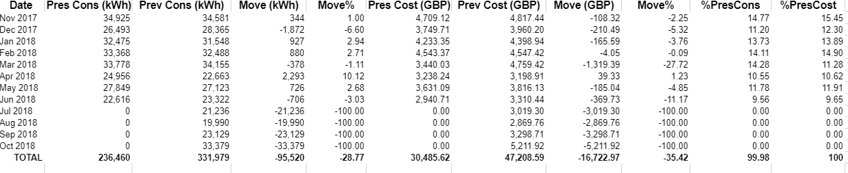

Electricity Appendix Sent via email due to abundance of excel document

