 |  | RESULT:

ASSIGNMENT SPECIFICATION

Student name: | Assignments will not be accepted without a name here |  |  |  | Student P number: |  | Assignments will not be accepted without P number
Programme: | MDes/BA(Hons) Product Design |  |  |  | Faculty/School: |  | FAD/SoDAA
Module: | User Experience Design |  |  |  | Module Level (4, 5, 6, 7): |  | 5
Module code: | M5X01239 |  |  |  | Contribution to Overall  Module Assessment (%): |  | 100%
Lecturer: | Sean Jenkins |  |  |  | Internal Verifier: |  | Matthew Archer
Assignment Title: | RE-SIT ASSIGNMENT: PEELER |  |  |  | Assignment No (x of x): |  | 1 of 1
Hand Out Date: | 8th February 2018 | Submission Date: |  | 19th March 2018 |  | Feedback Date: |  | 30th April 2018

Referencing: | Written coursework submissions: In the main body of your submission you must give credit to authors on whose research your work is based. Append to your submission a reference list that indicates the books, articles, etc. that you have read or quoted in order to complete this assignment (e.g. for books: surname of author and initials, year of publication, title of book, edition, publisher: place of publication). Harvard or APA referencing systems is accepted.  Practical coursework submissions: You must give credit to designers or artists whose work you have used to inspire your own. Where specific designs or images have been used in your development work you must indicate the name of the ‘author’ and details of the source of the work (e.g. book, journal, website etc.).
Disclosure: | I declare that this assignment is all my own work and that I have acknowledged all materials used from the published or unpublished works of other people. All references have been duly cited.
Student’s Signature: | Assignments will not be accepted without a signature here and date > | Date of submission:
Turnitin: Lecturer to tick to indicate if an electronic version of the assignment must be submitted to Turnitin.  If both electronic and hard copy submissions are required then both versions MUST be submitted by the same deadline. No marks will be released until both submissions are received.  Note: the Turnitin version is the primary submission and acts as a proof of receipt for the student.  A paper receipt must be completed for hard copy submissions, including portfolios and other design work. |  |  | YES
 |  |  | NO
Penalties for late submission: Not applicable - THIS IS A RE-SIT ASSIGNMENT SO IT IS CAPPED AT 40%
Late or non-submission = 0%.

- The Assignment Specification Form MUST be at the front of all assignment submission. Assignments will not be accepted without this form, as it is a requirement that you sign the disclosure regarding referencing conventions.
- DO NOT include this form in your Turnitin submission or it will match many similarities with other students’ submissions.

ASSIGNMENT DESCRIPTION

Learning Outcomes
Module Learning Outcomes being Assessed:
- Select and utilise a variety of research techniques and methods to observe and investigate user experience across the full spectrum of physical, cognitive, emotional and social interactions with/through artefacts, systems and services;
- Communicate the process and insights gained from of user experience research and the application of this knowledge in the development of design proposals in response to a specified context.

Task
There are essentially two types of ‘peeler’ – Type 1 has the peeling blade ‘in line’ with the handle/grip and Type 2 has the blade perpendicular to the grip (basic models as illustrated below).
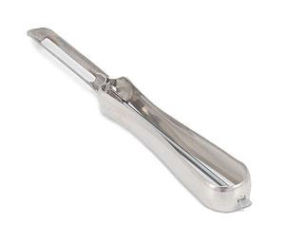 | 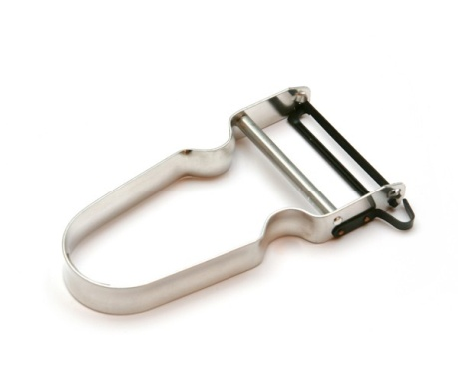
Type 1 | Type 2

YOUR RE-SIT ASSESSMENT CONSISTS OF TWO TASKS:

Assessment Component 1 – 60% of module.
Coursework – Portfolio of UX Research & Design tasks consisting of Kitchen Peeler Design Research = 30% & Design Development and Prototyping = 30%

Working individually and using appropriate research methods, you must undertake design research & development to produce 3 different working concept design models for a ‘peeler’. You must develop your concepts around one of the existing types, incorporating the existing peeler blade. You must undertake detailed analysis of existing products and their use to identify scope for design development. You must then explore, develop and prototype 3 concepts using an appropriate 2D sketching and 3D modelling strategy. You must consider the following three key design criteria of ergonomics, usability, and aesthetics.

The outcome of this process must be presented visually in a portfolio, submitted as a PPT or PDF file and should consist of two clear sections:

- 30% = You must produce evidence of detailed design research and analysis of existing products and their use (both online and offline). For example; ethnographic studies, ergonomic analysis, competitive product survey/testing etc.
- 30% = You must produce evidence of design development and prototyping using an appropriate 2D sketching and 3D modelling strategy which may include; drawing, CAD, photographs of concept modelling etc. You must manufacture 3 working prototypes (in appropriate materials to enable functional testing).

Assessment Component 2 – 40% of module.
Coursework – Design Testing and Evaluation Report (2000 words)

You must test and evaluate the 3 working prototypes using a ‘focus group’ of a minimum of 5 participants. The criteria used to evaluate the design are stated in the task description above.

- 40% = You must produce a written and illustrated report that clearly documents the process and outcome of your design testing and evaluation methodology. The report should contain the following elements;
  - identification of the key design issues addressed in the design R&D stage,
  - description of the new designs to be evaluated,
  - descriptions of your test methods, t
  - the criteria and methods used to measure product effectiveness/user experience
  - summary of results
  - conclusions and selection of the final design.

The report must be submitted via TURNITIN.

Guidance for Students in the Completion of Tasks
Useful resources for completion of the project are listed below:

ONLINE RESOURCES:
http://designingwithpeople.rca.ac.uk/
http://www.hhc.rca.ac.uk/
http://www.inclusivedesigntoolkit.com/betterdesign2/
http://www.ideo.com/work/method-cards/
http://enabledbydesign.org/

PHYSICAL RESOURCES:
Design Studio G07/8
CAD Studios (Alex)
Clay Studio (Alex)
Workshops (Alex)
Griffith Library

BIBLIOGRAPHY:
Universal Methods of Design by Bella Martin & Bruce Hannington (Rockport, 2012)
Measuring the User Experience by Tom Tullis & Bill Albert (Morgan Kaufmann, 2008)

Assessment & Feedback
The following common assessment and marking criteria will be used to assess the learning outcomes above;

1. Research & Analysis
2. Development
3. Technical Skill
4. Subject Knowledge
5. Presentation & Communication
6. Personal Learning & Development
7. Professional Practice

Submission: 12pm 19th March 2018
Feedback by 30th April 2018
Note: this is a re-sit assignment so your mark is capped at 40%

