Information Engineering

University of wales trinity saint davis
nasko tinchev
2020
Table of Content
Relationship Diagram 2
StaffPersonalData 3
StaffProfile 4
Absence 5
Branches 6
Courses 7
CourseID 8
JobID 8
Salary 9
Users 10

Relationship diagram
This diagram shows all relations between the different tables.
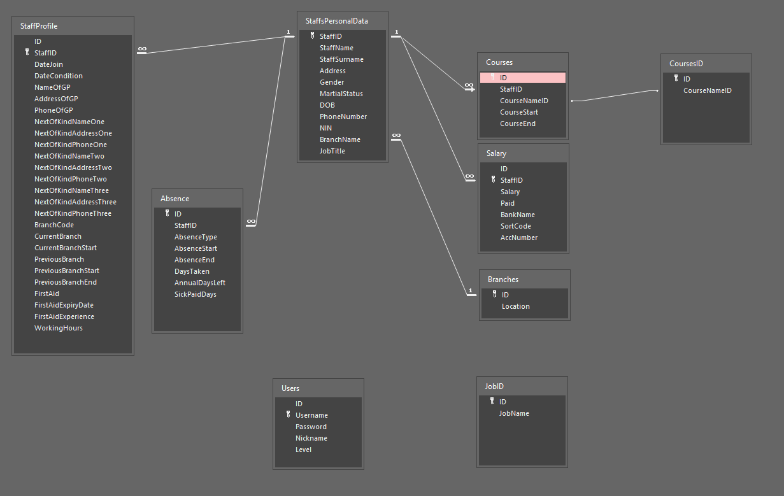

StaffPersonalData
General Information for all staffs. This is the main table which is stored in Birmingham.
Design View:
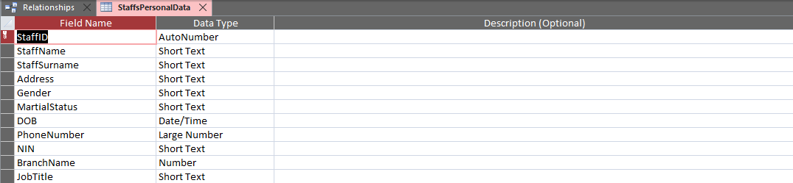
Table Content:
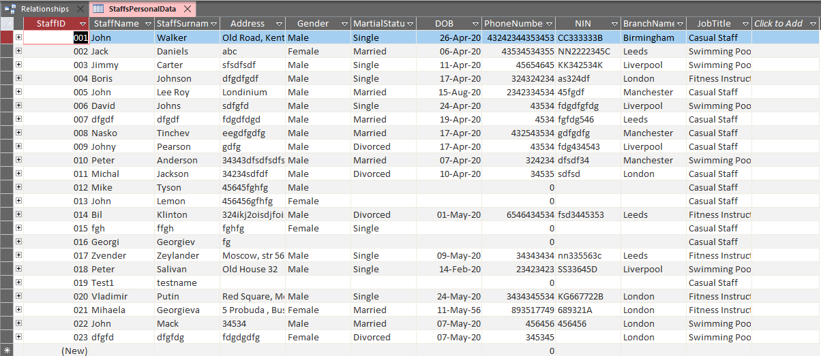
StaffPersonalData containing all personal information about every employee in the company. Information like name, surname, date of birth etc. The primary key StaffID is used to connect this table to the others table.

StaffProfile
That table contain all the information for every employee in the current branch.
Design View:
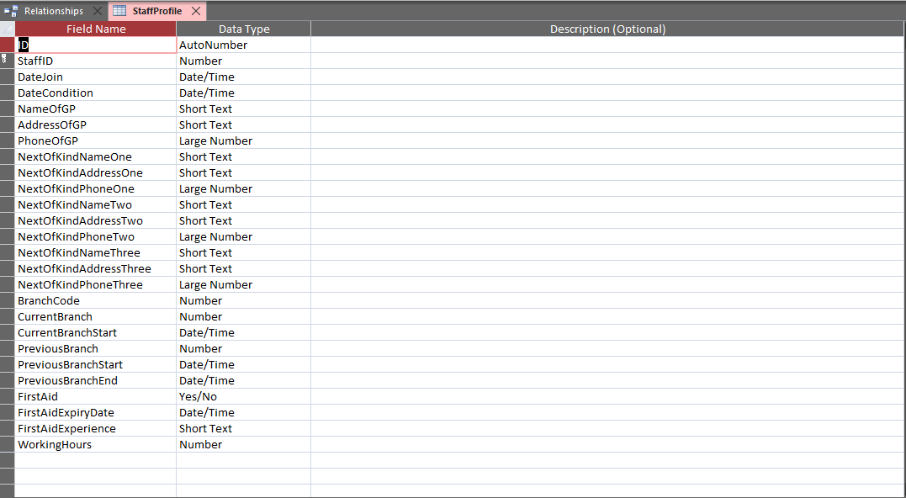
Table Content:
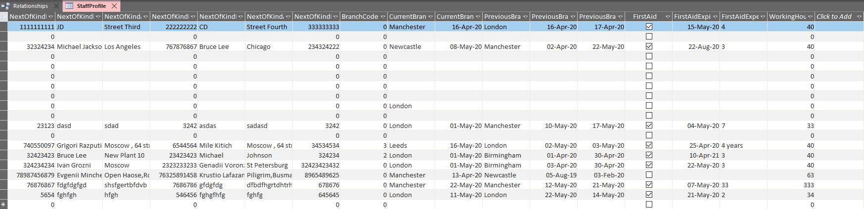
Primary key StaffID is used to connect this table with StaffPersonalData table.

Absence
Contains records about absence, holidays or sick days. Here easly we can add additional forms of absence like maternity, authorized absence or unauthorized.
Design View:
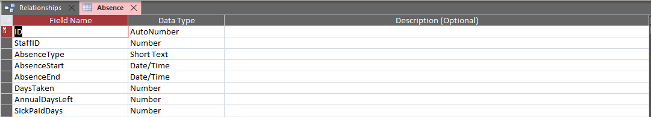
Table Content:
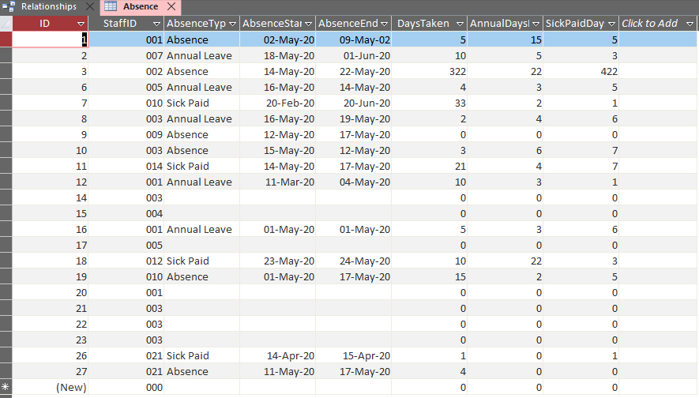
Again StaffID is used to connect this table to the StaffPersonalData.

Branches
The role of that table provide choice for selected branch where is necessary. In future expansion of the company here can be added additional branches. Every branch has his own unique ID number.
Design View:
Table Content:
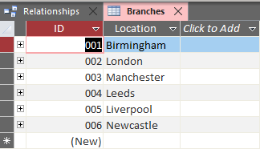

Courses
Contains records of the employees and their courses taken or courses that are in progress.
Design View:
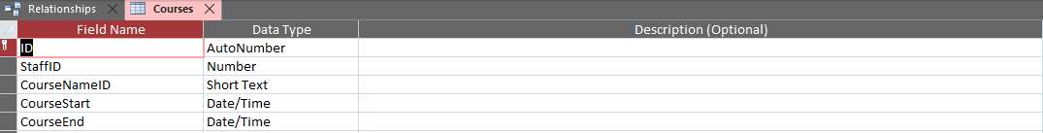
Table Content:
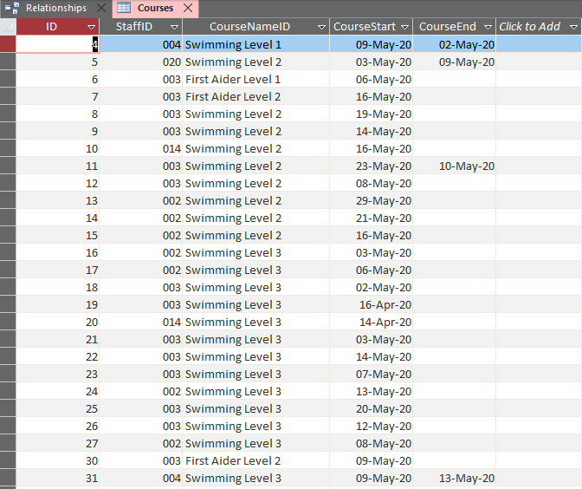
StaffID is a foreign key used to connect that table to StaffPersonalData.

CoursesID
Here is stored information for the available courses in the company. Through the application we can easily add or change course.
Design View:
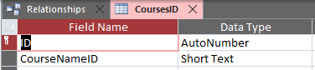
Table Content:
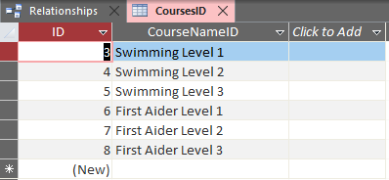
Every single course has his own unique ID.

JobID
This table is used to contain all the position in the company.
Design View:
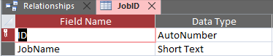
Table Content:
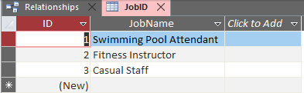
Column ID is used to create unique number for every single position.
Salary
Contains financial records for every employee in the current branch.
Design View:
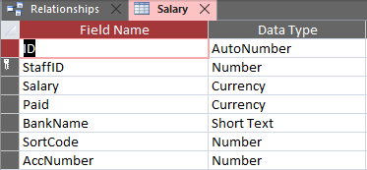
Table Content:
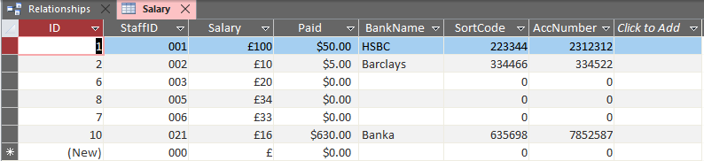
Primary key StaffID is used to connect that table to StaffPersonalData.

Users
The purpose of that table is to contain records for all users who will has access to the database.
Design View:
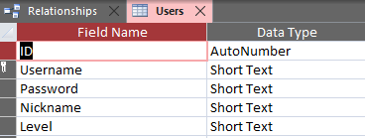
Table Content:
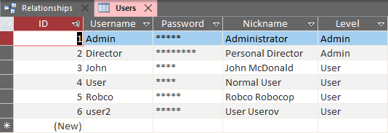
ID is a primary key. The login form gets information from that table about username and password, also about user access level which is deciding what level of access is granted to certain user.

References
Microsoft. (2020, 4 15). Add or change a table’s primary key in Access. Retrieved from https://support.office.com: https://support.office.com/en-gb/article/add-or-change-a-table-s-primary-key-in-access-07b4a84b-0063-4d56-8b00-65f2975e4379
Microsoft. (2020, 5 1). Introduction to tables. Retrieved from https://support.office.com: https://support.office.com/en-us/article/introduction-to-tables-78ff21ea-2f76-4fb0-8af6-c318d1ee0ea7
Point, T. (2020, 4 20). MS Access - Macros. Retrieved from Tutorials Point: https://www.tutorialspoint.com/ms_access/ms_access_macros.htm
Ulrich-Fuller, L. (2020). MS Access 2019 for Dummies. New York, United States: John Wiley & Sons Inc.

