Enhancing your grades. 1 Discussing and applying CSR concepts
(12 January 2022)
Do look at the grade criteria.
Higher grades need deeper ANALYSIS and more sophisticated EVALUATION. Simple DESCRIPTION is a lower skill in academic work, hence advice to locate this in an appendix or simply refer the reader to websites or documents, sourced and put in your bibliography.
What is deeper and more sophisticated?
Always start with the easier interpretation. For this assignment CSR and the broad and narrow interpretation.
- Do the basics and build complications in later.
Using Carroll’s pyramid can take the arguments to a higher level so long as you interpret it applied to your cases.
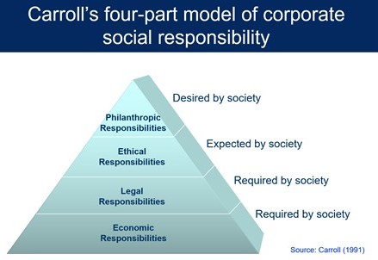

Use of a stakeholder map is a good way to identify how broad the organisations in defining who they need to look after. You can then criticise them for not have the right ones in or not doing very much to help the ones they do identify.
Make your own or adapt from your research. See other files uploaded.

- You might challenge the definition of CSR.

- You might take a tough line on the broad interpretations.
Taking the Friedman view you might say unless policies help profitability in private, service delivery targets set by government in the public sector or achieve the mission of NFP organisations, they will not happen. Therefore, the bottom line is always the most important thing. The Triple Bottom line for example is a distraction. You can still see articles which say this. So long as you also put in the broader view as an alternative it is OK to take this line.
- You might fully take the broad view but want to push it even further.
Two ways might be:

- Corporate Citizens (CC).
The Crane et al (2016) view that organisations should be managing to become Corporate Citizens (CC).
They describe:
- A limited view of CC
this essentially equates CC with corporate philanthropy.
- An equivalent view of CC
this essentially equates CC with CSR.
- An extended view of CC
this acknowledges the extended political role of the corporation in society.

It is therefore more than philanthropy (giving to charities) or even the broad CSR, in their extended view there should be a full integration of the corporation into society as a citizen, as you and I can get involved.

However

Is this too optimistic? Not really happening very soon.

Is it only true for private organisations?

Is the concept generally understood? How is it different to broad CSR?
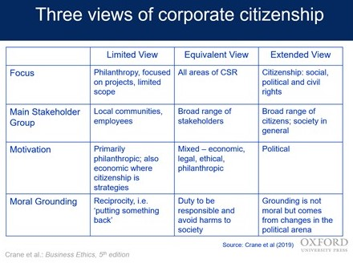
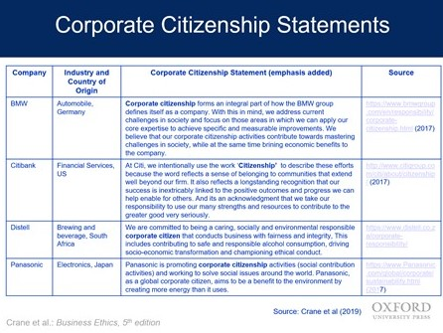
- Corporate Social Value (CSV)

Michael Porter at Harvard Business School is quoted by everyone who writes on strategy. Even if you do not like him, he is still good to quote.
He has written on CSR for many years with Kramer, see below. CSV is a form of social interaction however it is different. Since 2011 there are many who have adopted it and who have analysed it. Simply showing you know there is an alternative will impress the reader.

Porter, M.E. and Kramer, M.R. (2002) ‘The competitive advantage of corporate philanthropy’, Harvard Business Review 80, No. 12: 57–68.
Porter, M.E. and Kramer, M.R (2006) ‘Strategy and Society: The Link Between Competitive Advantage and Corporate Social Responsibility’ Harvard Business Review 84, pp. 78–85.
Porter, M.E. and M. R. Kramer, M.R. (2011) ‘Creating Shared Value,’ Harvard Business Review, Vol. 89, No. 1, pp. 2-17. This article has been uploaded. So, you can see better versions of the diagrams.
What is CSV?
- Creating shared value is the practice of creating economic value in a way that also creates value for society by addressing its needs and challenges.
- There are 3 ways to create shared value: by reconceiving products and markets, by redefining productivity in the value chain, and by enabling local cluster development.
- Shared value is not corporate social responsibility or philanthropy—creating shared value is at the core of the business strategy.

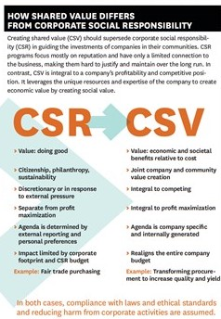
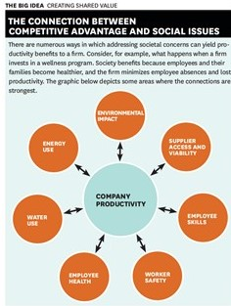

Steve’s analysis
Value is benefits AND costs….shared value allows competitive advantage and benefits for the community.
Needs engagement and communications with society.
Is it really Friedman in disguise?

- What about SUSTAINABILTY?

Both CSR and Sustainability have been talked about for decades. The UN links say wonderful things. However, the word has been slow to change.
If sustainability is more important now as the world is in crisis, how does it fit with CSR. It looks like it asks corporations to be wider in their analysis of stakeholders, what they need and how to operate.
The UN sustainability goals are easily to be found. Most countries agree with them but getting agreement on implementation and time scale has been difficult. Government by itself needs to work with all organisations in all sectors or it will not happen.
Therefore, sustainability campaigner will tend to think most CSR policies and implementations are not good enough in the face of the challenges the world is presented with.
A few policy lists:

https://www.sdgfund.org/mdgs-sdgs

Millennium Development Goals
In September 2000, leaders of 189 countries gathered at the United Nations headquarters and signed the historic Millennium Declaration, in which they committed to achieving a set of eight measurable goals that range from halving extreme poverty and hunger to promoting gender equality and reducing child mortality, by the target date of 2015.

The Millennium Development Goals (MDGs)
Goal 1 | Eradicate extreme poverty and hunger
Goal 2 | Achieve universal primary education
Goal 3 | Promote gender equality and empower women
Goal 4 | Reduce child mortality
Goal 5 | Improve maternal health
Goal 6 | Combating HIV/AIDs, malaria, and other diseases
Goal 7 | Ensure environmental sustainability
Goal 8 | Develop a global partnership for development

In July 2014, the UN General Assembly Open Working Group (OWG) proposed a document containing 17 goals to be put forward for the General Assembly’s approval in September 2015. This document set the ground for the new SDGs and the global development agenda spanning from 2015-2030.
Sustainable Development Goals (SDGs) as proposed by the OWG
Goal 1 | End poverty in all its forms everywhere
Goal 2 | End hunger, achieve food security and improved nutrition, and promote sustainable agriculture
Goal 3 | Ensure healthy lives and promote well-being for all at all ages
Goal 4 | Ensure inclusive and equitable quality education and promote life-long learning opportunities for all
Goal 5 | Achieve gender equality and empower all women and girls
Goal 6 | Ensure availability and sustainable management of water and sanitation for all
Goal 7 | Ensure access to affordable, reliable, sustainable, and modern energy for all
Goal 8 | Promote sustained, inclusive and sustainable economic growth, full and productive employment, and decent work for all
Goal 9 | Build resilient infrastructure, promote inclusive and sustainable industrialization, and foster innovation
Goal 10 | Reduce inequality within and among countries
Goal 11 | Make cities and human settlements inclusive, safe, resilient and sustainable
Goal 12 | Ensure sustainable consumption and production patterns
Goal 13 | Take urgent action to combat climate change and its impacts
Goal 14 | Conserve and sustainably use the oceans, seas, and marine resources for sustainable development
Goal 15 | Protect, restore and promote sustainable use of terrestrial ecosystems, sustainably manage forests, combat desertification, halt and reverse land degradation, and halt biodiversity loss
Goal 16 | Promote peaceful and inclusive societies for sustainable development, provide access to justice for all, and build effective, accountable and inclusive institutions at all levels
Goal 17 | Strengthen the means of implementation and revitalize the global partnership for sustainable development

This is a pretty big list!
What is the organisation you are study doing to help achieve these things?

The Corporate Shared Value for Sustainable Development: An Ecosystem Perspective
Yang, Ta-Kai ; Yan, Min-Ren
MDPI AG
Sustainability (Basel, Switzerland), 2020-03-17, Vol.12 (6), p.2348

While corporate social responsibility (CSR) is prevailing, the concept of creating shared value (CSV) by coordinating business activities and social concerns brings a great opportunity to transforming the business model for sustainable development. To better understand the systems comprising corporate shared value chains would be beneficial to economics, society, and sustainability. This study refers to the ecosystem as the theoretical lens in the exploration of the CSV components and contexts, and takes Macy’s as a focal case. In terms of academic contributions, this study generalizes the CSV components, including markets, social innovations, social performances, new business models, corporate entrepreneurship, and social network support. The research findings contribute to conceptualize and systemize the concept of CSV. In terms of practical contributions, the contexts for the operation of CSV, as summarized by this study, can serve as a template for corporate planning of CSV activities and sustainable development.

Ethical Corporation published by Reuters does many company profiles and rates them.
https://reutersevents.com/events/reports/docs/magazine-december-2020.pdf

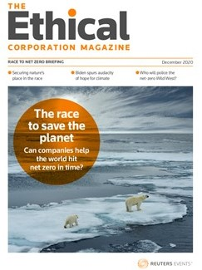
https://www.reutersevents.com/sustainability/how-consumers-are-stepping-plate-cutting-food-waste
Reuters seems to have taken over Ethical Corporation.
Here is a story on Covid-19 and food waste management.

