
TITLE: MANAGING PEOPLE
ASSESSMENT-1

STUDENT NAME: GURVINDER KAUR
STUDENT ID: 2238951
PROGRAMME: MBA – MASTER OF BUSINESS ADMINISTRATION
MODULE: MANAGING PEOPLE
MODULE CODE: LCMB7011
LECTURER NAME: REXON NTING
DATE OF SUBMISSION: 20/12/2023
TABLE OF CONTENTS
- Introduction………………………………………………….3
- Globalization…………………………………………………4
  - Impact of Human Resource Management
in Globalization……………………………………....6
- The Elusive UK and Chinese business system………………………………………………………......7
- Issues in the field of International human
resource management………………………………….8
  - Contemporary issues……………………………..9
  - Ethical issues…………………………………………12
- Institutional arrangements in United Kingdom
and China ……………………………………….................14
5.1 PESTLE Analysis…………………………………….16
- Difference in work culture across UK and China…………………………………………………….…….21
  - Management of Human Relationship
across different countries………………….…29
- Conclusion……………………………………………………33
- Reference…………………………………………………….35

- INTRODUCTION
Human resource management is a multi dimensional organizational function which entails policies regarding design and implementation of relevant strategies and procedures of efficient workforce management in an organization. Human resource management seeks for the production of the most efficient output that complies with the company goals, employee growth, levels of employee wellbeing and the organization’s laws. This is very wide field comprising different sections, including recruitment, selection, training, performance management among others, compensation, employee relations and also workforce planning.

Starting a career in human resources management in a global environment is like navigating a complex terrain where many human components collide in complex ways.
The challenges inherent in this practice are dynamic and complex, and require careful evaluation of the factors essential to the productivity and cohesion of diverse teams.
This project involves everything from negotiating different HR rules, accommodating and understanding cultural differences, overcoming language barriers, and reconciling different ways of working, so strategic talent and cultural sensitivity A careful balance needs to be struck between.
The challenge of assembling cohesive and effective teams within this complex web of international cooperation highlights the need for sophisticated strategies.
This research investigates various aspects of managing multinational teams, with an emphasis on the complex interactions between law, custom, language, incentives, safety and health regulations and work style that shape the dynamic world of workforce management today.
- GLOBALIZATION
Globalization implies the forms that diminish boundaries among nations (Frenkel & Peetz,1998). It may be a term that came into utilization within the 1980's to depict the expanded development of people, information, and concepts, and products and cash over national borders that have led to expanded interconnecting among the world's populaces, financially, politically, socially and socially. It implies that the world is getting to be more consolidated. Growing internationalization of trade has its affect on HRM like- new laws, languages, practices, competitions, attitudes, administration styles, work morals, etc. It has made the world exceptionally little. We have to be coordinate human creatures in such a way that they can acquire appropriate information which is based on encounter, confidence; common sense & interest, change in enrollment and selection program, introduction program, and preparing and development, etc. Workers will be treated as assets when their aptitudes, abilities, knowledge, capabilities, etc. will be expanded and utilized within the profitable division which will have financial values. So, overseeing human asset is one of the vital capacities of an organization. Human asset administration is the utilization of human assets to achieve organizational destinations. It is utilized to the logic, arrangements, methods, and practices related to the administration of individuals inside an organization (French, 1997). It is the approaches and hones included in human asset viewpoints of a administration position, including enlisting, screening, and preparing, fulfilling and evaluating (Dessler, 2005).Managers get things are done through the endeavors of others: this requires successful human resource administration (Mondy, Noe, & Premeaux, 1999). Thus, all directors at every level must concern themselves with human asset administration.
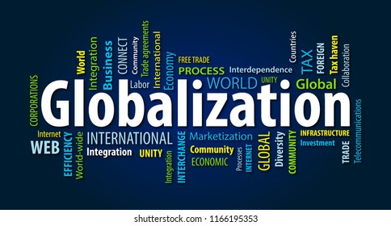
Source: shutterstock.com

2.1 IMPACT OF HUMAN RESOURCE MANAGEMENT IN GLOBALIZATION
Human resource management techniques that deal with overseeing a diverse workforce from across the globe are referred to as global HRM. The process of worldwide inclusion that results from the flow of goods, ideas, and other cultural elements is known as globalization. The economics and cultures of the globe have become more interconnected extremely swiftly in the last few decades. Due to its emphasis on diversity, globalization has a significant effect on how businesses handle their workforces as well. Although "globalization," or the increased integration of the world, has improved living, it has also led to new issues with human resource management. Managers may better prepare their firms for the increasingly global economic environment by having a deeper understanding of how globalization affects human resources. The impact of Globalization is as follows:
- Human Resource Planning
- Job Design
- Recruitment and Selection
- Training and Professional Development
- Management of Laws
- Organizational Culture
- Motivation
- Quality Management

- THE ELUSIVE UK AND CHINESE NATIONAL BUSINESS SYSTEMS
The NBS method is a good place to start, but it has limits when it comes to identifying and analyzing practices in specific organizations (Smith and Thompson, 1998 The International Journal of Human Resource Management568-70). Capital, people, and ideas, for example, are all confined in different ways by national borders. The NBS method also has a tendency to cryogenize national 'models,' ignoring ongoing change. Furthermore, business activity is over-determined, and the possibility for human agency is overlooked within this framework.
There are issues in determining what defines a British or a Chinese NBS, as well as unique 'British' and 'Chinese' approaches to HRM. Child et al. (2000) discovered significant cross-sector disparities in British management techniques. There appear to be significant differences even within retail enterprises. Turnbull and Wass (1998), on the other hand, depict a UK retail store with an internal labor market divided into a primary 'managerial' segment and a secondary 'shop floor' segment, with no mobility between segments. Turnbull and Wass report workers' remarks about being 'treated as if you're nothing' (ibid.: 108) and 'it's quite "Them and Us" ' (ibid.: 106). Both are UK retail companies, yet their management styles and approaches appear to be considerably different.

- ISSUES IN THE FIELD OF INTERNATIONAL HUMAN RESOURCE MANAGEMENT When doing business between the UK and China, companies face a plethora of international HR (HRM) challenges. The cultural, legal and economic differences between the two countries create a number of issues that require detailed analysis and strategic planning. From managing different labor standards and employment laws to promoting cross-cultural awareness and best practices, the combination of these elements presents significant challenges for businesses operating in the UK and China. Some of the multi-faceted issues in HR that arise when doing business with China and the UK are discussed below:
4.1 CONTEMPORARY ISSUES IN THE FIELD OF INTERNATIONAL HUMAN RESOURCE MANAGEMENT
International Human Resource Management (IHRM) faces various contemporary challenges when companies engage in business activities between the United Kingdom (UK) and China. These challenges stem from differences in culture, legal systems, labor markets, and business practices between the two countries.
- CULTURAL DIFFERENCES IN WORK NORMS AND VALUES : Numerous studies demonstrate the important distinctions between the individualism and short-term perspective of the UK and the collectivist culture and long-term orientation that are prevalent in China. Decision-making, leadership philosophies, employee motivation, and communication may all be impacted by this (Hofstede, 2001). As a result, companies must adjust policies and training to accommodate both cultural perspectives.

- LEGAL COMPLIANCE: Ensure legal compliance across borders, including labor laws, privacy rules, and other legal obligations, is a complicated and crucial task for multinational human resource managers. Because of China's complicated legal structure and the ever-changing nature of the HR industry, a thorough awareness of local employment laws and regulations is required. (Dowling et al., 2008).

- TALENT MANAGEMENT: In both the UK and China, the problems of recruiting, developing, and keeping top personnel are enormous. HR executives managing teams in both countries prioritize adapting HR methods to the growing HR profession in China, talent management, and training and developing a global workforce(oyestrhr.com)

- ORGANISATIONAL DEVELOPMENT AND CHANGE MANAGEMENT: The changing nature of the Chinese HR profession, as well as problems connected to organizational growth, change management, and communication between foreign and local management, create unique challenges for HR professionals heading teams in China(onlinelibrary.wiley.com)

- MANAGING DIFFERENT CULTURES: One of the biggest challenges for HR professionals is bridging cultural divides and managing a diverse workforce. The UK and China have very different ways of working, working relationships and cultural norms. This means that HR managers need to be able to navigate and deal with these differences.

- COMMUNICATION AND LANGUAGE BARRIERS: It might be difficult to communicate effectively across a multicultural workforce and to overcome language hurdles. Language skills and the use of multilingual communication technologies are key. (Harzing & Pudelko, 2016).

These modern challenges highlight the ever-evolving nature of International HR Management, particularly when it comes to conducting business between and within China. HR leaders must navigate a diverse cultural, regulatory, and operational environment to manage a globally distributed workforce and address China’s unique set of challenges.

  - ETHICAL ISSUES IN THE FIELD OF INTERNATIONAL HUMAN RESOURCE MANAGEMENT
Some important ethical difficulties that might arise in an international human resource management scenario, as a UK-trained HR executive operating business in China, include:
- PAY DISPARITY: Due to the large wage differences between local and foreign employees in China, this can lead to equality concerns (Zhu, 2014). To navigate compensation across regions and positions, fairness should be based on responsibility, skills and abilities - not ethnicity - to comply with ethical pay principles.

- BRIBERY AND CORRUPTION: Bribery is illegal under the Foreign Corrupt Practices Act. This regulation, however, cannot reasonably cover the entire spectrum of payments that overseas enterprises face. Things like facilitation payments may be required to operate in a foreign country, and the US government has ruled differently on multiple situations involving these types of payments, posing a true ethical quandary for the company, particularly a human resources manager who must assist an employee facing bribery attempts overseas. Furthermore, according to a 2011 Ernst & Young assessment, international corporations operate in an atmosphere of widespread corruption. According to the poll, 39 percent of respondents thought corruption was common in their nation.(smallbusiness.chron.com)

- FAIR EMPLOYMENT PRACTICES: It is an ethical duty for international HR managers to uphold fair employment practices and comply with labour legislation, anti-discrimination legislation and other employment legislation in the UK and China. This includes equal opportunity, diversity and inclusion issues in the workplace.

- PRIVACY AND DATA PROTECTION: One of the most crucial ethical problems for multinational HR managers is ensuring compliance with privacy and data protection legislation in several nations, such as the United Kingdom and China. Handling employee data, especially when it comes to cross-border data transmission, necessitates a thorough understanding of local privacy legislation as well as ethical issues.

- DISCRIMINATION AND BIAS CHALLENGES: Despite rules, unconscious prejudice throughout China's selective recruiting and localized HR procedures may disadvantage diverse demands such as gender, age, or handicap (Cooke, 2014). Ensuring unbiased evaluation processes, broadening talent pools, and accommodating workplace adaptations all correspond with ethical standards.

- INSTITUTIONAL ARRANGEMENTS IN UNITED KINGDOM AND CHINA
The UK’s and China’s institutional arrangements have a significant impact on various HR matters when conducting business in the two countries. In both China and the UK, institutional frameworks play a significant role in some HR issues. Chinese culture and institution are more collaborative in character; recent attempts have sought to combine individualism and collectivism with a minimum of power distance to give workers more autonomy and rights. Work behavior and employment relationships are influenced by this, which impacts on HR processes such as hiring, selection, training and development. On the other hand, the UK’s institutional set-up has a strong focus on Human Rights, Accountability and the Rule of Law (UK and china pdf) Government policies, labor market regulations, cultural standards, and legal frameworks are all taken into consideration in these arrangements. Below is an analysis of their potential influence on HR-related issues:
- INVESTMENT IN TRAINING AND DEVELOPMENT: The UK has a strong history of investing in development and training, which is supported by the institutional setup and various government program rive its growth.

- RECRUITMENT AND SELECTION: The UK follows anti-discrimination laws and gives firsthand importance to diversity and inclusion in HR processes (UK government “Equality Act 2010”) and Hiring processes in China may depend on the relation and emphasize the importance of personal relations within commercial exchanges.

- WELFARE OF EMPLOYEES: The way HR manages employee benefits is influenced by the social security system in the United Kingdom. HR frequently concentrates on tiered benefits like health insurance, pensions, and paid time off. (UK Government, "Employment rights and conditions"). Whereas China’s social insurance policies have an impact on human resources (HR) policies related to employee well-being. Human Resources (HR) policies often include social insurance, health care, and housing benefits. (Ministry of Human Resources and Social Security, "Social insurance").

- TRADE UNION MEMBERSHIP AND INFLUENCE: Trade unionism has a long history in the UK, and institutional frameworks include laws that control collective bargaining and trade union rights. These agreements govern the impact of trade unions on labor practices and industrial relations whereas Trade unions in China are often government-affiliated, and they play a significant role in harmonizing labor relations. HR practices may involve collaboration with unions, particularly in state-owned. (All-China Federation of Trade Unions, "About ACFTU").

5.1 PESTLE ANALYSIS
Francis J. Aguilar, a professor at Harvard Business School, introduced the idea of the PESTLE analysis. In 1964, he presented the framework in his book "Scanning the Business Environment."

Since then, the PESTLE analysis has gained popularity as a strategic tool for evaluating an organization's macro environment on a global scale.

As a UK-trained HR professional working in China, needs to understand the political, economic, social, technological, legal, and environmental (PESTLE) factors that shape the business landscape. Here’s a customized analysis of PESTLE factors :

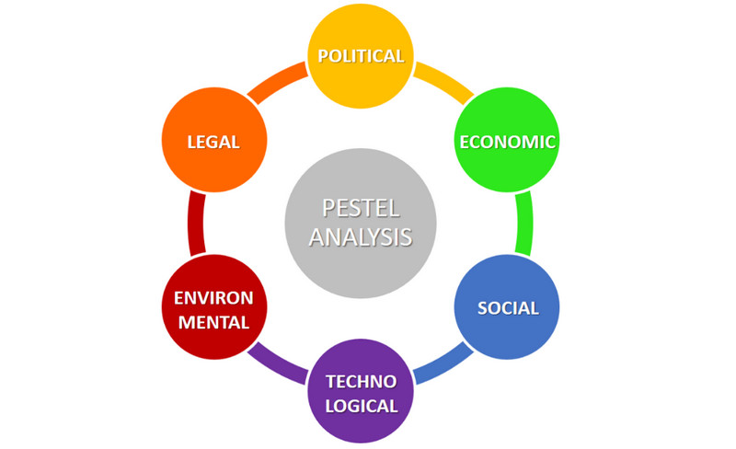

- POLITICAL FACTORS: In the 21st century, the UK is a parliamentary democracy. The UK is a constitutional monarchy. This means that the monarch has a relatively ceremonial role in the country's political life. The Prime Minister is the head of government. The UK's main political parties are Labor, the conservative party, the liberal Democrats and the Scottish Nationalist party whereas, In China, the ruling Communist Party has political power, but there is no political freedom. Political tension with the US, protests in Hong Kong and disputes in the South China Sea can cause business uncertainty. Government regulation and international politics, such as trade wars, can also significantly affect the business environment(linkedin.com).

- ECONOMIC FACTORS: The UK is a robust and diversified economy, with an emphasis on finance, manufacturing and innovation. Brexit, exchange rate, and labor cost can have a significant impact on businesses working in the UK.(paydata.co.uk) On the other hand, China has one of the biggest and fastest growing economies in the world. Exchange rate, labor cost, trade policy, and government support for state-owned enterprises can have a significant effect on business operations in the country. China's rapid economic growth and dynamic market make the country an attractive but challenging environment for businesses.(edrawmax.com)

- SOCIAL FACTORS: The UK is a diverse and multicultural society with a strong focus on consumer rights and data protection, as well as social stability. The ageing of the population and the growing consumer purchasing power are other key social factors that affect businesses. On the other hand, China has a large population, growing consumer purchasing power and cultural influences. The country’s focus on environment issues and its entry into the electric vehicle market are other key social dynamics that affect businesses. The cultural and social dynamics in China are very important for HR professionals to understand.

- TECHNOLOGICAL FACTORS: The UK has a well-developed technology infrastructure and is an innovation powerhouse. The country has a strong focus on technological innovation, digitalization, and R&D, which can have a significant impact on businesses across various industries. China is well-known for its fast-paced technological development and government-driven innovation. China’s focus on science & technology, online shopping, and domestic tech giants have a huge impact on businesses and their technology strategies. HR professionals need to adjust to the technological environment and incorporate technology into their HR processes.

- LEGAL FACTORS: In the UK, the legal framework is very strong and businesses need to comply with various laws and regulations. Factors such as labor standards, immigration policy, and policy changes have a big impact on business and their HR practices. In contrast, China has a very complex legal framework that governs business and employment practices in the country. Labor standards, remuneration of employees, and law interpretation are some of the issues businesses face. The country’s legal environment and the risk of corruption can affect business activities and risk management plans. HR professionals must have an in-depth knowledge of employment laws and regulations in China.

- ENVIRONMENTAL FACTORS: Sustainability, Renewable Energy, and Environmental Regulations are some of the environmental factors that UK businesses need to consider. While the UK is facing environmental challenges, its tourism industry is thriving and attracting tourists from all over the world. On the other hand, China’s environmental factors, such as pollution control measures, environmental legislation, and the focus on sustainability, is a major concern for UK businesses operating in China. Businesses in China need to comply with the country’s environment laws and regulations in order to carry out their operations. HR professionals in the UK also need to think about environmental factors that relate to the health and safety of their employees.(edrawmax.com)

- DIFFERENCE IN WORK CULTURE ACROSS UNITED KINGDOM AND CHINA
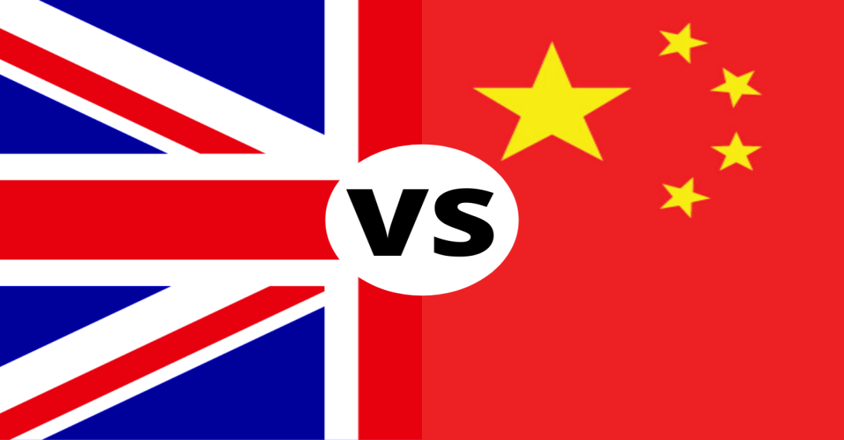
The biggest surprise in terms of work and employment is that shops are closing so early, at different times of the day. For example, Churchill Square is closed from Monday to Wednesday, Friday and Saturday at 6 pm, Thursday at 8 pm, and Sunday at 5 pm. We have found this so amazing so far.
In China, almost every shop opens and closes the same time each day, and the opening time is much longer. We think it’s a bit inconvenient that the opening times vary on different days because it’s hard for people to remember them, especially new ones. We also think that business is more about making more money, so the longer the opening hours the better.
The thing that strikes me the most is, when it comes to closing time, when it’s time to close, the clerks remind the customers, and they don’t hesitate for a minute. That’s very interesting.
Britons have more free time than Chinese They can sit in the bar with their friends and family and enjoy each other’s company. On the other hand, Chinese are more focused on earning more money, even if it means working overtime and spending less time with family and friends.
I’m a big fan of how the Brits manage to balance work and life, and I hope more Chinese will see the value of balancing work and life and appreciate life more, rather than just focusing on making money.
There are significant disparities in working life between the United Kingdom and China in several areas. The primary points about the discrepancies may be summarized into following points :
- WORKING DURATION
To begin, working hours are perceived differently in the United Kingdom and China. Working hours are largely fixed in the UK, and incidents of employees working past their working hours are unusual, and even on these occasions, they are compensated for overtime. In China, on the other hand, although employees have defined contractual hours, examples of employees remaining past their allocated hours without additional pay are prevalent.
- MANAGEMENT STYLES
Management styles differ in the United Kingdom and China. In particular, in the United Kingdom, the majority of managers use democratic and participatory management styles, and delegate some decision-making authority to their subordinates by including them in the decision-making process. In an eastern nation like China, on the other hand, managers have a paternalistic and authoritative management style, and employees are rarely involved in decision making (Wood, 2009).
- MOTIVATIONAL DISPARITIES
There are motivational disparities between UK and Chinese managers. Financial incentives are often regarded as one of the most effective motivating techniques in UK organizations. On the other hand, "while additional money may motivate Chinese employees, it is unlikely that demand will rise directly." The Chinese, as members of a collectivist culture, are more prone to regard success or failure as a communal endeavor, leading to group recognition and increases rather than individual incentives" (Silvermore, 2005, p.116).
- DIFFERENCES IN DURATION OF EMPLOYMENT
There are significant disparities in job length between the UK and China. individuals in the United Kingdom frequently change jobs every few years due to changes in conditions and individuals' eagerness to participate in a variety of activities. In China, on the other hand, there is a contrasting scenario in which individuals tend to work in the same firm for many years, and examples of lifelong employment in the same company are not uncommon.
- MASCULINE AND FEMININE
Chinese and British ethnic groups stress both masculine (assertiveness, independence) and feminine (interpersonal relationships) elements of work values, while the meaning of feminine work values differs for each groups. The patterns of male work values match the results of the extrinsic component of work values, with Chinese respondents giving somewhat greater attention to masculine work values such as assertiveness, independence, and emphasis on material lives. This might be explained by the varied socioeconomic environments in which they grew up, as well as the modernization thesis. Both groups place a premium on interpersonal ties in the feminine dimension of job values. The interpersonal relationship, according to the Chinese respondents, suggests that they must maintain excellent ties with individuals from whom they may benefit in the future (Guanxi in Chinese). In contrast, interpersonal relationships imply that the British must properly collaborate with their commercial partners. While interpersonal relationships appear to be an important route to "money" and "achievement," most British respondents emphasize the intrinsic rather than the extrinsic components of collaboration. In other words, they regard collaboration as a worthwhile characteristic rather than a means. As a result, it appears that the means-end link between masculine and feminine labor ideals is weaker among British respondents.

- INTRINSIC-EXTRINSIC
The results show the importance of the social milieus where diverse work habits of both ethnic groups originated in the intrinsic-extrinsic dimension of work ideals. We discovered that, whereas the economic and social environment in which the Chinese respondents grew up has changed dramatically, the environment in which the British respondents live has remained relatively steady. Growing up amid the modernization process, Chinese respondents' demands for improved living conditions are unprecedentedly high, fueled further by their want to improve the lives of their family members. Such goals have encouraged them to work extremely hard and to place a greater emphasis on the extrinsic parts of their jobs. While they have transferred to a new workplace, their work habits have not altered totally and continue to impact their work ideals and attitudes. In contrast, British respondents in a relatively stable post-industrialization period show significantly fewer intense cravings for material lives than their Chinese counterparts. While they may be driven to work hard by personal desire, their work ethic is less than that of Chinese respondents.
We discovered that British respondents are more willing to take entrepreneurial risks and devote more effort to entrepreneurial activities in the uncertainty avoidance-entrepreneurial risk dimension of work values, which was driven by their personal interest, self-actualization, and pursuit of better material lives. Many of our Chinese respondents have been discouraged from engaging in various entrepreneurial activities due to structural constraints, particularly cultural barriers. They value stability in their life, favor low-cost companies, and attempt to avoid large entrepreneurial risks. In contrast, British respondents who live in the UK naturally have more entrepreneurial advantages than Chinese respondents, such as access to social networks. Thus, as compared to Chinese respondents, British respondents appear to place a greater emphasis on individual efforts and entrepreneurial risks.
- EMPLOYMENT CONTRACT
In China the parties to an employment contract are mostly free to negotiate economically relevant terms, while the ECL requires that the following major issues be addressed:
Employee's name, domicile, and identity card (or other valid identity document) number; term of employment; job description and place of work; working hours (generally no more than eight hours per day and forty hours per week), rest time, and holidays (up to 15 days' allowance per year, beginning after the first year of employment); pay; social insurance; labor protection, working conditions, and protection against occupational hazards; and other matters, as required by laws and regulations.
Employment contract parties are often allowed to negotiate reasonable conditions, as is the case in China whereas in UK there are no specific rules governing content if an employee has been provided with written Particulars of Employment, except that some minimum statutory requirements can override contractual provisions in relation to matters such as pay, working hours, and notice periods.
Furthermore, both employers and workers should be aware that some provisions are implicit in all employment contracts. Employees, for example, must use reasonable care and competence, follow reasonable commands, and not leak sensitive information or work for rivals. Employers, for their part, must maintain a trusting and confident relationship with their employees.
- MATERNITY AND PATERNITY
Female employees are entitled to 98 days (14 weeks) of maternity leave, with 15 days available shortly before the child's birth. In the event of pregnancy difficulties, this 15-day period may be prolonged. Female employees are entitled to full salary and are immune from contract termination during their maternity leave. Mothers are also entitled to one hour of leave per day (per kid) for nursing throughout the first year of the child's life. In China, there is no statutory paternity leave. Depending on local legislation, dads may be entitled to one or two days of paid leave in specific instances.
In UK if a woman has worked for her employer for a continuous period of 26 weeks, she is entitled to 39 weeks of 'Statutory Maternity Pay' (SMP). The 26-week period must have elapsed by the time a woman reaches the end of the 15th week before the projected week of labor. In this briefing, we will not go into the intricate factors that influence maternity pay rates. Fathers are also eligible for two weeks of paternity leave, which can be taken in any order within 56 days of the child's birth. In many situations, employees will also be entitled to statutory paternity leave for two weeks. When a woman returns to work following OML, the father is entitled to 26 weeks of Additional Paternity Leave, subject to certain criteria. Employers should be informed that new parental rights guidelines were implemented in October 2014 for newborns whose projected due date is on or after April 5, 2015. In general, they will allow parents to share the statutory maternity leave and pay that was previously solely accessible to mothers and will eliminate Additional Paternity Leave.
6.1 MANAGEMENT OF HUMAN RELATIONSHIP ACROSS DIFFERENT COUNTRIES
Managing human interactions across distinct workplace cultures in the UK and China necessitates a thorough awareness of the two nations' cultural and institutional variations. Here are some fundamental practices for managing human interactions effectively across these varied working cultures:
- CULTURAL SENSITIVITY AND AWARENESS:
Human resource managers must promote cultural sensitivity and awareness among personnel working in both the United Kingdom and China. This includes cross-cultural training, fostering open communication, and encouraging respect for other cultural norms and customs.
- ADAPTATION OF HR PRACTICES:
It is critical to adapt HR practices to each country's cultural and institutional framework. In China, for example, where collectivism and individuality coexist, HR methods should be customized to foster cooperation, collaboration, and employee participation. In the United Kingdom, where the culture is more individualistic, HR methods may emphasize autonomy and personal accomplishment.

- GUANXI AND RELATIONSHIP BUILDING: Guanxi, or the development of strong interpersonal ties, is an important idea in China. HR managers should realize the importance of guanxi and encourage the formation of strong ties among workers. Building professional relationships based on trust and mutual respect should be prioritized in the United Kingdom.
- COMMUNICATION AND CONFLICT RESOLUTION: Effective communication is essential for managing human connections in diverse working cultures. Human resource managers should promote open and honest communication techniques while keeping language and cultural limitations in mind. Furthermore, they should be prepared to discuss and resolve problems that may emerge as a result of cultural differences.

- TALENT MANAGEMENT AND DEVELOPMENT:
It is critical to tailor talent management and development programs to each country's cultural and institutional situation. This includes recognizing and rewarding culturally relevant actions and achievements, as well as offering culturally relevant training and development opportunities.

- RESPECT FOR DIVERSITY:
Foster an inclusive workplace that supports variety and values variations in opinions, work habits, and communication styles.

- FEEDBACK PROCESS:
The UK prioritizes open 360-degree input at all levels focused on progress, but China maintains a top-down approach with less openness. Encouraging constructive feedback and ensuring two-way coaching can assist.

To manage human interactions effectively across multiple workplace cultures, a mix of cultural knowledge, flexibility, and proactive HR initiatives is required. HR professionals may contribute to a happy and productive multicultural work environment by recognizing and accepting cultural differences, supporting open communication, and modifying policies to meet the unique elements of each culture.

- CONCLUSION
Finally, managing the intricacies of International Human Resource Management (IHRM) while relocating from the United Kingdom to China necessitates a thorough awareness of current and ethical concerns, the institutional landscape, and cultural variations. Because of the dynamic interaction of legal frameworks, cultural subtleties, and various workplace practices, HR directors must take a strategic and culturally aware approach.
Modern difficulties, including as cultural sensitivity and regulatory compliance, as well as worldwide talent acquisition challenges, need flexible and adaptive HR strategies. Respecting human rights, maintaining fair remuneration methods, and ensuring openness and honesty are all ethical issues that highlight the need of aligning HR processes with globally accepted norms.
Analyzing institutional structures in both the United Kingdom and China emphasizes the importance of legislative frameworks, government-led initiatives, and trade unions in defining HR practices. It is critical to tailor HR policies to these institutional differences in order to maintain a healthy work environment.
Workplace cultural differences, particularly in communication methods, work hierarchy, and decision-making processes, bring both obstacles and possibilities. HR directors should embrace cultural sensitivity training, harness cross-cultural communication platforms, and develop localized HR policies to successfully manage human interactions. Leadership development programs, mentorship efforts, and frequent feedback mechanisms all help to the formation of an international team that is cohesive and collaborative.
In summary, successful human resource management in an international environment necessitates ongoing learning, adaptation, and a commitment to creating an inclusive and culturally conscious workplace. HR executives may contribute to the creation of a cohesive, productive, and morally sound global workforce by tackling modern concerns, comprehending institutional arrangements, and proactively managing cultural variations.

- REFERENCE

- (All-China Federation of Trade Unions, "About ACFTU").
- (Ministry of Human Resources and Social Security).
- (PDF) Impact of Globalization on Human Resource Management. Available from: https://www.researchgate.net/publication/339636102_Impact_of_Globalization_on_Human_Resource_Management [accessed Dec 06 2023].
- (Smith and Thompson, 1998 The International Journal of Human Resource Management568-70).
- (UK Government, "Employment rights and conditions").
- Adler, NJ & Gundersen, A, 2008, International Dimensions of Organisational Behaviour, Cengage Learning
- Benson, J., Zhu, Y. & Morgan, G.(2018). Green Shoots: Human resource management with Chinese characteristics in the 21st century. Human Resource Management, 57(4), 983-1004
- Cooke, F.L. (2014). Chinese multinational firms in Asai and Africa: Relationships with instutional actors and patterns of HRM practices. Human Resource Management, 53(6), 877-896
- Dowling, P. J., Festing, M., & Engle, A. D. (2008). "International Human Resource Management."
- French W. L. (1997). "Human Resource Management" Third Edition, Houghton Mifflin Company, U.S.A. ISBN No. 0-395-47278-4 pp. 44-63
- Gary Dessler (2012) “ Human Resource Management” Book January 2012
- Harzing, A. W., & Pudelko, M. (2016). "Do we need to distance ourselves from the distance concept? Why home and host country context might matter more than (cultural) distance."
- Hofstede's cultural dimensions theory (Hofstede, 2001)
- https://committees.parliament.uk/publications/7214/documents/75842/default/
- https://onlinelibrary.wiley.com/
- https://smallbusiness.chron.com/ethical-issues-human-resource-management-multinational-corporations-55821.html
- https://www.edrawmax.com/article/china-pestel-analysis.html
- https://www.lancaster.ac.uk/fass/projects/ndcc/download/uk-and-china.pdf
- https://www.linkedin.com/
- https://www.oysterhr.com/library/the-most-pressing-challenges-of-international-hr-and-how-to-solve-them
- https://www.paydata.co.uk/hr-hub/blogs/how-to-do-a-pestle-analysis-for-your-human-resources-planning/
- Liu & Yu Dowling, 2016
- Mondy R. W., Noe R. M., and Premeaux S. R. (1999). "Human Resource Management" Seventh Edition, Prentice Hall International, Inc., ISBN 0-13-096201-5.
- Silvermore, CP, 2005, Organisational Psychology in Cross-Cultural Perspective, NYU Press
- Stephen Frenkel, David Robert Peetz (1998) “Industrial Relations A Journal of Economy and Society Ar’ticle July 1998
- UK government “Equality Act 2010”
- Wang, X. (2022). Employment Bonds, Worker Surveillance, and the Law in China. ILR Review, 75(5), 1220-1246
- Wood, G, 2009, Human Resource Management: A Critical Approach, Taylor & Francis
- Zhu, C. J., Thomson, S.B., & De Cieri, H. (2014). A retrospective and prospective analysis of HRM research in Chinese firms: Implications and directions for future study. Human Resource management, 53(1), 133-156.

