https://pesacheck.org/altered-this-image-of-the-front-cover-of-the-economist-newspaper-is-doctored-cb261a179557 (Retrieved 09-11-23)

ALTERED: This image of the front cover of the Economist newspaper is doctored

The legitimate front cover of the magazine carries an image of Italy’s former Prime Minister, Silvio Berlusconi, not Kenya’s Deputy President William Ruto.
·
Apr 23, 2021

A tweeted image claiming to show Kenya’s Deputy President William Ruto on the front cover of the June 11–17, 2011, edition of The Economist newspaper is ALTERED.
The headline reads, “The man who screwed an entire country”, with the front cover of the international weekly newspaper promising “a 14-page special report on William Ruto Kenya”.
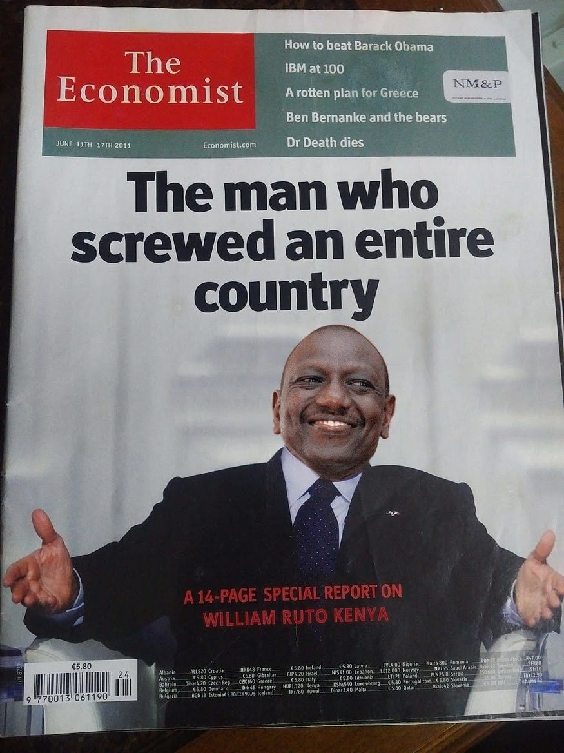
A reverse image search of the newspaper’s cover reveals it was Italy’s former Prime Minister, Silvio Berlusconi, and not DP Ruto, who featured on the June 11–17, 2011 edition of the Economist.
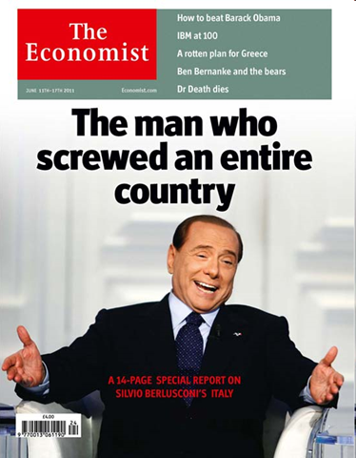
In that particular issue, the newspaper shared a 14-page special report on Mr Berlusconi.
The headline of the original copy and the story highlights of the original cover are the same as those on the altered cover.
The second longest-serving prime minister in Italy after Benito Mussolini, Berlusconi’s tenure spanned 17 years. The special report of the June 11–17, 2011 edition of the Economist examines the economic state of Italy during Mr Berlusconi’s tenure as prime minister and the state of the critical state of the public debt.
PesaCheck has looked into a tweet with an image claiming to show Deputy President William Ruto on the front cover of the Economist newspaper June 11–17, 2011 edition and finds it to be ALTERED.
This post is part of an ongoing series of PesaCheck fact-checks examining content marked as potential misinformation on Facebook and other social media platforms.
By partnering with Facebook and similar social media platforms, third-party fact-checking organisations like PesaCheck are helping to sort fact from fiction. We do this by giving the public deeper insight and context to posts they see in their social media feeds.
Have you spotted what you think is fake news or false information on Facebook? Here’s how you can report. And, here’s more information on PesaCheck’s methodology for fact-checking questionable content.

