Student Name: Stefani Alenova Stefanova
Student Number 2028009
Lecture Name: Amitave Banik
Module Code: LCBB5000
Module Name: Data Handling and Business Intelligence
Submission Date: 02/09/2022

LCBB5000 DATA HANDLING & BUSINESS INTELLIGENCE (ASSIGNMENT 1)

Current Trends of Business Intelligence

Executive Summary
In this report, a brief description of "Business Intelligence (BI)", and the current trends associated with it, have been discussed properly. In this report, five current trends have been selected based on "Business Intelligence (BI)" such as "Artificial Intelligence in data warehousing", “Collaborative Business Intelligence”, “Data Quality Management and Data Mining”, “Predictive & Prescriptive Analytics by using Big Data” and “Natural Language Processing (NLP)”. Moreover, five current BI tools that are used in business operations, such as Loop, “Microsoft Power BI”, Domo, Tableau and “Oracle Analytics Cloud (OAC)” have been described. All of these technologies ensure “Predictive Analytics (PA)” technologies in a business organisation by which the management of the business organisation can improve their inventory management and decision making which increase their revenue generation.

Table of Contents
Introduction 4
Discussion 4
“Identify and critically evaluate the current trends in data warehousing, business intelligence, and data mining” 4
Trend 1: “Artificial Intelligence in data warehousing” 4
Trend 2: “Collaborative Business Intelligence” 5
Trend 3: “Data Quality Management and Data Mining” 6
Trend 4: “Predictive & Prescriptive Analytics by using Big Data” 6
Trend 5: “Natural Language Processing (NLP)” 7
“5 current Business Intelligence Tools and their usage” 8
“Demonstrate a comprehensive knowledge and systematic understanding of essential concepts and principles, by using predictive analytic software” 8
Conclusion 9
Reference List 10
Appendix: Increasing market growth of “Natural Language Processing (NLP)” 12

Introduction
“Business Intelligence (BI)” refers to the technical and procedural infrastructure that collects, gathers and critically analyses the information produced by the activities of a particular organisation. “Business Intelligence (BI)” is associated with descriptive analytics, performance benchmarking, process analysis and data mining. “Business Intelligence (BI)” tools and associated software come in a large variety of forms such as "online analytical processing (OLAP)", "data mining tools", "data visualisation software", and "reporting/query software", "spreadsheets". In this report, five current trends have been selected based on “Business Intelligence (BI)” such as “Artificial Intelligence in data warehousing”, “Collaborative Business Intelligence”, “Data Quality Management and Data Mining”, “Predictive & Prescriptive Analytics by using Big Data” and “Natural Language Processing (NLP)”.

Discussion

“Identify and critically evaluate the current trends in data warehousing, business intelligence, and data mining”

Trend 1: “Artificial Intelligence in data warehousing”
As per the observation of Berhil et al. (2020), appropriate product slotting puts an impact on the productivity of labour and their accuracy. Old "slotting solutions" need extensive engineering and customised models and "measurement and data collection". “Artificial Intelligence (AI)” can eliminate a lot of engineering work as well as warehouse mapping manually, which are needed for traditional slotting systems. An “Artificial Intelligence (AI)” can smoothly run simulations in order to determine the best ways of finishing a task and removing the unnecessary delays and ensuring the most efficient utilisation of workers (Berhil et al. 2020).
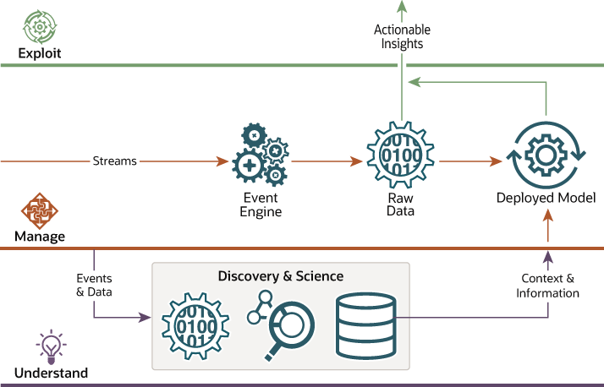
Figure 1: “Artificial Intelligence in data warehousing”
(Source: Influenced by Sun and Li, 2020)
“Artificial Intelligence (AI)” technology is based on “real-world performance data”, gathered from within the business operation associated with various operations such as “quantity to be handled”, “product to be handled”, “ending travel location”, “starting travel location”, work area and work type (Sun and Li, 2020). Workers associated with warehouses generally spend a lot of time of their workday travelling within a facility developing travel decrementing a way to enhance productivity. “Artificial Intelligence (AI)” and automation both can eliminate travelling issues associated with data warehouse management.

Trend 2: “Collaborative Business Intelligence”
In this era of digital transformation, workers and managers are required to communicate differently as they work in a competitive environment. “Collaborative Business Intelligence” can be considered as a combination of “collaborative tools” associating 2.0 technologies and social media with online BI tools. “Collaborative Business Intelligence” enables for setting up "business intelligence alerts" as well as sharing of embedded or public dashboards with a flexible level of communication. As per the illustration of Teruel et al. (2019), three main features are associated with “Collaborative Business Intelligence” such as “collaborative decision-making”, “information enhancement” and “collaborative information”.
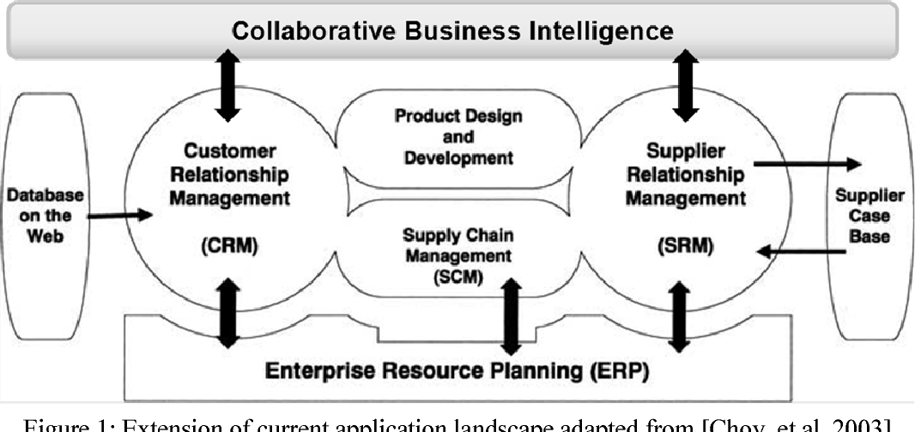
Figure 2: “Collaborative Business Intelligence”
(Source: Adapted from Teruel et al. 2019)
As per the argument of Rikhardsson and Yigitbasioglu (2018), “Collaborative Business Intelligence” does not only remain around the exchange of documents and updates. In this new era, the "Collaborative Business Intelligence '' have new responsibilities for tracking the different progress of meetings, collecting of ideas, exchange of emails and calls.

Trend 3: “Data Quality Management and Data Mining”
As per the statement of Rikhardsson and Yigitbasioglu (2018), “Data Quality Management and Data Mining” is beneficial for a particular business organisation because the management of the business organisation can develop the right “data-driven decision” though utilising the appropriate information in order to their analytical purpose. Various negative factors can be associated with bad quality of data such as poor estimation and costing, poor understanding of customer behaviour and business process and action making. Various associate software such as Sisense, Tableau, and "SAP Business Intelligence" can be beneficial in order to proper quality management and mining of collected data for a particular business organisation (Sun and Li, 2020). Business Intelligence is beneficial for providing easy access to both unstructured and structured data, and they have the ability to develop and manage “data engineering pipelines”.

Trend 4: “Predictive & Prescriptive Analytics by using Big Data”
As per the analysis of Yan et al. (2017), “Big Data and Predictive Analytics processing” is beneficial for knowing future market conditions by collecting current data and analysing them. As per the observation of Dubey et al. (2019), “Institutional Theory of Management” can be beneficial for a particular business organisation in terms of improving business operation efficiencies by implementing the “Big Data culture" which promotes “Predictive Analytics (PA)”. Big Data technology and related tools can be used in order to understand the data, data mining, text analysis, analysis of the collected information and Big Data insights.
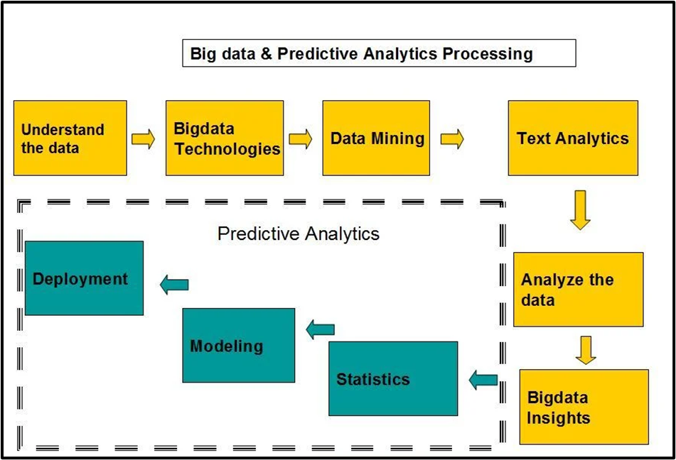
Figure 3: “Big Data and Predictive Analytics processing”
(Source: Influenced by Yan et al. 2017)
As per the viewpoint of Salas-Rueda and Salas-Rueda (2021), the “Technology Acceptance Model” can be beneficial for implementing a particular technology which can fulfil two major factors such as “perceived usefulness” and “perceived ease of use”. It can be said that by proper implementation of “Big Data'' and “Predictive Analytics (PA)” technologies in a business organisation, the management can improve their inventory management and decision making which increases their revenue generation.

Trend 5: “Natural Language Processing (NLP)”
As per the current statistical data, it has been predicted that the growth of the “Natural Language Processing (NLP)” can reach $23999.1 million in 2022 to $43.289.9 million by 2025 [Refer to Appendix]. “Natural Language Processing (NLP)” can develop the connection between humans and computers through removing the requirement for any kind of programming language. This can allow us to connect with information through asking queries in an interacting format (Kang et al. 2020). So, it can be said that “Natural Language Processing (NLP)” enables associated softwares in order to generate concerns that are easy to understand, irrespective of technical skills.

“5 current Business Intelligence Tools and their usage”
Five current BI tools that are used in business operations are Loop, “Microsoft Power BI”, Domo, Tableau and “Oracle Analytics Cloud (OAC)”.
Loop: “Loop” can be considered as a mixture of “business performance management software” and “business intelligence software” which can increase the dashboard by providing access to information cataloguing and visualisation tools (Richardson et al. 2020).
“Microsoft Power BI”: “Microsoft Power BI” offers analytics, interactive dashboards, “visual-based data discovery” and data preparation and consists of a wide range of visual graphics.
Domo: Domo is a "cloud-based platform" which provides scalable and engaging visualisation along with mobile support and "advanced security features" (Chandra and Dwivedi, 2022).
Tableau: Tableau software is developed particularly enabling users to access present analysis and finding from their data with the "VizQL engine” (Richardson et al. 2020).
“Oracle Analytics Cloud (OAC)”: “Oracle Analytics Cloud (OAC)” is an "AI-powered solution" which provides both analytics and reporting features (Chandra and Dwivedi, 2022).

“Demonstrate a comprehensive knowledge and systematic understanding of essential concepts and principles, by using predictive analytic software”
Two most-used software for “Predictive Analytics (PA)” are “Apache CouchDB” and “Cassandra” (Richardson et al. 2020). Both of these software’s are used in order to collect the current industry data and customer data for the purpose of sorting and maintenance of the collected data, analysis and provide a visual representation of the data. This ensures the management of the business organisation can improve their inventory management process and decision making which in tun in beneficial for increasing their revenue generation. “Business Intelligence (BI)” tools such as data mining and data warehousing can be improved by future market prediction and collecting market data (Yan et al. 2017).

Conclusion
It can be concluded that “Business Intelligence (BI)” and associated software or tools such as Loop, “Microsoft Power BI”, Domo, Tableau and “Oracle Analytics Cloud (OAC)” are beneficial in order to store, maintaining and visual representation of information which can ensure business growth and revenue generation. Current “Business Intelligence (BI)” trends are beneficial for a particular business organisation in order to data warehousing and data mining.

Reference List
Berhil, S., Benlahmar, H. and Labani, N., 2020. A review paper on artificial intelligence at the service of human resources management. Indonesian Journal of Electrical Engineering and Computer Science, 18(1), pp.32-40.
Chandra, T.B. and Dwivedi, A.K., 2022. Data visualization: existing tools and techniques. In Advanced Data Mining Tools and Methods for Social Computing (pp. 177-217). Academic Press.
Dubey, R., Gunasekaran, A., Childe, S.J., Blome, C. and Papadopoulos, T., 2019. Big data and predictive analytics and manufacturing performance: integrating institutional theory, resource‐based view and big data culture. British Journal of Management, 30(2), pp.341-361.
Kang, Y., Cai, Z., Tan, C.W., Huang, Q. and Liu, H., 2020. Natural language processing (NLP) in management research: A literature review. Journal of Management Analytics, 7(2), pp.139-172.
Richardson, J., Sallam, R., Schlegel, K., Kronz, A. and Sun, J., 2020. Magic quadrant for analytics and business intelligence platforms. Gartner ID G00386610.
Rikhardsson, P. and Yigitbasioglu, O., 2018. Business intelligence & analytics in management accounting research: Status and future focus. International Journal of Accounting Information Systems, 29, pp.37-58.
Salas-Rueda, R.A. and Salas-Rueda, E.P., 2021. Analysis Of The Web Application On Bayes’theorem Considering Data Science And Technological Acceptance Model. Turkish Online Journal of Distance Education, 22(3), pp.55-78.
Statista, 2022. Revenues from the natural language processing (NLP) market worldwide from 2017 to 2025 [Online] Available at: https://www.statista.com/statistics/607891/worldwide-natural-language-processing-market-revenues/ [Accessed on: 10th July, 2022]
Sun, M. and Li, Y., 2020. Eco-environment construction of English teaching using artificial intelligence under big data environment. IEEE Access, 8, pp.193955-193965.
Teruel, M.A., Maté, A., Navarro, E., González, P. and Trujillo, J.C., 2019. The new era of business intelligence applications: Building from a collaborative point of view. Business & Information Systems Engineering, 61(5), pp.615-634.
Yan, J., Meng, Y., Lu, L. and Li, L., 2017. Industrial big data in an industry 4.0 environment: Challenges, schemes, and applications for predictive maintenance. IEEE Access, 5, pp.23484-23491.

Appendix: Increasing market growth of “Natural Language Processing (NLP)”
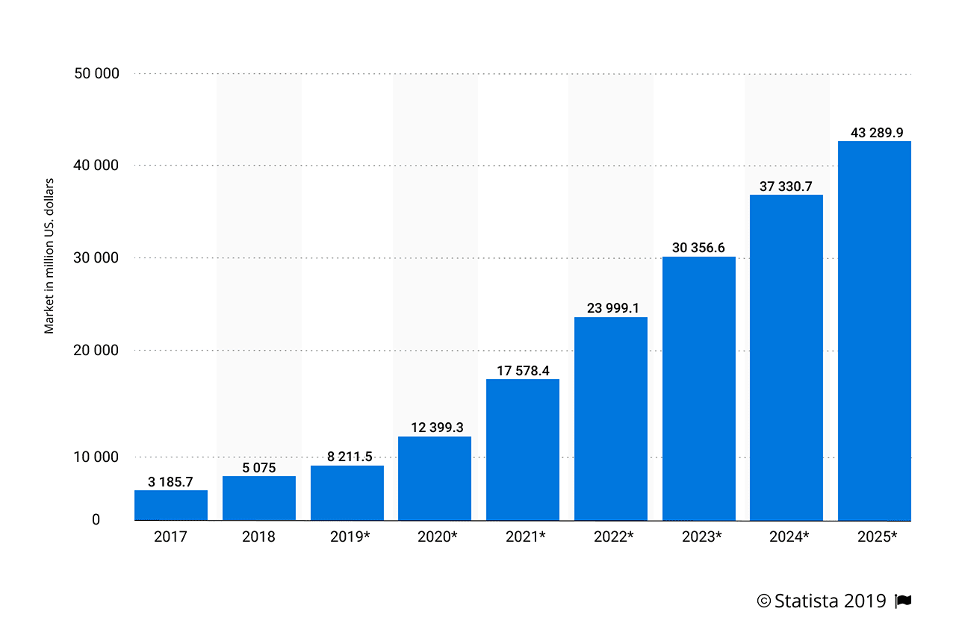
(Source: Statista, 2022)

