
Applied Leadership and Management in the Workplace
Module Assignment Submission
Student Name: | Whitney Davies
Student Number: | 2329046
Module No: | BMSK6010
Module Title: | Emotional Intelligence
Statement of Confirmation of Authenticity
By the act of making this submission, the student declares that this is the work of the student named above. The work has not, in whole or in part, been knowingly presented elsewhere for assessment, or where assessment has been built on a previous assessment, this has been identified. Where materials have been used from other sources it has been properly acknowledged. If this statement is untrue, the student acknowledges that an assessment offence has been committed.
Attention is drawn to the plagiarism and unfair practice policies of both the University and of ILM.

Table of Contents
Introduction 3
Critically Assessing Goleman's Six Leadership Styles 3
Introduction to Goleman's Six Leadership Styles 3
Goleman's Six Leadership Styles and Individual Workplace Performance 4
Critical Assessment of Goleman's Ability to Influence Individual Workplace Performance 5
Overall Judgement 6
Evaluation of Personal Leadership Style 6
Introduction 6
Evaluation of Leadership Style 7
Evaluation of Leadership Skills 7
Critical Reflection on the Evaluation Process 8
Evaluation of Leadership Capabilities 9
Introduction 9
Evaluating the Ability to Set Direction 9
Evaluating the Ability to Motivate Others 10
Evaluating the Ability to Delegate and Empower Others 10
Overall Reflection on Leadership Capabilities 11
Conclusion 11
References 13
Appendix A – Leadership Styles Questionnaire 15
Appendix B – Leadership Skills Questionnaire 18
Appendix C – Reflective Mapping Table 22
Appendix D – Personal Development Action Plan 1

Introduction
Leadership theories provide valuable frameworks for understanding how leaders influence individuals and organisational performance; however, they should not be accepted as definitive explanations of effective leadership simply because they are well established. Organisations are continually evolving through technological advancement, changing workforce expectations, increasing diversity and new ways of working. Therefore, leadership models developed within different organisational contexts should not be assumed to remain universally applicable. Established practice should not be mistaken for best practice, making it necessary to continually evaluate whether leadership theories continue to reflect the realities of contemporary organisations.
This report argues that the value of leadership theories lies in supporting professional judgement rather than prescribing leadership behaviour. Effective leadership is unlikely to result from consistently applying a preferred leadership style; instead, it requires leaders to critically evaluate organisational circumstances, understand the needs of the individuals they lead and determine which behaviours are most appropriate for achieving organisational objectives. Leadership theories therefore provide valuable guidance, informing decision making whilst encouraging leaders to apply critical thinking rather than relying upon predetermined approaches.
To explore this argument, the report critically assesses Goleman's (2000) Six Leadership Styles in relation to its ability to influence individual workplace performance, evaluating both its strengths and limitations through comparison with contemporary leadership literature. The report then evaluates personal leadership style and leadership capabilities using recognised leadership questionnaires, workplace experience and critical reflection. Throughout the discussion, it is argued that whilst leadership theories remain valuable, successful leadership ultimately depends upon a leader's ability to question assumptions, adapt appropriately and continually evaluate whether established practices remain suitable for the people and organisations they serve.

Critically Assessing Goleman's Six Leadership Styles

Introduction to Goleman's Six Leadership Styles
Leadership literature offers numerous theories seeking to explain how leaders influence organisational performance, including transformational, servant and situational leadership. Whilst each contributes valuable insights, Goleman's (2000) Six Leadership Styles was selected because it challenges the assumption that effective leadership can be reduced to a single behavioural approach. Instead, Goleman argues that successful leaders demonstrate emotional intelligence and behavioural adaptability, selecting different leadership styles according to workplace context.
This emphasis on adaptability initially appears particularly relevant within contemporary organisations, where leaders must respond to rapidly changing business environments, increasingly diverse workforces and evolving employee expectations. Rather than suggesting one leadership style consistently produces superior outcomes, Goleman's framework recognises that successful leadership requires flexibility and judgement.
However, this also raises an important question. If leadership effectiveness depends upon selecting the most appropriate leadership style, how accurately can leaders interpret the operational environment? Furthermore, can leadership behaviour alone explain improvements in individual workplace performance, or are wider organisational factors equally influential? These questions provide the foundation for the following critical assessment.

Goleman's Six Leadership Styles and Individual Workplace Performance
Goleman (2000) argues that leadership effectiveness is underpinned by emotional intelligence, proposing that leaders who are able to recognise and regulate both their own emotions and those of others are better positioned to influence employee behaviour and organisational performance. Building upon this foundation, he identifies six leadership styles: coercive, authoritative, affiliative, democratic, pacesetting and coaching. Instead of proposing a universally effective leadership style, the framework argues that leaders should adapt their behaviour according to the demands of the situation, the needs of employees and wider organisational objectives. The central contribution of the model is not the identification of six distinct leadership styles, but the rejection of a one-size-fits-all approach to leadership.
This represents a significant strength because organisations rarely operate within predictable environments where a single leadership approach consistently produces positive outcomes. Employees differ in their knowledge, confidence, motivation and experience, whilst organisational priorities continually evolve in response to internal and external pressures. Therefore, leadership that remains fixed regardless of circumstance risks becoming ineffective. Goleman's recognition that leaders should adapt their behaviour according to organisational need provides a more realistic interpretation of leadership than theories implying one preferred style should be consistently applied.
The framework is further strengthened by its emphasis on emotional intelligence. Beyond the exercise of authority, Goleman argues that effective leaders understand how their behaviour influences organisational climate, employee engagement and ultimately workplace performance. Research continues to demonstrate positive relationships between emotionally intelligent leadership, employee engagement and organisational outcomes, suggesting that leaders who demonstrate empathy, self-awareness and effective relationship management are more likely to create environments in which employees perform effectively (Coronado-Maldonado & Benítez-Márquez, 2023; Bonini et al., 2024). This evidence supports Goleman's argument that leadership extends beyond technical competence and requires an understanding of the people being led.
However, whilst Goleman's framework provides a persuasive explanation of how leadership behaviours may influence employee performance, the relationship appears considerably more complex than the model suggests. Leadership undoubtedly shapes organisational climate, yet employee performance is also influenced by organisational culture (Schein & Schein, 2021), workload, reward systems, available resources, individual capability and organisational strategy. Attributing workplace performance primarily to leadership behaviour therefore risks oversimplifying organisational reality, as leaders may demonstrate highly effective behaviours yet still fail to achieve high performance where organisational systems prevent employees from working effectively.
This observation does not weaken Goleman's framework; instead, it highlights an important distinction between influence and control. Leaders influence workplace performance, but they rarely determine it independently. The framework therefore provides a valuable explanation of one important contributor to organisational performance rather than a complete explanation of why individuals succeed or fail within organisations. Its value lies in encouraging leaders to recognise that their behaviour matters whilst acknowledging that leadership operates alongside wider organisational systems rather than above them.

Critical Assessment of Goleman's Ability to Influence Individual Workplace Performance
The greatest strength of Goleman's framework lies in its challenge to traditional assumptions regarding leadership. Rather than asking leaders to identify their preferred leadership style and apply it consistently, the model encourages leaders to evaluate the challenges they face before determining how they should respond. This represents a significant shift from leadership as behavioural consistency towards leadership as informed judgement. In practice, this reflects the reality that organisational challenges rarely present themselves in identical forms and therefore cannot reasonably be expected to require identical leadership responses.
Nevertheless, the framework also assumes leaders possess the ability to accurately diagnose organisational circumstances before selecting an appropriate leadership style. This assumption is arguably more problematic than the framework itself acknowledges. Leadership decisions are frequently made under conditions of uncertainty, incomplete information and competing stakeholder expectations. Leaders may correctly recognise that different situations require different approaches whilst simultaneously misinterpreting the situation itself. For this reason behavioural adaptability alone cannot guarantee leadership effectiveness if the judgement underpinning that adaptability is flawed.
Yukl (2013) argues that leadership effectiveness cannot be explained solely through leader behaviour because organisational performance is influenced by multiple interacting variables, including organisational systems, follower characteristics and external environmental factors. Conversely, Judge and Piccolo's (2004) meta-analysis found strong relationships between transformational leadership and organisational effectiveness. Taken together, these perspectives suggest that leadership behaviour is important but insufficient in isolation. Goleman's framework therefore appears strongest when integrated with wider leadership thinking rather than applied as a comprehensive explanation of workplace performance.
The framework should also be considered in relation to contemporary organisational practice. Since its publication, organisations have experienced significant change through hybrid working, digital communication, greater workforce diversity and increased recognition of employee wellbeing. These developments do not invalidate Goleman's framework; instead, they arguably strengthen one of its central propositions that effective leadership requires continual adaptation as organisational circumstances evolve. More importantly, they raise a broader question regarding leadership theory itself. If organisations, employees and leadership expectations continue to evolve, it seems difficult to justify treating leadership theories as static explanations of organisational behaviour. Leadership theories should not become immune from critical evaluation simply because they remain influential. Instead, they should be continually reassessed to determine whether their underlying assumptions remain appropriate for contemporary organisational practice.
This is where the framework makes its most valuable contribution. Its importance lies less in providing six leadership styles than in encouraging leaders to avoid rigid thinking. This interpretation is consistent with Dinh et al. (2014), who argue that contemporary leadership research increasingly recognises leadership as a complex, context-dependent process requiring multiple theoretical perspectives rather than reliance upon a single explanatory model. Consequently, the real value of Goleman's framework lies not in providing definitive answers, but in encouraging leaders to exercise informed judgement when responding to organisational challenges.
The real lesson is not that leaders should memorise six behavioural approaches, but that they should remain sufficiently reflective to question whether their current approach continues to meet the needs of the organisation and the people within it. In this respect, the framework promotes leadership as a process of continual evaluation rather than behavioural consistency.
Ultimately, Goleman's Six Leadership Styles provides a valuable framework for understanding how leadership behaviours influence individual workplace performance. However, this critical assessment concludes that leadership effectiveness depends upon more than behavioural adaptability alone. Effective leadership also requires sound judgement, an appreciation of wider organisational systems and a willingness to question whether established leadership practices remain appropriate as organisations continue to evolve. Goleman's framework is best understood as a guide for informed leadership decision making rather than a definitive explanation of effective leadership.

Overall Judgement
Goleman's (2000) Six Leadership Styles remains one of the most influential contemporary leadership frameworks because it rejects the assumption that effective leadership can be achieved through the consistent application of a single leadership style. Its emphasis on emotional intelligence, behavioural adaptability and organisational climate provides leaders with a practical framework for understanding how leadership behaviours may influence individual workplace performance. However, this critical assessment has demonstrated that the framework should not be viewed as a comprehensive explanation of organisational performance. Leadership represents one important influence upon employee performance, but it operates alongside organisational culture, structural systems, individual differences and external organisational pressures. Goleman's greatest contribution lies not in providing six leadership styles, but in encouraging leaders to think beyond fixed models and recognise that effective leadership requires continual judgement rather than behavioural consistency.

Evaluation of Personal Leadership Style

Introduction
Critically assessing leadership theory provides only a partial understanding of effective leadership. Equally important is evaluating how leadership theories compare with personal leadership preferences and behaviours demonstrated within the workplace. To achieve this, the Leadership Styles Questionnaire and Leadership Skills Questionnaire (Northouse, 2022) were completed (see Appendices A and B). These questionnaires were selected because together they assess both preferred leadership behaviours and the competencies required to lead effectively.
However, whilst recognised leadership questionnaires provide a useful framework for self-reflection, they should not be interpreted as objective measures of leadership effectiveness. Leadership is influenced by organisational context, professional experience and how behaviours are perceived by others, none of which can be fully captured through self-assessment alone. The questionnaire findings are critically evaluated alongside workplace experience and academic literature rather than being accepted uncritically.

Evaluation of Leadership Style
The Leadership Styles Questionnaire identified a clear preference for democratic and coaching leadership behaviours (Northouse, 2022; see Appendix A). These findings were unsurprising because they closely reflect both personal leadership beliefs and workplace experience. Leadership is viewed less as directing employees towards predetermined solutions and more as creating opportunities for individuals to think independently and contribute confidently to decision making. This aligns with the democratic leadership style, which encourages participation, and the coaching leadership style, which focuses upon long-term development rather than immediate performance (Goleman, 2000).
Workplace experience provides further support for these findings. When training new colleagues, the priority has never been simply explaining how to complete a task correctly. Instead, the process begins by understanding what the individual already knows before explaining the wider purpose of the task and how it contributes to organisational objectives. Once this understanding has been established, increasingly complex responsibilities are introduced whilst gradually reducing support as confidence develops. This approach reflects the belief that employees are more likely to perform effectively when they understand why they are completing a task rather than simply being instructed how to complete it. Leadership is viewed as a process of developing understanding rather than controlling behaviour.
The questionnaire findings therefore reinforced an existing leadership philosophy rather than revealing unexpected behaviours. However, they also prompted critical reflection. A strong preference for collaboration and coaching may create a tendency to favour participation even in situations requiring more directive leadership. Whilst collaborative decision making often improves engagement, organisational crises, urgent operational decisions or inexperienced employees may require leaders to adopt a more authoritative approach. Therefore, effective leadership should not be judged by consistently demonstrating preferred behaviours, but by recognising when alternative leadership approaches better serve organisational objectives.
More importantly, the questionnaire highlighted that preferred leadership style should never become professional identity. Just as this report has argued that leadership theories should not be accepted without critical evaluation, leaders should also avoid assuming their preferred leadership style is appropriate in every circumstance. Self-awareness therefore involves recognising not only personal strengths but also situations where different leadership behaviours may produce better outcomes.

Evaluation of Leadership Skills
The Leadership Skills Questionnaire (Northouse, 2022; see Appendix B) identified interpersonal leadership skills as the strongest area of performance, particularly communication, supporting others and building positive working relationships. These findings again reflected workplace experience and were largely expected. Throughout professional experience, leadership opportunities have predominantly involved supporting colleagues, providing training and helping individuals build confidence rather than exercising formal authority. Interpersonal leadership has naturally developed through repeated practical application rather than theoretical understanding alone.

Communication emerged as a particular strength, reinforcing the belief that leadership extends beyond providing information and instead requires creating understanding. Workplace experience has demonstrated that employees often become more confident when leaders explain the purpose behind a task rather than simply outlining the process. This encourages individuals to make informed decisions independently when circumstances inevitably change, reducing reliance upon continual supervision. In practice, this has reinforced the view that effective communication is measured not by how clearly instructions are delivered, but by how confidently employees are able to apply their understanding without further guidance.
The questionnaire also highlighted strengths in supporting and developing others. Initially, these findings appeared unsurprising; however, further reflection suggested they stem from a broader leadership belief rather than individual behaviours alone. Leadership is viewed less as directing performance and more as creating opportunities for people to develop their own capability. This explains why coaching, delegation and empowerment have consistently emerged throughout both the questionnaire findings and workplace experience. Rather than solving problems on behalf of colleagues, there is a preference for helping individuals develop the confidence to solve future problems independently. From a leadership perspective, this represents a more sustainable contribution to organisational performance than simply achieving short-term results.
Despite these strengths, the questionnaire identified comparatively lower confidence within administrative and strategic leadership skills. Rather than interpreting these findings as weaknesses, they appear to reflect current professional experience. Opportunities to influence organisational strategy, communicate long-term vision or lead larger organisational initiatives have naturally been more limited than opportunities to coach colleagues on an individual basis. These findings should be viewed as identifying areas requiring greater exposure rather than deficiencies in leadership capability.
This distinction is important because leadership capability should not be evaluated solely according to current job responsibilities. Leadership questionnaires inevitably measure current experience as much as future potential. Therefore, whilst interpersonal leadership skills appear comparatively stronger at present, continued professional development should focus upon broadening strategic leadership experience without compromising the collaborative leadership philosophy demonstrated throughout this evaluation.

Critical Reflection on the Evaluation Process
Although both questionnaires provided a valuable framework for self-evaluation, they also demonstrated the limitations of relying upon self-assessment when evaluating leadership. Leadership is inherently relational, meaning effectiveness is determined not only by how leaders perceive themselves but also by how their behaviours influence the people around them. Self-assessment questionnaires cannot fully capture this complexity because responses are influenced by personal interpretation, previous experiences and individual self-awareness. They should therefore be viewed as tools for reflection rather than objective measures of leadership effectiveness.
This evaluation also reinforced the importance of critically interpreting questionnaire findings rather than accepting them at face value. Several results confirmed existing leadership preferences that had already become evident through workplace experience, whilst others prompted reflection regarding leadership situations that had not yet been encountered professionally. Viewed through this perspective, the findings should not be interpreted as fixed descriptions of leadership capability but as indicators of current leadership tendencies that will continue to develop through experience.
Perhaps the most significant learning from this evaluation was recognising that leadership development is not simply about strengthening existing abilities. Equally important is recognising when preferred leadership behaviours may become limitations if applied without sufficient consideration of organisational context. This reflects Schön's (1983) argument that professional judgement develops through critical reflection on experience rather than through the application of theoretical knowledge alone. Similarly, Kolb (1984) proposes that meaningful learning occurs when experience is followed by reflection, reinforcing the value of evaluating questionnaire findings alongside practical workplace experience rather than relying on self-assessment in isolation.
Throughout this report, the importance of questioning leadership theories has been repeatedly discussed. This evaluation suggests the same principle should also apply to personal leadership. Leaders should remain willing to question their own assumptions, challenge their preferred behaviours and adapt when organisational circumstances require alternative approaches. Self-awareness therefore involves more than recognising strengths and weaknesses; it requires continual reflection on whether existing leadership behaviours remain the most effective response to changing organisational needs.
A summary of the questionnaire findings, supporting workplace evidence and identified development priorities is provided in Appendix C.
Overall, the questionnaires provided a valuable starting point for self-evaluation, but workplace experience ultimately provided the greater insight. Leadership is demonstrated through behaviour rather than questionnaire scores, and this evaluation suggests a leadership approach characterised by communication, trust and developing others whilst recognising that continued growth depends upon expanding strategic leadership experience and remaining open to continual learning.

Evaluation of Leadership Capabilities

Introduction
Whilst leadership style reflects preferred behaviours, leadership capability concerns the practical application of those behaviours to influence workplace performance. This section evaluates the ability to set direction, motivate others, and delegate and empower colleagues by integrating workplace experience with leadership literature. Rather than assessing whether these capabilities are present in isolation, the evaluation considers how effectively they contribute to employee development and organisational performance, whilst identifying priorities for future leadership development.

Evaluating the Ability to Set Direction
Setting direction is often associated with communicating organisational objectives; however, effective direction requires more than simply telling employees what needs to be achieved. Locke and Latham (2002) argue that clear goals improve performance, yet workplace experience suggests that understanding the purpose behind those goals is equally important. Employees are more confident making decisions when they understand why a task matters rather than simply how it should be completed.
This has been reinforced through training new colleagues. Rather than beginning with instructions, training typically starts by identifying existing knowledge before explaining the wider objective of the task. Complex activities are then introduced gradually, with support reducing as confidence develops. This approach has consistently demonstrated that understanding promotes independence more effectively than instruction alone.
However, this evaluation also highlights a development need. Current experience has largely involved setting direction for individuals rather than communicating strategic direction across larger teams. As leadership responsibilities develop, greater experience will be required in translating organisational vision into clear objectives for multiple stakeholders. Consequently, setting direction is evaluated as a current strength in operational leadership whilst recognising that strategic leadership remains an important area for future development.

Evaluating the Ability to Motivate Others
One aspect of leadership literature that prompted the greatest reflection was motivation. Whilst theories frequently discuss how leaders motivate employees, workplace experience has reinforced a different perspective. Leaders cannot create motivation directly; instead, they create environments in which motivation is more likely to develop. Vroom's (1964) Expectancy Theory and Rousseau's (1995) psychological contract both support this view by demonstrating that motivation depends upon employees believing their efforts are meaningful, recognised and supported. This also aligns with Deci and Ryan's (2000) Self-Determination Theory, which argues that autonomy is fundamental to developing intrinsic motivation. Similarly, Herzberg (1968) argues that meaningful work and opportunities for achievement are stronger motivators than external controls or supervision.
This perspective reflects personal leadership practice. Trust, constructive feedback and increasing autonomy have consistently produced greater engagement than close supervision or continual instruction. Employees who understand expectations and feel trusted to contribute appear more willing to take ownership of their work and develop confidence in their own judgement.
Nevertheless, motivation remains highly individual. What encourages one employee may have little influence upon another, meaning leaders should avoid assuming universal motivational strategies exist. Effective leadership should therefore focus less on attempting to motivate employees directly and more on creating conditions in which motivation can develop naturally. This capability is consequently evaluated as a developing strength founded upon communication, trust and understanding rather than authority.

Evaluating the Ability to Delegate and Empower Others
Delegation is frequently viewed as a means of distributing workload; however, workplace experience has reinforced the belief that its greatest value lies in developing people. Covey (2020) argues that effective delegation focuses upon responsibility for outcomes rather than controlling methods, whilst Marquet (2020) similarly advocates empowering employees to make informed decisions instead of waiting for permission. This emphasis on enabling others to develop also reflects Whitmore's (2017) coaching philosophy, which encourages leaders to support individuals in finding their own solutions rather than creating dependence upon managerial direction. Edmondson (1999) further argues that employees are more willing to contribute ideas, learn from mistakes and exercise judgement when they experience psychological safety, highlighting that empowerment depends upon trust as well as accountability.
When supporting colleagues, responsibility is intentionally increased as competence develops rather than being transferred immediately. Guidance remains available, but the objective is always to reduce dependence rather than encourage it. This approach has reinforced the belief that successful delegation should leave employees more capable than before, not simply less supervised.
However, empowerment should not be confused with unrestricted autonomy. Employees require appropriate support, feedback and accountability if delegation is to improve performance. This capability is therefore evaluated as a current strength whilst recognising that empowering larger teams with varying levels of experience will require continued professional development.

Overall Reflection on Leadership Capabilities
Collectively, this evaluation demonstrates a consistent leadership approach centred upon developing people rather than directing them. Across each capability, workplace experience suggests that communication, trust and understanding produce more sustainable improvements in performance than authority alone. At the same time, current leadership experience has largely involved supporting individuals and smaller teams. Future development should therefore focus upon applying these leadership principles within increasingly complex organisational environments whilst remaining willing to adapt personal leadership behaviours when organisational conditions require different approaches. This reflects Day's (2000) view that leadership capability develops progressively through experience, learning and continual reflection rather than through the acquisition of isolated competencies. The resulting development priorities have been summarised within a personal development action plan (see Appendix D).

Conclusion
This report critically assessed Goleman's (2000) Six Leadership Styles in relation to its ability to influence individual workplace performance before evaluating personal leadership style and leadership capabilities through recognised leadership questionnaires, workplace experience and contemporary literature. Whilst Goleman's framework remains valuable for recognising that effective leadership requires behavioural adaptability rather than a single preferred leadership style, this report concludes that leadership behaviour alone cannot fully explain individual workplace performance. Organisational culture, structural systems, employee capability and wider organisational circumstances all influence performance alongside leadership, meaning no leadership theory should be viewed as a complete explanation of organisational success.
The personal leadership evaluation identified a collaborative and developmental leadership approach characterised by communication, trust and supporting others to become increasingly independent. Workplace experience reinforced that employees are more likely to perform confidently when they understand the purpose behind their work, are trusted to exercise judgement and receive support that gradually develops autonomy rather than dependence.
Ultimately, this report argues that the greatest value of leadership theories lies not in providing leaders with predetermined answers, but in developing their ability to make better leadership judgements. Established leadership practices should not be accepted simply because they remain influential. Instead, effective leaders should continually evaluate organisational circumstances, question their own assumptions and adapt their behaviour to meet the changing needs of both employees and organisations. Leadership is therefore best understood not as the application of a model, but as an ongoing process of critical thinking, reflection and informed professional judgement.

References

Bonini, A., Ghorbel, A., Sakka, O., & Obeid, H. (2024). Leadership and organisational performance: A systematic literature review. Administrative Sciences, 14(2), Article 36. https://doi.org/10.3390/admsci14020036
Coronado-Maldonado, I., & Benítez-Márquez, M. D. (2023). Emotional intelligence as a predictor of leadership effectiveness: A systematic review. Heliyon, 9(5), Article e15806. https://doi.org/10.1016/j.heliyon.2023.e15806
Covey, S. R. (2020). The 7 habits of highly effective people (30th anniversary ed.). Simon & Schuster.
Day, D. V. (2000). Leadership development: A review in context. The Leadership Quarterly, 11(4), 581–613. https://doi.org/10.1016/S1048-9843(00)00061-8
Deci, E. L., & Ryan, R. M. (2000). The "what" and "why" of goal pursuits: Human needs and the self-determination of behaviour. Psychological Inquiry, 11(4), 227–268. https://doi.org/10.1207/S15327965PLI1104_01
Dinh, J. E., Lord, R. G., Gardner, W. L., Meuser, J. D., Liden, R. C., & Hu, J. (2014). Leadership theory and research in the new millennium: Current theoretical trends and changing perspectives. The Leadership Quarterly, 25(1), 36–62. https://doi.org/10.1016/j.leaqua.2013.11.005
Edmondson, A. (1999). Psychological safety and learning behavior in work teams. Administrative Science Quarterly, 44(2), 350–383. https://doi.org/10.2307/2666999
Goleman, D. (2000). Leadership that gets results. Harvard Business Review, 78(2), 78–90.
Herzberg, F. (1968). One more time: How do you motivate employees? Harvard Business Review, 46(1), 53–62.
Judge, T. A., & Piccolo, R. F. (2004). Transformational and transactional leadership: A meta-analytic test of their relative validity. Journal of Applied Psychology, 89(5), 755–768. https://doi.org/10.1037/0021-9010.89.5.755
Kolb, D. A. (1984). Experiential learning: Experience as the source of learning and development. Prentice Hall.
Locke, E. A., & Latham, G. P. (2002). Building a practically useful theory of goal setting and task motivation: A 35-year odyssey. American Psychologist, 57(9), 705–717. https://doi.org/10.1037/0003-066X.57.9.705
Marquet, L. D. (2020). Leadership is language: The hidden power of what you say—and what you don't. Portfolio.
Northouse, P. G. (2022). Leadership: Theory and practice (9th ed.). Sage.
Rousseau, D. M. (1995). Psychological contracts in organizations: Understanding written and unwritten agreements. Sage.
Schein, E. H., & Schein, P. A. (2021). Organizational culture and leadership (6th ed.). Wiley.
Schön, D. A. (1983). The reflective practitioner: How professionals think in action. Basic Books.
Vroom, V. H. (1964). Work and motivation. Wiley.
Whitmore, J. (2017). Coaching for performance: The principles and practice of coaching and leadership (5th ed.). Nicholas Brealey.
Yukl, G. (2013). Leadership in organizations (8th ed.). Pearson.

Appendix A – Leadership Styles Questionnaire

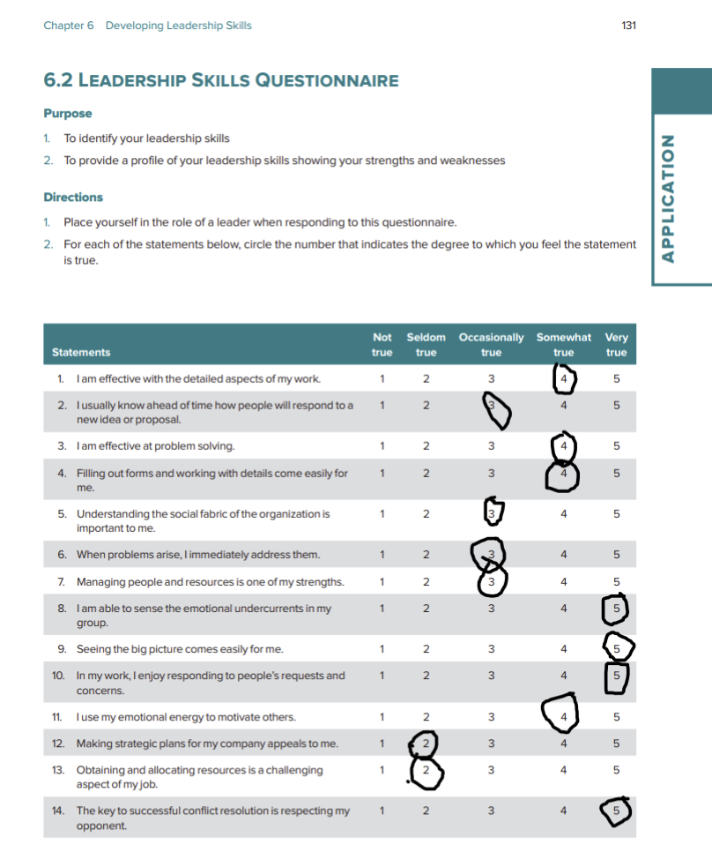

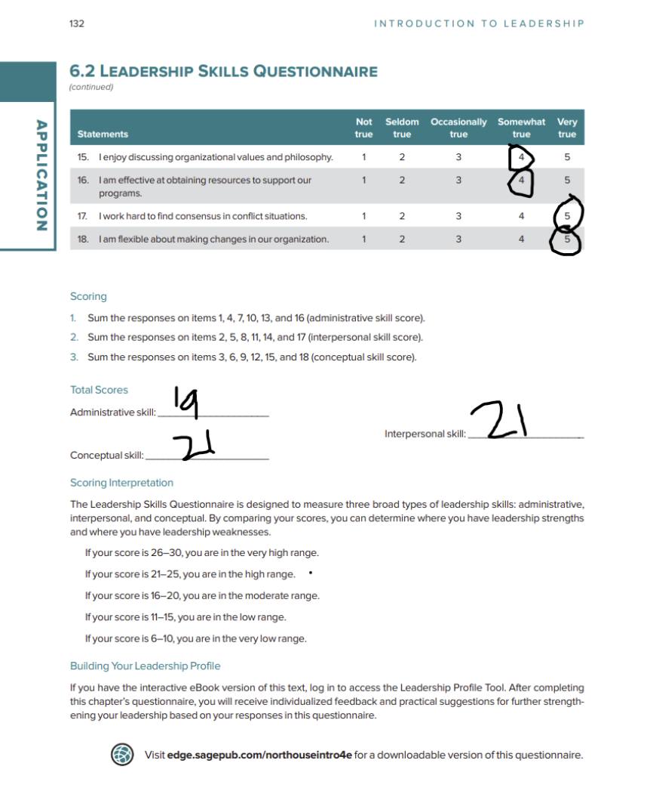

Appendix B – Leadership Skills Questionnaire

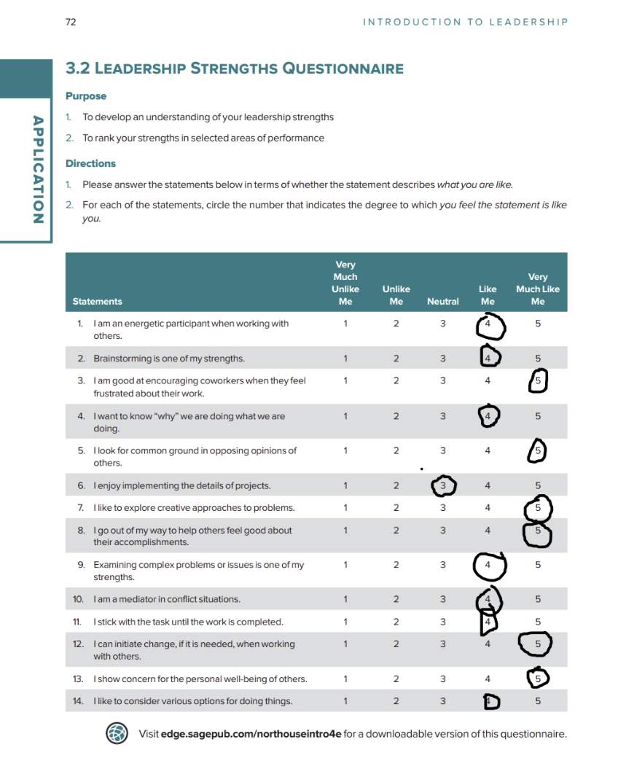

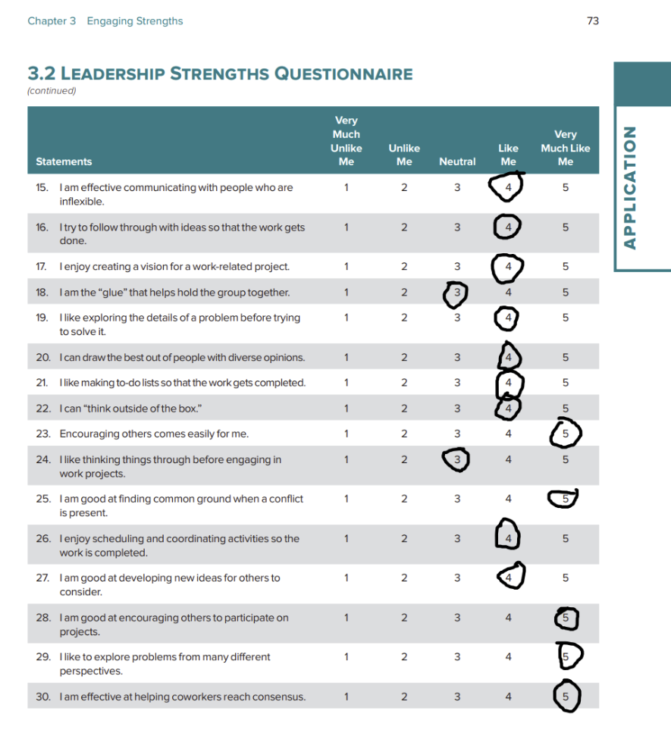

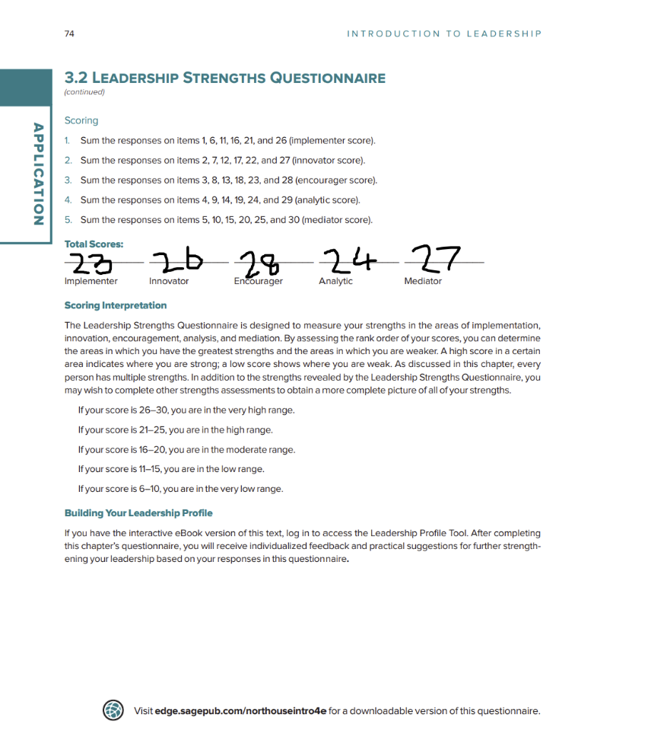

Appendix C – Reflective Mapping Table

Questionnaire Finding | Workplace Evidence | Development Action
Democratic style | Training colleagues through discussion | Develop confidence using directive leadership when appropriate
Coaching style | Gradually reducing support | Increase strategic coaching opportunities
Communication | Explain the "why" before the "how" | Develop communication across larger teams

Appendix D – Personal Development Action Plan

Capability | Current Evaluation | Action | Timescale
Strategic leadership | Limited experience | Lead a cross-team project | 12 months
Vision communication | Operational focus | Present team updates | 6 months
Leading change | Developing | Shadow senior leaders | 12 months

