MOCK EXAM - ANSWERS
MODULE CODE: ACDA6019
MODULE NAME: ADVANCED RADIO FREQUENCY SYSTEMS
ANSWER ALL QUESTIONS

Question 1 [25 marks]
- Discuss the impact of side lobes and back lobes on antenna performance. [5 Marks]
Answers:
Side lobes are secondary lobes that occur in an antenna's radiation pattern outside the main lobe. Side Lobes can lead to unwanted radiation and interference, reducing efficiency by radiating power in unintended directions. [2 Marks]
Back lobes, which radiate opposite to the main lobe, cause interference behind the antenna and decrease forward gain, impacting applications requiring directional signals. A strong back lobe reduces the front-to-back ratio of the antenna [2 Marks]
High side and back lobe levels reduce overall performance and lead to communication issues. [1 Mark]
- A 3-element Yagi-Uda antenna is to be designed for operation at a frequency of 150MHz. Apply the knowledge of antenna design principles to calculate the lengths of the driven element, director, and reflector. Also, calculate the spacing between antenna elements, if the distance from the driven element to the reflector is 0.15λ, and the distance from the driven element to the director is 0.2λ. Assume a 5% difference in length between adjacent elements. [10 Marks]
Answers:
Wavelength:
$λ=\frac{c}{f}=\frac{3×{10}^{8}}{150×{10}^{6}}=2m$ [1 Mark]
Length of the Driven element:
$L=\frac{λ}{2}=\frac{2}{2}=1m$ [1 Mark]
Length of Director:
$L_{D}=0.95×L=0.95×1$
$L_{D}=0.95m$ [2 Marks]
Length of Reflector:
$L_{R}=1.05×L=1.05×1$
$L_{R}=1.05m$ [2 Marks]
The distance from the driven element to the reflector=0.15λ
$=0.15×2=0.3m$ [2 Marks]
The distance from the driven element to the director=0.2λ
$=0.2×2=0.4m$ [2 Marks]
- A Monopole antenna resonates at a frequency of 1GHz, calculate the operating wavelength and the length of the antenna. [5 Marks]
Answers:
$λ=\frac{c}{f}=\frac{3×{10}^{8}}{1×{10}^{9}}=0.3m$ [2 Marks]
$L=\frac{λ}{4}=\frac{0.3}{4}$ [2 Marks]
$L=0.075m=75mm$ [1 Mark]
- What is a phased array antenna? How does it operate? [5 Marks]
Answers:
- A phased array antenna is an electronically scanned array or a computer-controlled array of antennas. It creates a beam of radio waves that can be electronically steered to point in different directions without moving the antennas. [2 Marks]
- In a phased array, the power from the transmitter is fed to the radiating elements through devices called phase shifter, controlled by a computer system. The Phase shifter can alter the phase or signal delay electronically, thus steering the beam of radio waves to a different direction. [2 Marks]
- When the signals are in-phase, they combine together to form a signal of additive amplitude, thus controlling the direction of an emitted beam by exploiting constructive interference between two or more radiated signal. This is known as Beamforming. [1 Mark]
Question 2 [25 marks]
- A helical antenna is designed for satellite communication and operates at a frequency of 5 GHz. It has a diameter of 10cm and a pitch of 3cm. Calculate the transition distance from the near field to the far field for this helical antenna. [4 Marks]
Answers:
The transition distance from near field to far field.
$D=10cm=0.1m$
$λ=\frac{c}{f}=\frac{3×{10}^{8}}{5×{10}^{9}}=0.06m$ [2 Marks]
$Transition Diatance= D_{TD}=\frac{2D^{2}}{λ}=\frac{2×{0.1}^{2}}{0.06}$ [1 Mark]
$D_{TD}=0.33m$ [1 Mark]
- Formulate the S-Matrix for a two port network, with two ports are perfectly matched. [3 Marks]
Answers:
$S_{11}=0$
$S_{22}=0$
$S=\left|\begin{matrix}0 & S_{12} \\ S_{21} & 0\end{matrix}\right|$ [3 Marks]
- A two port network is known to have the following scattering matrix. Determine the following.
$$\left[S\right]=\left[\begin{matrix}0.15∠0^{o} & 0.85∠{-45}^{o} \\ 0.85∠{45}^{o} & 0.2∠0^{o}\end{matrix}\right]$$
- Analyse if the network is reciprocal. [2 Marks]
- Evaluate if the network is a lossless network. [3 Marks]
- Calculate the return loss at port 1 when port 2 is terminated with a load that matches the network's impedance. [4 Marks]
Answers:

- If the network is reciprocal:
If the network is reciprocal $S_{21}=S_{12}$
$S_{21}=S_{12}$ $= 0.85∠{45}^{o}≠ 0.85∠{-45}^{o}$ [2 Marks]
As they are not equal, this is not a reciprocal network
- If the network is a lossless network:
For a network to be lossless network, The sum of the squares of the magnitudes of the S-parameters for any port must equal 1.
For Port 1:
To verify if, ${\left|S_{11}\right|}^{2}+{\left|S_{21}\right|}^{2}=1$ [1 Mark]
${\left|0.15\right|}^{2}+{\left|0.85\right|}^{2}=0.745$ [1 Mark]
${\left|S_{11}\right|}^{2}+{\left|S_{21}\right|}^{2}≠1$ [1 Mark]
This is not a loss less network
- Calculate the return loss at port 1 when port 2 is terminated with a load that matches the network's impedance.
$Return loss =-20\log_{10}\left|S_{11}\right|$ [2 Marks]
$Return loss =-20\log_{10}\left|0.15\right|$ [1 Mark]
$Return loss =16.48db$ [1 Mark]
- Identify the antennas listed in table 1. [5 Marks]
Table 1: List of antennas
Question Number | Antenna
 | 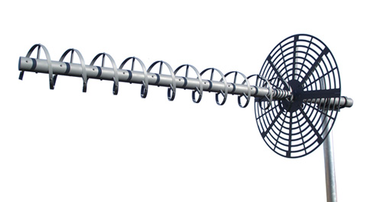
 | 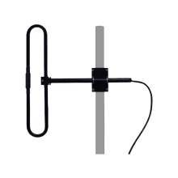
 | 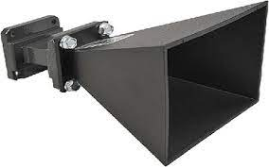
 | 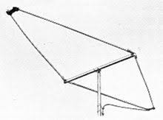
 | 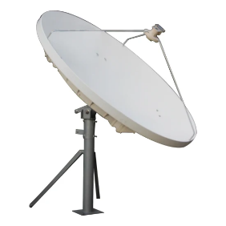
Answers:
- Helical antenna
- Folded Dipole antenna
- Horn antenna
- Rhombic antenna
- Parabolic Antenna [Each 1 Mark, Total 5 Marks]
- Differentiate between a Broadside Array and an End Fire array Antenna.[4 Marks]
Answers:
Broadside Array:
The elements in a broadside array are typically arranged in a linear fashion or in a planar configuration, with all elements fed in-phase.
The maximum radiation occurs perpendicular to the axis of the array elements. The main beam is directed along the broadside, or side, of the array structure. [2 Marks]
End Fire array:
The elements in an end-fire array are also arranged linearly, but the elements are fed with a progressive phase shift along the array to achieve radiation in the end-fire direction.
In an end-fire array, the maximum radiation occurs in the direction parallel to the axis of the array elements. [2 Marks]
Question 3 [25 marks]
- A transmission line working at radio frequencies has the following constants $L=9μH/m,$ $C=16pF/m$. The line is terminated with a resistive load of $R_{L}=1000Ω$. Calculate the reflection coefficient and standing wave ratio. [6 Marks]
Answers:
$Z_{0}=R_{0}=\sqrt{\frac{L}{C}}=\sqrt{\frac{9×{10}^{-6}}{16×{10}^{-12}}}=750Ω$ [2 Marks]
Reflection Coefficient
$Γ=\frac{Z_{R}-Z_{0}}{Z_{R}+Z_{0}}=\frac{1000-750}{1000+750}=0.1423$ [2 Marks]
Standing Wave Ratio , S
$S=\frac{1+\left|Γ\right|}{1-\left|Γ\right|}=\frac{1+0.1423}{1-0.1423}=1.33$ [2 Marks]
- An antenna has a Radiated power density given by $W_{rad}=2{Sin}^{2}θ$ W/$m^{2}$, in the far field. The radiation is over a spherical surface with radius 5cm. Calculate the total radiated power. [14 Marks]
Answers:
$W_{rad}=2{Sin}^{2}θ$ W/$m^{2}$
$r=5cm$
$P_{rad}=∯_{S}{W_{rad}}ds$
$ds=r^{2}sinθ dθ dϕ$ , $\left(0≤θ≤π\right), (0≤ϕ≤2π)$
$P_{rad}=∯_{S}{2{Sin}^{2}θ }r^{2}sinθ dθ dϕ$ [1 Mark]
$P_{rad}=2r^{2}\int_{0}^{2π}{dϕ}\int_{0}^{π}{{Sin}^{2}θ}sinθ$ $dθ$ [1 Mark]
$P_{rad}=2r^{2}\left[{\left[ϕ\right]}_{0}^{2π}\int_{0}^{π}{{Sin}^{3}θ}dθ\right]$ [2 Marks]
$P_{rad}=2r^{2}\left[[2π-0]\int_{0}^{π}{{Sin}^{3}θ}dθ\right]$ [1 Mark]
$P_{rad}=4πr^{2}\int_{0}^{π}{{Sin}^{3}θ}dθ$
$P_{rad}=4πr^{2}\int_{0}^{π}{\frac{(3 sinθ-sin3θ)}{4}}dθ$ [2 Marks]
$P_{rad}=πr^{2}\int_{0}^{π}{(3 sinθ-sin3θ)}dθ$
$P_{rad}=πr^{2}\left[3\int_{0}^{π}{ sinθ}dθ-\int_{0}^{π}{sin3θ} dθ\right]$ [1 Mark]
$P_{rad}=πr^{2}\left[3{\left[-cosθ\right]}_{0}^{π}-{\left[\frac{-cos3θ}{3}\right]}_{0}^{π}\right]$ [2 Marks]
$P_{rad}=πr^{2}\left[6-\frac{2}{3}\right]$ [1 Mark]
We know that r=0.05m
$P_{rad}=π{(0.05)}^{2}\left[6-\frac{2}{3}\right]$ [1 Mark]
$P_{rad}=0.0418W$ [2 Marks]
- An antenna radiates energy. At a distance of 10 meters from the antenna, the radiated power density in a specific direction is measured to be 0.05 W/m². Calculate the radiation intensity U in that direction, solve step by step. [5 Marks]
Answers:
$r=10m$
$W_{rad}=0.05$ W/$m^{2}$
$U=r^{2}W_{rad}$ [1 Mark]
$U={10}^{2}×0.05$ [2 Marks]
$U=5 W/sr$ [2 Marks]
Question 4 [25 marks]
- A 50 $Ω$ transmission line operates at 500MHz and is terminated with a load impedance of $Z_{L}=25+j50Ω$. Calculate the following to design a open circuited series single-stub tuner to match the impedance.
- Normalised load impedance [2 Marks]
Using Smith chart determine the following
- SWR [2 Marks]
- Return Loss [2 Marks]
- Normalised Load Admittance [3 Marks]
- Distance of the stub from the load ($d_{A})$ using smith chart [10 Marks]
- Length of the Stub ($l_{A})$ using smith chart [6 Marks]
Answers:
- Normalised load impedance
Normalised load impedance ${\overline{Z}}_{L}=\frac{Z_{L}}{Z_{0}}=\frac{25+j50}{50}$ [1 Mark]
${\overline{Z}}_{L}=(0.5+j1$) Ω [1 Mark]

- SWR
SWR= 4.2 [2 Marks]
- Return Loss
Return Loss= 4.2 [2 Marks]
- Normalised Load Admittance
${\overline{Y}}_{L}=(0.4-j0.8$)$Ω^{-1}$ [plotting 2 marks, correct answer 1 Mark]
- Distance of the stub from the load ($d_{A})$ using smith chart
$λ=\frac{c}{f}=\frac{3×{10}^{8}}{500×{10}^{6}}$
$λ=0.6m$ [1 Mark]
$d_{A}=0.178λ-0.135λ=0.043λ$ [1 Mark]
$d_{A}=0.043×0.6=0.0258m$ [1 Mark]
Smith chart: VSWR circle 2 marks, unit circle 1 mark, plotting the intersection 2 Marks, Marking the wavelengths 2 Marks]
- Length of the Stub ($l_{A})$ using smith chart
$l_{A}=0.342λ-0.25λ=0.092×0.06=0.00552m$ [2 Marks]
Smith chart: Plotting-jX 2 Marks, Marking the wavelength 2 Marks]
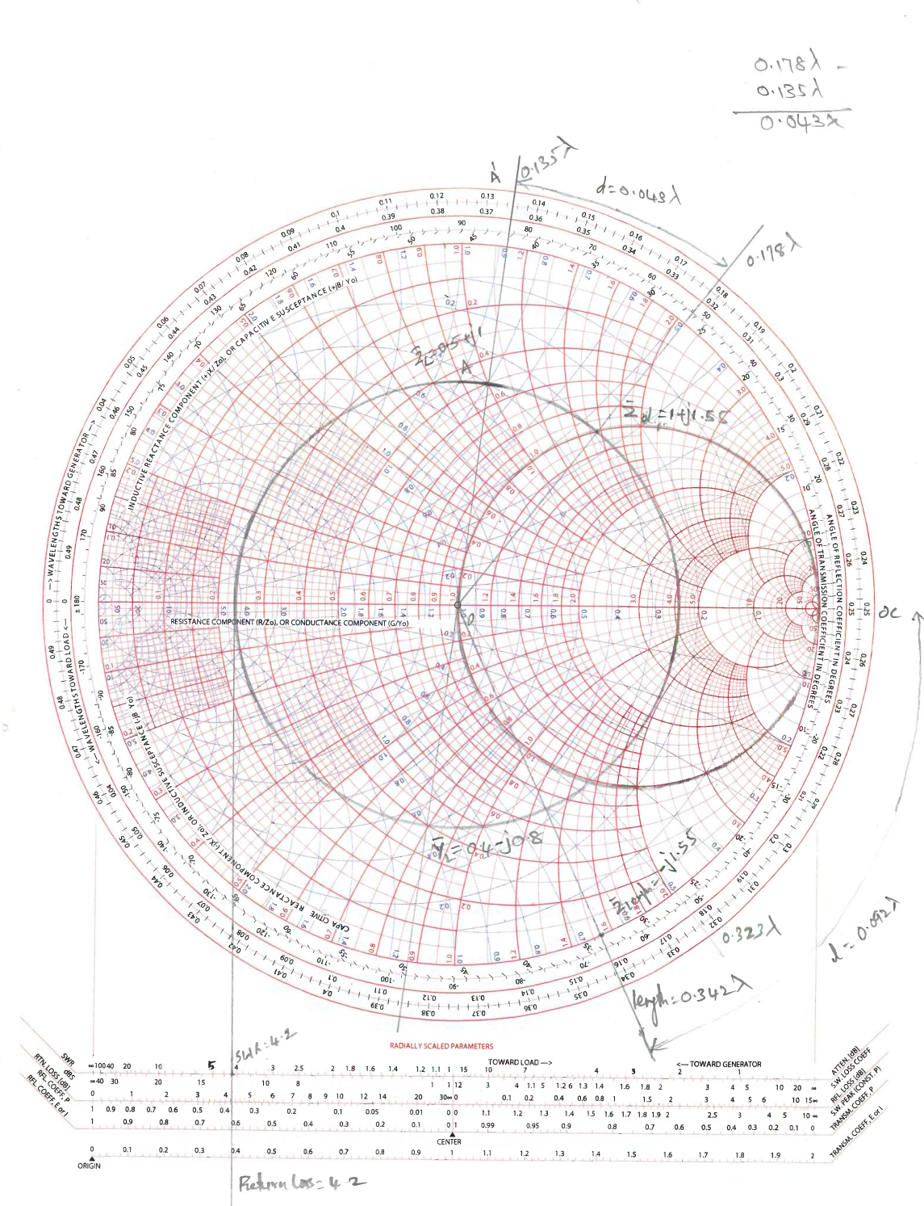

Diwedd/End

