
Operating Systems
Module Name: Computer Architecture & OS
Module Code: ACCA4022
Student Name: Prince Derick Yeboah
Student ID: 2523170
Lecturer Name: Dr Md Shantanu Islam

Submission date: 24/07/2026

Contents
Introduction 3
Key functions of general Operating Systems 3
Task Management: 3
Application/Program Management: 4
File/Directory Management: 5
Device Management: 5
Security Management: 6
Use of Windows OS CLI commands 7
Example 1: DIR 7
Example 2: CD/CD.. 7
Example 3: MKDIR 8
Example 4: RMDIR 8
Example 5: RENAME 9
Example 6: IPCONFIG 9
Example 7: NETSTAT 10
Example 8: SYSTEMINFO 11
Example 9: TASKLIST 11
Example 10: PING 12
Use of Linux OS CLI commands 12
Example 1: pwd (present working directory) 12
Example 2: su 13
Example 3: ls 14
Example 4: cd 14
Example 5: mkdir 15
Example 6: rmdir 15
Example 7: touch 16
Example 8: echo and cat 16
Example 9: ifconfig 17
Example 10: whoami and date 17
Use of Windows OS scripts 18
Example 1: Display Current Date and Time 18
Example 2: Create Folder 19
Use of Linux OS scripts 20
Example 1: Simple Calculator 20
Example 2: Multiplication Table 22
Conclusion 23
References 24
Appendices 25

Introduction
This report explains the functions of Windows and Linux operating systems and shows how they are used through the Command Line Interface (CLI) commands and simple scripts. The report includes practical examples of Windows Batch scripts and Linux Bash scripts, together with screenshots and explanations of their outputs. It helped me understand how an operating system manages files, programs, hardware, security and network settings. Overall, this coursework has improved both my practical and technical knowledge of operating systems.

Key functions of general Operating Systems
Microsoft introduced the Windows operating system in 1985. It provides a graphical interface that allows users to run programs, manage files, connect hardware and keep the computer secure. Today, Windows is one of the most widely used operating systems worldwide because it is easy to use and supports many applications [1].

Task Management:
Task Manager helps users monitor everything on the computer. It shows active applications, background processes and how much CPU, memory, disk and network resources each program uses. If a program stops responding, it can be closed using the End task option. It can also be used to identify programs that use too many system resources. Task Manager can be opened by pressing Ctrl + Shift + Esc on the keyboard or by right-clicking the Start button and selecting Task Manager [2].
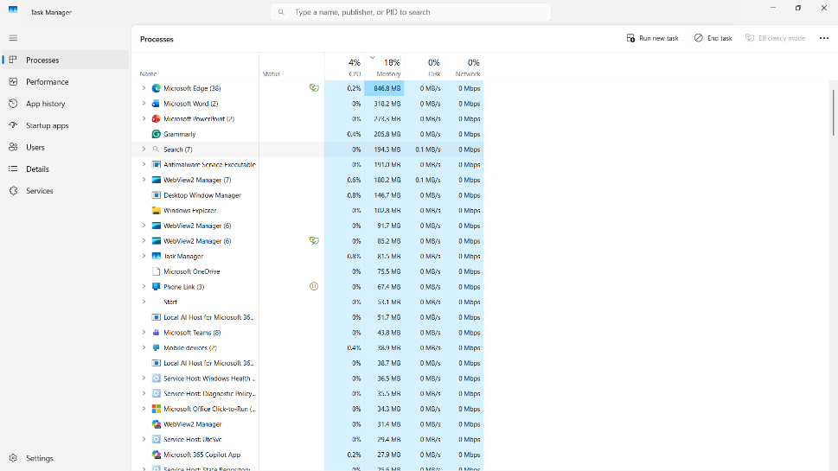
Figure 1: Task Manager showing running applications, background processes, CPU and memory usage.

Application/Program Management:
Application management allows users to install, update and remove software in Windows. The Installed Apps page shows all the programs on the computer, together with details such as the installation date and storage size. Users can free up storage space by uninstalling applications they no longer need and improve computer performance. Windows also allows users to repair or modify some applications if problems occur. To open Installed Apps, click Start, select Settings, and click Installed Apps or search for it on the search button. This helped me view and manage the software installed on my computer more easily [3].
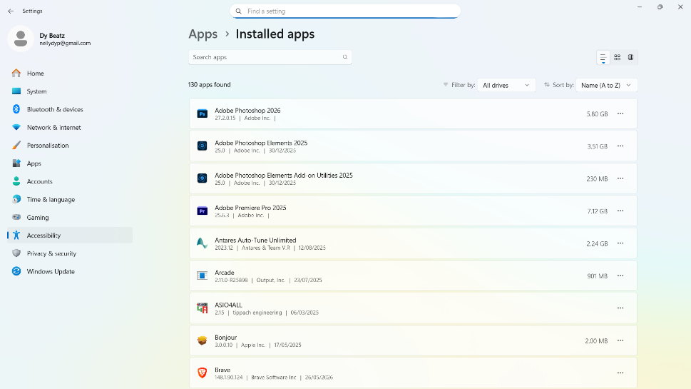
Figure 2: Installed Apps window

File/Directory Management:
File/Directory Management lets users organise documents, pictures, videos and other files on a computer. Users can create folders, rename files, move files to different locations and delete unwanted files. Keeping files organised makes them easier to find and helps users work more efficiently. Windows provides a search feature that helps users quickly locate files and folders, especially when many items are stored on the computer [4].
To open File Explorer, press Windows + E on the keyboard. I could also open it by clicking the File Explorer icon on the taskbar. This made it easy to manage files more efficiently.
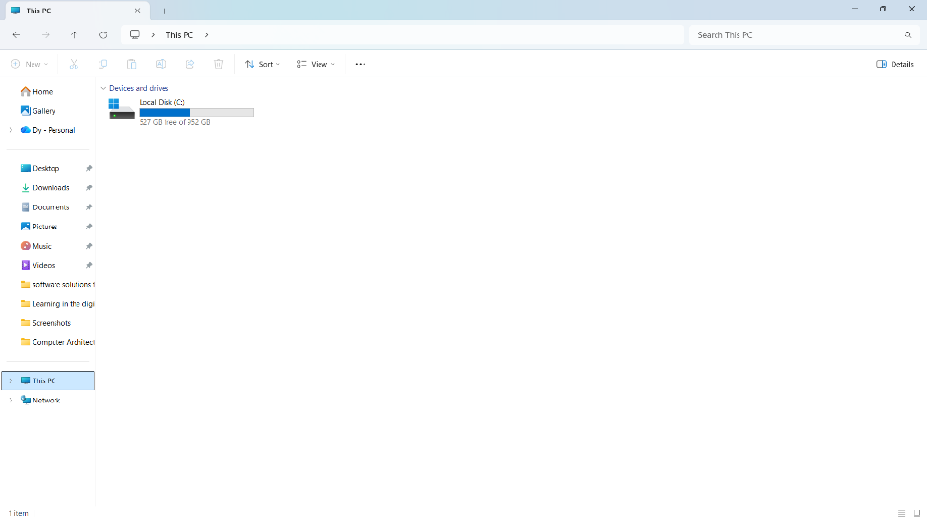
Figure 3: File Explorer

Device Management:
Device Manager is used to manage the hardware connected to a computer. It displays devices such as keyboards, monitors, printers, network adapters and storage drives. Users can update drivers, disable devices or check for hardware problems. If a device is not working properly, Device Manager usually shows a warning icon to help identify the problem. This tool is important for maintaining hardware performance and ensuring all devices work correctly with Windows [5].
Device Manager can be opened by right-clicking the Start button and selecting Device Manager. This allowed me to view all the hardware installed on my computer and check whether every device was working properly.
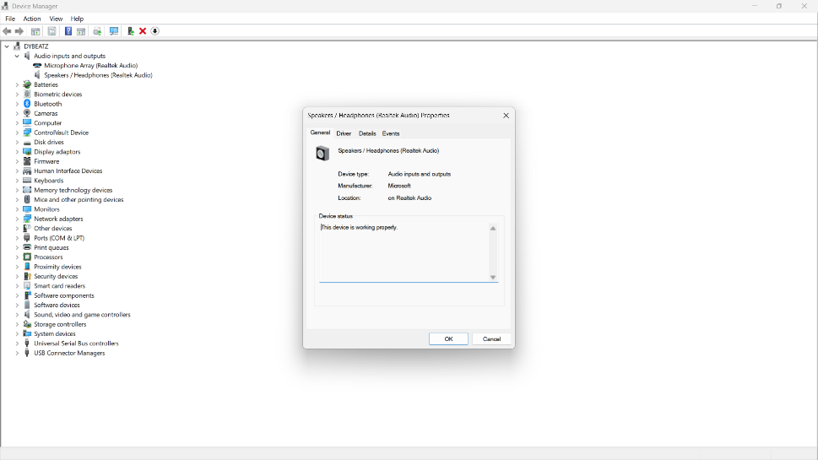
Figure 4: Device Manager displaying the hardware devices

Security Management:
Windows Security helps protect the computer from viruses, malware and other online threats. It includes features such as virus and threat protection, firewall settings, account protection and device security. Users can scan their computers for harmful software and check if security features are working properly. Keeping Windows Security enabled helps reduce the risk of cyberattacks and protects personal information stored on the computer. [6].

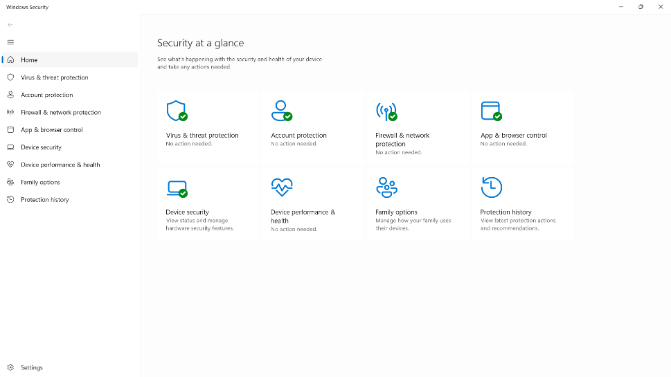
Figure 5: Windows Security window

Use of Windows OS CLI commands
The Windows CLI allows users to communicate with the operating system by typing commands instead of using the mouse. Users can use it to manage files and folders, check network information, and perform different system tasks more quickly. It is also useful for troubleshooting computer problems [7].

Example 1: DIR
I pressed Windows + R, typed cmd and pressed Enter. Then I typed DIR. The command showed all files and folders in my current directory. This helped me check what was stored before creating or moving folders. ↴
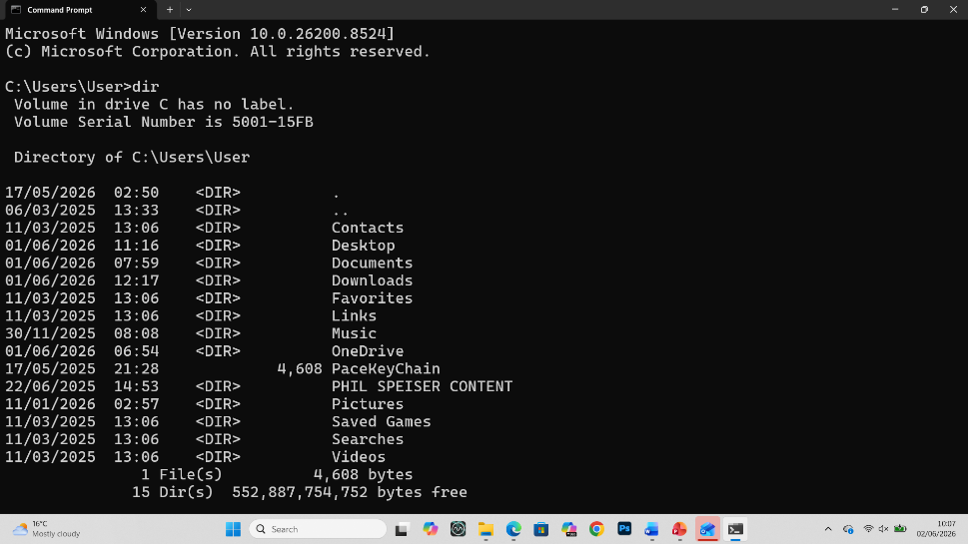
Figure 6: Output of the DIR command showing files and folders in the current directory.

Example 2: CD/CD..
I opened Command Prompt, typed cd contacts and pressed Enter to move to the contacts folder. Then I typed cd.. and pressed Enter to move me back to the previous folder. This helped me change folders quickly. Figure 7 shows the command working correctly.
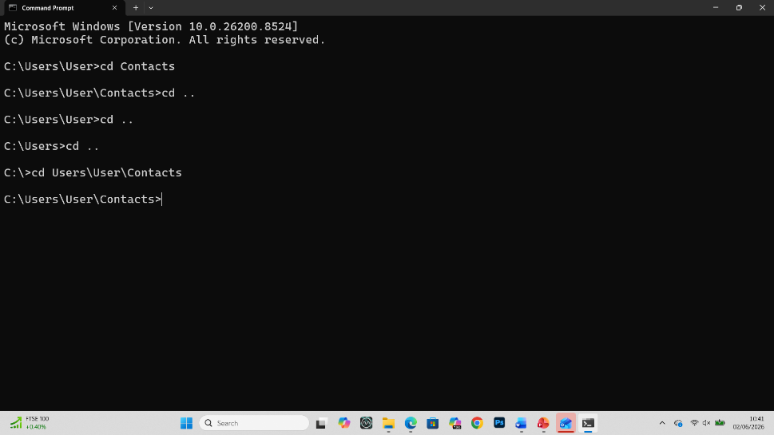
Figure 7: Output of CD and CD..

Example 3: MKDIR
I opened Command Prompt, typed mkdir prince, then pressed Enter. Windows created the new folder successfully. I used this command to create a directory quickly from the Command Prompt. Figure 8 shows the result.
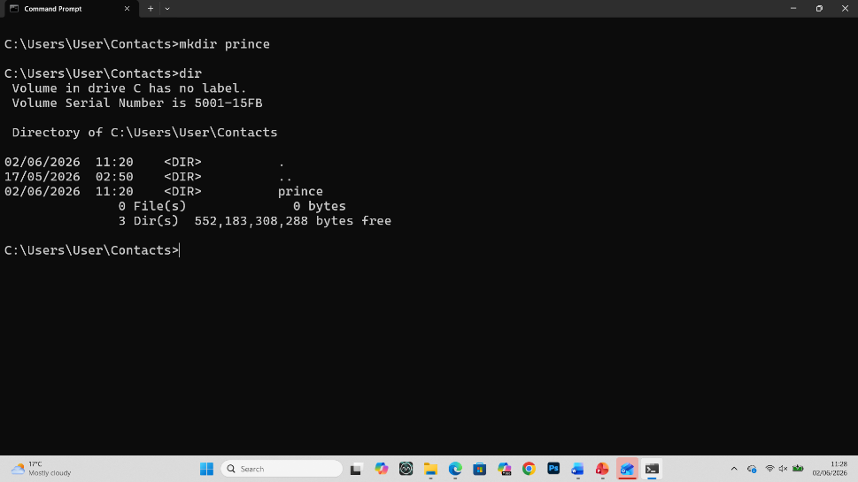
Figure 8: Output showing the creation of a new folder using the MKDIR command

Example 4: RMDIR
I opened Command Prompt, typed rmdir prince, then pressed Enter. The command deleted the folder successfully. I used it to remove a folder that I no longer needed. Figure 9 shows the output.
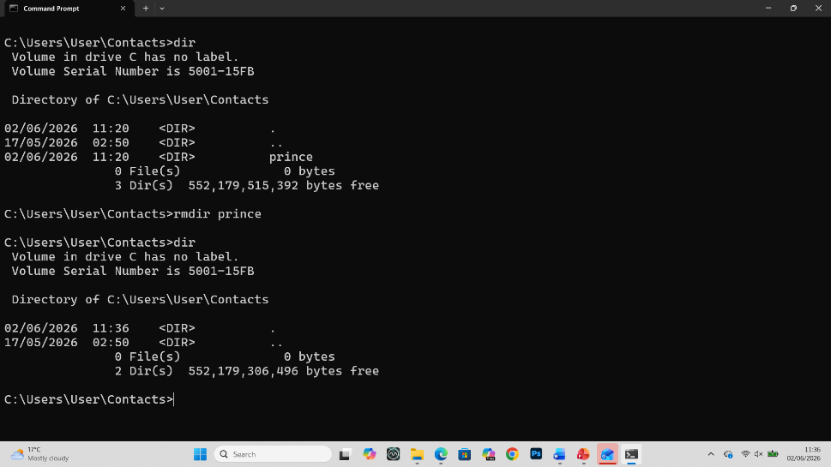
Figure 9: Output showing the removal of a folder using the RMDIR command.

Example 5: RENAME
I opened Command Prompt, typed rename primce prince, then pressed Enter. Windows changed the folder name successfully without affecting the files inside it by typing dir to check. Figure 10 shows the renamed folder.
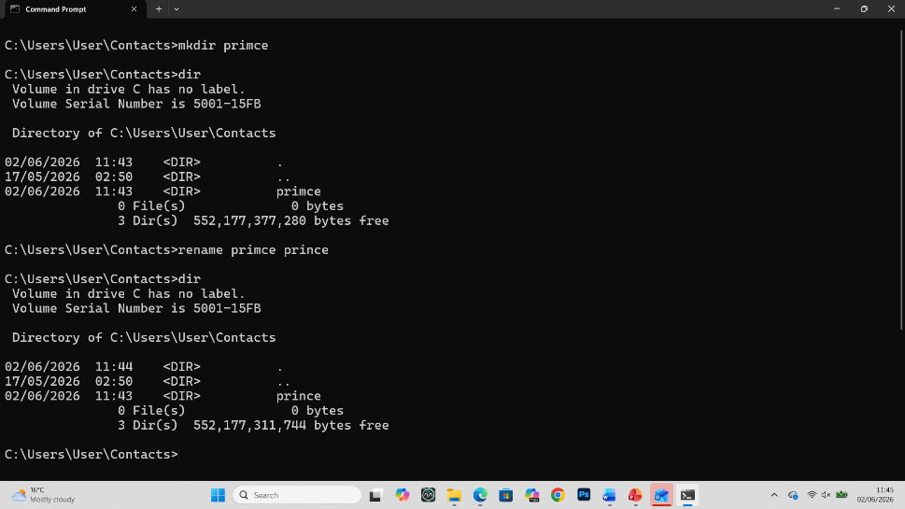
Figure 10: Output showing the folder name being changed using the RENAME command.

Example 6: IPCONFIG
I opened Command Prompt, typed ipconfig, and pressed Enter. The command showed my computer’s network details, including the IPv4 address and default gateway. I used it to check my network connection. Figure 11 shows the output.
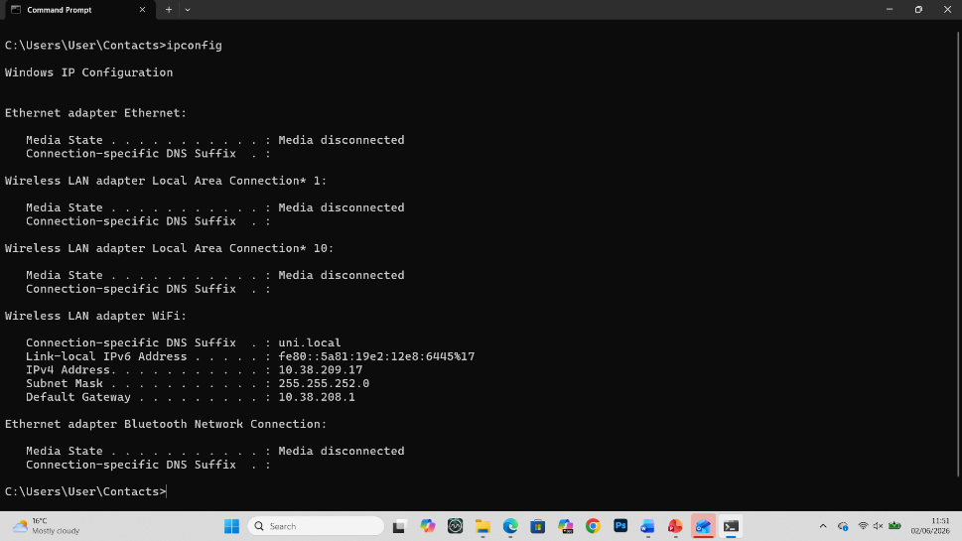
Figure 11: Output of the IPCONFIG command showing the computer's network configuration.

Example 7: NETSTAT
I opened Command Prompt, typed netstat and pressed Enter. The command displayed the active network connections. I used it to see which connections were currently running on my computer. Figure 12 shows the results.
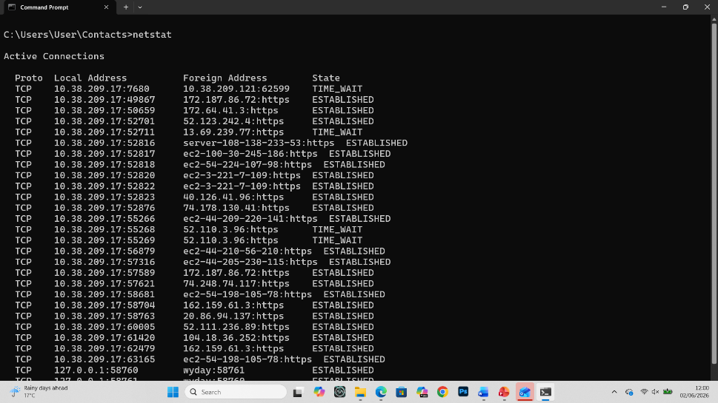
Figure 12: Output of the NETSTAT command displaying active network connections.

Example 8: SYSTEMINFO
I opened Command Prompt, typed systeminfo and pressed Enter. The command displayed information about my computer, including Windows version, processor and installed memory. I used it to check my system details quickly.
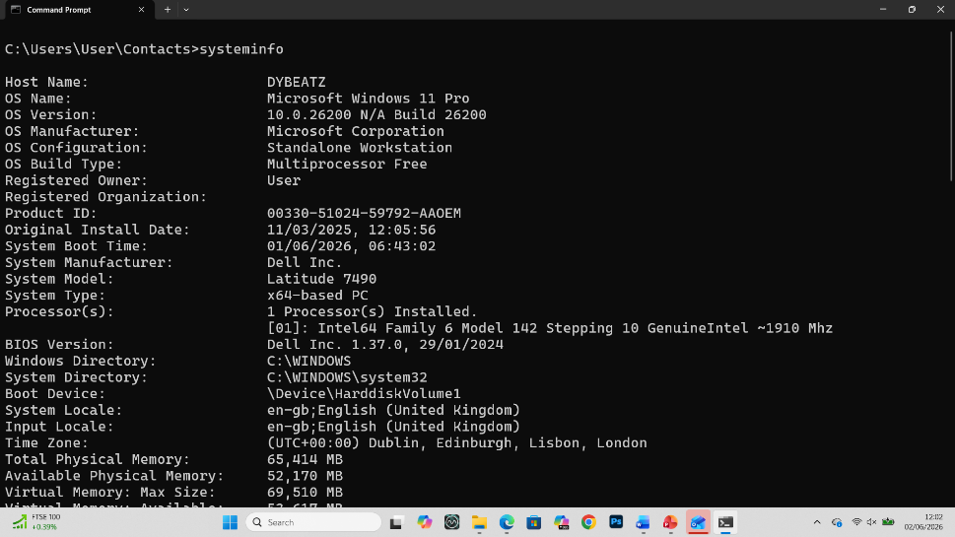
Figure 13: Output of the SYSTEMINFO command showing system information.

Example 9: TASKLIST
I opened Command Prompt, typed tasklist and pressed Enter. The command displayed all running programs and background processes. I used it to see which applications were active without opening Task Manager.
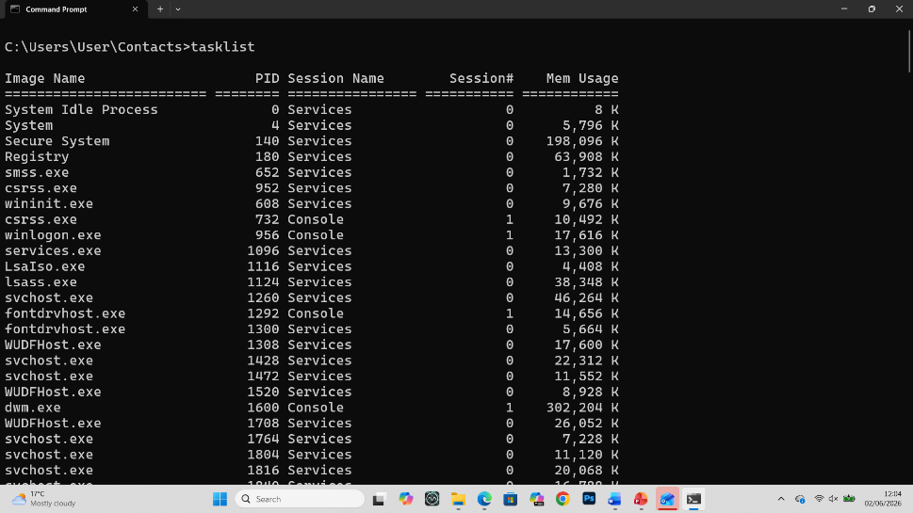
Figure 14: Output of the TASKLIST command displaying running processes.

Example 10: PING
I opened Command Prompt, typed ping www.dymultimedia.net, then pressed Enter. The output showed that packets were sent and received successfully, along with the response time. This helped me confirm that the internet connection was working properly.
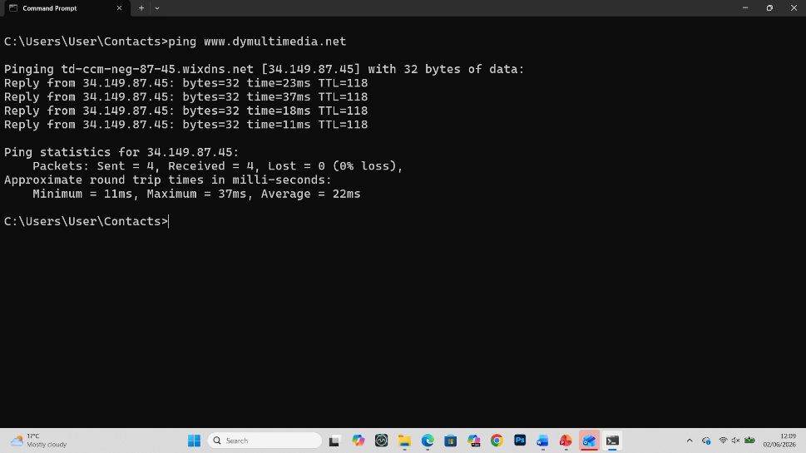
Figure 15: Output of the PING command testing communication with a website.

Use of Linux OS CLI commands
Linux CLI is a text-based tool that is used to control the computer by typing commands. It helps users manage files, create folders, change permissions and solve problems quickly. It is useful for learning Linux and system administration. I used the NDG Linux Unhatched Ubuntu course on Cisco Networking Academy to complete the practical activities [8].

Example 1: pwd (present working directory)
I typed pwd and pressed Enter. The command showed my current working directory. I used it to check my location before creating folders or files. Figure 16 shows the output.
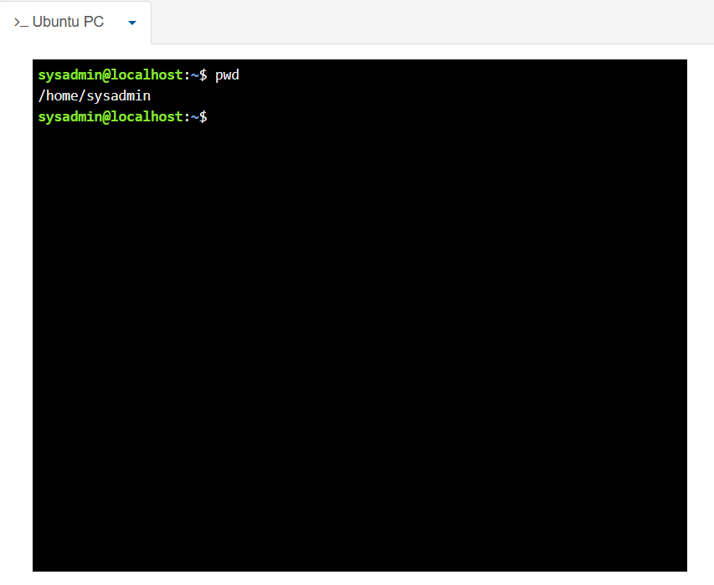
Figure 16: pwd command output showing my present working directory.

Example 2: su
I typed su and pressed Enter. I entered the root password to switch to the root user. This gave me permission to perform administrator tasks. Figure 17 shows the output.
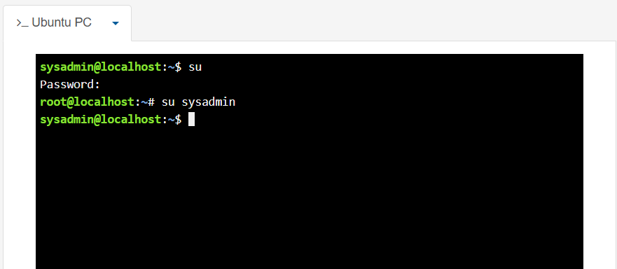
Figure 17: Output of the su command switching to the root user.

Example 3: ls
I typed ls and pressed Enter. The command showed the files and folders in my current directory. Ls -a shows all files, including hidden files; ls -1 shows one folder on each line; ls -la shows detailed information about all files and hidden ones. Figure 18 shows the output.
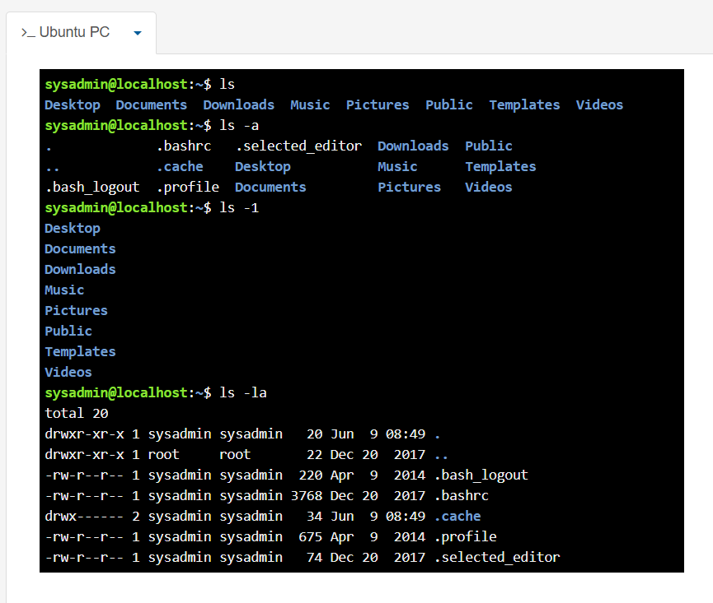
Figure 18: Output of the ls, ls -a, ls -1, ls -la command listing files and folders.

Example 4: cd
I typed cd Desktop/ and pressed Enter. The command moved me to the Desktop directory. I used it to access different folders. Figure 19 shows the output.
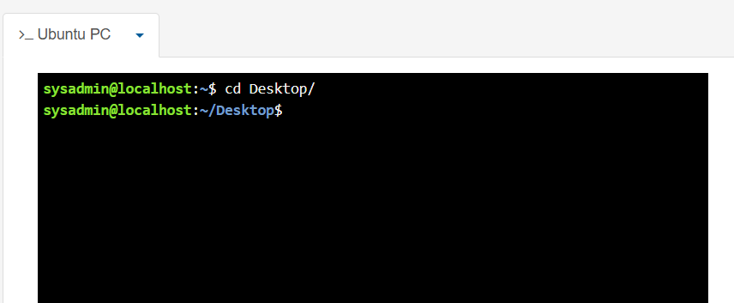
Figure 19: Output of the cd command changing the current directory.

Example 5: mkdir
I typed mkdir yeboah and pressed Enter. The command successfully created a new empty folder. Then I typed ls to see the newly created folder. I used it to create new folders when needed. Figure 20 shows the output.
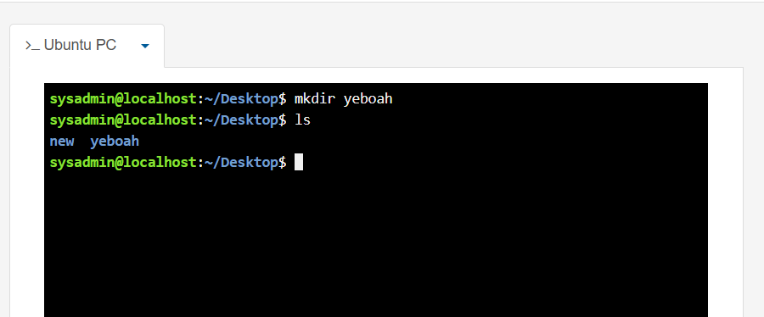
Figure 20: Output of the mkdir command creating a new directory

Example 6: rmdir
I typed rmdir yeboah and pressed Enter. This command removed the empty folder from my directory. I used it to delete folders I no longer needed. Figure 21 shows the output.
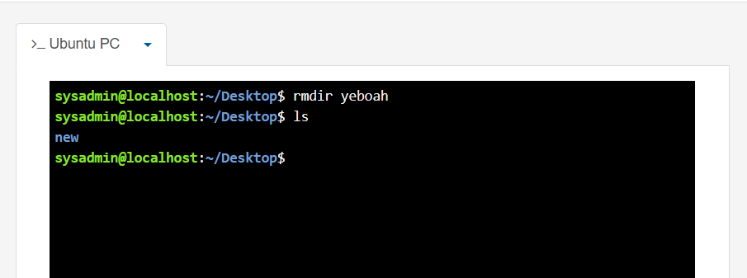
Figure 21: Output of the rmdir command deleting an empty directory.

Example 7: touch
I typed touch yeboah.txt and pressed Enter. The command created a new empty file in my current directory. I used it to create a file quickly. Figure 22 shows the output.
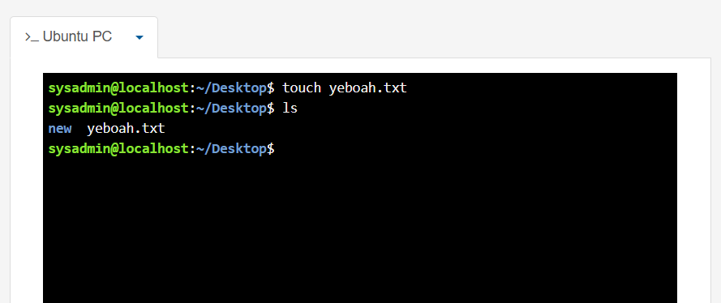
Figure 22: Output of the touch command creating a new file.

Example 8: echo and cat
I typed echo yeboah is my surname >yeboah.txt, then pressed Enter. The command wrote text into my created file yeboah.txt, and cat yeboah.txt showed the text on the screen. Figure 23 shows the output.

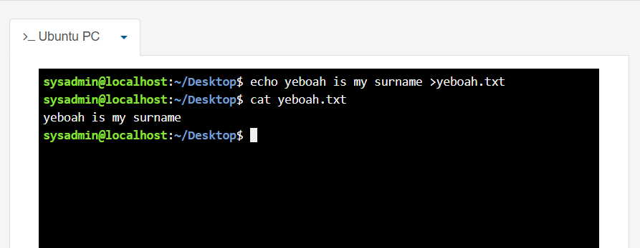
Figure 23: Output of the echo and cat commands displaying text from a file.

Example 9: ifconfig
I typed ifconfig and pressed Enter. The command showed my computer's network information, including the IP address and network settings. Figure 24 shows the output.
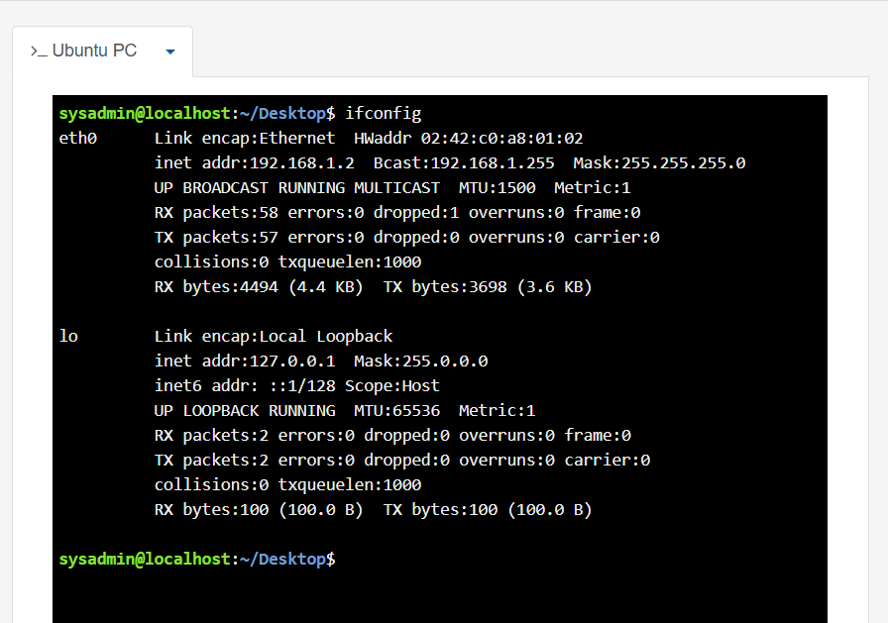
Figure 24: Output of the ifconfig command showing network configuration.

Example 10: whoami and date
I typed whoami, then pressed Enter. The command showed my username, and then I typed date and pressed Enter to show the current system date and time. Figure 25 shows the output.

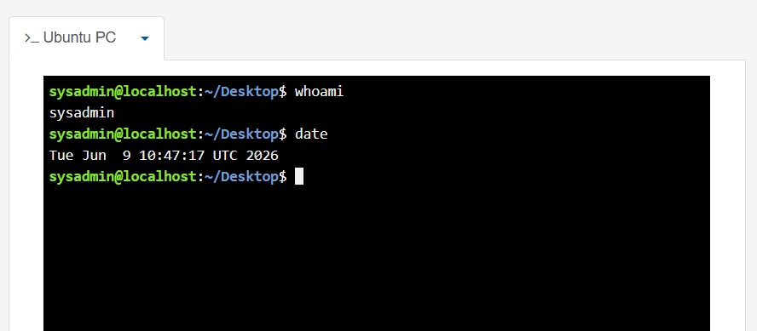
Figure 25: Output of the whoami and date commands showing the current user and system date.

Use of Windows OS scripts
Windows Batch scripting automates simple tasks using Command Prompt. Instead of typing the same commands every time, users can save them in a batch file and run them whenever needed. This helps complete tasks faster and improves understanding of how simple scripts work in Windows [9].

Example 1: Display Current Date and Time
I opened Notepad++ and typed the batch script shown in Figure 26 below to display the current date and time, and ended with pause so the output wouldn't disappear after running the script. After I clicked on File in the menu bar, I then clicked Save As to open the Save As window. I chose a destination folder, typed Display current date and time as the file name, I selected Batch file as the file type and clicked Save at the bottom right to save my file.
I double-clicked the batch file I saved to run the script. A Command Prompt window opened and showed the current system date and time in Figure 27. The output matched the current date and time on my computer, so I knew the script was working correctly. This practical task improved my understanding of Batch scripting.
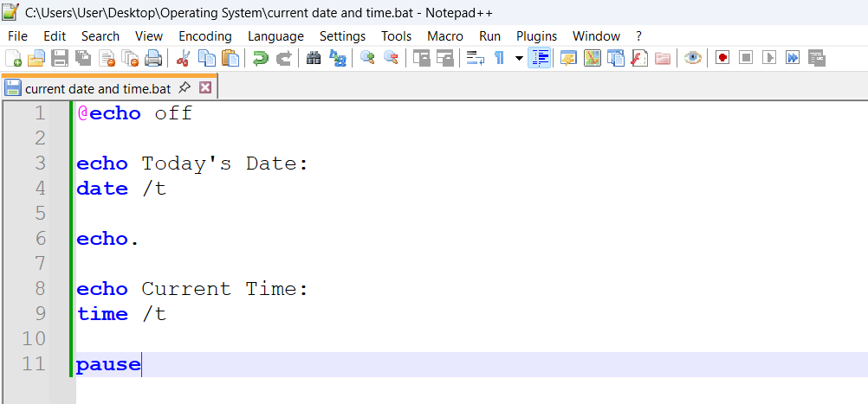
Figure 26: Batch script written in Notepad++ to display the current date and time.

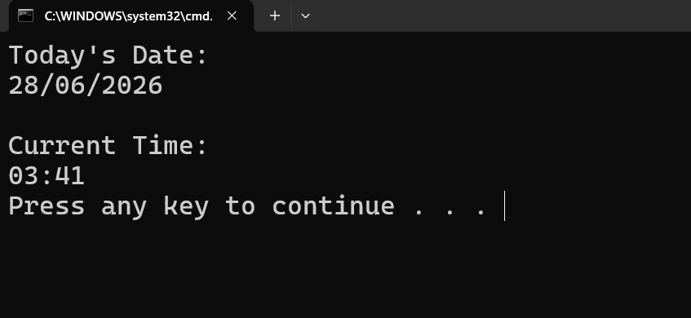
Figure 27: Output of the batch script showing the current system date and time.

Example 2: Create Folder
I opened an empty Notepad++ and typed the batch script in Figure 28, then I saved it as a batch (.bat) file. After running the saved batch file, the script asked me to enter a folder name, which I entered uwtsd and pressed Enter; it created the folder automatically in the selected location. I used this script because it creates a new folder automatically after the user enters a folder name, and it showed me how batch can accept user input and perform tasks without typing each command separately. The output in Figure 29 confirmed that the folder was created successfully, which meant the script worked as expected. I found this practice useful because it saved time and reduced the number of commands I needed to type. Figures 28 and 29 show the script and the output after creating the folder.
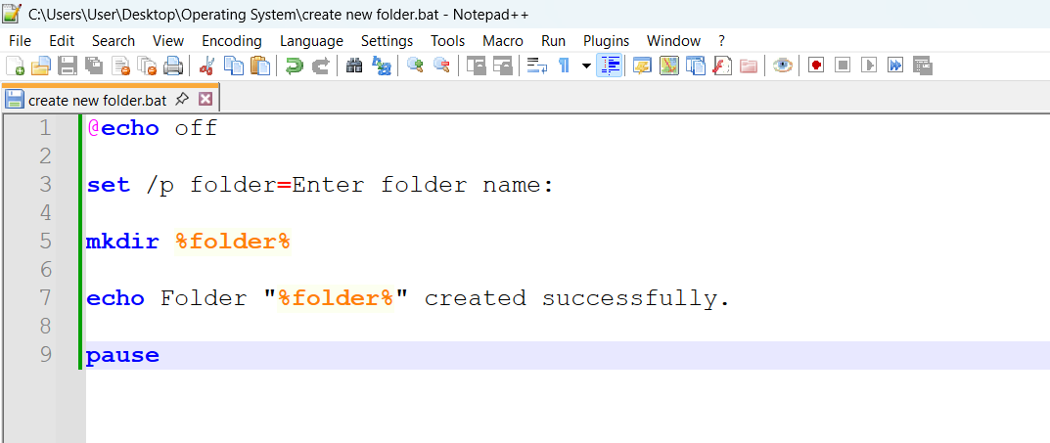
Figure 28: Batch script used to create a new folder.

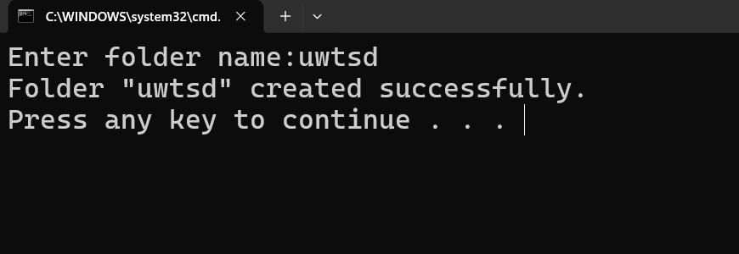
Figure 29: Output showing the new folder created successfully.

Use of Linux OS scripts
Bash scripting in Linux automates simple tasks in the Terminal. Instead of typing the same commands many times, they can be saved in a script file and run together. This helped me understand how Bash scripts work and made my work easier [10].
I used NDG Linux Unhatched on the Cisco Networking Academy page for these practical activities.

Example 1: Simple Calculator
I opened the Linux Terminal, I typed nano calculator.sh, and pressed Enter to create a nano file, which opened the nano editor in Figure 30 (GNU nano 2.2.6). Then I typed my calculator script, a script that echoed “Addition, subtraction, multiplication and division” at the same time. After typing my script, I pressed ctrl x, then Y followed by Enter, which took me back to the terminal showing sysadmin@localhost:~$ nano calculator.sh on the screen. Next, I typed ls to see the nano file calculator.sh, then I typed “chmod +x calculator.sh” to make it executable. Then I typed ls and pressed Enter, and saw the file name turn green, meaning it's ready to run. I then typed ./calculator.sh and pressed Enter. I was asked to enter the first and second numbers, then pressed Enter. The script displayed the results for addition, subtraction, multiplication, and division simultaneously, as shown in Figure 31.
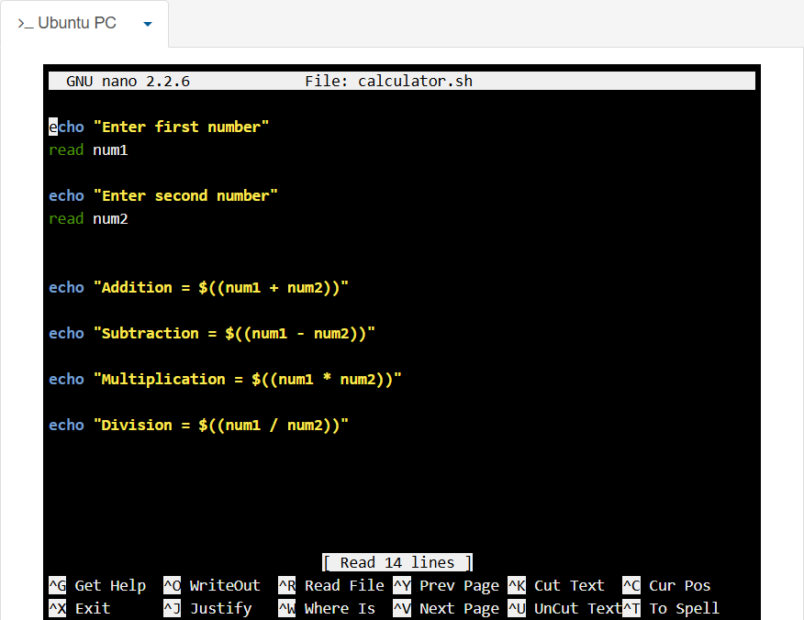
Figure 30: Bash calculator script written using Nano Editor.

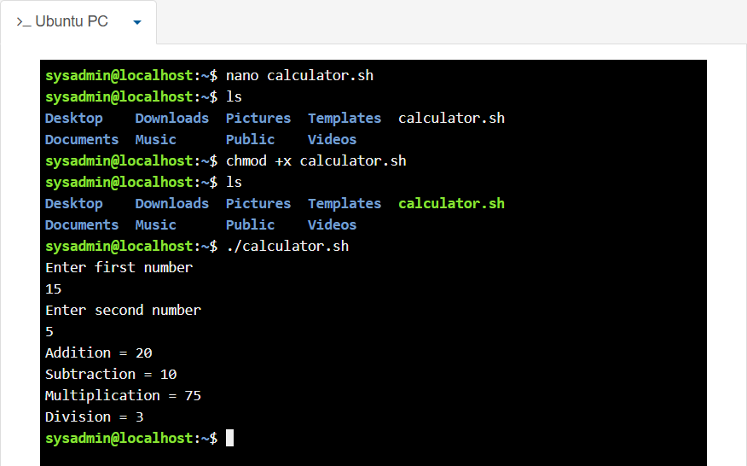
Figure 31: Output of the Bash calculator script after entering two numbers.

Example 2: Multiplication Table
I opened the Linux Terminal and used Nano Editor to write the Bash script shown in Figure 32. After saving in the same way as in Example 1, I ran the script in the terminal. Next, I typed ls to see the nano file multiplication.sh, then I typed “chmod +x multiplication.sh” to make it executable. Then I typed ls and pressed Enter, and saw the file name turn green, meaning it's ready to run. I then typed ./multiplication.sh and pressed Enter. The script asked for a number and then displayed its multiplication table after pressing Enter, as shown in Figure 33. The output followed the number 2 I entered, which showed that the script was working properly. This practical task improved my understanding of writing simple Linux scripts.
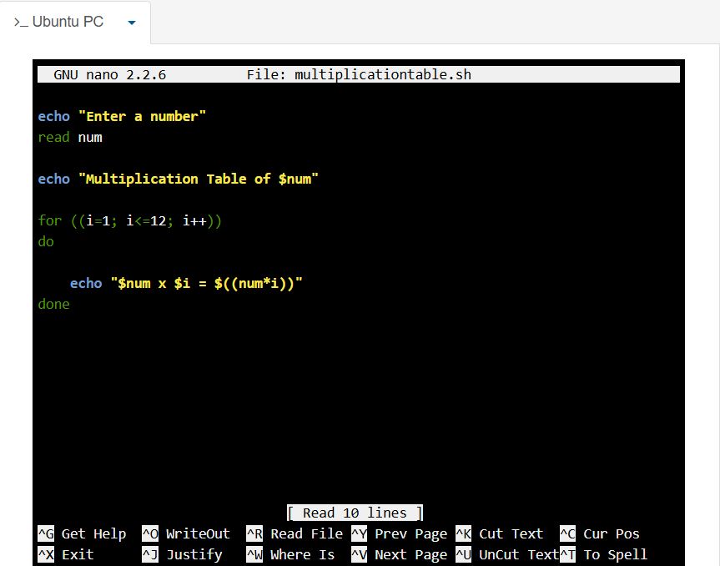
Figure 32: Bash script written in Nano Editor to display a multiplication table.
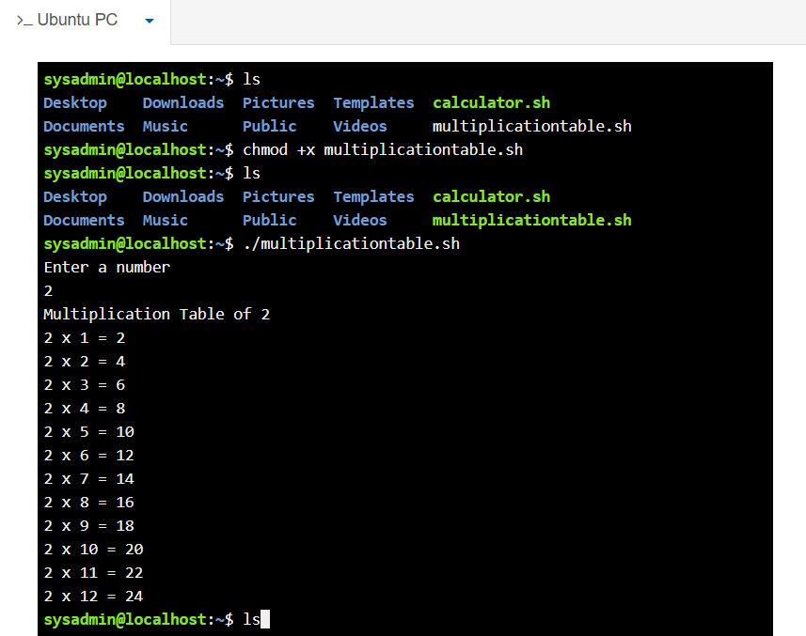
Figure 33: Output of the multiplication table after running the Bash script.

Conclusion
This coursework helped me understand how Windows and Linux operating systems work. I learnt how to use different CLI commands to manage files, folders and system information. I also created simple Batch and Bash scripts and tested them successfully. Overall, this practical work improved my confidence in using operating systems and simple scripting.

References

[1] W. R. Stanek, Windows 10 Administration Pocket Consultant. Redmond, WA, USA: Microsoft Press, 2016.
[2] M. E. Russinovich, D. A. Solomon, A. Ionescu and A. Yosifovich, Windows Internals, 7th ed. Redmond, WA, USA: Microsoft Press, 2017.
[3] M. E. Russinovich, D. A. Solomon, A. Ionescu and A. Yosifovich, Windows Internals, 7th ed. Redmond, WA, USA: Microsoft Press, 2017.
[4] P. Yosifovich, A. Ionescu, M. Russinovich and D. Solomon, Windows Internals, Part 1, 7th ed. Redmond, WA, USA: Microsoft Press, 2021.
[5] T. Carpenter, Microsoft Windows Operating System Essentials. Indianapolis, IN, USA: John Wiley & Sons, 2011.
[6] R. Shimonski and M. G. Solomon, Security Strategies in Windows Platforms and Applications, 4th ed. Burlington, MA, USA: Jones & Bartlett Learning, 2023.
[7] J. P. Mueller, Windows Command Line Administration Instant Reference. Indianapolis, IN, USA: John Wiley & Sons, 2010.
[8] W. E. Shotts Jr., The Linux Command Line: A Complete Introduction, 2nd ed. San Francisco, CA, USA: No Starch Press, 2019.
[9] B. Forouzan, Windows Batch File Programming. Bloomington, IN, USA: AuthorHouse, 2007.
[10] A. Robbins, Bash Pocket Reference: Help for Power Users and Sys Admins, 2nd ed. Sebastopol, CA, USA: O'Reilly Media, 2016.

Appendices
Online Course name: Linux Unhatched

Figure 34: Certificate of completion of Linux Unhatched


