cc
Children
with
cancers
F
FAMILY
FUNDING
PARENTS
SUPPORT
ILL
CHILD
PREVENTING
SUPPORT OTHER
MEMBERS OF
FAMILY
TALK WITH
THEM
ABOUT IT
FIND THE
SPONSOURS
AUCTIONS
ASK FOR
DONATIONS
EXPLAIN
LET THEM
ASK THE
QUESTIONS
SELL THINGS DONE
BY CHILRENS AND
THEIR FAMILES
SUPPORT
THEM
SHOW
THEM THEY
ARE NOT
ALONE
INDIVIDUAL
THERAPHY
SHOW
FULLY
SUPPORT
TALK TO
THE
CHILD
INFORM
INFORM ALL PARENTS
TO DO CHECK UP FOR
CHILDRENS
GIVE THEM
CONTACT TO
PARENTS IN
SIMILAR
SITUACTION
FAMILY
THERAPHY
EXPLAIN
ALL
ANSWER
FOR
ALL
QUESTIONS
LEAFLETS
MEETINGS
AT
SCHOOLS
Not many people talk about one of the most important topics which is the children with cancers and their families. Sometimes it is because it is hard situation and people around do not really know what to say to make sure that the families will not take that in any wrong way. According to Cancer Research UK (2018) there were 1838 new cases, 253 deaths and 84% children survived but what is when the child has no chance to survive. Mind map is showing what still needs to be done to improve the support for those children and their families. The first one and the most important is to get more funding what will help to get as much support the children and their families need. There is loads of ways to get more funding one of them is to sell the things the children do, that is the easiest way to get to the harts but also find the sponsors is the other way but that it is not easy . People have to remember that not once the medications cost a lot of money and not every family can pay from own pocket. ​
The next one very important thing is to give the family and the ill child as much support they need that can be even contact with the family who have to go through same situation so they can share experience, answer for some questions when not once that are not easy questions but who will know the better answer if not the people who have to go through same bad experience in their lifes.​
The next one is promoting the importance to do checkups for the children even if children have no symptoms whatsoever. Why schools do not do the meetings about how to check children health, why there is not much leaflets been out. One of the most and priority thing is talk with the child and all the family about it. Answer for all questions they have specially the ill child will has lots of questions, try to answer and always be honest and there is nothing wrong if we do not know the answer there is nothing wrong to say I do not know . Stop running away from the problem, from the hard questions or situations - communications is the key to everything even if sometimes it is not easy.​. The most important is to give the support for the parents because not once they are left behind the child and they are the most important support for the rest of the family . They need as much support maybe not physical but if comes to mental health.

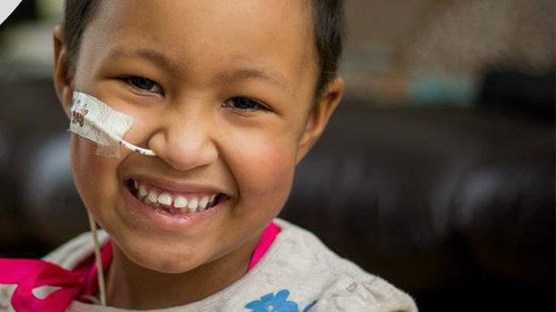
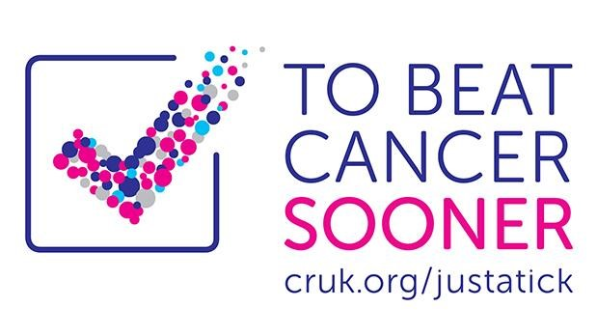
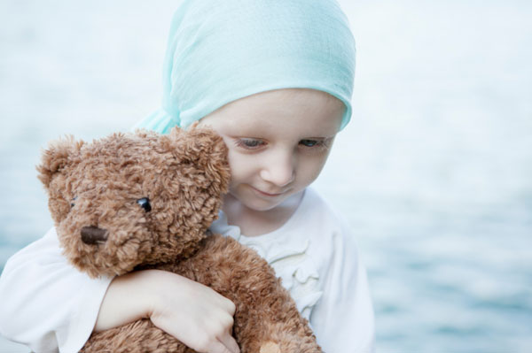
CHILDREN IN NEEDS
-
WE ALL CAN HELP !
CHILDREN IN NEEDS
–
WE ALL CAN HELP!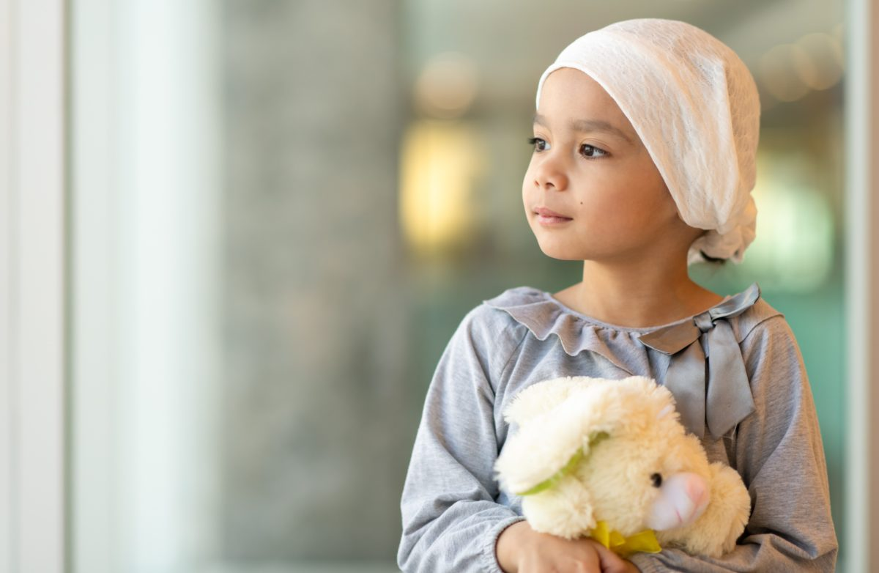 CAN HELP
We all can help by giving the
small donation.
Everyone can be the one
who can change their life's
and put a smile on their
faces.
We all can be the hero!
QUESTIONS ABOUT CANCER?
DROP IN AND ASK !
EVERY LITTLE HELP MATTERS
This Photo by Unknown Author is licensed under CC BY-NC-ND

The leaflet is showing the way we all can support the children with cancers, but also is saying that we all can be the hero by the give some donations does not matter how much money as long we are taking the part of that. If even each family will give a small donation in the end, we can rise the maise amount the money for those children. Im quicker we get sort of money then quicker the support can be given for those who need that the most. Sometimes one or two days can make a huge difference if comes to the children that is why it is important to make sure they have ass support what they need as quick as possible. Children cannot wait they have all life Infront of them. The leaflet is saying if you have any questions just come and ask. There is no silly questions so there is no reason to be afraid to come and ask.
The pictures I have chosen are showing that we all can make a difference in their life just help to raise the money for all stuffs they need to get better. On that leaflet there is a logo of the organisation which support children and young people with the cancers so whatever information we do want there is all explained well and if there is any questions there is always a email address where people can send all types of questions and get the answers as quick as possible, but also on that website there is lots of information about other ways we all can support those children, young people and their families. I have chosen the pictures instead the text because pictures are saying much more then words, one pictures is explaining more the a thousand words. When people are looking on the leaflets with pictures they straight away know what the leaflet is about, but when is more text very less people will pay attention and read all the information, they will most likely throw away the leaflet after they see how much text is there. This time no one has a time to read much . Colours which I have used that bright once are more eye catching and that include the most information. I have used the exclamation marks because that leaflet is asking for help , that shows that those children need emergency support and of course with every little support we can reach the goal .

CAMPAIGN “ YOUNG LIVES VS CANCER”

This campaign is about to raise the money for all children and young people who are suffering with the cancer called sacrococcygeal teratoma. It is the very rare type of tumor that develops before birth and grow from a baby coccyx Flake (2006). The cause of sacrococcygeal teratomas is unknow but still lots of children diagnosed with that type of tumor.
According to Cancer Research UK for Children and young people about 4200 are diagnosed with the cancer each year. That is a lot. The most common cancer is leukaemia’s. The second the most common cancer is the brain tumors Albright(1993). Of course, all the children and their families need as much support their need, but all the organisations talk about the most common cancers what about those families who are suffering from the that type of tumor or cancer which is rare?
That campaign is for those families who are fighting with the sacrococcygeal teratoma. I have organized this campaign not only because there is a need to talk about of rare types of cancers but also as a mother who had been through that myself but that was not only me abut also the whole the family. I lost my daughter for that cancer and I know what type of support the families need but also what the hospital needs to help with the diagnoses.
What I want to do is to organise the banquet with one or two famous people and invite as many people I can. While that there will be some small places where all families and all children with all types of cancers will sell all things, they made their own just for small amount but still every little help matters. There will be a place where all people invited can buy homemade food just for the donation as much, they feel they can give.
Another thing is to organise the sales in a children hospital with all toys which children do not play with anymore same for a small donation. Then made a small advertise on internet and ask all to share and with every share the phone network will give the donation of £1 to the charity.

The money which will be rise I would like to buy a new ultra scan so that will help diagnosed that much quicker than the normal scan.
There is another thing I want to rise money is for the mental support for the families. As I have been through that I know the waiting time to see the specialists that was over 6 months and that is not acceptable at all that all families in that hard situation have to wait for so long so if there will be enough of money, I would like to get a couple of specialists just for that families and that will help them to deal with the situation which will have impact on the whole family.
Another aspect is lots of parents travel long way to the hospital and not once they cannot stay with the children because of the costs. What need to be done is have a building next to the hospital where parents can stay overnight so they can spent time and support their children what is so important for those children but also for parents. If there is no chance to have a building next to the hospital, then pay for the nearest hotel or al least buy some beds which can be used overnight and let parents stay in the same room with the child.
Another way to raise the money is doing some lotteries even at schools, hospitals, shops. People will always have a part of that specially if they know that money are for the children. Also, I want to organise different types of shows e.g. Dance show, music show and much more and all the money from the tickets will go to the charity account.
I think the best way to get to the people is telling them the true stories from life. My plan is to organise meetings where all families of course if they want will tell all their stories, what they been trough of course I have no problem to tell my story if that will help someone to be more open as I know that is not easy to talk about but there is a needs that world will hear that because there is so much to improve if comes to cancers and all diagnoses specially if comes to children. The most important thing is that is not inly the child is suffering but with that child the whole family is suffering and that is forgotten most of the time that not only the child needs support but parents as well.
The money I will rise I would like to give for the Children Hospital in Birmingham but also for a Women Hospital in Birmingham which are the main one who specialised in that type of cancers. Maybe that will not be enough to get some big things but still does not matter how much amount of money I will get but what is matters the faith that one day will be better, and the hospitals will get all what they need to help children and young people but also to support families in that hard times. Sometimes a good word means much more than money specially if comes to the one we love the most.

References:
Albright, A.L., (1993.) Pediatric brain tumors. CA: a cancer journal for clinicians, 43(5), pp.272-288.
Cancer Research ,(2018)

Flake, A.W., (1993), May. Fetal sacrococcygeal teratoma. In Seminars in Pediatric Surgery (Vol. 2, No. 2, pp. 113-120).

