MSc Public Health and Social Care in Practice
MODULE ASSESSMENT COVER PAGE
Module Title: Population Health and Digital Health Promotion
Module Code: LCHS7009
Assignment Title: Component 1: Two Digital Health Promotion Blogs

Blog 1: Can Smartphone Apps Help People Quit Smoking? A Critical Evaluation of Digital Health Promotion
Blog 2: HealthySteps: Designing a Personalised Digital Intervention to Reduce Physical Inactivity
Student name: Paul Amoh
Student number: 2246297

Lecturer: Dr Raheela Shaikh
Assessment Weighting: 25%
Submission Deadline: 23 October 2026, 2:00 pm (UK time)
Word Count: 1000

Blog 1: 500
Blog 2: 500

Blog 1: Can Smartphone Apps Help People Quit Smoking? A Critical Evaluation of Digital Health Promotion

1. Smoking as a public health problem
Smoking is a major public health issue because it leads to cancer, cardiovascular disease and chronic respiratory diseases. It is also a factor in health inequities, with lower rates of adverse outcomes in disadvantaged communities. According to the World Health Organization (WHO, 2024a), over 750 million people around the world are currently tobacco users and over 70% of them have no access to effective tobacco cessation services. In 2024, cigarette smoking prevalence amongst adults (16 and older) was higher in the most deprived areas than in the least deprived areas in England, at 11% (NHS England Digital, 2026). This indicates that support is needed that is accessible and affordable. Digital health technologies can do this and provide information and behavioural support beyond the health care system.

2. Existing digital technology: the NHS Quit Smoking app
NHS Quit Smoking app is a digital health promotion resource for quitters. It provides daily guidance and advice, motivational material and progress tracking. Users can monitor their achievements, see how much money they save and access tips for managing cravings (NHS, 2025). These features can help reinforce motivation by allowing people to track their progress and set goals that are attainable.
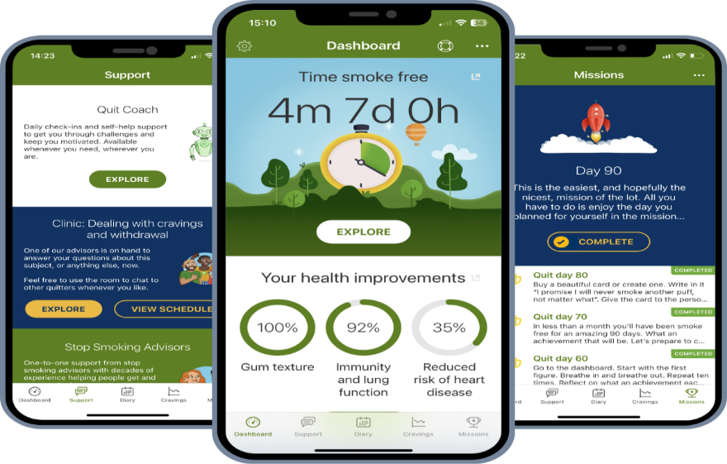
Figure 1: Smokefree Wiltshire mobile application interface
Source: Wiltshire Healthy Schools (2025), ‘Wiltshire Smokefree App and Health Coach support’

3. Evidence and critical evaluation
The app is easy to use, private and flexible and users can get guidance without attending appointments. But it is not an assurance of successful quitting. Smartphone apps yielded no statistically significant advantages over minimal support in six studies with a total of 5,424 participants (RR = 0.93, 95% CI 0.79–1.09) (WHO 2024b). This means that research into app-stand-alones is inconclusive. The results do not prove the effectiveness of the NHS app, but rather of smartphone apps in general. There is the need to differentiate engagement with an application from successful smoking cessation. Initially users can monitor progress, then forget to use the app, has cravings or relapses. Low digital literacy, limited internet connectivity or older devices could also pose challenges. There are issues of privacy too. Technical and optional information about the profile is collected, but progress is stored locally on the device (NHS, 2024).

4. Recommendations and conclusion
The app could include more accessible design, personalised guidance on craving management, and transparent privacy statements and direct connections to trained cessation counsellors. Sustained quit rates, continued engagement and outcomes by socioeconomic groups should be measured. In summary, the NHS Quit Smoking app is a helpful health promotion tool, but must not be used as a substitute for evidence-based behavioural support and suitable cessation medication (WHO, 2024a).

Blog 2: HealthySteps — Designing a Personalised Digital Intervention to Reduce Physical Inactivity

1. Public health problem
Physical inactivity is a significant public health problem, as it is linked to an increased risk of cardiovascular disease, type 2 diabetes and poor mental wellbeing. According to the World Health Organization (WHO, 2024), 31% of adults globally (1.8 billion people) were not active enough in 2022. This underscores the need for interventions that are accessible and take into account barriers like lack of time, motivation, safety, and access to exercise facilities.

2. Proposed digital technology: HealthySteps
HealthySteps is not a validated intervention, but a proposed mobile app for promoting sustainable behaviors among inactive adults. It would set personalised targets for walking, track steps, set reminders to walk, show weekly progress and deliver motivational short lessons. Goals would be adjusted to the abilities of the users and low-cost indoor activities would be provided for those who are unable to walk outside. The app would include the COM-B behaviour change model, which describes behaviour as the function of capability, opportunity and motivation (Michie, van Stralen and West, 2011). It would be capable to simple instructions and attainable objectives, opportunity would be enhanced by providing indoor activities and convenient alternatives, and motivation would be increased by feedback on progress and reminders at suitable times.

3. Critical evaluation of expected impact
HealthySteps might enable users to transform basic health information into everyday practices. In the trials included, standalone digital behaviour-change interventions showed improvement in physical activity, but the certainty of evidence for activity outcomes was low (Lee and Park 2025). However, He et al. (2024) reported no overall statistically significant increase in physical activity in healthy young adults with the use of a smartphone application. The differing results indicate a possible effect of HealthySteps, though it is not assured. Tracking and reminders can help ensure development of a routine, but too many can lead to disengagement, and faulty tracking can result in lost trust. Digital exclusion is another issue is raised. Abdelmalak et al. (2024) identified gaps in how inequalities are considered in mobile-health intervention trials. Individuals who have less access to the internet or are less technologically literate or disabled may be at further disadvantage. Also, there is no evidence that more steps result in long-term behaviour change or disease protection.

4. Recommendations and conclusion
HealthySteps should have easy to use interfaces, flexible reminders, privacy protection and low data options. More support and non-digital options should be provided in the area of community health services. At least physical activity at baseline and follow-up, continued use of the app, accessibility and outcomes across population groups should be measured in a pilot evaluation. In sum, while HealthySteps may contribute to healthier lifestyles, its public health impact requires inclusive design, engagement, and robust evaluation.

Figure 2: Community walking as an accessible form of physical activity
Source: Walks4all (2026)

References
Abdelmalak, N. et al. (2024) ‘Consideration of inequalities in effectiveness trials of mHealth applications: A systematic assessment of studies from an umbrella review’, International Journal for Equity in Health, 23, article 181. Available at: https://doi.org/10.1186/s12939-024-02267-4
He, Z. et al. (2024) ‘Smartphone app-based interventions on physical activity behaviors and psychological correlates in healthy young adults: A systematic review’, PLOS ONE, 19(4), e0301088. Available at: https://doi.org/10.1371/journal.pone.0301088
Lee, S.-A. and Park, J.-H. (2025) ‘Systematic review and meta-analysis of standalone digital behavior change interventions on physical activity’, npj Digital Medicine, 8, article 436. Available at: https://doi.org/10.1038/s41746-025-01827-4
Michie, S., van Stralen, M.M. and West, R. (2011) ‘The behaviour change wheel: A new method for characterising and designing behaviour change interventions’, Implementation Science, 6, article 42. Available at: https://doi.org/10.1186/1748-5908-6-42
NHS (2024) Privacy policy for the NHS Quit Smoking app. Available at: https://www.nhs.uk/better-health/privacy-policy/privacy-policy-for-the-nhs-quit-smoking-app/ (Accessed: 15 October 2026).
NHS (2025) Quit smoking: Better Health. Available at: https://www.nhs.uk/better-health/quit-smoking/ (Accessed: 13 October 2026).
NHS England Digital (2026) Health Survey for England, 2024: Adults’ health-related behaviours. Available at: https://digital.nhs.uk/data-and-information/publications/statistical/health-survey-for-england/2024/adults-health-related-behaviours (Accessed: 11 October 2026).
Walks4all (2026) Walking health update: May 2026. Available at: https://www.walks4all.com/wellness/walking-health-update-may-2026/ (Accessed: 11 October 2026).
Wiltshire Healthy Schools (2025) Wiltshire Smokefree App and Health Coach support. Available at: https://www.wiltshirehealthyschools.org/news/items/wiltshire-smokefree-app-and-health-coach-support (Accessed: 09 October 2026).
World Health Organization (WHO) (2024) Physical activity. Available at: https://www.who.int/news-room/fact-sheets/detail/physical-activity
World Health Organization (WHO) (2024a) WHO clinical treatment guideline for tobacco cessation in adults. Geneva: World Health Organization. Available at: https://www.who.int/publications/i/item/9789240096431 (Accessed: 10 October 2026).
World Health Organization (WHO) (2024b) WHO releases first-ever clinical treatment guideline for tobacco cessation in adults. Available at: https://www.who.int/news/item/02-07-2024-who-releases-first-ever-clinical-treatment-guideline-for-tobacco-cessation-in-adults (Accessed: 13 October 2026).

