

Hotel Placement Research Project
Topic: Understanding the impact of staff shortage on the overall service quality, satisfaction of the guests along with operational efficiency: A case study at Hilton Hotel

Lecturer Name: Ka Po Chong
Module Code: BMIH6008
Student Name: Emanuela Diana Simon
Student ID: 2108561

Abstract
The different types of factors related to the hotel industry has been brought forward to understand their operations regarding the market scenario. A case study related to Hilton Hotels and its Spa and Event room services has been brought forward to understand the operations and the revenue generation process adopted by this organization. The existing literature sources has been brought forward to understand the several views shared by the authors related to the operating procedure. It has helped a lot in framing the hypothesis of the study and improving the overall aspects for further research. The method selected to gather the information and to implement the facts has been brought forward along with proper comparisons regarding the hotel. Exploration of the theme has also been selected to identify the areas related to the objectives which has been formed. Finally, future recommendations have also been carried out to allow for improved performance over time.

Table of Contents
Chapter One: Introduction 4
1.1 Introduction 4
1.2 Aim and Objectives 4
1.3 Research Question 5
1.4 Background of the project 5
1.5 Scope and organisation 6
Chapter Two: Literature Review 7
2.1 Introduction 7
2.2 The factors that cause the staff shortage issue within the spa and event room of UK hotels and hospitality companies 7
2.3 Analysing the effect of the shortage of employees on the well-being and job satisfaction of the existing workers in the spa and event room of hotels 9
2.4 Evaluating the possible solution to reduce the staff shortage issue while considering management and recruitment practices in hotels 10
2.5 Literature Gap 12
2.6 Summary 12
Chapter Three: Methods 13
3.1 Case Study 13
3.2 Data collection technique used 13
3.3 Data analysis 13
3.4 Materials and Instruments 14
3.5 Philosophy 14
3.6 Limitations 14
3.7 Ethical Considerations 15
Chapter Four: Case Study Discussion 16
4.1 Descriptions 16
4.2 SWOT analysis 20
4.3 PEST analysis 23
4.4 Competitor analysis 24
Chapter Five: Theme Exploration 26
5.1 Thematic Analysis 26
5.2 Discussion 32
Chapter Six: Conclusion and Recommendation 36
6.1 Conclusion 36
6.2 Recommendation 37
Chapter Seven: Reflective Account 39
References 42
Appendix 50

Chapter One: Introduction

1.1 Introduction
The overall perspective of the project is based on the analysis of the staff shortage issue in the Spa and Event room services of Hilton Hotels. The following section will shed light on the aim, and objectives along with the research perspective on the background information regarding this aspect. Based on that, the scope section will critically highlight the overall structure that will be followed here to conduct the study.

1.2 Aim and Objectives
Aim
To understand the impact of staff shortage on the overall service quality, guest satisfaction and operational efficiency of the Spa and Event room services in the Hilton Hotel.
Objectives
1. To examine the factors that cause the staff shortage issue within the Spa and Event room of the Hilton Hotel.
2. To analyse the effect of the shortage of employees on the well-being and job satisfaction of the existing workers in the Spa and Event room of the Hilton Hotel.
3. To evaluate the possible solution to reduce the staff shortage issue while considering management and recruitment practices in the Hilton Hotel.

1.3 Research Question
1. What are the factors that cause the staff shortage issue within the Spa and Event room of the Hilton Hotel?
2. What is the effect of the shortage of employees on the well-being and job satisfaction of the existing workers in the Spa and Event room of the Hilton Hotel?
3. What are the evaluate the possible solutions to reduce the staff shortage issue while considering management and recruitment practices in the Hilton Hotel?

1.4 Background of the project
The overall UK hospitality industry faces a crisis of staff shortage irrespective of having vacancies 48 per cent higher than the pre-Covid situation. Various secondary data have analysed that this problem has delayed in providing service which has reduced the satisfaction rate of the customer. Based on that, negative reviews impacted on the overall reputation of the organisation. In many departments such as the Spa and event room, a reduced number of workers has limited the operating hours which primarily dissatisfied guests (Kwok, 2022). Therefore, understanding the key factors associated with this can help the firms to mitigate the issue followed by strengthening its recruitment and well-being aspects. Hilton Hotels and Resorts is a global brand that provides full service for its customers. It was founded by Conrad Hilton in the year of 1919 in May and has headquarters in Tysons, Virginia and the United States (Hilton, 2024). The recent data have shown that the world this has generated 10.24 billion dollars in revenue in 2023 which is a 16.66 per cent increase from 2022.

1.5 Scope and organisation
The overall structure of the project will be based on discussing background information regarding the staff shortage in the hospitality industry along with aims and objectives. The literature review will critically examine the objectives in a general manner to shed light on the facts associated with it. A diverse perspective linked with the chosen hotel will be examined in the case study section by SWOT, PESTLE and competitive analysis. Furthermore, a thematic explanation will be done along with the recommendation for improvement of the issue faced by the firm.

Chapter Two: Literature Review

2.1 Introduction
The UK hospitality sector is one of the major associated industries of tourism and travel and is considered one of the large job provider segments. This report will review previous findings from previous research regarding the impacts and reasons for employee shortage issues within the spa and event rooms of the UK hospitality sectors. Furthermore, the researcher will discuss the data collected from the secondary resources to understand the ways this particular issue can be overcome.

2.2 The factors that cause the staff shortage issue within the spa and event room of UK hotels and hospitality companies
The hospitality sector within the UK is one of the largest and fastest-growing tourism sectors which contributes to a larger portion of employment opportunities with domestic as well as international segments. However, with dynamic business aspects, this industry is currently experiencing huge issues in its different segments due to a high employee turnover rate. There are several attributing factors that are majorly responsible for causing employee storage in the hospitality sector.
Reduction and retention problems
According to Szromek and Polok (2022), within the hotel industry employee retention can be difficult in several stressful job responsibilities, especially in Spa and event rooms. Multiple factors such as improper working situations, employee burnout, and insufficient career growth opportunities are majorly considerable as the leading factors of employee shortage. As opined by Albayrak et al. (2024), high-scale competition with other sectors with escalated payscale, better advantages, and flexible and reliable working hours can also be significant contributing factors to high employee turnover.
Insufficient skills and improper training
Based on the research of Kotsakov et al. (2024), certain competencies and knowledge are essentially required for any positions in Spa and event rooms within the hospitality sectors. Therefore, searching for and finding skills and best suitable employees with the required competencies can be very difficult due to the limited talent pool in this particular segment. Apart from that, providing training to unskilled employees can be hectic due to high time and operational investments.
High fluctuation in demands
As stated by Sealy et al. (2023), hotel sectors generally witness on-season pressures and off-season troughs due to fluctuations in consumer demand. Mainly in summer vacation, festive and occasional holidays as well as any specific events, a significant fluctuation and inconsistency in activities can be experienced by hotel marketers. Kariru (2023) stated, that during the seasonal period, huge work pressure can be created on existing workers which further makes it difficult to hire new staff as soon as possible to reach the high expectations.
Training and certification requirements
As opined by Song (2023), the staff of the event rooms and spa must complete specialised training and certification courses to ensure quality service delivery. The job roles of spa therapists, event planners, and banquet staff require the training programs to perform their roles effectively. However, the number of institutions that offer these kinds of certification courses is less in the market. Most people do not like to invest their time and money in this training program due to its fluctuating demand.

2.3 Analysing the effect of the shortage of employees on the well-being and job satisfaction of the existing workers in the spa and event room of hotels
Demotivated employees
As stated by Dwyer (2022), the issue of staff shortages within the spa and event rooms of hotels can be resolved by implementing effective recruitment and retention strategies. Some hotels fail to offer competitive compensation packages and other benefits to the workforce. Employees frequently change their workplace due to the lack of career development opportunities at their present workplace. Some hotels do not foster a positive work environment which demotivates employees to leave their jobs which contributes to staff shortage.
Decreased morale and job satisfaction
As discussed by Collins and Pearlman (2023), jobs in the hospitality sector, particularly those within event rooms and spa rooms of hotels, often involve irregular hours, weekend shifts, and high pressure. Balancing work commitments with personal life can be challenging for employees which leads to burnout and turnover. Sometimes, the pressure of work on the existing staff increases due to the lack of a sufficient number of employees. Hence, the work-life balance of the workforce is hindered and they try to leave their job. This problem can influence job satisfaction and employee morale which helps in increasing turnover rates of hotels.

Increased workload
According to Frost et al. (2023), staff shortages within the spa and event rooms of a hotel impact its other existing staff due to the high demand for these services in peak seasons. The responsibilities that used to be shared by a large team are now accomplished by a few employees. The workforce of those hotels feels frustrated due to the workload as they are involved in multiple duties. Maintaining cleanliness and attending guests in spa and event rooms require a huge number of employees. The lack of employees increases the work pressure on other staff and faces challenges to uphold the quality of services.

Impact on mental health
As demonstrated by Wallenius and Virtanen (2023), issues like staff shortages can impact on the emotional well-being and mental health of the present employees of a hotel. Most employees in his sector go through emotional breakdowns due to the constant pressure to meet the expectations of customers as well as management. The workload of the existing employees may lead them to anxiety, depression, and helplessness. They feel isolated and unsupported while struggling with their mental condition due to the lack of employees. These issues can hinder the mental well-being of employees and they can suffer from prolonged health problems.

2.4 Evaluating the possible solution to reduce the staff shortage issue while considering management and recruitment practices in hotels
The issues of staff shortage are resolved by the human resource managers or HRM as it is their responsibility to hire and retain employees. There are various models that are used by these managers to increase employee retention rates and reduce the staff shortage issue. According to Wood and Kispál-Vitai (2021), hotels may implement the Harvard model of HRM to manage their workforce and mitigate this challenge. According to this model, 5 components such as the interest of stakeholders, situational factors, HRM policies, outcomes, and long-term consequences must be prioritised. The strategies that could be implemented by aligning with this model are:
Competitive compensation and benefits
As discussed by Gowan et al. (2022), hotels in the UK are facing competition from different industries such as retail, restaurants, and entertainment for skilled employees. Other hotels in the hospitality sector are also competitors of each other. Competitors often offer high wages, better benefits, and other attractive advantages which make challenges for hotels while recruiting and hiring talent. The emergence of alternative accommodation options has increased the competition. Therefore, hotels which desire to offer spa and event room services to customers must provide competitive benefits to their employees. Remaining competitive in the market is possible by reviewing and adjusting wages regularly. Some factors such as the local labour market as well as cost of living must be reviewed to make compensation strategies. Apart from that employees will be motivated to be engaged with the workplace when they will be assisted with retirement plans, health insurance, and other facilities.

Strategic workforce planning
As mentioned by Wilton (2022), the availability of skilled employees in the hospitality sector is influenced by various external factors including local demographics, immigration policies, as well as economic conditions. Some hotels are located in areas where the unemployment rate is lower hence they struggle to find the required workforce for spa and event rooms. However, the lack of qualified candidates may be a reason behind increasing this staff shortage issue. These challenges could be resolved by engaging in strategic workforce planning to meet the staffing needs. Fluctuation in demand could be resolved by this plan which will involve historical data and future demand analysis. Hotels can proactively adjust schedules and hire part-time staff during peak seasons.

Efficient recruitment procedure
According to Ferrer et al. (2022), the event rooms and spas are mainly booked in the peak seasons hence existing staff cannot provide desired services. However, the demand of employees for these two services is less in other times which creates challenges like staff shortage in peak seasons. Therefore, efficient recruitment procedures are essential for addressing this issue in hotels. Using new technological advancements in the hiring processes can help in recruiting the best candidates for the job roles. Clear communication channels as well as standardised procedures can be used in the overall recruitment procedures. Job vacancies related to these services will be fulfilled within time by leveraging applicant tracking systems. The role of online job portals is very extensive in this matter as hiring national and international talent is possible through this digital advancement. Moreover, employee referral programs will help in identifying qualified candidates and expand the talent pool of hotels.

2.5 Literature Gap
While reviewing all the literature associated with three fundamental objectives, the researcher has experienced certain difficulties. Although there was a large quantity of valuable and reliable information available they were not all easily accessible to the researcher to collect and analyse data and find profound insights. Apart from that, how employee retention can be increased by hotel industries was not clearly discussed in the majority of research articles and journals. Therefore, the researcher stated further research on finding specific solutions towards improved employee retention is majorly required.

2.6 Summary
The researcher has discussed the contributing factors of employee turnover within the UK hotel industry. Additionally, the impacts of high employee turnover rate on the consumer requirements and satisfaction in the spa and event segment within the UK hotel companies. Moreover, certain suitable solutions regarding employee retention have been also demonstrated by the researcher. Overall, gaps in the literature findings have been also highlighted in this section.

Chapter Three: Methods

3.1 Case Study
A case study aims to provide a detailed analysis of a particular organisation and helps in understanding the areas of its performance. The descriptive methodology has been selected to point out several facts regarding the Hilton Hotel and to let the viewers understand the areas and the services offered. This has allowed for providing a detailed analysis based on a particular scenario and possibly investigating further (Pereira et al., 2021).

3.2 Data collection technique used
A proper thematic analysis has been carried out to gather all the possible facts regarding the Hilton Hotel from the different types of secondary sources. The theme has been selected and based upon the objectives the particular information has been searched over the Internet to analyse the facts. It has allowed the researcher to provide an in-depth methodology into the entire study process (Braun and Clarke, 2021). The development of the different types of aspects related to the data collection process has been easily brought forward using the thematic method. It has also allowed for easy understanding regarding the areas of the Hilton Hotel. This has also provided a large amount of information regarding a particular matter which has also enabled the generation of adequate hypothesis (Ayre and McCaffery, 2022).

3.3 Data analysis
A comprehensive tool has been used to analyse all the facts related to the data collection process to get the possible results. Thorough understanding of all the information has been carried out to get the relevant idea about Hilton Hotels to bring out the hypothesis accordingly (Collis and Hussey, 2014). It has a lot for improving the acceptability rate of the study and filling out the gaps in the existing sources of literature (Mölder et al., 2021).

3.4 Materials and Instruments
The existing published sources has been thoroughly analysed to get the details regarding the hotel industry. This has allowed for getting relevant ideas which are applicable to the selected area and to implement them within the study procedure (Bryman, 2008). The different websites and the official sites have also been visited to gather information related to Hilton hotels based on their location availability and turnover rates (Reis et al., 2020).

3.5 Philosophy
Interpretivism philosophy has also been selected by the researcher to bring out the facts accordingly and to validate it with a universal acceptance hypothesis. The quantitative data has been given more emphasis during this overall study to analyse the facts related to the Hilton Hotel. All the data has been measured properly before implementing them within the research process to get the facts checked (Park ret al., 2020).

3.6 Limitations
There are several types of drawbacks that are usually faced during the data collection process and the formation of the required hypothesis. The bias of the researcher is one of the major aspects that is prevalent and usually occurs (Saunders et al., 2012). Hence the cross-checking of the facts with the available information from the different types of secondary sources has been carried out at several stages to prevent any kind of data manipulation (Hubbard, 2024).

3.7 Ethical Considerations
All the aspects related to the Data Protection Act has been followed to make the results much more acceptable to a wide range of people (Cottrell, 2014). Proper citations have been provided related to the authors from which the information has been gathered regarding the existing sources. This has allowed for making the research much more viable and Suffice the needs of the individuals conducting the study (Chesser et al., 2020).

Chapter Four: Case Study Discussion

4.1 Descriptions
Location
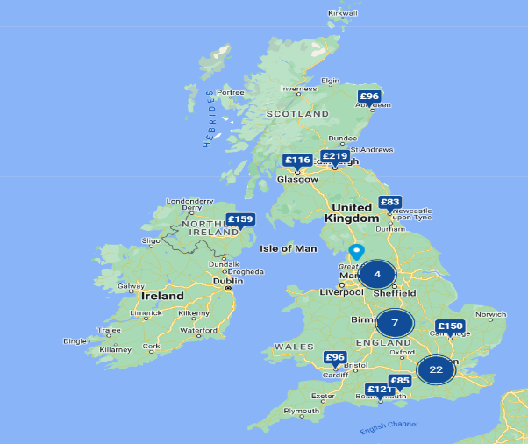
Figure: Location of Hilton Hotels in the United Kingdom
Source: (hilton, 2024)
Analysis
Hilton Hotel is a global brand belonging to the hospitality industry and operates resorts and other properties at different locations. The brand was formed on May 31st 1919 and since then it has been operating effectively to provide good service the tourists the other people. Different types of spa-related services are also provided to attract customers regarding their blissful stay at these locations (hilton, 2024). There are around 57 Hilton Hotels all over the United Kingdom to suffice the needs of the individuals and to provide them with luxurious amenities. They are spread across all the major cities to attract a large number of crowds throughout the year to keep their businesses ongoing. Multiple ranges of room facilities and other areas are catered to suit the needs to improve the positive feedback. These all properties handled the crowd effectively to provide the people with enhanced services related to spas and other areas (hilton, 2024).
Staffing
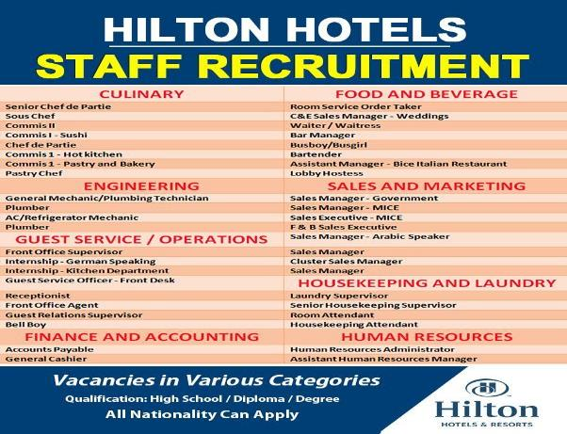
Figure: Staff Recruitment at Hilton Hotels
Source: (hilton, 2024)
Analysis
Jobs for the different types of positions at Hilton Hotels are provided at regular intervals to allow the candidates to apply for them. Multiple types of tasks are undertaken by this chain of properties and hence varied positions are available. Starting from the Food and beverage sector to finance and accounting including human resources are also provided. The sales and marketing and the engineering department are also present which allows for employing a large number of workers (hilton, 2024).
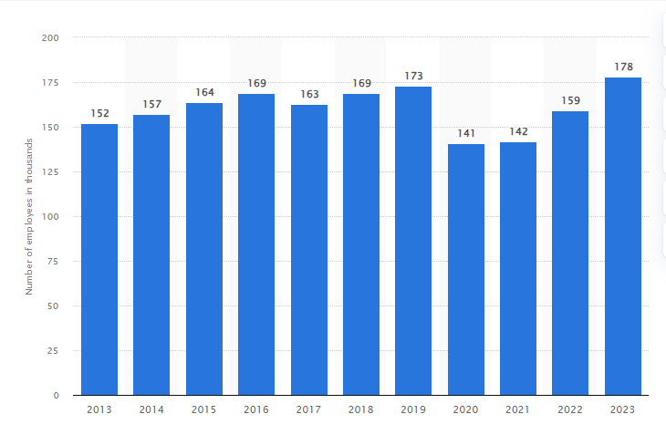
Figure: Staff quantity at Hilton Hotels
Source: (statista, 2024)
Analysis
The employee count for Hilton Hotels has increased over the years starting from 2013 to 2023. According to recent reports around 178 thousand people are employed by this chain to allow them to serve the needs of the guest. This helps in fulfilling all the choices accordingly and implementing them to reach newer heights. A slight decline was seen in the years 2020 and 2021 due to the adverse effects of the pandemic that shook the entire world. After that, the company has recovered to a large extent and has provided enormous growth to provide unprecedented services. It has been possible due to the implementation of regulatory measures to protect the rights of the employees. Thus, it allows for attracting a large crowd throughout the year to fulfil their requirements (statista, 2024).
Turnover
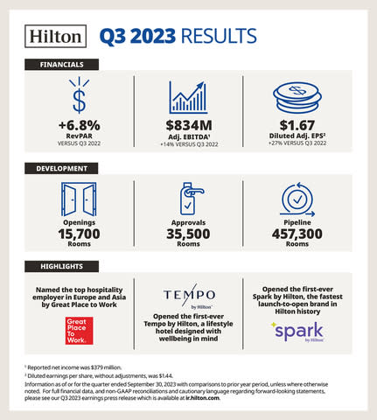
Figure: Turnover rate of Hilton Hotels
Source: (hilton, 2024)

According to the quarter three reports of the Hilton Hotels there has been a growth of around 6% in the overall revenue generation process. There has been an increase of about $834 million throughout the scenario to help the hotel group attain a good brand image. Hence there has been a constant increase in the profit rates throughout the year and the needs of the customers are fulfilled accordingly. This shows that all the necessary policies are adopted accordingly to suit the current needs and to attract the crowd. This turnover rate is projected to improve in the next financial year with a larger number of people and newer openings of properties (hilton, 2024).
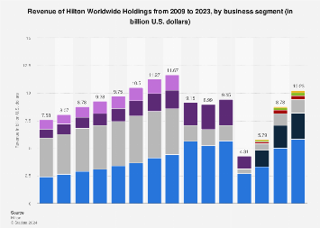
Figure: Turnover rate of Hilton Hotels
Source: (financialtimes, 2024)
Analysis
There has been a constant increase in the overall revenue that has been generated by Hilton Hotels to improve its brand value. It has been possible due to the implementation of varied aspects and innovation within their business strategies to suit the needs of the customers. The turnover is projected to grow at an estimated rate of around 8% within the next financial year to suffice the needs of the hospitality industry. There are further chances of reopening older properties along with the newer mosque to accommodate more tourists every year (financialtimes, 2024).

4.2 SWOT analysis
This is mainly a study undertaken by the organisations to critically examine their internal strength and weaknesses. Based on that, the upcoming opportunities and threats can also be understood, which helps establish a strong brand presence in the market. On the other hand, it is also associated with improving the competitive position within the industry.

Strengths
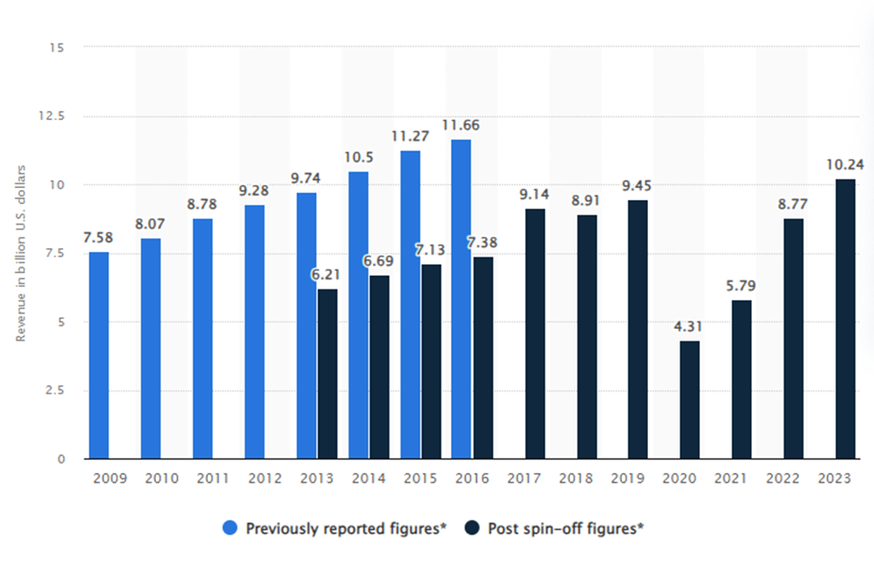
Figure: Revenue of worldwide holdings of Hilton hotel
Source: (Statista, 2024)
The above-mentioned company is one of the reputed business establishments across the globe and has a diverse portfolio of different well-organised chains in various market segments. Along with that, it is also present in over 100 countries and established a strong international network. This has significantly attracted both the business and travellers while maintaining a stable revenue stream. The above-mentioned statistical graph highlighted that the firm has generated 10.24 billion US dollars in 2023 which is higher than the previous years (Statista, 2024). However, a significant reduction has been observed during the COVID-19 pandemic to control the spread of the disease.
Weaknesses
Hilton mainly operates through management as well as franchise agreements which reduces its ability to the ownership of the properties. Along with that, the rise of competition in the market such as Airbnb and others has negatively impacted the overall services. It has been seen that these platforms often offer lower prices as well as a unique experience for the customers (Maglovska and Dimitrov, 2020). Irrespective of that, the firm heavy reliance on technological facilities and increased complaints about data breaches have reduced its revenue and brand image in the competitive market. On the other hand, during the pandemic, the staff shortage issue in the hospitality industry also becomes prominent. Various departments such as Spa and event services could not operate due to the restrictions from the government (Race, 2021). This has reduced the percentage of wages which negatively impacted impact on the well-being aspects of employees in the Hilton hotels.
Opportunities
After the COVID-19 pandemic, as economic growth continues in the different countries the demand for accommodation in the hotel also increases. According to the statistical information, by August 2020, the monthly change in the number of online hotel searches showed increasing trends. In 2022, the share of UK travellers grew by 37 per cent for eco-friendly hotels (Statista, 2024). On the other hand, the strategic acquisition to strengthen the brand portfolio can help the firm maintain its competitive edge (Brunner and Baum, 2020). This has been observed that the organisation is heavily focused on sustainability and eco-friendly practices. Through collaborating with the communities, it can leverage the expansion across the globe while gaining trust and attracting new customers. This can also positively impact the staff shortage issue of the Hilton hotels along with the employee well-being.
Threats
The rise of sharing economic platforms and providing alternative accommodation options can pose a huge threat to the company. Irrespective of that, economic recessions can negatively impact on the spending of the customer on travel (Crespí-Cladera et al., 2021). Governmental regulations during the pandemic situation have forced hospitality chains to stop their operations. It can create as restrictions and affect the ability of Hilton Hotels to attract more travellers.

4.3 PEST analysis
Political factors
Hilton Hotel is known as a leading hospitality company in the world as it operates in more than 126 countries. Over 7,600 properties are owned by this company in different nations hence the government regulation influences the business of this company (hilton, 2024). Every country has their own set of regulations that are applied to the hospitality industry. The profitability and operations of this hotel can be impacted by the changes in laws and rules regarding taxation, labour laws, environmental policies, and safety standards. Being a multinational company, the operation of Hilton Hotel is hugely impacted by international relationships of the government. The labour markets are affected by political stability and government regulations which can extensively impact the staff shortage issue of the Hilton Hotel. Moreover, strict laws regarding hiring employees and high rates of minimum wages may pose challenges to this organisation.
Economic factors
The economic condition of each country where this hotel operates its business impacts its financial aspects. The economic factors that influence most are global economic conditions, exchange rate fluctuations, as well as income levels of individuals. Some events like currency depreciation or appreciation can impact the financial performance and profitability of the Hilton Hotel. Spending of consumers on travel and leisure activities is reduced due to recession or economic downturns which reduce the amount of revenue generation of Hilton Hotel. However, the pricing strategy of this hotel is highly affected by the changes in income distribution and economic inequality (Brannon, 2024). Economic conditions of operating countries and income levels are influencing hiring capabilities of Hilton Hotel. Sometimes, potential burnout among existing staff of this hotel takes place due to increased workloads and economic stress. Therefore, this organisation is implementing competitive compensation packages and incentives to attract employees.
Social factors
Growing awareness of health and wellness concerns influences the preferences of consumers while buying hospitality services like spas. Most people like to buy these services from those hotels where trained and certified employees are present. Therefore, this hotel must invest in staff training and in these facilities. Apart from this, Hilton Hotel operates in multiple countries where people from different cultures and backgrounds belong. Therefore, their preferences, norms, and beliefs regarding spa and event rooms can influence the services of this business (Walls, 2021). A well-trained workforce is needed in this hotel to offer spa services due to increased demand for health and wellness services. Both the service quality and guest satisfaction could be directly impacted by the absence of qualified employees. The staff of this hotel are also not satisfied due to high cultural pressure and service expectations.
Technological factors
The changing technological landscape is also impacting the business of the hospitality industry including hotels. The emergence of online booking systems, mobile applications, and digital payment techniques has a great role in the operations of Hilton Hotel. However, this company must prioritise data security and privacy concerns to avoid threats related to digital technologies. Offering a personalised experience will be easier for this hotel by leveraging innovations like virtual reality, automation, and artificial intelligence (Barten, 2024). The use of technology can mitigate the issues related to staff shortages by streamlining operations and maintaining service quality. Efficient utilisation of digital tools can improve guest satisfaction and operational efficiency. Hilton Hotel may leverage technology to enhance recruitment processes.

4.4 Competitor analysis

Competitors | Price | Quality
Marriott International | Different market segments such as mid-scale, budget-conscious, as well as luxury are served by this hotel. Luxury properties are located in premium places and the price of the rooms and services are higher than budget-friendly and mid-scale hotels of this company. Marriott International is a big competitor of Hilton Hotel in the same markets which provides similar services and amenities (marriott, 2024). | Delivering exceptional services and guest experiences are the objectives of this hotel. The consistent quality standard of Marriott International is known by the guests. Clients can experience premium services through its personalised offerings as the staff concentrates on detail more than anything (marriott, 2024).
InterContinental Hotels Group (IHG) | A diverse portfolio of brands are operated by IHG including luxury, upscale, and midscale options. Market dynamics, location, and position of hotels of this company are analysed to create the pricing strategies. However, the price of the hospitality services is higher in this hotel compared to midscale and budget options (ihg, 2024). | This hotel group is known as a luxury brand due to its refined accommodations, prestigious properties, as well as excellent services. Business travellers and people who like leisure accommodation mostly prefer this hotel. However, Holiday Inn is a brand of this group which provides a reliable stay experience for budget-conscious customers (ihgplc, 2024).

Chapter Five: Theme Exploration

5.1 Thematic Analysis
Theme 1: Causes for staff shortage in the Spa and Event Rooms of the Hilton Hotel
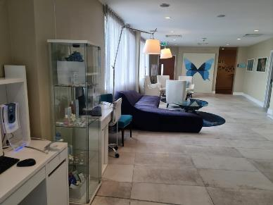
Figure 1: Hilton Hotel Southampton
(Source: Author)
The issues regarding staff shortages are huge in the competing environment of spa and event rooms of Hilton Hotel in Southampton, which affects a wide range of operations. Hence, exploring the reasons which underlies the issue would highlight a dynamic overview of the factors which are influencing such problems (Sperance, 2022).
Primarily, seasonal fluctuations have been emerging as a prominent factor for staff shortage. The flow of visitors all year round builds peak times that demands for effective services and leads to staff shortages. During these peak seasons, like holidays and special events, the need for spa treatments or event coordination goes high which surpasses the capacity of the workforce available. Similarly, during off-peak times, there is an increase of staff which leads to their underutilisation and possible cost inefficiencies for the company (Jelski, 2022). Secondly, turnover or attribution majorly led to shortage of staff for the spa or event rooms. Increased turnover rates in this industry which are driven by aspects like job dissatisfaction or burnout leverages these challenges to keep a stable workforce. Along with that, attrition that is influenced by elements like retirement or relocation also reduces the talent pool which builds staffing gaps which disrupts continuity of services. Additionally, insufficient workplace planning or recruitment methods increase the problems of staff shortage. Therefore, the recruitment process of Hilton Hotel might fail to make alignment with the comprehensive demands of the spa or event departments which would lead to mismatches among staffing. Moreover, other factors like legislative changes and economic downturns influences the availability of staff even though they lie beyond the control of the hotel. Few regulatory amendments such as modifications towards immigration policies affecting the hiring of international employees hinder the talent pools. Thus, economic fluctuations including recessions as well as devaluations of current trends can majorly affect the staffing budgets leading to recruitment issues (Jeavons, 2023). Lastly, culture and societal aspects play another role in such issue where the perception of hospitality work is seen as a low-skilled job deters people from pursuing such careers.

Theme 2: Impact of staff shortage on employee well-being and job satisfaction at Hilton Hotel
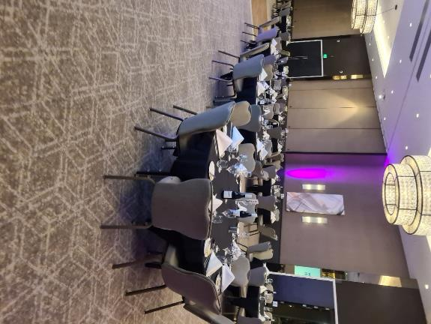
Figure 2: Hilton Hotel Southampton
(Source: Author)
The effect of staff shortage towards employee wellness as well as job satisfaction surrounds different domains of the workplace atmosphere in Hilton Hotels which leads to major effects on the workforce (tripadvisor, 2019).
Firstly, shortage of staff brings higher stress levels and workload intensity among the remaining workers that are available, which results in detrimental effects on their overall well-being. When there are fewer hands to handle the spa or event operation demands, workers often become stretched thin, affected by higher workloads along with compressed timelines. Therefore, the increased pressure for providing high quality services during resource constraints puts a toll on their physical and mental health, leading to fatigue and burnouts. These bad working conditions comprise whole staff wellness while also impacting their capability to give optimal performance and such actions result in bad service quality and guest satisfaction (Hoisington, 2023). Secondly, staff shortage brings a feeling toward job dissatisfaction or disillusionment among the workers that undermine their complete morale or engagement levels. When they are faced with such shortages, staff might go through disengagement since their effort for meeting guest satisfaction are affected by insufficient staffing. Hence, the inability of offering sufficient attention as well as personalised service to guests because of shortage depletes the pride and fulfilment of staff in their roles, reducing any motivation to offer better service. Along with that, morale plummets combined with attrition rates enhances when workers seek for better opportunities somewhere else, affecting the lifecycle of employee shortage or organisational stability. Thirdly, the effect of staff shortage goes beyond individual wellness to include interpersonal factors and cohesion among teams in the workplace. When there are less workers to share the workload and support, staff might go through isolation and alienation feelings which increases workplace tensions and reduces collaborative efforts. Such a form of erosion on team cohesion and companionship compromises the ability of the hotel to bring a positive and inclusive form of work culture that depletes productivity. Lastly, staff shortages impact any skill development or career advancement opportunities which stifles their career growth or long-term commitment for the company (medium, 2023). Therefore, when there are insufficient resources to invest in training activities, workers might find themselves being stagnated in their respective roles with no chances to develop new skills. This process reduces any sense of purpose or dedication of staff for their organisation.

Theme 3: Importance of management strategies and recruitment initiatives in addressing staff shortage issues at Hilton Hotel
Staffing shortages can greatly impact consumer satisfaction service quality and overall operational efficiency across the hospitality sector, especially in the hotel environment. Effective management techniques and recruitment campaigns can be helpful to overcome such obstacles significantly. Implementing a proactive administration approach is inevitable to handle personnel shortage challenges across the spa and event room significantly. Addressing these discrepancies becomes crucial before they negatively impact operations anticipating staffing demands, recognising gaps at the personnel level and establishing significant plans successfully are necessary.
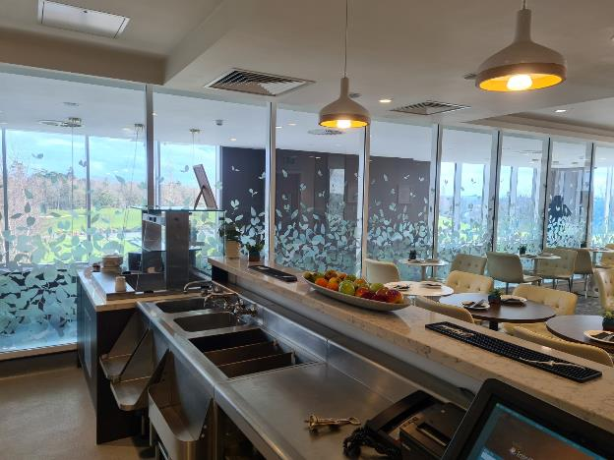
Figure 3: Hilton Hotel Southampton
(Source: Author)
Proactive management techniques of Hilton Hotel encompass regular workforce assessments, projecting personnel needs based on demand patterns and seasonal variations, and putting cross-training programmes into place to increase workforce flexibility (Shumway, 2022). Also, Hilton Hotels needs to focus on job allocation, workflow patterns, employee feedback and grievances. It is important for them to locate root causes and take hands-on steps to resolve the issues (Race, 2021). They can then customise solutions that directly address these issues, such as job redistribution, scheduling practice optimisation or the introduction of retention incentives for current employees, based on this information (mckinsey, 2023).
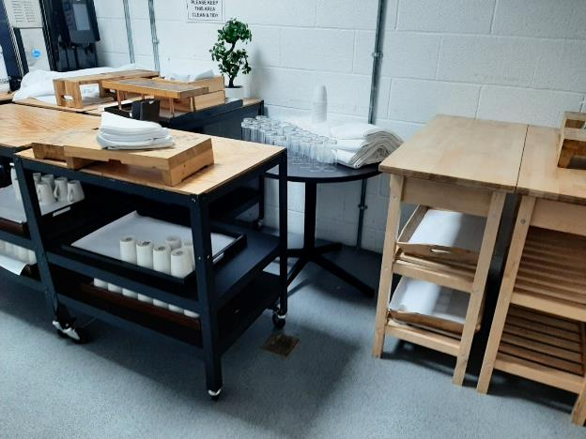
Figure 4: Hilton Hotel Southampton
(Source: Author)
Based on relevant research, it is crucial for hospitality sectors to fulfil employees' commitments through which they can feel valued and respected across the organisation. Considering that, Hilton Hotels needs certain approaches like investing in training initiatives, mentorship programs and utilising performance metrics to fulfil employee needs (Sperance, 2020). Apart from that, the firm has to build a platform for hiring only talented, responsible and effective pools in terms of mitigating staff shortage issues. Within this process, several tactics like leveraging digital platforms, conducting attractive interviews and collaborating with effective hospitality schools majorly retain workers within the work field (Bullock, 2023). On top of that, assessing a strong employer brand via strategic marketing efforts also placed a major option for enhancing the reputation of the business. Understanding employees' mindsets and requirements, building diversity and inclusion initiatives also bring key opportunities for maintaining a positive work environment which ultimately essential for upgrading organisational performance (HASTWELL, 2021). Incorporating these sorts of activities and approaches, Hilton Hotel not only maintains its operational excellence but also expands its brand image across the worldwide hospitality sector.

5.2 Discussion
The following section has addressed the impact of staff shortage issue on the overall service quality of guest satisfaction with maintaining operational efficiency of Hilton Hotel. Based on the analysis, a differentiation between literature review and findings section has been demonstrated by highlighting the gap of the project by reducing this factor. Gathering data from relevant literature sources, key factors of staff shortage issues have been addressed that hinder the quality of UK hotel businesses' spa and event rooms. Analysis of Szromek and Polok (2022) clearly discussed recruitment and retention problems due to stressful job responsibilities. Alternatively, Albayrak et al. (2024) mentioned the impact of high-scale competition within flexible working hours which uplifts turnover rate. Sealy et al. (2023) stated about fluctuating demands of on-season pressures and off-season troughs that majorly impacted customer requirements. Apart from that, the point of view of Kotsakov et al. (2024) clearly dictated the reasons for improper training and insufficient skills that limited the engagement of potential pools within this sector. Some researchers more relied on the frustrating workload while maintaining cleanliness and attending to guests that ultimately upholding the quality of services. These sorts of situations directly impact the well-being and generate mental health issues of employees. Based on that, it became difficult for them to promote best facilities for consumers which downgrades the performance of the organisation. Hence, relevant management and recruitment practices have been observed by undertaking the Harvard model of HRM with finding suitable areas of increased retention and reducing staff shortage issues. The activities of this model have been dictated by addressing compensation benefits, strategic workforce planning and efficient recruitment procedures to sustain employee retention and meet customer expectations. Alternatively, the findings section has derived the causes of staff shortage issues within the spa and event room of Hilton Hotel. Being a renowned hospitality business, the primary aim for them is to provide top-quality services for their consumers at least-effective prices. However, due to several controversial situations, few regions of this hospitality sector faced this issue which ultimately downgraded their operational efficiency. While explaining these themes, an analysis of off-season and peak-season problems has been defined about the problems in spa and event room requirements which surpassed the capacity of the workforce. A clear evaluation of the recruitment process has been investigated which created mismatches among staff levels. Here, a thorough analysis of inadequate forecasting about competitive market trends which causes overestimation of workforce needs. Also, the concerns of economic fluctuations about recessions that affected staff budgets and shifting demand patterns which led to recruitment issues.
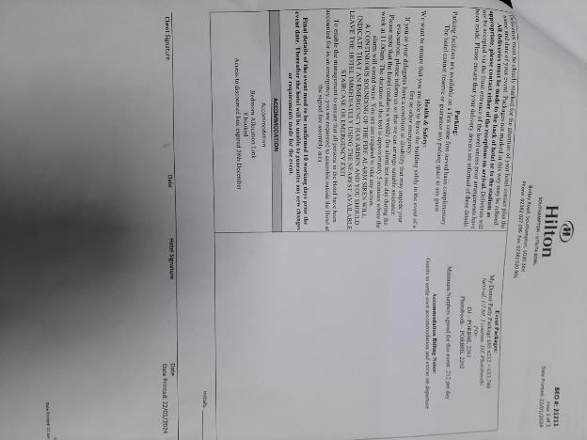
(Source: Author)
Approaches of Gen-Z generations have been addressed about the differentiation in work preferences which generates hiring and retention issues of Hilton Hotel. According to the statements of various websites, businesses faced several challenges in establishing strong employee-employer bonds that significantly impact on production rate due to companionship compromises. These issues have negative influence on professional development changes which undermines the organisation’s long-term commitment. Hence, incorporation of proactive management approaches needs to be developed by recognising major gaps and improving workplace flexibility. Apart from that, the organisation needs to invest in training initiatives, periodic performance evaluations and mentorship activities by sustaining staff retention in spa and event room sectors. Considering this factor, Hilton Hotel needs to reevaluate their tactics for closing the staffing gap and maintaining operational excellence in an intense competition atmosphere.

Chapter Six: Conclusion and Recommendation

6.1 Conclusion
The hospitality sector of the UK has faced a significant labour shortage issue and the pandemic has made the condition worse. During this time, increased workload and less flexible schedules have increased the turnover rate. There are several factors associated with it such as retention, improper training facilities, high fluctuations in demand and others. This has been observed that it has also affected the customer satisfaction rate followed by the overall efficiency across the sector. The research has been conducted based on the secondary framework and all the information has been collected through the reputed and authentic journals, articles and others. Based on that, interpretivism philosophy has been opted by the researcher by considering the limitations and advantages. The case study analysis has shed light on the diverse perspectives of the location, staffing, revenue and others. The higher management of the hotel has implemented diversity while recruiting staff. The statistical data have analysed that, the organisation have reported around 178 thousand individuals to work with them. The SWOT analysis has identified that a strong brand presence is highly important along with the revenue. Irrespective of incorporating technology, the company must take into the consideration of risks faced by the customers such as data breaches and others. On the other hand, the external environment analysis has been conducted by using the PESTLE examination followed by the competitive aspects based on pricing and quality. Irrespective of that, different strategies have been suggested such as focusing on the proper recruitment channels, management structure and work-life balance to improve the condition while increasing productivity and innovation. However, a continuous chain of promotion and a high salary package should also be implemented to deal with the issue in the upcoming future.

6.2 Recommendation
Implement a diverse hiring strategy
The COVID-19 pandemic has negatively impacted the overall operation of the Hilton Hotels and due to that many of the firms have implemented forced layoffs. After the situation, the HR of the organisation should incorporate diversification to attract different individuals to work with them. It is suggested to do blind recruitment to examine them based on the current scenario irrespective of their cultural belief and gender (Gonzalez et al., 2020). The organisation also showcases the positive aspects of working in the hotel industry to motivate them. Through highlighting effective communication and workplace culture, it can also increase productivity as well as innovation.
Flexible schedule
This is highly recommended for the firm to offer work-life balance towards all of their employees to increase job satisfaction and retention. Various secondary articles have analysed that, Hilton Hotels offers different flexible schedule options as well as engagement programmes to support the workers (Rossidis et al., 2021). On the other hand, the firm also established educational programmes to take a break from the career and engage in the outdoor activities. This will be significantly helpful to increase engagement while demonstrating the value of achieving organisational objectives through positive outcomes.
Improvement in the management practices
Staff shortage issue is one the significant problems that Hilton Hotels is facing throughout the years. The higher authority of the company should foster a positive, inclusive as well as supportive chain of networks to foster a sense of belonging. On the other hand, competitive compensation will also be a useful strategy by the management along with incorporating health insurance, retirement and others (Rossidis et al., 2021). All of this decreased the issue of employee reduction while promoting internal strength for better achievement in the upcoming future.

Chapter Seven: Reflective Account
Hilton Hotels, Ageas Bowl in Southampton is one of the reputed hotels where I have gotten a placement as an intern in Spa and Event rooms. I have been working for a few months there and have gone through certain events and circumstances to learn from my experiences. While working with seniors and peers, I have gathered a large scale of knowledge and skills as well as have been able to address my insufficient and unimproved skills. I have observed many unknown aspects of internal processes and working activities in the Spa and Event rooms at Hilton Hotels Ageas Bowl. Different perspectives on managing guests have influenced me to discover more aspects of job roles and responsibilities in the Spa and event segments of the Hilton Hotels, Ageas Bowl. While working as a trainee, different situations and incidents have provided me with valuable knowledge regarding how to manage guests, understand their requirements and meet their expectations in peak seasons. However, I have also observed significant issues facing Hilton Hotels, Ageas Bowl in Southampton. Employee shortage due to seasonal fluctuation, lack of suitable, skilled candidates for managing guests in Spa and event rooms. Therefore, during festive seasons and holidays, along with my co-workers, I have witnessed extreme work pressures to fulfil the demands and requirements of visitors to provide them with excellent experience and treatment. Spa and event room responsibilities and job positions require certain specific skills, qualifications, knowledge and business competencies. Within the UK segment, while searching for the best suitable candidates for the vacant position from a limited talent pool based on regions. Apart from that, I have also discovered other aspects that can be considered contributing factors including reducing approaches of Hilton Hotels regarding employee skill and knowledge development programs for better performance. However, I have acknowledged that initiatives regarding employee training and development programs are less concerning factors for the hospitality company due to high time and money investment. On the other hand, while I have performed my job role as a Spa and Event room intern during seasonal periods in this segment, I have been able to improve my several skills. Working under pressure has honed my organisation and communication skills to a certain extent. Moreover, seniors' perspectives and opinions as well as advice have majorly guided me to improve my time management and problem-solving skills effectively. As a result, I have been able to boost my confidence level and thus foster my presentation skills at a certain level. Therefore, I have been able to handle some special guests during an event which has been held at the Spa and event room of Hilton Hotels, Ageas Bowl in Southampton. Management instructions regarding guest occupation and requirements somehow created additional pressure on me although my several seniors have saved me from the situation through their proper guidance and advice. I have gained concrete experience regarding staff shortages and a profound workforce insufficiency in the spa and event rooms of the hotel companies. Moreover, I have also noticed the ways staff insufficiency has been creating major impacts on guest demands and satisfaction as well as on the existing employees. The Spa and Event segment in the hospitality sector is one of the newest and upgraded aspects where a wide range of knowledge and efficiency are stored (Barten, 2024). Although I have learnt so many new skills, improved my potential as well as honed my professional development for future employment purposes, the lack of recruitment opportunities in this hotel chain has majorly disappointed me. While working as a trainee in terms of placement in the Hilton Hotels, Ageas Bowl in Southampton, I have also addressed a certain lack in management which fails to attract more talented candidates. Lack of working flexibility, stressful management pressures, lack of bonuses or any other additional benefits for employees are the major reasons for the failure in recruitment and retention (Lacalle, 2023). Other hospitality sectors like Marriott hotels with high-pay scale offerings, options for work-life balance career growth opportunities and promotional advantages have become major competitors for Hilton Hotel chains. Hence, I would like to recommend the hotel segment focus on management efficiency and reformulate the management operational structure to improve employee retention and recruitment rate. As per my observation, I can say that Spa and event room management is one of the new courses for degree achievement for the majority of business students. Therefore, it is important for hotels to recruit apparently unskilled candidates and provide them with training with proper guidance to improve the workforce capability and produce more efficient performance. As an intern, I would definitely like to work within this sector in future as I want to improve the Spa and Event room management culture and structure in this Southampton segment. Shifting from the aspects of the hotel's business, I would like to focus on reflecting on my knowledge and skill improvements. During my working period, at Hilton Hotel, Ageas Bowl in Southampton, I have escalated my capacity in active listening, analysis and conflict management. Although my verbal and written communication has been a great strength to me, my emotional intelligence has been insufficient which I have been able to improve there. Overall, my learning and contributing experience was excellent. However, I would suggest the management of the Spa and event room take a strategic approach to invest more time and cost in the recruitment process. This will improve guest and employee satisfaction ensuring gear profitability.

References
Albayrak, T., Dursun-Cengizci, A., Fong, L.H.N. and Caber, M., (2024). The changing role of hotel attributes in destination competitiveness throughout a crisis. International Journal of Csontemporary Hospitality Management.
Ayre, J. and McCaffery, K.J., (2022). Research Note: Thematic analysis in qualitative research. J Physiother.
Barten, M., (2024). Hotel Facilities: Everything You Should Know About Facilities in Hotels. [Online] Available at: https://www.revfine.com/hotel-facilities/ [Accessed 3 May 2024].
Barten, M., (2024). The Latest Technology Trends in the Hospitality Industry of 2024. [Online] Available at: https://www.revfine.com/technology-trends-hospitality-industry/ [Accessed 4 May 2024].
Brannon, I., (2024). A Larger Hotel Chain Is Good For The Industry And The Economy. [Online] Available at: https://www.forbes.com/sites/ikebrannon/2024/01/31/a-larger-hotel-chain-is-good-for-the-industry-and-the-economy/?sh=1db4d80b3372 [Accessed 4 May 2024].
Braun, V. and Clarke, V., (2021). Can I use TA? Should I use TA? Should I not use TA? Comparing reflexive thematic analysis and other pattern‐based qualitative analytic approaches. Counselling and psychotherapy research, 21(1), pp.37-47.
Brunner, C.B. and Baum, M., (2020). The impact of brand portfolios on organizational attractiveness. Journal of Business Research, 106, pp.182-195.
Bryman A. (2008), Social Research Methods, 2 nd Ed, Oxford University Press
Bullock, C., (2023). Hospitality bosses share tips for navigating industry challenges. [Online] Available at: https://www.ft.com/content/ffdbcaba-f73b-442e-a73a-749e99710912 [Accessed 02 May 2024].
Chesser, S., Porter, M.M. and Tuckett, A.G., (2020). Cultivating citizen science for all: ethical considerations for research projects involving diverse and marginalized populations. International Journal of Social Research Methodology, 23(5), pp.497-508.
Collins, M.D. and Pearlman, D.M., (2023). Quality internships in the hospitality industry: a way to help address the labour shortage. Journal of Human Resources in Hospitality & Tourism, 22(4),
Collis, J and Hussey, R (2014), Business Research, A Practical Guide for Undergraduate and Post Graduate Students, Palgrave, London
Cottrell, S. (2014) Dissertations and project reports : a step by step guide. New York: Pallgrave.
Crespí-Cladera, R., Martín-Oliver, A. and Pascual-Fuster, B., (2021). Financial distress in the hospitality industry during the Covid-19 disaster. Tourism Management, 85, p.104301.
Dwyer, L., (2022). Productivity, destination performance, and stakeholder well-being. Tourism and Hospitality, 3(3),
Ferrer, J., Waheduzzaman, W. and Holland, P., (2022). The ethics of Human Resource Management: an impossible position. In The Emerald Handbook of Work, Workplaces and Disruptive Issues in HRM. Emerald Publishing Limited.
financialtimes, (2024). Hilton Worldwide Holdings Inc. [Online] Available at: https://markets.ft.com/data/equities/tearsheet/profile?s=HLT:NYQ [Accessed 04 May 2024].
Frost, J., Van Dijk, P. and Ooi, N., (2023). Coping with occupational stress: exploring women's spa therapist’s experiences. International Journal of Spa and Wellness, 6(2),
Gonzalez, R., Gasco, J. and Llopis, J., (2020). Information and communication technologies and human resources in hospitality and tourism. International Journal of Contemporary Hospitality Management, 32(11), pp.3545-3579.
Gowan, M., DeMarr, B.J. and David, J., (2022). Human resource management: Managing employees for competitive advantage. SAGE Publications.
HASTWELL, C., (2021). How Hilton Maintained Employee Trust After Major Layoffs. [Online] Available at: https://www.greatplacetowork.com/resources/blog/how-hilton-maintained-employee-trust-after-laying-off-10-000-staff [Accessed 03 May 2024].
hilton, (2024). ABOUT HILTON. [Online] Available at: https://ir.hilton.com/#:~:text=Hilton%20is%20a%20leading%20global,in%20126%20countries%20and%20territories [Accessed 4 May 2024].
Hilton, (2024). About Us. [Online] Available at: https://www.hilton.com/en/locations/united-kingdom/ [Accessed 1 May 2024].
hilton, (2024). Dreaming of sunshine-filled stays?. [Online] Available at: https://www.hilton.com/en/ [Accessed 04 May 2024].hilton, (2024). Hotels in United Kingdom. [Online] Available at: https://www.hilton.com/en/locations/united-kingdom/ [Accessed 04 May 2024].
hilton, (2024). HOW WILL YOU MAKE THE STAY?. [Online] Available at: https://jobs.hilton.com/emea/en [Accessed 04 May 2024].
hilton, (2024). Reducing the Friction of Travel. [Online] Available at: https://stories.hilton.com/2023-annual-report [Accessed 04 May 2024].
Hoisington, A., (2023). Staffing shortages persist despite hiring efforts, record wages. [Online]Available at: https://www.hotelmanagement.net/operate/shortages-persist-despite-hiring-efforts-record-wages [Accessed 5 May 2024].
Hubbard, L., (2024). Limitation for a Marketing Research Project. [Online] Available at: https://smallbusiness.chron.com/limitation-marketing-research-project-75633.html [Accessed 04 May 2024].
ihg, (2024). 19 hotel brands. 6,000+ destinations. One loyalty program.. [Online] Available at: https://www.ihg.com/content/us/en/about/brands [Accessed 5 May 2024].
ihgplc, (2024). How our business works. [Online] Available at: https://www.ihgplc.com/en/about-us/how-our-business-works [Accessed 5 May 2024].
Jeavons, M., (2023). Hospitality staff shortage and turnover. [Online]Available at: https://www.go1.com/blog/hospitality-staff-shortage-turnover [Accessed 3 May 2024].
Jelski, C., (2022). High demand plus staff shortage equals stress for hotel spas. [Online]Available at: https://www.travelweekly.com/Travel-News/Hotel-News/High-demand-staff-shortage-hotel-spas [Accessed 2 May 2024].
Kariru, A.N., (2023). Contemporary trends and issues in the hospitality and tourism industry.
Kotsakov, V., Marinov, V., Assenova, M. and Minkovski, R., (2024). Dimensions of employability in the hospitality industry at destination level—the case of a spa destination in Bulgaria. Journal of the Bulgarian Geographical Society, 50, pp.1-19.
Kwok, L., (2022). Labor shortage: a critical reflection and a call for industry-academia collaboration. International Journal of Contemporary Hospitality Management, 34(11), pp.3929-3943.
Lacalle, E., (2023). Ending hotel staff turnover: how to increase your employee retention. [Online] Available at: https://www.mews.com/en/blog/hotel-staff-turnover [Accessed 3 May 2024].
Maglovska, C.R. and Dimitrov, N.V., (2020), September. The Internet of Things in a Hotel Context. In Tourism International Scientific Conference Vrnjačka Banja-TISC (Vol. 5, No. 1, pp. 416-433).
marriott, (2024). Brands. [Online] Available at: https://www.hotel-development.marriott.com/brands [Accessed 4 May 2024].
marriott, (2024). Core Values & Heritage. [Online] Available at: https://www.marriott.com/culture-and-values/core-values.mi [Accessed 4 May 2024].
mckinsey, (2023). Three innovations to solve hotel staffing shortages. [Online] Available at: https://www.mckinsey.com/industries/travel-logistics-and-infrastructure/our-insights/three-innovations-to-solve-hotel-staffing-shortages [Accessed 30 April 2024].
medium, (2023). Addressing Workplace Violence: Strategies for Hotels. [Online]Available at: https://medium.com/@sopforhotel/addressing-workplace-violence-strategies-for-hotels-2da196185b2b#:~:text=Risk%20Factors%20in%20the%20Hospitality%20Industry&text=Long%20working%20hours%2C%20demanding%20customer,the%20issue%20at%20its%20roots [Accessed 6 May 2024].
Mölder, F., Jablonski, K.P., Letcher, B., Hall, M.B., Tomkins-Tinch, C.H., Sochat, V., Forster, J., Lee, S., Twardziok, S.O., Kanitz, A. and Wilm, A., (2021). Sustainable data analysis with Snakemake. F1000Research, 10.
Ntounis, N., Parker, C., Skinner, H., Steadman, C. and Warnaby, G., (2022). Tourism and Hospitality industry resilience during the Covid-19 pandemic: Evidence from England. Current Issues in Tourism, 25(1), pp.46-59.
Park, Y.S., Konge, L. and Artino Jr, A.R., (2020). The positivism paradigm of research. Academic medicine, 95(5), pp.690-694.
Pereira, V., Silva, G.M. and Dias, Á., (2021). Sustainability practices in hospitality: Case study of a luxury hotel in Arrábida Natural Park. Sustainability, 13(6), p.3164.
Race, M., (2021). Is there a solution to the hospitality staff crisis?. [Online] Available at: https://www.bbc.com/news/business-57817775 [Accessed 01 May 2024].
Reis, J., Amorim, M., Melão, N., Cohen, Y. and Rodrigues, M., (2020). Digitalization: A literature review and research agenda. In Proceedings on 25th International Joint Conference on Industrial Engineering and Operations Management–IJCIEOM: The Next Generation of Production and Service Systems 25 (pp. 443-456). Springer International Publishing.
Rossidis, I., Belias, D. and Vasiliadis, L., (2021), June. Strategic human resource management in the international hospitality industry. An extensive literature review. In Culture and Tourism in a Smart, Globalized, and Sustainable World: 7th International Conference of IACuDiT, Hydra, Greece, 2020 (pp. 337-346). Cham: Springer International Publishing.
Saunders, M., Lewis, P. and Thornhill, A. (2012) Research Methods for Business Students, FT/Prentice Hall: Harlow
Sealy, W.C., Jenkins, P. and Jalley, A., (2023). The Recruitment Crisis in the British Hospitality Industry: A Case for More Sustainable Practices. In Embracing Business Sustainability Through Innovation and Creativity in the Service Sector (pp. 31-46). IGI Global.
Shumway, E., (2022). Hilton’s CHRO on how purpose drives the company’s HR strategy. [Online] Available at: https://www.hrdive.com/news/hiltons-chro-how-purpose-drives-hr-strategy/638449/ [Accessed 05 May 2024].
Song, X., (2023). Employee Satisfaction during the Pandemic: A Content Analysis of Online Reviews on Full-Service Hotel.
Sperance, C., (2020). Hilton’s Diversity Strategy Underscores Recruiting Efforts in a Time of Deep Job Cuts. [Online] Available at: https://skift.com/2020/07/06/hiltons-diversity-strategy-underscores-recruiting-efforts-in-a-time-of-deep-job-cuts/ [Accessed 04 May 2024].
Sperance, C., (2022). Hilton’s Latest Employee Benefit Leans Into the Labor Shortage Crisis. [Online]Available at: https://skift.com/2022/01/19/hiltons-latest-employee-benefit-leans-into-the-labor-shortage-crisis/ [Accessed 1 May 2024].
Statista, (2024). Hotel industry in the UK - statistics & facts. [Online] Available at: https://www.statista.com/topics/3146/hotel-industry-in-the-united-kingdom-uk/#editorsPicks [Accessed 16 May 2024].
statista, (2024). Number of Hilton Worldwide Holdings employees from 2013 to 2023. [Online] Available at: https://www.statista.com/statistics/297758/number-of-hilton-worldwide-employees/#:~:text=Global%20hotel%20company%20Hilton%20Worldwide,changes%20in%20its%20global%20operations. [Accessed 04 May 2024].
Statista, (2024). Revenue of Hilton Worldwide Holdings 2009-2023. [Online] Available at: https://www.statista.com/statistics/297760/revenue-of-hilton-worldwide-holdings-inc/ [Accessed 4 May 2024].
Szromek, A.R. and Polok, G., (2022). A business model for spa tourism enterprises: transformation in a period of sustainable change and humanitarian crisis. Journal of Open Innovation: Technology, Market, and Complexity, 8(2), p.72.
tripadvisor, (2019). Hilton Southampton - Utilita Bowl. [Online]Available at: https://www.tripadvisor.com/ShowUserReviews-g186299-d7356312-r665944576-Hilton_Southampton_Utilita_Bowl-Southampton_Hampshire_England.html [Accessed 4 May 2024].
Wallenius, M. and Vertanen, V., (2023). The multidimensionality of work well-being in the hospitality industry: employee and management perspective.
Walls, A., (2021). Economic, Social impact and key aspects of the Hospitality Industry. [Online] Available at: https://www.scitechnol.com/peer-review/economic-social-impact-and-key-aspects-of-the-hospitality-industry-hZsU.php?article_id=17611 [Accessed 4 May 2024].
Wilton, N., (2022). An introduction to human resource management.
Wood, G. and Kispál-Vitai, Z., (2021). CONCEPTS, PRACTICES AND TRENDS IN SHRM. Strategic Human Resource Management: An International Perspective, p.74.

Appendix


