Nicholas Liam Gelstharp – 2211042
Artificial Intelligence and Machine Learning – ML Model
Abstract
This assignment investigate the applicability of machine learning in being able to predict player engagement in order to uncover behavioural patterns within the data that is publicly available and related to gaming. The dataset used was encoded with both categorical and numerical features that were standarised to prepare for data analysis. Two supervised learning approaches were used – Decision Tree and SVM, there were also evaluated using performance metrics including accuracy, precision and F1-score. The Decision Tree machine learning model was consistently the stronger performer across these metrics with even better results being achieved through tuning. The kernel adjustments made to SVM did result in improved evaluation metrics, but they did not compare as well as the Decision Model that was produced.
An unsupervised model was also explored through KMeans clustering, however due to overlapping of clusters the reliability of the insights that were produced were not viable. Overall, further data refinement is needed for actionable business plans and insights would be able to be produced and further characteristics would need to be made available before any business recommended plans could be implemented.
Introduction
The gaming industry has evolved significantly with the availability of digital devices being ubiquitous in society. Gaming is one of the largest industries in the world with an estimated 455 billions dollar market for 2024 [1]. With this much capital at stake companies worldwide are significantly invested in capturing as much of that growing revenue share as possible.
Problem Statement with literature support
The data analytics team are trying to utilise machine learning to better understand their player base to improve player engagement strategies [2]. To support this the behaviour dataset from Kaggle will be utilised to look into key behavioural metrics including playtime, frequency of sessions and in game purchase behaviours, with the ultimate aim predicting player engagement and using unsupervised learning techniques to discover behavioural patterns. This will be achieved through the development of a predictive machine learning model using Decision Tree and Support Vector Machine [3] [4] classifiers instead of physiological methods [5].

Methodology
The data that is available online is mostly of a very good quality, the data is all consistent and that means that there isn’t a great requirement for data cleansing to take place. Within the code though the information held within player time I have changed to be represented within 1 decimal place instead of the multiple decimal places that were held in the original data. This is more in line with the requirements.
data['PlayTimeHours'] = data['PlayTimeHours'].round(1)

Python is also used to apply numerical values to columns within the dataset that contain text, the reason for this is that the machine learning model is not able to use non-numerical data, and so below you can see the mappings that have been applied to the columns that are non numerical, including the engagement level column
gender_map = {'Male': 0, 'Female': 1}

location_map = {'Asia': 0, 'Europe': 1, 'USA': 2, 'Other': 3}

genre_map = {
'Action': 0,
'RPG': 1,
'Simulation': 2,
'Sports': 3,
'Strategy': 4
}

difficulty_map = {'Easy': 0, 'Medium': 1, 'Hard': 2}

data['Gender'] = data['Gender'].map(gender_map)
data['Location'] = data['Location'].map(location_map)
data['GameGenre'] = data['GameGenre'].map(genre_map)
data['GameDifficulty'] = data['GameDifficulty'].map(difficulty_map)

engagement_map = {'Low': 0, 'Medium': 1, 'High': 2}
data[TARGET] = data[TARGET].map(engagement_map)

With the information processed the model was now able to be trained which can be seen in the code below. 80% of the data was used to train the model and the remaining 20% was used to test. The random_state is used as the data is randomly split, this integer can be used so that the code can be used by someone else and the same end results can be achieved
X_train, X_test, y_train, y_test = train_test_split(
X, y, test_size=0.2, random_state=42, stratify=y
)

The Decision Tree model code to train it is below, the same random state was chosen for reproducibility, a depth of 6 was chosen so that the tree wouldn’t become too granular, and a lead sample of 50 was also chosen to hopefully allow enough branching choices to produce a meaningful decision. These were partially chosen at random and can be tuned depending on the end result.
model = DecisionTreeClassifier(
random_state=42,
max_depth=6,
min_samples_leaf=50
)

model.fit(X_train, y_train)

The models were evaluated using Accuracy, Precision, Recall, F1-Score, Confusion Matrix and also AUC-ROC as shown below
y_pred = model.predict(X_test)
from sklearn.metrics import accuracy_score

accuracy = accuracy_score(y_test, y_pred)

from sklearn.metrics import classification_report
from sklearn.metrics import confusion_matrix
import seaborn as sns

cm = confusion_matrix(y_test, y_pred)

from sklearn.metrics import roc_auc_score
from sklearn.preprocessing import label_binarize

y_test_bin = label_binarize(y_test, classes=[0,1,2]) # 0=Low,1=Medium,2=High
y_pred_prob = model.predict_proba(X_test) # predicted probabilities for each class

auc_roc = roc_auc_score(y_test_bin, y_pred_prob, average='macro')
print("AUC-ROC (macro-average):", auc_roc)

Once this Decision Tree was done and implemented the SVM machine learning model was created, the first action was to import the required tools from sklearn that allowed the machine learning model to be chosen and a scaler which is required for SVM to operate as needed
from sklearn.svm import SVC
from sklearn.preprocessing import StandardScaler
X_train_scaled = scaler.fit_transform(X_train)
X_test_scaled = scaler.transform(X_test)

Then the SVM model was created with the same random state that was used previously
svm_model = SVC(
kernel='rbf'
probability=True,
random_state=42
)

svm_model.fit(X_train_scaled, y_train)

y_pred_svm = svm_model.predict(X_test_scaled)

Finally, a clustering algorithm was needed to see if there were any player segments that could be prised from the data that weren’t immediately apparent from using the data labels themselves, below is the code annotated with notes on how this was achieved using Kmeans clustering machine learning algorithms
#Here is where I have started to apply Kmeans (clustering) machine learning to this dataset

# I have removed the target column as this is not needed for the clustering
X_clustering = data.drop(columns=['EngagementLevel'])
print("Shape of data used for clustering:", X_clustering.shape)

from sklearn.preprocessing import StandardScaler

scaler = StandardScaler()
#Scaling has been applied here so that columns are normalised and so ones with large numbers like playtime don't dominate over columns I have manually assigned numbers from 0 to 3 and so the end result is not impacted
X_scaled = scaler.fit_transform(X_clustering)

#importing the machine learning model Kmeans which uses clustering
from sklearn.cluster import KMeans
kmeans = KMeans(n_clusters=3, random_state=42)
cluster_labels = kmeans.fit_predict(X_scaled)
data['Cluster'] = cluster_labels

Results
Initially the Decision Tree results came through as shown below
Accuracy = 0.87. This indicates that the initial model was able to accurately predict 87% of the time the outcome of the engagement level. This is a good score but independently it doesn’t really give a thorough indication of the overall usefulness of this machine learning model. Below is a table containing the precision, recall and F1-Score.

 | Precision | Recall | F1-Score
Low | 0.86 | 0.81 | 0.84
Medium | 0.86 | 0.91 | 0.89
High | 0.91 | 0.86 | 0.88
Accuracy |  |  | 0.87
Macro Avg | 0.88 | 0.86 | 0.87
Weighted Avg | 0.87 | 0.87 | 0.87

This tells me that the precision in predicting High engagement is actually very good at 91%, but it is less good at Medium and Low with just 85% accuracy. The Recall states that predicting Medium and High engagement levels is good, but once again predicting low player engagement is less accurate. The F1 Score is also high which means if is already quite good at not providing false positives and also good at not providing false negatives. Here is a confusion matrix produced from the same model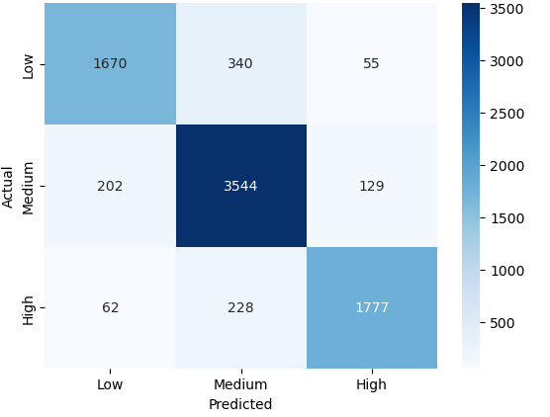
This tells me the model is best at predicting Medium engagement levels, the AUC-ROC score was: 0.93 which also indicated that the model is very capable of identifying the difference between positive and negative classes.
For the SVM model the scores that were initially received were not as good as the decision tree model that was developed. The accuracy was 0.82 with the score across all of the evaluation metrics coming out lower across the board as seen below
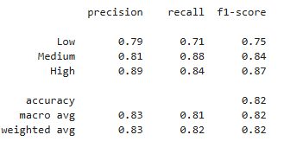
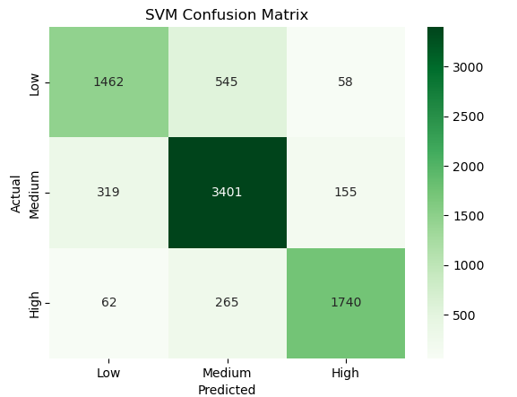

Kmeans was used to see (using clustering ) if there were any hidden player segments within the data that could be ascertained. The results of this are shown in the screenshot below
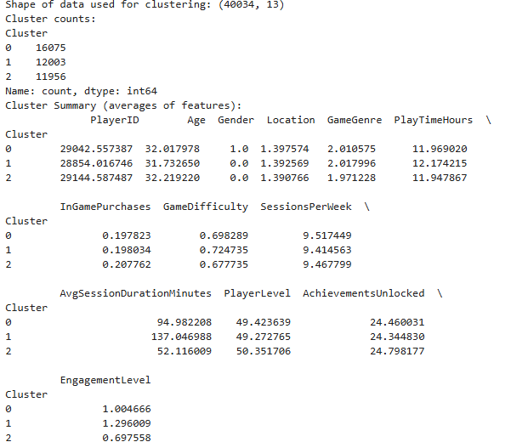

What this is essentially telling me is that there are 3 distinct segments that it has been able to find in the data. The first is Gender 1 which means Female, who have an medium engagement and session length. The second is Gender 0 which means Male and they have the longest sessions and the highest engagement. The Third segment is made up of mostly males, with the shortest duration and lowest engagement. These three segments were not immediately obvious when looking at the raw data. However, the silhouette score is 0.1037 which is low and indicates that there is a significant amount of overlap within the clusters that have been identified, and this suggests that theses identified segmentations should not really be used for analysis and making business decisions as they are not reliable enough.

Experimentation
Once the Decision Tree evaluations were completed, it was achieving satisfactory evaluation metrics across all evaluations especially in predicting Medium and High levels of engagement. The hyperparameters were tweaked to see the impact that this would have on the evaluation metrics. I changed the following hyperparameters doubling the maximum depth and the leaf samples to see the impact on the model.
model = DecisionTreeClassifier(
random_state=42,
max_depth=12,
min_samples_leaf=100
)

This resulted in an accuracy score of 0.89 which was a 2% increasethe precision also increased by roughly the same percentage value as shown in the image below which again indicates that this change has been beneficial to the model, and the confusion matrix did show improvements but only minor and the AUC-ROC raised to 0.94 (with rounding).
I further changes these hyperparameters doubling again to see the impact on the machine learning model
#Here I am training the Decision Tree model
model = DecisionTreeClassifier(
random_state=42,
max_depth=24,
min_samples_leaf=200

However this did not result in further benefits, the accuracy reduced down to 0.87 and all of the other metrics basically returned back to where they were originally except the AUC-ROC which was reduced significantly even from the original value down to 0.93.
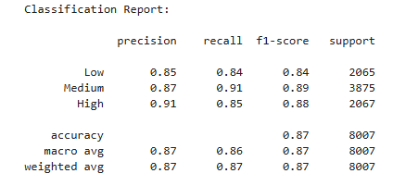
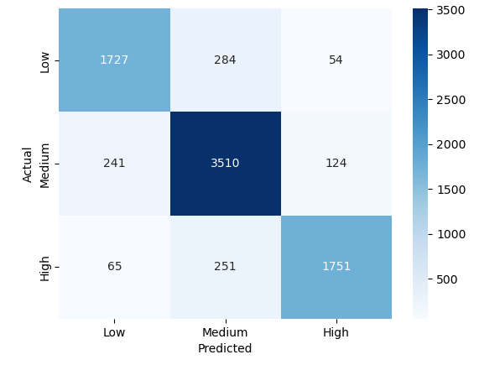
Overall, then I think that the second set of hyperparameters were the best in all areas and so these were chosen in the final code.
With the SVM model I tried changing the kernel hyperparameter to Polynomial Kernel to see the impact it would have on the evaluation metrics, I did this as shown below
svm_model = SVC(
kernel='poly',
probability=True,
random_state=42
)

This overall resulted in higher accuracy, precision, recall and f1-score as shown below
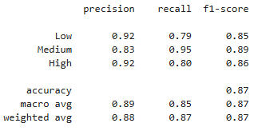
But the confusion matrix was largely unchanged
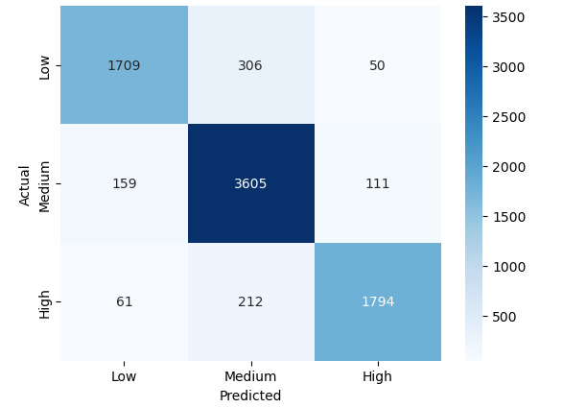
I then tried using a sigmoid kernel instead to see what the impact of this would be on the end results. This resulted in a significantly worse model with accuracy dropping to 68% and across the board worse scores than had been seen previously 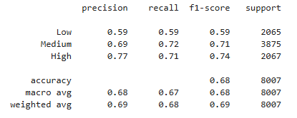
For this reason the poly kernel was the chosen hyperparameter in the final code as it produced the best results when compared to the alternatives.
For the Kmeans machine learning model, it was clear that 3 segments were insufficient to produce any results that were meaningful and so in order to see what could improve that score I change the hyperparameter from 3 to 9, and reproduced the same evaluation metrics originally used for comparison. This resulted in a silhouette score of 0.074 which was even worse than before, and so I changed this to 4 and then this resulted in 0.097 which was still worse than originally received and so I tried 2 which resulted in 0.089. What this all indicates to me is that there are no hidden segments within the database beyond what was immediately obvious.
Conclusion
In conclusion through experimentation it is clear that the decision tree learning model is preferable over the SVM as it consistently achieved a higher score in all evaluation metrics, which could have also been further increased through further hyperparameter tuning. The decision tree model was over 90% accurate with the tuning. The clustering (KMeans) machine learning model was successfully applied, but the results had such a low silhouette score that the confidence in using the output of this model were extremely low and not recommended for consideration for identification of any new customer segments for targeting in a business context.
Recommendation
The ultimate recommendation would be to utilise the decision tree machine learning model to produce a repeatable model that is able to accurately produce a model that affect player engagement. This model was used to evaluate the other columns within the data to see which had the largest influence on player engagement as shown below
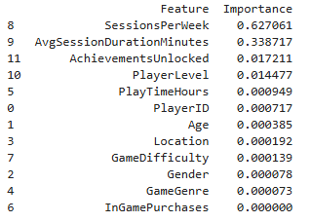

This information shows things which are largely obvious, namely that the session per week, average session time and player level all influenced engagement. In a business context this isn’t particularly useful as it also shows that there is hardly any correlation between marketable features and player engagements names age, location and gender. It would be advisable to remove the columns that are obviously going to result in an increased engagement level. It looks from the data that age is roughly twice as important as the other features, and so having more granular data around age could help in identifying target audiences and providing marketing in places where they would be likely to engage, and therefore sell more games and get them to engage more with them.

References

[1] | “Video game industry - Statistics & Facts,” 6 November 2024. [Online]. Available: https://www.statista.com/topics/868/video-games/#topicOverview.
[2] | L. Rismayanti, “Predicting Online Gaming Behaviour Using Machine Learning Techniques,” International Journal of Data Analytics Studies, vol. 31, 2024.
[3] | V. Stavropoulos and e. al, “Machine Learning(s) in Gaming Discorder through the User-Level Lens,” Frontiers in Computer Scienece, 2024.
[4] | s. Minami and e. al, “Prediction of esports competition outcomes using EEG data and machine learning,” Entertainment Computing / Psychology & Gaming (Elsevier), 2024.
[5] | Review Team, “A Review of Player Engagement Estimation in Video Games,” ACM Transactions / CHI PLAY / ACM DL, 2024.

