8 Reference List  Bags of ability. (2016). Sensory storytelling for professionals .Available: https://www.mencap.org.uk/blog/sensory-storytelling-professionals. Last accessed 03/04/2017.  Corbett, P. (2008). Storytelling and story-making . Available: http://www.torre-primary.torbay.sch.uk/sites/torreprimary/files/downloads/Storytelling.pdf. Last accessed 14/03/2018.  Grace J Robinson L. (2017). Co-authoring sensory stories with individuals with PMLD . PMLD Link. 29 (88), 29-32.  Talk sense. (2016). Sensory stories, theory and practice.. Available: https://talksense.weebly.com/sensory-stories.html. Last accessed 14/01/2018. | 1  A sensory story Video resource.  How to use  How to adapt  Why story telling is important  
2  This sensory story can bring an interactive and fun story time session to both adults and children with a range of additional needs. You can alter and adapt as necessary for each individuals level of understanding. The actions can be used to embed the story and although a very useful tool for those with additional needs could be used for any child.  Additional communication devices could be used as appropriate including, but not limited to; signing, Makaton is widely used for children with additional needs, or BSL if that is the child's given language. Additionally switches could be used with a pre programmed phrase that relates to the story pre loaded, this will give the child who has limited or no spoken words or language an opportunity to participate. Symbols are another widely used communication aid, these can be used to embed certain words with the correct symbol. | 3  Story telling has long been an useful educational tool that crosses boundaries and is generally an easy resource to adapt.  Pie Corbett has done extensive work in this area, it has been seen as an excellent strategy to improve literacy in more able children and as an effective motivator in children for who English is a second language as it enables them to utilise the building blocks already in place in their first language to improve on their learning, understanding and development of the second language.  The story telling process is made up of the following stages; Imitation, innovation and invention. Imitation is where the listener becomes familiar with the story, constant repetition enables the story to become more memorable and familiar, you can adapt and use a multi sensory approach which gives the children a sense of doing well and is a fully inclusive action. In the case of additional needs, a good approach would be to retell the story using drama, this is great to make it more fun and to help those with additional needs participate. Innovation is where even those with additional learning needs can contribute and help to think up ideas and become the author of their own story. Invention is enabling the child to use their own ideas and to be creative.  
4  The video resource can be used as a standalone resource or as a simple demonstration of how to deliver a sensory story.  Firstly, it is important to prepare thoroughly, make sure you know your audience and plan accordingly.  Make sure you have differentiated according to need.  You can add subtitles and symbols using sym writer or another appropriate programme.  You can also print off symbols to accompany the story.  Be as animated as you feel comfortable being.  Most importantly have fun and take the time to involve each participant fully.  A sensory story should aim to bring the story to life for the person its being presented to, it should always be enjoyable for every single participant and everyone should be able to play an active and equal part in the process. It should provide a better learning experience that enables enhanced comprehension of the narrative providing sensory experiences that relate directly to each participant individually and finally it should help the learner to better understand their own world (Talksense, 2016). The theory that individuals with PMLD are capable of co authoring their own stories has been tested thorough a collaboration with a PMLD unit in Torbay and the sensory trust, although at the onset there was no idea if this would come to a successful conclusion they were able to successfully co-author their own story by the end of the day. The pupils reaction to various stimuli was recorded and even those with only a 1 or 2 word spoken vocabulary were able to participate and generate a plot (PMLD Link, 2017). | 5  It is more effective to try if possible to break your story down into somewhere in the region of 6 to ten key moments, if you are adapting a well-known book then you are going to have to leave out a lot of it, however you can still break it down into a familiar plot. Try to decide what the key moment will be in each stage and use appropriate props to bring the story to life, if you do not have the props then you can make them or utilise spare bits of cloth, so in the video you see a board with stairs on made from carpet, if you did not have the board you could simply use a spare piece of carpet cut into the shape of stairs, be as animated as possible, use facial expressions and the tone of your voice alongside the props you have to hand, before you begin make sure you have everything to hand and practice, in the video there is only one participant but in reality you will have more people to present to, make sure you repeat each phrase to each person and they have a chance to use the prop.  When you are telling the story it helps to be as animated and expressive as possible and be consistent with each learner as this helps to embedd the story, once people begin to become familiar with the story and the actions you can leave a gap in a certain place and encourage the learner to speak or complete the action, for example in the video when we say suddenly the alarm goes off, eventually the learner will know that they have to ring the bell or you could say 'suddenly the alarm …... goes off' and they would know the missing word is bell, that is how that would work and is completely adaptable to each individual and story (Bags of ability, 2016).
6  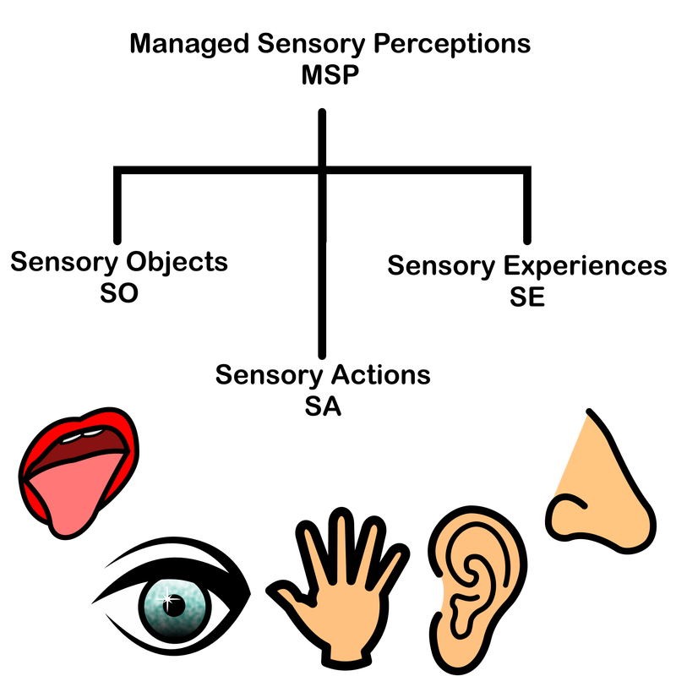  All the above things should be incorporated into a sensory story, sensory objects would be your props, sensory experiences would be if the story says suddenly it went dark and someone turned off the light, the clothes, the smells and the music that go together to create the overall experience and sensory actions are when the learner completes an action to tell part of the story (Talksense, 2016). | 7  Story telling should be fun for everyone, sensory stories are an amazing resource that can open the door to a whole new world they are inclusive, adaptable and useful for all educational levels. Please enjoy learning to use sensory stories and enjoy the video!  Many thanks for watching      

