The Market Failure of the Tobacco Industry and the Solution

Name: Jordan Evans
Student Number: 1808395
Programme of Study: BA Business and Management
Module: Economics of Sustainability (BMSP6007)
Tutor: Anthony Burns
Date: 14/05/21
Word Count: 2584

Introduction
For decades, smoking has been the leading cause of death and illness in the UK and the biggest contributor to the gap in life expectancy between the most and least deprived parts of society. In the tobacco industry, there are multiple market failures at work (Health.org, 2020). Classic microeconomic theory states that a market failure is the economic situation defined by an inefficient distribution of goods and services in the free market (Boyle, M. 2020). A market failure occurs when there is a disequilibrium in the market, when the quantity of goods or services supplied is not equal to the quantity of goods or services demanded (CFI, 2021). Some causes of a market failure include imperfect competition, imperfect information, public goods, and externalities (Callan & Thomas, 2013).
In April 1994, the chief executive officers of seven tobacco companies stated under oath before a United States Congressional subcommittee that they did not believe nicotine was an addictive drug (WHO, 2008). Several years later in 1988, after many advances in the science and understanding of addiction it was concluded that; 1) cigarettes are addicting, 2) nicotine is the drug in tobacco that causes addiction, 3) the processes that determine tobacco addiction are similar to those that determine addiction to drugs such as cocaine and heroin (USSG, 1988). The burden which smoking has on society is enormous. It is estimated that 100million people worldwide were killed by tobacco in the 20th century, and that number will increase to 1 billion in the 21st century (ERS, 2020).
Using real figures, this essay will take a look at the market failure of the tobacco industry, stating why the market is failing, the causes and also the affects on the general public as a result of smoking tobacco. Furthermore, the solutions to the failure will be analysed, as well as future recommendations in order to help eradicate the habit which damages the health and well-being of millions worldwide.
The Market Failure of the Tobacco Industry
Mainstream economic theory outlines four main causes of market failure and it is already well established that two of these, information failure and externalities, already exist in the tobacco industry (Gilmore et al., 2010). Firstly, externalities occur in an economy when the production or consumption of a specific good or service impacts a third party that is not directly related to the production or consumption of that good or service (Kenton, W. 2020). The existence of externalities in an economy lead to non Pareto optimal outcomes and therefore market failures (Tian, G., Yang, L. 2009). Pareto optimality is the economic state where resources cannot be reallocated to make one individual better off without making at least one individual worse off (Brock, T. 2020), therefore pareto efficiency is considered to be the optimal point of economic efficiency.
When a third party is affected by the production or consumption of a product this is known as an externality. Externalities come in two types: positive and negative. If the external effect generates costs to a third party, it is a negative externality. If the effect generates benefits to a third party, it is a positive externality (Callan, S., Thomas, J. 2013). Smoking is an example of a negative consumption externality, which means the social cost of consuming the good is more than the private benefit (CFI, 2020). When consuming a product that produces negative externalities, it means that the marginal social benefits are less than the marginal private benefits (as visible in Figure 1).
There are multiple negative externalities that derive from cigarette smoking. Firstly, secondhand smoke is proven to cause multiple medical issues from cardiovascular disease to lung cancer. Secondhand smoke contains more than 7000 chemicals, hundreds of which are toxic and about 70 of which cause cancer. More than 1.2 million premature deaths per year and serious cardiovascular and respiratory diseases are caused by secondhand smoking (WHO, 2020), these statistics alone show the detrimental affect that smoking has on third party individuals.
Cigarettes are known as demerit goods as they are regarded as unhealthy and negatively affect the consumer, they can also affect individuals other than the consumer e.g general population (Whiting, B. 2021). The usage of tobacco is one of the largest health threats the world has ever faced, as well as causing multiple health problems to non-smokers, the results of individuals smoking place heavy strain on hospitals and health services which are required to care for those who get sick as a result of smoking, whether passive or direct. In England in 2019/20 there were estimated to be 506,100 hospital admissions attributable to smoking and 74,600 deaths as well as 710,000 prescription items dispensed to help aid people quit smoking (NHS, 2020). The financial burden which smoking places on the national health service is enormous. Published data from Action on Smoking Health (ASH) shows that smoking costs communities in England £12.6 billion a year (ASH, 2018). The cost price of a cigarette fails to take into account the cost of poor health, the addictive nature of the product and the potential harm to others through inhaling secondhand smoke (Health.org, 2020).
The image below (Figure 1.) shows the negative externality in the consumption of demerit goods.
Figure 1.
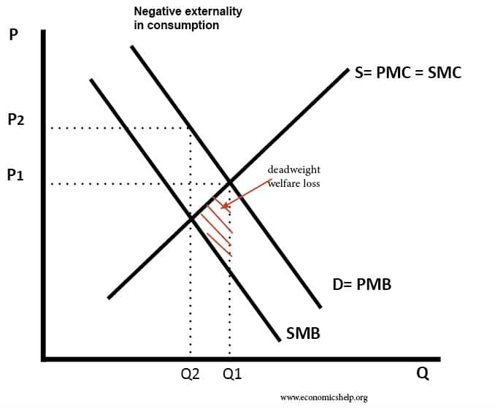
Negative Externality
https://www.economicshelp.org/wp-content/uploads/2017/03/negative-externality-consumption.jpg

As visible above, the marginal social cost (MSC) and marginal private cost (MPC) curves are identical as there are no externalities in production. When there is a negative consumption externality, the marginal social benefit (MSB) is less than marginal private benefit (MPB), this is because the individual who smokes receives the personal satisfaction from smoking, however the external costs of smoking are the air pollution and health problems to individuals who breathe in the second hand smoke, meaning third parties do not receive benefit from smoking. Furthermore, the highlighted red triangle is dead-weight welfare loss which relates to the consequences for economic efficiency when the market is not at an equilibrium (Riley, G. 2018). At point Q1 on the diagram above, the negative externality is being ignored and therefore causing an overconsumption of cigarettes.
The highest recorded level of smoking among men in the UK was 82% in 1948 and 41% for women (ASH, 2016). However, since 1974 when the national surveys on smoking first began, the proportion of adults who smoke has been steadily declining. The image below from the Office of National Statistics presents a line graph which represents the steady decline in men and women smoking from 1974-2013. In 1974, approximately 52% of men smoked tobacco and 42% of women, as a result of many different factors, the smoking rates have been declining steadily to more than half of what they previously were. Many factors may have contributed to this which will be discussed in the next part of this essay.
Figure 2.
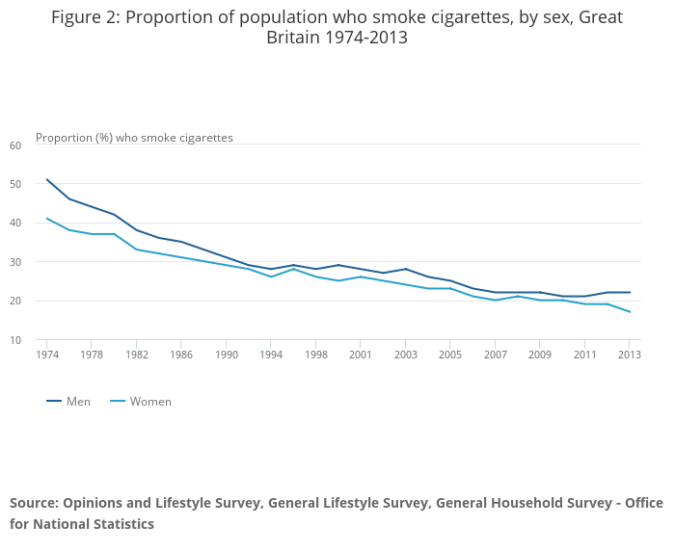
https://www.ons.gov.uk/peoplepopulationandcommunity/healthandsocialcare/healthandlifeexpectancies/compendium/opinionsandlifestylesurvey/2015-03-19/adultsmokinghabitsingreatbritain2013
In economic theory, a market with perfect information and no externalities can distribute resources efficiently without any regulation. However, if there are externalities present, the market fails to allocate resources efficiently and regulation or policy by government is needed to improve the markets allocation (Mankiw, N. 2020). Smoking adversely affects third parties near to smokers as well as the smoker themselves and therefore it produces a negative consumption externality which does not affect the profits of tobacco companies. The externalities from smoking are not taken into account by the producers and consumers, which causes the free market to fail in the efficient allocation of resources. The next part of this essay takes a look at the measures taken in order to correct the inefficiency and reduce the prevalence of smoking.

Government Intervention on Smoking to Correct the Market Failure
Once it is made evident that a market is failing, there are multiple different methods which can be used in order to correct the market. Governments can try to correct a market failure through four main channels: taxation, regulation, public spending and information (Health.org, 2020).
Firstly, competitive markets are an essential step toward efficient resource allocation, but efficiency also requires that buyers and sellers are fully informed and that their actions do not affect the welfare of others (Winston, C. 2007). If consumers are made aware of the damage smoking has upon themselves, as well as others nearby, it would improve the likelihood that they would stop smoking or smoke in isolation. In recent years, there has been a massive drive by the government to ensure that smokers are made properly aware of the dangers of smoking in an effort to lose any information gaps between consumers and tobacco companies (Riley, G. 2011). Furthermore, a Canadian study found that 15% of smokers were deterred from having a cigarette after being showed picture warnings, this is proof that bridging information gaps and making individuals more aware of the effects of smoking will decrease the number of smokers. Negative advertising campaigns could also be used as a method to increase consumer understanding of the negative affects of smoking.
Figure 3.
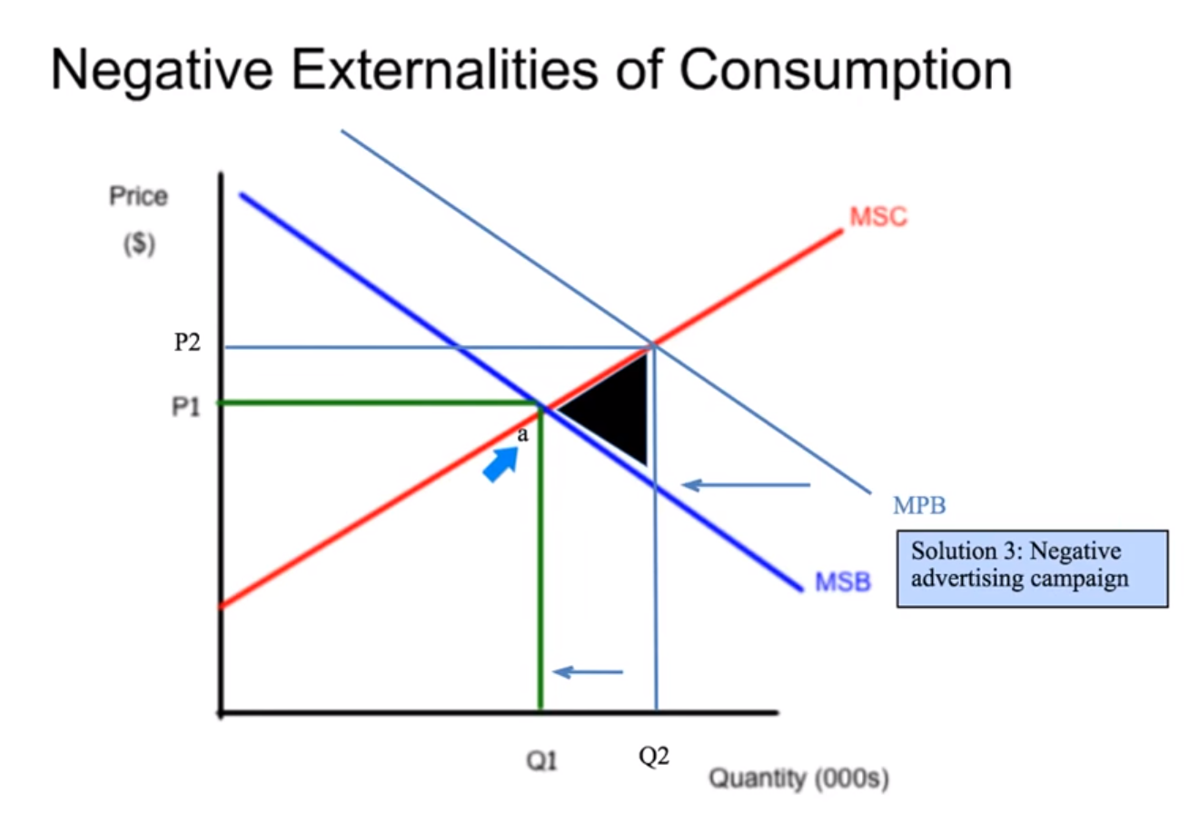
Screenshot taken from video: https://www.youtube.com/watch?v=DSmFdkEWb2s&t=406s
A negative advertising campaign could be used to correct the market failure, this would cause the marginal private benefit curve to shift to the left by reducing the benefit the consumer receives when smoking as they will be aware they are causing damage to their own health, as well as others. Ideally, this would cause the MPB=MSB and therefore completely eliminating the externality costs and reducing the quantity demanded and restoring the market to maximum efficiency.
Additionally, regulation is another method which has been used in order to correct the market failure of the tobacco industry and reduce the prevalence of smoking. Government regulations are laws that control the way a business can operate (Cambridge Dictionary, 2021). Following the implementation of the Tobacco Advertising and Promotion Act 2002, most forms of tobacco advertising and promotion in the UK were banned (legislation.gov.uk, 2002). Similarly, the Health Act 2006 states that premises are smoke-free if they are open to the public (legislation.gov.uk, 2006). The regulations meant that smoking was banned in any enclosed or largely enclosed public place or workplace, the ban also covered public transport. The introduction of this ban helps to limit the amount of secondhand smoke which third parties breathe in, and therefore reducing the negative affects which they gain from secondhand smoke. The ban also makes it more difficult for others to smoke which could act as a restraint to their own habit.
Taxation on tobacco products is another method which has been used to correct the market failure of the tobacco industry. Excise tax is a legislated tax on specific goods or services (Kagan, J. 2020). Usually, excise tax is placed on the producer and then deflected onto the consumer through higher prices. Tobacco and cigarettes are highly addictive and an example of a price inelastic good, therefore taxes are unlikely to cause a dramatic decrease in demand as the price rises, however it can act as a deterrent to stop people from beginning to smoke and in the long term can decrease consumption gradually over the long term. Below is an image showing the price of cigarettes and tax from 1990-2015. It is clear to see that prices and tax have gradually been increasing, when compared with Figure 2, it shows a correlation that as price per pack increases, the amount of smokers decreases.

Figure 4.
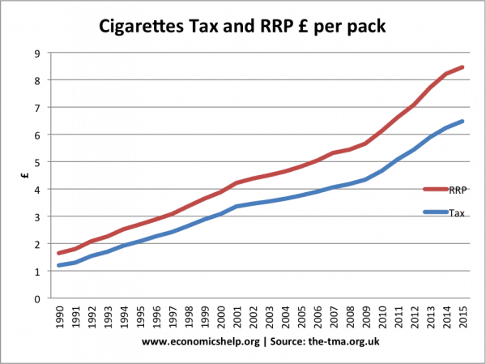
https://www.economicshelp.org/blog/12407/microeconomics/cigarette-tax-smoking-rates/
In the UK alone for 2015-2016, tobacco duties paid to the government amounted to £10.2billion (Pettinger, T. 2016). Although the duties paid do not completely cover the cost of smoking, the money received can be very useful going towards further funding to eradicate negative externalities caused as a result of smoking.
When an indirect tax on consumption is added, the MSC curve will move upwards to MSC+Tax, this will reduce the consumption to the socially efficient level of output and will raise the price simultaneously.

Figure 5.
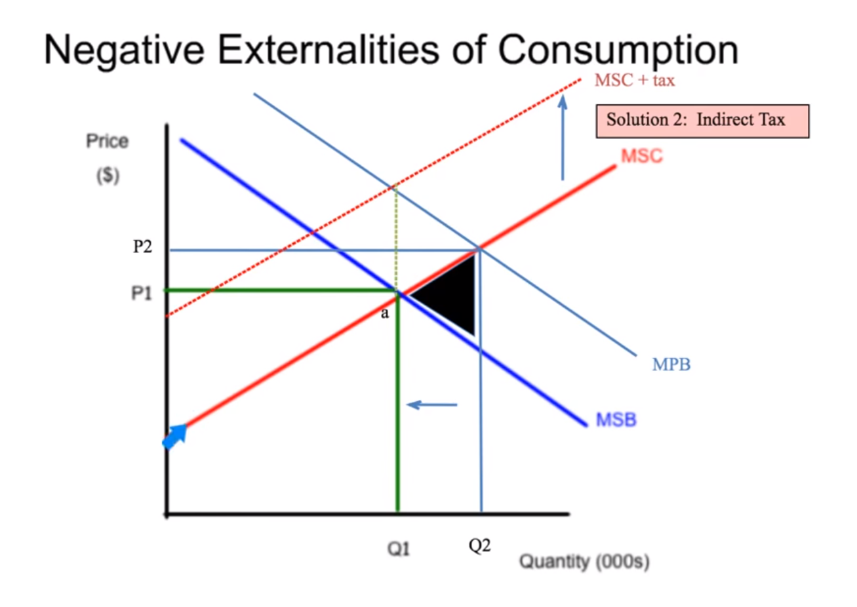
P3
B
Screenshot taken from video: https://www.youtube.com/watch?v=DSmFdkEWb2s&t=406s
As visible above, when taxation is added a new curve is created called MSC+Tax. The aim of adding tax is to move the quantity demanded from Q2 to Q1. In doing so, at the new equilibrium the price to the consumer has increased to P3 and the quantity demanded has decreased which corrects the market failure. Also, due to the new quantity demanded the loss in social welfare is eliminated as are the negative externalities.
Overall, the sum of all the measures carried out in order to reduce the amount of smokers has clearly worked. As a result of the combined efforts, smoking rates fell 2.2% from January- July 2019- equivalent to 200 fewer smokers every hour (Public Health England, 2019). With the market correction techniques used, the market failure of the tobacco industry has been corrected and the number of smokers globally, as well as the UK has been steadily declining consistently for the past few decades.
The Future of the Tobacco Industry
Looking into the future of the tobacco industry and the effects of regulations from an economic efficiency viewpoint, rather that that of a public health view point, some believe that private property rights would solve the problem better than regulations or prohibitions. Property rights are the set of valid claims to a good or resource that permits its use and the transfer of its ownership through sale (Callan, S., Thomas, J. 2013). Developed by economist, Ronald Coase the appropriately name Coase Theorem is applied when there are conflicting property rights and it states that involved parties can bargain or negotiate terms that will accurately reflect full costs and underlying values of the property rights and therefore resulting in the most efficient outcome, pareto optimal (Kindness, D. 2021).
It is not defined whether smokers own the right to smoke or whether non-smokers own the right to clean air, the introduction of property rights to business owners could help solve this. In order to maximize profits a company must mediate between demand for customers who want to smoke and customers who want clean air, depending upon willingness to pay, business owners should be able to decide for themselves which is more beneficial (Sakho, A. 2011).
In an idealistic world for many, the future of the tobacco industry would be non-existent and therefore market correction techniques will not be required. However, for now the correct steps are being carried out to reduce the issue and the externality costs to third parties.
Conclusion
Undoubtedly, the tobacco industry market was failing massively any period before the 1970s where steps were introduced in order to combat the issue. The negative externality costs of consumption of the product were too great to ignore and change was required, drastically. Although smoking is still an issue which affects millions globally each year, government intervention has taken massive steps in the right direction to eradicate the habit and correct the market failure. From Figure 2 it is clear to see that the smoking rates have steadily been declining and will hopefully continue to do so in years to come.
The market failure diagrams used show how the correction techniques will work in theory however we cannot assume that the market is now 100% efficient, or pareto optimal. Government intervention has proven to be effective, despite cigarettes being relatively price inelastic, excise tax has decreased the demand for cigarettes over time. Excise tax coupled with regulations and more available information have all worked simultaneously to tackle the issue. There are also other factors which may affect the market, however this essay has focused purely on the negative consumption externalities rather than any production externalities.

References
ASH (2016) Smoking statistics: who smokes and how much. Action on Smoking and Health. Online article retrieved from http://ash.org.uk/wp-content/uploads/2016/06/Smoking-Statistics-Who-Smokes-and-How-Much.pdf accessed on 13/05/21 at 10:34
ASH (2018) True cost of smoking revealed in advance of World No Tobacco Day. Online article retrieved from https://ash.org.uk/media-and-news/press-releases-media-and-news/true-cost-of-smoking-revealed-in-advance-of-world-no-tobacco-day/ accessed on 13/05/21 at 22:16
Boyle, M. (2020) Market Failure. Online article retrieved from https://www.investopedia.com/terms/m/marketfailure.asp accessed on 10/05/21 at 21:11
Brock, T. (2020) Pareto efficiency. Online article retrieved from https://www.investopedia.com/terms/p/pareto-efficiency.asp# . Accessed on 13/05/21 at 11:12
Callan, S., Thomas, J. (2013) Environmental economics and management: Theory, policy and applications. 6th Ed. Mason, OH: South-Western, Cengage Learning, pp. 53
Cambridge Dictionary (2021) Government Regulation. Online article retrieved from https://dictionary.cambridge.org/us/dictionary/english/government-regulation accessed on 14/05/21 at 11:49
CFI (2020) What are negative externalities? Online article retrieved from https://corporatefinanceinstitute.com/resources/knowledge/economics/negative-externalities accessed on 12/05/21 at 18:06
CFI (2021) Market Failure. Online article retrieved from https://corporatefinanceinstitute.com/resources/knowledge/economics/market-failure0 accessed on 10/05/21 at 21:24
Gilmore, A., Branson, J., Sweanor, D. (2010) The case of OFSMOKE: how tobacco price regulation is needed to promote the health of markets, government revenue and the public. Tobacco Control, 19, pp. 423-430
Health.org (2020) Improving health by tackling market failure. Online article retrieved from https://www.health.org.uk/publications/long-reads/improving-health-by-tackling-market-failure accessed on 10/05/21 at 21:56
Health.org (2020) Improving health by tackling market failure. The Health Foundation. PDF available from https://www.health.org.uk/sites/default/files/2020-02/Improving%20health%20by%20tackling%20market%20failure.pdf
Kagan, J. (2020) Excise Tax. Online article retrieved from https://www.investopedia.com/terms/e/excisetax.asp accessed on 14/05/21 at 13:30
Kenton, W. (2020) Externality. Online article retrieved from https://www.investopedia.com/terms/e/externality.asp accessed on 12/05/21 at 18:00
Legislation.gov.uk (2002) Tobacco Advertising and Promotion Act 2002. https://www.legislation.gov.uk/ukpga/2002/36/contents accessed 13/05/21 at 23:26
Legislation.gov.uk (2006) Health Act 2006. Chapter 28. PDF available from https://www.legislation.gov.uk/ukpga/2006/28/pdfs/ukpga_20060028_en.pdf
Mankiw, N. (2020) Principles of Economics. Cengage Learning.
NHS (2020) Statistics on Smoking, England 2020. NHS Digital, retrieved from https://digital.nhs.uk/data-and-information/publications/statistical/statistics-on-smoking/statistics-on-smoking-england-2020/part-1-smoking-related-ill-health-and-mortality accessed on 12/05/21 at 19:43
Pettinger, T. (2016) Tax revenue sources in UK. Online article retrieved from https://www.economicshelp.org/blog/4001/economics/tax-revenue-sources-in-uk/ accessed on 14/05/21 at 19:42
Public Health England (2019) Fastest drop in smoking rate in over a decade as Stoptober launches. Online article retrieved from https://www.gov.uk/government/news/fastest-drop-in-smoking-rates-in-over-a-decade-as-stoptober-launches accessed on 13/05/21 at 23:20
Riley, G. (2011) Information Failuers: Health Warning on Cigarette Packets. Online article retrieved from https://www.tutor2u.net/economics/blog/information-failures-health-warnings-on-cigarette-packets accessed on 13/05/21 at 23:11
Riley, G. (2018) Deadweight Loss of Economic Welfare Explained. Online article retrieved from https://www.tutor2u.net/economics/reference/deadweight-loss-of-economic-welfare-explained accessed on 12/05/21 at 20:31
Sakho, A. (2011) Coase and cigarettes: on efficiency of smoking regulations. Online article retrieved from https://www.academia.edu/4888459/Coase_and_cigarettes_on_efficiency_of_smoking_regulations accessed on 14/05/21 at 12:51
Tian, G., Yang, L. (2009) Theory of negative consumption externalities with applications of the economics of happiness. Economic Theory, 39(3), pp. 399-424
United States Surgeon General (1988) The Health Consequences of Smoking: Nicotine Addiction: A Report of the Surgeon General. United States Public Health Service Report.
Whiting, B. (2021) Demerit Goods: Definition & Examples. Online article retrieved from https://study.com/academy/lesson/demerit-goods-definition-examples.html accessed on 12/05/21 at 20:16
WHO (2008) Evolution of the tobacco industry positions on addiction to nicotine. A report prepared for the Tobacco Free Initiative, World Health Organization. Pp.1
Winston, C. (2007) Government failure versus market failure: Microeconomics policy research and government performance. Brookings: Institution press, pp. 24
World Health Organization (2020) Tobacco. Online article retrieved from https://www.who.int/en/news-room/fact-sheets/detail/tobacco accessed on 12/05/21 at 19:33

