

LOCATION: Swansea | LLEOLIAD: abertawe
LEVEL 7 | LEFEL 7
EXAMINATION PERIOD | CYFNOD ARHOLIADAU
may 2016 | mai 2016

MODULE CODE: M7X11112
WATER TREATMENT TECHNOLOGY
TIME: 2.0 HOURS
answer all questions

Equipment or materials required – None
Adnoddau neu ddefnyddiau sydd eu hangen - Dim

ANSWER ALL QUESTIONS

Question One (25 marks)

- In brief, compare the properties and characteristics of ground water and surface water?
(8 marks)
- The results of laboratory tests carried out on the water quality of the treated water in a water treatment plant before supply to the customers are as follows:
1 - Colour 18 units (PCU)
2 - Turbidity 7.5 NTU
3 - PH 10.2

Explain in brief whether or not the treated water is fit for human consumption as drinking water.
(7 marks)
- Find the hardness of water that has a ${Ca}^{2+} concentration of$ $70\frac{mg}{L}as ions$ and${ a Mg}^{2+}concentration of 9.7\frac{mg}{L} as ions.$
(10 marks)
Question Two (25 marks)

- A pre-sedimentation tank is to be designed to treat a maximum flow rate of 60,000 $m^{3}/d$ of surface water. The target particle for settling has the following characteristics: average diameter $d_{s}$ = 200×${10}^{-6}$m, cohesion constant k=0.05, Daracy-Weisbach friction factor f = 0.025, and density $ρ_{s }$= 1.25×${10}^{3}$kg/$m^{3}$.
The viscosity of water is 1.003×${10}^{-3}kg$/ms and its density is $ρ_{l}$=1.0×${10}^{3}$kg/$m^{3}.$ G is the acceleration due to gravity (9.81m/s²).
For a rectangular classifier having length to width ratio of 6, the overflow rate is at least four times the settling velocity and the horizontal velocity is at most one-third of the scour velocity.

- Find the dimensions of the rectangular tank.
(ii) Determine the detention time.
(15 marks)
- Explain in brief, using schematic diagrams, the difference between an Aerobic ground water treatment plant and a deep anaerobic groundwater treatment plant.
(10 marks)
Question Three (25 marks)

- A rapid mixer of square cross section is to be used for coagulation of surface water with high turbidity. If the flow is 720m³/h finds the volume and dimensions of the tank and the power requirements. Assume that the detention time is 30 seconds and the mean velocity gradient G = 1000S^{‐1}. The viscosity of water μ = 1.518 x 10^{‐3}N.m/s² at 5ºC.
(10 marks)
- A dual media filter is composed of 0.30m anthracite (mean particle size 0.20mm) that is placed over a 0.60m layer of sand (mean particle size 0.70mm) with a filtration rate of 9.78m/h. Assuming the grain sphericity ф = 0.75 and porosity (ε) = 0.40 for both, estimate the head loss in the clean filter at 15ºC.
(7.5 marks)
- Briefly describe the different classifications of the membrane processes used in water treatment.
(7.5 marks)

Question Four (25 marks)

- The molar concentrations of the major ions in a brackish ground water supply are as follows:

$${Na}^{+}, 0.02;{Mg}^{2+}, 0.015;{Ca}^{2+}, 0.01;K^{+}, 0.001; {Cl}^{-}, 0.025; {HCO_{3}}^{-}, 0.001;{NO_{3}}^{-}, 0.002;$$
$$and {SO_{4}}^{2-}, 0.012$$

What would be the approximate osmotic pressure difference across a semipermeable membrane that has brackish water on one side and mineral-free water on the other, assuming the temperature is 25 degrees centigrade? How much pressure needs to be applied on the brackish water side to increase the mineral-free water content?
(10 marks)

- 1 - Explain in brief the principle of Electrodialysis water treatment process.
2 - What are the major limitation of the ozonation process?
(8 marks)

- Referring to the Figure below, if a dosage of 1.8mg/L of chlorine is applied to disinfect water in water treatment plant, determine:
- The amount free chlorine residual.
- The amount of combined residual.
- The amount of total residual.
- The chlorine demand?
(7 marks)

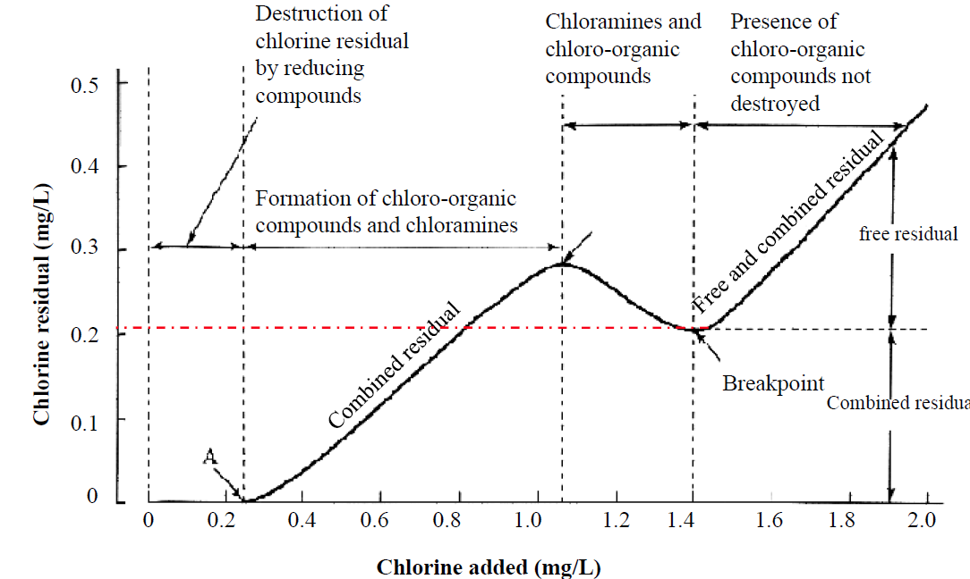

Diwedd/End

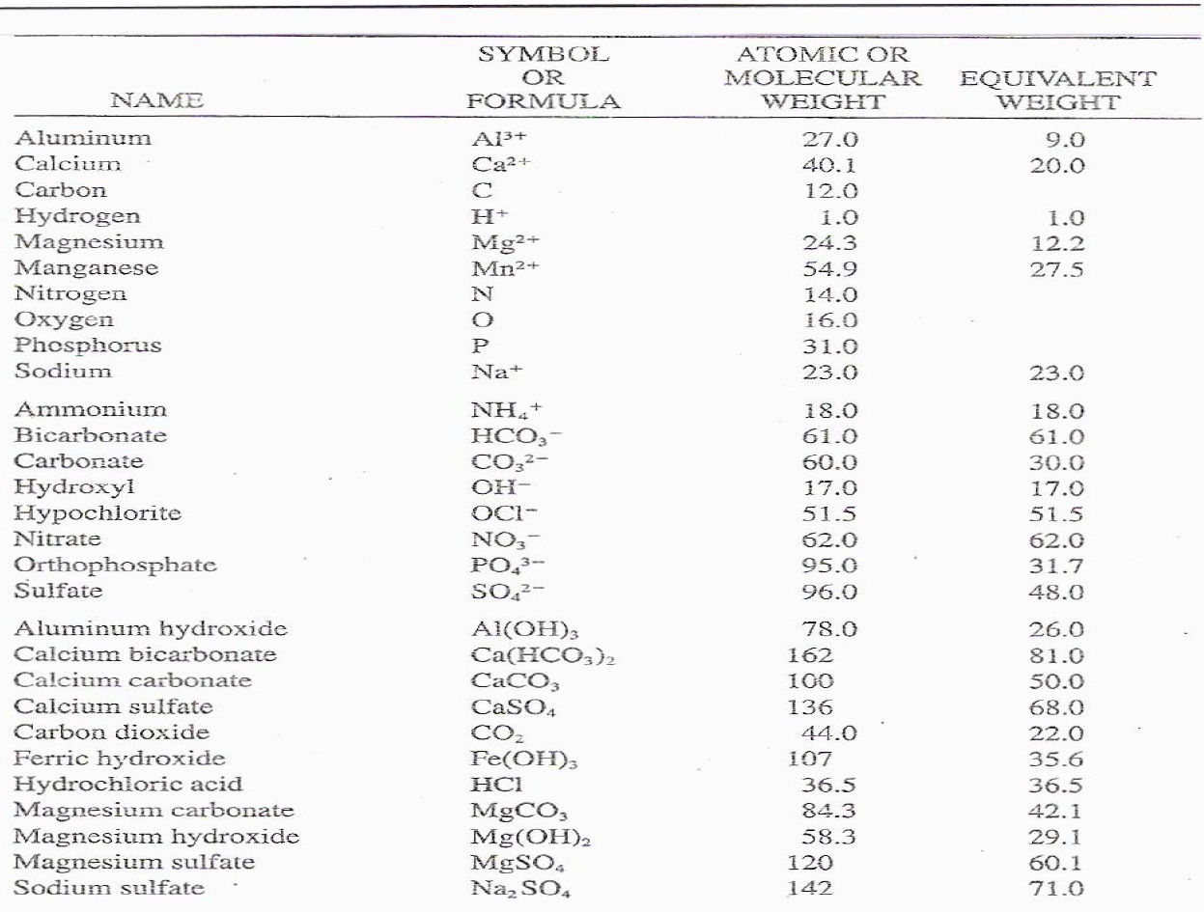

Physical Characteristic of standards water

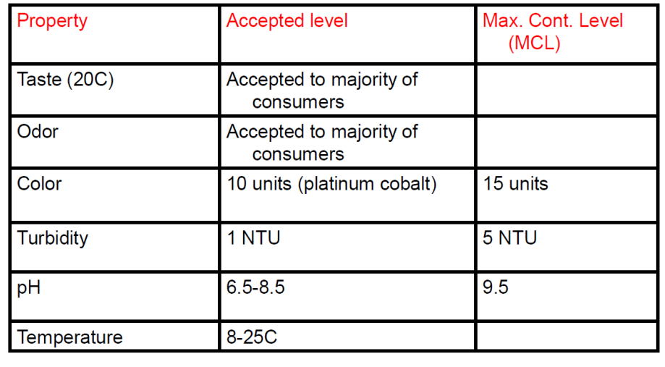

$${Maximum horizontal velocity V}_{H}=\sqrt{\frac{8k}{f}\frac{(ρ_{s}-ρ_{l})}{ρ_{l}}gd_{s}}$$

$v_{t}=\frac{gD^{2}}{18μ}(ρ_{s}-ρ_{l}$) Stokes law

$$R_{e}=\frac{ρv_{t}D}{μ}$$

$$P=μVG^{2}$$

V = Qxt

$$\frac{h}{L}=\frac{kμ{\left(1-ε\right)}^{2}}{gρε^{3}}{(\frac{V}{A})}^{2}v$$

$$\frac{V}{A}=\frac{6}{∅d}$$

π = cRT

R = Universal gas constant 0.08206 L.atm/K.mol

