Post-excavation and Analysis – Llanllyr 2016/2017
Site Introduction
Llanllyr and Talsarn have been the focus of archaeological investigation since May 2014.
The location chosen for the 2016/2017 archaeological investigations was a pastoral field that has a suspected palaeochannel running through it with an oxbow lake. There is a modern canal running nearby (Grid Ref: SN 54224, 50350). The objective was to open a number of test pits to locate and investigate both the oxbow lake and the palaeochannel, and to use hand augers to collect samples for further analysis. The methodology used included hand dug test pits, taking dumpy levels, geophysical surveying, gps recording, hand auguring, using archaeological context sheets to record test pits and any finds of archaeological significance.
The excavations took place over the course of two seasons during May 2016/2017 and lasted for two weeks on each occasion. A total of fifteen test pits were dug over the course of the two excavations; six during 2016 and a further nine during 2017.
Excavation of the Test Pits

Each test pit was dug manually using hand tools, this included shovels to clear the topsoil, then hand trowels to clean up the surface. This was followed by a recording on an archaeological context sheet with any finds put into the correlating context finds bag. Mattocks were then used to work down until the next context presented itself, where then hand trowels were again used to clean the surface so that the contexts and finds could again be recorded. This process was repeated until the test pit reached a sufficient depth (about 1m) that would allow an attempt at using a hand auger to reach the paleochannel material further down. Section drawings were then created when possible as the test pits deepened. The test pits were photographed where possible and their locations recorded using GPS. Once all the data/samples had been collected the test pits were then backfilled.
Test Pit 1
Test pit one had a total number of 8 contexts recorded. Context 101 consisted of ploughed topsoil that then became silty clay for contexts 102 and 103 which then transitioned to silty sand for 104 and silty clay/fine gravel for the rest. The compaction was mostly moderate and there were few inclusions with the exception of 104 that had iron staining and charcoal. Plans were drawn and there were finds recorded. No samples were taken.
Test Pit 2
Test Pit 2 had a total number 9 contexts recorded. Context 201 consisted of ploughed topsoil which then transitioned into context 102 which showed some signs of bioturbation. The contexts comprise mostly of silty clay until context 207 where there is a transition to sand/gravel. The compaction was mostly moderate and there were inclusions such as manganese and organic fragments. Context 204 showed evidence of Paleo root systems. Plans were drawn and there were finds recorded. No samples were taken.
Test Pit 3

Test Pit 3 had a total of 10 contexts recorded. Context 301 consisted of ploughed topsoil with 303 showing evidence of a possible deposit from water action. The compaction was mostly firm. The contexts consisted of mostly silty clay/silt transitioning to gravel at 310. Plans were drawn and there were very few inclusions. There were finds recorded.
Test pit 4

Test pit 4 had a total of 13 contexts recorded. Context 401 consisted of ploughed topsoil which then transitioned to clay up until 407 which then became a fine silt/clay up to 413. The compaction was mostly moderate with stone and root inclusions recorded. Plans were drawn and there were no finds recorded.
Test pit 5

Test pit 5 had a total of 12 contexts recorded. The top contexts consisted of silty/clay soils which then became a fine silty sand in the deeper contexts. The contexts more mostly moderately compact with some organic material being observed. Plans were drawn and there were finds recorded.
Test pit 6

Test pit 6 had a total of 2 contexts recorded and consisted of moderately firm silty sand. A cobbled floor was recorded, plans were drawn and there were finds recorded.
Test pit 7
Test pit 7 had a total of 7 contexts recorded. The compaction varied between firm to very loose with iron and magnesium inclusions being observed. The soils consisted clay/soil up until 704 where there was a transition into gravel. At 707 the water table was hit and the test pit began to fill up with water. Plans were drawn and there were finds recorded.
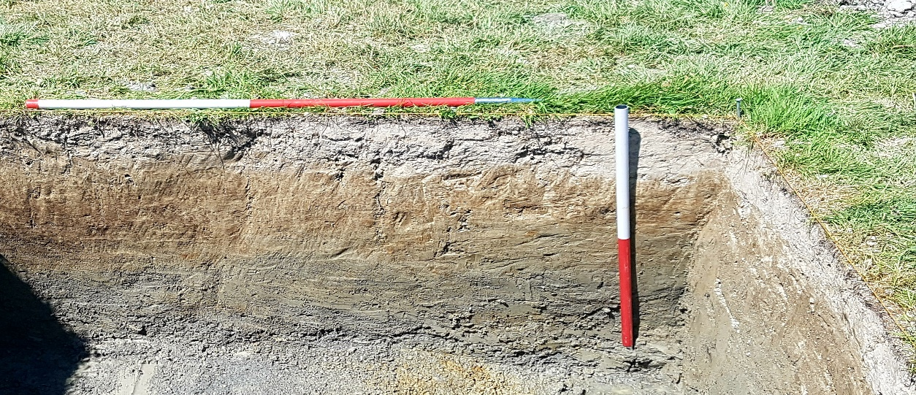
Test Pit 7
Test Pit 8
Test pit 8 had a total of 6 contexts recorded. The contexts were consistently made up of silty clay, the compaction was firm to compact throughout, with some iron and magnesium inclusions observed. Plans were drawn and there were no finds recorded.
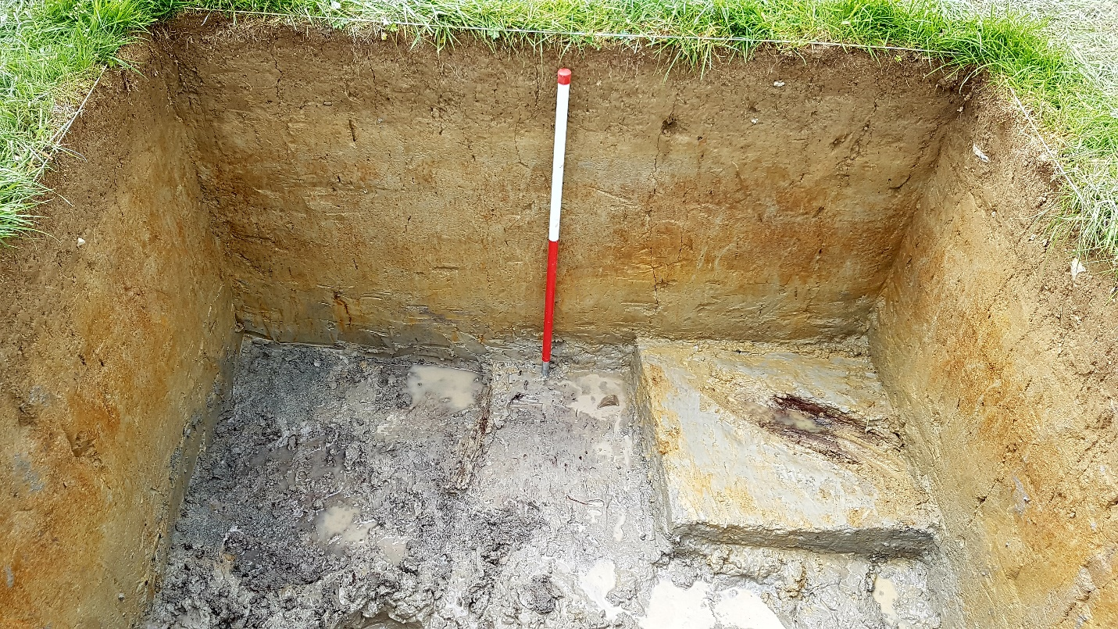
Test Pit 8

Test Pit 9

Test Pit 9 had a total of 7 contexts recorded. Context 902 consisted of sand which then transitioned into clay and gravel/stone in later contexts. The compaction was initially loose but had become compact by 904. Plans were drawn and there were finds recorded. Some wooden remains were uncovered – possibly that of a camp fire.
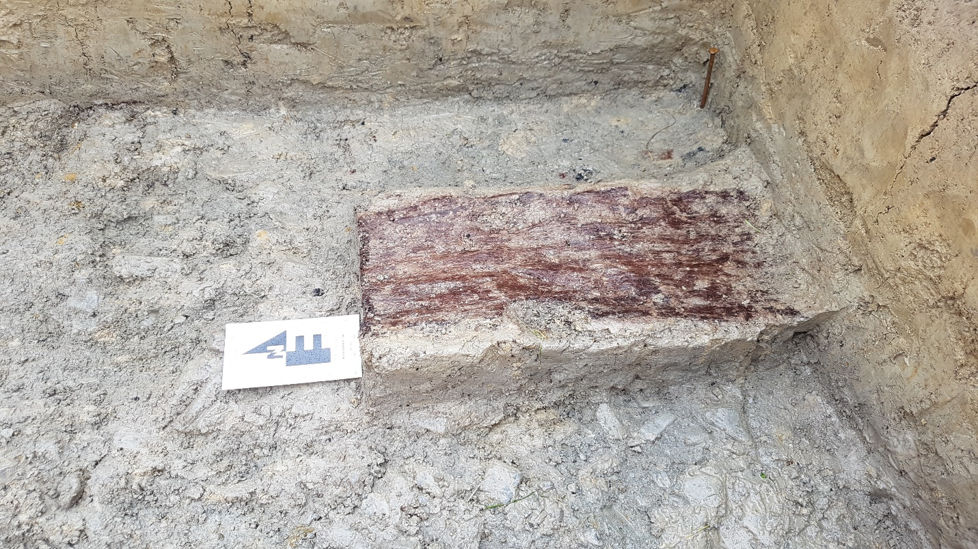
Test pit 9 with wooded remains.
Test Pit 10
No data recorded.
Test Pit 11

Test Pit 11 had a total 6 contexts recorded. The contexts mostly consisted of clay/gritty clay. The compaction was firm/wet throughout. There were no inclusions recorded. Water table was hit and bottom of test pit filled with water. Plans were drawn and finds were recorded.
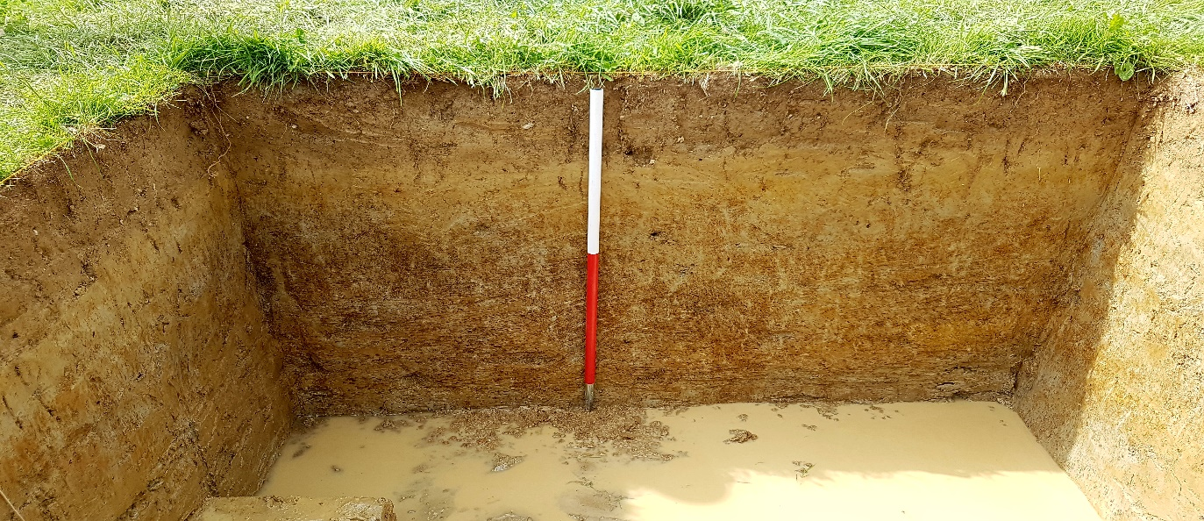
Test pit 11
Test pit 12

Test Pit 12 had a total of 5 contexts recorded. Context 1201 was made up of sandy soil with a loose compaction. This transitioned into silt/clay that became increasingly firm. There were no inclusuons onbserved. There were no finds and no plans drawn.
Test Pit 13
Test Pit 13 had a total of 6 contexts recorded. Context 1301 consisted of sandy soil which then transitioned into silt/clay. The compaction was at first loose and became increasingly firm. There were no inclusions observed. There were finds that were recorded.
Test Pit 14

No data available.
Test Pit 15
Test pit 15 had a total of 3 contexts recorded. Context 1501 consisted of sandy soil which transitioned into clay by 1503. The compaction was at first loose for 1501, then firm for 1502 and then firm again for 1503. There were lots of concretions observed in 1502. There were finds that were recorded.
Site Matrix
1501
1401
1301
1201
1001
1101
901
801
701
601
501
401
201
301
101
Possibly related
Related material
304
305
602
411
513
512
511
510
413
412
410
309
508
509
507
506
505
504
1106
1105
902
905
907
906
807
806
805
803
804
802
1104
904
404
704
707
705
702
706
408
409
407
405
308
307
1205
1204
1202
1203
1103
903
303
503
703
402
403
302
1503
1502
1305
1304
1303
1306
306
406
206
108
209
208
107
205
207
204
203
202
502
1302
1102
106
105
104
102
103

