Designing a kiteboard: Fluid flow assessment
ACMA6010
Gavin Williams
University of Wales Trinity Saint David

Student number:1503534
Date of submission: 31st July 2024

Word count: 3282

Table of Contents

List of figures: 3
Introduction 4
Task 1 5
Task 2 10
Task 3 15
Task 4 18
Task 5 21
Summary 24
References 25

List of figures:
- Figure 1: Reynold’s Number
- Figure 2: Time average estimate for laminar and turbulent flow
- Figure 3: Excel spreadsheet used to formulate Reynolds number of the fluid flowing around the board.
- Figure 4: Graph illustrating the increase in Reynolds number with laminar flow velocity increments.
- Figure 5: The twin tip kiteboard
- Figure 6: A diagram showing lift and drag angles
- Figure 7: A diagram showing separation from the boundary layer
- Figure 8: Materials of a kiteboard
- Figure 9: Layers in a kiteboard
- Figure 10: Drag force formula
- Figure 11: buoyancy force formula
- Figure 12: Towing tank for manoeuvres in Confined Water
- Figure 13: Design of a water tunnel
- Figure 14: Small water tunnel

Introduction
Understanding the fluid flow of materials is essential for optimising their production for the best performance. Measuring contributing variables and applying theoretical principles are used to best interpret the flow patterns (Tan & Dong, 2023). This report will specifically focus on applying the Reynolds number to determine a laminar or turbulent flow pattern for a kiteboard (Barr, 1980). The kiteboard presents an ideal product to assess, as the design is crucial to its performance in the water, with varying materials combined in its production to form the ideal shape, weight, and composition in line with the fluid flow it encounters. Boundary flow, defined as the flow next to the surface, is essential to understanding the aerodynamic drag created (Blakeslee, 2016). The boundary flow of the kiteboard will be discussed, along with the materials used, and modelling techniques will be evaluated to simulate flow and test such materials. The report will propose an experiment using these techniques.

Task 1
Osborne Reynolds was a 19th-century British engineer and physicist. He famously studied fluid flow in pipes, which transitioned from laminar to turbulent flow. Reynolds (1883) demonstrated the transition of the flows using glass pipes and dyed water, allowing the experiment to be easily observed (Kadivar et al., 2021). The equation used to identify Reynolds's number is shown below, along with the dimensions used.

Reynold’s Number
Re = Reynolds number
P = Density
V = fluid velocity
L = Length
$μ$ = dynamic viscosity
d = diameter
Re = Inertial Forces / Viscous Forces
Re = $\frac{pVL}{μ}$

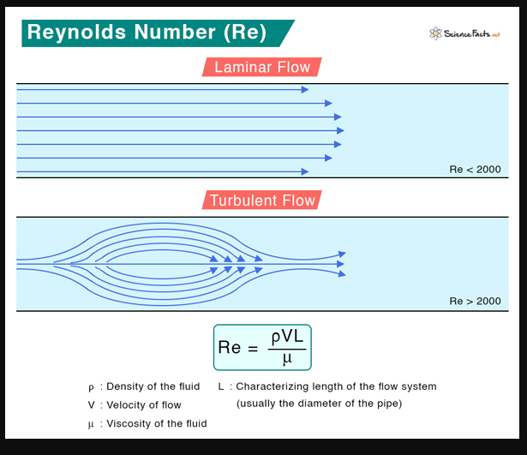
Figure 1: Reynold’s Number (Bhuyan, 2023)
Reynolds number is considered a dimensionless number used to determine whether a fluid flow is laminar or turbulent utilising the measurements seen in Figure one (Abramov, 2023; Bhuyan, 2023). Reynolds number is used throughout the engineering field today. It can be inputted into software, allowing the user to help identify fluid flow around structures, pipelines, aerodynamic shapes, and vehicles. Utilising Reynolds number for aeronautical purposes is essential for the health and safety of an aircraft structure, ensuring that it is least affected by the wind for a smooth flight and less turbulence (Zhou et al., 2021).

Laminar flow: Re < 2000
Transitional flow: 2000 < 4000
Turbulent flow: Re > 4000
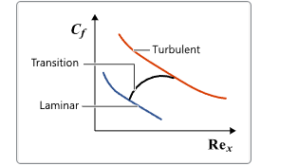
Figure 2: Time average estimate for laminar and turbulent flow (Blakeslee, 2016)
Reynolds number changes for different shapes and diameters. Generally, for the fluid flow of a pipe, the number is given anywhere between 2000 and 2300 for laminar flow. This changes for differing shapes and diameters. To gain the least drag and optimal lift to work optimally. Reynolds number can help identify the fluid flow around the kiteboard and allow the manufacturer to analyse its performance. This will give the end user a better kiteboard experience (LaNasa & Upp, 2014). By using Reynolds number and the latest technology software, the influence of CFD modelling on the design of the kiteboard can allow the creator to understand the fluid flow around the kiteboard and give full indication to predict the fluid flow where the boundary layer meets the separation (Kadivar et al., 2021).
To estimate the Reynolds number of fluid flow around a kiteboard, the following factors must be considered: Fluid density (kg/m³), flow velocity (m/s), length (m) and dynamic viscosity (kg/ms). The assumptions were based on the UK’s seawater located in Southampton (Sea Temperatures, 2024). The kiteboard used for this calculation has a length of 139cm with a depth of 42cm (North Focus kiteboard, 2023; 2024). Information was obtained for Figure 3 to allow for the calculation. The flow velocity of the board was determined by sourcing information from the Kitesurf Centre (Cawte, 2020), which determined that the average speed was between 15-25mph, which was then converted into m/s. The dynamic viscosity and fluid density values were obtained from (The Engineering ToolBox, 2004).
Sea Temp (°C) | Fluid density (kg/m³) | Flow Velocity (m/s) | Length (m) | Dynamic Viscosity (kg/m.s) | Reynolds number
7.4 | 1027 | 5 | 1.39 | 0.0014126 | 5052846
7.4 | 1027 | 7.5 | 1.39 | 0.0014126 | 7579269
7.4 | 1027 | 10 | 1.39 | 0.0014126 | 10105692
7.4 | 1027 | 12.5 | 1.39 | 0.0014126 | 12632115
7.4 | 1027 | 15 | 1.39 | 0.0014126 | 15158537
18.1 | 1025 | 5 | 1.39 | 0.0010491 | 6790344
18.1 | 1025 | 7.5 | 1.39 | 0.0010491 | 10185516
18.1 | 1025 | 10 | 1.39 | 0.0010491 | 13580688
18.1 | 1025 | 12.5 | 1.39 | 0.0010491 | 16975860
18.1 | 1025 | 15 | 1.39 | 0.0010491 | 20371032
Figure 3: Excel spreadsheet used to formulate Reynolds number of the fluid flowing around the board.
The information obtained for Figure 3 was used as raw data to plot a graph to investigate the role of temperature in determining the Reynolds number. This was to illustrate how flow velocity changes in laminar and turbulent flow by interpreting the table above. As seen in Figure 4, the temperature rises alongside the flow velocity, and so does the Reynolds number, indicating a much more turbulent flow.

Figure 4: Graph illustrating the increase in Reynolds number with laminar flow velocity increments.
Figure four illustrates that during warmer weather conditions, the Reynolds number increases, showing a higher turbulent flow. It could be inferred that this is due to the lower density of volume in salt water as the temperature changes.

Task 2
Estimating and understanding the Reynolds number for fluid flowing around the board is insufficient. The boundary flow must also be investigated to determine the pressures and forces always acting upon the board.
This board features a progressive rocker and a square flat outline, as seen in Figure five.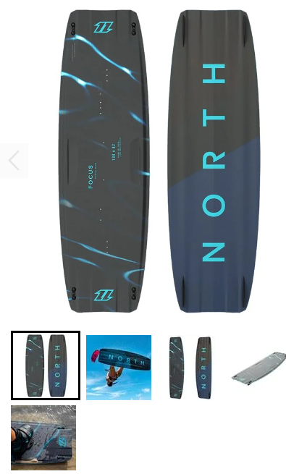
Figure 5: The twin tip kiteboard (North Focus kiteboard 2023; 2024).
The board in Figure five is a hybrid carbon with a lightweight and responsive flex. In the figure, it is possible to see the natural curve of the board, which impacts the surface of the seawater. The boundary flow is commonly referred to as the layer of fluid between the surface and the kiteboard, which it impacts, causing frictional forces. As the kiteboard progresses through the water, the fluid is displaced through the boundary layer, causing pressure differences that encounter the kiteboard. When this occurs, the velocity of flow increases from zero to stream velocity at the length of the kiteboard. It will, in turn, return to its original velocity outside of the kiteboard boundary layer (Oggiano & Pierella, 2018).

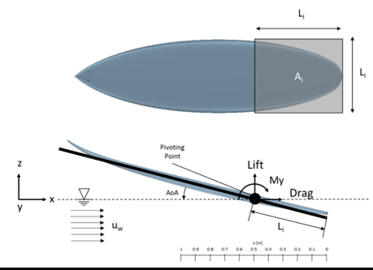
Figure 6: A diagram showing lift and drag angles (Oggiano & Pierella, 2018).
Figures six and seven show that the boundary layer will occur when the fluid impacts the board. This will impact the board's performance and dictate where laminar or turbulent flow will occur (Barr, 1980). The less drag that occurs when the board mixes with the flow will increase performance and less friction (Barr, 1980). Minimising the board's drag will reduce the separation and increase the velocity surrounding the boundary layer; this is Bernoulli’s principle, where the velocity will increase in fluid flow due to the lower pressure created (Moin & Adrian, 2020).
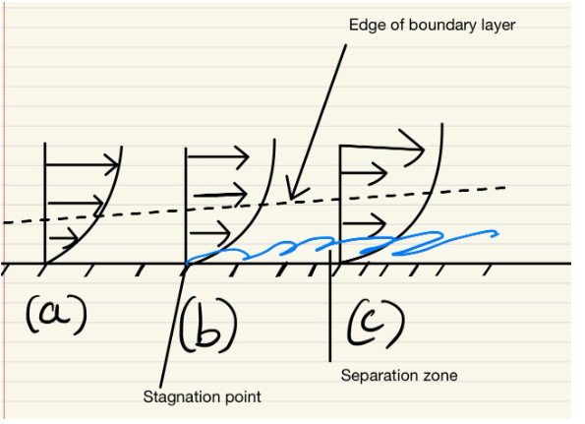
Figure 7: showing separation from the boundary layer (Douglas, Gasiorek & Swaffield, 2001).
The kiteboard's design is based on a rocker motion, the higher the rocker, the easier it is to create lift and the board's surface touches the water (Hapgood, 2014). The rocker is simply the curved angle of the kiteboard. A board with a higher rocker has a much steeper angle at the tips (front or back), and a board with a less steep rocker is much flatter (Laurinaityte, 2023). Much like a snowboard with leading edges, a higher rocker allows for better handling over the water's edge and will not catch the tips as quickly going into the water (Kiteboard Rocker Line Guide, 2024). The kiteboard's shape and size help with the separation and turbulent flow, as shown in Figure seven. Once the board contacts the water's surface, the separation occurs due to the pressure gradient. Pressure then increases along the direction of fluid flow, and separation of the boundary layer occurs due to the turbulence and change in flow velocity, as well as pressure change from laminar to turbulent flow (Barr, 1980; Wu et al., 2020). The kiteboard has been designed so that it is optimised for performance in water. The rocker system, material choice, size, shape, curvature and board channels all have roles that dictate how the kiteboard performs once in and out of the water. The kiteboard is usually symmetrical in shape, which allows it to be ridden in either direction with uniform flow and balanced separation and turbulence (Stier et al., 2015).
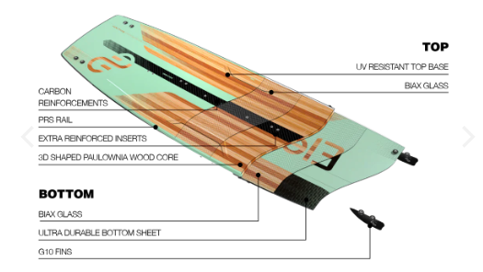
Figure 8: Materials of a kiteboard (Eleveight Ignition Kiteboard, 2024)
Kiteboard material plays a very important role in its performance; the material must withstand the water's impact, have suitable flexibility for the rider, have adequate stiffness, and be light enough in weight to use. The boards are usually made of wood (paulownia) or foam cores and then covered in fibreglass or carbon; each material adds strength, flexibility, durability and impact resistance. The shape and curvature of a twin-tip board allow for uniform fluid flow in whichever direction the board is being ridden. It also allows for fluid separation from both ends. This allows the rider to have the same reduced turbulent wake and increased drag in either direction. By being symmetrical, the board allows for a higher stability gradient rather than being overloaded at one end. Allowing for an even fluid flow from laminar to turbulent. Board channels are also often implemented to help direct fluid flow, which can help reduce drag and help with board stability (Kaufmann, 2015) (Lang, 2009).

Task 3
Historically, kiteboards were single-directional boards, known as surfboards, that had the addition of kitesurfs. Only by the late 20th century did twin-tip boards become the kiteboard of choice due to their directional capabilities. Kiteboarding is known to apply more stress on the board than surfboarding. Therefore, changes were needed to cope with this (Lang, 2009). The kiteboard's historic material choice was a wooden core with a surrounding outer layer of foam. The addition of attachments for the kitesurf was not fit for purpose as it was difficult to control and expose the materials. This often led to enhanced failure rates due to the flex needed for the additional pressures exerted on the board being propelled by the kitesurf (Kaufmann, 2015).
In the development of the kitesurf, before the introduction of carbon fibre, fiberglass and epoxy resins were introduced to decrease the overall weight of the board which also added strength to the board due to the differing complexity of the materials resulting in increased flexibility, therefore being more durable than foam, which could be easily damaged. However, as noted in the literature, there were failures in indentations and the peeling of the laminate coverings prior to introducing a stable wooden core with an outer layer of reinforced plastics (Kaufmann, 2015). The twin tip-board in Figure 8 is multidirectional, with a wooden core and several layers of fibreglass and carbon. This gave the boards a much-needed weight reduction, increasing performance, strength and durability needed for the water impact.
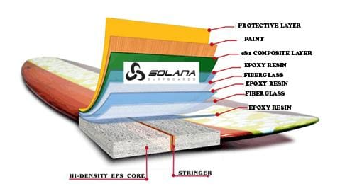
Figure 9: Layers in a kiteboard (Sheppard, 2018).
Wooden cores using paulownia wood are less prone to indentations and are more prominent sustainable wood. Once a stable core was introduced, fibre-reinforced plastics (FRP), were layered onto the board. Each material gives its strength, thickness and durability and allows for a specific flex for different users. As noted above, there are limitations to this material; however, it is commonly used due to its cost efficiency in comparison to carbon fibre. These types of boards are marketed at a lower cost, whilst still meeting industry standards (Stefani & Siebert, 2010). The twin-tip board shown in Figure 5 is known as an all-round board, being the board of choice for both beginners and professionals as it balances its performance with the dependent variables of the user and the sport (Kaufmann, 2015). Higher specifications can be purchased that are fitted with more carbon fibre, Kevlar and other composite materials. One of the significant reasons these became most popular was the enhanced mechanical properties and the advancement in new technology that focused on the masses. Although they come with higher price tags, these models yielded a much higher tensile strength, durability, and resistance to impact. In addition, they are highly sustainable and more accessible to recycle. As industry standards were required to focus on the environmental impact of materials, this also being a selling point for the end consumer, identifying more sustainable boards was essential to output the highest performance (Stefani & Siebert, 2010).
Carbon fibre-reinforced plastics (CFRP) are critical to high performance, durability and sustainability. The literature is however mixed, noting there are dependent variables that contribute to which materials and boards are optimal. For instance, consumer weight and water conditions play a role (Cawte, 2020).

Task 4
Computational Fluid Dynamics (CFD) is one of the most used modelling techniques to simulate fluid flow and observe the role of exerted forces on a design. It utilises software to solve intricate equations, most notably the Navier-Stokes equations (Shakib et al., 1991). These equations help simulate fluid flow patterns around the component's boundary layer and other pressures that may be exerted on the board (Huang et al., 2022).
The data exerted from the CFD simulation creates a visual image of the actual fluid flow around the boundary layer of the kiteboard, enabling the user to act on any design specifications that may be impacting the board. This is a clear advantage, which would result in lower costs in the production of the product with no physical prototypes required (Takami et al., 2018). The CFD package calculates the Navier-Stokes equation, saving significantly on manual time. However, the package is expensive and requires trained professionals to utilise the software, input the raw data with extreme accuracy and simulate the design parameters (Huang et al., 2022; Zawawi et al., 2018). It is known as an industry standard for the clear advantages; however, for companies producing one product, it would be financially beneficial to outsource the component design over purchasing the CFD software.
Other methods that can be utilised include the Finite element, Boundary element method and the Lattice Boltzmann method. The finite element method (FEM) is used for Finite Element Analysis (FEA) to solve complex mathematical equations, both CFD and FEA can handle highly complex geometries and boundary conditions, however, the more complex nature of the design, the higher computational power and intensity required. Research suggests that FEA should be utilised for solid structures that behave mechanically compared to CFD, which focuses on the fluid dynamics of the structure. It is recommended that although FEA can be used for fluid dynamics, CFD is more stable and can be applied when strong convection is a factor, producing more accurate results without having to add stabilisation to the equations (Cadence, 2024). It must be noted that information is more readily available through blogs and websites on system analysis rather than peer-reviewed journals. Therefore, the personal bias of the authors is a factor to consider in the credibility of the information. For instance, they may work within one industry that prefers one simulation package. Additionally, depending on what training a person has received, this would highly influence what package they use and what they deem to be the best to use; someone may only have training on CFD through a company without regard for others.
An alternative is the Lattice Boltzmann method, which uses a lattice grid to solve the Boltzmann equation, which can solve complex boundary conditions quite quickly. This method can be used for highly detailed flow analysis as the lattice grids can be extremely small for adequate accuracy (Takami et al., 2018). However, similarly to the CFD and FEA, the software requires significant computer energy. This can be limiting for smaller companies or companies that do not require large-scale supercomputers daily.
The Boundary Element Method (BEM) is a potential solution, as it is less costly and provides calculations at speed. It simplifies a problem by reducing the dimensions and solving surface integrals, rather than larger-scale volume integrals. However, BEM is less accurate compared to CFD and FEA as the complexity of the geometries increases (Zawawi et al., 2018). If the complexity of the geometries is known to be minimal, this would be a great cost-effective option. Given the requirements for the kiteboard, it would seem most appropriate to use this method in the industry as it would be most cost-effective, the calculations are not too complex for accuracy to be substituted for cost, and it saves significantly on computer power needed.

Forces on a kiteboard estimation
To calculate the forces estimated on the kiteboard regarding lift, drag, and buoyancy.
The forces estimated on the kiteboard regarding drag must be calculated using the drag force formula (The Engineering ToolBox, 2004).
$$F_{d}=\frac{1}{2}c_{d}ρAv^{2}$$
An assumption has been made that a streamlined half body will be used with a drag coefficient is equal to 0.09 (Engineeringtoolbox, 2024). Density of water is assumed to be 1027kg/m³, Flow velocity is assumed to be 10 m/s, assume the submerged depth of the board is 10mm.
Figure 10: Drag force formula
$$F_{ⅆ}=Drag Force \left(N\right)$$
$c_{d}$= Drag coefficient
$v^{2}$= Flow velocity (m/s)
P = Density of fluid (kg/m³)
A = Area of the body (m²)

$$F_{d}=\frac{1}{2}0.09*1027*0.0139*10²$$
$F_{d}=$64.2 N

The forces estimated on the kiteboard regarding buoyancy, to calculate this the buoyancy formula must be used (The Engineering ToolBox, 2004)
$$F_{b}=buoyancy force \left(N\right)$$
g= gravity (9.81 m/s)
p = Density of fluid (kg/m³)
V = volume (m³)

Assume the submerged depth of the board is 10mm.
$F_{b}=pgv$
$F_{b}= 1027*9.81*$ (1.39*0.42*0.01)
$$F_{b}=58.8 N$$
Figure 11: buoyancy force formula

Task 5
For the experimentation of fluid flow surrounding the kiteboard as a physical test, several water-based facilities use different techniques to capture the hydrodynamic properties (Carrasco & García de la Torre, 1999). The choice of these facilities is determined by the scale of the model and the forces being measured. The facilities most notably used are tow tanks, wave tanks, wind tunnels with water flow, cavitation tunnels, and ocean engineering basins (García de la Torre & Hernández Cifre, 2020). 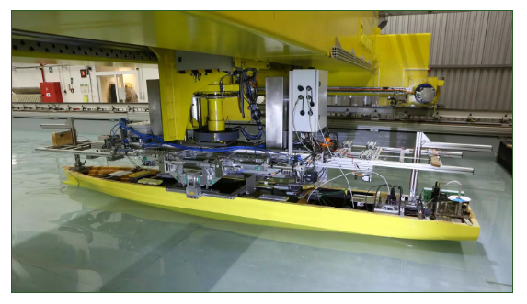
Figure 12: Towing tank for manoeuvres in Confined Water (2024).
For the kiteboard in question, lift, drag, buoyancy, and stability are key design aspects. For this component of a full-scale design prototype, either a tow tank, wave tank, or wind tunnel with water flow would be suitable for this experiment (Franken et al., 2020). The water simulation tests use various measurement devices such as force and pressure sensors to measure hydrodynamic forces and use CFD to visualise the flow, ensuring the accuracy and precision required for obtaining the correct results (Wibowo et al., 2018).

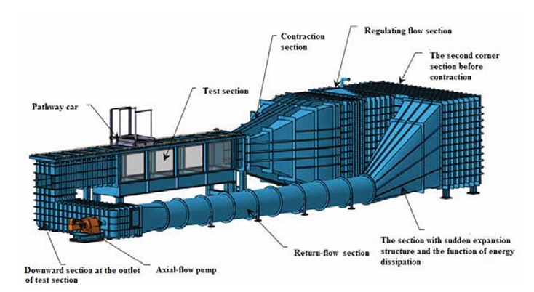
Figure 13: Design of a water tunnel (Jiang et al., 2018).
The wind tunnel has a glass test sectional area for a thorough visual of the fluid flow around the component (see figures eleven and twelve). The controlled environment allows the input of a controlled flow, temperature of the water, and turbulence if required (García de la Torre & Hernández Cifre, 2020).

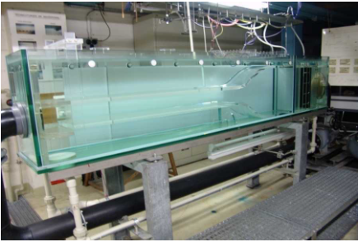
Figure 14: Small water tunnel (Experimental, 2024).
In Figure fourteen a dye injection can be added to see the stream of water as it continuously flows around the component. It is also possible to use a scaled version of the component rather than a full-size scale to see how it adapts. Wind tunnels are in such a controlled environment that they can give extremely high accuracy regarding any results that can be used for CFD validation when comparing data (Franken et al., 2020). All results from any test should be compared to all data so that there are no clinical errors before the prototype design goes out to manufacturing (Wibowo et al., 2018).

Summary
Reynolds number is undoubtedly crucial in determining how water flow is determined to show the differences between laminar and turbulent flow. Combined with many other aspects of fluid dynamic engineering and the ability to solve hand calculations as well as interpret these equations into computational fluid dynamics (Bhuyan, 2023), allows the consumer to identify any issues of opposing equivalent forces acting upon a structure or component (Oggiano & Pierella, 2018), thus allowing to make any necessary changes at a stage prior to ever making a component at the company's loss of expenditure due to advancements in the technical stages of development rather than making many prototypes that could fail. The testing ability of new purpose-built scenarios also allows scaled-size prototypes to be tested in near-perfect conditions as they would be expected to be once built. Water tunnels can replicate natural water turbulence along with the correct temperature to mimic the environment in the component that would be needed (Huang et al, 2022).

References
Abramov, R.V. (2023). ‘Turbulence via intermolecular potential: Viscosity and transition range of the Reynolds number’, Fluids, 8(3), p. 101. doi:10.3390/fluids8030101.
Avila, M., Barkley, D. and Hof, B. (2023). ‘Transition to turbulence in pipe flow’, Annual Review of Fluid Mechanics, 55(1), pp. 575–602. doi:10.1146/annurev-fluid-120720-025957.
BARR, D. (1980). ‘Technical note. the transition from laminar to turbulent flow.’, Proceedings of the Institution of Civil Engineers, 69(2), pp. 555–562. doi:10.1680/iicep.1980.2555.
Blakeslee, M. (2016). Turbulent Flow Verses Laminar Flow, Turbulent flow verses laminar flow. Available at: https://help.altair.com/hwcfdsolvers/acusolve/topics/acusolve/training_manual/turb_flow_vs_lam_flow_r.htm (Accessed: 16 June 2024).
Bhuyan, S. (2023). Reynolds number: Definition, equation, and solved problem, Science Facts. Available at: https://www.sciencefacts.net/reynolds-number.html (Accessed: 16 June 2024).
Cadence (2022). FEA vs. CFD: The differences and applications of Simulation Tools. Available at: https://resources.system-analysis.cadence.com/blog/msa2021-fea-vs-cfd-the-differences-and-applications-of-simulation-tools (Accessed: 05 July 2024).
Carrasco, B. and García de la Torre, J. (1999). ‘Hydrodynamic properties of rigid particles: Comparison of different modeling and computational procedures’, Biophysical Journal, 76(6), pp. 3044–3057. doi:10.1016/s0006-3495(99)77457-6.
Cawte, T. (2020). How fast can kitesurfers go?, The Kitesurf Centre. Available at: https://www.thekitesurfcentre.com/news/how-fast-can-kitesurfers-go#:~:text=An%20average%20rider%20on%20a,achievable%20speeds%20with%20different%20equipment. (Accessed: 23 June 2024).
Diaz Ruiz, C. and Makkar, M. (2021). ‘Market bifurcations in board sports: How consumers shape markets through boundary work’, Journal of Business Research, 122, pp. 38–50. doi:10.1016/j.jbusres.2020.08.039.
Douglas, J.F., Gasiorek, J.M. and Swaffield, J.A. (2001). Fluid mechanics Vol 2. Upper Saddle River, NJ: Prentice Hall.
Eleveight Ignition Kiteboard 2024 (2024). Session Sports. Available at: https://sessionsports.com/products/2024-eleveight-ignition-kiteboard (Accessed: 02 July 2024).
Engineeringtoolbox (2024). Drag coefficient, Engineering ToolBox. Available at: https://www.engineeringtoolbox.com/drag-coefficient-d_627.html (Accessed: 05 July 2024).
Experimental (2024). Institute of Fluid Dynamics | ETH Zurich. Available at: https://ifd.ethz.ch/infrastructure/experimental.html (Accessed: 05 July 2024).
Hapgood, A. (2014). Kiteboarding: Where it’s at ... London: Adlard Coles Nautical, Bloomsbury.
Franken, H.H., Knoetze, J.H. and Schwarz, C.E. (2020). ‘Influence of fluid properties on the hydrodynamics and operability of a countercurrent supercritical packed column’, Chemical Engineering Research and Design, 159, pp. 592–604. doi:10.1016/j.cherd.2020.05.009.
García de la Torre, J. and Hernández Cifre, J.G. (2020). ‘Hydrodynamic properties of Biomacromolecules and macromolecular complexes: Concepts and methods. A tutorial mini-review’, Journal of Molecular Biology, 432(9), pp. 2930–2948. doi:10.1016/j.jmb.2019.12.027.
Huang, S., Jiao, J. and Guedes Soares, C. (2022). ‘Uncertainty analyses on the CFD–FEA co-simulations of ship wave loads and whipping responses’, Marine Structures, 82, p. 103129. doi:10.1016/j.marstruc.2021.103129.
Jasim, N.A. and Muhammed, M.A. (2022). ‘The design of Reynolds Number Apparatus with demonstration’, Mathematical Modelling of Engineering Problems, 9(4), pp. 1005–1016. doi:10.18280/mmep.090418.
Jiang, Y. et al. (2018). ‘The hydrodynamic design and critical techniques for 1M×1M Water Tunnel’, AIP Conference Proceedings [Preprint]. doi:10.1063/1.5033637.
Kadivar, M., Tormey, D. and McGranaghan, G. (2021). ‘A review on turbulent flow over rough surfaces: Fundamentals and theories’, International Journal of Thermofluids, 10, p. 100077. doi:10.1016/j.ijft.2021.100077.
Kaufmann, J. (2015). ‘New materials for sports equipment made of anisotropic fiber-reinforced plastics with stiffness related coupling effect’, Procedia Engineering, 112, pp. 140–145. doi:10.1016/j.proeng.2015.07.189.
Kiteboard Rocker Line Guide (2024). 24-7 Boardsports. Available at: https://24-7boardsports.com/kiteboard-rocker-line-guide/ (Accessed: 01 July 2024).
LaNasa, P.J. and Upp, E.L. (2014). ‘Basic flow measurement laws’, Fluid Flow Measurement, pp. 19–29. doi:10.1016/b978-0-12-409524-3.00002-2.
Lang, P. (2009). Below the surface: The materials that make kiteboarding possible, Kiteboarding & Kitesurfing. Available at: https://www.thekiteboarder.com/2009/11/10/below-the-surface-the-materials-that-make-kiteboarding-possible/ (Accessed: 02 July 2024).
Laurinaityte, S. (2023). Guide to twintip kiteboard design, features and Styles, Kitespot.com. Available at: https://thekitespot.com/twintip-kiteboard-design-features-and-styles/ (Accessed: 02 July 2024).
North Focus kiteboard 2023 (2024). king of watersports. Available at: https://www.kingofwatersports.com/product/north-focus-kiteboard-2023/north-focus-twintip-2022?refPage=%2Fkitesurf%2Fkitesurf-boards~mgnlArea%3Dcontent~%3Fsort%3DpriceAsc (Accessed: 22 June 2024).
Oggiano, L. and Pierella, F. (2018). ‘CFD for surfboards: Comparison between three different designs in static and maneuvering conditions’, The 12th Conference of the International Sports Engineering Association [Preprint]. doi:10.3390/proceedings2060309.
Shakib, F., Hughes, T.J.R. and Johan, Z. (1991). ‘A new finite element formulation for computational fluid dynamics: X. the compressible Euler and navier-stokes equations’, Computer Methods in Applied Mechanics and Engineering, 89(1–3), pp. 141–219. doi:10.1016/0045-7825(91)90041-4.
Sheppard, B. (2018). Surf & Surfboard History: 1778 to 2018 an Indepth Time-Machine, Surf Nation. Available at: https://www.surfnation.com.au/blogs/news/surf-surfboard-history-1778-to-2018-an-indepth-time-machine (Accessed: 05 July 2024).
Southampton Water Temperature: United Kingdom: Sea temperatures (2024). World Sea Temperatures. Available at: https://www.seatemperature.org/europe/united-kingdom/southampton.htm (Accessed: 20 June 2024).
The Engineering ToolBox (2004). Drag Coefficient. [online] Available at: https://www.engineeringtoolbox.com/drag-coefficient-d_627.html [Accessed: 05 July 2024].
Towing tank for manoeuvres in Confined Water (2024). Towing Tank. Available at: https://www.waterbouwkundiglaboratorium.be/en/towing-tank-for-manoeuvres-in-confined-water-antwerp-0 (Accessed: 04 July 2024).
Stefani, J. and Siebert, M. (2010). ‘Fe-analysis and lay-up strategies for a kiteboard’, Procedia Engineering, 2(2), pp. 3311–3316. doi:10.1016/j.proeng.2010.04.150.
Stier, B. et al. (2015). ‘Analysis, manufacturing, testing, and structural optimization of a novel composite kiteboard design’, Proceedings of the Institution of Mechanical Engineers, Part P: Journal of Sports Engineering and Technology, 229(4), pp. 248–265. doi:10.1177/1754337115584874.
Takami, T., Matsui, S., Oka, M & Iijima, K. (2018). ‘A numerical simulation method for predicting global and local hydroelastic response of a ship based on CFD and FEA Coupling’, Marine Structures, 59, pp. 368–386. doi:10.1016/j.marstruc.2018.02.009.
The Complete Kiteboard Buyers Guide (2024). LIEUWE® Custom Boards. Available at: https://lieuweboards.com/blogs/the-lieuwe-kiteboard-buyers-guide/the-complete-kiteboard-buyers-guide#:~:text=Kiteboard%20rocker%20is%20the%20amount,water%20when%20riding%20upor%20downwind. (Accessed: 01 July 2024).
The Engineering ToolBox (2004). Water - Dynamic (Absolute) and Kinematic Viscosity vs. Temperature and Pressure. [online] Available at: https://www.engineeringtoolbox.com/water-dynamic-kinematic-viscosity-d_596.html [Accessed: 22 June 2024]
Wang, L., Quant, R. and Kolios, A. (2016). ‘Fluid structure interaction modelling of horizontal-axis wind turbine blades based on CFD and Fea’, Journal of Wind Engineering and Industrial Aerodynamics, 158, pp. 11–25. doi:10.1016/j.jweia.2016.09.006.
Wibowo, D., Zhao, C.-X. and He, Y. (2018). ‘Fluid properties and hydrodynamics of microfluidic systems’, Microfluidics for Pharmaceutical Applications, pp. 37–77. doi:10.1016/b978-0-12-812659-2.00002-8.

Wu, X., Moin, P. and Adrian, R.J. (2020). ‘Laminar to fully turbulent flow in a pipe: Scalar patches, structural duality of turbulent spots and transitional overshoot’, Journal of Fluid Mechanics, 896. doi:10.1017/jfm.2020.304.
Zawawi, M.H., A, Saleha., A, Salwa., N, Hassan., N, Zahari., M, Ramli and Z, Muda (2018). ‘A review: Fundamentals of Computational Fluid Dynamics (CFD)’, AIP Conference Proceedings [Preprint]. doi:10.1063/1.5066893.
Zhou, Z., Wu, T. and Yang, X. (2021). ‘Reynolds Number Effect on statistics of turbulent flows over Periodic Hills’, Physics of Fluids, 33(10). doi:10.1063/5.0062786.

