Manage and maintain network resources, and its services applying suitable policies and drafting security and redundancy practices.
Joseff Thomas
Digital Degree Apprenticeship
School of Applied Computing
Date of submission 29th of April 2022

Contents
Part 1: Practical 4
NTFS 4
Group Policies 12
FTP server 22
Installing and Configuring the Routing and Remote Access Service 31
IP Packet Filtering 40
Filter 1 40
Filter 2 43
Filter 3 46
Part 2: Observational 50
Password Principles in a Modern Network Environment 50
Failover Clustering for High Availability Systems & Services 51
Cluster Concepts 51
Active/Passive 51
Active/Active 52
Windows Failover Clustering 52
Example of implementation on Windows Server 53
Network Security Policy 57
References 58
Appendix 1 60
Password Policy 60
Appendix 2 61
Remote Access Policy 61
Appendix 3 62
Server Security Policy 62
Appendix 4 65
Monitoring and Auditing of Systems Policy 65
Appendix 5 66
Vulnerability Assessments Policy 66
Appendix 6 67
Server Virtualisation Policy 67

Part 1: Practical

NTFS
The configuration of the NT file system (NTFS) permissions on a folder and file are created in the c drive of Client 1. A folder was created, Share_Files_NOSS, with the administration account. The default group and users' permissions were removed for the folder properties, see figure 1.
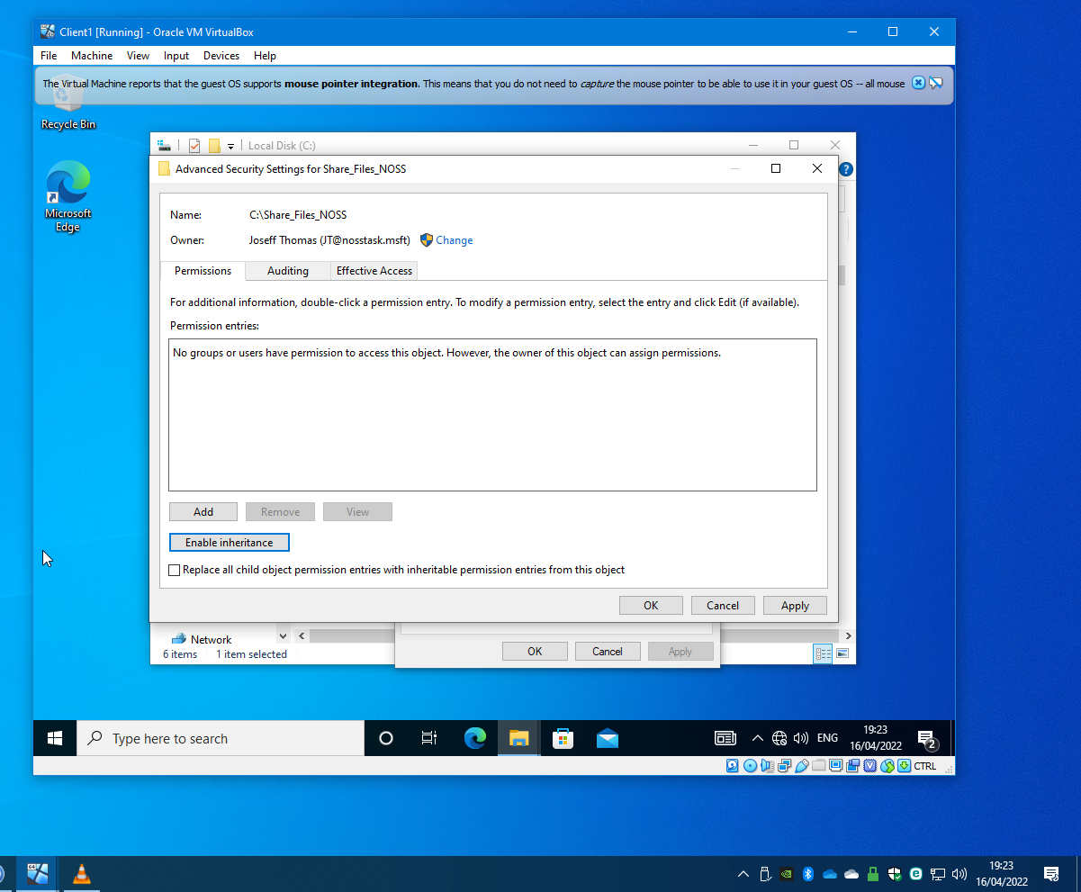
Figure 1

The administration account was added with full folder permissions, see figure 2.
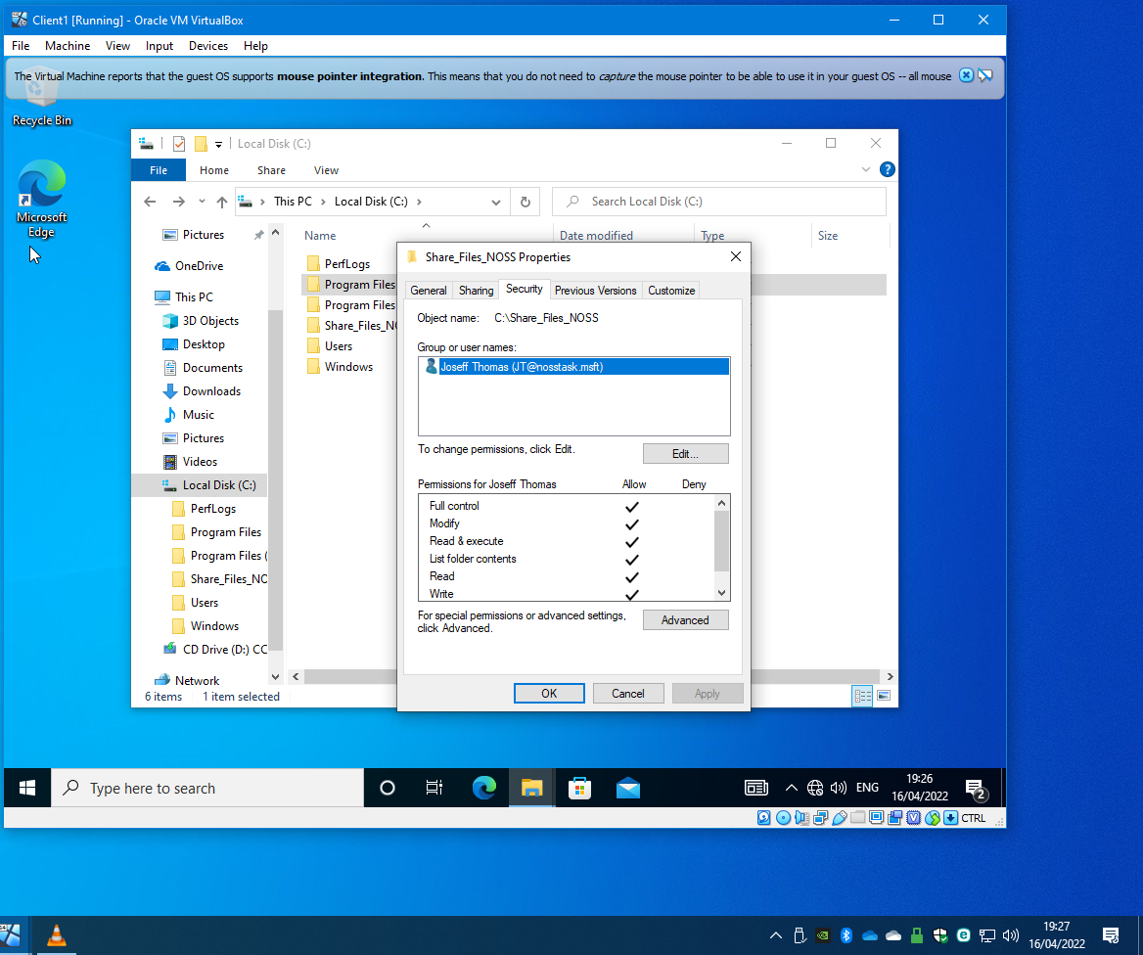
Figure 2

A standard account with limited permissions was added as shown in figure 3.

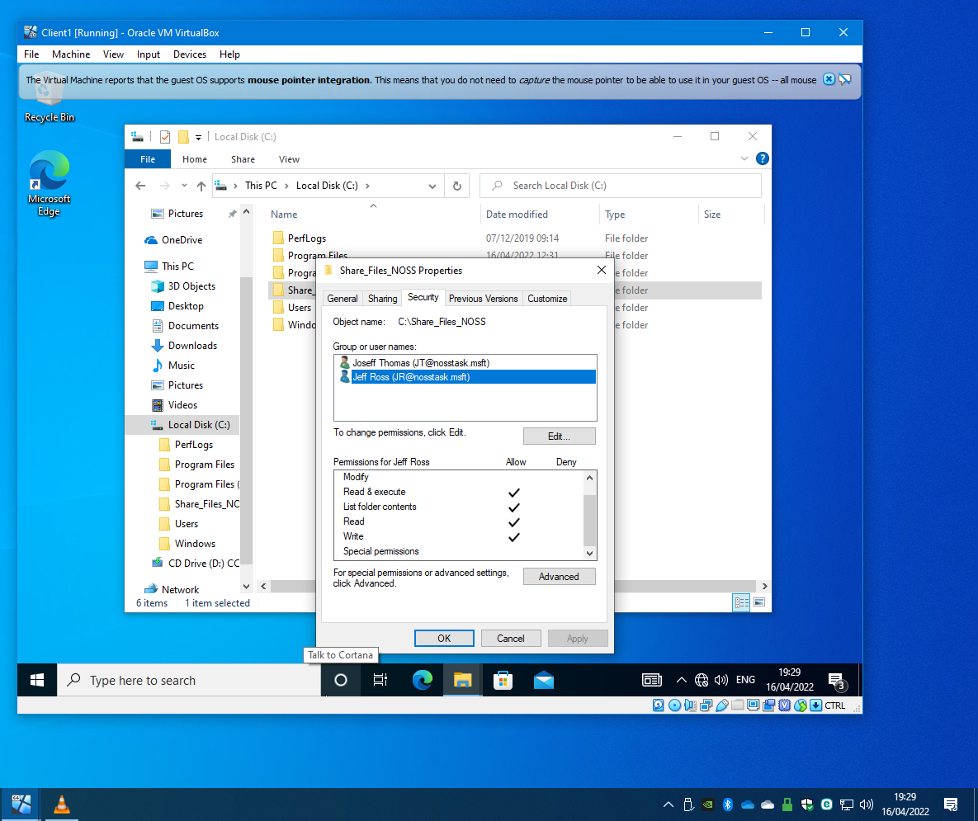
Figure 3

A text document was created within the folder which inherited the permissions from the parent folder, see figure 4 and 5. The logged-in standard account can create and edit the document in the folder, but cannot delete any files/folders within that folder.

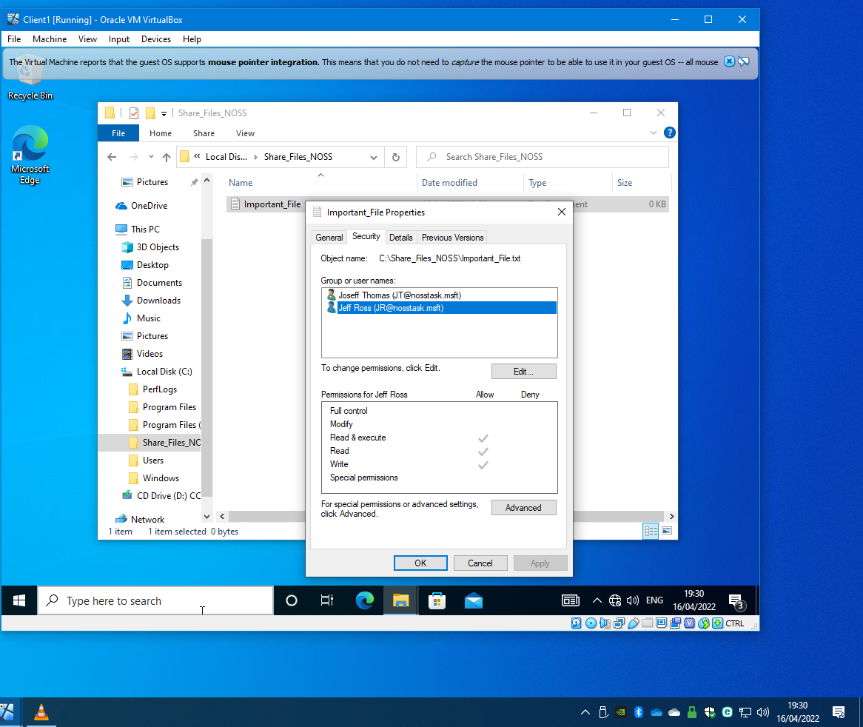
Figure 4

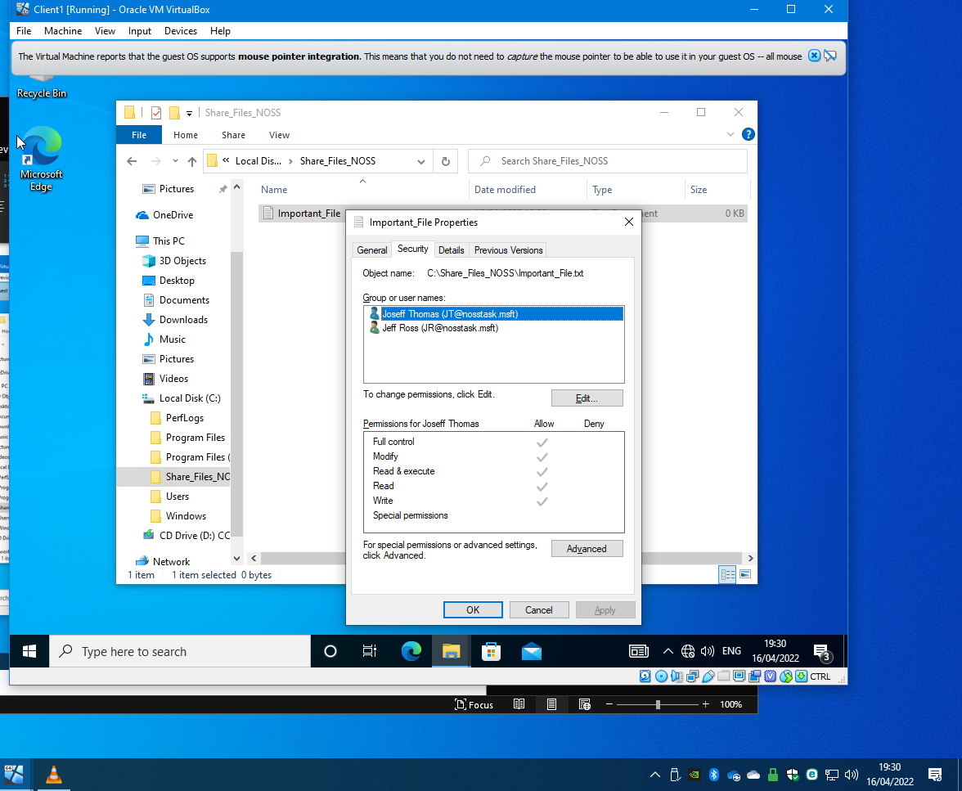
Figure 5

The activity requires setting up a network share on DC1-NWT and enabling share permissions to control access to data on a network.
Using the New Share wizard, the File and storage services role was set up on the Server Manager, and a new shared folder was created on DC1-NWT. The Share Profile was enabled with SMB Share – Quick. The path configured was \\DC1-NWT\Share_Files_NOSS$ so that any files and folders shared within the network assets will use this path to access resources.
On the setup wizard settings, the standard user and two administrator user was added to the network share. The standard user will have limited permissions compared to the administrator.
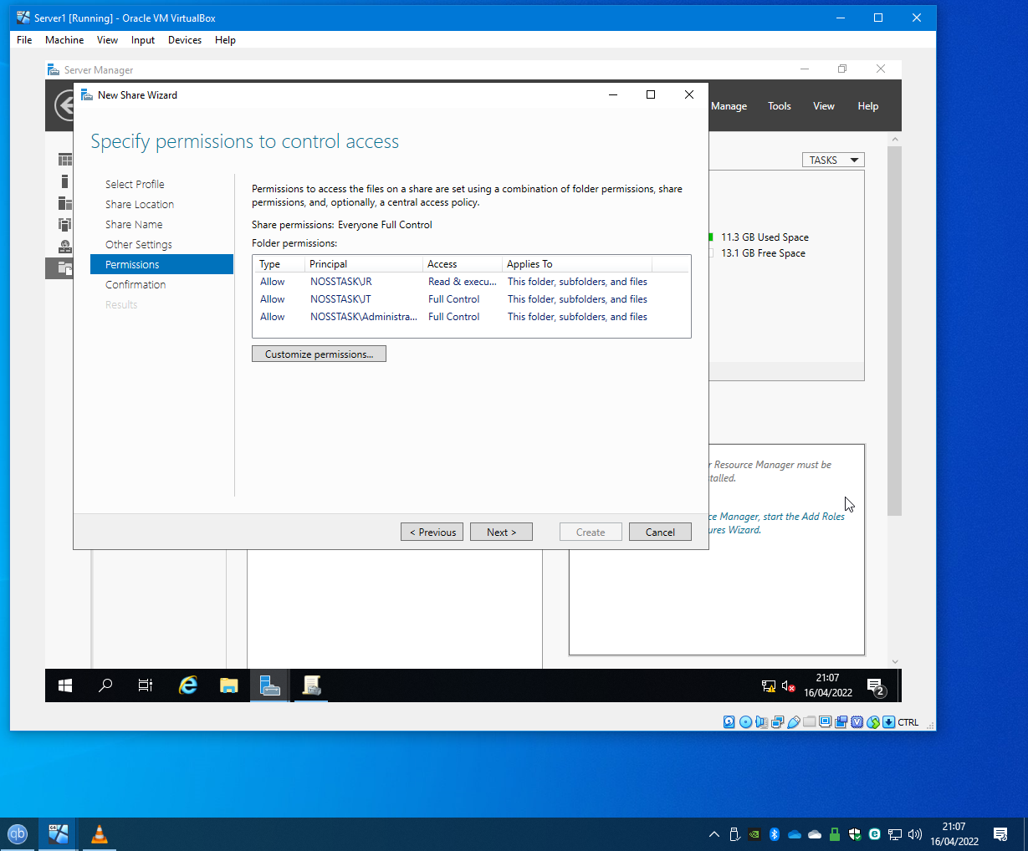
Figure 6

The permissions were added to the network share. Figure7 shows the confirmation page and the settings before the created folder.
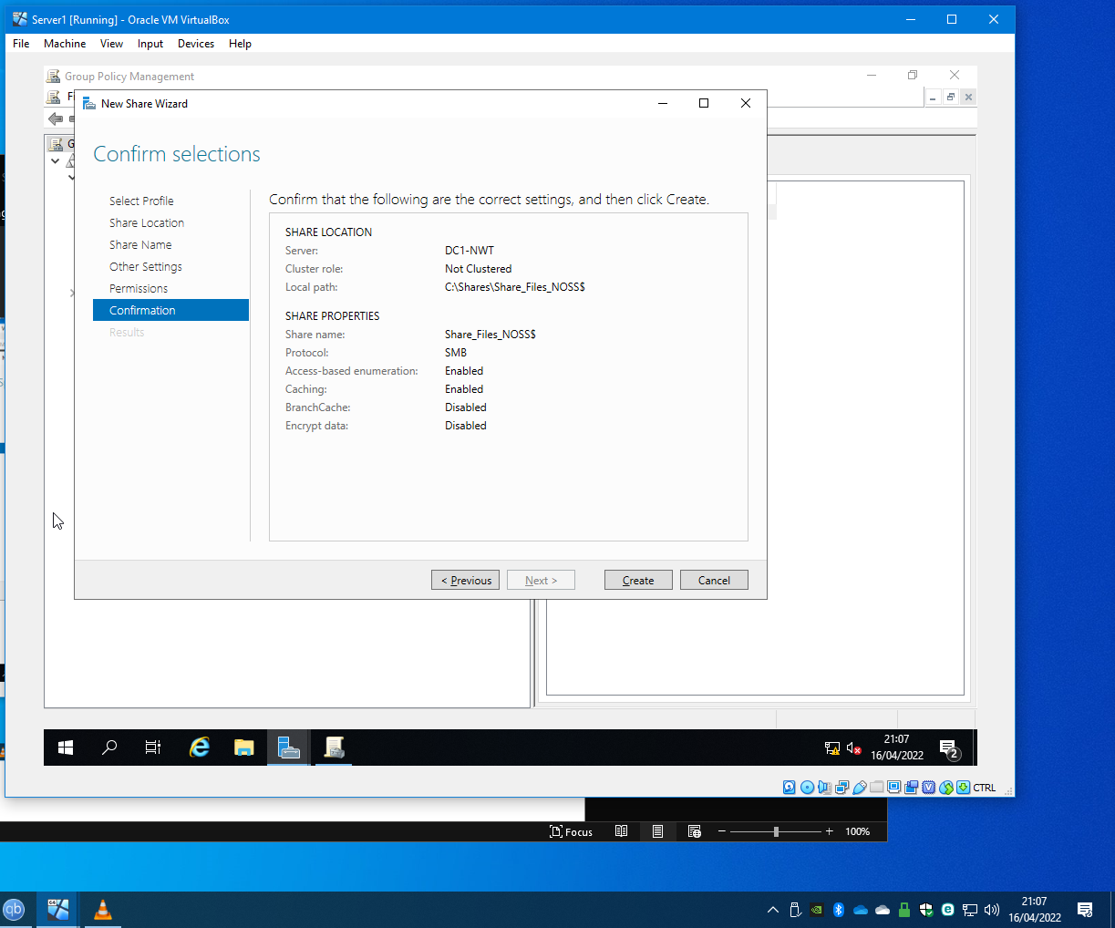
Figure 7

Figure 8 shows the completed configuration of the shared folder, Share_Files_NOSS$, under File and Storage services.

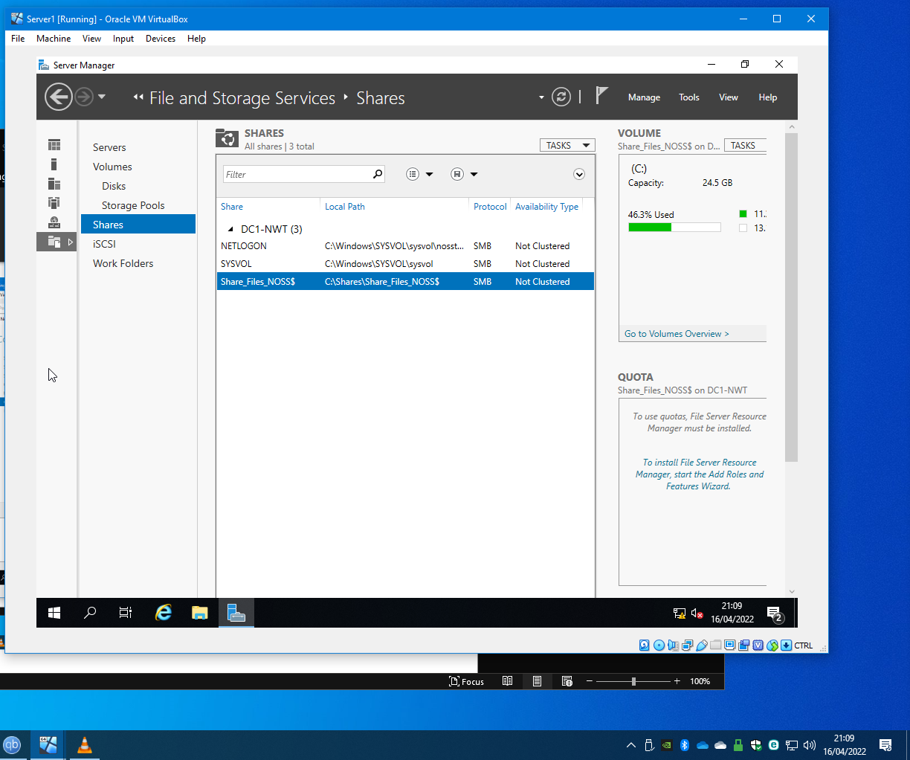
Figure 8

The shared folder needs to be mapped to WS1-NWT using the administrator account. The mapped drive was showing in the network locations, as illustrated in figure 9.

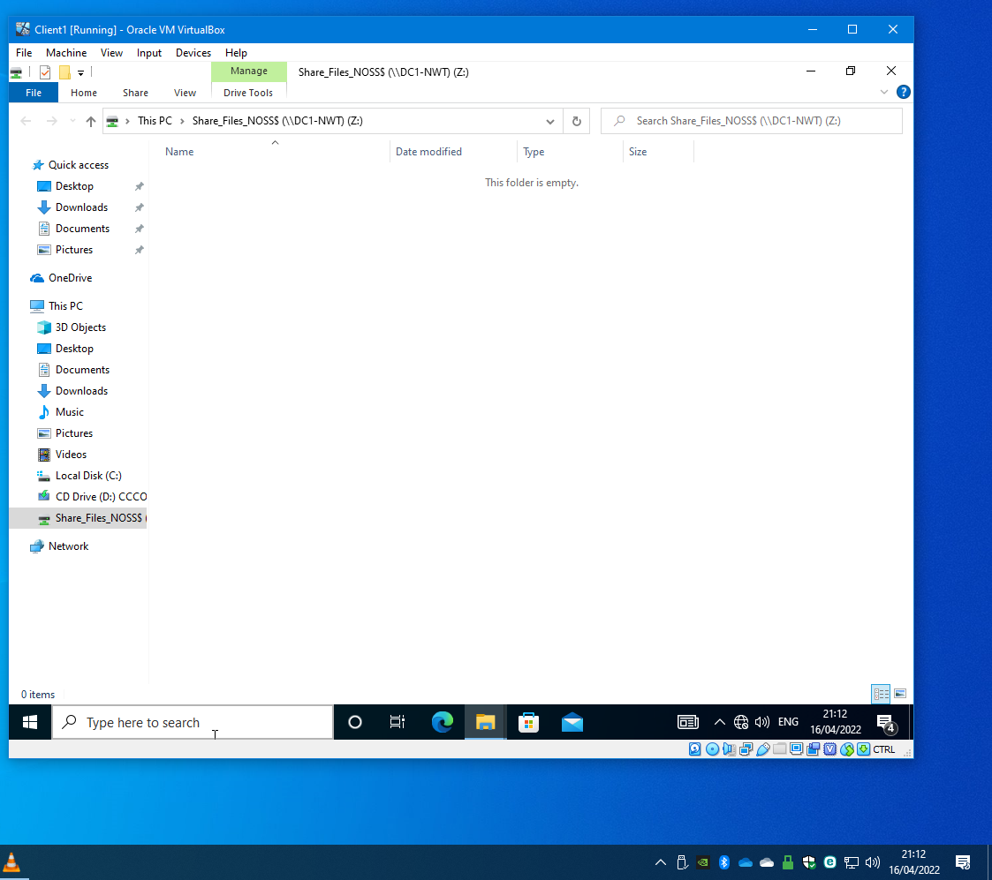
Figure 9

Group Policies
Implementing group policies on the NOSSTASK domain for standard users, an organisational unit was created, ‘Non-Admin Users’. A user was created as shown in figure 10.

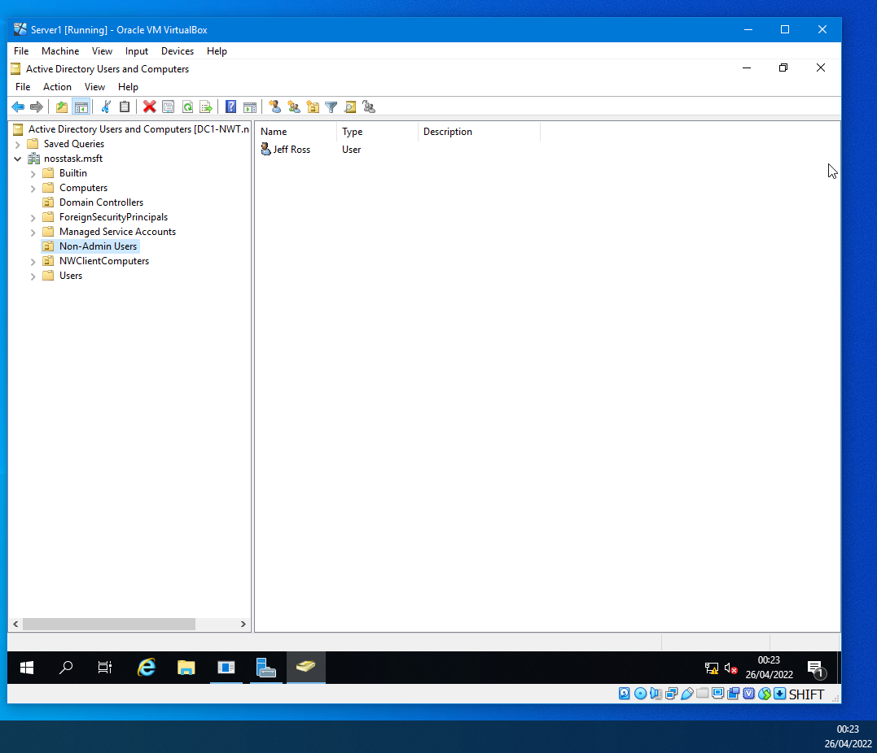
Figure 10

Implementing the group policy was to create them in the Group Policy Management Console (GPMC). Within GMPC the non-admin user domain was expanded to create a group policy object (GPO), which deny control panel access and the policy template was enabled. A command was entered into the command prompt to force apply the policy, see figure 11.

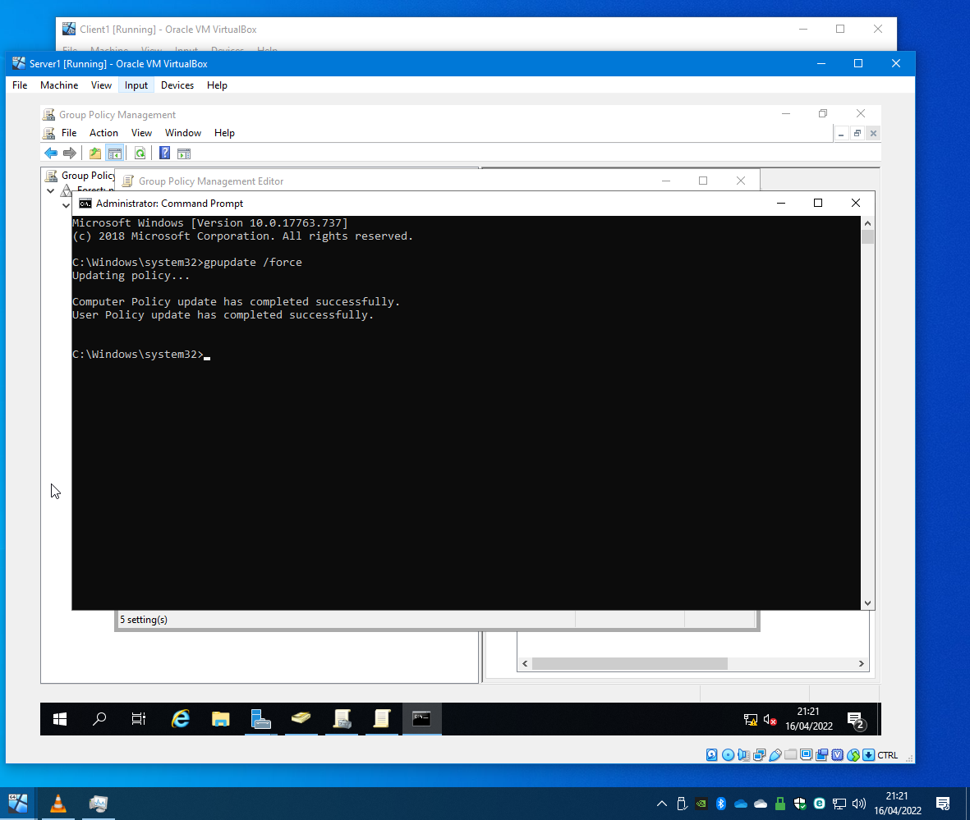
Figure 11

The standard user account was accessed to test the GPO. An attempt was made to access the Control panel, but as illustrated in figure 12, was denied.

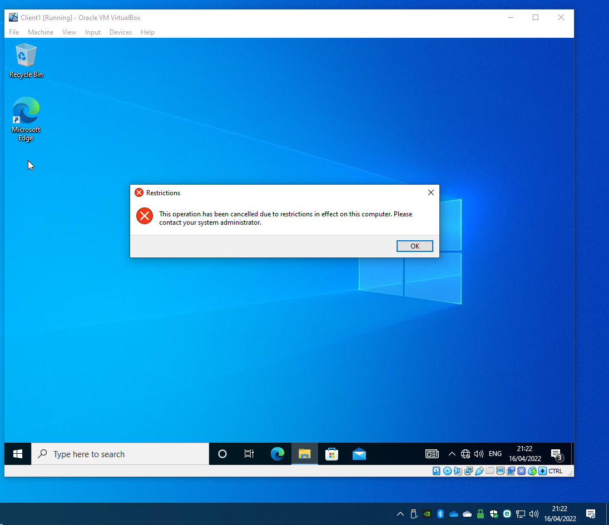
Figure 12

A GPO was created to restrict the access to the command prompt. The name of the policy created was NoCmdPrmptAccess, and the policy template was enabled. The policy was tested on the standard account and figure 13 shows the policy working.
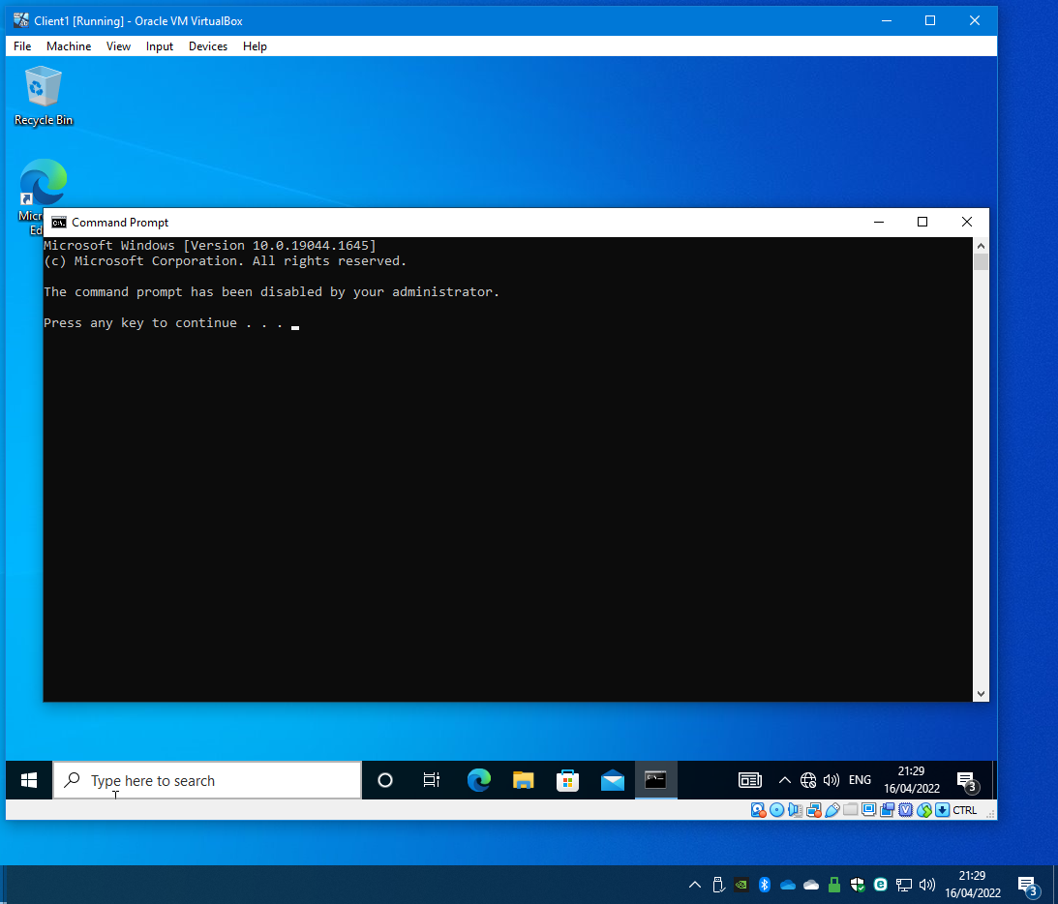
Figure 13

The following policy to be implemented was to restrict access for removable media drives. As discussed by the National Cyber Security Centre (NCSC) article ‘Device Security Guidance’ [1], restricting this is essential in protecting the network from malicious applications being deployed. It also allows mitigates sensitive documents from being stolen using memory sticks.
The policy object was created NoRemDriveAccess, and the administrative system templates to deny all access was enabled.
On WS1-NWT, trying to access the disk drive was denied as illustrated in figure 14.

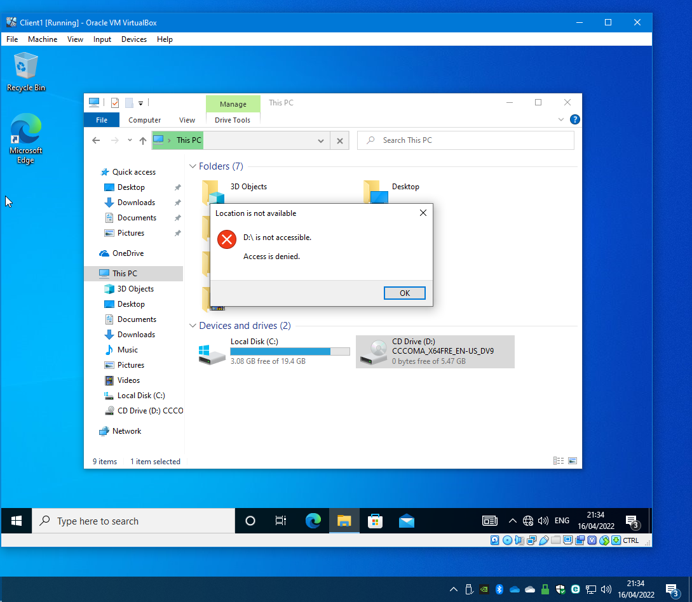
Figure 14

Another policy to implement was the restriction of software installed on managed devices. An organisation unit was created called NWClientComputers and WS1-NWT was moved from the computers to NWClientComputers, as shown in figure 15.
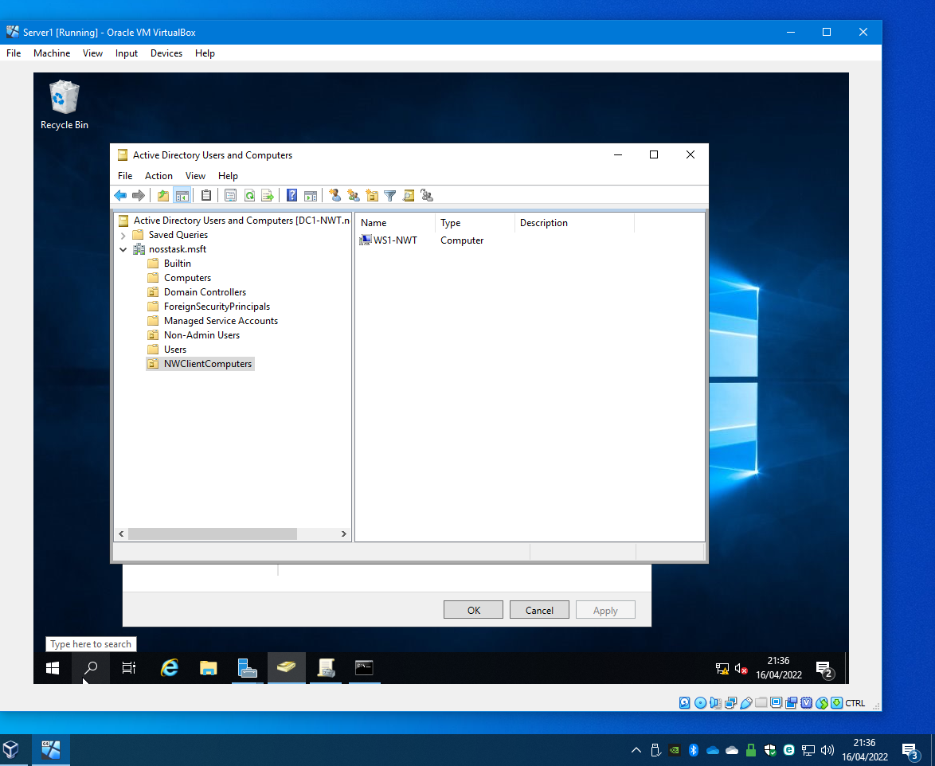
Figure 15

In GPMC, a new policy object was created in NWClientComputers called NOunauthsoftinstallS and in the policy template was enabled. Figure 16 and 17 shows the policy working.

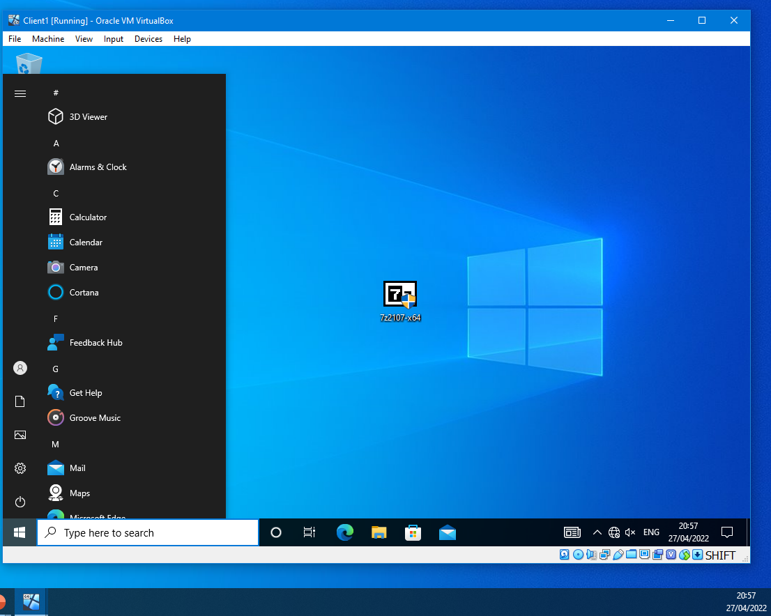
Figure 16
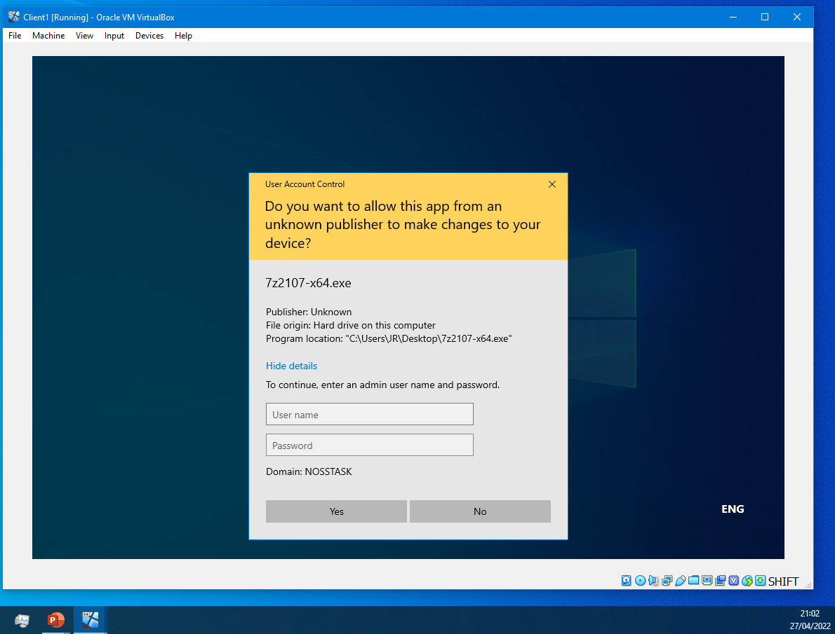
Figure 17

A password policy was created on the nosstask.msft domain. The default domain policy was chosen within the GMP console. Figure 18 shows the criteria of the password policy.
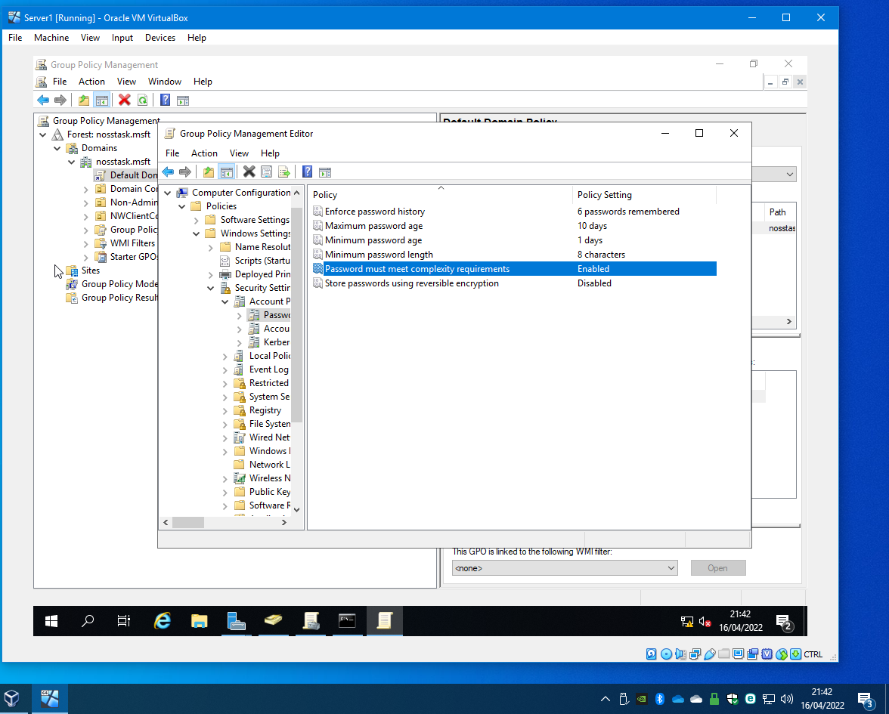
Figure 18

Configuration of the password policy was completed and tested on the new account. A poorly chosen password was entered, and an Active Directory Domain Service error message was prompted as illustrated in figure 19.
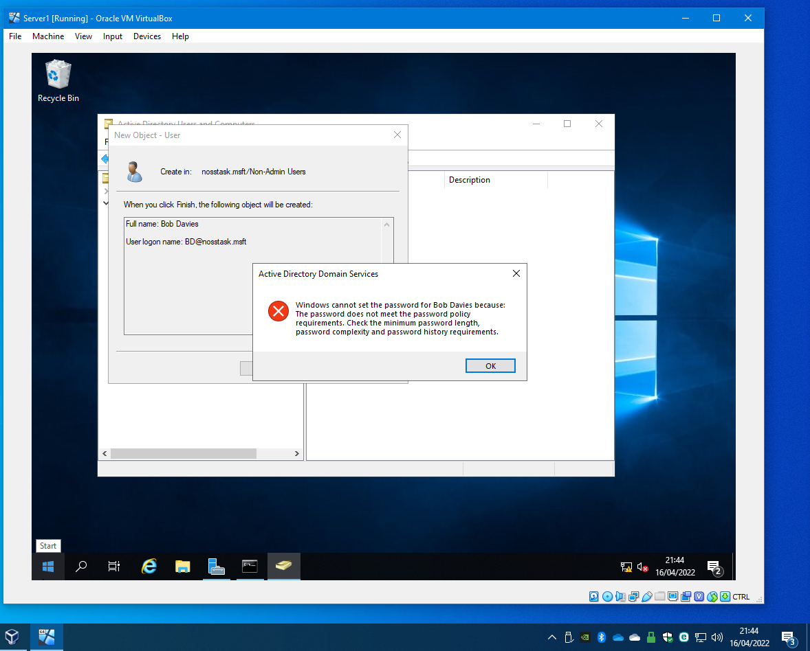
Figure 19

FTP server
DC2-NWT was set up as a File Transfer Protocol (FTP) server, see figure 20.

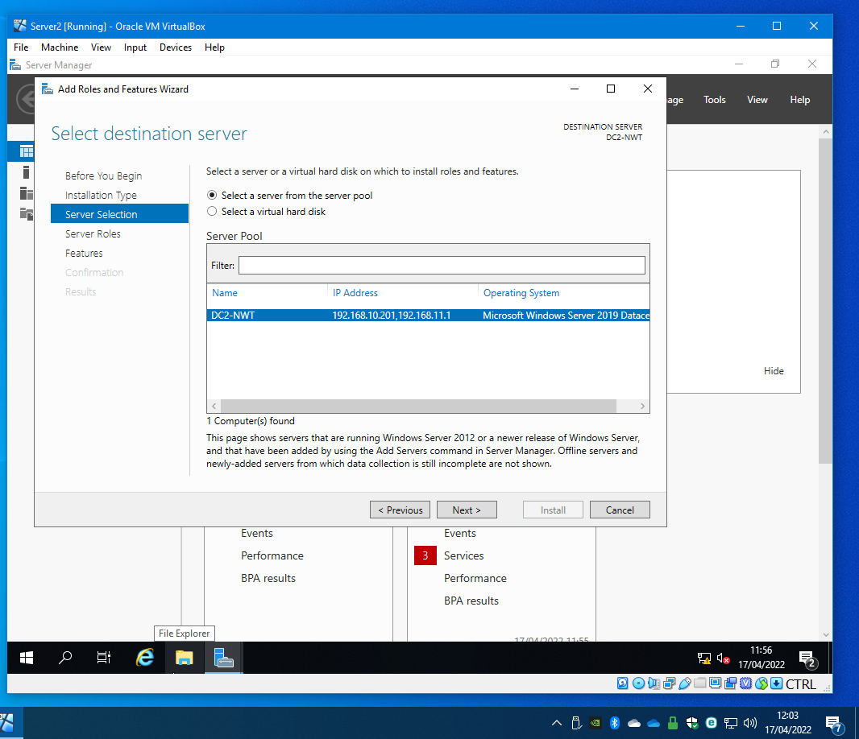
Figure 20

Once the Web Server (IIS) installation was completed, as show in figure 21.
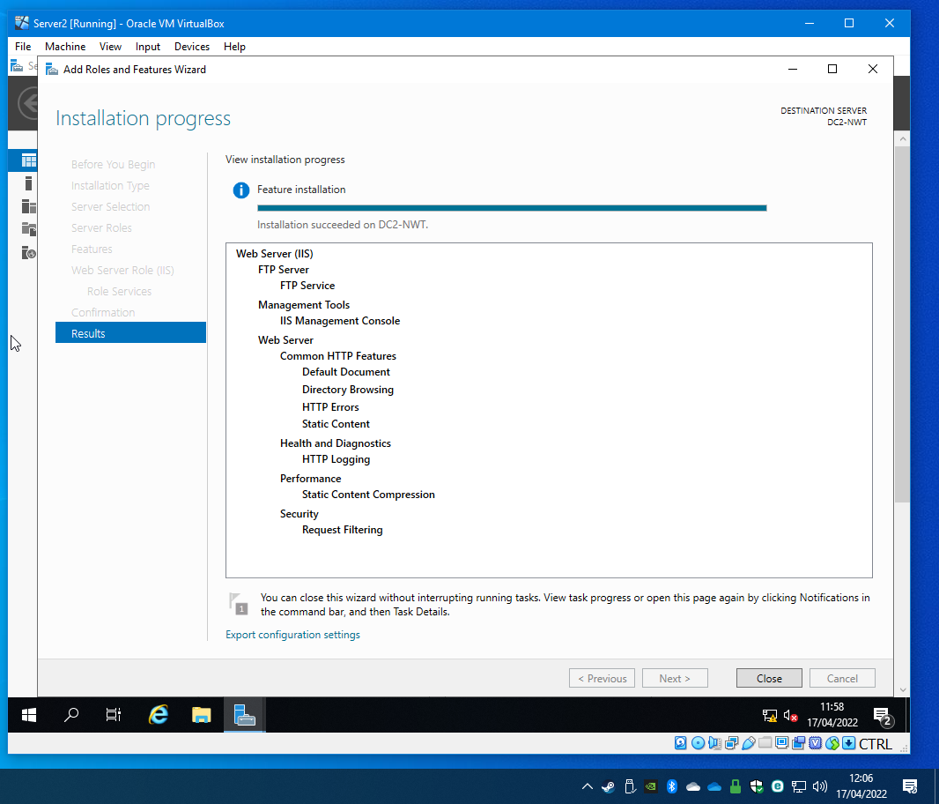
Figure 21

Figure 22 illustrates that a user was created called and added to the local users and groups which will be used to login to the FTP server both locally and remotely.

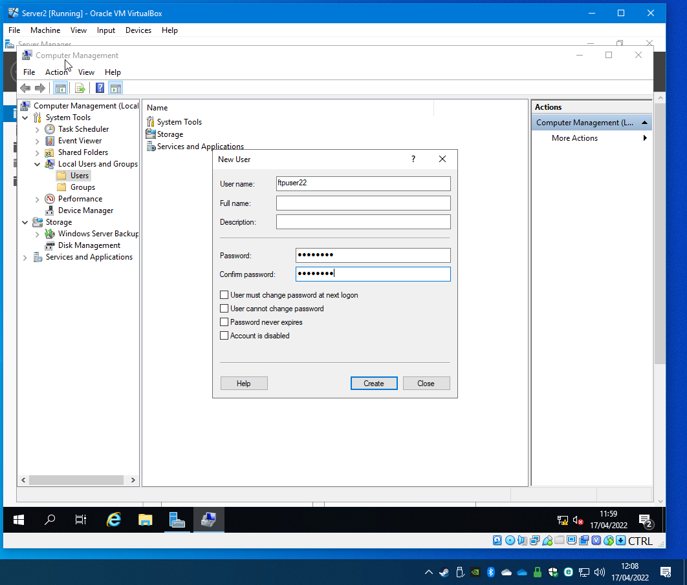
Figure 22

Figure 23 illustrates the created user.

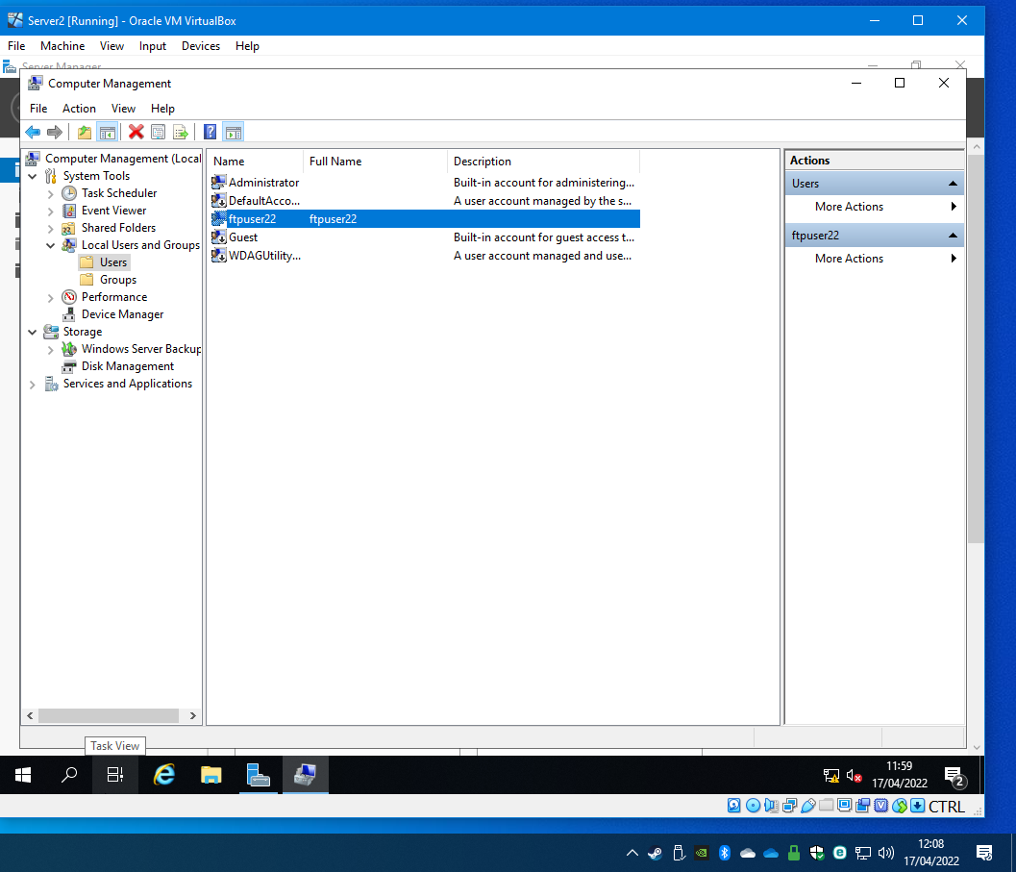
Figure 23

Internet Information Services (IIS) manager was opened, and a new FTP site was added which was called MYFTPSITE. The root drive was C:\inetpub\ftproot, with No SSL chosen and the Port number was 21 with preferred mode chosen as basic authentication. The user that was created, DC2-NWT\FTPuser22, was chosen as the specified user with read/write permissions. Figure 24 shows a completed setup.

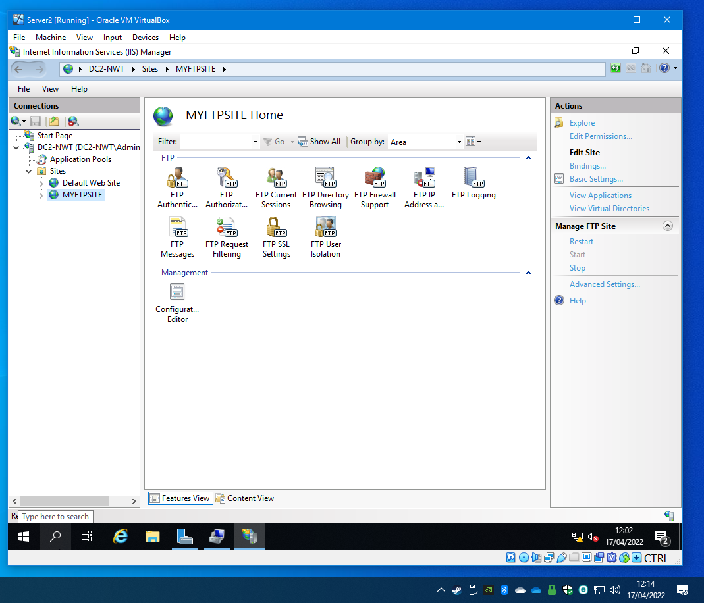
Figure 24

A banner was added to the FTP site, see figure 25.

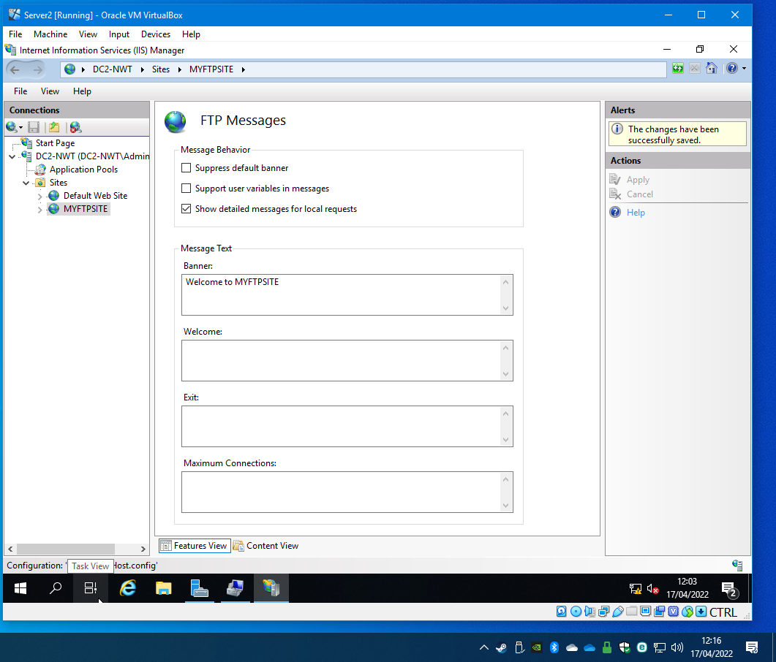
Figure 25

Ftpuser22 was added to the permissions of the ftproot folder in C:\inetpub, see figure 26.

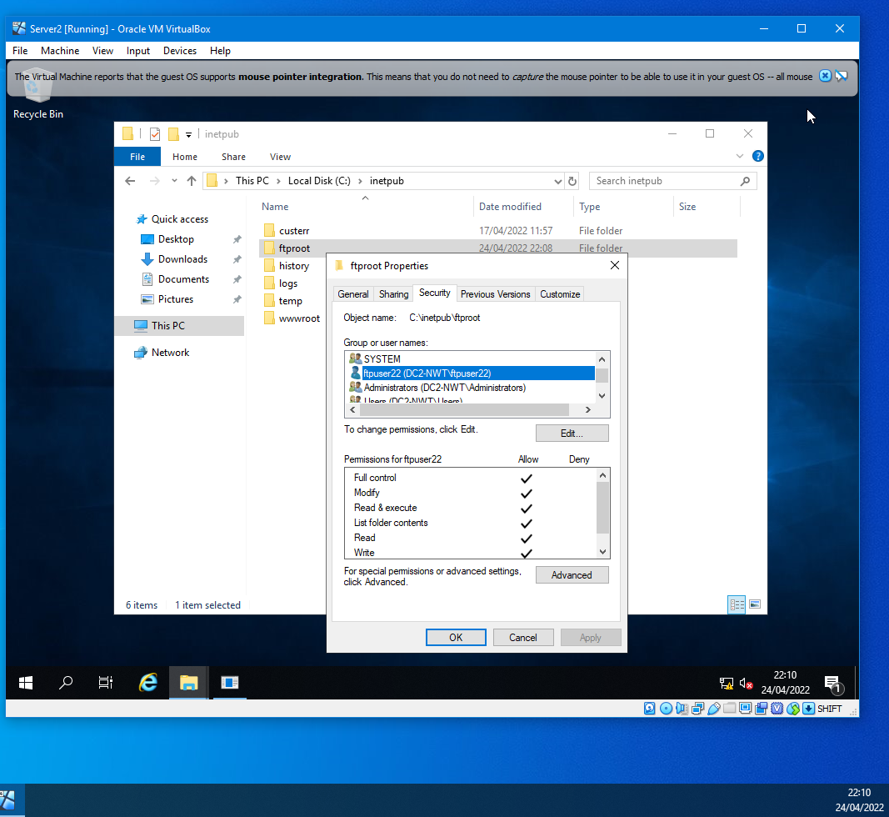
Figure 26

FTP connection was tested between the client and the server. A folder was created in the C drive called MYFTPFiles and a text document was created within the folder called myftpfile2upload.txt. Command prompt was opened on client2 and a connection to the ftp service was initiated Figure 27 shows Ftpuser22 logged-in with the banner displayed.
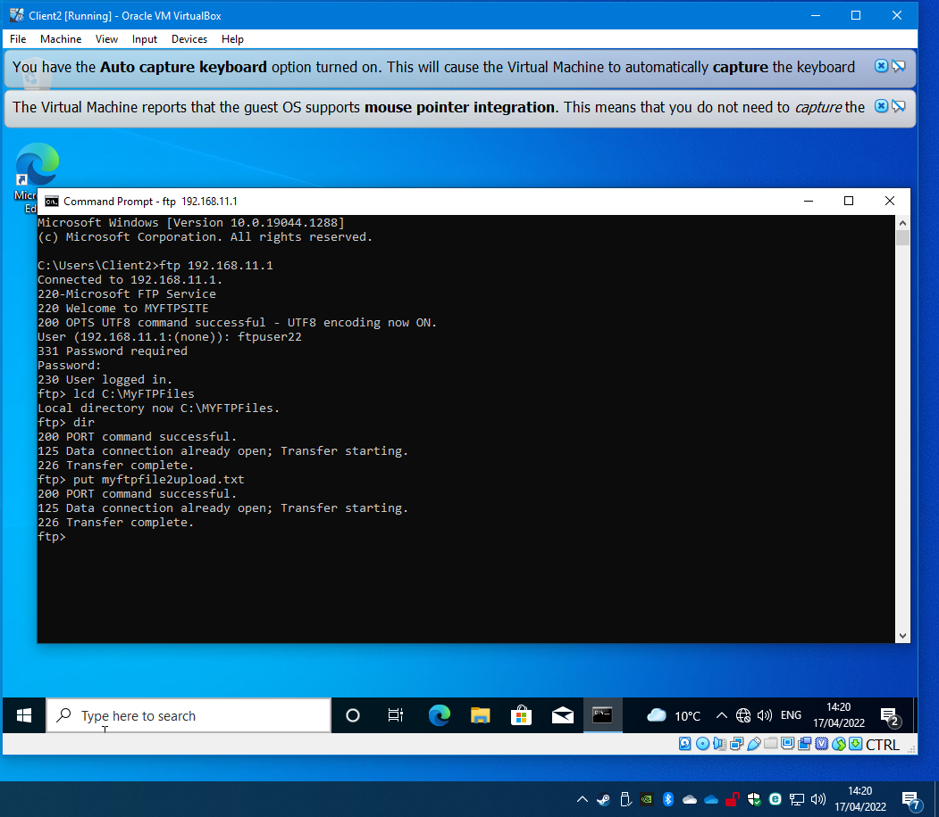
Figure 27

The text document that was created on the client was requested to be transferred to the FTP server in the directory C:\inetpub\ftproot folder using the commands shown in the above screenshot. The screenshot below shows a successful transfer of the document.
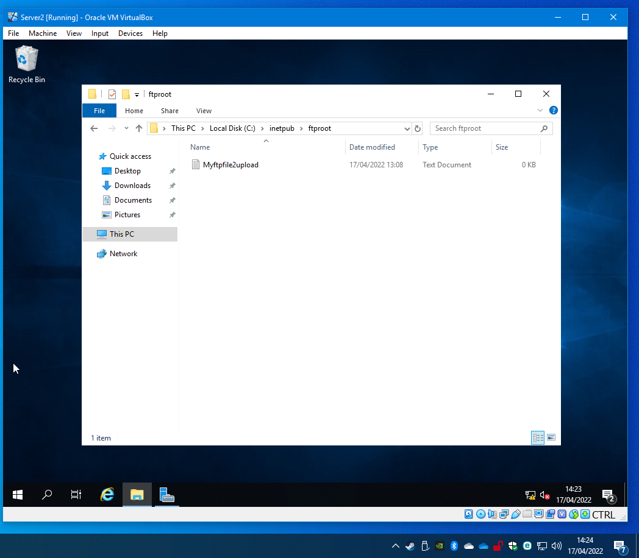
Figure 28

Installing and Configuring the Routing and Remote Access Service
Installing and configuring the routing and remote access service on DC1-NWT. The screenshot below shows the installation completion of adding Remote Access role and the role services were DirectAccess & VPN RAS and Routing services.

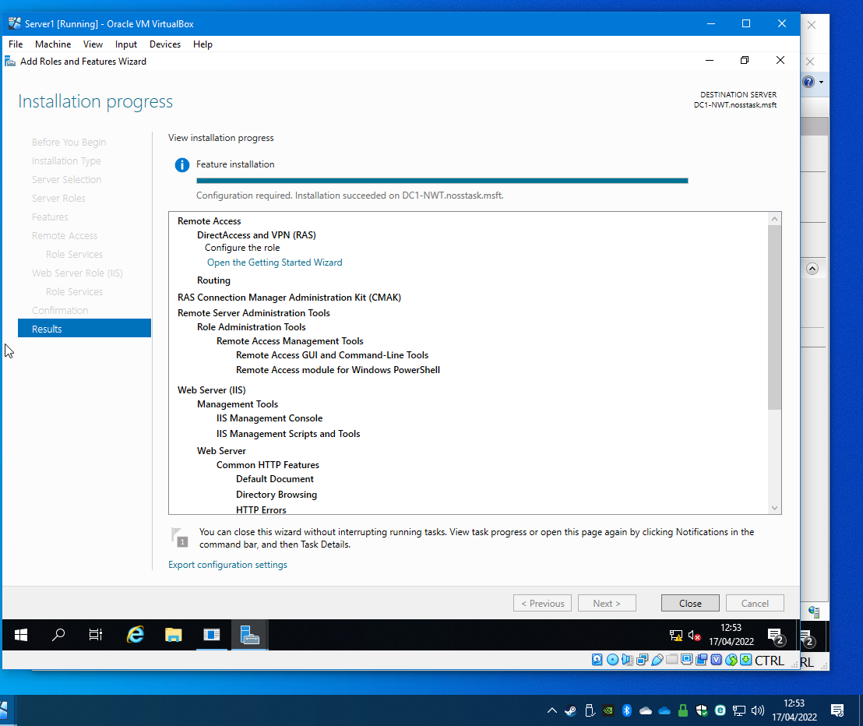
Figure 29

Once the installation was completed the setup wizard was opened. On the main screen the Deploy VPN only which opened Routing and remote access window. On the list of servers, enable and configure routing and remote access were selected for DC1-NWT. Using the wizard, the custom configuration was selected, and LAB routing was chosen. Figure 30 and 31 shows the service starting

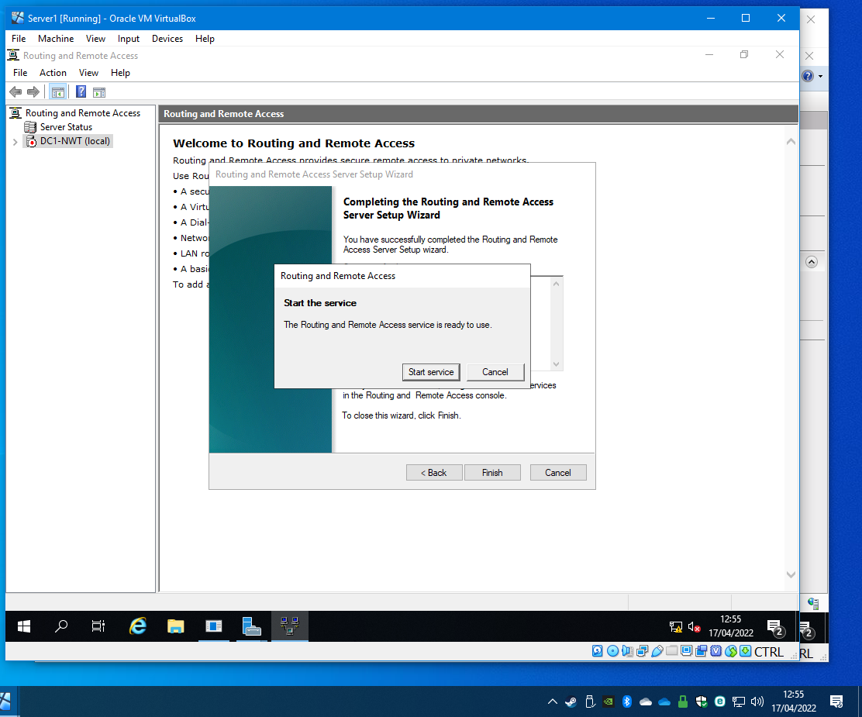
Figure 30

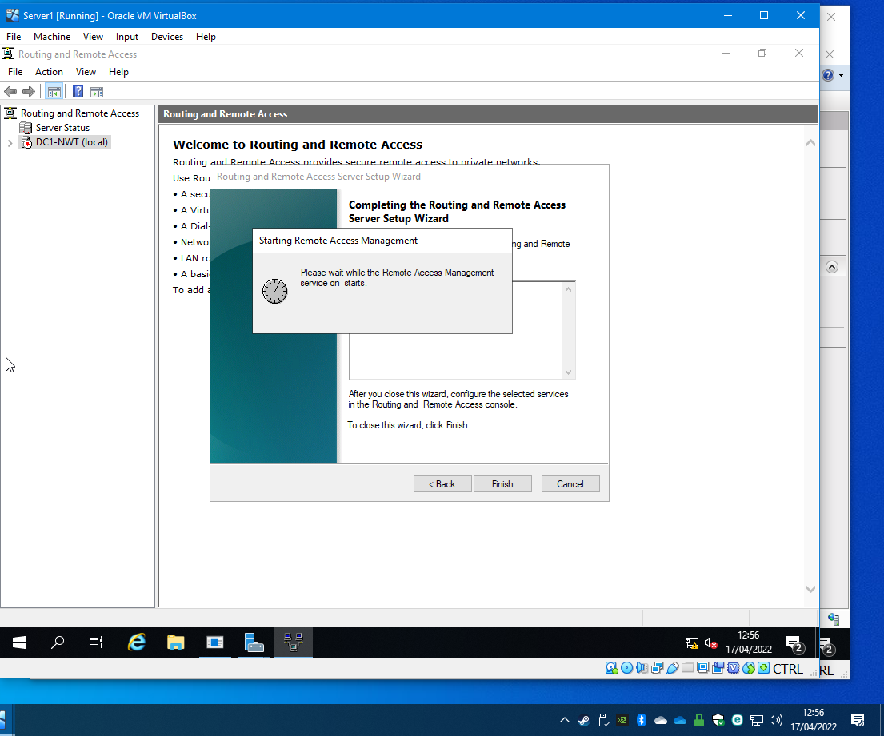
Figure 31

Starting the service finished and the new routing protocol was chosen which was RIP2. Both network faces were configured, see figure 32. Same steps were repeated for DC2-NWT, see figure 33.

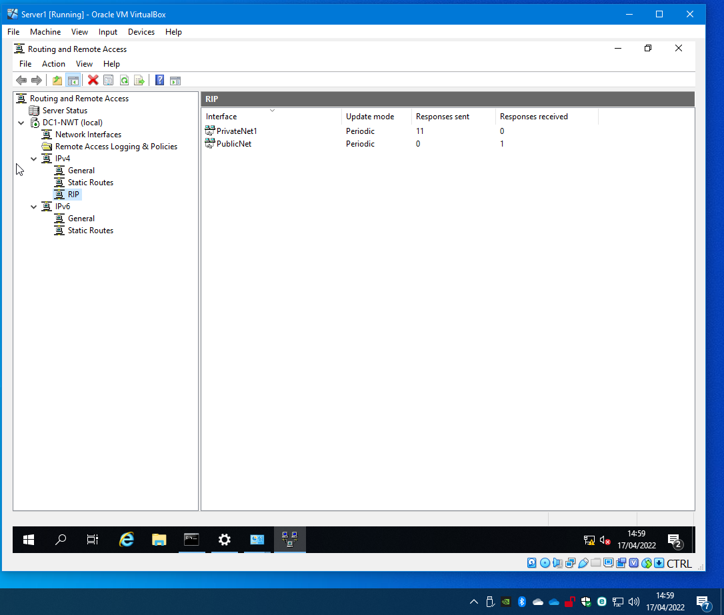
Figure 32

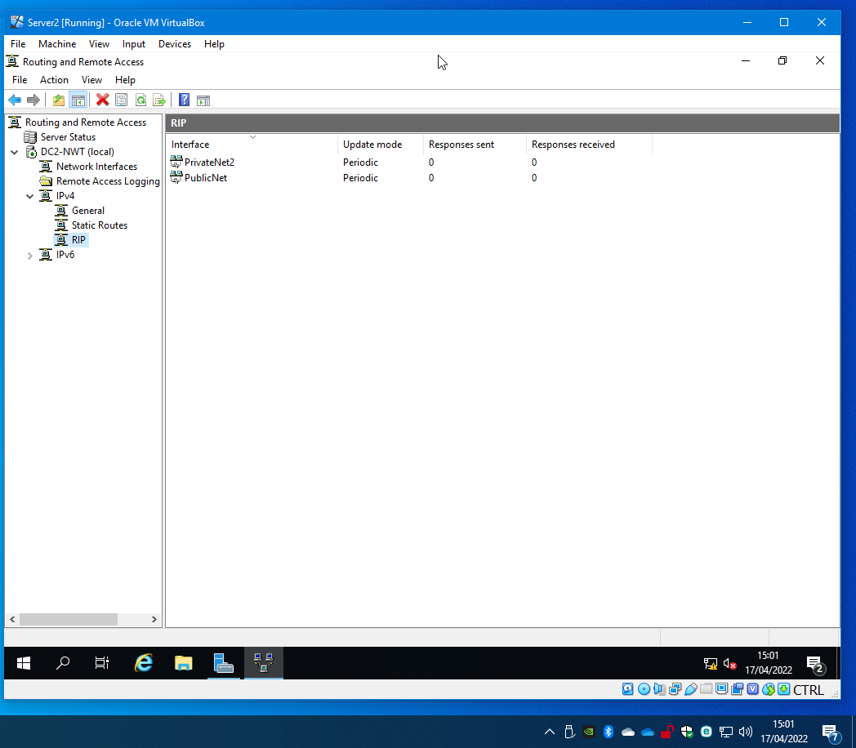
Figure 33

To test the wide area network (WAN) configuration, a ping was sent from DC1-NWT to DC2-NWT PublicNet IP address (192.168.10.201) which was successful, as illustrated in figure 34.

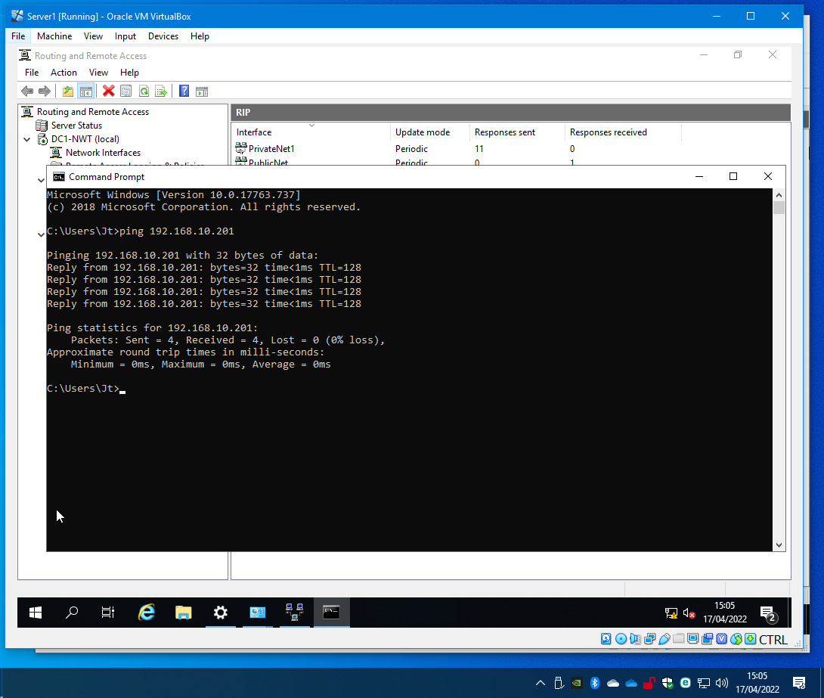
Figure 34

The default gateway was added to the client2 PrivateNet2 properties see figure 35.

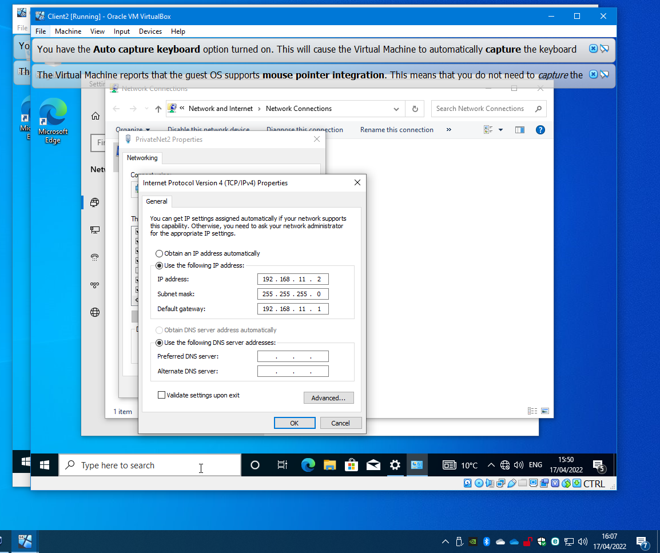
Figure 35

On WS1-NWT a ping was sent to the IP address for client2 which is the PrivateNet2 IP address 192.168.11.2. Figure 36 shows the configured WAN is working.

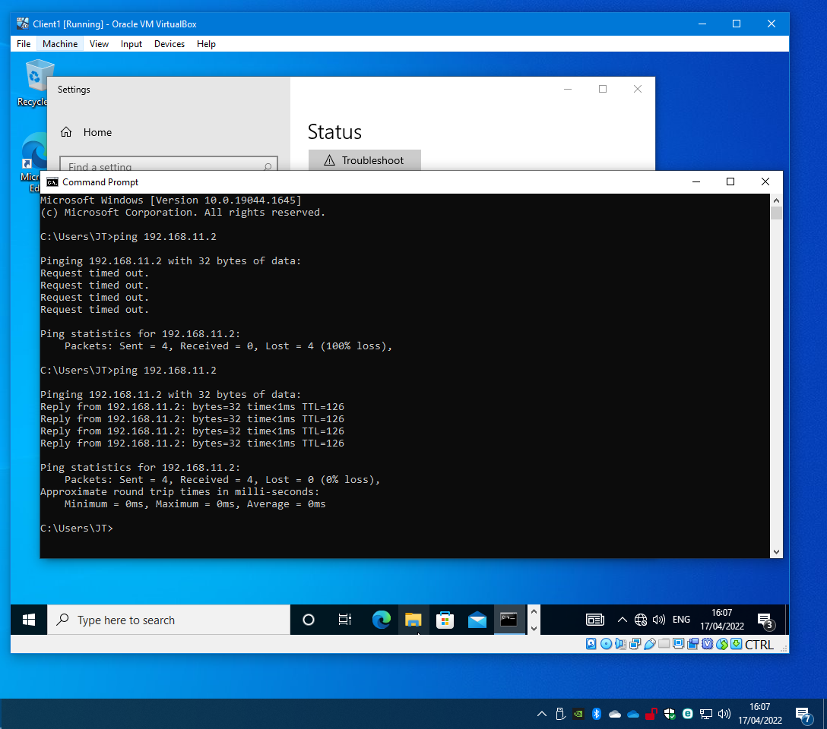
Figure 36

IP Packet Filtering

Filter 1
The activity in figure 37 illustrates what is required to stop any client in PrivateNet1 from ping DC1-NWT. The illustrates shows that prior to adding the inbound filter rules on DC1-NWT that WS1-NWT was able to ping the server.
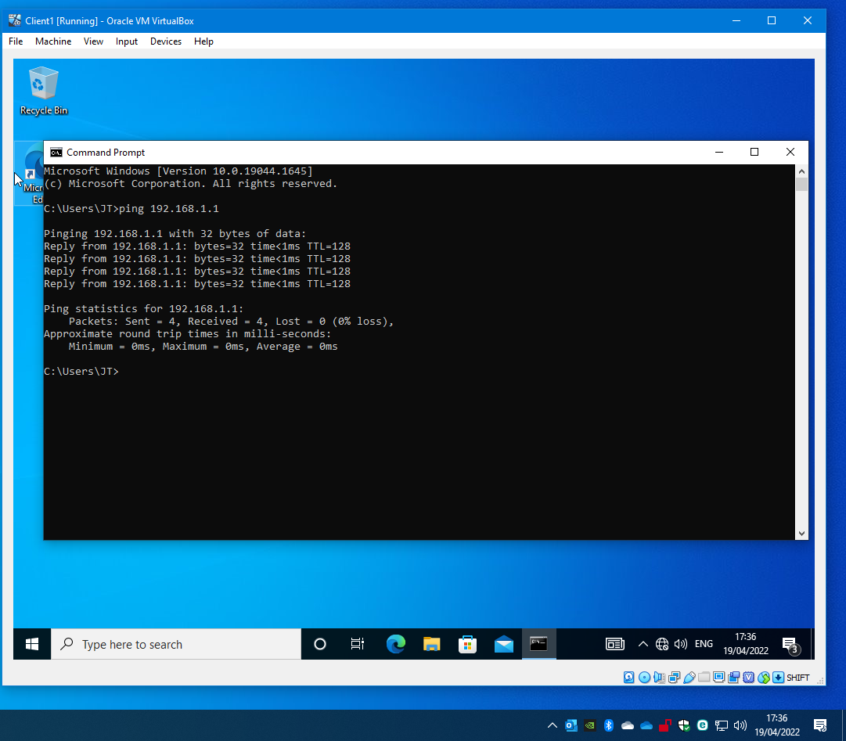
Figure 37

On the PrivateNet1 properties in routing and remote access an inbound filter was added that any source address to the destination address 192.168.1.1 on the ICMP protocol. The filter action ‘receive all packets except those that meet the criteria in figure 38 meaning that any inbound packet will be dropped if on the ICMP protocol.
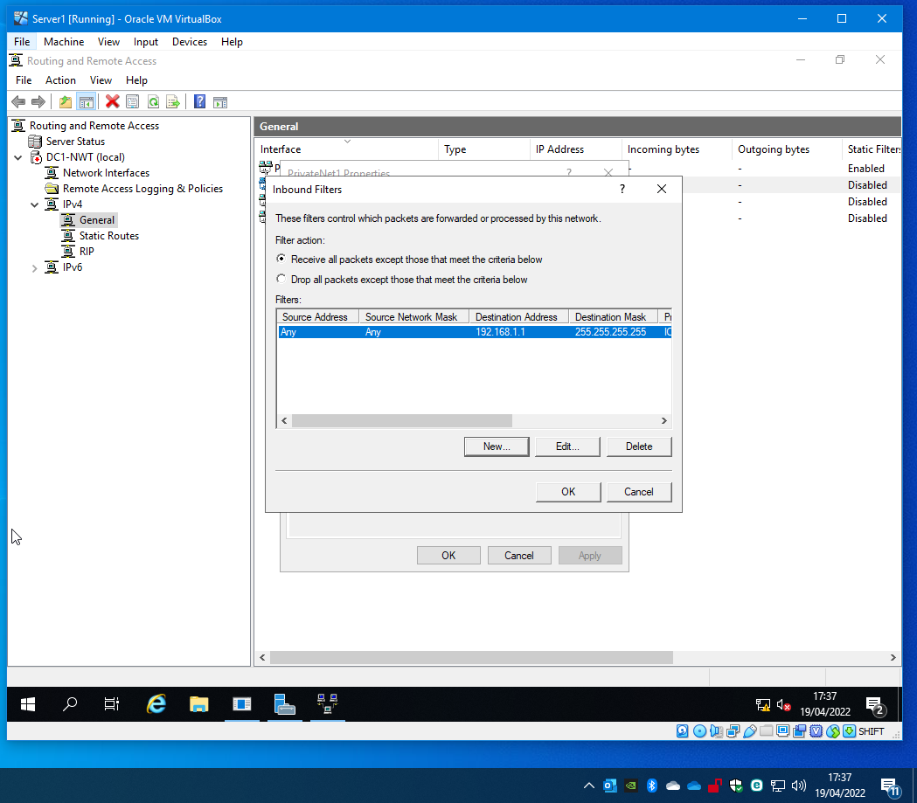
Figure 38

Another ping was sent from WS1-NWT to DC1-NWT and repeated, but with the inbound filter now implemented the pings were not successful. See figure 39.
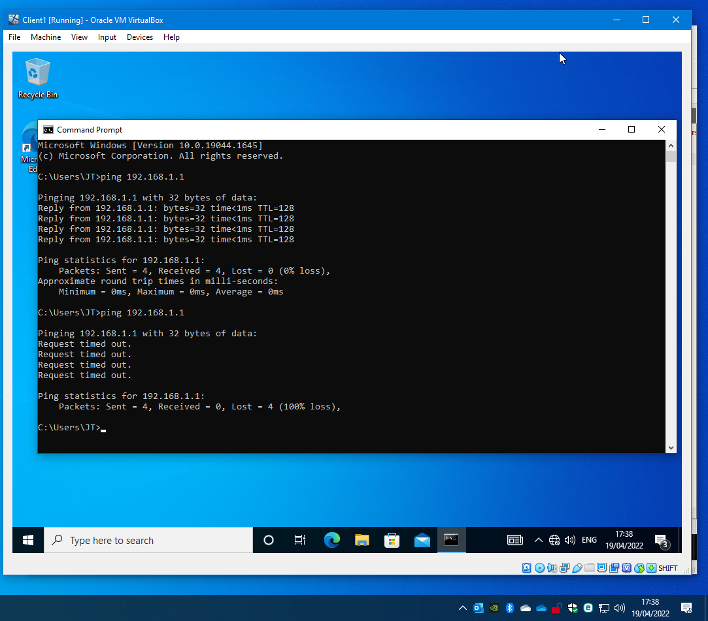
Figure 39

Filter 2
The next filter added was to restrict access to the FTPserver from PrivateNet1. Figure 40 shows WS1-NWT can access FTP on both IP addresses.
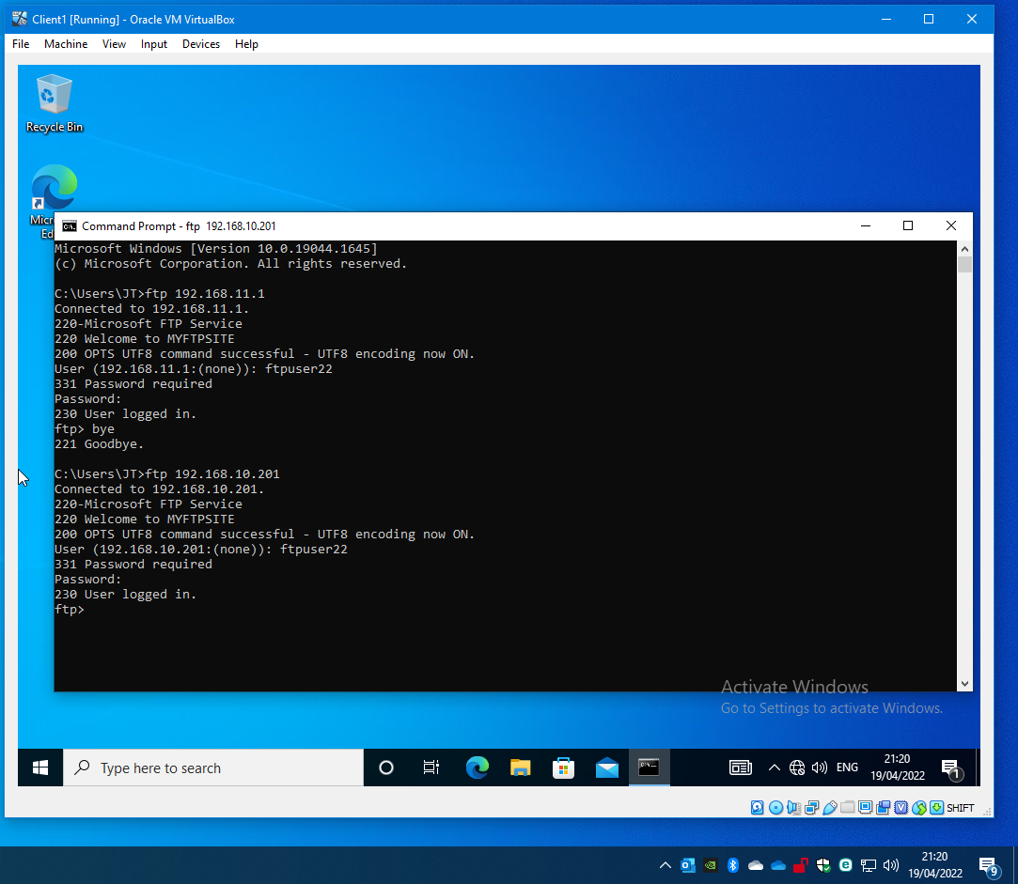
Figure 40

On DC1-NWT an outbound filter was added to the PublicNet network interface. The two filters are for public (192.168.10.201) and private IP address (192.168.11.1) for DC2-NWT on the TCP protocol, which is used for FTP communication, port 21 which was noted on the set up for the FTP server previously. The filter action ‘transmit all packets expect those that meet the criteria below’, any packets being sent to those address on the TCP protocol, port 21 will be dropped.
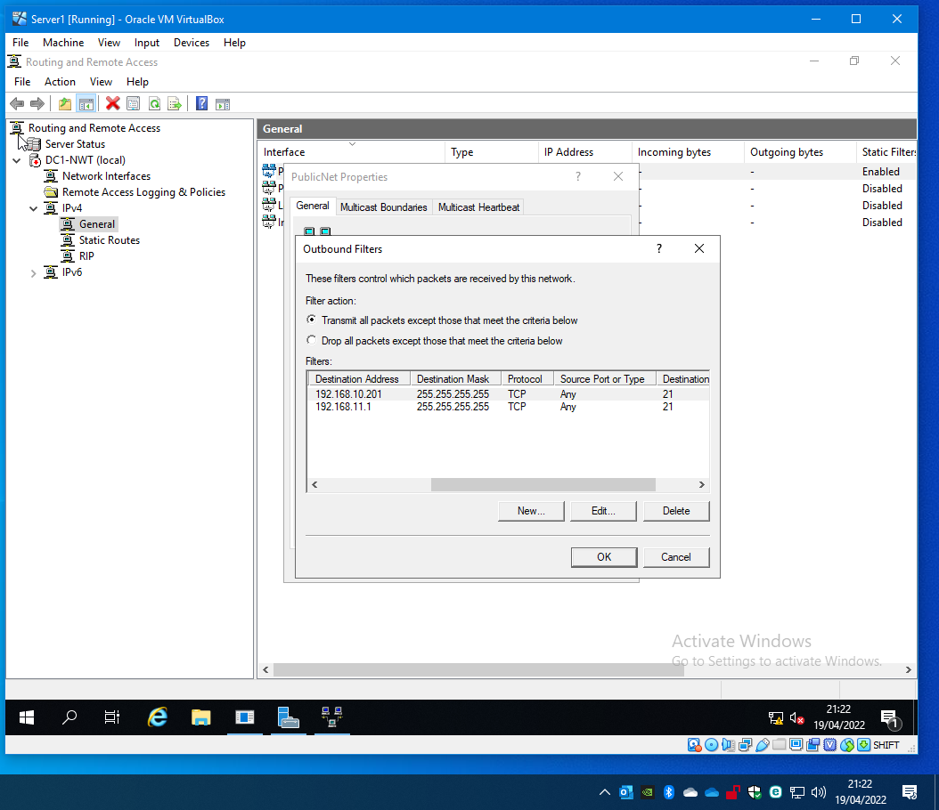
Figure 41

Another attempt was done on WS1-NWT to connect to FTP server on both IP address. Figure 42 illustrates the failed attempt to connect.

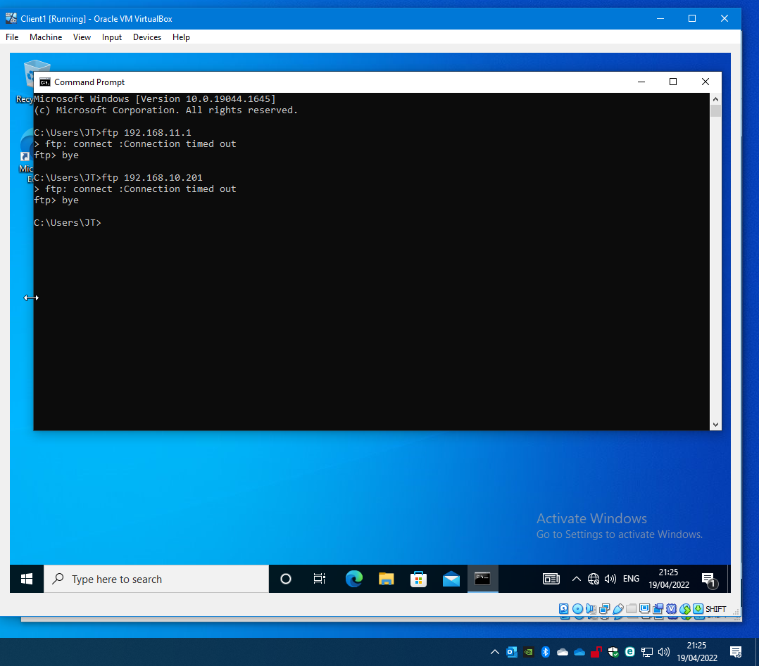
Figure 42

An extra filter was added to the outbound filter which is identical to the other two apart from this is for port 20 as a precaution.

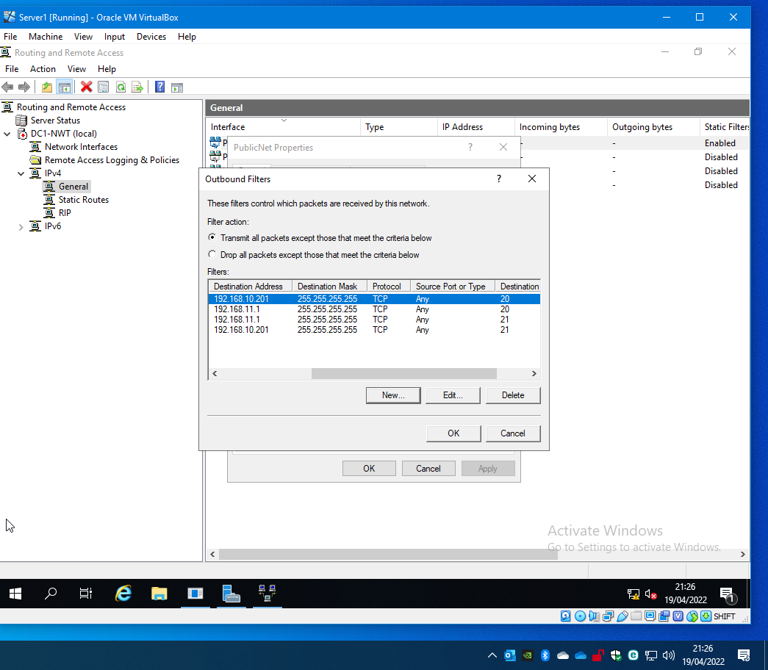
Figure 43

Filter 3
The last inbound rule to be added was an inbound filter on DC1-NWT to only allow WS1-NWT to access the FTPserver. Figure 44 shows the source address which is WS1-NWT and the destination address is the PublicNet and PrivateNet2 address for the FTPserver. The protocol was TCP only and port 20 and 21. The filter rule is to drop all packets except the one that is listed. This is to only allow WS1-NWT to connect to the FTPserver.
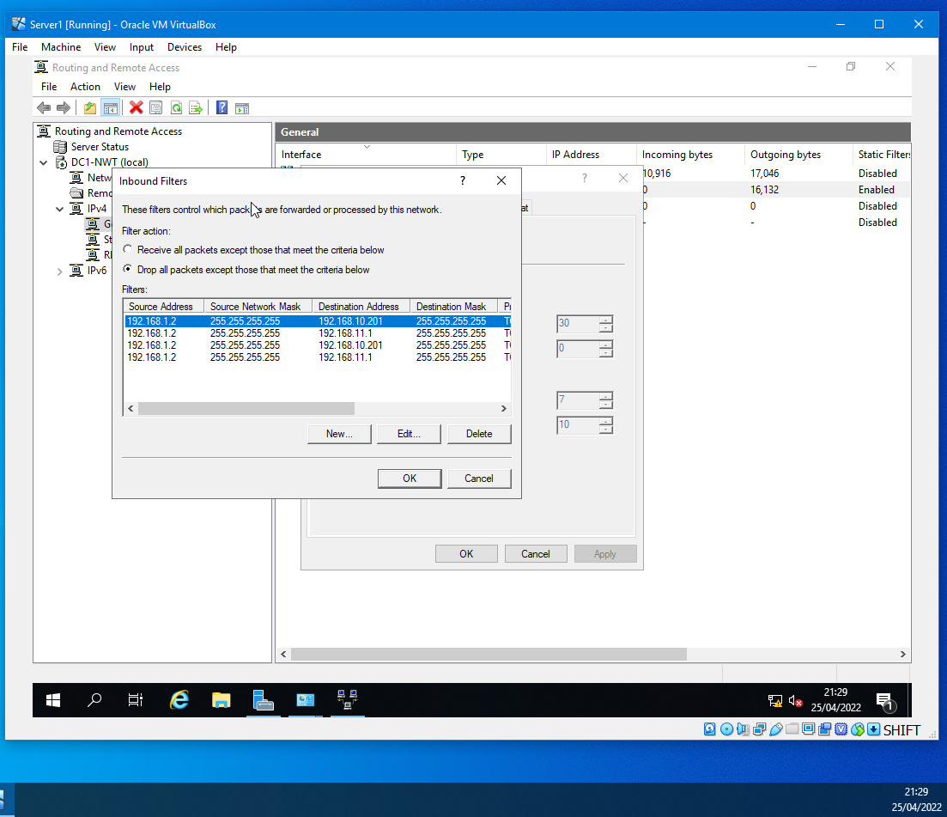
Figure 44

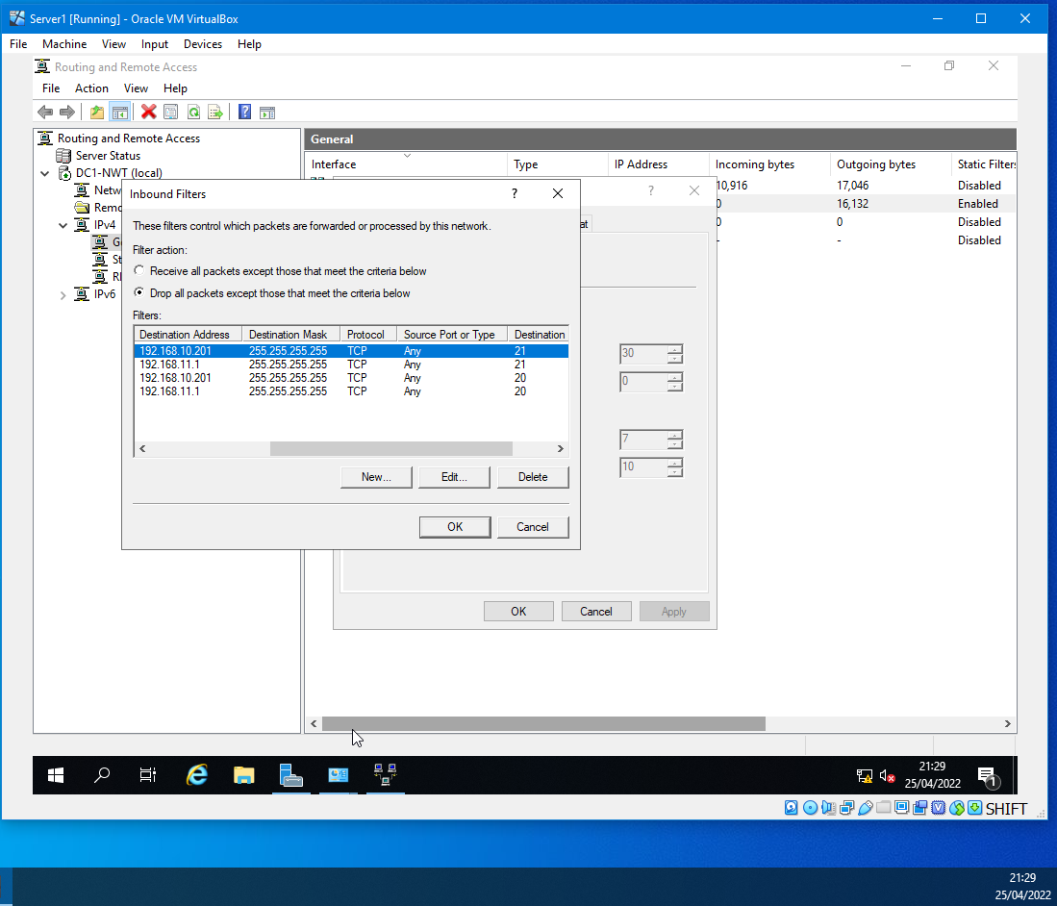
Figure 45

Figure 46 shows WS1-NWT successfully access the FTP on both IP addresses.
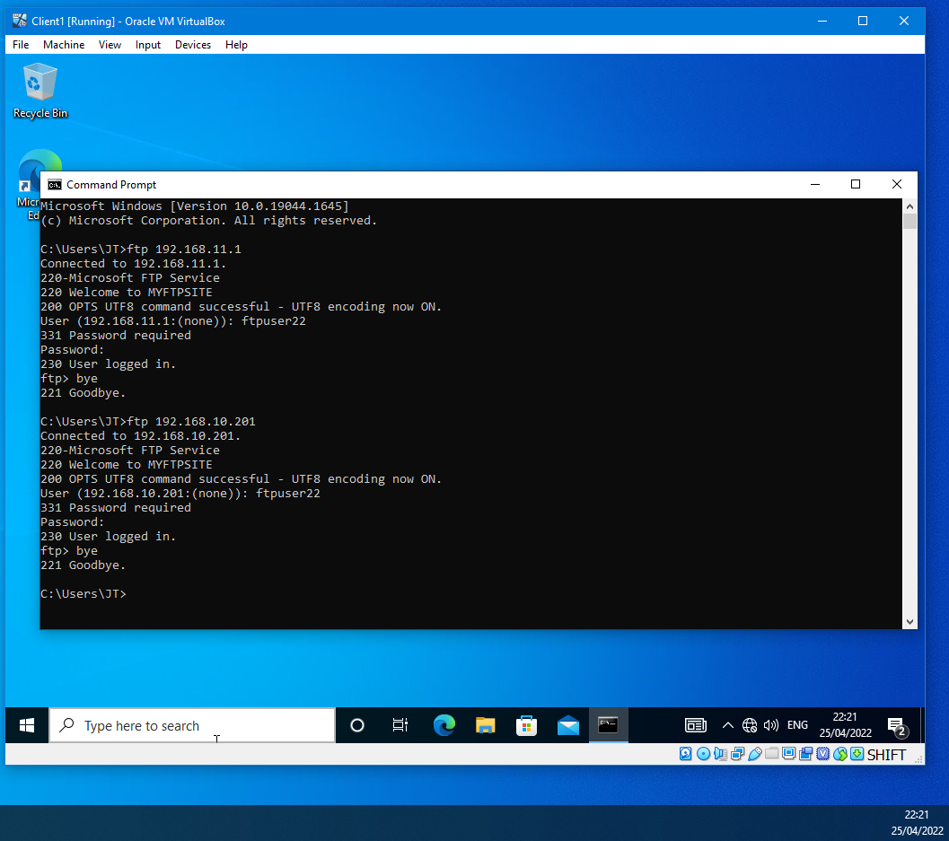
Figure 46

Part 2: Observational

Password Principles in a Modern Network Environment
Good practice when setting a password is to have a minimum password length, which Microsoft recommends on its documentation called ‘Password Policy Recommendations’ [2], being no less than eight characters. Microsoft further recommends not enforcing long passwords such as a minimum of 16 characters, which can result in predictable and undesirable behaviours from users.
Another step that the administrator can do is ban the most common types of passwords from being used on the network, as this is one of the most common types of brute force attacks as mentioned on United Kingdom’s NCSC called ‘Password administration for system owners’ [3].
NCSC guidance further mentions that the use of complex passwords that have been generated is not recommended as they are difficult to remember, and that the adoption of a three random words technique will assist users in remember a suitable complex password. NCSC article [4] on the three random word technique notes that the use of easy memorable words like ‘onetwothree’ is not recommended, nor are words personal to the users as this can be guessed by individuals known to them.
Enabling multi-factor authentication (MFA) on web accounts will provide an extra security layer that will protect the account as discussed by NCSC guidance article on MFA , titled ‘Multi-factor authentication for online services’ [7].The user will need to provide an alternative email address, smartphone number, or use of an authentication app such as Microsoft Authentication [5] or Google Authenticator [6].
When users log in to the account, they will receive a one-time limited code to enter on the login screen or approve a sign-in request using the authentication app, which will proceed to login once approved. MFA will also inform users if a failed login attempt has been made on the account, as further discussed by NCSC guidance article [7].
There is NCSC guidance in the article ‘Step 4 - Using passwords to protect your data’ on cyber security for small businesses [8], but the advice is relevant for any users with multiple passwords is to use password managers. Password managers stores all the user’s login credentials which requires a master password to de-crypt and access them. The MalwareBytes article ‘What is a password manager’ [9] explains there are several benefits of using a password manager. The application saves the user from having to remember multiple passwords, and includes a feature that can generate new passwords if required by the user.

Failover Clustering for High Availability Systems & Services
A Failover Cluster aims to ensure continual access to companies’ web services and applications on the network with none or minimal downtime, as discussed in Jacqueline Emigh Failover clustering article [10]. A failover clustering is made upon a group of nodes which can either compose of a mix of physical and virtual servers or either. Emigh article further explains that if one of the servers in the failover cluster has stopped working or requires a reboot, one or more servers in the group will take over the servers existing workload and will take on any further request that the server would have handled.
High availability (HA) clusters are a group of physical and virtual machines designed to act as one system, providing continuous access to critical applications such as databases, websites, financial systems, or organisation’s resources as discussed on David Clinton article ‘An Introduction to High Availability Computing: Concepts and Theory’ on FreecodeCamp sites [11].

Cluster Concepts

Active/Passive
Kemp Technologies white paper ‘Active/Passive vs Active/Active’ [12] explains that an active/passive cluster is designed to suddenly transfer the service or application to the passive node when the active node fails. Clinton’s article [11] further explains that the IP address or the load balance moves over to the standby node depending on how the failover cluster is configured. The concept is designed so that only one node serves the clients, and the other node is reserved as a backup. The idea can be applied to multiple servers or server room components such as power supplies and provides redundancy provides enough resources to meet any failures as discussed in Clinton’s article [11].

Active/Active
An active/active cluster design comprises two or more identically configured nodes serving clients on the network independently, as explained in Clinton’s article [11] on the cluster concept. Clinton further discusses that If one of the nodes fails, the clients automatically connect and start working with the second node depending on if the second node has enough resources to handle the extra workload. Once the failed node is either restored to entire operations or replaced, the clients will then start to work with the failed node again.
Compared to active/passive clusters, the active/active concept has the main advantage: efficiently balancing the workload between the nodes and the networks. This is done by configuring the load balancer to monitor activity on the nodes and network and routing the traffic to the node that can handle the extra workload using predetermined algorithms.
The network administrator can add a routing strategy which can follow the round-robin model which distributes the clients indiscriminately between the available nodes. Routing strategy can also follow a weighing scheme so that one node can take priority over other nodes by a particular percentage as discussed by Clinton’s article [11].
It is recommended to combine an active/passive cluster within the configuration of an active/active architecture as it will provide a major built-in redundancy as further explained by Clinton [11]. This should especially be considered if the operations require uninterrupted service and a seamless transition of a failover cluster.

Windows Failover Clustering
Microsoft Windows Server operating system (OS) has a role within the server manager that provides failover cluster that increases the availability and scalability of the clustered roles as explained by Microsoft Documents [13] and Gavin Wright’s knowledge article on TechTarget called ‘Windows Server Failover Clustering’ [14].

Example of implementation on Windows Server
Microsoft documentation show how to install a failover clustering feature [15], the add roles and features wizard was used in Server Manager to install the failover cluster role. Figure 47 shows a failover clustering feature being add to DC1-NWT with the relevant tools.
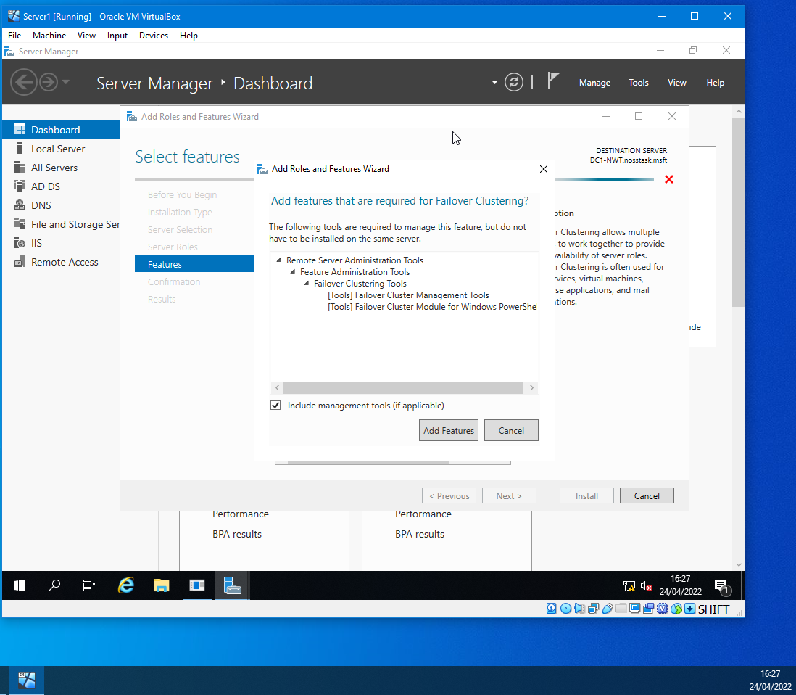
Figure 47

Figure 48 shows the feature being installed.
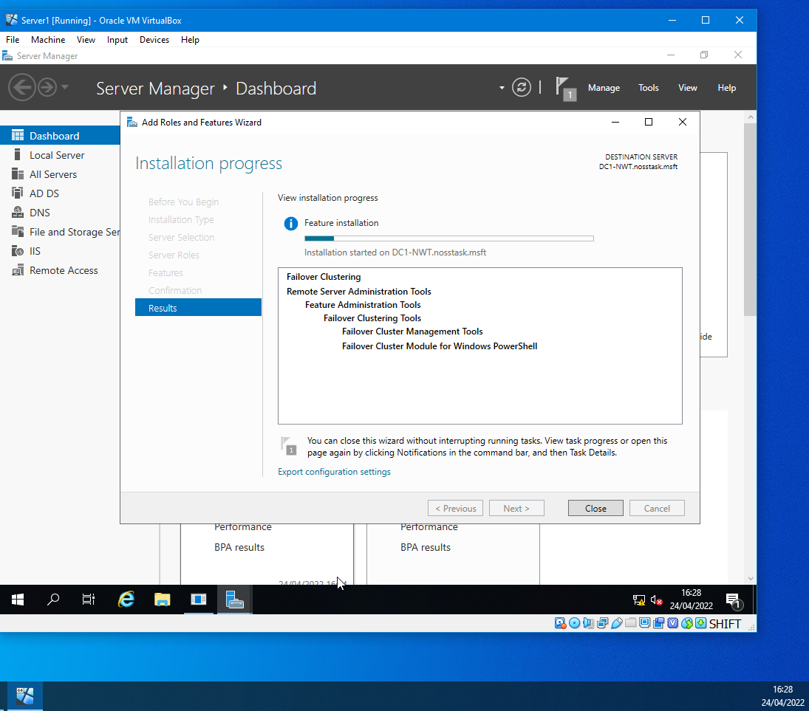
Figure 48

A failover clustering was installed as shown with failover cluster manager, see figure 49.

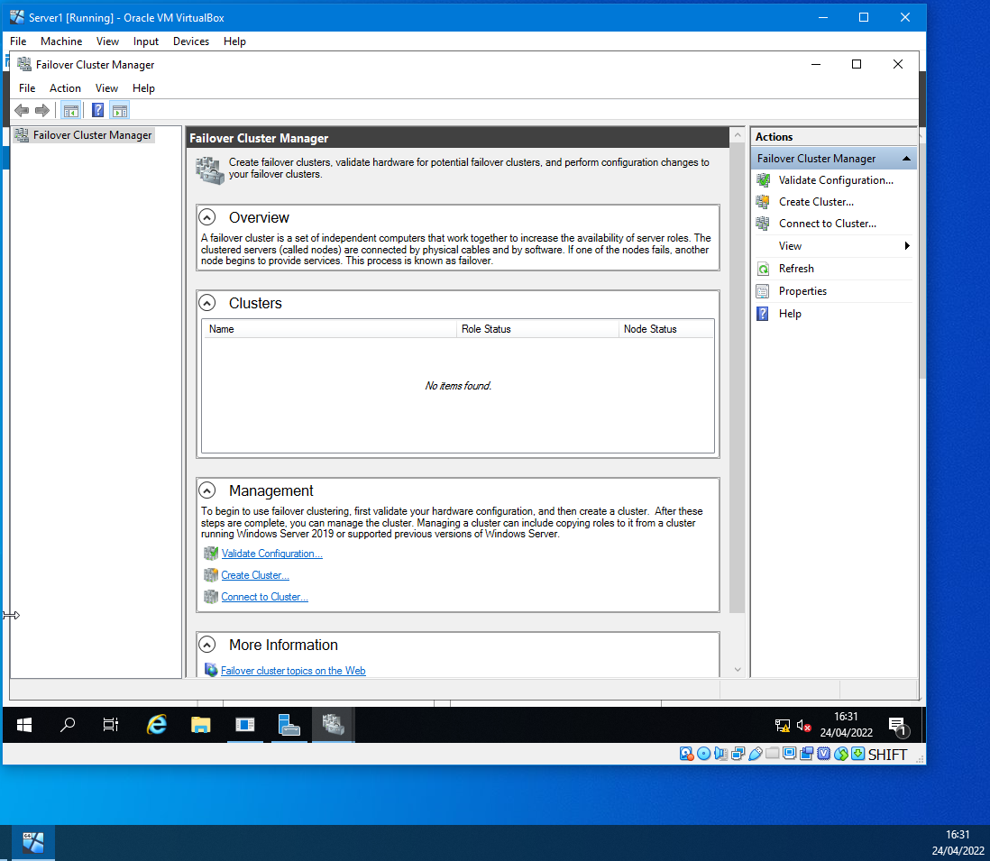
Figure 49

A new failover cluster was created, and a validation was run prior to completing the cluster. Microsoft explains [15], that validation is required to ensure the hardware and hardware settings are compatible with failover clustering. The validation was successful and figure 50 shows some of the roles that the Windows failover cluster can perform.
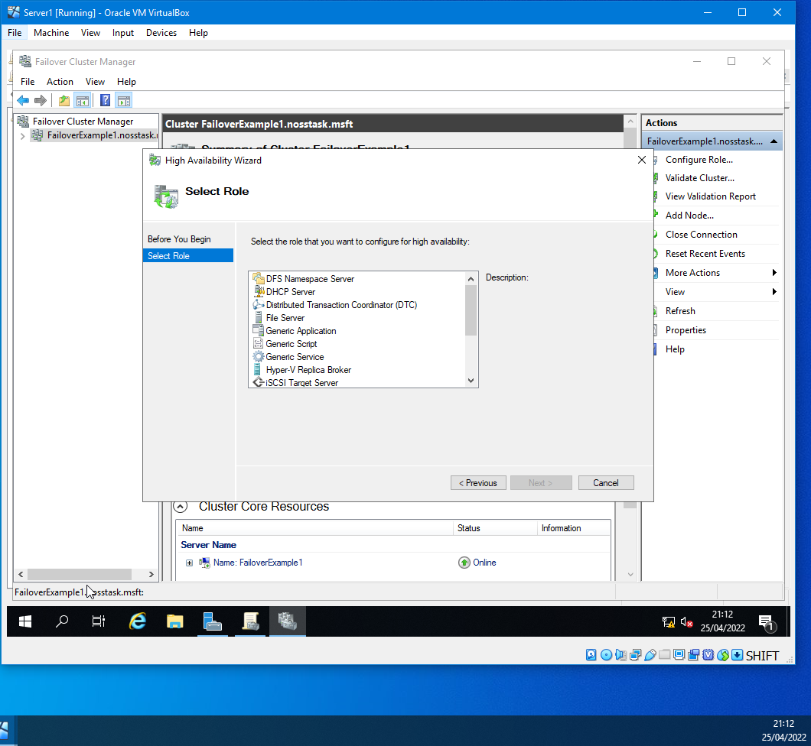
Figure 50

Network Security Policy
Network policies have been put together as a guideline within an organisation that would give employees, contractors, or vendors guidance when it comes to those situations that would require them to follow the organisation's policies. When creating the example policies, free to use templates assisted in the creation from SANS Institute for the Internet community [16], [17], [18] and PurpleSec free IT & Cyber Security template site [19]. Please see the appendices for the policies.

References

[1] | National Cyber Security Centre, "Device Security Guidance," [Online]. Available: https://www.ncsc.gov.uk/collection/device-security-guidance/policies-and-settings/using-peripherals-securely. [Accessed 20 April 2022].
[2] | Microsoft, "Password policy recommendations," 2 March 2022. [Online]. Available: https://docs.microsoft.com/en-us/microsoft-365/admin/misc/password-policy-recommendations?view=o365-worldwide. [Accessed 19 April 2022].
[3] | NCSC, "Password administration for system owners," [Online]. Available: https://www.ncsc.gov.uk/collection/passwords/updating-your-approach. [Accessed 19 April 2022].
[4] | NCSC, "Top tips for staying secure online," 17 December 2018. [Online]. Available: https://www.ncsc.gov.uk/collection/top-tips-for-staying-secure-online/three-random-words. [Accessed 17 April 2022].
[5] | Microsoft, "Microsoft Authenticator App," [Online]. Available: https://www.microsoft.com/en-us/security/mobile-authenticator-app. [Accessed 17 April 2022].
[6] | Google, "Google Authenticator," [Online]. Available: https://play.google.com/store/apps/details?id=com.google.android.apps.authenticator2&hl=en_GB&gl=US. [Accessed 18 April 2022].
[7] | NCSC, "Multi-factor authentication for online services," 14 June 2018. [Online]. Available: https://www.ncsc.gov.uk/guidance/multi-factor-authentication-online-services. [Accessed 25 April 2022].
[8] | NCSC, "Small Business Guide: Cyber Security," 20 December 2017. [Online]. Available: https://www.ncsc.gov.uk/collection/small-business-guide/using-passwords-protect-your-data. [Accessed 17 April 2022].
[9] | MalwareBytes, "What is a password manager?," [Online]. Available: https://www.malwarebytes.com/what-is-password-manager. [Accessed 25 April 2022].
[10] | J. Emigh, "Failover Clustering," Technology Advice, 15 May 2019. [Online]. Available: https://www.serverwatch.com/servers/failover-cluster/. [Accessed 21 April 2022].
[11] | D. Clinton, "An Introduction to High Availability Computing: Concepts and Theory," Freecode Camp, 23 July 2019. [Online]. Available: https://www.freecodecamp.org/news/high-availability-concepts-and-theory/. [Accessed 23 April 2022].
[12] | Kemp Technologies, "Active/Passive vs. Active/Active," [Online]. Available: https://kemptechnologies.com/uk/white-papers/unfog-confusion-active-passive-activeactive-load-balancing/. [Accessed 24 April 2022].
[13] | Microsoft, "Failover Clustering in Windows Server and Azure Stack HCI," 11 February 2022. [Online]. Available: https://docs.microsoft.com/en-us/windows-server/failover-clustering/failover-clustering-overview. [Accessed 25 April 2022].
[14] | G. Wright, "Windows Server Failover Clustering (WSFC)," TechTarget, March 2022. [Online]. Available: https://www.techtarget.com/searchwindowsserver/definition/Windows-Server-failover-clustering. [Accessed 22 April 2022].
[15] | Microsoft, "Create a failover cluster," 11 February 2022. [Online]. Available: https://docs.microsoft.com/en-us/windows-server/failover-clustering/create-failover-cluster. [Accessed 24 April 2022].
[16] | SANS Institute, "Password Construction Guidelines," October 2017. [Online]. Available: https://assets.contentstack.io/v3/assets/blt36c2e63521272fdc/blta5be14c7136a535f/5e9dde89db124263e8afce3d/password_construction_guidelines.pdf. [Accessed 20 April 2022].
[17] | SANS Institute, "Remote Access Policy," [Online]. Available: https://assets.contentstack.io/v3/assets/blt36c2e63521272fdc/blt957812312514f63a/5e9df9554c47dc64d2a649d0/remote_access_policy.pdf. [Accessed 20 April 2022].
[18] | SANS Institute, "Server Security Policy," June 2014. [Online]. Available: https://assets.contentstack.io/v3/assets/blt36c2e63521272fdc/blt50e440e7b0db16c9/5e9dfee150e659126c8d77d5/server_security_policy.pdf . [Accessed 20 April 2022].
[19] | PurpleSec, "30 Free IT & Cyber," [Online]. Available: https://purplesec.us/resources/cyber-security-policy-templates/. [Accessed 20 April 2022].

Appendices

Appendix 1

Password Policy

Overview
Passwords are an essential for information security and aid in protecting user accounts. A poorly made password may compromise systems, data, or networks. This policy provides the best practices for creating safer passwords.
Purpose
The purpose of these guidelines is to provide best practices for creating strong passwords.
Scope
This policy provides guideline NOSSTASK employees, contractors, and vendors . The policy applies to all passwords including standard user accounts, system administrator accounts, local router logins and other required accounts.
Password Guidelines
It's recommended a minimum of 8 characters in a password. In addition, it enforces use of multi factor authentication to add an extra layer of security. A unique password should be set for every work account and to allow users to do this, it's highly recommended that users use an approved password manager.
Example of weak, or poor passwords:
- Six characters or less.
- Personal information such as birthdates, addresses, contact numbers, names of pets, and movie or video game characters.
- Number patterns such as aabbccddeeff or 1234567.
- Common passwords “Hello1234”, “Password98765”, “Newpass1234”
Non-Compliance
Employees could be subject to disciplinary action, including termination of employment if found to be in violation of this policy.

Appendix 2

Remote Access Policy
Overview
Remote access to the NOSSTASK corporate network is essential to maintain productivity when employees work from home or travel for business needs.
Purpose
This policy aims to define requirements for connecting to the NOSSTASK network from any managed host. These rules and conditions are designed to reduce the potential exposure to damages which may result from the unauthorised use of resources. The damages include the loss of sensitive or confidential data, intellectual property, public image, critical internal systems, regulatory fines, or other costly penalties.
Scope
The policy applies to all NOSSTASK employees, contractors, and vendors managed devices used to connect to the network remotely.
Policy
It is the responsibility of NOSSTASK employees, contractors, and vendors with remote access privileges to the NOSSTASK corporate network, to ensure that their remote access connection is given the same consideration as the user's on-site connection. Illegal activities using the network by any user (Authorised or otherwise) is prohibited. The Authorised User are responsibility for and consequences of misuse of the Authorised User’s access. Authorised Users will not use networks to access the Internet for outside business interests.
Requirements
- Remote access connection must be done with Virtual Private Networks (VPNs), strong passwords, and, if possible multi-factor authentication. For further information, see the Password Policy.
- Using a managed device to connect remotely to the corporate network, the authorised users responsible for the device is not connected to another network during the same session.
- Personal equipment is not authorised to be used for remote access or to be connected to the corporate network.
Non-Compliance
Employees could be subject to disciplinary action, including termination of employment if found to be in violation of this policy.

Appendix 3

Server Security Policy
Overview
Servers that are unsecured and vulnerable continue to be a significant entry point for cyber-attacks. Uniform Server installation policies, ownership and configuration management are all about doing the basics well.
Purpose
This policy aims to establish standards for the base configuration of server equipment owned and/or operated by NOSSTASK. Implementation of this policy will mitigate unauthorised access to the network and assets.
Scope
All employees, contractors, consultants, temporary and other workers at NOSSTASK must comply with this policy. The policy applies to server equipment owned, operated, or leased by NOSSTASK.
Policy
All internal servers deployed must be owned by an operations group responsible for system administration. Each operations group must establish and maintain server configuration guides based on business needs and approved by the Information security team. Operations groups should monitor configuration compliance and implement an exception policy tailored to their environment. Each operations group must establish a process for changing the configuration guides, including review and approval by the Information security team. The following items need be met:
Servers must be registered within the NOSSTASK enterprise management system and at minimum the subsequent information is required to identify the point of contact:
- Server location and contact information
- Backup information
- Hardware information
- Operating System and version details
- If required, the main server functions and applications
- NOSSTASK enterprise management system must be kept up to date.
For security, compliance, and maintenance purposes, authorised personnel may monitor and audit equipment, systems, processes, and network traffic per the Audit Policy.
Configuration Requirements
- Operating System configuration should be per approved Information security guidelines.
- Non active services and applications should be disabled.
- Access to services should be logged and protected with access-control methods such as firewalls and VPN.
- The most recent patches or updates must be installed on the system as soon as possible, with the only exception being when an immediate application would interfere with business needs.
- Trust relationships are a security risk between systems and should not be useless other methods are available.
- Privileged access must be done over secure channels using encrypted network connections such as SSH or IPSec.
- Servers should be physically located in an access-controlled environment.
Monitoring
All security-related events on critical or sensitive systems must be logged, and audit trails as required below:
- Daily incremental tape backups will be retained for minimum one month.
- Weekly full tape backups of logs will be retained for minimum one month.
- Monthly full backups will be retained for a minimum of one years.
Security-related events will be reported to the Information security team, will review logs and report incidents to the IT management. Protective measures will be required. Security-related events include:
- Port-scan attacks
- Evidence of unauthorised access to any administrative accounts
- Suspicious events that are not related to specific applications on the host.
Exceptions
The Information security team must approve exception in advance.
Non-Compliance
Employees could be subject to disciplinary action, including termination of employment if found to be in violation of this policy.

Appendix 4

Monitoring and Auditing of Systems Policy
Overview
Systems monitoring and auditing at NOSSTASK must be performed to decide when a failure of the information system security has occurred and determine whether it is a failure or a breach.
Purpose
Monitoring and auditing of systems will decide if inappropriate or suspicious activity has occurred on any corporate devices. System monitoring will be utilised to investigate the activity in real-time and audit the system for evidence.
The policy applies to all systems and clients of NOSSTASK including:
- Servers, workstations, and other devices
- All centralised storages
- Desktops, laptops, and other devices
- Routers, switches, and other network devices
- Firewall and Intrusion Detection/Prevention sensors
- Security capabilities devices
Policy
User activity will be configured to capture login/logout sessions and all administrator accounts. System administrators will be notified if inappropriate, unusual, and suspicious activity arises. Appropriate administrators will thoroughly investigate inappropriate, unusual, and suspicious activity and report findings to Information Security team.
Information systems will provide sufficient primary (online) storage to retain 30-days’ worth of log data and sufficient secondary (off-line) storage to keep one year’s worth of data. If primary storage capacity has surpassed the limit, this shall be increased.
System logs will be manually analysed monthly. Appropriate administrative personnel will thoroughly investigate inappropriate, unusual, and suspicious activity, and findings will be reported to the proper Information Security Team.
System logs are confidential data. Access to logs and other audit information requires prior authorisation. Further, access to logs or additional system audit information will be captured in the records.
Exceptions
The Information security team must approve exception in advance.
Non-Compliance
Employees could be subject to disciplinary action, including termination of employment if found to be in violation of this policy.

Appendix 5

Vulnerability Assessments Policy
Overview
Vulnerability assessments at NOSSTASK are crucial to managing the increasing threats and risks from Cybercriminals. NOSSTASK also has responsibilities and costs to ensure compliance with laws and rules while retaining business continuity and safety of NOSSTASK and corporate data.
Purpose
The purpose of the policy is to specify standards for vulnerability assessments. This policy reflects NOSSTASK’s dedication to identifying and implementing security controls, which will keep threats to data and resources at reasonable and appropriate levels.
This policy covers all NOSSTASK managed computer and communication devices.
Policy
All information system resources’ operating systems or environments must experience a standard vulnerability assessment. The standard will delegate the Information Security Team to perform routine security risk assessments to determine the location of vulnerabilities and to initiate appropriate remediation. Employees are required to cooperate with risk assessments fully.
Vulnerabilities to the operating system or system environment and corporate data must be identified and corrected to minimise risks.
Performed audits will be performed to verify:
- Ensure integrity, confidentiality, and availability (CIA) of information and resources
- Investigate possible security incidents and ensure compliance to NOSSTASK’s security policies
- Monitor user or system activity were essential
All information system resources’ operating systems or environments must undergo an authenticated vulnerability assessment to address these vulnerabilities adequately.
The frequency of these vulnerability assessments will be dependent on the operating system, the information system resources, and the data.
System evaluation shall be continuously performed until the vulnerabilities are rectified. Third-Party vendor and Information Security team shall perform an authenticated scan.
Information Security team shall make vulnerability scan reports and ongoing correction progress to senior management and Board of Directors.
Exceptions
The Information security team must approve exception in advance.
Non-Compliance
Employees could be subject to disciplinary action, including termination of employment if found to be in violation of this policy.

Appendix 6

Server Virtualisation Policy
Purpose
This policy specifies server virtualisation requirements that define server virtualisation technologies’ purchase, use, and administration.
Policy
NOSSTASK’s Director of IT ensures that policies are followed to establish contracts and the confidentiality, integrity, and availability of NOSSTASK data.
Under the oversight of the Director of IT, the Information security team are responsible for following the procedures and policies within IT.
Server virtualisation software consolidates new and existing workloads onto high-capacity servers. Consolidating workloads onto high-capacity servers allows NOSSTASK to reduce the server inventory, decreasing the data centre footprint and power consumption.
NOSSTASK will migrate existing physical servers’ workloads to virtual machines. These servers will be retired at such time as planned by IT management.
Server Virtualisation Requirements:
- Embedded security technology e.g Trusted Platform Module
- Single centralised management console
- Industry-standard management tools, backup, and recovery
- Interoperate with other platform technologies
- Industry-standard hardware and storage,
- Functionality to support virtual server management network isolation
- Migrate running guests without interruption
- Automatically detect a hardware failure
- Support Lightweight Directory Access Protocol (LDAP) for authentication and authorisation for administrative console
- Intra-host and administrative console traffic should be encrypted.
Exceptions
The Information security team must approve exception in advance.
Non-Compliance
Employees could be subject to disciplinary action, including termination of employment if found to be in violation of this policy.

