Elon Musk: Charismatic Leader or Crazed Billionaire?

E
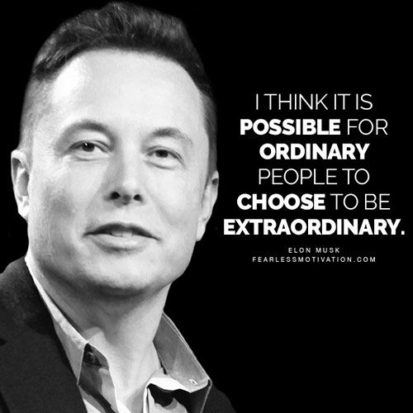
lon Musk rose to fame after founding multiple companies. His claim to strive for the use of sustainable energy has gained him a loyal following. His fans often suggest that he is out to save humanity from itself, but is this really what he’s up to? With one tweet Musk has the power to crash the entire crypto currency market. Did musk stumble into this position of power of was this a carefully formulated plan?
Musk started his career by co-founding Zip2, an online city guide marketed towards newspapers. In 1999, four years after its launch, Zip2 was sold, and Musk secured $22 million for his share. His next venture was an online financial service called X.com which eventually merged with a company called Confinity, who had PayPal as their money transfer service. During his time with X.com and Confinity, Musk was replaced for being inexperienced, only to return later as CEO and cause division within the company. This division resulted in technical issues and a fragmented business model, once again Musk was replaced. When PayPal was eventually bought out by eBay, Musk received around $165 million for his share. After being shunned by Russian missile designers, Musk set up SpaceX in order to build supposedly affordable rockets. Amidst work on creating reusable rockets and launching various rockets, SpaceX set to work developing Starlink. Starlink is a chain of satellites aimed at providing worldwide internet access. Musk then joined Tesla as chairman of the board of directors before becoming CEO and product architect in 2008. According to the Tesla website they are “accelerating the world’s transition to sustainable energy with electric cars, solar and integrated renewable energy solutions for homes and businesses”. Despite reports of being drastically in debt and haemorrhaging money, Tesla became the highest valued car manufacturer in 2020. Tesla branched out from being solely a car manufacturer in 2016 when they purchased SolarCity, creating Tesla Energy. In the same year Musk co-founded Neuralink, a company dedicated to integrating artificial intelligence with the human brain. 2016 appeared to be a busy year for Musk as he also founded The Boring Company, with the intent to create underground tunnels for transport. This is just an overview of some of Musk’s larger business ventures, in between these Musk has kept himself busy with other various projects, charities, and even an attempted cave rescue. He really is a man on a mission.

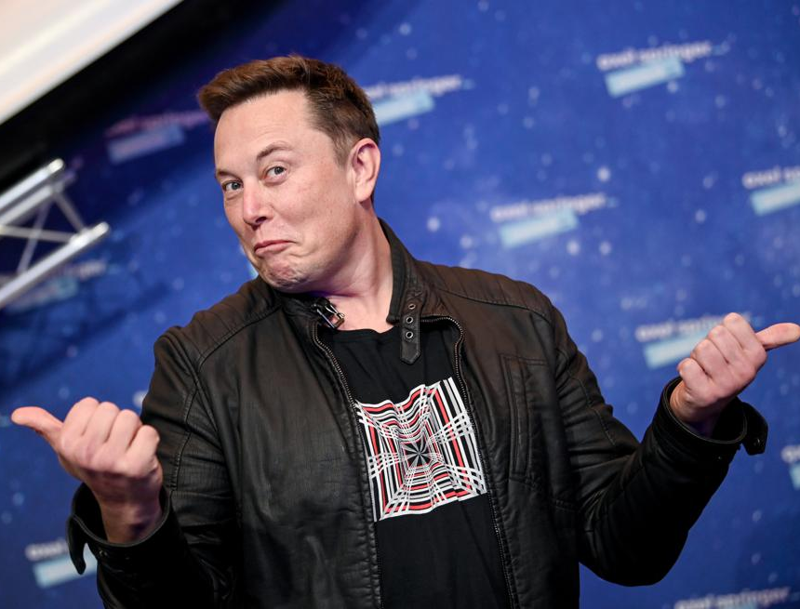
Musk has been fired from several companies for being incompetent or causing major issues within the company, but he always seems to end up back in his spot at the top, how on earth does he manage this? His management style has been widely criticised, suggesting that he is a bully and paranoid. One former employee quoted in a Vanity Fair article suggested that he is pathological and a sociopath. Yet Musk still has a loyal following and his net worth grows by the day. He is often described as a true genius, by both those who hate him and those who love him. Since we already know he has been fired from jobs for being incompetent is he really a genius or is he simply good at playing one? Charisma is a personality trait that compels people to follow, it is a confidence that inspires devotion in others. Is this how Musk has gained such a loyal following?

2020 was a difficult year for all of us, one that I’m sure most of us would love to forget. Musk however appears to have had quite the rollercoaster of a 2020. His following changed after multiple tirades about Covid-19, claiming wildly that death tolls had been exaggerated and that lockdowns were a terrible idea. Prior to this Musk had plenty of left leaning followers due to his work to move away from fossil fuels and his apparent passion for the climate crisis. However, his disregard for the severity of the pandemic, and his refusal to close down Tesla factories lost him a large portion of those followers. This could potentially have destroyed Musk’s public image and made him widely unpopular, yet instead he managed to gain a whole new following, the right leaning population. A large population of the United States believe that the pandemic was either a complete fabrication, or simply played up to a far more serious level than it actually was, after Musk’s outburst these people found a new hero to follow.
Charisma is often linked to the ability to influence others, arguably something that Musk does rather well. After discovering the Crypto currency world Musk invested hugely, primarily in Bitcoin. By buying Bitcoin when its value was low, Musk then had the opportunity to influence the market in order to make more money, he did so by allowing people to purchase Tesla products using the crypto currencies. This was then sold for a far higher value than originally bought for, at which point Musk decides to announce that Tesla will no longer be accepting crypto currency due to it’s links to the fossil fuel industry, once again crashing the value of Bitcoin. Psychologists Richardson and Thayer suggested there were three steps to charisma in their 1993 book “The Charisma Factor”. The first step is to create an appearance of charisma using enthusiasm and passion, then create a connection with followers that inspires them in some way, then finally you must speak to your followers on an emotional level. It could be argued that this is what Musk uses to gain such influence, appealing to his followers’ emotional side by using climate change as a public reasoning for his actions. Musk has such confidence in everything he says and does that he creates an air of “I know what I’m doing”, whether he does or not. Another charismatic trait.
Musk chose to take part in a Joe Rogan podcast interview, a podcast known for being for the “lads” and “bros”. On this Musk drank whiskey and attempted a puff on Rogan’s marijuana laced cigar. The media ran with this claiming that Musk was losing it, however to the left leaning pot smokers Musk had alienated with this Covid rants, this was a sign that Musk was down to earth and becoming likeable again. This appears to show that Musk will adapt to the crowd, showing them or telling them what they want to see or hear in order to gain their following. When he hasn’t been in the news or media headlines, he will send out a Tweet to get people’s attention once again.
Speaking of Tweets, Musk has gained a loyal internet following. Musk’s online presence offers him an exceptional position, whereby from the comfort of his own home he can send out a single sentence and gain more followers, influence the stock market, or set his fans on a person he perceives to have wronged him. Some fans have even written songs inspired by Musk, with one being titles “The Future Smells Like Elon Musk”, his followers are fervent in their belief that Musk is on a mission to save the world and change the future for the better. According to an article published in The Verge, some followers even suggest that the criticisms of Musk’s treatment of staff is simply a ploy by the media to gain more interest.
So, to sum up, Musk has had his fingers in many pies, and instils a sense of confidence in him from others no matter what business venture he is up to. He claims to want to change the world for the better, to fight climate change, to make sure artificial intelligence is safe, to take humans to Mars, to create underground travel systems to alleviate traffic, to save humankind from itself. Having been involved in an impressive number of businesses, and always in a position of power be it CEO or chairman, Musk has convinced the world that he is highly intelligent and knows what he is doing be it cars, rockets, or solar energy. This apparent mission to save the world and create a better future has gained him an impressive following. Despite having been involved in countless controversies (far too many to mention in one article!), he is still widely admired. After trawling through countless pages with different views on Musk, it can be difficult to pin down an accurate description of him. Charisma is certainly a trait that seems to be used often when describing Musk, and I would tend to agree. He certainly invokes devotion from his followers, and it can be easy to be sucked into his mission to save the world.

