Dissertation Proposal: Development of Electonic Testing Autonomous Equipment

  - Daniel Watts

Reasons and Relevance of the Report 1
Aim of the project 2
Time scale and provisional workplan 2
Background Research 2
Details of facilities required to carry out work 2
Details of any cooperative industrial partners 2

Reasons and Relevance of the Project
The reason for this project is to reduce the number of non-value adding tasks carried out by operators within the SONY UK Technology Centers manufacturing facility, specifically for testing 3rd party businesses products. This reduction in non-value-added tasks allows operators to be moved to jobs that are more difficult to automate and add value to products, increasing profitability in the operation.
A second reason for the project is to increase utilization of the existing test equipment to load the test jigs evenly. Currently the process involves an operator manually opening a draw of an RF (Radio Frequency) enclosure, loading a PCB, and then closing the draw to initiate the test procedure. With a layout consisting of 10 machines, 5 facing each other, the equipment closest to the product storage end is being used significantly more than the equipment at the other end, resulting in wear and tear being uneven across the equipment and if machines nearest the product storage areas break down the test cycle time due to the repeated longer distance to travel increases, reducing test efficiency significantly.

Aim of the project
The aim of this project is to research, design and develop a new method and piece of automated equipment. This will involve automating the loading of the test equipment, designing a multi-use RF enclosure that allows various PCB’s to be tested with the change of only a few components, automating the closure and opening of the RF enclosure as well as unloading and presenting the PCBs in a suitable way for the next operation.
All this work is intended to increase operational efficiency per test jig, reduce test cycle time, reduce non-value adding tasks and reduce unplanned maintenance by loading the equipment evenly.

Time scale and provisional workplan
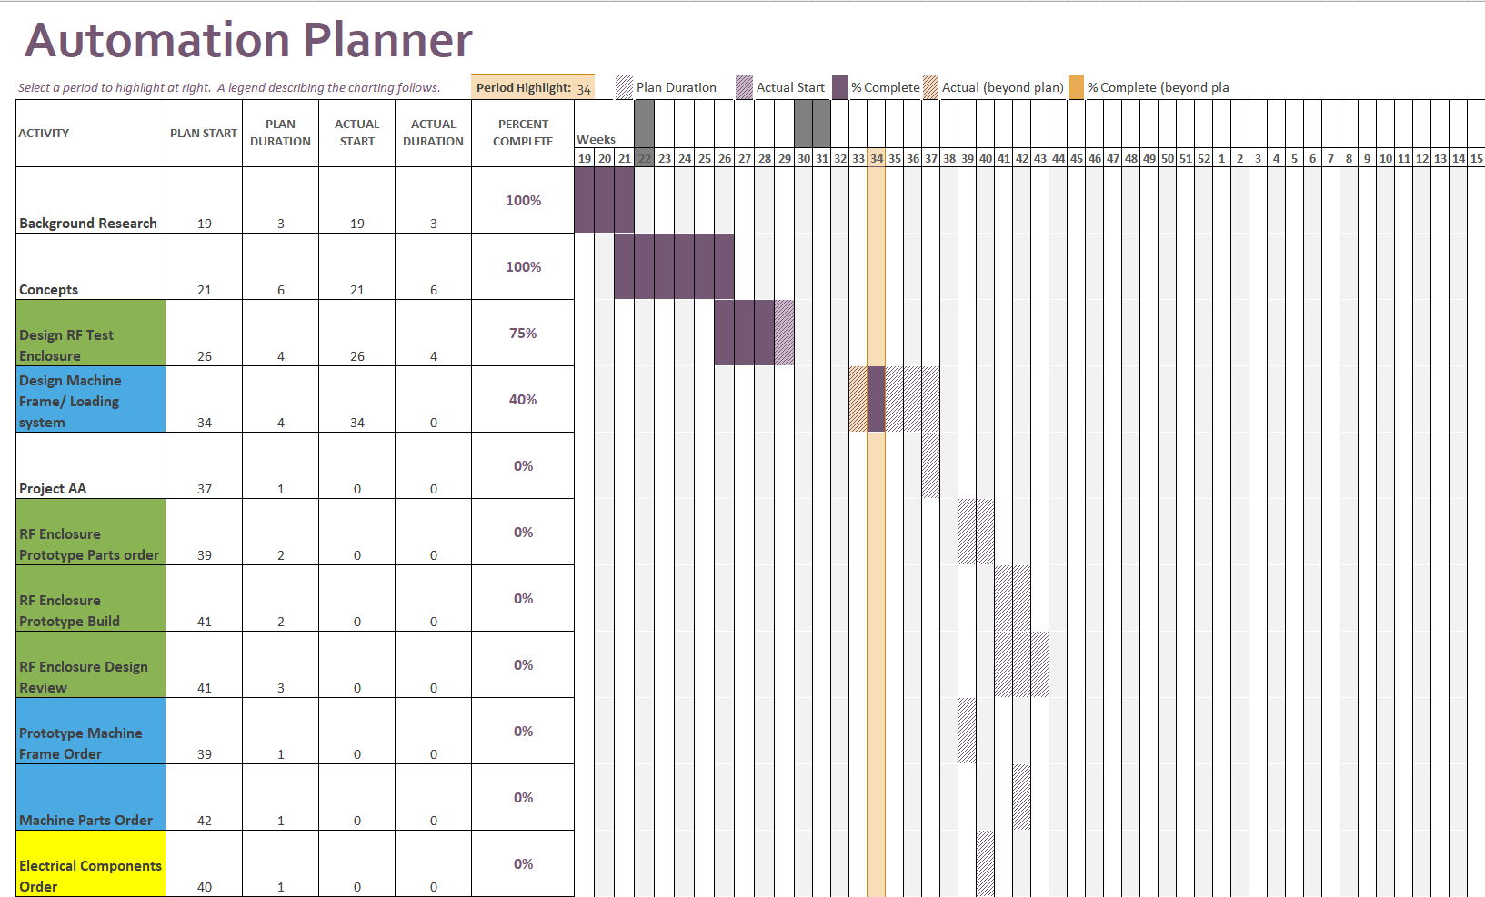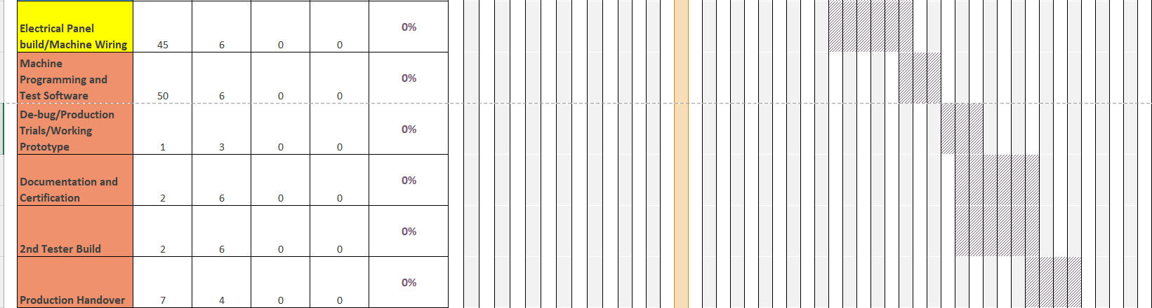

Background Research

Existing Equipment Research
Research has been carried out into existing equipment and mechanisms that will be able to guide and help generate solutions to some of the problems that will be encountered whilst undertaking this project. This research involves equipment already used on site and equipment available from third-party suppliers.

RF (Radio Frequency) Shielding Research
A requirement of the test of the product the automated test equipment is being developed for is that it must be conducted within an RF shielded environment. Research has been carried out to investigate suitable materials, test equipment to ensure the shielding is up to standard, how to carry out RF testing, earth bonding and research into available product to increase the shielding effectiveness such as seals, shield strips and RF absorbing materials to reduce reflection.
- http://www.clpe.com.cn/product269/detail562.html - Example Machinery
- https://docs.rs-online.com/462a/0900766b811b5d1b.pdf - Copper beryllium strips for electrical contact and EMI shielding between jig body and doors.
- https://www.mouser.co.uk/ProductDetail/LeaderTech/EA-PF3000-24?qs=wnTfsH77Xs72%2FG68dYI%252B6Q%3D%3D&mgh=1&vip=1&gclid=Cj0KCQjwxuCnBhDLARIsAB-cq1oerezvha8VrIujkJk8AbNBbf8rXPXAUHiQm0AaGvPCBFR2OZHs2OwaAj2PEALw_wcB – RF Foam.
- https://www.emcstandards.co.uk/files/bonding_cable_shields_at_both_ends_to_reduce_noise_for_emcj_may_02_pdf_version_4_may_02.pdf- Earth bonding.
- https://www.modusadvanced.com/hubfs/RF%20Shielding%20Guide.pdf - RF SHIELDING: EVERYTHING YOU NEED TO KNOW

Automation Research
Again, for automation research existing equipment already operational at SONY that do a similar task with similar production targets have been evaluated to see how they operate, what components have been used and why along with trying to achieve a high commonality of parts for ease of maintenance and training. The designers and engineers involved in building this equipment are also available for advice and guidance as this project progresses.
- https://control.com/technical-articles/what-are-cartesian-robots/ -Cartesian (Gantry) Robots
- https://www.smc.eu/en-gb/products/actuators~16635~nav -Pneumatics
- https://shop.elsevier.com/books/industrial-process-automation-systems/mehta/978-0-12-800939-0?country=NL&format=print&utm_source=google_ads&utm_medium=paid_search&utm_campaign=nlpmax&gclid=EAIaIQobChMI4eaI_520gQMV09_tCh2_iwthEAQYASABEgJmuvD_BwE&gclsrc=aw.ds -Industrial Process Automation Systems- B.R. Mehta, Y. Jaganmohan Reddy.
- Industrial Automation: Hands On (Mechanical Engineering).
- Project Management, Planning and Control- Albert Lester.

Details of facilities required to carry out work.
- SONY UK technology centers engineering workshop and build area.
- 3rd party component manufacturing facilities. (Listed below)

Details of any cooperative industrial partners
- SONY UK Technology Center-
- X-Stk Automation Components- Primary pneumatic and electronics suppliers and advisors.
- KNJ Extrusion Profiles-3rd party component and frame manufacturer.
- SMC Europe (Pneumatics)- Pneumatic and electronics manufacturer (Support).
- Omron- Electronics, control, and sensor manufacturer (Support).
- Protolabs/Hubs CNC Manufacturing- 3rd party component manufacturing.

