University of Wales Trinity Saint David

Wales Institute of Science & Art



‘UNPLANNED RAPID DISASSEMBLY’ FIRST REPORT
Integrating Project (ACHA4008)

Akeem Amin-Scott, Darryl Diaz, Joanna Shand, Will Townsend, Isabella Wratten
2400078, 2404983, 2411040, 2405263, 2405144
Date (01/2025)

Contents
Table of Figures iii
Table of Tables iv
1. Introduction 1
2. Organisation 2
2.1 How we have organised our team 2
2.2 Meeting Minutes 2
2.3 Gantt Chart 6
3. Design 7
3.1 Three Wheeled Designs 7
3.1.1 Single Front Wheel 7
3.1.2 Single Rear Wheel 9
3.2 Four Wheeled Designs 11
3.3 Final Design 13
4. Driveability 19
4.1 Steering 19
4.2 Suspension 19
4.3 Wheels 19
4.4 Brakes 19
4.5 Driver’s Seat 20
4.6 Driver Safety 20
5. Materials 21
5.1 Mild Steel 21
5.2 Stainless Steel 21
5.3 Zinc Plated Steel 21
5.4 Aluminium 21
5.5 Carbon Fibre 22
5.6 Pine Wood 22
5.7 Oak Wood 22
6. Costing 23
6.1 Mild Steel 23
6.2 Pine Wood 24
6.3 Stainless Steel 25
6.4 Zinc Plated Steel 25
6.5 Miscellaneous 26
7. Conclusion 27
8. Evaluation 28
9. References 29

Table of Figures
Figure 1- Gantt Chart PT1 6
Figure 2- Gantt Chart PT2 6
Figure 3- Original Concept Single Front Soapbox 7
Figure 4- Second Version of A Single Front Wheeled Soapbox 8
Figure 5- Technical Drawing of Single Front Wheel Soapbox 8
Figure 6- Reliant Robin Cornering (The Times, 2016) 9
Figure 7- Original Concept Single Rear Wheeled Soapbox 9
Figure 8- Technical Drawing of A Single Rear Wheeled Soapbox 10
Figure 9- Original Concept (Four Wheeled Soap Box) 11
Figure 10- Four Wheeled Design Steering Mechanism 12
Figure 11- Four Wheeled Soapbox Technical Drawing 13
Figure 12- Lomax 223 (Flickr, 2020) 14
Figure 13- Technical Drawing of A Single Rear Wheeled Soapbox 14
Figure 14- Isometric of A Single Rear Wheeled Soapbox 15
Figure 15- Inspiration for Steering Mechanism (Gerrit GoKartGuide , 2024) 15
Figure 16- Rough Design of Brake Pedal 16
Figure 17- Brake Lever Angles 17
Figure 18- Brake Pedal Mechanism Final Design 18
Figure 19 - Materials Needed Part 1 23
Figure 20- Materials Needed Part 2 23

Table of Tables
Table 1- Mild Steel 24
Table 2- Timber 24
Table 3- Stainless Steel 25
Table 4- Miscellaneous 26

Introduction
The task for this project was to design a soapbox racer, that could run in an event called Richard’s Castle Soapbox Derby. The team was to look in depth at materials, driveability and costings when designing the soapbox, ensuring that it fit within the supplied regulations by the event. While also looking at the group’s ability to work together, overcome problems and manage time.

Organisation

How we have organised our team
The team has been split into five different sections to ensure that every member had an equal role to play, while also guaranteeing that none of the crucial components were overlooked or forgotten. It also made sure that every member held equal responsibility for the project and that each section essentially had its own team leader.
The individual sections were given a set deadline to work towards, with milestones being set in between these key dates. This helped to ensure that there was a continual progression with the project. While the weekly meetings allowed for this progression to be shared and any obstacles to be sorted efficiently. The roles were.
- Joanna Shand (Team Lead and Communication)
- Darryl Diaz (Design, Driveability and Materials)
- Akeem Amin-Scott (Driveability)
- Will Townsend (Materials)
- Izzy Wratten (Costings and Management)

Meeting Minutes
Unplanned Rapid Disassembly Project Meeting
Date – 25.10.24
Location – Outside 002, IQ Building
Time – 11:00-12:00
Duration – 1 hour
Present – Darryl Diaz, Izzy Wratten, Joanna Shand, Will Townsend
Absent – Akeem Amin-Scott
Agenda
- Meet each other and discuss what roles and responsibilities we would like
- Pick a team name
- Discuss basic ideas for our soapbox
- Discuss an overall deadline to work towards
Plan of Action
- Darryl to draw up some designs based off our discussion
- Izzy to read up on the regulations and assignment brief
- Begin the meeting minutes and Gantt chart looking at potential individual task deadlines
Next Meeting Planned For 28.10.24
Unplanned Rapid Disassembly Project Meeting
Date – 28.10.24
Location – Outside 002, IQ Building
Time – 11:00-12:30
Duration – 1 ½ hours
Present – Darryl Diaz, Izzy Wratten, Will Townsend, Akeem Amin-Scott
Absent – Joanna Shand
Agenda
- Look at Darryl’s designs
- Explain the regulations making sure future improvements on the design fit within them
- Discuss the individual task deadlines
- Brainstorm materials we could use on the soap box
Plan of Action
- Darryl to adjust the designs to the regulations and make any improvements as discussed in the meeting
- Begin looking into the discussed materials and brief look into the cost.
- Update Gantt chart and minutes
Next Meeting Planned For 04.11.24
Unplanned Rapid Disassembly Project Meeting
Date – 04.11.24
Location – Outside 002, IQ Building
Time – 11:00-12:15
Duration – 1 ¼ hours
Present – Darryl Diaz, Izzy Wratten, Will Townsend
Absent – Joanna Shand, Akeem Amin-Scott
Agenda
- Look over the designs and decide on our final choice
- Discuss our findings on materials and finalize the list
- Discuss the steering mechanism we want to use on the design
- Look at how we are compared to our deadlines
Plan of Action
- Make all designs into technical drawings and begin an isometric for the final design
- Draw up the discussed design for the steering mechanism
- Begin a write up on the materials list and make an excel sheet on current amounts needed
- Update Gantt chart and minutes
Next Meeting Planned For 11.11.24
Unplanned Rapid Disassembly Project Meeting
Date – 11.11.24
Location – 006 IQ Building
Time – 11:00-12:30
Duration – 1 ½ hours
Present – Darryl Diaz, Izzy Wratten, Will Townsend
Absent – Joanna Shand, Akeem Amin-Scott
Agenda
- Inspect all designs and check they are on track
- Discuss the braking mechanisms
- Ensure materials write up is nearly complete to begin costings
- Discuss assignment layout ideas
Plan of Action
- Complete the isometric drawing and all other designs
- Draw up the braking mechanism
- Write up about the driveability aspects of our designs
- Update the excel sheet with material amounts for the braking mechanism
- Complete materials write up
- Begin costings write up
- Create a basic layout for the assignment
- Update Gantt chart and minutes
Next Meeting Planned For 18.11.24
Unplanned Rapid Disassembly Project Meeting
Date – 18.11.24
Location – 006 IQ Building
Time – 11:00-13:00
Duration – 2 hours
Present – Darryl Diaz, Izzy Wratten, Will Townsend
Absent – Joanna Shand, Akeem Amin-Scott
Agenda
- Look over the designs one last time before uploading onto the assignment
- Read the materials and driveability write ups
- Look at how the costing write up is coming along
- Look over assignment layout
Plan of Action
- Being the assignment write up
- Upload the designs with a small blurb under each section
- Upload the driveability and materials write ups
- Complete the costings write up
- Look into an introduction and conclusion
- Think about how the project went for an evaluation
- Update the Gantt chart and minutes
Next Meeting Planned For
Unplanned Rapid Disassembly Project Meeting
FINAL MEETING
Date – 15.01.25
Location – 006 IQ Building
Time – 11:00-13:00
Duration – 2 hours
Present – Darryl Diaz, Izzy Wratten, Will Townsend, Akeem Amin-Scott, Joanna Shand
Agenda
- Look over the current assignment and check we are all happy
- Add the costings section in
- Write up an introduction and conclusion
- Discuss and write up the evaluation between us
- Add the minutes and Gantt chart to the organisation section
Plan of Action
- Individually read through the complete assignment making sure it is in third person and check we are happy before submission on the 20th of January 2025

Gantt Chart
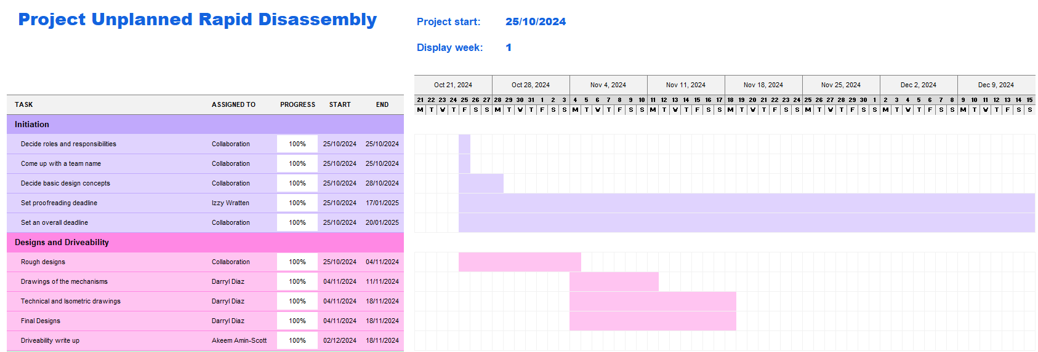
Figure 1- Gantt Chart PT1
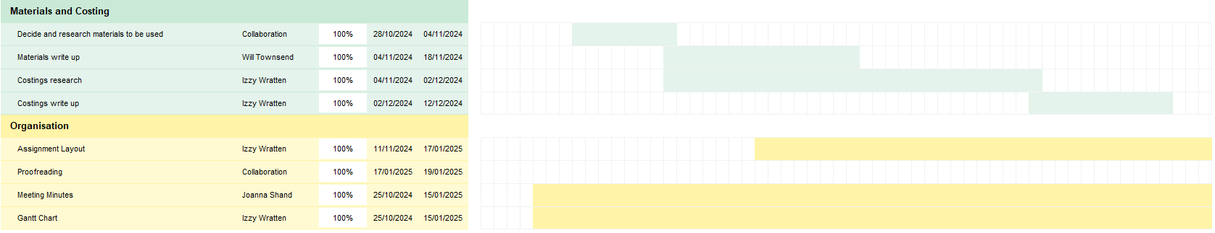
Figure 2- Gantt Chart PT2

Design
The team wanted to come up with a design that fit within the 2024 regulations of Richard’s Castle Soapbox Derby, while also being a relatively simple yet strong design. The goal was to minimize the number of parts on the vehicle where faults could arise. To make this decision, the team examined three different designs: two with three wheels and one with four, in order to consider all available options.

Three Wheeled Designs

Single Front Wheel
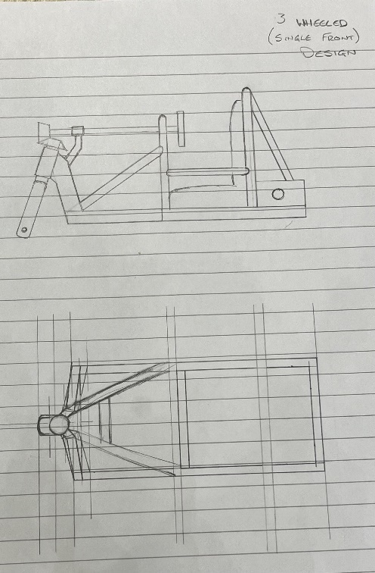
Figure 3- Original Concept Single Front Soapbox
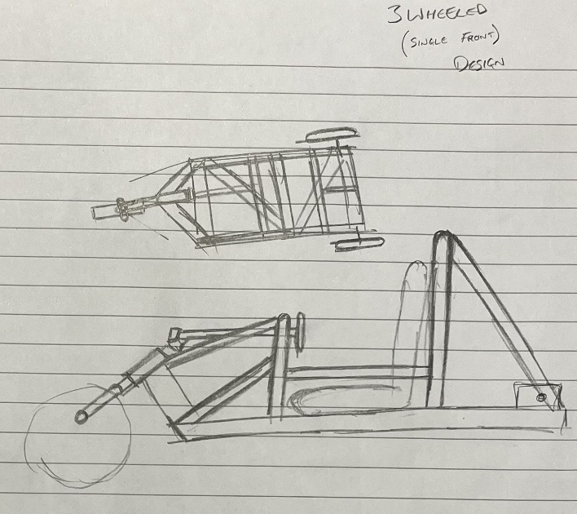
Figure 4- Second Version of A Single Front Wheeled Soapbox
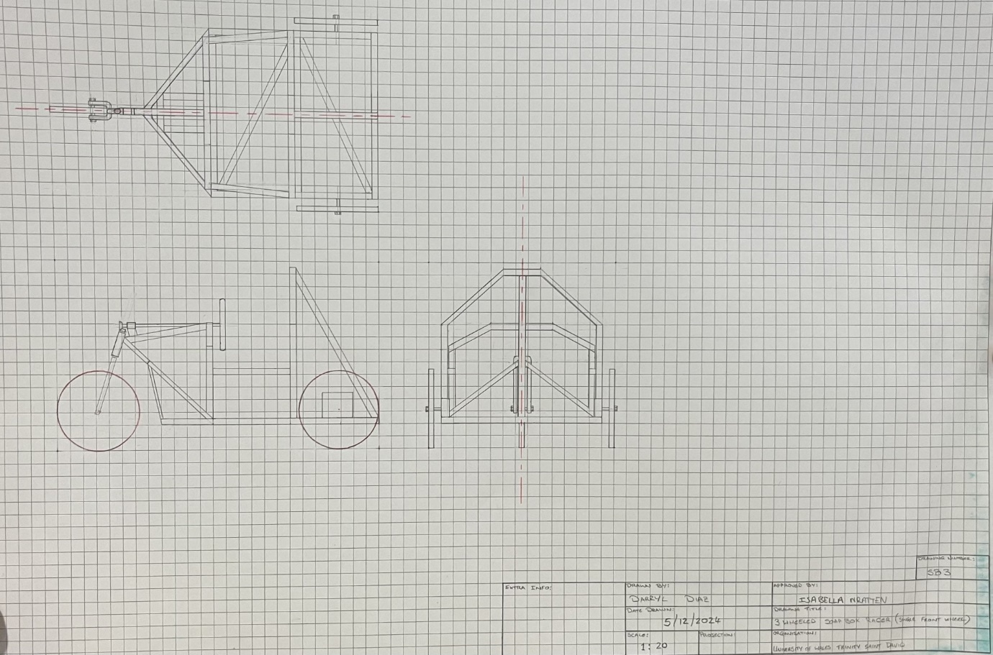
Figure 5- Technical Drawing of Single Front Wheel Soapbox
It was decided that this design would be too unstable in cornering and prone to rolling over, similar to the reliant robin.
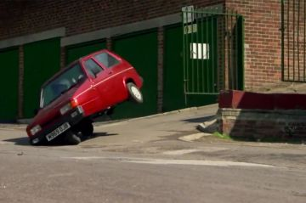
Figure 6- Reliant Robin Cornering (The Times, 2016)

Single Rear Wheel
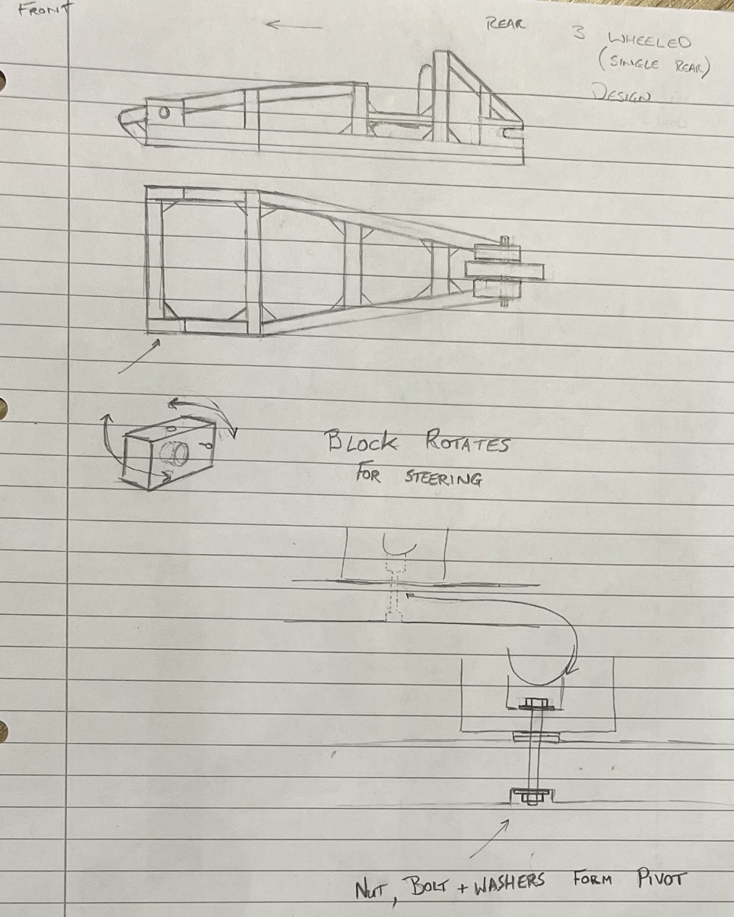
Figure 7- Original Concept Single Rear Wheeled Soapbox
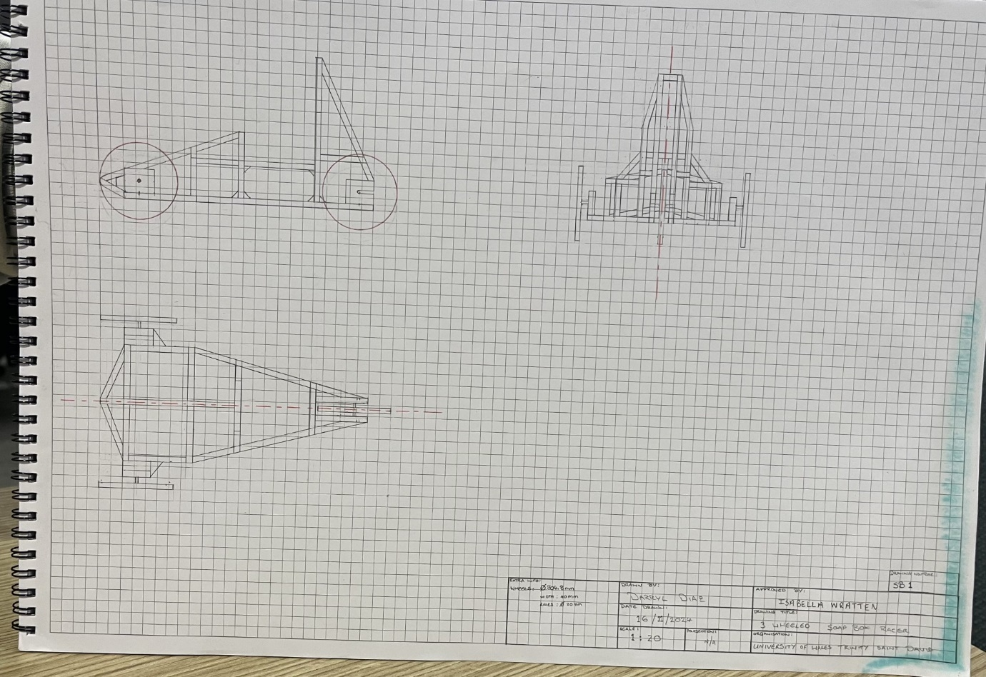
Figure 8- Technical Drawing of A Single Rear Wheeled Soapbox

Four Wheeled Designs
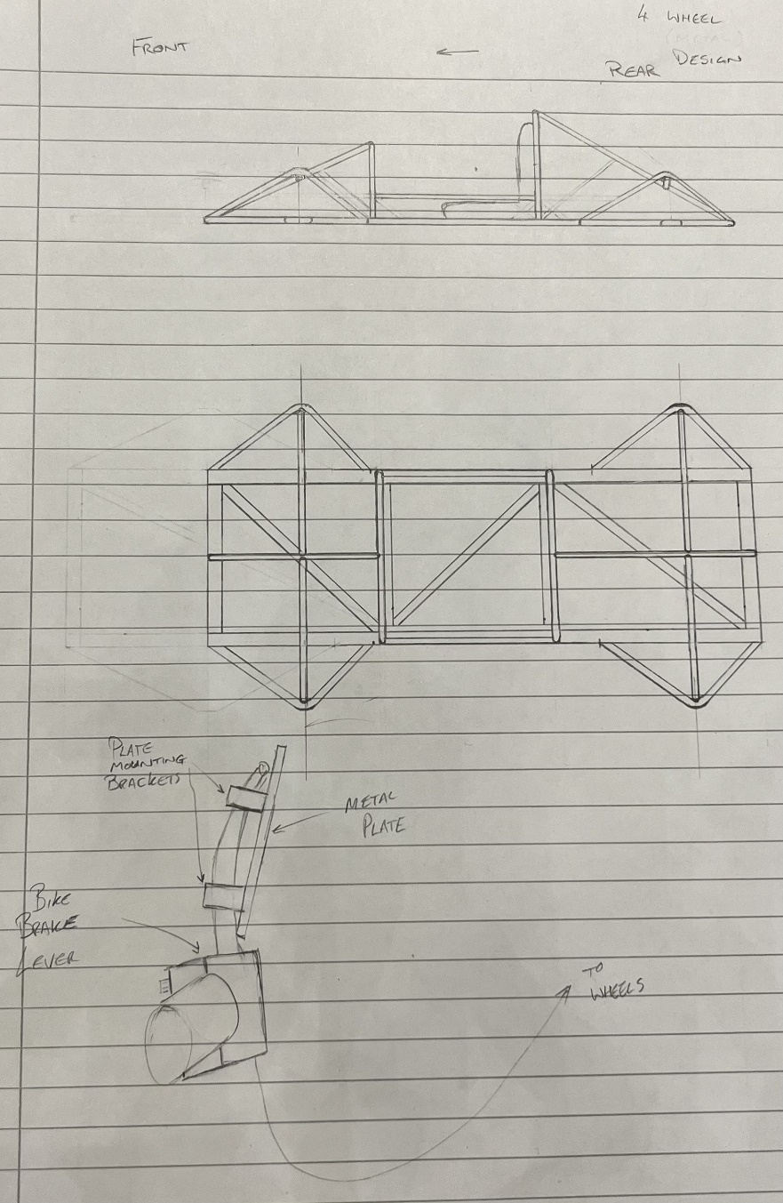
Figure 9- Original Concept (Four Wheeled Soap Box)
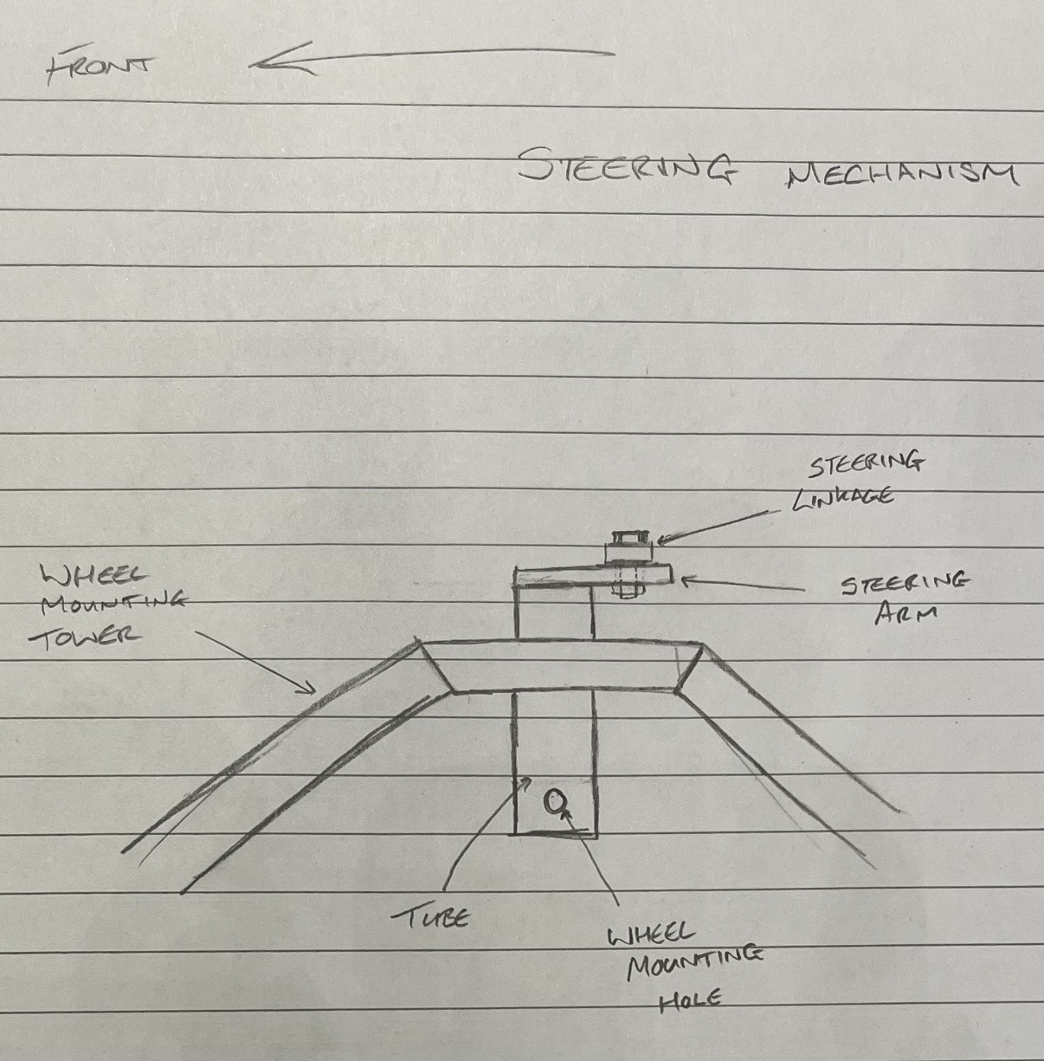
Figure 10- Four Wheeled Design Steering Mechanism
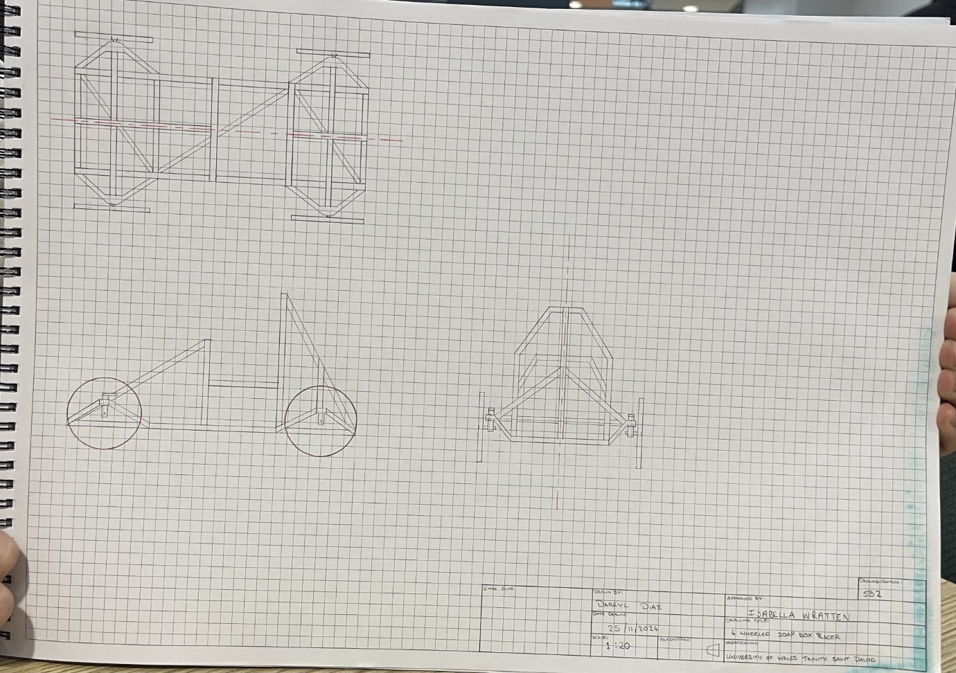
Figure 11- Four Wheeled Soapbox Technical Drawing
It was decided not to go with this design due to the fact it would be heavier than the three-wheeler, and would use more materials making it more expensive, for a similar level of stability.

Final Design
The design chosen to proceed with was the three-wheeled design, with the single wheel placed at the rear of the vehicle (similar to the Lomax 223).

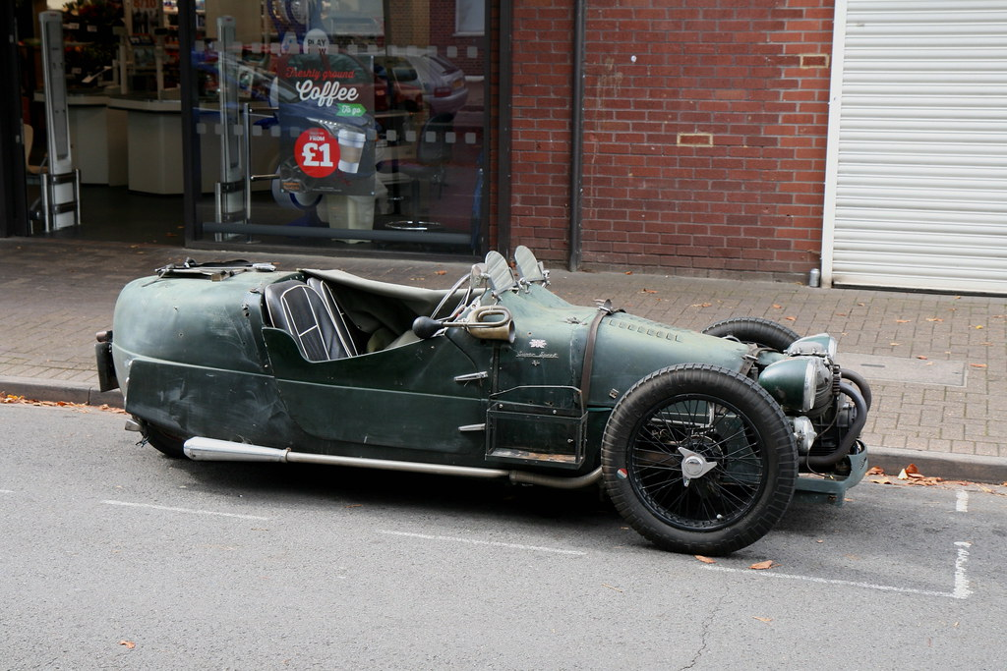
Figure 12- Lomax 223 (Flickr, 2020)
This design was thought to be the most stable of the three, with the three wheeled approach offering reduced cost and weight. This is due to the fact the design would need one less wheel, use a v-brake system and wheel mounting block as well as having a reduced amount of material required for the frame due to it having a narrower end. This design also sticks with the team’s plan of designing a soapbox which is simple and strong.
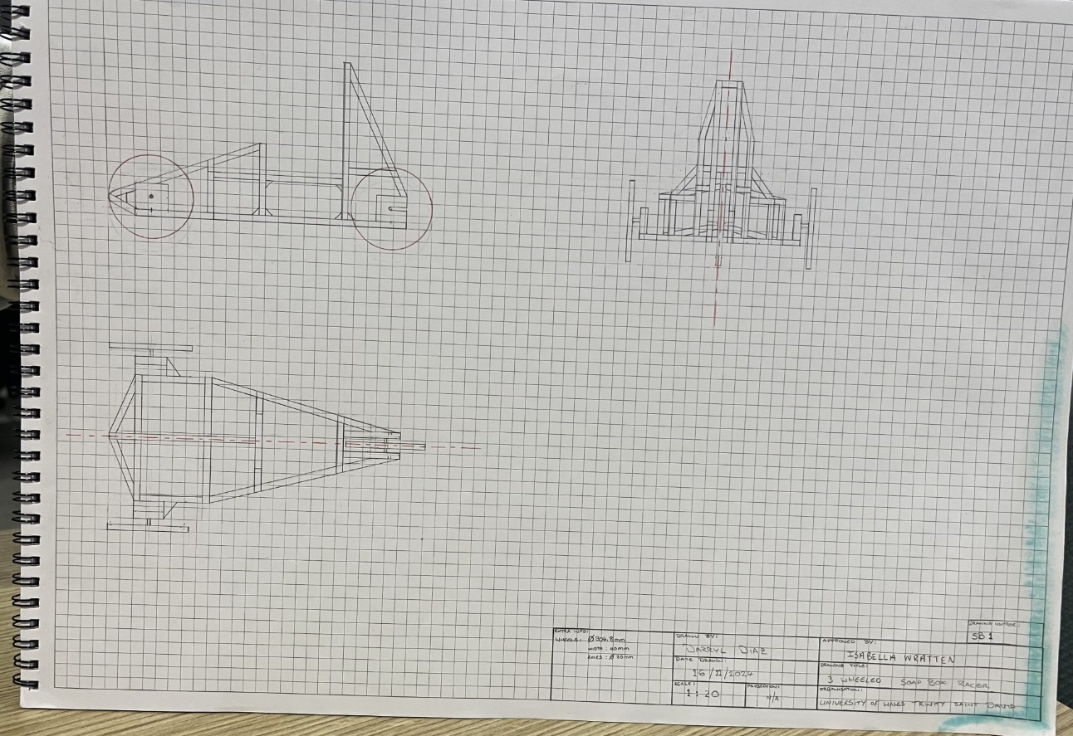
Figure 13- Technical Drawing of A Single Rear Wheeled Soapbox
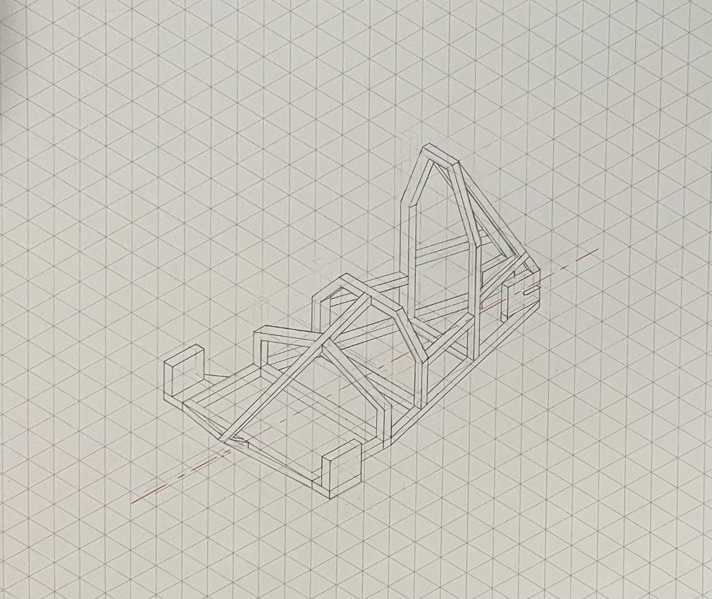
Figure 14- Isometric of A Single Rear Wheeled Soapbox

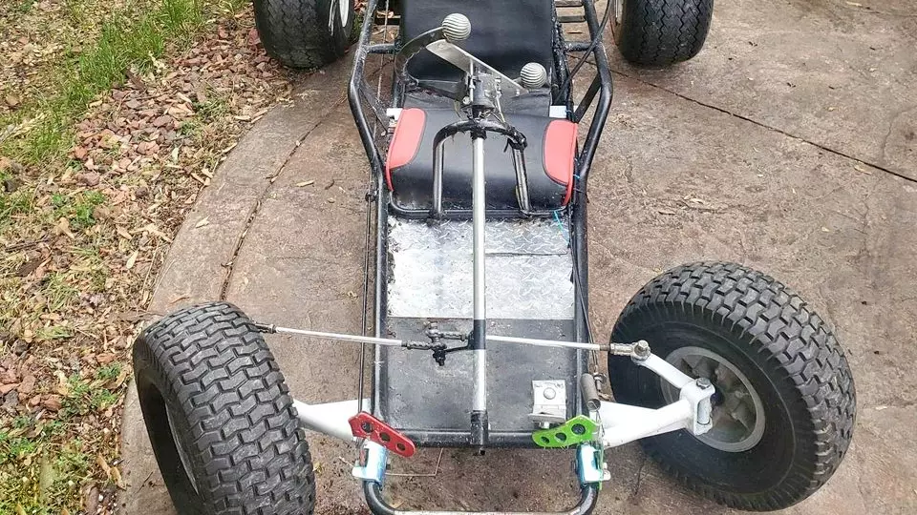
Figure 15- Inspiration for Steering Mechanism (Gerrit GoKartGuide , 2024)
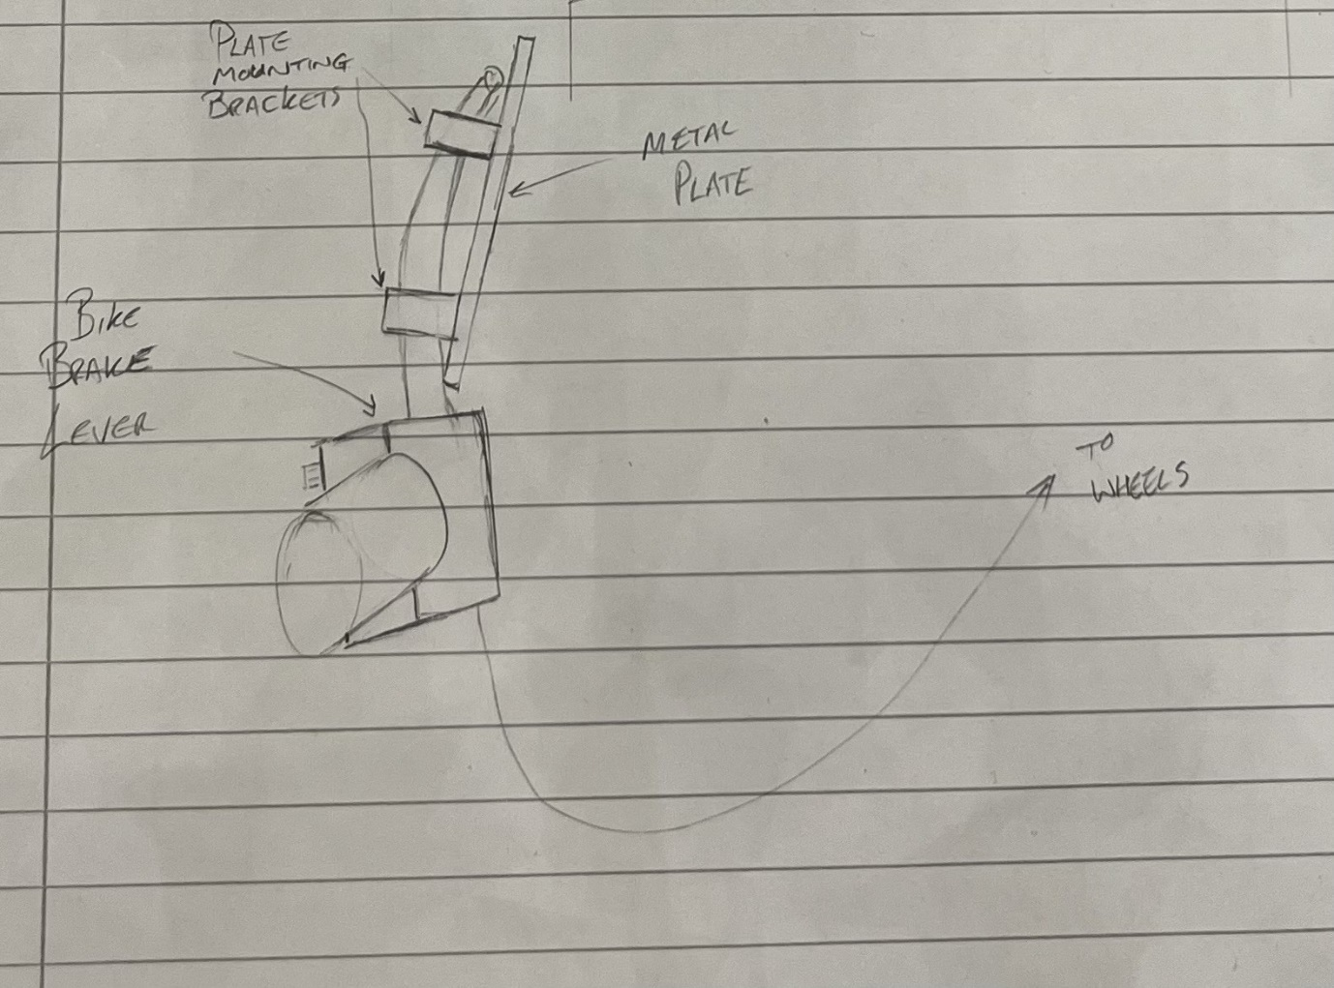
Figure 16- Rough Design of Brake Pedal
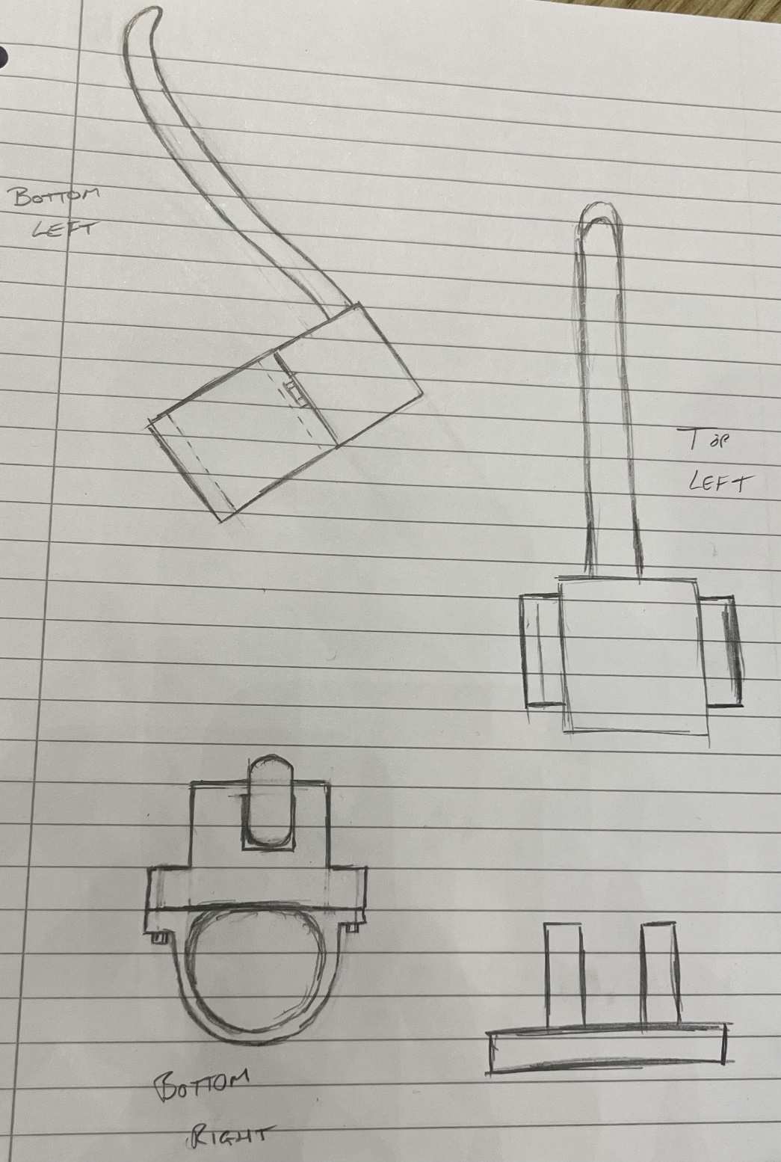
Figure 17- Brake Lever Angles
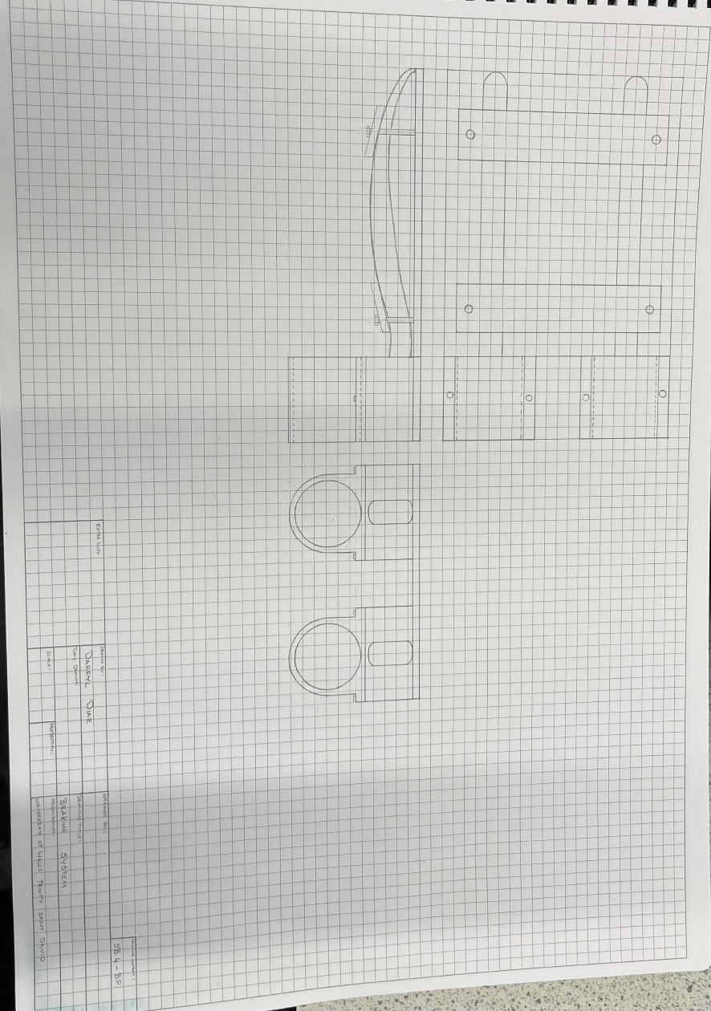
Figure 18- Brake Pedal Mechanism Final Design

Driveability

Steering
A simple system for steering using linkage bars connected to a metal tab welded to a metal tube (steering column) was decided on as it is very simple and should be quite strong. The steering knuckle is made from a simple block of wood with an eye bolt connecting the linkage to the steering column. The block pivoting around an M10 bolt will keep the steering as simple and strong as possible. The M10 bolt will have four washers, with the central two being used to minimise the resistance to the block rotating. These may be steel or changed to nylon washers if needed. The steering wheel will be bolted to a simple plate, welded in turn to the steering column. This design of steering will meet with regulation 2.15 which states that “steering must not have excessive play or any characteristic promoting instability” (Richard's Castle Soap Box Derby, 2024)

Suspension
The vehicle will not have any conventional suspension, instead the tyres will be the primary form of suspension as they will deform enough to be a basic form of shock absorber. The suspension will be adjustable by changing tyre pressure. The frame of the vehicle will have a slight flex to it providing a little shock absorption as well, though the tyres will do the majority. This should be suitable as the vehicle is very light weight and will have one occupant for very short periods of time.

Wheels
The wheels for the vehicle will be 12-inch bike wheels, minimising weight whilst being strong. They also allow for a simple braking system to be fitted with little effort. While the tyres having a thicker wall will provide the vehicles suspension as stated earlier. Theses wheels will also conform with regulation 2.4 which states that “Ground clearance should be sufficient to clear the top and bottom of the starting ramp – 50mm minimum is recommended” as well as saying that wheels need to be fitted with “pneumatic tyres” (Richard's Castle Soap Box Derby, 2024).

Brakes
The braking system will utilise a mountain bikes V-braking system. The brakes (at the wheel end) will be fixed at the end of a simple arm. The brakes will be applied to the wheels as on the bike, the brake levers will be mounted on the floor to a tube rising from it. A plate will be bolted to two metal bars/rods, clamping the brake levers between them. This will allow the driver to use the brake in the same way as on a car, in pedal form. The regulations state that “good brakes are essential” and that “if the axel has a braked wheel, then both wheels on that axel should be braked” (Richard's Castle Soap Box Derby, 2024).

Driver’s Seat
Regulation 2.6 and 2.7 states that “seats must be securely bolted to the soapbox” and that “Soapboxes must be designed to carry one person only, in a feet first direction”. (Richard's Castle Soap Box Derby, 2024). So, the driver’s seat will be fixed to the floor by four M8 bolts as far rearward as possible. The seat may need to be tipped backwards a little depending on driver preference, to make it a little more comfortable to operate the vehicle.

Driver Safety
The driver will be fixed to the seat using a 4-point race harness, as the regulations recommend them for heavier boxes. While the seat will also be positioned in such a way to ensure that the driver is within the confines of the roll cage. The roll cage will be made from “tubular steel or similar” as stated by the regulations, and will fully encase the driver within the vehicle, while providing even more strength to the chassis. The regulations state that “the roll bar should be at least 35mm above the driver’s helmet when seated normally.” And that “a second roll bar should extend 25mm beyond the driver’s gloved hands when placed at 12 o’clock.” (Richard's Castle Soap Box Derby, 2024).

Materials
Several materials were discussed for making this soapbox racer. These included, Mild steel, Stainless steel, Zinc plated steel, Aluminium, Carbon fibre, Pine wood and oak.

Mild Steel
The regulations state that any roll bars must be constructed from “tubular steel or similar” (Richard's Castle Soap Box Derby, 2024). This is to ensure the drivers safety as other materials may snap or buckle in the event of an impact, or roll, which has the potential to cause damage to the driver. Mild steel is also very tough allowing for it to absorb impacts without deforming (Velling, 2020). It is also very strong and reasonably light, while also being a relatively low cost.

Stainless Steel
Stainless Steel is much like mild steel only its composition makes it much more resistant to corrosion and as a result is slightly more expensive than mild steel (Thyssenkrupp). As the project is not at significant risk of corrosion, and with cost considerations in mind, it was decided that this steel would be suitable only for some of the vehicle’s fixings, particularly in areas requiring extra strength, such as the steering blocks/knuckles.

Zinc Plated Steel
Zinc Plated Steel is a strong, lightweight and relatively cheap material. Its main benefit is its corrosion resistant properties. This is due to its sacrificial layer of zinc. This layer prolongs the life of the steel underneath (McMullen, 2019). Other than that, it has the same properties of mild steel. It should be used on the soapbox for the wood screws that will be holding the bulk of the vehicle together, ensuring that it is strong while once again being relatively low budget. These are readily available in most hardware stores.

Aluminium
Aluminium is a very lightweight and relatively cheap metal. It is also ductile, so therefore can be shaped easily. However, it is not as easy to weld so help would be required from a skilled individual on that part. The ductility also presents a problem in that while it can be shaped easily, it also takes damage just as easily (Thyssenkrupp). This could lead to the vehicle buckling and or becoming uncontrollable if an impact occurred and leading to potential injury to the driver if it rolled. As such, aluminium was not chosen to be used for anything on the soapbox except from perhaps the outer skin.

Carbon Fibre
Carbon fibre is a composite material which comprises of carbon strands (fibres) that are woven together to form a cloth which is then set in resin. It is incredibly light and has an extremely high strength to weight ratio (greater than steels) (Deeraj, Mathew, Parameswaranpillai, & Joseph, 2020). However, this is very expensive to make meaning the price for even a small amount is very high.
While this material could be used on a soapbox, significantly enhancing its strength due to its properties, the benefits do not outweigh the costs in this scenario. Additionally, it is a challenging substance to work with, necessitating the involvement of an external company to ensure it is properly prepped and manufactured. This includes ensuring that any air bubbles in the resin are removed, as their presence would render the product ineffective and result in wasted resources.

Pine Wood
Pine wood was decided to be used to make the frame and some of the steering components, due to its strength and ease to work with. It is also relatively cheap allowing the vehicle to be produced on a low budget. This wood while strong, also has little flexibility, which should aid in coping with the stresses of the race without damaging the structure, making it reusable with minimal maintenance. As pine wood is soft it is also light weight, allowing the vehicles weight to be minimised (Teoh, 2022).

Oak Wood
Oak wood, compared to pine wood, is denser making it a heavier material, while also being more expensive. It is however tougher making it much more resistant to dents/damage forming due to impacts. Oak is a hard wood making it less flexible than pine, and a little harder to work with. This would not be a major issue, but the cost and weight led to it being a less desirable option when making the frame (WL West TImber, 2024)

Costing
From the materials discussed above, the team conducted research into each material finding which would be the most cost effective and realistic, before going on to create a spreadsheet that consists of the specific quantities of each materials needed to build the chosen soapbox. This is shown in figures 19 and 20 below. All materials have been individually researched and costed; these were all accurate prices at the time.
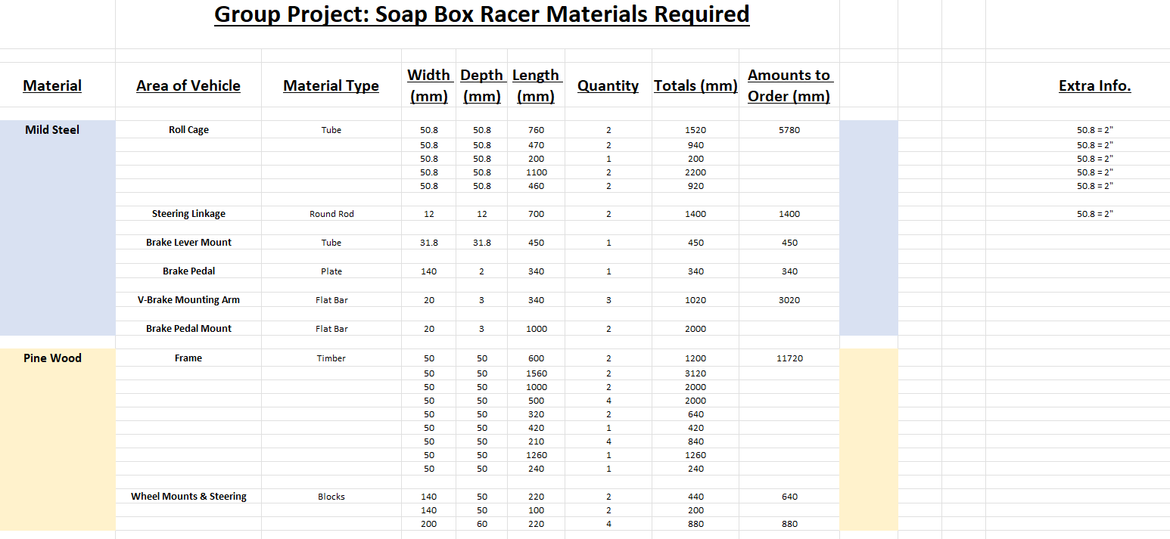Figure 19 - Materials Needed Part 1
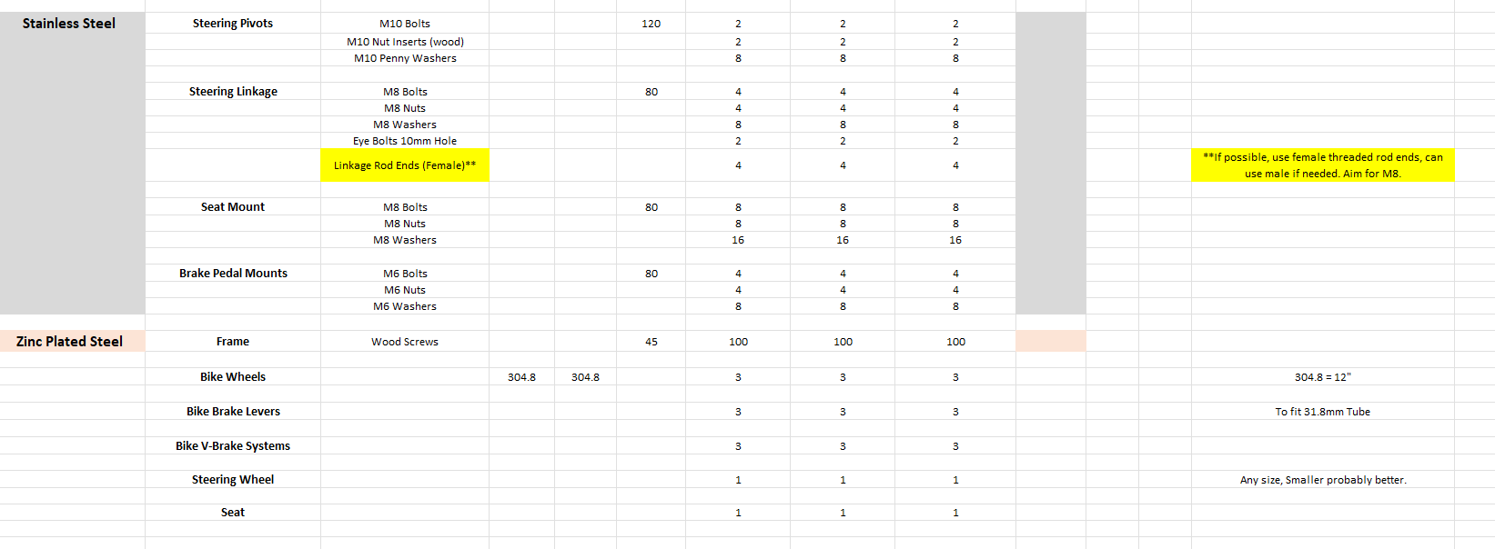
Figure 20- Materials Needed Part 2

Mild Steel
All the Mild Steel for the roll cage will be purchased from a company called metals4u, which sells a variety of metals in multiple different shape profiles.
Table 1- Mild Steel
Vehicle Area | Amount of Material | Total Cost | Reference
Roll Cage | 5780mm | £48.48 | (Metals4U, 2025)
Steering Linkage | 1400mm | £7.76 | (Metals4U, 2025)
Brake Lever Mount | 450mm | £1.88 | (Metals4U, 2025)
Brake Pedal | 340mm | £2.43 | (Metals4U, 2025)
V-Brake Mounting Arm and Brake Pedal Mount | 3020mm | £6.41 | (Metals4U, 2025)

The total costs for mild steel comes to £66.96.

Pine Wood
Pine wood was meant to be used but that turned out to be quite expensive when looking for specific measurements so instead the team decided it was best to use whatever was cheapest. For this reason, there are two options on where to purchase the timber from, a company called Jewson Builders Merchants that sells timber in 1M planks or Selco Builders Warehouse which sells the timber in both 3M and 3.6M planks.
Table 2- Timber
Vehicle Area | Amount of Material | Total Cost | Reference
Frame | 11,720mm | From Jewson = £27.60  From Selco = £32.76 | (Jewson Builders Merchant, 2025)  (Selco Builders Warehouse, 2025)  (Selco Builders Warehouse , 2025)
Wheel Mount and Steering Blocks | Small blocks  (140x50x220) x2  (140x50x100) x2  640mm | £6.64 | (Jewson Builders Merchants , 2025)
Wheel Mount and Steering Blocks | Big blocks  (200x47x220) x4 | £9.19 | (Jewson Builders Merchants, 2025)

The price for timber will come to £43.43 if the team decides to use Jewson for the frame, or £48.59 if Selco is the chosen company for the frame.

Stainless Steel
All the nuts, bolts and washers are to be purchased from a company named Accu while the linkage rod ends, and eye bolts are to be purchased from a company called Bolton Engineering Products Ltd.
Table 3- Stainless Steel
Product | Quantity | Total Cost | Reference
M10 Bolts | 2 | £3.90 | (Accu, 2025)
M10 Nut Inserts | 2 | £13.16 | (Accu, 2025)
M10 Penny Washers | 8 | £1.52 | (Accu, 2025)
M8 Bolts | 12 | £7.80 | (Accu, 2025)
M8 Nuts | 12 | £1.68 | (Accu, 2025)
M8 Washers | 24 | £2.64 | (Accu, 2025)
M6 Bolts | 4 | £2.24 | (Accu, 2025)
M6 Nuts | 4 | £0.88 | (Accu, 2025)
M6 Washers | 8 | £1.20 | (Accu, 2025)
Linkage Rod Ends (Female) (8mm) | 4 | £13.60 | (Bolton Engineering Products, 2025)
Eye Bolts (8mm) | 2 | £6.80 | (Bolton Engineering Products, 2025)

The price for stainless steel comes to £52.42.

Zinc Plated Steel
The zinc plated steel is only needed for the wood screws. The soapbox will need 100 screws for the main body, but it is cheaper to buy a pack of 200 screws for £4 (Wickes, 2025). This also means that there are spares in case more are needed later in the build.

Miscellaneous
This section contains the rest of the components necessary for the designed soapbox from a variety of different sources, this will all be shown within the table below.
Table 4- Miscellaneous
What It Is | Quantities | Company/Site | Total Cost | Reference
Bike Wheels | 3 (4 Purchased) | eBay | £33.98 | (eBay, 2025)
Bike V-Brake Systems and Brake Levers | 3 (4 Purchased) | Amazon | £29.98 | (Amazon, 2025)
Steering Wheel | 1 | Amazon | £17.99 | (Amazon, 2025)
Seat | 1 | Amazon | £22.38 | (Amazon, 2025)
4 Point Harness | 1 | JDM Performance | £64.99 | (JDM Performance, 2025)

The cost for the miscellaneous items is £169.32. Meaning that the total costs at this part of the project are either, £339.13 or £344.29.

Conclusion
In conclusion, the team has developed a design that meets with the regulatory requirements while also preserving the teams’ original concepts of strength, simplicity and cost effectiveness.
After careful consideration of various materials, their properties and costs. The team landed on mild steel, pine wood, stainless steel and zinc plated steel as the main four going to be implemented in the project, as all these materials are relatively cheap, easy to work with and are readily available.
The mechanisms were also heavily considered as the team wanted to design what is believed to be the most efficient and strongest soapbox while still complying with the events rules. As discussed earlier in the project the final design was the single rear wheeler, as it is believed that this perfectly matches the criteria set out from the first meeting.

Evaluation
The team demonstrated effective collaboration throughout the project. Members worked well together, maintaining clear and open communication, which contributed to a smooth workflow. Regular updates were provided by all team members, ensuring everyone stayed informed and aligned on progress. Ideas were discussed openly, and decisions were made quickly, allowing the project to move forward efficiently.
The team worked harmoniously, with no significant disagreements, and maintained a positive working atmosphere. Communication remained clear and respectful, fostering a productive environment. Regular meetings were held to address any issues as they arose, which helped to resolve challenges promptly. Tasks and roles were clearly defined from the outset, which allowed each team member to focus on their specific responsibilities and contribute effectively to the overall project.
However, one area for improvement would be time management. While the project was completed successfully, there were opportunities to finish it earlier. A better approach to time management, could have led to tasks being completed faster and a more efficient finish overall.
In conclusion, the team performed well in terms of collaboration, communication, and leadership, but could have improved their time management to improve project completion speed.

References
Accu. (2025, 01 14). M10 Self Tapping Insert - Stainless Steel (A2). Retrieved from Accu: https://www.accu.co.uk/self-tapping-inserts/410816-HSTI-M10-A2
Accu. (2025, 01 14). M10 x 120mm Full Thread Hexagon Bolts (DIN 933) - Stainless Steel (A2). Retrieved from Accu : https://www.accu.co.uk/full-thread-hexagon-bolts/18951-SEBF-M10-120-A2
Accu. (2025, 01 14). M10 x 25mm Penny Washers - Stainless Steel (A2). Retrieved from Accu: https://www.accu.co.uk/metric-flat-washers/14674-HYW-M10-25-A2
Accu. (2025, 01 14). M6 Hexagon Nylon Locking Nuts (DIN 985) - Stainless Steel (A2-70). Retrieved from Accu: https://www.accu.co.uk/hexagon-nylon-locking-nuts/7948-HNN-M6-A2
Accu. (2025, 01 14). M6 x 11mm Reduced Diameter Flat Washers (DIN 433) - Stainless Steel (A2). Retrieved from Accu: https://www.accu.co.uk/metric-flat-washers/404900-HRDW-M6-A2
Accu. (2025, 01 14). M6 x 80mm Full Thread Hexagon Bolts (DIN 933) - Stainless Steel (A2). Retrieved from Accu: https://www.accu.co.uk/full-thread-hexagon-bolts/18883-SEBF-M6-80-A2
Accu. (2025, 01 14). M8 Hexagon Nylon Locking Nuts (DIN 985) - Stainless Steel (A2-70). Retrieved from Accu: https://www.accu.co.uk/hexagon-nylon-locking-nuts/7949-HNN-M8-A2
Accu. (2025, 01 14). M8 x 25mm Penny Washers - Stainless Steel (A2). Retrieved from Accu: https://www.accu.co.uk/metric-flat-washers/14670-HYW-M8-25-A2
Accu. (2025, 01 14). M8 x 80mm Full Thread Hexagon Bolts (DIN 933) - Stainless Steel (A2). Retrieved from Accu: https://www.accu.co.uk/full-thread-hexagon-bolts/18912-SEBF-M8-80-A2
Amazon. (2025, 01 14). Compatible with Large Size Racing Go Kart Man Sprint Track Seat Kit Racing Kit Karting Seat Drift Car Seat,Go Kart Seat. Retrieved from Amazon: https://www.amazon.co.uk/Compatible-Large-Racing-Sprint-Karting/dp/B0BZ8F3D1Y/ref=asc_df_B0BZ8F3D1Y?mcid=eed61d3b906b3aec8fe2ea5c956d2b0d&tag=googshopuk-21&linkCode=df0&hvadid=696350735928&hvpos=&hvnetw=g&hvrand=16634976508841241944&hvpone=&hvptwo=&hvqmt=
Amazon. (2025, 01 14). ICOUVA 1 Pairs Bike Brakes,Universal Complete V Bike Brakes Set,Mountain Bike Replacement for Most Bicycle,Road Bike Brakes Cables with Front Back Wheels Bike Brake Levers and All Fixings. Retrieved from Amazon: https://www.amazon.co.uk/ICOUVA-Brakes-Universal-Set-Replacement/dp/B0CWRVB2FC/ref=asc_df_B0CWRVB2FC?mcid=dd41595f8d5f3fec9429f12129182c4c&tag=googshopuk-21&linkCode=df0&hvadid=697292508373&hvpos=&hvnetw=g&hvrand=1762599915978518556&hvpone=&hvptwo=&hvqmt=
Amazon. (2025, 01 14). QOTSTEOS Off-Road Kart Steering Wheel, 270mm Go Kart Steering Wheel Strong Iron Steering Wheel Fit for Compatible with Riding Go Kart Cart Racing Bike Replacement Wheel. Retrieved from Amazon: https://www.amazon.co.uk/QOTSTEOS-Off-Road-Steering-Compatible-Replacement/dp/B099WN7PR1/ref=sr_1_11?crid=1UO2H88H5YROS&dib=eyJ2IjoiMSJ9.UtMH96Wrb4IQHva4BXtFG3eYeUQKitTMFvuydwGmwDv5t7jzk2WaoZh0O2MFCvN1_xANd-y2nqr2fDElSQvGdW4eGtYPjv-lC8SCDbB5Jy-yxucRdl8b0-
Bolton Engineering Products. (2025, 01 14). PHS8 Bronze Liner Female Right Hand Rod End Bearing M8X1.25 (FB-M08G). Retrieved from Bolton Engineering Products: https://bepltd.com/products/phs8-bronze-liner-female-rod-end-bearing-m8x1-25
Bolton Engineering Products. (2025, 01 14). POS8 Bronze Liner Male Right Hand Rod End Bearing M8X1.25 (MB-M08G). Retrieved from Bolton Engineering Products: https://bepltd.com/products/pos8-bronze-liner-male-rod-end-bearing-m8x1-25
Car and Classic . (2025, 01 14). 1978 Lomax 223. Retrieved from 1978 Lomax 223: https://www.carandclassic.com/l/C1632845
Deeraj, B. D., Mathew, M. S., Parameswaranpillai, J., & Joseph, K. (2020, February 28). EMI shielding materials based on thermosetting polymers. Retrieved from Science Direct: https://www.sciencedirect.com/science/article/abs/pii/B9780128175903000063
eBay. (2025, 01 14). Pair Of 12" Front & Rear White 300mm Mag Wheels With Solid Tyres For Kids Bikes. Retrieved from eBay: https://www.ebay.co.uk/itm/393153769753?_skw=kids+bike+12%22+wheels&itmmeta=01JHJ66G0P68FGH2MGMEZVK2GC&hash=item5b89ca7119:g:GlkAAOSwErJjV56X&itmprp=enc%3AAQAJAAAA0HoV3kP08IDx%2BKZ9MfhVJKm0Pau29%2BaPNJgsvEgSkFx4NHXUwBs7fIQxgMpuy46EMf2%2BE%2FO3bxrz%2FaYfed
Flickr. (2020, 04 17). Lomax 223. Retrieved from FLickr: https://www.flickr.com/photos/77492252@N05/48798834398
Gerrit GoKartGuide . (2024, 12 09). How To Fix Go Kart Steering Problems: A Comprehensive Guide. Retrieved from Gerrit GoKartGuide: https://www.gokartguide.com/how-to-fix-go-kart-steering-problems/
JDM Performance. (2025, 01 14). 4 Point Nylon Safety E Marked Harness Racing Seat Belt. Retrieved from JDM Performance: https://jdmperformance.net/products/4-point-nylon-strap-safety-e-marked-harness-universal-racing-seat-belt-buckle-4pt?variant=43559400046827&country=GB&currency=GBP&utm_medium=product_sync&utm_source=google&utm_content=sag_organic&utm_campaign=sag_organic
Jewson Builders Merchant. (2025, 01 14). Kiln Dried Regularised Treated Timber 45x45mm. Retrieved from Jewson Builders Merchant: https://www.jewson.co.uk/p/fsc-standard-kiln-dried-regularised-treated-carcassing-45-x-45mm-FVRT4545
Jewson Builders Merchants . (2025, 01 14). Kiln Dried C16 Regularised Treated Timber 47 x 150mm. Retrieved from Jewson Builders Merchants : https://www.jewson.co.uk/p/fsc-standard-kiln-dried-regularised-c16-treated-carcassing-150-x-47mm-FVRT4715
Jewson Builders Merchants. (2025, 01 14). FSC Premium C24 Kiln Dried Regularised Carcassing 47 x 200mm. Retrieved from Jewson Builders Merchants: https://www.jewson.co.uk/p/international-timber-kiln-dried-treated-carcassing-200-x-47mm-brown-FAJR4720
McMullen, J. (2019, April 26). The 4 Advantages of Using Zinc Plating. Retrieved from Dorsetware Limited: https://www.dorsetware.com/the-4-advantages-of-using-zinc-plating/#:~:text=Zinc%20coating%20is%20ideal%20to,100x%20slower%20than%20other%20metals.&text=Zinc%20plating%20is%20an%20environmentally,be%20recycled%20and%20re-used.&text=Applying%20a%20coating%2
Metals4U. (2025, 01 14). 12mm Diameter Mild Steel Round. Retrieved from Metals4U: https://www.metals4u.co.uk/materials/mild-steel/mild-steel-round/round-bright/3072-p
Metals4U. (2025, 01 14). 20mmx3mm Black Mild Steel. Retrieved from Metals4U.co.uk: https://www.metals4u.co.uk/materials/mild-steel/mild-steel-flat/flat-black/2260-p
Metals4U. (2025, 01 14). 2mm thick Mild Steel Sheet. Retrieved from Metals4U.co.uk: https://www.metals4u.co.uk/materials/mild-steel/mild-steel-sheet/2500-p
Metals4U. (2025, 01 14). 31.7mm x 1.2mm Mild Steel . Retrieved from Metals4U.co.uk: https://www.metals4u.co.uk/materials/mild-steel/mild-steel-tube/2336-p
Metals4U. (2025, 01 14). 50.8mm x 1.6mm Mild Steel Tube. Retrieved from metals4u.co.uk: https://www.metals4u.co.uk/materials/mild-steel/mild-steel-tube/2345-p
Richard's Castle Soap Box Derby. (2024, January 1st ). Richard's Castle Soap Box Derby Regulations 2024. Retrieved from Richard's Castle Soap Box Derby 2024: https://www.richardscastlesoapbox.co.uk/_files/ugd/346d1b_49e3774ee510446baa2ee4ba9c558fe7.pdf
Selco Builders Warehouse . (2025, 01 14). Sawn Easi Edge Timber 50 x 47mm Kiln Dried 3m. Retrieved from Selco Builders Warehouse (3m): https://www.selcobw.com/sawn-easi-edge-timber-50-x-47mm-2-x-2-kiln-dried-fsc-010011650p?timber_length=65676
Selco Builders Warehouse. (2025, 01 14). Sawn Easi Edge Timber 50x47mm Kiln Dried 3.6m. Retrieved from Selco Builders Warehouse (3.6): https://www.selcobw.com/sawn-easi-edge-timber-50-x-47mm-2-x-2-kiln-dried-fsc-010011650p?timber_length=62202
Teoh, C. (2022, December 16). Beginner's Guide to PIne Wood: Properties, Types, Best Uses and Tips for Care. Retrieved from Timber Actually: https://timberactually.com/blogs/resources/pine-wood?srsltid=AfmBOopamI1nkKWg69xotwJx5P0KrH4BzK_fxvK0xqBwcJgfmghP0JHs
The Times . (2016, 01 10). A little bird told us: Clarkson fesses up about Top Gear's rolling Reliant Robin. Retrieved from A little bird told us: Clarkson fesses up about Top Gear's rolling Reliant Robin: https://www.thetimes.com/article/a-little-bird-told-us-clarkson-fesses-up-about-top-gears-rolling-reliant-robin-0sszkwvf56s
Thyssenkrupp. (n.d.). Properties of Aluminium. Retrieved from Thyssenkrupp Materials UK: https://www.thyssenkrupp-materials.co.uk/properties-of-aluminium
Thyssenkrupp. (n.d.). Properties Of Stainless Steel. Retrieved from Thyssenkrupp Materials UK: https://www.thyssenkrupp-materials.co.uk/properties-of-stainless-steel
Velling, A. (2020, 01 24). Mild Steel - All You Need To Know. Retrieved from Fractory: https://fractory.com/what-is-mild-steel/
Wickes. (2025, 01 14). Wickes Single Thread Zinc & Yellow Screw - 4 X 45mm Pack Of 200. Retrieved from Wickes: https://www.wickes.co.uk/Wickes-Single-Thread-Zinc+Yellow-Screw---4-X-45mm-Pack-Of-200/p/225656
WL West TImber. (2024). Hardwood Timber: Oak Wood Uses and Properties. Retrieved from WL West TImber: https://www.wlwest.co.uk/news/the-best-uses-and-properties-of-oak-wood

